# Docker

sudo systemctl status docker

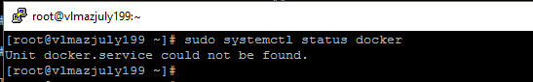

yum install -y yum-utils

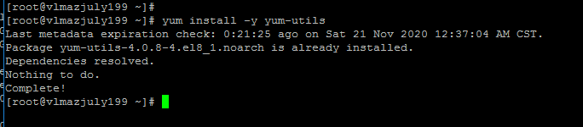

3. Setting up the docker-ce.repo under /etc/yum.repos.d

yum-config-manager --add-repo https://download.docker.com/linux/centos/docker-ce.repo

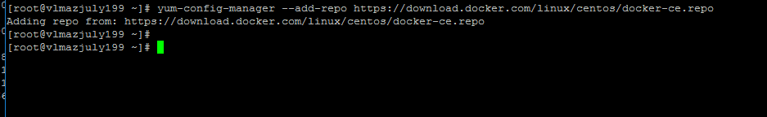

4. Install docker

yum install docker-ce docker-ce-cli containerd.io --nobest

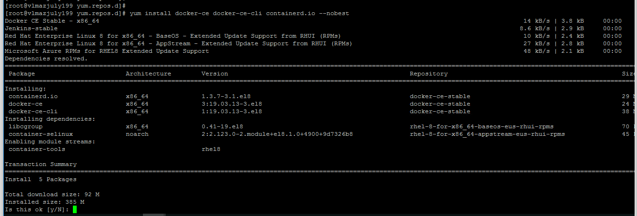

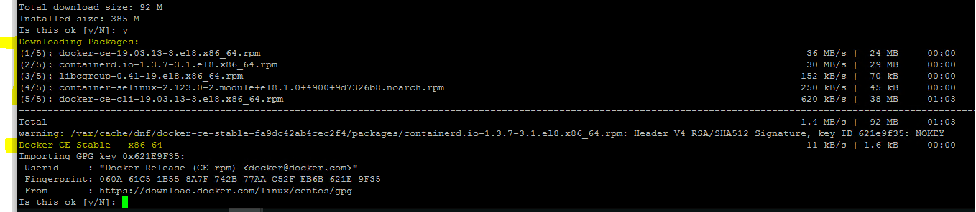

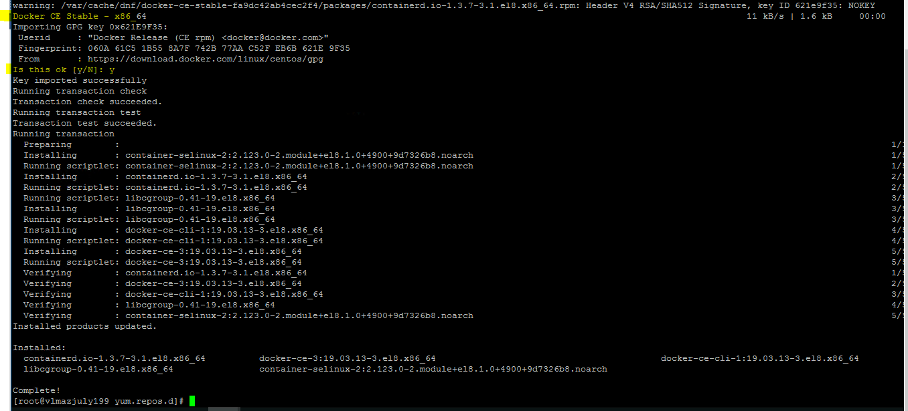

yum list docker-ce

yum list containerd.io

yum list docker-ce-cli

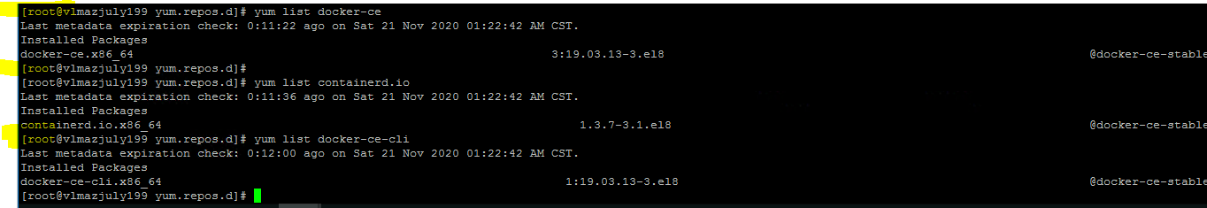

5. Check for the docker version

docker --version

systemctl status docker

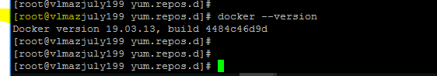

systemctl status docker

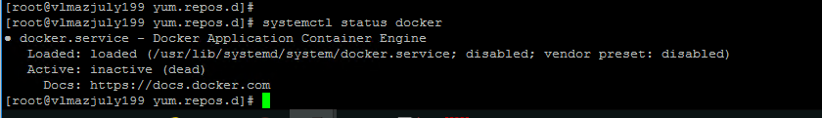

6. Start the docker

systemctl start docker

systemctl status docker

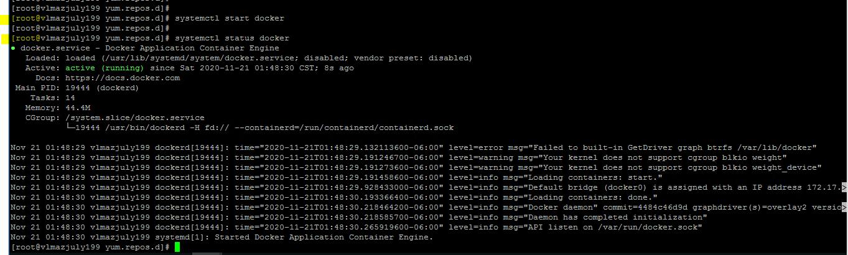

7. To check the docker process

docker ps

8. To check the docker images list

docker images or docker image ls

10. Pulling httpd image from registry(hub.docker.com)

docker pull httpd

11. List images

docker images

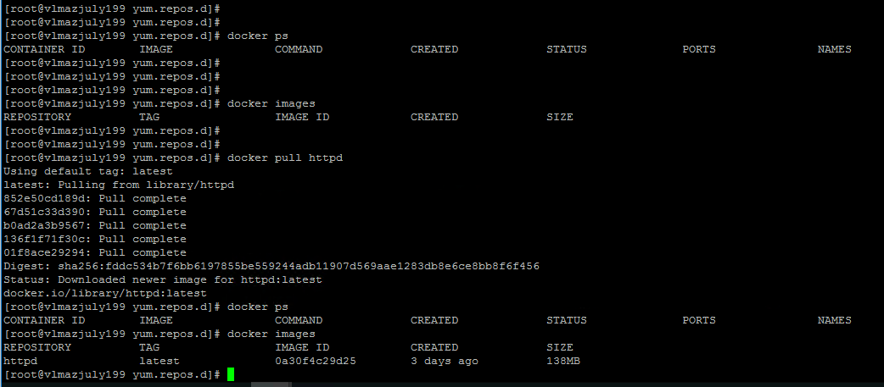

12. Run the docker images

docker run -itd <img_id>

13. To stop a container

docker stop <contianer_id>

14. To start a container

docker start <container_ID>

docker ps -a

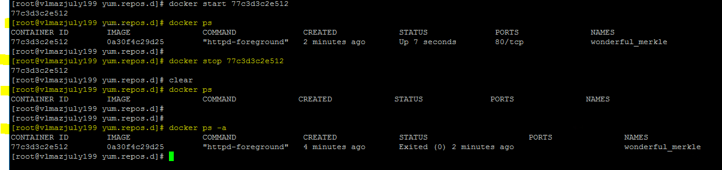

Dockerfile

Step 1 : Create a file named Dockerfile

Step 2 : Add instructions in Dockerfile

Step 3 : Build dockerfile to create image

##Getting Base Image Ubuntu from hub.docker.com

FROM ubuntu

##Getting empty image from hub.docker.com

#FROM scratch

## MAINTAINER {NAME} {EMAIL_ID}

MAINTAINER ShankarPrasad <shankarprasad.nonavenakerejayadeva@fisglobal.com>

##Gets executed during image creation

RUN apt-get update

##Gets executed during creating of container ofthe image.

CMD ["echo", "Hello World...! from my first docker image"]

Step 4 : Run image to create container

COMMANDS

: docker build .

-t : <name>:<TAG>

: docker build -t ImageName:Tag **directoryOfDocekrfile**

docker build -t njspubuntu:1.0 .

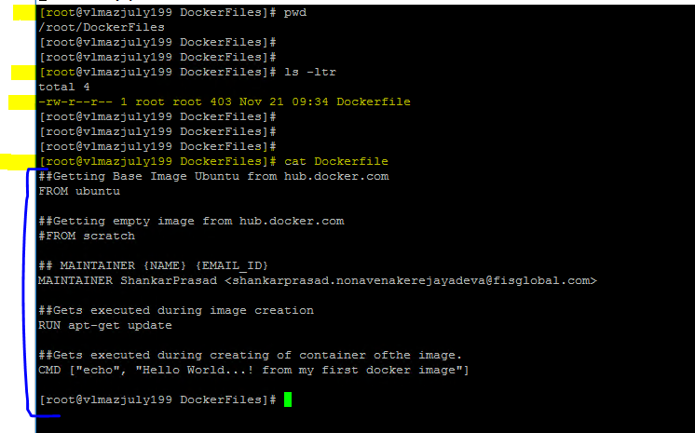

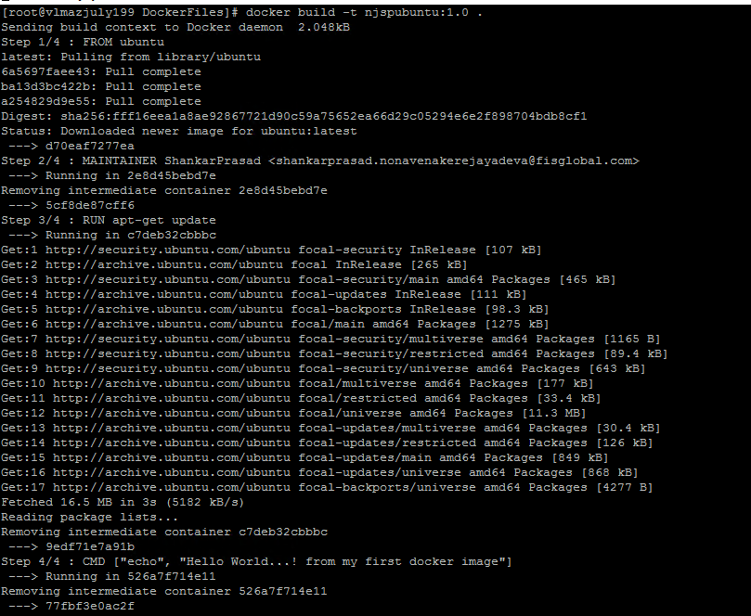

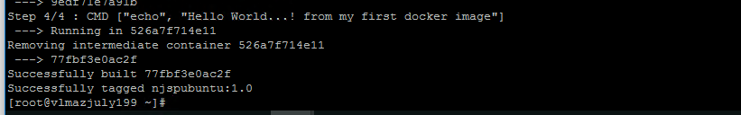

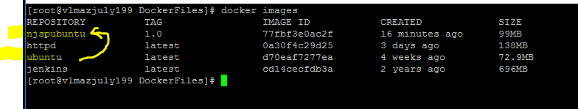

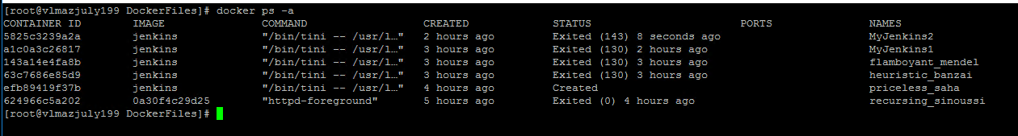

docker run njspubuntu:1.0

docker ps

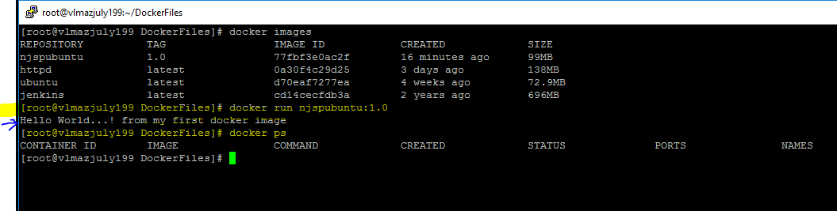

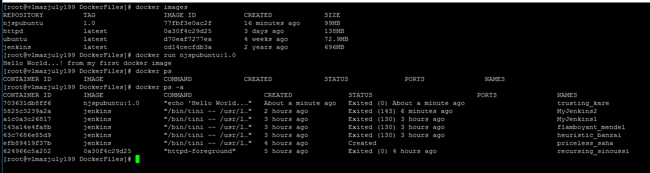

docker images

docker run -itd njspubuntu:1.0

docker ps

docker ps -a

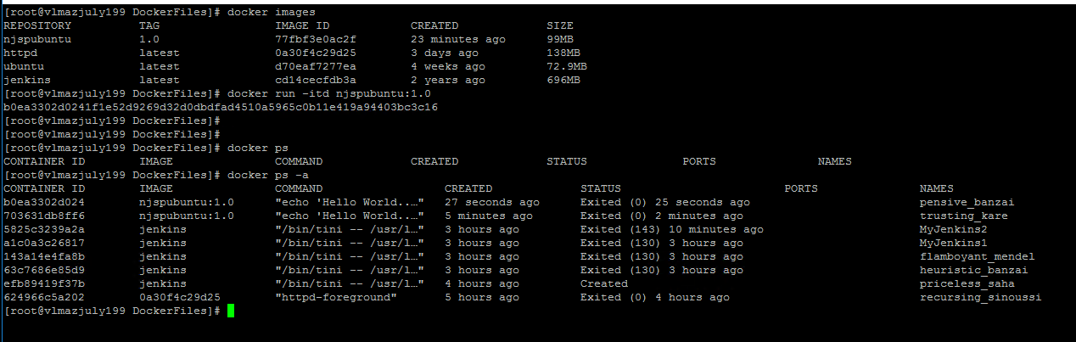

docker run -itd njspubuntu:1.0 /bin/bash

docker ps

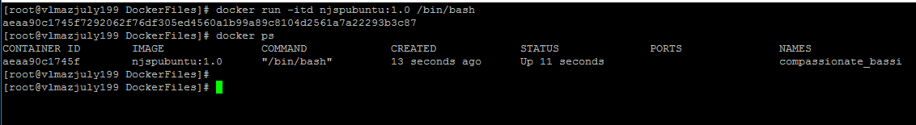

docker attach aeaa90c1745f

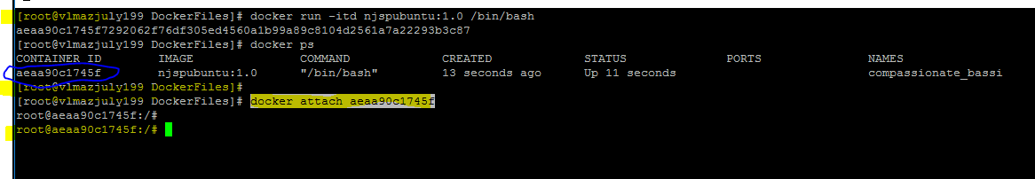

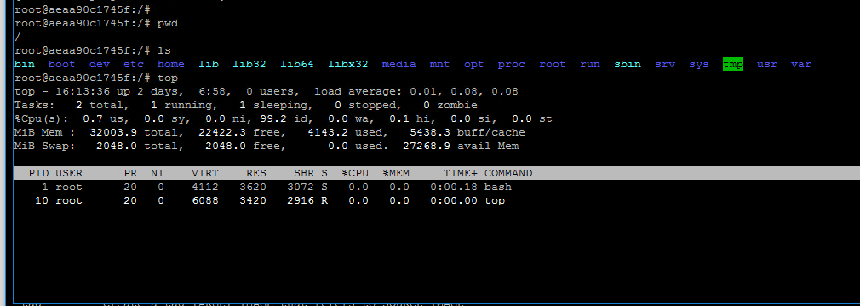

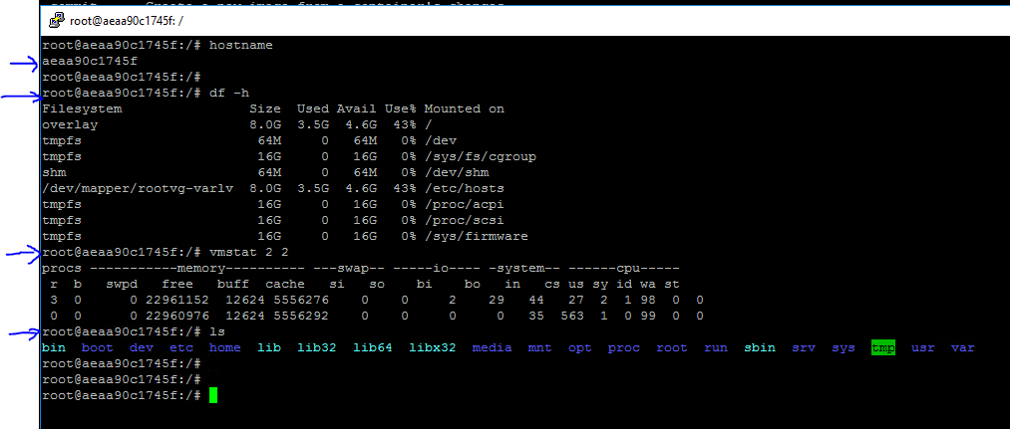

Press Ctrl+P+Q to exit from attached docker container

