**Results**

Connected UDP –

As soon as the server starts –

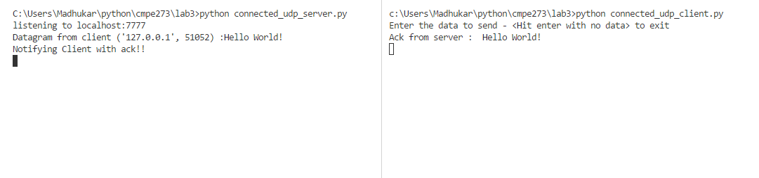

On typing some data in the client and exiting–

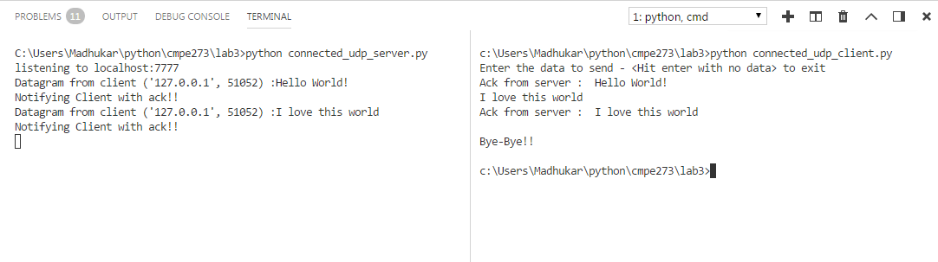

**Multicast UDP –**

