1. Diff bet TWA and RWA

2. Consider there are 2 entities Emp and Dept. Emp is having dept as FK. And one Emp can belong to many dept

How to establish the relation?

3. Have you used any forge component? IF yes then what are the steps to use it?

OutSystems Forge is a repository of open-source reusable components and applications that speed application delivery. They provide multiple additional features and components such as:

* String manipulation libraries
* Widgets to display maps or charts
* Connectors to integrate with external services such as Box, LinkedIn, or Twitter
* Entire business applications such as Timesheets, Expenses or Sales that you can customize to get a head start

To install a component as a dependency of your application:

1. In the Development tab in Service Studio, click on the **Install Application** button.
2. Search for the component, select the component and click **Install**. Once the component is declared to be compatible with your version of Service Studio, click on the **Install** button again.
3. After installing the component, from the detail screen of your application, click on the **Manage Dependencies** button.

1. On the Manage Dependencies window, find the list of installed components you can add as a dependency on left window pane. For each selected item you can see a list of its public elements on the right window pane; you can check or uncheck the elements of the component you want to use in your module.
2. Click on OK to add the component to your application and use it as required.

In the case of installing an entire application, open it and customize it to suit your needs.

4.There is one entity having 25 attribues and out of that 5 attributes are of Binary data type ..how can we create entity..Whether I should create an extension entity..and suppose we have to add many documents of any person i.e document number is not fixed ..in such case how  we can create an entity to store Dynamic(un-fixed) number of documents.

How to add more than one binary data attribute to an entity?

By Manasa mam

5. What leadership quality you have shown and when?

6. How will you handle conflict between your colleagues?

7. How will you handle misunderstanding between you and your manager?

What is Entity Identifier?-

In OutSystems, a primary key is called Entity Identifier. When an Entity is created, an attribute called Id is automatically added as Entity Identifier. By default, it is of data type Long Integer and its value is automatically calculated in sequence (an AutoNumber in OutSystems).

Entity identifiers are attributes, specifically, key attributes that uniquely identify each entity. An entity identifier is not an optional attribute; every entity must have a key attribute to uniquely identify it. Entity identifiers (key attributes) become primary keys in a table.

What is static entity in OutSystems?

A static entity is an entity that has static data associated to it. This static data is managed at design time and can be used directly in the business logic design of the application, benefiting from strong typing.

What are Extension Entity?-

One-to-one relationships allow you to extend an existing entity with additional information that is not yet in the database model.

A common scenario is when you want to extend an entity with more attributes and it's not possible to add them to it. This happens when you are using a referenced entity from a different module, and adding more attributes don't make sense in the referenced module. In this case, you create an entity in your module to store the additional information.

To create a one-to-one relationship to an existing entity:

1. [Create an Entity](https://success.outsystems.com/Documentation/11/Developing_an_Application/Use_Data/Data_Modeling/Create_an_Entity_to_Persist_Data).
2. Change the Id attribute to be the identifier of the entity you want to extend.
3. Add the attributes.

Explain One to One, One to Many and Many to Many relationship with example.- Explain Master, Details Entity with example.-

What are junction entity?-

Explain the Delete Rule in detail.-

How to create the Entity Diagram in the Outsystem?-

<https://success.outsystems.com/Documentation/11/Developing_an_Application/Use_Data/Data_Modeling/Entity_Relationships>

OS 11 features

Faster App Creation

Screen Templates

Replace Data

OutSystems UI Framework

Architectural Agility at Scale

App Architecture

Improved Dependency Management

Low-Code Micro-services

Productivity and Team Collaboration

1-Click Publish: Accelerated by Differential Deployment

Automatic Text Merge

Inline Records

Folders Everywhere in Service Studio

Disable Elements

ListDistinct

General Improvements

Web Block Events and Event Handlers

Consume SOAP Web Services Improvements

WYSIWYG Editor Updates

Styles Editor Improvements

Publish Outdated Consumers

Boolean Conditions in Aggregate Joins and Filters Simplified

Reorder Aggregate Filters

Split Logging Data

Microsoft SQL Server 2017 Support

Updated Stack on OutSystems Cloud

Service Studio on 64-bits

Service Studio for Mac

Artificial Intelligence

How interaction happens between one web page to another in the Outsystem?-

What happens when the user clicks on the submit button on the screen?-

What are screen actions?-

In OutSystems web applications you can create the following Actions:

* Screen Actions
* Server Actions

Screen actions

In a web screen to update a Contact, for example, you will need to define an action that reacts to the user interaction of clicking the "Save" button and execute the logic to update the Contact. In OutSystems web applications you do this in a **Screen Action**:

**Screen Actions** allow you to run logic when the user interacts with the screen, such as clicking on a button or a link.

You can also add **Screen Actions** to your Web Blocks.

What are Server actions?-

An application typically has its own business rules. In OutSystems you can create **Server Actions** to encapsulate the logic that implements the business rules of your application and use them in other actions, such as Preparation actions, Screen Actions or other **Server Actions**:

You can set a **Server Action** as a function and use it directly in expressions.

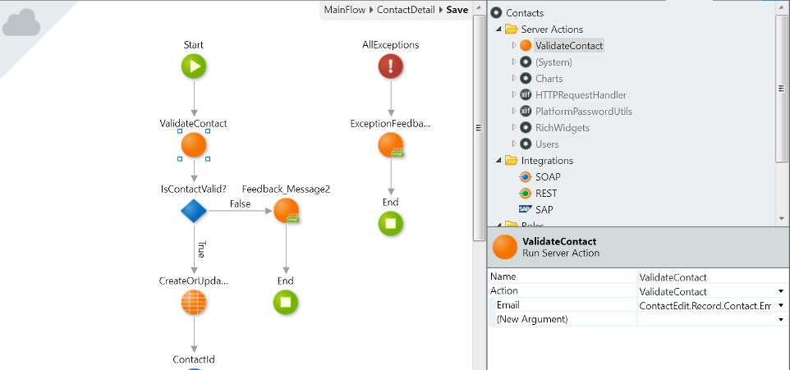

Explain the Submit Screen Life Cycle of the web page?-

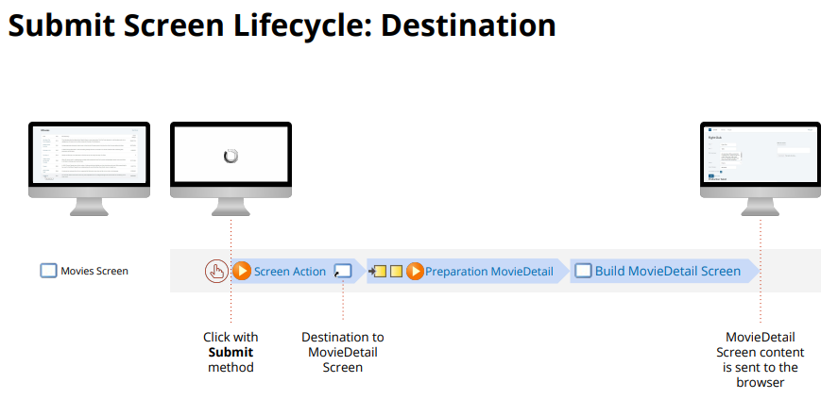

What is Preparation?-

**Preparation Actions**

When you have for example a web screen that lists Contacts, you will need to execute some logic before the screen is displayed to fetch the list of Contacts from the database.

In OutSystems, you execute that logic in a **Preparation** action:

* You don't have to explicitly invoke the **Preparation** action because it is automatically executed before a screen is rendered. It is right place to add all the logic you want to execute before the screen is displayed, such as setting values to variables and fetching data from the database.
* You can also add a **Preparation** action to your Web Blocks.

Can aggregates have multiple resources?- Yes

Does aggregates supports Join? Explain how?- Yes.

With: Full join (will return all records from both tables)

With or Without: Left outer join (will return all records from left table whether its match or not in right table)

Only With is Inner Join.

Automated is just Only With (if foreign key is a mandatory attribute) and With or Without (if is not mandatory) because they are the obvious choices:

If it is mandatory, I can do a Inner Join because they will match. If it is not mandatory, I keep the relevant table and all the extra info is a bonus.

What is calculated attributes?-

There are situations when the data fetched from the database isn't enough and you need to add more information to each record, namely based on the values returned. OutSystems allows you to do it. You can add new attributes to the records returned by the aggregate based on the value of the other attributes:

1. In the aggregate, click **New Attribute** to add a new attribute to the aggregate and name it.
2. Open the attribute menu and select **Edit formula...**
3. Define the expression to calculate the value.

Ex. price, discount percentage, discounted price

https://success.outsystems.com/Documentation/11/Developing_an_Application/Use_Data/Query_Data/Create_a_Calculated_Attribute_in_an_Aggregate

Explain SQL Tool Widget.-

The SQL **SQL** element lets you run, test, and review SQL queries in your apps. SQL is an all-purpose tool for developers who know SQL language. For a more straightforward and optimized data manipulation use **Aggregates**.

**Accessing data**

**SQL** accesses data through the input parameters only, and other logic can access only what the SQL query returns through its Outputs.

**Input parameters**

Providing input parameters lets you use dynamic data in the SQL query. Input parameters are optional. To reference an input parameter in your SQL statement use  @ prefix, e.g. @CustomInputParameter.

**Output parameters**

**SQL** in OutSystems queries always have two output parameters, even when the query executed doesn't return a result:

* **List**: The list with the result returned by the query. The list is empty if there are no results.
* **Count**: The number of records returned by the query without considering the SQL Max Records property.

**Output Structure**

Output Structure is mandatory. You need to define the structure (data types of the columns) that your query returns. You can use any combination of Entities, Structures or both, but the attribute order/data type must match your Select. Output Structure is needed even if your SQL statement doesn't return any results.

* Example 1: When selecting all attributes of the Employee Entity (with Id, Name, Email, and PhoneNumber attributes), specify the Employee Entity as the Output Structure. This enforces that List output parameter of the SQL query returns Employee List data type.
* Example 2: When selecting only the Name and Email of the same Employee Entity, create a Structure (named EmployeeInfo) to hold the attributes you need and use it as the Output Structure. The data type and order of the attributes in the SELECT statement must match the data type and order of the attributes of the EmployeeInfo Structure. This enforces that List output parameter of the SQL query returns EmployeeInfo List data type.

To reference an entity in your SQL query write it between curly brackets (for example, {User}) and to reference an entity attribute write it between square brackets (for example, [PhoneNumber]).

To learn more about SQL in OutSystems, check out the following free courses:

* [SQL Queries](https://www.outsystems.com/training/courses/146/sql-queries/). Write your SQL queries to interact with data in OutSystems.
* [Getting Started with OutSystems for SQL Developers](https://www.outsystems.com/training/courses/169/getting-started-with-outsystems-for-sql-developers/). Learn how to create a data model, fetch data, and how to use an existing external database in an OutSystems app.

Write your own SQL query

Do the following:

1. Add a **SQL** element to an action flow.
2. If necessary, define the query parameters.
3. Write the SQL query.
4. Define the output structure used for the output of the SQL node.
5. Use the output list of the SQL node to access the result of the SQL query.

In Reactive Web Apps and Mobile Apps you can use the SQL element in **server-side logic**, like Server Actions.

Test your SQL query

You can test your work by clicking the TEST button located at the bottom of the SQL editor. To test it successfully make sure that:

1. If you have Query Parameters you should first assign a test value in the Test Inputs tab.

Note: If no values are assigned, the query will be tested with empty values.

1. There is one or more output entities/structures that will match the attributes on the SELECT statement.
2. Click **TEST**.

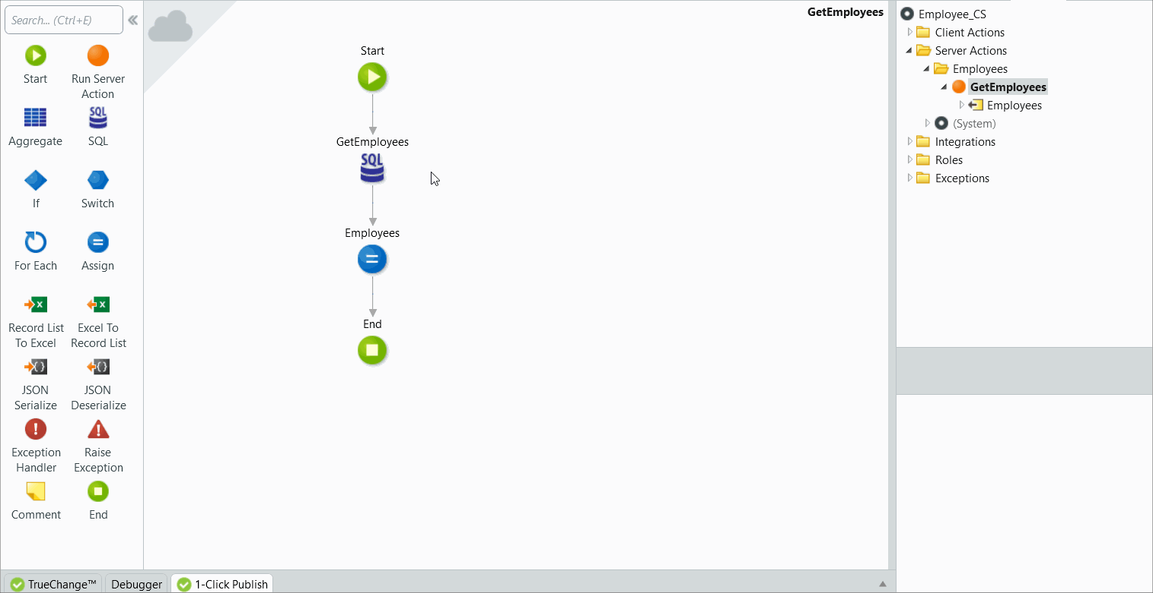

Convert an Aggregate to SQL

As your application grows, you may need to change an existing Aggregate to fetch data in a different way. If your use case requires more advanced data fetching, such as subqueries or IN clauses, use a SQL element instead of an Aggregate. You can also **convert an existing Aggregate to a SQL element**, which lets you keep evolving the SQL generated from your original Aggregate.

Although the **SQL** element enables you to refine your query, **Aggregates have the following advantages**:

* The runtime SQL statement of an Aggregate is optimized to fetch the necessary number of rows and columns.
* The effort to maintain an Aggregate is lower.

Therefore, you should always start fetching data using an Aggregate and convert to a **SQL** element only when necessary.

**How to convert an Aggregate to a SQL element**

To convert an existing Aggregate to a SQL element follow these steps:

1. In your action flow, double-click the Aggregate you want to convert.
2. In the Aggregate window, double-click the Executed SQL property to open the Executed SQL window.
3. Click **CONVERT AGGREGATE TO SQL**.

The **CONVERT AGGREGATE TO SQL** button is only enabled if your Aggregate doesn't include any of the [limitations listed above](https://success.outsystems.com/Documentation/11/Developing_an_Application/Use_Data/Query_Data/SQL_Queries#limitations).

1. Click **PROCEED**.

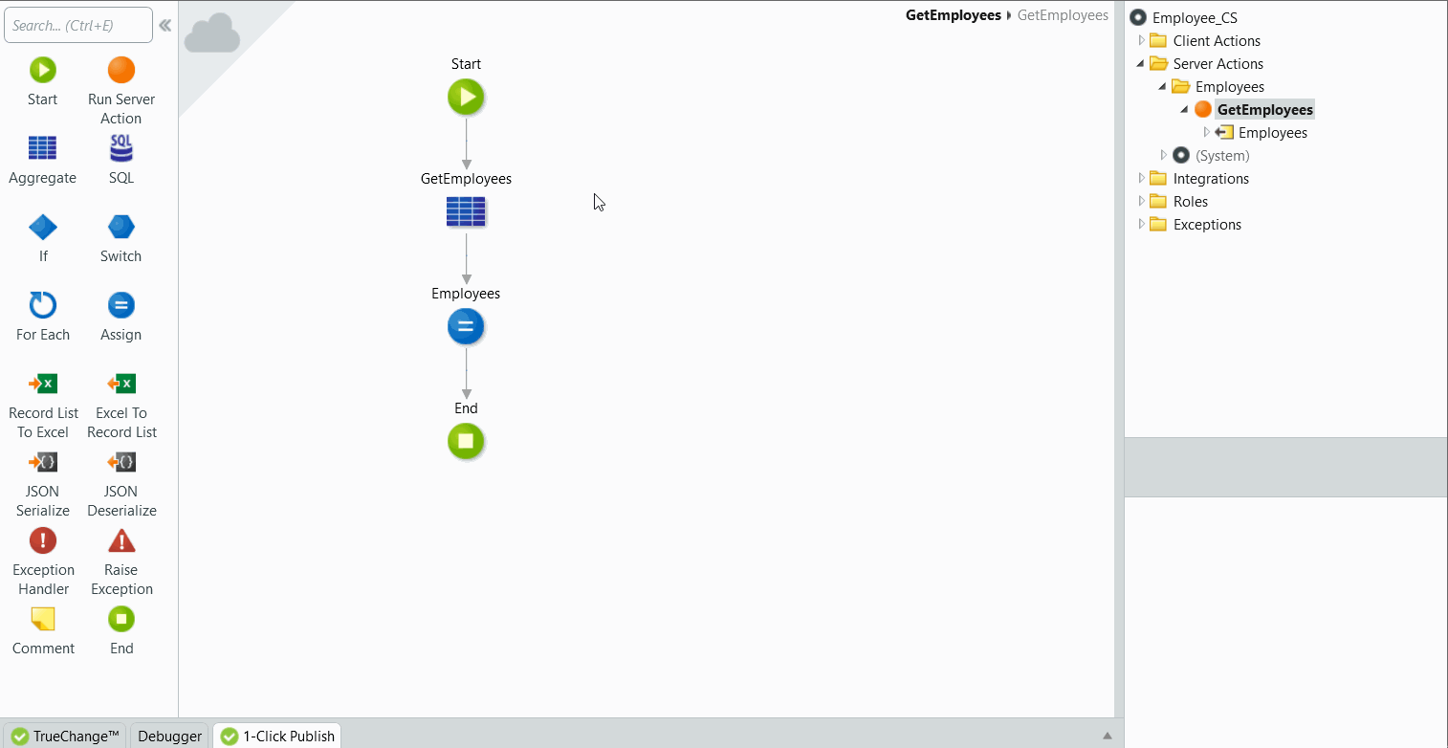

Your action flow now includes a **SQL** element based on the original Aggregate. Service Studio disables and keeps the original Aggregate in the action flow. After you validate the query results of the new **SQL** element, delete the Aggregate.

**Limitations**

The option to convert an Aggregate to a SQL element is only be available if your Aggregate **doesn't** include:

* Structures in Sources
* Calculated Attributes
* Group By Attributes
* Dynamic Sorts

In Reactive Web and Mobile apps, this feature isn't available for Aggregates in Client Actions or Screens.

Explain how to use IF widget.-

Allows you to control the content that is displayed in the screen based on a condition.

You specify the content of the True and False branches at design time. At runtime the condition is evaluated and only one of the alternatives is rendered into the screen.

**Properties**

| **Name** | **Description** | **Mandatory** | **Default value** | **Observations** |
| --- | --- | --- | --- | --- |
| Name | Identifies an element in the scope where it is defined, like a screen, action, or module. | Yes |  |  |
| Condition | Boolean literal or expression to decide which content is displayed. | Yes |  |  |
| Animate | Performs an animation on the content when the condition changes its value. | Yes | No |  |

Runtime Properties

| **Name** | **Description** | **Read Only** | **Type** | **Observations** |
| --- | --- | --- | --- | --- |
| Id | Identifies the widget instance at runtime (HTML 'id' attribute). You can use it in JavaScript and Extended Properties. | Yes | Text |  |

How to bind Combo Box in the Outsystem?-

Allows the user to select a specific value within a list of possible values.

The list of possible values can be an Attribute of an Entity, an Attribute of a Structure or a list of special values. You can also add special values like "All" and "None" to the list fetched from an Entity or Structure.

**Properties**

| **Name** | **Description** | **Mandatory** | **Default value** | **Observations** |
| --- | --- | --- | --- | --- |
| Name | Identifies an element in the scope where it is defined, like a screen, action, or module. | Yes |  |  |
| Variable | Holds the value entered by the user. |  |  | Mandatory if Source Entity/Structure is specified. |
| Validation Parent | Specifies an Edit Record widget. Widgets with the same Validation Parent are validated as a group. |  |  |  |
| Mandatory | Boolean literal or expression that defines if the user input is required. | Yes | No |  |
| Source Record List | Current list of records displayed by the widget. |  |  |  |
| Source Entity | Data entity to populate the widget. |  |  |  |
| Source Attribute | Specifies the attribute of the records in the list to populate the widget. |  |  |  |
| Source Identifier Attribute | Attribute of the structure to be used as the identifier of the selected value. |  |  |  |
| Special Variable | Holds the value selected by the user if this value belongs to the defined Special List. |  |  | The variable must be of type Text, Phone Number, Email, Boolean, Integer, or Long Integer. At runtime, if the user selects a value among the Source Entity/Structure list of values, this property will have the value "". |
| Style Classes | Specifies one or more style classes to apply to the widget. Separate multiple values with spaces. |  |  |  |
| Visible | Boolean literal or expression that defines if the widget is displayed. |  | Yes |  |
| Enabled | Boolean literal or expression that defines if the widget is editable. |  | Yes |  |

Explain Exception handling in the Outsystem.-

The exceptions raised in your module are handled in a flow starting with an Exception Handler element. In an action, you can have more than one Exception Handler flow to handle different types of exceptions.

An exception can be raised by OutSystems or in your logic at any point of your module. For typical UI requests, you can handle the raised exceptions by:

* Adding an [Exception Handler](https://success.outsystems.com/Documentation/11/Reference/OutSystems_Language/Logic/Implementing_Logic/Logic_Tools/Exception_Handler) element and its logic in your action's flow.
* Adding an On Exception action in your UI Flows.
* Let the Global Exception Handler of your module do the work. By default, Global Exception Handler property of your module is set to the On Exception action of the "Common" UI Flow.

In action flows starting in Timers you can only handle the raised exceptions by adding Exception Handler elements in your logic, otherwise, the execution flow is interrupted and the error is logged.

When an exception is raised, the current execution flow is interrupted and the flow restarts in the first Exception Handler element which handles that type of exception.

As an example, consider an Action B raising a User Exception named MyUserException. Action B is invoked by Action A, which is a screen action. When MyUserException is raised in Action B, the exception handling mechanism works as follows:

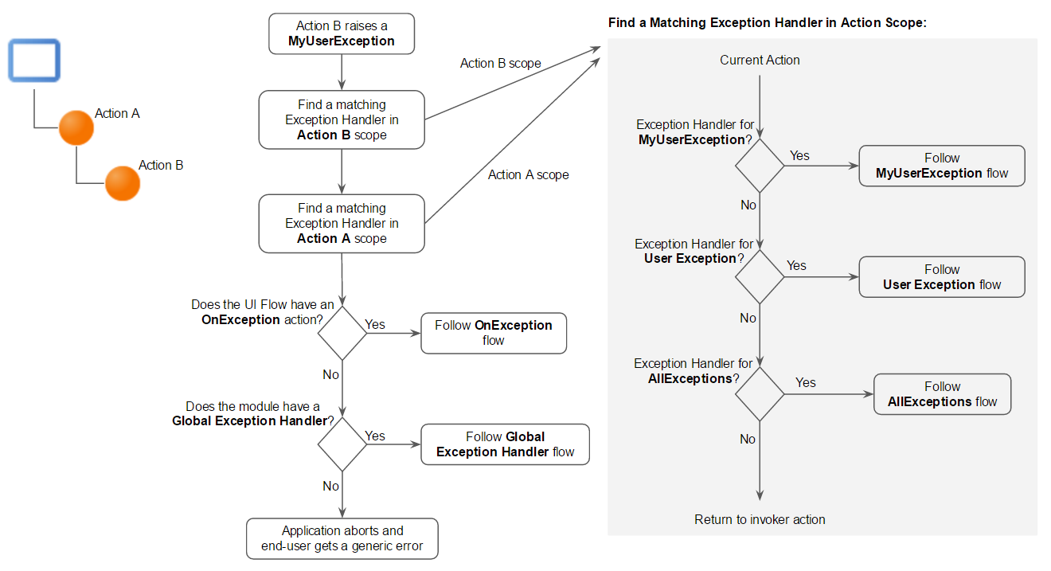

You should have, at least, one Exception Handler in your application flow to inform and allow the end user to continue to navigate.

**Handling exceptions raised by integrations**

When you are handling exceptions raised by an integration you are consuming (such as an action of an Extension or a method of a REST API) you won't be able to determine the type of exception. In these situations, you should handle the exception with an All Exceptions Handler. Then, you can use the **ExceptionMessage** property of the Exception Handler element to identify the exception.

What is action flow?-

Explain the concept of Validation- When users enter data in a form and click a submit button, check if the data is valid. If the data seems valid, the app can continue. If not, you should tell the users which fields contain the errors and how to fix them.

For example, if your users need to enter their emails in the field, and they enter their name instead — that information isn't valid. You can use the built-in capabilities of the app to show the error message and ask the users to retry.

The client-side validation improves the user experience because it's quick feedback about information users enter in the form. However, **you should always check the data that comes from the client side before you save that data to the database**.

Most of this document applies to Reactive Web App and Mobile App. For Traditional Web App, see [Validation in Traditional Web](https://success.outsystems.com/Documentation/11/Developing_an_Application/Design_UI/Forms/Validate_the_fields_of_a_form#validation-in-traditional-web).

**Using accelerators to create initial validation flow**

In OutSystems low-code approach, the **automatic client-side form validation is provided by default for the supported data types**. To use the built-in validations, you need to:

1. Set the data types of the values in the form. You can do this manually or [scaffold the form fields from Entity](https://success.outsystems.com/Documentation/11/Developing_an_Application/Design_UI/Forms/Validate_the_fields_of_a_form#generate-form-fields).
2. Set the fields as mandatory, if required.
3. Trigger an accelerator to create a new Client Action with initial validation flow. To automatically create the logic, select the **New Client Action** from the Event list of the element that submits the data inside the form. Check [this example step to create a new Action](https://success.outsystems.com/Documentation/11/Developing_an_Application/Design_UI/Forms/Validate_the_fields_of_a_form#step-new-action) for a Button.

**Set an input field as mandatory**

The field is mandatory if users must enter a value in that field. To set a field as mandatory, select the widget and in the **Properties** pane set the **Mandatory** property to **True**. Widgets have the **Mandatory** field, for example, **Input Widget** or **ButtonGroup Widget**, if their common use case requires it.

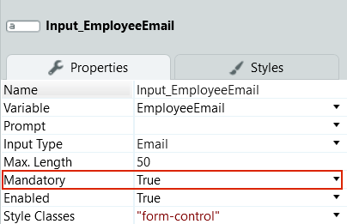

**Set the data type of a form field**

To automatically check whether the value user enters is valid, you first need to tell the app which value you expect. Select the data type from the **Input Type** list in the properties of the widget. There are several Data Types you can choose from, such as Integer, Currency, Date, Time, Email.

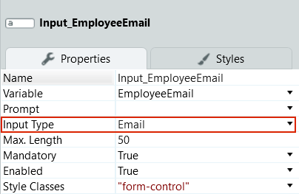

**Enable or disable the built-in validation**

To activate the built-in client-side validation, set the **Built-In Validations** property of the **Event** that submits the data to **Yes**. For example, **On Click** Event of a Button Widget or a Link Widget that calls a Client Action.

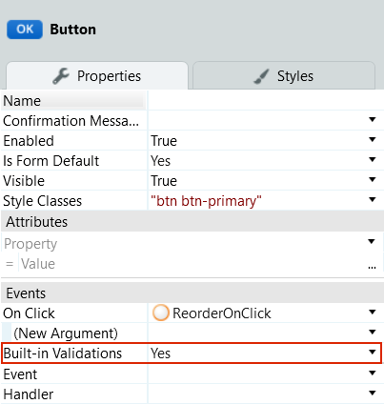

**Validate the data in a Client Action**

With the built-in validation enabled, you can access the boolean **Valid** property of the Form Widget in the Client Action that submits the form. For example, if you have a form ReorderItemForm, and a user submits correct data, the value of ReorderItemForm.Valid is True. If a check for any of the fields fails, the value of ReorderItemForm.Valid is False.

In this example, an **If** node has ReorderItemForm.Valid in the **Condition**. If the value of Valid is False, the validation fails and the **False** branch of the **If** flow runs.

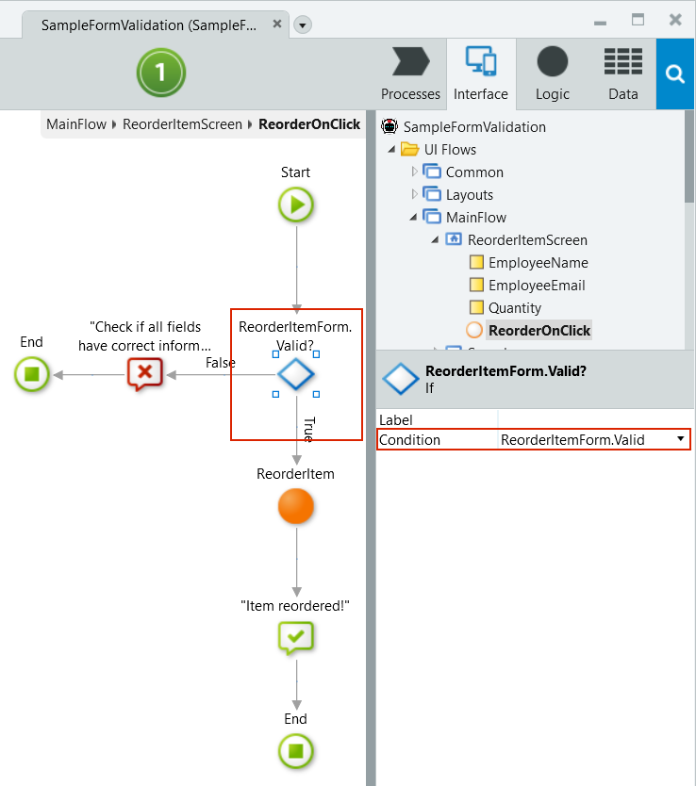

The app validates only the fields you set as mandatory. The app skips the fields that you don't set as mandatory, as those fields are then optional.

Customizing validation error and warning messages

Here are some ways to edit the validation messages.

**Editing the default validation messages**

You can edit the default validation messages on the module level. Go to the module properties by clicking the module name (1) in any of the main Service Studio tabs (**Process**, **Interface**, **Logic**, or **Data**). Then, edit the messages in the **Validation Messages** section (2).

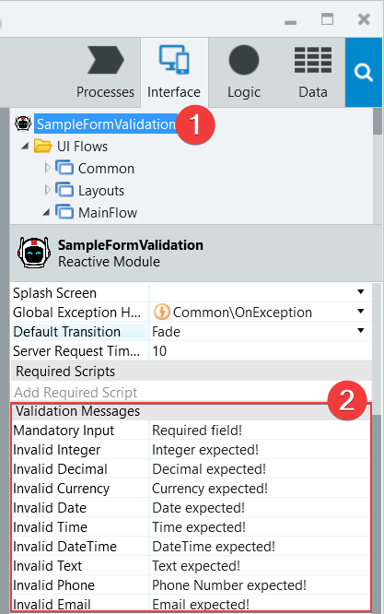

**Changing the field validation messages programmatically**

You can change the validation messages for fields during the execution of the app. You do that by assigning a text value to the **ValidationMessage** of the widget. Keep in mind that the message only shows after the validation fails, when the value of **Field.Valid** is **False**.

What are the types of Validation?-

Client side and Server side validation.

In both validation methods, "Client & Server" and "Server", the page will perform the standard validation in the client (browser): Wrong Data Type and Missing Mandatory Value

The difference is that in the first case ("Client & Server"), the javascript that does this validation will not call the screen action. Instead, it will mark the wrong inputs (usually red border) and set the standard validation messages and warn the user.

In the second case ("Server"), these two steps, set the input/form valid to false and set the standard message will ALSO be performed, but you need explicit logic in the action (that will be called), to check if the form is valid or not (the form Valid property will be set to False if there is something wrong).

Explain Client side and Server side validation.-

**Create your custom javascript to validate inputs on client side**. Client Side Validation allows you to create a custom client side javascript validation that can be fired on change event to provide an instant feedback.

How to debug your code in the outsystem?

**How to debug your app**

To debug your app, do the following in Service Studio:

1. Click the 1-Click Publish button to save the latest changes in the module before debugging.
2. Set one or more [breakpoints](https://success.outsystems.com/Documentation/11/Developing_an_Application/Troubleshooting_Applications/Debugging_Applications/Breakpoints) in the module you're debugging.
3. Before debugging a **native mobile app**, choose a debugging target in the [Debugger tab](https://success.outsystems.com/Documentation/11/Developing_an_Application/Troubleshooting_Applications/Debugging_Applications/Debugger_Tab_Reference): Android, iOS, or Google Chrome which emulates a device. The section [Mobile Debugging Scenarios](https://success.outsystems.com/Documentation/11/Developing_an_Application/Troubleshooting_Applications/Debugging_Applications#mobile-debugging-scenarios) includes further details about the different targets. If you're debugging a **mobile app distributed as a PWA**, select **Emulate using Google Chrome** in **Debugger** > **Debug Setup**.

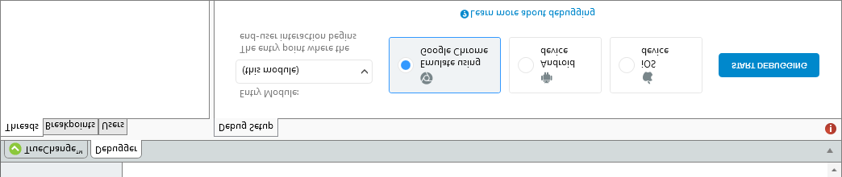

1. Start debugger by clicking the **Start Debugging** button in the [Debugger tab](https://success.outsystems.com/Documentation/11/Developing_an_Application/Troubleshooting_Applications/Debugging_Applications/Debugger_Tab_Reference) or by selecting **Debug in the Public Area** in the Debugger menu. When you're debugging mobile apps using the Google Chrome target, Service Studio opens a dedicated Chrome browser instance for debugging only.

Note: To also open a browser when starting a debug session in a **web application**, check the **Open in new browser window** option in the **Debug Setup** tab.

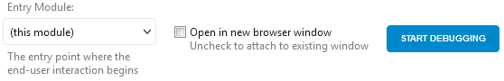

1. Do some tasks in the module, up to a point when the execution runs into a breakpoint and suspends.
2. When you switch to the Service Studio window, the flow or screen containing the element with the breakpoint shows on the canvas. Service Studio selects the element with the breakpoint and marks is with the debug icon debug icon.
3. The execution context shows in the **Threads** tab of the **Debugger** tab, marked with the current thread current thread icon, showing the current execution stack of the module elements. The **Debugger** tab also shows additional information you can explore.
4. After analyzing the runtime values at that execution point, you can continue running the app by:
   * Selecting one of the commands available for advancing the execution of the application logic: continue icon **Continue**, step over icon **Step Over**, step into button **Step Into** or step out button **Step Out**. The execution point advances according to the command you run.
   * Right-clicking an element on the canvas (or in the module tree) and selecting the **Continue To Here** option in the context menu. The execution continues until it reaches that element on the canvas.

In some scenarios you need to [debug some functionality exposed by another module](https://success.outsystems.com/Documentation/11/Developing_an_Application/Troubleshooting_Applications/Debugging_Applications/Debugging_Producer_Modules) (called a producer module).

While developing **Traditional Web apps** you can also [debug modules in your Personal Area](https://success.outsystems.com/Documentation/11/Developing_an_Application/Troubleshooting_Applications/Debugging_Applications/Public_and_Personal_Areas). This lets you test your changes separately from other developer's changes in the same module.

How Ajax works?

Refreshing only certain parts of a screen without having to re-render the whole screen improves the end user experience by creating dynamic interfaces and supporting faster user interactions.

For web applications, you can use Ajax to perform asynchronous requests to the web server that fetch only the necessary data to dynamically refresh the screen, without needing to refresh the whole page.

To refresh only part of a screen on a web app:

1. Add a button or link to the screen and set the property Method to 'Ajax Submit' so that the request to the server is performed asynchronously.
2. Associate a new screen action with the button or link.
3. In the new screen action, update the data displayed on the screen. For example, assign screen variables or refresh data from the database using the Refresh Data tool.
4. Drag the Ajax Refresh from the toolbox to the action flow and select the widget that displays the updated data on the screen. The Ajax Refresh can only refresh widgets that have the property Name defined.

Why to use Ajax?

Ajax allows web pages to change content dynamically

● No need to reload the entire page

How does it work?

● Sends small asynchronous requests to server

● End user continues to interact with the Screen

○ No need to wait for response

○ Page state is kept

End-user experience greatly improved

To refresh only part of a screen on a web app.

Use the Ajax Refresh element in your flow to **refresh parts of the screen without** reloading the entire page

What is the difference between Refresh Data and Ajax Refresh?

The **Refresh Data** element is used to get updated data from the existing data source (ex: Aggregate or SQL Query). This means that the query will be re-executed and the data retrieved will be updated.

The **Ajax Refresh** element is used to refresh a part or parts of the screen without reloading the entire page.

For example, if you want to refresh the data that is being displayed on a table in the screen when you apply a filter or a pagination, you will need to execute both of them.

First, you refresh the data (Aggregate that populates the table) and after you refresh the table itself (element) in the screen:

Explain the screen lifecycle with the Ajax.

What is the difference between Ajax life cycle and page life cycle in the Outsystem? Explain the screen lifecycle with the Ajax.

What are Web Blocks in the Outsystems? There are many benefits of using WB.One being standardizing the UX/UI

A Web Block is a reusable UI Component

● Web Blocks promote reusability

○ Develop once, use many times

○ Encapsulate its own logic

● Web Blocks improve maintainability

○ Changes are reflected on every Screen that uses the Web Block

How to create the Web Blocks in the Outsystem?

What is the use of the placeholder widget in the Outsystem?

How interaction happens between parent screen and child screen?

How to handle events in the Web Block?

What are different event handlers in the Web Block?

On parameter changed

On initialise

On ready

On render

On destroy

Explain Web Block lifecycle with respect to screen life cycle.

Why to use Web Block?

How to handle security in the Out system?

Explain the concept of Authorization and Authentication in the Out system.

How to create Groups and grant role to them? -

What are Roles in the Out system?

Where we can check the Roles?-

What is Screen Role property?

What are sessions in the Out system?

What are session variables and site properties?

For what purpose we can use site variables? Explain with examples.

What is Web Service?

What are SOAP and REST web service?

**********************************************************************

What is the difference between a web application and web service?

What is the difference between a web application and Reactive web application?

Explain the basic architecture of HTTP request response model of web application

Which languages are used by browser to render the response

Explain the difference between responsive web application and reactive web application

What is the use of blank module

Explain producer consumer model

Explain the steps for consuming a module

Name 4 main components of Out Systems

Explain the steps involved in integrating a .NET module in Out Systems

What is continuous iteration of the Out Systems application

What is the use of switching environment

How to change the version of application

Tell me a situation when you will use widget tree to design a page instead of designing directly on canvas

What is the difference between SQL table and Out Systems entity

************************************************************************************************************

1.Name 3 alphanumeric datatypes available in Out Systems

Text

Phone number

Email

2.Explain the concept of Entity Actions

CRUD

3.Can a static entity have referential integrity attribute from dynamic entity?

Yes, we can have, it can be referenced by record name.

4.Can we set default value for a mandatory input variable

no. We can set for non-mandatory and local variables

5 .Can we set a server method as function if there are 2 output variables

no, if the output variable is 1 then only it can BE SET

6. What do you mean Compound type?

Structures are custom compound data types.

Compound MEANS we can store different data type.

7.How screen templates can speed up application development?

In screen templates we need to give source and the screen are ready.

7. What is the role of preparation in screens ?

The Preparation is a special Screen Action Which has access to the Screen Inputs and Local Variables and can access other data. Data needed to help render the Screen should be fetched in the Preparation

8.   Name 3 important steps of screen lifecycle in sequence

When accessing a Screen, it all starts with a request from the browser

1. Mandatory Input Parameters are set to the value sent in the request

2. Empty Non-mandatory Input Parameters and Local Variables are set to default values

3. Preparation runs

4. Screen is built (rendered) from top to bottom

When the response gets to the browser, it is displayed to the user

9.When you drag n drop an entity directly from Data tab to action flow, aggregate gets automatically created

yes, it creates but the reference id is not created that we can add source manually.

 10.Explain the diff bet SQL Tool and aggregate

 Sql is actual representation of database

Aggregate is virtual representation of database.

SQL TOOL: SELECT, DELETE, UPDATE, RETRIVE/GET

Aggregate: Filter, Sorting, Joins, Testing etc. There are more advanced options available in Aggregates.

   ● Multiple Sources

   ● Calculated attributes

   ● Aggregated functions

11.How to implement a group by statement in aggregate

If you have a GROUP BY, you can only SELECT the Grouped BY columns, a

and aggregate functions (like SUM, COUNT, MAX, MIN etc.). But again, this is bog-standard SQL,

and has nothing to do with Out Systems.

12.What is the output of an aggregate?  Explain with its properties

List of records with several properties

● Length - number of elements returned

● Empty - True if no records were returned

● EOF, BOF, CurrentRowNumber - filled while iterating the List

Aggregate Get<Entity> contains a “List. Current”

● Type matches the definition in the query

● The “Current” cursor moves through the List when iterating

○ Points at first row by default

● Filled in with default values if no rows returned by query

○ Empty List

Count has the total number of records that match the criteria defined in the Aggregate .

13. Explain Max records property of aggregate?

It is possible to limit the Aggregate’s output to a maximum number of records

14. What can be possible values for Type property of an image widget

Database

URL

Static

**********************************************************************************

What are the steps to bootstrap the data in Out systems??

To bootstrap data from the first sheet of an Excel file to an existing entity, follow these steps:

In Service Studio, go to the Data tab, right-click on the entity and in the Advanced menu, choose 'Create Action to Bootstrap data from an Excel...'.

Select the Excel file, check the mappings to see if they're correct and click on Proceed. Service Studio creates:

An action with the bootstrap logic named "Bootstrap<entity name>" in the Server Actions folder in the Logic tab.

A structure with the content of the Excel file named "Excel_<filename>" in the Structures folder in the Data tab.

A resource with the Excel file in the Resources folder in the Data tab.

A timer to execute the action at publish time named "Bootstrap<entity name>" in the Timers folder in the Processes tab.

***********************************************************************************

How to transfer data from one screen to another screen.

To pass information with Input Parameters:

In the destination Screen add an Input Parameter.

In the source Screen add a link to the destination Screen and set the Input Parameter value.

We can also pass data from block.

Add web source block and event to for changing and send to target block

How to create timer.

Create the Timer

To create a Timer in your module, do the following:

In the module tree, under the Process tab, right-click on the Timer folder and select Add Timer.

Choose the action to execute when the timer runs or select (New Server Action) to create a new action.

If the Action you specify has input parameters, when creating the Timer you need to specify the values that are passed as parameters when the Timer wakes. However, if the action has output parameters, there is no way of accessing them after the action is finished executing.

You can set a schedule to run the Timer automatically or you can explicitly run the Timer.

-Set the Timer Schedule

You can set the schedule of a Timer in one of the following ways:

Setting the Schedule property of the Timer at design time: You can define a recurrent schedule, such as daily or weekly, or define the Timer to run each time the module is published, for example to execute configurations or bootstrap data.

Setting the Timer schedule at runtime in Service Center: The effective Timer schedule is set in Service Center. If you define the Timer schedule both when designing the application, and in Service Center, the first schedule is ignored. This ensures you can customize the Timer schedule when deploying an application to another environment, without having to change the application itself.

Implement logic that changes the Timer schedule at runtime: Assign the Schedule runtime property of the Timer with a specific schedule within your logic. Make sure to use the correct time format.

When you define a schedule for your Timer, the Timer will run at the predefined time.

Run the Timer Explicitly

There are two ways of explicitly run a Timer:

Using the Wake<Timer Name> built-in action

Running the Timer in Service Center .

 Have you ever worked with Integration Studio/What you devoloped in IS.-

there was 1 library which was developed for converting any date format to hijari date format,using nuget packages so i hav used that library through

integration studio. it was already developed.

i created action from which we send normal date format to convert hijari date.

I am working with Omnepresent from last 2 years and I have been though OutSystems training. This training was included with TWA, RWA, Mobile app development, 3LC architecture, BPT and working with integration studio. After this training I was working with different clients for various projects. Some of them were on TWA and most of them were implemented on reactive.

I have also studied about mobile app developement but never worked on any live project for it.

I have registered for OutSystems certification and exam is scheduled in first week of Oct but if you want I can reschedule and clear this exam in next 2 days

Recently I was working on National Insurance Application  project, and the project was about......  This application is designed to provide facility to apply and manage various Insurance   application. Facilitating the applicant to apply for Insurance via a portal where user can view a list and apply for new Insurance.

This application was intended for users to view all applied insurance. As well as agent user can approve or reject or RMI (request more information).

Have you done any integration please explain.

Install OutSystems integration

Install visual studio

Open OutSystems integration

Login your personal environment

Open out system integration

Select. NET tab

Verify your integration configuration

Create new and do edit on source code. Net

It will create extension file

Click ok

Visual studio will open

You can see extension is open in vs

What is session?

Sessions are a mechanism that can be used to store state between requests

Session Data OutSystems supports two types of cross-request data User

 Session Variables\\

 ● Available while a user is using the application

● Values are stored per user

● Values expire when session times out Cross-session

(Site) Properties

 ● Always available to all users

 ● Values are shared between all user sessions

● Values never time out.

Explain project

Insurance application

Which methodology is followed in current project?

agile

Have you implemented any JavaScript?

no

How to implement JavaScript on button action?

We can take button n create action and drag JavaScript widget n write code.

Do you involved in requirement gathering?

How many team's member in project?

What was your role in project?

Which authentication is implemented?

Roles were given and screen roles were implemented on every page.

How to create test cases in unit testing framework.

*************************************************************************

1.Tell me about yourself and your technical experience

2.tell me about 4 LC architecture

A framework to support architecture design

Orchestration module- access portals, Backoffice application. -

We can reuse this application in in other application.

End user=UI&Processes. -

Web blocks module

Process module

We can consume in other application.

Core Business Module=Business services

Server action, service action=crud APIs,Entities.

Libraries Module=External Database, external libraries, themes, -

3.have you certified?

No, soon I will get certified.

4.What is Timers in Out systems?

A Timer is an Out Systems tool that allows executing application logic periodically on a scheduled time. These are also known as **batch jobs**. Different Timers can be executed at the same time, but the same Timer never has more than one execution at a time

5.Scenario Timer(if you have 100's of mails which is sending everyday at 4:30 PM.only 50 mails are gone but remaining 50 mails you need to add something..is there anything that you stop the  timer?

Schedule runtime property then it will ignore first assigned property

6.What is Aggregate and SQL widget? Which is more preferable?

Sql is Actual representation of database

Aggregate is virtual representation of database.

aggregates are optimized

SQL TOOL: SELECT, DELETE, UPDATE, INSERT

Aggregate: Filter, Sorting, Joins, Testing etc. There are more advanced options available in Aggregates.

   ● Multiple Sources

   ● Calculated attributes

   ● Aggregated functions

Types of Joins

Only With

Only fetch records that have a match in both entities.

● Only Customers with Orders are returned (SQL INNER JOIN)

With or without

Returns all rows from the left Entity even if there is no match in the right Entity

● Customers with or without Orders (SQL LEFT JOIN)

With

Returns all rows from both Entities (SQL FULL OUTER JOIN)

8. Delete rule: When you create relationships between the Entities in your module, you must define which kind of referential integrity you want to use when deleting records. The referential integrity specifies what happens to a record of an Entity B that references a record of Entity A, when the Entity A record is deleted.

To specify the referential integrity in a relationship between two Entities, you need to edit the reference attribute of the related Entity and set the Delete Rule property to one of the following values:

Protect

Setting the Delete Rule to Protect prevents deleting records of the main Entity while there are associated records in the related Entity.

This behaviour is ensured by a database constraint created on the reference attribute. If you try to delete a record in the main Entity that still has associated records in the related Entity, the Platform Server returns a database exception and the operation is not executed.

Delete

Setting the Delete Rule to Delete guarantees that when a record of the main Entity is deleted, all the associated records in the related Entities are also deleted. This mechanism is commonly known as **Cascade** Delete.

This behaviour is ensured by a database constraint created on the reference attribute.

Ignore

Setting the Delete Rule to Ignore allows deleting records of the main Entity keeping the associated records in the related Entity.

The Ignore value does not guarantee referential integrity and, therefore, no database constraint is created. Accordingly, when you change the Delete Rule property from a previous value to Ignore, the corresponding automatic index is deleted (unless you have manually changed any of its properties).

If the foreign key attribute references an external Entity exposed by an Extension, the only possible value for the Delete Rule property is **Ignore**, as the referential integrity can’t be guaranteed.

1. Web block

A Web Block is a reusable UI component

 ● Web Blocks promote reusability

○ Develop once, use many times ○ Encapsulates its own logic

● Web Blocks improve maintainability

 ○ Changes are reflected on every Screen that uses the Web Block

10.How to add roles at run time

11.entity and static entity

An Entity is persisted in a Database Table.

 ● Each new instance or record of an Entity is inserted as a row on the corresponding table

A different Entity should be created for each application concept.

● Customer, Order and Order Item an Entity is defined by fields called Attribute

Static Entities are Entities that have a predefined set of possible values.

 ● Attribute values are defined at design time Each value of a Static Entity is a Record Static Entity records can NOT be created, updated, or deleted; only retrieved.

● Get is the only Entity Action Static Entities can be used like enumerations.

12.practical (print star pattern)

13.what is BPT? have you implemented BPT...

OutSystems allows you to design and manage your business processes and integrate them into your applications. A business process is simply called a Process in OutSystems and is understood as the way that a particular task is carried out in your organization, such as handling invoices, processing orders, or handling complaints. Processes are also known as BPT (Business Process Technology)..

14.explain rest web service

REST ● Lightweight alternative to SOAP

○ No formal API contract file

○ Provide documentation and examples instead of a contract

 ● Requests and responses (usually) in compact JSON

On before request m

On After Request.

15.how many start we can take in BPT

conditional and normal start

16.Explain conditional start in BPT

Enables repetitive execution of a process flow execution triggered by a create or update database event.

1) can you please tell advantage of aggregate over the advance SQL.

2) I have list records and have attached entity source to the list and i m going to deploy this code in project and i got time out error. What would you oppose as a senior developer to team?

1. add pagination to list

2. instead of entity as a source, have a service action

3) Have you used service module and blank module then why we use the service module and what's the core advantage.

In OS 11 Service module is basically design to expose API so that another module can consume and perform CRUD.

Blank module allows screens.

Service module does not allow screens.

4) Most probably why we write logic in server side instead of client side...what's the benefit do you think.

Server Actions

An application typically has its own business rules.

In Out Systems you can create Server Actions to encapsulate the logic that implements the business rules of your application and use them in other actions, such as Preparation actions, Screen Actions or other Server Actions:

security purpose.

while consume API what's the purpose of on before

Types of Environments

Development, quality, production, management.

Type of action in Outsystems.

A Screen Action-(Server Actions, data actions, Client Actions)

is an Action that's local to a Screen. It can only be called by Screen Elements (in Web) like Buttons or Links, or by a Notify of a Web Block. In Mobile, Screen Actions can also call each other. Screen Actions have local scope to the Screen (outside the Screen they are not visible), and have access to all Screen Input Parameters, Screen Local Variables and Widgets. Screen Actions are run either on the server (Web) or on the device (Mobile). Use Screen Actions for simple logic that's Screen-specific.

Server Actions- runs on server side-converted into funtions

are Actions that are always executed on the server, both in Web and Mobile. Since Web Apps run on the server in their entirety, this is the only available type of Action for a Web App. When a Mobile App calls a Server Action, it needs to be online (since it must reach the server to execute the Action). Use Server Actions in Web Apps whenever you need to abstract some business logic or core logic or domain specific logic. Use Server Actions in Mobile Apps only if you cannot avoid it (e.g. when syncing data), as it will incur a performance penalty (for calling the server and waiting for it to respond back).

Client Actions- runs on device side-machine side processing

are the Mobile equivalent to Server Actions. They run on the device, not on a server. Client Actions are therefore only available for Mobile Apps. Their use, like Server Actions, is to abstract logic.

Service Actions:- Asynchronous calling

Since OutSystems 11- there is a fourth type of Actions called Service Actions. These are very much like Server Actions, but share some properties with REST Methods (perhaps yet another type of Action), in that calling them only creates a "weak" Reference to the Module it's in (instead of the normal "strong" Reference.)

What is Data action in OutSystems?

In traditional –synchronous calling

In reactive- Asynchronous calling –multithreaded calling

Data Actions **run on the server**. You can create Data Actions to fetch complex data from the database, which you are not able to achieve using a single server Aggregate, or to fetch data from an external system, for example through a consumed REST API.

11: How you will handle if there is any Error comes after production-

 By using audit trail where we can get exact issue stored.

What if human activity flow in approval get stuck due to personal leave/any leave reason, then how you should handle?

An activity will only go in any of the mentioned states like open, running or exit, terminated

We can give timeout for activity on that time it will get closed automatically.

Difference between traditional and reactive.

Ajax Refresh-

Ajax Refresh in Traditional Web Apps refreshes parts of the interface. The UI elements in Reactive App refresh automatically on data change, so you don't need to use Ajax Refresh.

Optimize data fetching on the client side-

Design how Aggregates of a Reactive Web App should fetch data, by setting Aggregate Fetch property to At Start or Only on Demand. This provides a lot of flexibility for designing UI Patterns and speeds up the responsiveness of the UI

Customizing validation error and warning messages-

Here are some ways to edit the validation messages.

Editing the default validation messages

You can edit the default validation messages on the module level.

Go to the module properties by clicking the module name (1) in any of the main Service Studio tabs (Process, Interface, Logic, or Data).

Then, edit the messages in the Validation Messages section (2)

outsystem ui and silk ui

Client variable reactive and session variable traditional.

Inline stylesheet in reactive.

Outsystems 10.x vs 11.x -

-Faster App Creation

-Screen Templates

-OutSystems UI Framework

-Improved Dependency Management

Inline Records

Folders Everywhere in Service Studio

Disable Elements

ListDistinct

There's a new way to handle lists. Use the ListDistinct server and client actions to remove duplicated elements from a list.

Publish Outdated Consumers

-Boolean Conditions in Aggregate Joins and Filters Simplified

   When working with aggregate joins and filters, you can use “Is_Active” or “not Is_Active” only without having to add True or False. After all, a Boolean is a Boolean, True?

Reorder Aggregate Filters

OutSystems 11 introduces Service, a new type of application and module that brings greater visibility of the software portfolio architecture into the development process. Service elements promote reusability and the separation of concerns, mapping to the concept of core services in the 4 Layer Canvas and accelerating the design of complex applications. This results in maximum reuse of services across the software portfolio for greater agility.

What is a Human Activity?

Enables user interaction using a Screen where the end-user will have to complete the task.

What is an Automatic Activity?

Enables execution of logic flows in a process without the need for human intervention.

What is default event provided with screen in reactive? And why they have provided?

Screen and Block Lifecycle Events

These event handlers give the developer visibility over the screen and block lifecycle and the opportunity to implement logic when certain events occur.

1. What is synchronous and asynchronous process?

Synchronous means the processing happens in a single requester context, and

Asynchronous processing means giving the execution of the request to a batch requester.

.How can we change site property value from service studio?

Open the Service Center in your environment ( http://<environment>/ServiceCenter) and login with your credentials.

In the Factory tab, select Applications and filter by the name of your application.

Select the module in which the Site Properties are stored.

Click on the Site Properties tab and select the Site Property whose value you want to change.

Change the Effective Value of the Site Property and click Apply.

8. What is architecture canvas in outsystem?

The Architecture Canvas is an OutSystems architecture tool to make the design of Service-Oriented Architectures (SOA) simple. It promotes the correct abstraction of reusable (micro) services and the correct isolation of distinct functional modules, in cases where you are developing and maintaining multiple applications that reuse common modules

orchectration module-Access portals

End user modules-ui and processes

core modules-business services

foundation modules-non-functional requirements.

The orchestration layer is used in OutSystems 10 for hyperlinks between screens of two different applications. Such links are considered strong dependencies, which compromise each application's lifecycle independence. In OutSystems 11 screen destinations are considered weak references, so an orchestration layer is no longer required, and as such has been removed from the architecture canvas.

Multi-tenant

Multi-tenant refers to a kind of architecture where a single instance of software runs on a server and serves multiple customers.

Shared database used to serve multiple customers

Difference 11 10

Diff reactive traditional

Difference between traditional and reactive.

Ajax Refresh-

Ajax Refresh in Traditional Web Apps refreshes parts of the interface.

The UI elements in Reactive App refresh automatically on data change, so you don't need to use Ajax Refresh.

Optimize data fetching on the client side-

Design how Aggregates of a Reactive Web App should fetch data, by setting Aggregate Fetch property to At Start or Only On Demand. This provides a lot of flexibility for designing UI Patterns and speeds up the responsiveness of the UI

Customizing validation error and warning messages-

Here are some ways to edit the validation messages.

Editing the default validation messages

You can edit the default validation messages on the module level.

Go to the module properties by clicking the module name (1) in any of the main Service Studio tabs (Process, Interface, Logic, or Data).

Then, edit the messages in the Validation Messages section (2)

outsystem ui and silk ui

client variable reactive and session variable traditional.

Architecture 3lc

Database core business module.

Service module we can achieve reusability.

Traditional synchronous reactive asynchronous.

BPT (Business Process Technology)

OutSystems allows you to design and manage your business processes and integrate them into your applications. A business process is simply called a Process in OutSystems and is understood as the way that a particular task is carried out in your organization, such as handling invoices, processing orders, or handling complaints. Processes are also known as BPT (Business Process Technology).

**Caching**

You can improve the performance of your app by enabling the caching of some elements. The cache improves the performance by temporarily storing already retrieved or calculated data in fast memory and making that data available for an efficient loading in future requests.

Caching is RAM-based and is available in every front-end server. Whenever memory space is required, the elements are removed from the cache using the least recently used algorithm.

There is a specific cache for each tenant in the multitenant apps, which only stores data related to it. You can invalidate the cache in the multitenant environments by using [System Actions](https://success.outsystems.com/Documentation/11/Reference/OutSystems_APIs/System_Actions) **EspaceInvalidateCache** and **TenantInvalidateCache**.

The cache invalidation system action can have a negative performance impact during the first access of an application. It also increases the load in the servers due to the compilation of the applications in IIS. For these reasons use of the cache invalidation system action should be kept to a minimum.

These are the elements that **support** caching:

* The lists returned by Aggregate and SQL.
* Output parameters of custom Server Actions.
* Web Blocks and elements they contain (Traditional Web Apps only).

Some elements **don't support** caching. These are:

* Screens, as the feature currently does not support this element.
* Web Blocks with Submit or Ajax Submit.

**Notes about SOAP**

We recommend that you encapsulate SOAP Web Service into a Server Action. Then, activate caching for that Server Action.

There are two SOAP Web Service implementations, with different support for caching:

* Legacy SOAP Web Service implementation, which you can recognize by "(Deprecated)" in the name. This implementation does support caching. However, if you have to use this legacy feature and cache the output, we still recommend encapsulating it in a cached Server Action.
* New Soap Web Service. This implementation does not support caching, and you should encapsulate it in a cached Server Action if you want to use caching.

Activating the caching feature

To start caching the content of an element, set the **Cache in Minutes** property to a value greater than zero.

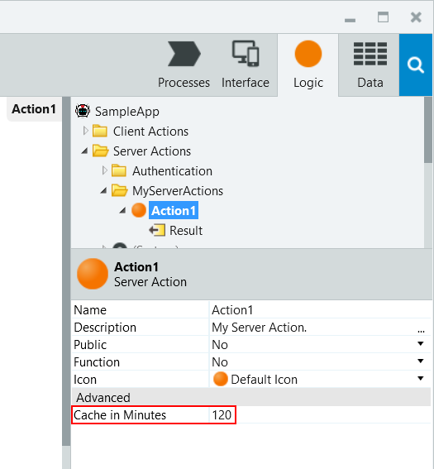

The caching mechanism

This is how the cache works:

* On the first use, the element is evaluated and the resulting content is stored in the cache.
* On the following uses, the stored content is returned by the server while skipping the evaluation.

Any cached element is evaluated again, and the resulting content is updated in the cache when:

* The elapsed time since the element content was last cached exceeds the element's **Cache in Minutes** value.
* The element has input parameters and there's no cached content for their new values.
* The cache is invalidated (for example: after republishing, deployment, server restart, explicit calls to invalidate the cache).

Additionally:

* Web Blocks of the Traditional Apps cache the content of all elements they contain. However, if the content of any of these elements changes, the cache won't be automatically updated. The cache is refreshed only when the whole Web Block is evaluated again.
* The cached elements cannot have input parameters of the following types: Record, List, and Binary Data.

Cache in producer and consumer modules

The cache also depends on whether the producer module is referenced as a strong or a weak dependency.

When the modules have a **strong dependency**, the Action logic is executed in the context of each consumer module handling the request. The cached value exists in each of the consumers and cannot be reused between them.

If you want a **single cached value** instance in memory and serve all requests with it, expose the Action through a **weak dependency**. This way, the request executing and caching the Action exists only in the producer module, and all its consumers see the same value.

Examples

You can consider caching the contents of:

* Elements with an execution time that negatively impacts the end user experience
* Elements that overload the system resources (database, CPU, memory...)
* Elements that fetch data from databases or external systems
* Elements for which the returned results rarely change or change in a controlled way for the same input parameters

Here are some examples of these situations:

* A Web Block with a list of categories that are stored in the database.
* A method of a consumed SOAP Web Service that fetches job opportunities from an external system.
* A method consumed from a SOAP Web Service that returns the list of employees.

**Integration Studio**

1. Last updated

Oct 20, 2020

1. [Edit](https://github.com/OutSystems/docs-product/blob/master/src/ref/integration-studio/workspace.md)

Integration Studio is a desktop tool that allows you to create and manage your [extensions](https://success.outsystems.com/Documentation/11/Extensibility_and_Integration/Extend_Logic_with_Your_Own_Code/Extensions).

The next screenshot presents the workspace for this tool:

The workspace is divided into the following areas:

[**Toolbar**](https://success.outsystems.com/Documentation/11/Reference/Integration_Studio/Toolbar)

Where you can create new extensions, verify and publish an extension, connect to the Platform Server, etc.

[**Multi-tree Navigator**](https://success.outsystems.com/Documentation/11/Reference/Integration_Studio/Multi-tree_Navigator)

Where you can add and select your Actions, Structures and Entities, in the **Extension** tree; add and select your Resources, in the **Resources** tree.

**Status bar**

Contains information about the extension, like the folder where the XIF (Extension and Integration Framework) is being saved.

[**Multi-tab editors**](https://success.outsystems.com/Documentation/11/Reference/Integration_Studio/Multi-tab_Editors)

Contains all the elements (extension, actions, structures, entities and resources) that you have selected in the Multi-tree Navigator.

**Specific Editor**

Where you can edit the [extension](https://success.outsystems.com/Documentation/11/Reference/Integration_Studio/Integration_Studio_Editors/Extension_Editor) and its elements: [actions](https://success.outsystems.com/Documentation/11/Reference/Integration_Studio/Integration_Studio_Editors/Action_Editor), [structures](https://success.outsystems.com/Documentation/11/Reference/Integration_Studio/Integration_Studio_Editors/Structure_Editor), [entities](https://success.outsystems.com/Documentation/11/Reference/Integration_Studio/Integration_Studio_Editors/Entity_Editor), or [resources](https://success.outsystems.com/Documentation/11/Reference/Integration_Studio/Integration_Studio_Editors/Resource_Editor).

**Server Info**

Where you can find information on which Platform Server you are connected to and which user has established this connection.

LifeTime is the centralized console for managing your OutSystems environments, applications, IT users, and security, covering the full application life cycle from development to deployment.

A typical OutSystems infrastructure comprises the following environments/server platform

* **Development**: The environment where applications are initially developed and tested
* **Quality**: The environment where testers and business users experiment applications to perform quality assurance
* **Production**: The environment that hosts the application version end users interact with

You can manage your OutSystems infrastructure in the **INFRASTRUCTURE** tab of LifeTime console (https://<your_lifetime_server>/lifetime).

While a Role in Service Center applies only to that specific environment, a **Role in LifeTime applies across all environments**. An IT User in LifeTime can only have one Role which specifies the IT user permissions in each environment of the infrastructure

By default, LifeTime has two built-in roles - **Administrator and Developer** - to address the simplest infrastructure security configuration: a single team developing all applications and an IT administrator responsible for managing the infrastructurRest vs Soap

REST and SOAP are 2 different approaches to online data transmission. Specifically, both define how to build [application programming interfaces (APIs)](https://www.redhat.com/en/topics/api), which allow data to be communicated between web applications. Representational state transfer (REST) is a set of architectural principles. Simple object access protocol (SOAP) is an official protocol [maintained by the World Wide Web Consortium (W3C)](https://www.w3.org/TR/soap12/). The main difference is that SOAP is a protocol while REST is not. Typically, an API will adhere to either REST or SOAP, depending on the use case and preferences of the developer.

**REST: representational state transfer**

REST is a set of architectural principles attuned to the needs of lightweight [web services](https://www.redhat.com/en/topics/cloud-computing/what-are-cloud-services) and [mobile applications](https://www.redhat.com/en/topics/mobile). Because it's a set of guidelines, it leaves the implementation of these recommendations to developers.

When a request for data is sent to a REST API, it’s usually done through hypertext transfer protocol (commonly referred to as HTTP). Once a request is received, APIs designed for REST (called RESTful APIs or RESTful web services) can return messages in a variety of formats: HTML, XML, plain text, and JSON. JSON (JavaScript object notation) is favored as a message format because it can be read by any programming language (despite the name), is human- and machine-readable, and is lightweight. In this way, RESTful APIs are more flexible and can be easier to set up.

An application is said to be RESTful if it follows 6 architectural guidelines. A RESTful application must have:

1. A client-server architecture composed of clients, servers, and resources.
2. [Stateless](https://www.redhat.com/en/topics/cloud-native-apps/stateful-vs-stateless) client-server communication, meaning no client content is stored on the server between requests. Information about the session’s state is instead held with the client.
3. Cacheable data to eliminate the need for some client-server interactions.
4. A uniform interface between components so that information is transferred in a standardized form instead of specific to an application’s needs. This is [described by Roy Fielding](https://www.ics.uci.edu/~fielding/pubs/dissertation/rest_arch_style.htm), the originator of REST, as "the central feature that distinguishes the REST architectural style from other network-based styles."
5. A layered system constraint, where client-server interactions can be mediated by hierarchical layers.
6. Code on demand, allowing servers to extend the functionality of a client by transferring executable code (though also reducing visibility, making this an optional guideline).

**SOAP: simple object access protocol**

SOAP is a standard protocol that was first designed so that applications built with different languages and on different platforms could communicate. Because it is a protocol, it imposes built-in rules that increase its complexity and overhead, which can lead to longer page load times. However, these standards also offer built-in compliances that can make it preferable for enterprise scenarios. The built-in compliance standards include [security](https://www.redhat.com/en/topics/security/api-security), atomicity, consistency, isolation, and durability (ACID), which is a set of properties for ensuring reliable database transactions.

Common web service specifications include:

* **Web services security (WS-security)**: Standardizes how messages are secured and transferred through unique identifiers called tokens.
* **WS-ReliableMessaging**: Standardizes error handling between messages transferred across unreliable IT infrastructure.
* **Web services addressing (WS-addressing)**: Packages routing information as metadata within SOAP headers, instead of maintaining such information deeper within the network.
* **Web services description language (WSDL)**: Describes what a web service does, and where that service begins and ends.

When a request for data is sent to a SOAP API, it can be handled through any of the application layer protocols: HTTP (for web browsers), SMTP (for email), TCP, and others. However, once a request is received, return SOAP messages must be returned as XML documents—a markup language that is both human- and machine-readable. A completed request to a SOAP API is not able by a browser, so it cannot be accessed later without resending to the API.

**SOAP vs. REST**

Many legacy systems may still adhere to SOAP, while REST came later and is often viewed as a faster alternative in web-based scenarios. REST is a set of guidelines that offers flexible implementation, whereas SOAP is a protocol with specific requirements like XML messaging.

REST APIs are lightweight, making them ideal for newer contexts like [the Internet of Things (IoT)](https://www.redhat.com/en/topics/internet-of-things-120511), mobile application development, and [serverless computing](https://www.redhat.com/en/topics/cloud-native-apps/what-is-serverless). SOAP web services offer built-in security and transaction compliance that align with many enterprise needs, but that also makes them heavier. Additionally, many public APIs, like the Google Maps API, follow the REST guidelines.

**Soap Advantages**  
SOAP provides the following advantages when compared to REST:  
•    Language, platform, and transport independent (REST requires use of HTTP)  
•    Works well in distributed enterprise environments (REST assumes direct point-to-point communication)  
•    Standardized  
•    Provides significant pre-build extensibility in the form of the WS* standards  
•    Built-in error handling  
•    Automation when used with certain language products

**REST Advantages**  
REST is easier to use for the most part and is more flexible. It has the following advantages over SOAP  
•    No expensive tools require to interact with the web service  
•    Smaller learning curve  
•    Efficient (SOAP uses XML for all messages, REST can use smaller message formats)  
•    Fast (no extensive processing required)  
•    Closer to other web technologies in design philosophy

Microservices are a type of software architecture where the functionality of the application is broken up into smaller fragments to make it more resilient and scalable. We call these fragments “services”. Each service focuses only on a single functionality of the application and is isolated from the others, making each one of them independent. This means that your development teams can work separately on different services and avoid a complex orchestration between them.

What is Entity Identifier?-

In OutSystems, a primary key is called Entity Identifier. When an Entity is created, an attribute called Id is automatically added as Entity Identifier. By default, it is of data type Long Integer and its value is automatically calculated in sequence (an AutoNumber in OutSystems).

What are Extension Entity?-

These entities allow you to use database tables that exist outside OutSystems. To publish a new extension that contains entities, your OutSystems user must have the "Allow External Entities" permission.

Explin One to One, One to Many and Many to Many relationship with example.-

One to One

One-to-one relationships allow you to extend an existing entity with additional information that is not yet in the database model.

One to Many

When modeling data, it is sometimes necessary to create one-to-many relationships between entities. For instance, a Place (parent entity) can have many Reviews (child entity). This is typically implemented with a foreign key - the identifier of the parent record - in the child records.

Many to Many

A many-to-many relationship happens when one entity has a one-to-many relationship with another entity, and vice-versa. For example, an Author can write several Books, and a Book can be written by severalAuthors. This kind of relationship is also known as N to M relationship.

Resolve this kind of relationships by adding a third entity, called junction entity. It must have at least two foreign keys, one to each entity in the relationship

Explain Master, Details Entity with example.-

Sometimes we want to show the information like list and detailed information on the same screen ,That time we can use master detail widget ,

youtube link to get better idea :https://www.youtube.com/watch?v=Zd1gZtdIAo8

What are junction entity?-

Resolve this kind of relationships by adding a third entity, called junction entity. It must have at least two foreign keys, one to each entity in the relationship

Explain the Delete Rule in detail.-

Protect

Setting the Delete Rule to Protect prevents deleting records of the main Entity while there are associated records in the related Entity.

Delete

Setting the Delete Rule to Delete guarantees that when a record of the main Entity is deleted, all the associated records in the related Entities are also deleted. This mechanism is commonly known as Cascade Delete.

Ignore

Setting the Delete Rule to Ignore allows deleting records of the main Entity keeping the associated records in the related Entity.

How to create the Entity Diagram in the Outsystem?-

Before Creating Entity Diagram we need to create entities and relationships afterthat in data tab we have a option of Entity diagrams,select and add entity diagram there .

How interaction happens between one web page to another in the Outsystem?-

Screen and Block Lifecycle Events

What happens when the user clicks on the submit button on the screen?-

Provides a button that users can click or tap to trigger an action, submit data or navigate to another screen

What are screen actions?-

What are Server actions?-

Explain the Submit Screen Life Cycle of the web page?-

What is Preparation?-

In OutSystems, you execute that logic in a Preparation action: ... It is right place to add all the logic you want to execute before the screen is displayed

Can aggregates have multiple resources?-

Yes

Does aggregates supports Join? Explain how?-

Yes

what is data actions ?

Data Actions run on the server. You can create Data Actions to fetch complex data from the database, which you are not able to achieve using a single server Aggregate, or to fetch data from an external system, for example through a consumed REST API

What is calculated attributes?-

Putting data into groups to calculate aggregated values allows you to extract more information from your data sets. In OutSystems, you can use aggregate functions to calculate values based on groups of identical data.

Explain SQL Tool Widget.-

 Sql is the actual representaion of the database ,Using Sql tool to fire sql queries in the database like bulk insert ,bulk copy,bulk update ,In sql we have five joins like inner join ,left outer join,right outer join,cross join ,self join

Explain how to use IF widget.-

Sometimes we need to add data in databse using deatailed screens,so in that detailed scree we will use one if condition like if (customerid<>nullidentifer())it will show edit customer otherwise it will show new customer .

How to bind Combo Box in the Outsystem?-

Expain Exception handling in the Outsystem.-

The Exception Handler element starts an action flow for handling all exceptions or exceptions of a certain type. You can define logic to handle exceptions pre-defined exceptions (like Database Exceptions), or custom exceptions (called User Exceptions) raised by your application logic.

What is action flow?-

In Action flow we can implement our logic to do some operation

Expalain the concept of Validation-

When users enter data in a form and click a submit button, check if the data is valid. If the data seems valid, the app can continue. If not, you should tell the users which fields contain the errors and how to fix them.

What are the types of Validation?-

Built in validation and Custom validation

Explain Client side and Server side validation.-

Client & Server: before calling the action, default validations will be performed client side (browser). If they fail, they will be shown to the user e the request will be aborted. If all validations pass, the request will be made, where a Server validation will be performed

How to Debug your code in the outsystem?

Start debugger by clicking the Start Debugging button in the Debugger tab or by selecting Debug in the Public Area in the Debugger menu.before that we need to add breakpoints to show the logic step by step  When you're debugging mobile apps using the Google Chrome target, Service Studio opens a dedicated Chrome browser instance for debugging only.

How Ajax works?

Use the Ajax Refresh element in your flow to refresh parts of the screen without reloading the entire page

Why to use Ajax?

What is the difference between Refresh Data and ajax Refresh?

Ajax refresh refreshes the element on your screen, and data refresh as the name says it will refresh your data again, make it go again get the data you want on your aggregate(updated).

Explain  the screen lifecycle with the Ajax.

What is the difference between Ajax life cycle and page life cycle in the Outsystem?Explian  the screen lifecycle with the Ajax.

What is the difference between Ajax life cycle and page life cycle in the Outsystem?

What are Web Blocks in the Outsystems?

Reusable screen part that can implement its own logic,so changes to the Blocks are automatically visible in all Screens that use it.

How to create the Web Blocks in the Outsystem?

In a UI Flow, add a Block (in Reactive Web and Mobile Apps) or a Web Block (in Traditional Web Apps).

Implement the user interface and logic in the new Block.

Set the Block as public if you want to reuse it across apps.

Drag it the Block to the Screen where you want to use it. If you want to use the Block in another App, you first need to reference the Block.

What is the use of the placeholder widget in the Outsystem?

Reserves space in your block for filling dynamic content when the block is used

How interaction happens between parent screen and child screen?

How to handle events in the Web Block?

What are different event handlers in the Web Block?

Explain Web Block lifecycle with respect to screen life cycle.

Why to use Web Block?

A Web Block is a reusable UI

component

● Web Blocks promote reusability

○ Develop once, use many times

○ Encapsulates its own logic

● Web Blocks improve maintainability

○ Changes are reflected on every

Screen that uses the Web Block.

How to handle security in the Out system?

Explain the concept of Authorization and Authentication in the Out system.

How to create Groups and grant role to them? -

What are Roles in the Out system?

ROles are used for authorization. WIth the help of roles we can provide previllages / rights to partciualr group of users.

Where we can check the Roles?-

What is Screen Role property?

What are sessions in the Out system?

What are session variables and site properties?

For what purpose we can use site variables? Explain with examples.

What is Web Service?

What are SOAP and REST web service?

**********************************************************************

What is the difference between a web application and web service?

What is the difference between a web application and Reactive web application?

Explain the basic architecture of HTTP request response model of web application

Which languages are used by browser to render the response

explain the difference between responsive web application and reactive web application

What is the use of blank module

Explain producer consumer model

explain the steps for consuming a module

Name 4 main components of Out Systems

Explain the steps involved in integrating a .NET module in Out Systems

What is continuous iteration of the Out Systems application

What is the use of switching environment

How to change the version of application

Tell me a situation when you will use widget tree to design a page instead of designing directly on canvas

What is the difference between SQL table and Out Systems entity

************************************************************************************************************

1.Name 3 alphanumeric datatypes available in Out Systems

Text

phone number

Email

2.Explain the concept of Entity Actions

CRUD

3.Can a static entity have referential integrity attribute from dynamic entity?

Yes, we can have, it can be referenced by record name.

4.Can we set default value for a mandatory input variable

no.

we can set for non-mandatory and local variables

5.Can we set a server method as function if there are 2 output variables

no, if the output variable is 1 then only it can BE SET

6.What do you mean Compound type?

Structures are custom compound data types.

compound MEANS we can store different data type.

7.How screen templates can speed up application development

in screen templates we need to give source and the screen are ready.

7.What is the role of preparation in screens

The Preparation is a special Screen Action

which has access to the Screen Inputs and

Local Variables and can access other data.

Data needed to help render the Screen should

be fetched in the Preparation

8.   Name 3 important steps of screen lifecycle in sequence

When accessing a Screen, it all starts with a

request from the browser

1. Mandatory Input Parameters are set to the

value sent in the request

2. Empty Non-mandatory Input Parameters and

Local Variables are set to default values

3. Preparation runs

4. Screen is built (rendered) from top to bottom

When the response gets to the browser, it is

displayed to the user

9.When you drag n drop an entity directly from Data tab to action flow, aggregate gets automatically created

yes, it creates but the reference id is not created that we can add source manually.

 10.Explain the diff bet SQL Tool and aggregate

 Sql is actual representation of database

aggregate is virtual representation of database.

SQL TOOL: SELECT, DELETE, UPDATE, RETRIVE/GET

Aggregate: Filter, Sorting, Joins, Testing etc. There are more advanced options available in Aggregates.

   ● Multiple Sources

   ● Calculated attributes

   ● Aggregated functions

11.How to implement a group by statement in aggregate

If you have a GROUP BY, you can only SELECT the Grouped BY columns, a

and aggregate functions (like SUM, COUNT, MAX, MIN etc.). But again, this is bog-standard SQL,

and has nothing to do with Out Systems.

12.What is the output of an aggregate?  Explain with its properties

List of records with several properties

● Length - number of elements returned

● Empty - True if no records were returned

● EOF, BOF, CurrentRowNumber - filled while iterating the List

Aggregate Get<Entity> contains a “List. Current”

● Type matches the definition in the query

● The “Current” cursor moves through the List when iterating

○ Points at first row by default

● Filled in with default values if no rows returned by query

○ Empty List

Count has the total number of records that match the

criteria defined in the Aggregate .

13.Explain Max records property of aggregate?

It is possible to limit the Aggregate’s output

to a maximum number of records

14.What can be possible values for Type property of an image widget

Database

URL

Static

**********************************************************************************

What are the steps to bootstrap the data in Out systems??

To bootstrap data from the first sheet of an Excel file to an existing entity, follow these steps:

In Service Studio, go to the Data tab, right-click on the entity and in the Advanced menu, choose 'Create Action to Bootstrap data from an Excel...'.

Select the Excel file, check the mappings to see if they're correct and click on Proceed. Service Studio creates:

An action with the bootstrap logic named "Bootstrap<entity name>" in the Server Actions folder in the Logic tab.

A structure with the content of the Excel file named "Excel_<filename>" in the Structures folder in the Data tab.

A resource with the Excel file in the Resources folder in the Data tab.

A timer to execute the action at publish time named "Bootstrap<entity name>" in the Timers folder in the Processes tab.

***********************************************************************************

How to transfer data from one screen to another screen.

To pass information with Input Parameters:

In the destination Screen add an Input Parameter.

In the source Screen add a link to the destination Screen and set the Input Parameter value.

We can also pass data from block.

Add web source block and event to for changing and send to target block

How to create timer.

Create the Timer

To create a Timer in your module, do the following:

In the module tree, under the Process tab, right-click on the Timer folder and select Add Timer.

Choose the action to execute when the timer runs or select (New Server Action) to create a new action.

If the Action you specify has input parameters, when creating the Timer you need to specify the values that are passed as parameters when the Timer wakes. However, if the action has output parameters, there is no way of accessing them after the action is finished executing.

You can set a schedule to run the Timer automatically or you can explicitly run the Timer.

-Set the Timer Schedule

You can set the schedule of a Timer in one of the following ways:

Setting the Schedule property of the Timer at design time: You can define a recurrent schedule, such as daily or weekly, or define the Timer to run each time the module is published, for example to execute configurations or bootstrap data.

Setting the Timer schedule at runtime in Service Center: The effective Timer schedule is set in Service Center. If you define the Timer schedule both when designing the application, and in Service Center, the first schedule is ignored. This ensures you can customize the Timer schedule when deploying an application to another environment, without having to change the application itself.

Implement logic that changes the Timer schedule at runtime: Assign the Schedule runtime property of the Timer with a specific schedule within your logic. Make sure to use the correct time format.

When you define a schedule for your Timer, the Timer will run at the predefined time.

Run the Timer Explicitly

There are two ways of explicitly run a Timer:

Using the Wake<Timer Name> built-in action

Running the Timer in Service Center .

 Have you ever worked with Integration Studio/What you devoloped in IS.-

there was 1 library which was developed for converting any date format to hijari date format,using nuget packages so i hav used that library through

integration studio. it was already developed.

i created action from which we send normal date format to convert hijari date.

Hi , Rajeshree Chablani this side. I hope you are doing well.

I am working with Omnepresent from last 2 years and I have been though OutSystems training. This training was included with TWA, RWA, Mobile app development, 3LC architecture, BPT and working with integration studio. After this training I was working with different clients for various projects. Some of them were on TWA and most of them were implemented on reactive.

I have also studied about mobile app developement but never worked on any live project for it.

I have registered for OutSystems certification and exam is scheduled in first week of Oct but if you want I can reschedule and clear this exam in next 2 days

Recently I was working on National Insurance Application  project, and the project was about......  This application is designed to provide facility to apply and manage various Insurance   application. Facilitating the applicant to apply for Insurance via a portal where user can view a list and apply for new Insurance.

This application was intended for users to view all applied insurance. As well as agent user can approve or reject or RMI (request more information).

Have you done any integration please explain.

Install Out system integration

Install visual studio

Open out system integration

Login your personal environment

Open out system integration

Select. NET tab

Verify your integration configuration

Create new and do edit on source code. Net

It will create extension file

Click ok

Visual studio will open

You can see extension is open in vs

What is session.

Sessions are a mechanism that can be used to store state between requests

Session Data Out Systems supports two types of cross-request data User

 Session Variables\\

 ● Available while a user is using the application

● Values are stored per user

● Values expire when session times out Cross-session

(Site) Properties

 ● Always available to all users

 ● Values are shared between all user sessions

● Values never time out .

Explain project

Insurance application

Which methodology is followed in current project?

agile

Have you implemented any JavaScript?

No

How to implement JavaScript on button action?

We can take button n create action and drag JavaScript widget n write code.

Do you involved in requirement gathering?

How many team's member in project?

What was your role in project?

Which authentication is implemented?

Roles were given and screen roles were implemented on every page.

How to create test cases in unit testing framework.

*************************************************************************

1.Tell me about yourself and your technical experience

2.tell me about 4 LC architecture

A framework to support architecture design

Orchestration module- access portals, Backoffice application. -

We can reuse this application in in other application.

End user=UI&Processes. -

Web blocks module

Process module

We can consume in other application.

Core Business Module=Business services

Server action, service action=crud APIs,Entities.

Libraries Module=External Database, external libraries, themes, -

3.have you certified?

No, soon I vl get certified.

4.What is Timers in Out systems?

A Timer is an Out Systems tool that allows executing application logic periodically on a scheduled time. These are also known as batch jobs. Different Timers can be executed at the same time, but the same Timer never has more than one execution at a time

5.Scenario Timer(if you have 100's of mails which is sending everyday at 4:30 PM.only 50 mails are gone but remaining 50 mails you need to add something..is there anything that you stop the  timer?

Schedule runtime property then it will ignore first assigned property

6.What is Aggregate and SQL widget? Which is more preferable?

Sql is Actual representation of database

Aggregate is virtual representation of database.

aggregates are optimized

SQL TOOL: SELECT, DELETE, UPDATE, RETRIVE/GET

Aggregate: Filter, Sorting, Joins, Testing etc. There are more advanced options available in Aggregates.

   ● Multiple Sources

   ● Calculated attributes

   ● Aggregated functions

7.types of Joins

Only With -

Returns only records where there is a match between Entities

● Only Customers with Orders are returned (SQL INNER JOIN)

With or without -

Returns all rows from the left Entity even if there is no match in the right Entity ● Customers with or without Orders (SQL LEFT JOIN)

With -

Returns all rows from both Entities (SQL FULL OUTER JOIN)

8.delete rule

Ignore

Delete

Protected

9.Web block

A Web Block is a reusable UI component

 ● Web Blocks promote reusability

○ Develop once, use many times ○ Encapsulates its own logic

● Web Blocks improve maintainability

 ○ Changes are reflected on every Screen that uses the Web Block

10.How to add roles at run time

11.entity and static entity

An Entity is persisted in a Database Table.

 ● Each new instance or record of an Entity is inserted as a row on the corresponding table

A different Entity should be created for each application concept.

● Customer, Order and Order Item an Entity is defined by fields called Attribute

Static Entities are Entities that have a predefined set of possible values.

 ● Attribute values are defined at design time Each value of a Static Entity is a Record Static Entity records can NOT be created, updated, or deleted; only retrieved.

● Get is the only Entity Action Static Entities can be used like enumerations.

12.practical (print star pattern)

13.what is BPT? have you implemented BPT...

OutSystems allows you to design and manage your business processes and integrate them into your applications. A business process is simply called a Process in OutSystems and is understood as the way that a particular task is carried out in your organization, such as handling invoices, processing orders, or handling complaints. Processes are also known as BPT (Business Process Technology)..

14.explain rest web service

REST ● Lightweight alternative to SOAP

○ No formal API contract file

○ Provide documentation and examples instead of a contract

 ● Requests and responses (usually) in compact JSON

On before request

On After Request.

15.how many start we can take in BPT

conditional and normal start

16.Explain conditional start in BPT

Enables repetitive execution of a process flow execution triggered by a create or update database event.

1) can you please tell advantage of aggregate over the advance SQL.

2) I have list records and have attached entity source to the list and i m going to deploy this code in project and i got time out error. What would you oppose as a senior developer to team?

1. add pagination to list

2. instead of entity as a source, have a service action

3) have you used service module and blank module then why we use the service module and what's the core advantage.

In OS 11 Service module is basically design to expose API so that another module can consume and perform CRUD.

Blank module allows screens.

Service module does not allow screens.

4) Most probably why we write logic in server side instead of client side...what's the benefit do you think.

Server Actions

An application typically has its own business rules.

In Out Systems you can create Server Actions to encapsulate the logic that implements the business rules of your application and use them in other actions, such as Preparation actions, Screen Actions or other Server Actions:

security purpose.

while consume API what's the purpose of on before

Types of Environments

Development, quality, production, management.

-----------------------------------------------------------------------------------------------------------------

A Screen Action is an Action that's local to a Screen. It can only be called by Screen Elements (in Web) like Buttons or Links, or by a Notify of a Web Block. In Mobile, Screen Actions can also call each other. Screen Actions have local scope to the Screen (outside the Screen they are not visible), and have access to all Screen Input Parameters, Screen Local Variables and Widgets. Screen Actions are run either on the server (Web) or on the device (Mobile). Use Screen Actions for simple logic that's Screen-specific.

Server Actions are Actions that are always executed on the server, both in Web and Mobile. Since Web Apps run on the server in their entirety, this is the only available type of Action for a Web App. When a Mobile App calls a Server Action, it needs to be online (since it must reach the server to execute the Action). Use Server Actions in Web Apps whenever you need to abstract some business logic or core logic or domain specific logic. Use Server Actions in Mobile Apps only if you cannot avoid it (e.g. when syncing data), as it will incur a performance penalty (for calling the server and waiting for it to respond back).

Client Actions are the Mobile equivalent to Server Actions. The run on the device, not on a server. Client Actions are therefore only available for Mobile Apps. Their use, like Server Actions, is to abstract logic.

Since OutSystems 11, there is a fourth type of Actions called Service Actions. These are very much like Server Actions, but share some properties with REST Methods (perhaps yet another type of Action), in that calling them only creates a "weak" Reference to the Module it's in (instead of the normal "strong" Reference). But if you've just started OutSystems, I'd forget about them for now.

11: How you will handle if there is any Error comes After production-

 by using audit trail

 where we can get exact issue stored.

what if human activity flow in approval get  stuck due to peronal leave/any leave reason, then how you should handle?

a activity will only go in any of the mentioned states like open , running or exit, terminated

we  can give timeout for activity

on that time it will get closed automatically .

Difference betwn traditional and reactive.

Ajax Refresh-

Ajax Refresh in Traditional Web Apps refreshes parts of the interface. The UI elements in Reactive App

refresh automatically on data change, so you don't need to use Ajax Refresh.

Optimize data fetching on the client side-

Design how Aggregates of a Reactive Web App should fetch data, by setting Aggregate Fetch property

to At Start or Only On Demand. This provides a lot of flexibility for designing UI Patterns and

speeds up the responsiveness of the UI

Customizing validation error and warning messages-

Here are some ways to edit the validation messages.

Editing the default validation messages

You can edit the default validation messages on the module level.

Go to the module properties by clicking the module name (1) in any of the main Service Studio tabs (Process, Interface, Logic, or Data).

Then, edit the messages in the Validation Messages section (2)

outsystem ui and silk ui

client variable reactive and session variable traditional.

inline stylesheet in reactive.

  Outsystems 10.x vs 11.x -

-Faster App Creation

-Screen Templates

-OutSystems UI Framework

-Improved Dependency Management

Inline Records

Folders Everywhere in Service Studio

Disable Elements

ListDistinct

There's a new way to handle lists. Use the ListDistinct server and client actions to remove duplicated elements from a list.

Publish Outdated Consumers

-Boolean Conditions in Aggregate Joins and Filters Simplified

   When working with aggregate joins and filters, you can use “Is_Active” or “not Is_Active” only without having to add True or False. After all, a Boolean is a Boolean, True?

Reorder Aggregate Filters

OutSystems 11 introduces Service, a new type of application and module that brings greater visibility of the software portfolio architecture into the development process. Service elements promote reusability and the separation of concerns, mapping to the concept of core services in the 4 Layer Canvas and accelerating the design of complex applications. This results in maximum reuse of services across the software portfolio for greater agility.

What is a Human Activity?

Enables user interaction using a Screen where the

end-user will have to complete the task.

What is an Automatic Activity?

Enables execution of logic flows in a process

without the need for human intervention.

what is default event provided with screen in reactive? and why they have provided?

Screen and Block Lifecycle Events

These event handlers give the developer visibility over the screen and block lifecycle and the opportunity to implement logic when certain events occur.

11.what is synchroonous and asynchronous process?

Synchronous means the processing happens in a single requester context, and

asynchronous processing means giving the execution of the request to a batch requester.

.can we change site property value from service studio?

yes,

Open the Service Center in your environment (http://<environment>/ServiceCenter) and login with your credentials.

In the Factory tab, select Applications and filter by the name of your application.

Select the module in which the Site Properties are stored.role

Click on the Site Properties tab and select the Site Property whose value you want to change.

Change the Effective Value of the Site Property and click Apply.

8.what is architecture canvas in outsystem?

The Architecture Canvas is an OutSystems architecture tool to make the design of Service-Oriented Architectures (SOA) simple. It promotes the correct abstraction of reusable (micro)services and the correct isolation of distinct functional modules, in cases where you are developing and maintaining multiple applications that reuse common modules

orchectration module-Access portals

End user modules-ui and processes

core modules-business services

foundation modules-non functional requirements.

The orchestration layer is used in OutSystems 10 for hyperlinks between screens of two different applications. Such links are considered strong dependencies, which compromise each application's lifecycle independence. In OutSystems 11 screen destinations are considered weak references, so an orchestration layer is no longer required, and as such has been removed from the architecture canvas.

multi tenant

Multi-tenant refers to a kind of architecture where a single instance of software runs on a server and serves multiple customers.

shared database used to serve multiple customers

project 1st

difference 11 10

diff reactive traditional

architecture 3lc

database core business module.

service module we can achieve reusability.

traditional synchronous reactive asynchronous.

Highcharts steps

1) take one container ,Name that container ,Select that screen and select on  on initialize in event property window in screen,in that event action drag and deop required script in predefined system in logic tab

 In reactive how screen knows that data is refreshed or changed?

Explain project

**1.What are the steps to bootstrap the data in outsystems**

In producer module, right click on entities click on advance bootstrap and choose the exel file

**2.How to transfer data from one screen to other screen.**

to create an input parameter to pass information to the destination screen.

**3.How to create timer.**

To create a Timer in your module, do the following:

1. In the module tree, under the **Process tab**, right-click on the **Timer folder** and select Add Timer.
2. Choose the action to execute when the timer runs or select (New Server Action) to create a new action.

**4.Have you did any integration please explain.**

I have done email integration with attachment and google authentication

**5.What is session.**

Sessions are a mechanism that can be used to store state between requests

They stored user specific data and they get reset when the user logout or when the session expires

**6.Which methodology is followed in current project**

The Agile methodology is **a way to manage a project by breaking it up into several phases**. It involves constant collaboration with stakeholders and continuous improvement at every stage. Once the work begins, teams cycle through a process of planning, executing, and evaluating.

Some of the most common frameworks agile teams use include: Scrum, Extreme Programing (XP), and Lean Agile. Many agile teams are using techniques and practices from all three of these approaches

***Scrum***

Scrum is a popular framework for**solving complex problems and providing a structure for teams to deliver high value software products**

**7.Have you implement any javascript.**

Yes I have implementing javascript for highchart, also used in action flows

**8.How to implement javascript on button action**

Open the button properties in that add in onclick new action in that action add javascript widget

**9.Do you involved in requirement gathering**

no

**10.How many team member in project**

5

**11.What was ur role in project**

Software developer

**12.How to create test cases in unit testing framework.**

* [Unit tests](https://success.outsystems.com/Documentation/How-to_Guides/DevOps/How_to_Automate_Unit_Testing_and_API_Testing?_gl=1*qmf7ye*_ga*MTI4MDExMjU1Ni4xNjM3Mjk3MTAy*_ga_ZD4DTMHWR2*MTYzNzgzMTExMi4yLjEuMTYzNzgzMTc2MC41OQ.#unit-testing-approach), for fast feedback on small pieces of code (server actions)
* [API tests](https://success.outsystems.com/Documentation/How-to_Guides/DevOps/How_to_Automate_Unit_Testing_and_API_Testing?_gl=1*qmf7ye*_ga*MTI4MDExMjU1Ni4xNjM3Mjk3MTAy*_ga_ZD4DTMHWR2*MTYzNzgzMTExMi4yLjEuMTYzNzgzMTc2MC41OQ.#api-testing-approach), for feedback on REST or SOAP APIs

**13.If you have any exerience in design?**

yes

**14.Explain agile methodology**

Project explanation

**15.types of actions in reactive.**

**1.Data Action:**

fetch complex data from data base with the help of restAPI

defined custom server side logic in data action

**2.Client Action:**

Client Action defined logic user device.

There are two different scope for a client Action: In the scope screen and in the client logic

Client action can be defined as client side

**3.Server Action:**

Server action can be used in our application it is used to encapsulate the logic, an this logic reuse in other  such as client action ,server action ,data action

Server action defined in server side

**16.can we call client action from server action**

no

**17.explain process,interface,logic and data tabs in service studio**

**Process-**

**Processes (for creating business processes) and**

**timers (to create a scheduled actions).**

**Interface-**

**UI flows (it contains all the screens and web blocks),**

**Images (it is used to import images and use them on screens, Icons),**

**Themes (to create custom themes) and**

**Scripts (JavaScript Resources).**

**Logic-**

**Client Actions (all actions to run on device),**

**Server Actions (actions which runs on server)**

**Integrations (SOAP Web Services, RESTful Services, SAP)**

**Roles (Anonymous, Registered, Custom Roles)**

**Exceptions (Database Exception, Security Exception, User Exceptions)**

**Data-**

**Entity Diagrams (Visual Data Model)**

**Entities Structures (Database, Local Storage)**

**Structures (Compound data types, In -memory data)**

**Client Variables (User-specific data, Client-side)**

**Site Properties (Cross app data)**

**Resources (Other files)**

**18. how will you decide whether to go for traditional or reactiv**e

It is based on company requirement

**19. Have you done any integration?**

Yes I have done email integration one of my project

**20. Have you used custom javascript. Give any example**

No I have not used

**21. Have you created reusable module**

Yes I have created one of my project

**22.Any experience with client interation. (like US or UK based clients)**

I have not any experience with client

**23.Any experience in taking requirements from client and creating requirement document.**

**no**

*. Have you used Agile methodology in your project and what its perspective

**24. Have you used JavaScript and HTML and How can you create JavaScript**

Yes I have used  java script and html  with the help of widgets ,screen

**25. Difference between Client action and Server action**

|  |  |
| --- | --- |
| **Client Action is asynchronous nature** | **Server Action is synchronous nature** |
| It runs on the device, not on a server. | that are always executed on the server |
| Client Actions are therefore only available for Mobile Apps. | , both in Web and Mobile. |
| we dont use client action in traditional i.e. Not Available | Server actions available in traditional as well as reactive |
| Their use is to abstract logic like Server Actions. | server action are work like function. |
|  |  |

**26. What is Site property and Site variable**

Session variables:

stores session data per user and data gets erased when session is expiered or after timeout. sets values to the default values.

-Site Properties:

Site Properties are global variables that have constant values.

Always available to all users ,Values are shared between all user sessions ,Values never time out.

Data types- Basic data types and entity identifiers.

**27. Do you know client variable and explain**

 Client Variables to store data client-side in a key-value format. For example, use these variables to store configurations and app context data.

28. How to  perform production for your project

**29. How many environment used in your project**

**4**

**Development**,quality,production,deployment

**30. Tell me variable  list used in your project**

input parameter:-passes the value from the outside scope

output parameter:-returns the value to the outside scope

local variable:-used and assigned locally inside that scope

**31. Have you worked on Aggregate and explain and which join used**

Yes I have worked on aggregarte in my project and I have used only with join because refereced attribute is mandatory and also used with or without join

**32. Explain TWA and Reactive**

**TWA:** traditional web applications that perform most of the application logic on the server

**Reactive web** applications are a powerful way of developing web apps. Logic can be executed client side and server side.Unlike server-side rendered apps that need expensive round-trips, reactive web quickly reacts to any user interaction.

**33. Web blocks with scenario based question**

A Web Block is a **reusable UI**

Component

Web Blocks can be placed inside a Web

Screen or another Web Block

**34. Have you  worked on both mobile and web.**

Yes I have knowledge about the mobile

**35. Have you create table in outsystems and how**

**36. How to create table using HTML**

<table>

  <tr>

    <th>Company</th>

    <th>Contact</th>

    <th>Country</th>

  </tr>

  <tr>

    <td>Alfreds Futterkiste</td>

    <td>Maria Anders</td>

    <td>Germany</td>

  </tr>

  <tr>

    <td>Centro comercial Moctezuma</td>

    <td>Francisco Chang</td>

    <td>Mexico</td>

  </tr>

</table>

**37.. How to Create JavaScript in HTML**

**You can add the script**

**38.  how to used web block within web block**

Create one web block and in that block use another web block

**39: What is the deff between entites and static entity**

Dynamic Entities

entities are nothing but Database Table with attributes(fields)./A entity is a element that allows us to store and access data that is needed in our application.

Each Attribute Is a Column on the respective database Table automatically creates ID attribute it is a primary key in that database.

Static Entities

Static Entities are Entities that have a predefined set of possible values(defined at design time).Each value of a Static Entity is a Record. Static Entities Records start with 4 automatically created attributes.

Id, Label, Order, Is Active. And Get<StaticEntityName> is the only Entity Action.

**40: What is Api? and how to consume it by Rest**

Application Programming Interface (API) is a software interface that allows two applications to interact with each other without any user intervention

Provide the consume URL and consume select single method and multiple method

**41: What is your strength in outsystem**

Creating UI and developing code

Q4: Explain Project

**42: have complete any certification?**

Yes I have complete TWA certification

Q6: What is Environment in outsystem.

1) Tell me about yourself and your technical journey

**43. What is static entities and can we change the records from static entities?**

    Static Entities are a special type of Entity that creates a predefined list of values that can be used in our applications.

    Static Entities are created with 4 default attributes

○ Id = Identifies a record and is always unique. Using auto-number is not recommended, as it might generate issues in complex scenarios.

○ Label = Holds a value to display in an application.

○ Order = Defines the order for displaying the records to the end user.

○ Is_Active = Defines whether a record is available during runtime. For example, the records with Is_Active set to false aren't used

 when scaffolding uses the Static Entity.

Yes we can chage the record at design time not a runtime

**44. what are the ways to a screen in canvas and how to add screen?**

By drag and drop screen in main flow or right click on main flow and add screen

**45.what is the difference between public and read only?**

If Public entity to set yes so it will available publically used in other consumer modules

If you set the ReadOnly  property to Yes for a Public entity, it means that the only entity action exposed is the Get<Entity>.

**46. What is the difference between Screen Action and client Action and How you will perform it?**

|  |  |
| --- | --- |
| **Screen Action** | **Client Action** |
| screen actions are bound to screens. Screen Actions do not have Output Parameters. | Client Actions run logic in the user device. You can create Client Actions in two different scopes: in the scope of a Screen and in the client logic. |
|  |  |
|  | You can set a Client Action as a function and use it directly in Expressions of the client-side logic. |
| **Can have** |  |

**47. Have you done Integration (Asked about REST API)?**

Yes I have done integration to fetch data from external system. restapi used already available services like google authentication , google maps

**48.How many types of environments and on which environment you have worked?**

**Development**,quality,production,deployment

**49. what are the delete rules?**

Introduction

Project description

which certification you have done

**50.Roles and responsibilities.**

developer

**51.Why we need users in application**

For accessing and managing the application

**52.How you can design your Database**

As per the  client requirements

*scenario: we have teacher and specialization entity is there. what type of relation you can establish.

**53.4LC**

4LC is a framework to support architecture design.

4LC makes easier to design service-oriented architectures.

Benefit- Modules can have more independent life cycles which reduces number of unmanageable dependencies and minimizes the impact of changes across module.

**54.BPT**

**I**s used to design and manage your business process and integrate them in your application

The business process also called process.

It understood that the particular task is carried out in your organization such as handling complaints and processing invoices

**55.Web block**

A Web Block is a **reusable UI**

Component

Web Blocks can be placed inside a Web

Screen or another Web Block

**56.purpose of placeholder**

Only available inside Web Blocks

 Reserves space for dynamic content defined when instantiated

**57.TWA and RWA difference**

|  |  |
| --- | --- |
| **TWA is Synchronous nature(Static nature** | **RWA is asynchronous  nature(Responsive nature** |
| Ajax refresh it is used to refresh part of screen | **Ajax refresh not needed (screen automatically refreshes)we can use refresh data for refresh contain on the screen** |
| **Preparation(fetch data from databases)** | **Aggregates and data action(fetch data from database)** |
| **Session variables** | **Client variable** |
| **In twa logic executed only in server side** | **In RWA logic executed in Client and server action** |

**Fetch data at start and only on                                    demand(aggregate fetch property)**

**58.Service action**

**Asynchronous nature**

Service Action is Rest based remote call to another process

It generates weak dependency from the consumer to producer module

**59.What is the main purpose of using Static entity?**

When we  need to predefined  list of values

**60. What happen in backend if Screen drag and drop in Menu block?**

The expression is added in the menu block and that expressions is linked to the screen to navigate.

61. After right click on Entity and uses the index tab and in it what happen if I click on Active attribute?

62. I want to change or update Rest API I have consumed in production how can I do that?

Go to Factory section and open your application.

        Open the module where you are consuming the REST API.

        Select the Integrations tab and click on the consumed REST API name to edit it.

       Set the effective URL and/or effective authentication credentials for the current environment and click apply

**(When a client needs to replace an existing Resource entirely, they can use PUT. When they're doing a partial update, they can use HTTP PATCH.)**

5) How to bootstrap excel?

6) What happens in backend after Bootstraping excel and where does excel file get stored (In server or in Service studio)?

7) How to create sub menu in traditional?

1.Data constraint for unique key

ensures the uniqueness of all values and no duplicate values are entered in a column of a table.

CREATE TABLE Employee(EmployeeID int,

    FirstName nvarchar(50) NOT NULL,

    LastName nvarchar(50) NOT NULL,

    EMail nvarchar(50),

    PhoneNo varchar(15),

    ADD CONSTRAINT UNQ_Emp_Phone Unique(PhoneNo))

2.Advanced query

According to this reply, advanced SQL covers **selecting columns**, aggregate functions like MIN() and MAX() , the CASE WHEN statement, JOINs , the WHERE clause, GROUP BY , declaring variables, and subqueries. ... I can understand why because one user hints at the problem with JOINs .

3.BPT

4.Timers

5.build timer which runs on every monday wants to check people who open tasks since last week pick condition on task table aggregate.

6.How you identify app open through browser link or refresh button(f5)

1)intro

2)Recent Project

3)tell me about outsystem experience

4)What is basic authentication in Rest API?

5)Consider we r having two roles one is employee and another one is manager ,Whenever I am login with employee role I want to see 13 records in the screen from database ,When I am login with manager role I should want to see 12 records(14th record to 25th )record ,How u will achieve this ?

Use the filter roles wise

reference attribute add karun user n manager cha

6)Consider we have one detailed screen with save and back button whenever I am modifying  information in detailed screen and Click back button ,should raise the alert message like data's are modified ,please save the information, How will u achieve this

Ans:Add the validation and add the message

Relevant experience

Why Static Entities are used

If i want to add 200 records in Static Entity how can be possible with convieniet way

Login screen role are registered or anonymous

Why we used Architectural Dashboard

How to set entity identifier has in hexa-decimal

How to create sub-menu

if menu is created then what 3 action Outsystems will do

why static entity exist in Outsystems

why expose ready only exist in the Outsystems

1)can you please tell advantage of aggregate over the advance SQL

2) I have list records and have attached entity source to the list and i m going to deploy this code in project And i got time out error. What would you oppose as a senior developer to team ?

3) have you used service module and blank module then why we use the service module and whats the core advantage

4) Most probably why we write logic in server side instead of client side...whats the benefit do you think

Introduction-

-Basic genral question

-What is static entity ?

-Difference between  entity and static entity?

-What is  screen actions

-Client   action in reactive

-how to consume rest api? ,

-how many environment in outsystems for web,reactive and mobile application

"How many environment in your outsystem project and

for example you worked in development environment in your project but the Api is for other environment so how you use this Api in another environment for example in testing environment"

-difference btw aggreates and sql tool ,uses and 2-3  question from them

Explian yourself.

Explain about the recent project.

What was your role in the project?

Explain the 4LC architecture.

What are the rule of the 4 LC Architecure.

No upward reference

No side reference

No Circular reference

Explain the Agile Methodology.

How will you make sure that the given task assigned to you

will complete on time?

Difference between the server action and service action.

When you will go for creating service action and will go for server action?

Relationship in the Outsystems?

Explain 1-1 relationship with example.

Explain the BPT flow in your project.

How will you handle performance issue in your project?

In your **LifeTime** console (https://<lifetime_env>/lifetime), navigate to the [Analytics](https://success.outsystems.com/Documentation/11/Managing_the_Applications_Lifecycle/Monitor_and_Troubleshoot/Troubleshoot_the_Performance_of_an_Application) tab, where you can explore the performance of your apps. You can drill down and see the performance of an application based on:

* [Client](https://success.outsystems.com/Documentation/11/Managing_the_Applications_Lifecycle/Monitor_and_Troubleshoot/How_Application_Performance_Is_Measured#client-metrics), where you can also check the most used operating systems and browsers.
* [Network](https://success.outsystems.com/Documentation/11/Managing_the_Applications_Lifecycle/Monitor_and_Troubleshoot/How_Application_Performance_Is_Measured#network-metrics), where you can check the most used network connections, and data carriers.
* [Server](https://success.outsystems.com/Documentation/11/Managing_the_Applications_Lifecycle/Monitor_and_Troubleshoot/How_Application_Performance_Is_Measured#server-metrics), where you can check for slow database queries, and slow integrations.

Who were involved in the scrum planning meeting? = Team members, team leader, project Manager and business analyst

Do u have any experience in creating/exposing the API?

**First we will expose the rest api an then adding the methods then create consume rest api and add the consume rest api and add rest api method and add url for consuming**

Have u ever worked on the production issue? No

Difference between static entity and dynamic entity.

How to create the roles at run time?

Advantages of Outsystems?

* **Very Secure**.
* **Development speed:to developed code much faster**
* **Agility:** enables enterprises to adapt and respond to market changes
* **Multiexperience made easy**

1) Introduction

2) Have you worked on database in your project?

3) Why and when to use SQL rather than Aggregate?

-Incase of bulk insert ,delete or update

-Need to perform complex queries on database

-Advanced  joins

4) What is aggregate? What are different Joins in general and explain? What is UNION and how it is different than JOINS?

The UNION operator is used to combine the result-set of two or more SELECT statements.

5) What is enumeration in OutSystems? Ans = Static entites

6) How to use SQL widget?

7) Scenario: How to add same employee in different departments but not by creating extra rows. (Many - to - Many relationship)

"8) Scenario: There is Project attribute containing Program entity with reference entity as Internal, External.

Now during production one more entity is added called Resources.

 And now if project is internal resources should be 0 and if external resource should be1.

so what will be the logic flow to fill up resource column with 0 or 1 accordingly."

Perfom the create or update then add the condition and

9)  Scenario: On UI want List widget with Project name and program list( total number of programs). How to achieve it when there are more than 1000 programs?

Basically wanted each and every step to be described in detail.

1.Tell me about yourself and your technical experience

2.tell me about 4 LC architecture

3.have you certified?

4.What is Timers in outsystems?

**5.Scenario Timer( if you have 100's of mails which is sending everyday at 4:30 PM.only 50 mails are gone but remaining 50 mails you need to add something..is there anything that you stop the  timer**?

Ans: We can restart it from service centre ⇒ Monitoring⇒Timers

6.What is Aggregate and SQL widget?which is more preferable?

Ans: Aggregate is a visual representation of a database.

It allows us to write database queries in a visual way so it becomes easier for those who are not aware of SQL.

We can perform basic Select queries in aggregate.

Not supports bulk insert and update.

SQL widget

SQL is the actual representation of a database.

Here we are supposed to write database SQL queries manually so one should be aware.

With this we can perform bulk insert ,update or delete.

Queries written in aggregates are optimized .

It depends on the requirement that which way we must choose to fire queries.

If the application requires just basic Select operations then we can go with Aggregate whereas if it’s bulk insert and needs complex queries then we should go with SQL Widget.

7.types of Joins

8.delete rule

9.Web block

10.How to add roles at run time

We can add roles at runtime

-> From service center

11.entity and static entity

12.practical ( print star pattern)

13.what is BPT?have you implemented BPT...

14.explain rest web service

Ans:

Rest stands for representational state transfer.

Rest is a restful state transition.

Rest web service is a lightweight alternative  component to SOAP.

15.how many start we can take In BPT

Ans:We can take two starts in BPT: conditional start and normal start.

16.Explain conditional start in BPT

Enables repetitive execution of a process flow execution triggered by a create or update database event.

While designing the action flow of our action ,we can start a flow when an event occurs in the entity/database.

Normally it starts the execution of it’s flow either when a record create or record update event occurs in the database.

Explain Integration studio?

Integration Studio is a desktop tool that allows you to create and manage your extensions.

An extension is a set of actions, structures, and entities, defined in Integration Studio, that increments OutSystems and allows the integration with external systems.

An extension can be used by any module that has access to it and can be published in multiple installations of the platform.

Integration with external systems(.NET code & database).

Traditional-

user interacts with the browser then input parameters are set to the value and local variables set to default values then preparation executes and then screen is built and rendered on browser.

Reactive-

when user interacts with the screen the on initialise event triggers.

Then data actions and aggregates starts loading. Whey they are ready then ready event is triggered. When data is ready to render then render event is triggered and with the necessary data the after fetch event gets triggered and then screen is rendered.

Why don't use Client Variables to store sensitive or confidential information.?

**can be abused by the end-user via its unauthorized modification and its is** [**shareable between applications**](https://success.outsystems.com/Documentation/11/Developing_an_Application/Use_Data/Share_a_Client_Variable_between_apps)**.**

**i have used advanced css not used inline css**

**click on style sheet editor**

Are working from home

Introduce ur self , working, education, projects, technologies

from where you have did BE and Mtech

What is your main role In projects

How much you comforable with sql query

What are the joins available in outsystem

Have you written query ?

Have you work on javascript and css in project

What is current task you are working and what are the challenging part for you development

how many team members in team

Have you work in static entity

What is difference between static and entity

What are Session variables

Have you written any REST api or SOAP in outsystem

What are the validations are available in outsystem

How can we achive custom validations

Where we have to write logic for custom validation

How to debug extension?

What are steps to write JS in for web block or where should we write JS

what is deference between function and server action?

there are processes, interface , logic and data. Then what is difference

why we need server action and function?

can you call server action in expression?

there is page and there is button , and huge data on screen. So onclick of button that data converted into excel sheet and get download

If we have very large data. Then how you get convert into excel because there will be time out. Then how you will handle this condition

Multiple users working on ssame data. And you have to download that data with excel sheet. Then how you will do this?

Where we can see the log?

Can we customise the logs in outsystem

How we can log into outsystem

Have you work on mobile application?

1) Introduce ur self

2) Project you mention is reactive or mobile

3) It is responsive?

4) What you have use for storage of data , the videos are taking much space. Then where the storage is?

5) You store into database or file system?

6) how comfortable with css and branding?

7) usually you modify the css , where you modify ? In theam or screen or web block

8) what is team size ?

9) what was your core role , you are full stack developer or backend part or css part

10) there is one page performing a very slow , we have to look into this , what is your steps to resolve the problem

11) have you work on the extension

12) can you explain one of it?

13) consider multirelationships , you have to form a data out of it and send it to email format , I have requirement to defile a template. The aqual email send it will have a complex query data and it has table and data, specific value and table values . How can you implement this

14) the data comes from complex query and the variable get runtime data. And send the email .How you will do this

15) if we want to change color what you will for the format the color of email and how you will change the css and mail for sending runtime

16) how you are good in scripting

17) have yo use any client side tool, such as cando or something else

18) you have grid, it has rows and coloumns. If we have to hide specific coloums according to roles. How we can do this?

19) Suppose we have to display 5 coloumn to admin and others to 3 , how you will do this.

20) Suppose we have one person having two roles admin and customer. Then how to display 5 coloumn to admin and 3 coloums to customer, suppose we have drop down. And on click of the dropdown how you will do this. The page will get refresh

21 what is combine unique key?

22) usually you use aggregate or sql

23) how to add combine unique key into table?

24) lets consider your queries performing slow, what will be the steps to increase performance?

1. brief about you and experience

2. which technologies you have used till date

3. on which database you have worked?

4.challenge in last project?

Then started for

5. Jquery & javascript:

how to call specific div using javascript and jquery?

how to fetch value of input using javscript & jquery?

how to add & remove specific itm from array using javascript & jquery?

did you used any scripting framework?

did you intgrated API using javascript and Jquery?

Are  you aware with Kendo UI(grid)?

how to clear array using javascript & jquery?

6.Sql Server :

Store procedure ,view,function

diff between Inner & left join

What are joins in Sql Server?

7.Asp.net(C#) :

did you created API and integration with outsystem? how?

How to sent mail uing SMTP configuration?

whats are OOPs properties?

8.OutSystem :

1.what is BPT and its use?

what is Timer & use?

.why  uses json instead of xml?

.suppose there is 2 webblock and its value get stored on button click on webblock one after another.

Differencce between traditional and reactiv?

1. Introduce yourelf.

2. Other questions regarding education and profile.

3. Mostly on which part of application you have worked?

4. Difference between Server action and Function?

5. What are the joins available in outsystem.

6. Hae you worked with MySQL database?

7. Have you worked on javascript?

8. Where should we write javascript for web block?

9. Joins in sql.

10. Difference between Inner join and Left outer join.

11. Have you worked with Advanced Sql widget?

12. Have you worked on CSS?

13. Where to add CSS in appliaction?

14. Have you worked on BPT?

15. What part you did in BPT.