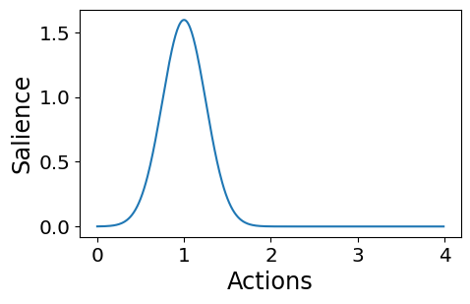

…v

Neuron Pop

…

Spikes

Bundle Vector

Salience Distribution

$$\left[\begin{aligned}-2.24 \\ -3.93 \\ 2.60 \\ … \\ 4.66\end{aligned}\right]$$