**Medals: (Gold – 5, Bronze – 5, Silver – 5)**

Place madBlocks logo on one side of medal – red ribbon

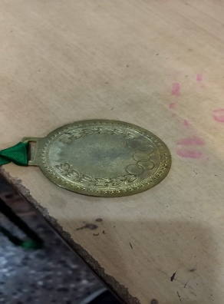

**First, Second and Third Prize: - 1 SET**

Place GEC College Logo on top left and madBlocks Logo on top right

Prize Number in the middle

Congrats!

36 Hours National Level IoT Hackathon

18th – 19th Dec 2021

Guntur Engineering College

Approved by AICTE, Affiliated to JNTUK

Yanamadala, NH5, Guntur, Andhra Pradesh, Andhra Pradesh 522019

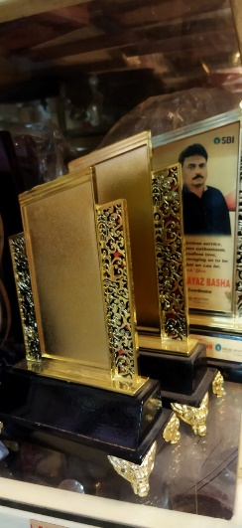

**Guest Memento – 6**

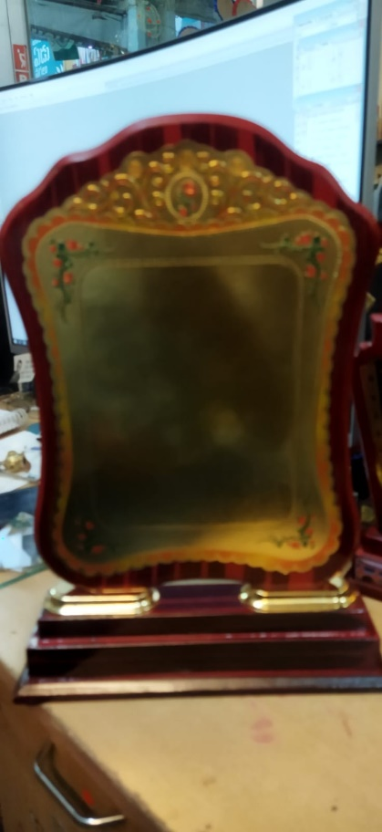

Place GEC College Logo on top left and madBlocks Logo on top right

THANK YOU!

36 Hours National Level IoT Hackathon

18th – 19th Dec 2021

Guntur Engineering College

Approved by AICTE, Affiliated to JNTUK

Yanamadala, NH5, Guntur, Andhra Pradesh, Andhra Pradesh 522019

**Prize Memento: - 2**

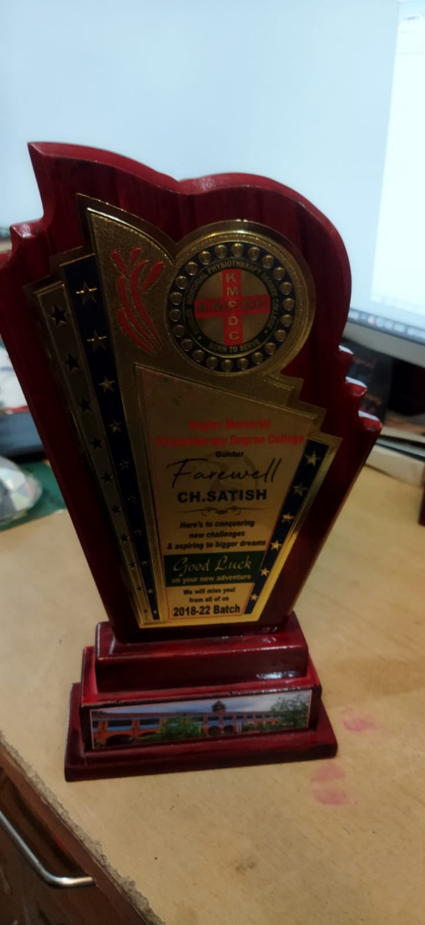

Place GEC College logo on top,

36 Hours National Level IoT Hackathon

“Innovation is the new Invention”

RUNNER-UP (Middle Background Black)

18th – 19th Dec 2021

**Guest Memento: 5**

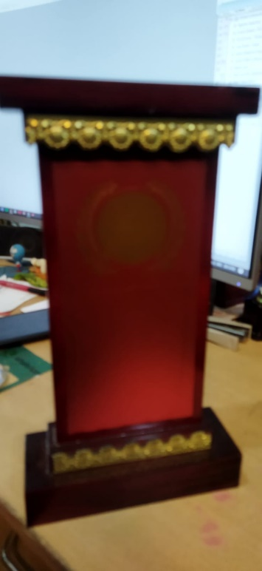

Place GEC College Logo on top left and madBlocks Logo on top right

THANK YOU!

36 Hours National Level IoT Hackathon

18th – 19th Dec 2021

Guntur Engineering College

Approved by AICTE, Affiliated to JNTUK

Yanamadala, NH5, Guntur, Andhra Pradesh, Andhra Pradesh 522019