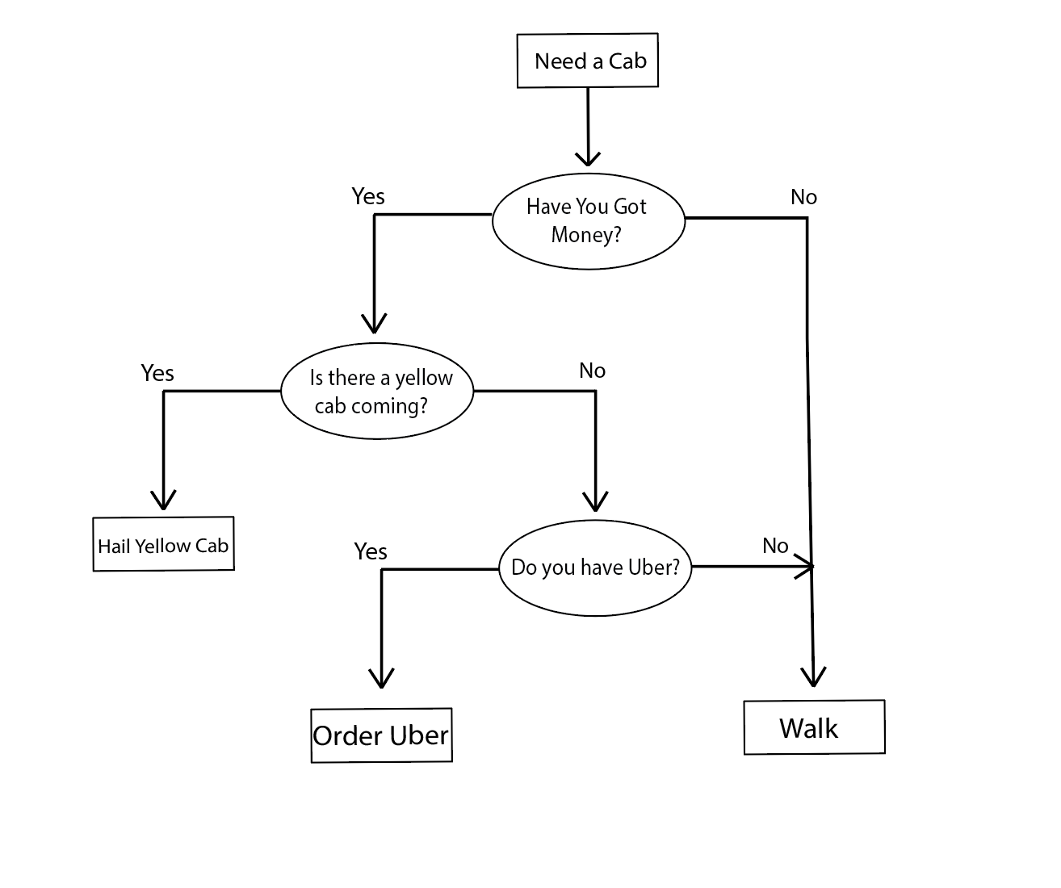

getCab()

if (haveMoney == false) {

walk();

} else {

if (yellowCabComing == true) {

hailCab ();

} else {

if (haveUber == true) {

orderUber();

} else {

walk();

}

}

}