
THE UNIVERSITY OF DANANG
VNUK INSTITUTE FOR RESEARCH AND EXECUTIVE EDUCATION

DIGITAL INNOVATION AND TRANSFORMATION
ACADEMIC YEAR 2026 – 2027
VNUK DIGITAL TRANSFORMATION STRATEGY
AI STUDENT SUPPORT HUB

Group Name: | Group 1
Group Members: | Liu Yu Han – 23060013  Le Nguyen Thanh Hang – 22060016  Tamás Pieskó  Zsombi Mester
Institutional affiliation: | VN-UK Institute for Research and Executive Education, the University of Danang
Lecturer | Dr. Đặng Trung Thành

October 2026

Sections 1–4

1 Executive Summary
We recommend Student Support and Academic Navigation as VNUK’s initial transformation domain, with a conditional pilot of an AI Student Support Hub for CSE course-registration guidance. The service would combine approved guidance, process checklists and accountable staff handoff. Its purpose is to help students obtain reliable answers and complete the next step, while reducing avoidable follow-up for staff. BMS should join only after its support procedures and demand are validated.
The diagnosis draws on Customer Experience module research conducted approximately December 2025 to January 2026. The group followed up with departmental contacts and revalidated in October 2026 that the identified issues remained relevant; no new survey was administered, so all numerical counts remain historical baseline measurements. The reported CSE study included 15 students and five faculty members; the interview material reviewed covers ten students or alumni and one faculty member. BMS survey results cover eight respondents. CSE interviews document inconsistent guidance alongside effective faculty support. In BMS, seven of eight respondents reported heat-related effects and four reported insufficient practical time (Customer Experience project teams, 2026a; 2026b; Group 1, 2026).
Three domains were compared using common value and feasibility criteria. Student support ranks first at 4.10 out of five, ahead of academic progression at 3.80 and practical learning operations at 3.50. These are transparent team judgments rather than measured returns. The ranking depends on approved content and available staff: reducing support feasibility from four to two lowers its score to 3.60 and changes the preferred domain.
The requested decision is permission to validate and test a bounded service rather than commit to university-wide deployment. Initial work should confirm a service owner, refresh evidence and establish baseline enquiry performance. A searchable knowledge base and staff workflow should precede student-facing AI. Major risks are incorrect guidance, outdated content, inappropriate disclosure and shifting work onto already busy staff. An initial business case therefore uses a break-even model instead of claiming unverified savings. Detailed delivery, architecture and change plans belong to subsequent report sections.

2 Organisational, Industry and Technology Context

2.1 Organisation and Value Proposition
VNUK is the VN-UK Institute for Research and Executive Education within the University of Danang. Its public positioning emphasises international higher education and cooperation between Vietnam and the United Kingdom (VNUK, n.d.a). This report studies two departmental contexts: Biomedical Science (BMS) and Computer Science and Engineering (CSE). The unit of analysis is the student service journey within these departments, rather than the whole institution.
VNUK’s value proposition connects academic learning with internationally oriented education and practical capability. Its BMS programme explicitly includes English-medium teaching and practical scientific preparation (VNUK, n.d.b). Our analysis treats reliable guidance, access to resources and clear academic milestones as operational conditions that help students realise that educational value. It does not assume that a support tool directly increases learning outcomes, retention or revenue.
Students are the primary service users. Academic advisors, lecturers and administrative staff provide guidance and make authorised decisions. Programme leaders should approve departmental rules, while IT and relevant institutional data owners should control access and technical arrangements. Lab and technical staff are central to practical-resource operations. Families are relevant stakeholders because seven of eight BMS respondents reported family tuition pressure, although they should not automatically receive access to student records (Customer Experience project teams, 2026b).

2.2 Industry Pressures and Strategic Fit
The relevant pressures are the need to support students across increasingly digital academic processes, maintain coherent information across channels and preserve staff capacity for complex cases. Within VNUK, interviews demonstrate that having a portal or communication channel does not guarantee that a student understands the next action. BMS evidence also shows that digital coordination must coexist with physical teaching requirements. These pressures are grounded in the case evidence; no market-share trend, competitor ranking or institutional budget trend is assumed.
Generative AI creates an opportunity to offer conversational access to institutional guidance, but educational use requires attention to privacy, human agency and suitability for learners. UNESCO (2023) recommends a human-centred approach to its adoption. For VNUK, the strategic implication is to retain staff authority and an accessible non-AI route while testing whether conversational guidance adds value beyond ordinary search.

2.3 Relevant Technologies and Realistic Capability
A controlled knowledge repository, search, structured forms and case tracking are the foundation. A retrieval-based AI interface could answer questions using approved material and display its source. Programme and cohort information would help select relevant guidance. The initial service should not require direct access to grades or official registration records. Verified reminders are a later option once a responsible owner maintains deadlines.
Existing channels and academic expertise provide a starting point, but the evidence does not establish integration readiness, dedicated development capacity or an approved budget. Accordingly, a configurable service using approved institutional tools should be evaluated before custom development. The AI component should be compared with a simpler searchable FAQ using the same content and questions. Selection of a vendor or model requires separate evaluation of cost, accuracy and data handling.

2.4 Ethics, Privacy, Security and Major Risks
The pilot should collect only the context needed to answer or route a request. It should separate public guidance from identifiable case records, restrict staff access by role and define retention and deletion rules before collecting student data. Students must understand when they are interacting with AI and how to reach staff. No live registration status or eligibility decision should be inferred from a conversational answer.
Wrong-cohort guidance, expired instructions and fabricated answers are material risks. The proposed controls are content ownership, review dates, visible sources, staff-tested questions and a refusal or escalation route where evidence is insufficient. These are project design choices informed by the need to manage AI risk across its lifecycle (NIST, 2023). Before procurement or deployment, VNUK’s authorised institutional reviewer should confirm the applicable Vietnamese data-protection, education-record and procurement requirements, including any vendor processing or cross-border transfers. This report does not claim legal clearance or technical compliance.

3 Current State Diagnosis and Priority Domain Selection

3.1 Evidence Base and Limitations
The evidence combines interviews, survey charts and student journey analyses from the Customer Experience module. Research dates are approximately December 2025 to January 2026; two interview records are dated December 2025. Group 1 followed up with departmental contacts in October 2026 and revalidated that the identified issues still described the current situation. This follow-up updates the qualitative status of the diagnosis, but it does not create a new numerical dataset because the survey was not repeated. Sample coverage is shown below. The reviewed CSE material is a subset of the reported study and must not be added to it.
Evidence source | Reported coverage | Material assessed
CSE interviews | 15 students and 5 faculty | 10 students or alumni and 1 faculty
BMS survey | 8 respondents | Aggregate response charts
BMS faculty interviews | Conducted according to the team | Completed transcript not available for this assessment

Source: Customer Experience project teams (2026a; 2026b) and team clarification. The material contains researcher interpretations as well as participant accounts. No representative sampling claim is made. Current enquiry volumes, resolution times, staffing costs and system availability have not been established.
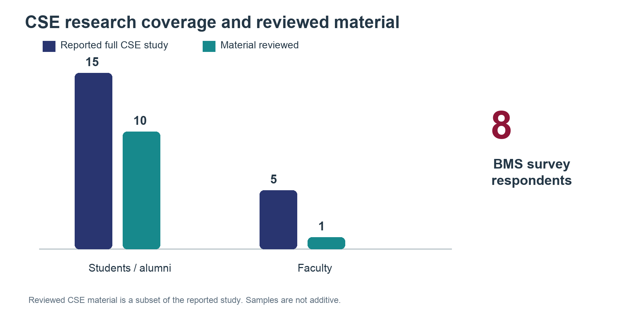
Figure 1. Research coverage and evidence reviewed
Source: Customer Experience module research; reviewed material is a subset of the reported CSE study.

3.2 Recorded Findings
CSE evidence shows service variability. One student recalled four to five LMS login attempts and a four-to-five-day advising email response. One alumnus reported missing a graduation notice and receiving faculty help, while also describing weekly thesis supervision. These individual accounts identify possible failure points and existing strengths; they are not institution-wide averages or prevalence estimates (Customer Experience project teams, 2026a).
BMS finding | Count | Interpretation
Heat-related fatigue or productivity effects | 7 of 8 | Physical learning conditions matter
Heavy academic workload | 6 of 8 | Reported pressure, not a measured staffing problem
Rushing to leave the hot lab | 5 of 8 | Potential disruption to practical experience
Insufficient practical time | 4 of 8 | Access or session capacity needs investigation
Specialist English difficulties | 2 of 8 | Guidance may need clearer terminology
Stress rated 7 or 8 out of 10 | 5 of 8 | Self-reported stress, not a clinical diagnosis

Source: Customer Experience project teams (2026b), survey figures 2–6. Responses to different questions may overlap and should not be summed into a combined total.
The laboratory satisfaction distribution is more positive than the report narrative suggests. Ratings from one to five have counts of zero, one, three, two and two respectively. The weighted mean is 29/8 = 3.625, reported as 3.63/5. Four respondents rated the lab four or five. This calculation supersedes the narrative’s approximate 2/5 statement. Overall satisfaction can coexist with specific complaints, so the diagnosis should target the recorded issues rather than portray every aspect of the laboratory negatively (Customer Experience project teams, 2026b, figure 1).
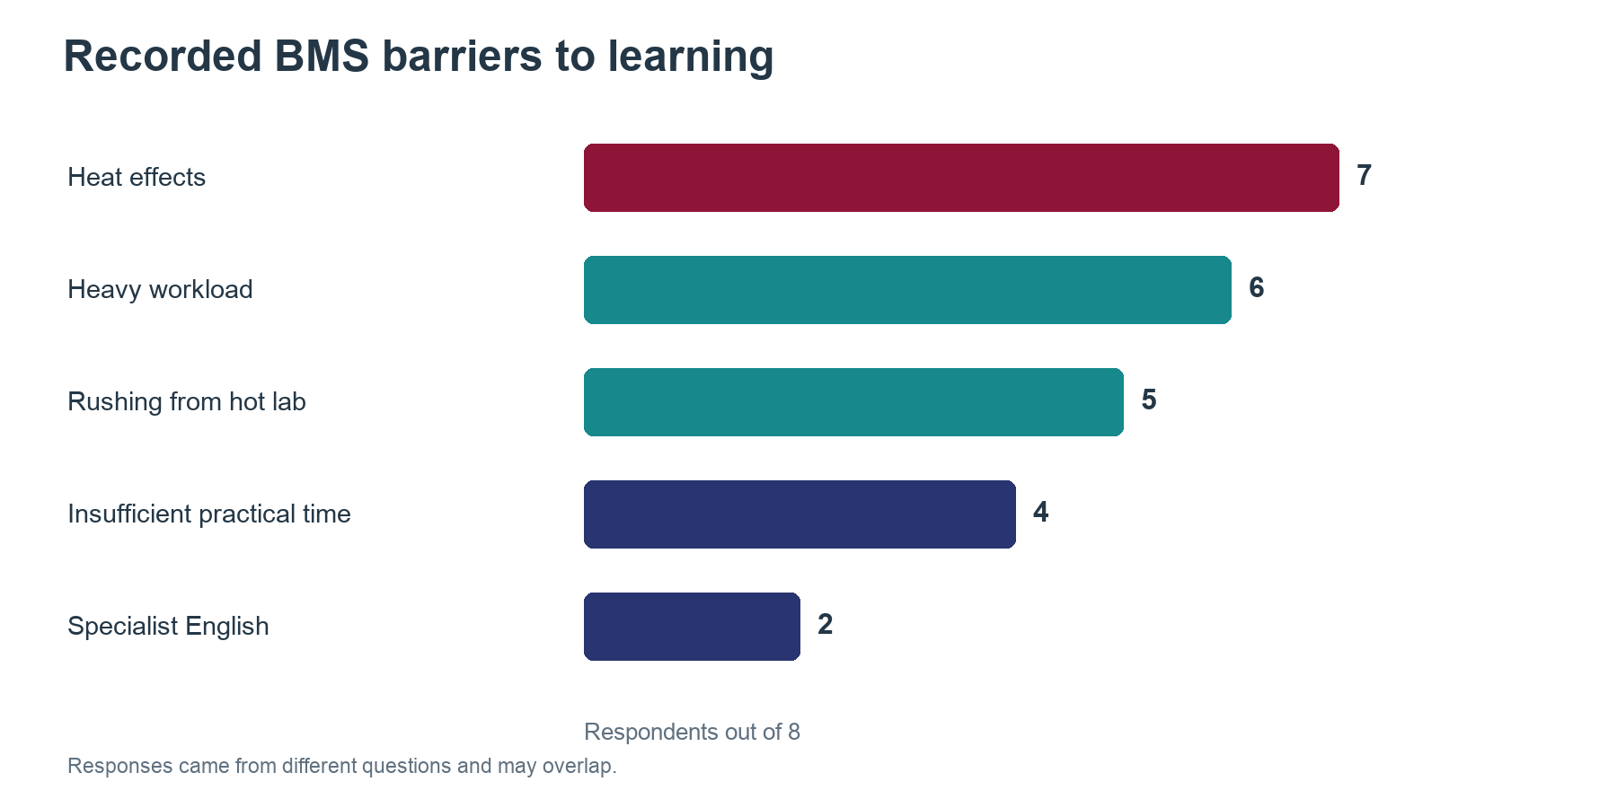
Figure 2. Recorded BMS barriers to learning
Source: BMS survey, n=8. Multiple responses permitted.
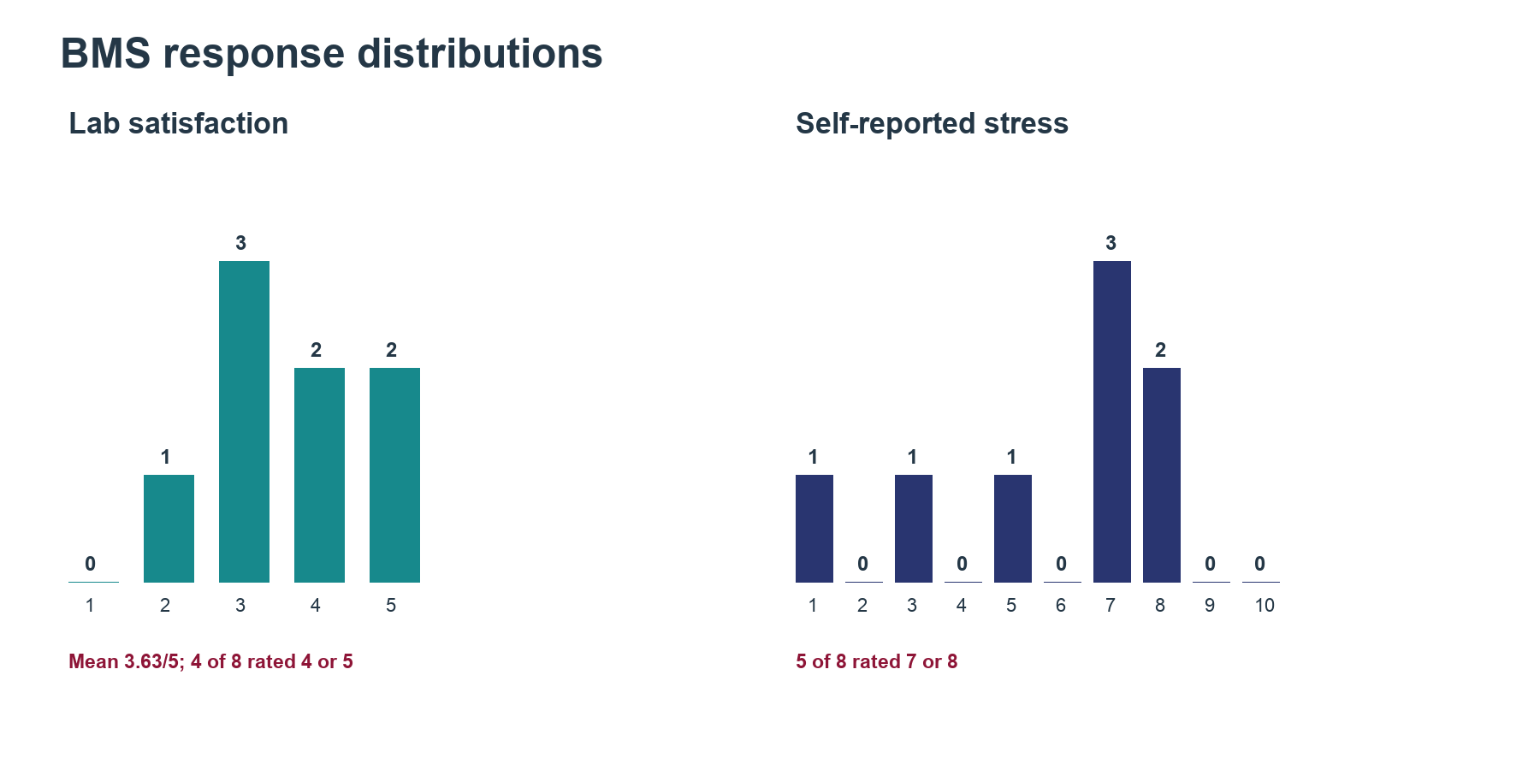
Figure 3. BMS satisfaction and stress distributions
Source: BMS survey, n=8. Historical baseline data.

3.3 Journeys, Processes and Causal Hypotheses
For student support, the reconstructed journey is: a student raises a question, searches for guidance, clarifies the need, receives an answer or referral, and follows up if unresolved. Dispersed information and uncertain case ownership are possible causes of repeated contact. A delay may also reflect case complexity or staff workload; the research does not isolate these factors.
For practical learning, the journey begins with a learning need and proceeds through resource allocation, access and supervision checks, session completion and resource return. Reported insufficient practice may arise from scheduling, physical capacity or supervision. A digital booking interface alone cannot resolve shortages or heat. For academic progression, the journey checks cohort rules and milestone status, resolves exceptions and confirms completion. Unclear status and missed notices suggest coordination issues, but current error rates and responsibilities require validation.

3.4 Candidate Domains and Curated Shortlist
Eight operational domains were mapped before selecting broader candidates. This prevents choosing a technology before defining the outcome it should improve.
Operational domain | Intended outcome
Course planning and registration | Valid course selection confirmed
Academic advising and enquiry resolution | Reliable answer or completed referral
Thesis registration and supervision | Agreed thesis milestones completed
Graduation eligibility and clearance | Requirements and exceptions resolved
Practical learning resource access | Practical session completed
Facility and equipment maintenance | Resource availability restored
Learning support | Identified learning difficulty addressed
Career and research opportunity access | Appropriate guidance or referral completed

Source: analytical mapping from Customer Experience project teams (2026a; 2026b).
Three candidates combine related activities. A, Student Support and Academic Navigation, owns guidance and referral from question to resolution. B, Practical Learning and Resource Operations, coordinates resources, supervision and maintenance through completed sessions. C, Academic Progression and Milestone Management, owns formal course, thesis and graduation checks. Support may explain a rule, but progression verifies a student’s official status. This boundary prevents counting the same benefit twice. Curriculum redesign, clinical counselling and major capital approvals are outside these candidates.
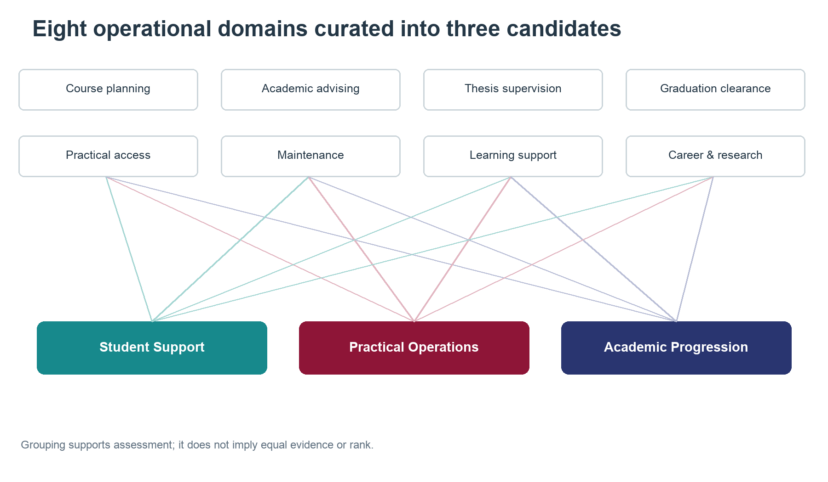
Figure 4. Operational domains and curated candidates
Source: Group 1 analytical mapping from Customer Experience interviews, survey data and journey analyses.
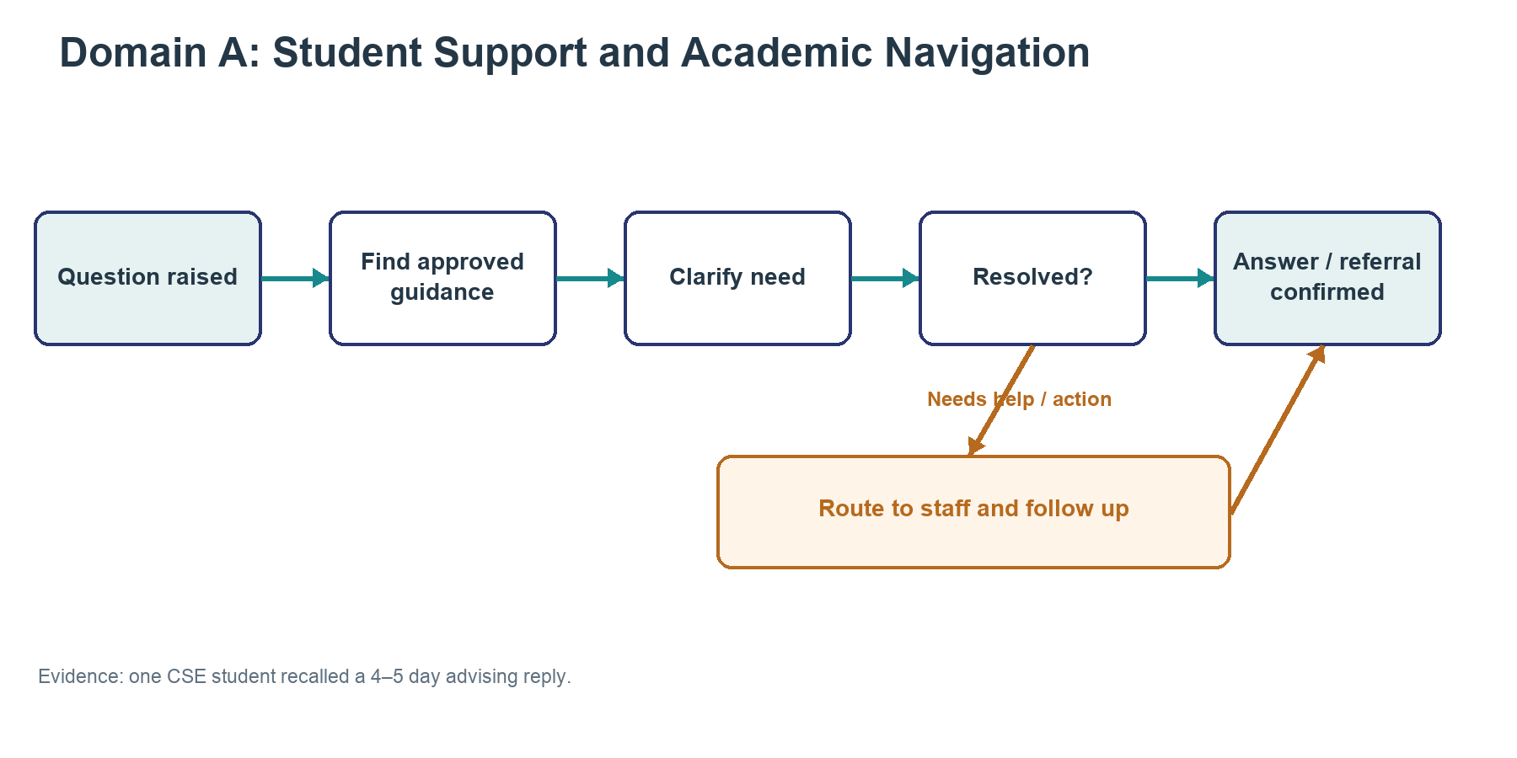
Figure 5. Student Support process map
Source: Reconstructed process for validation; individual interview evidence is not a population average.
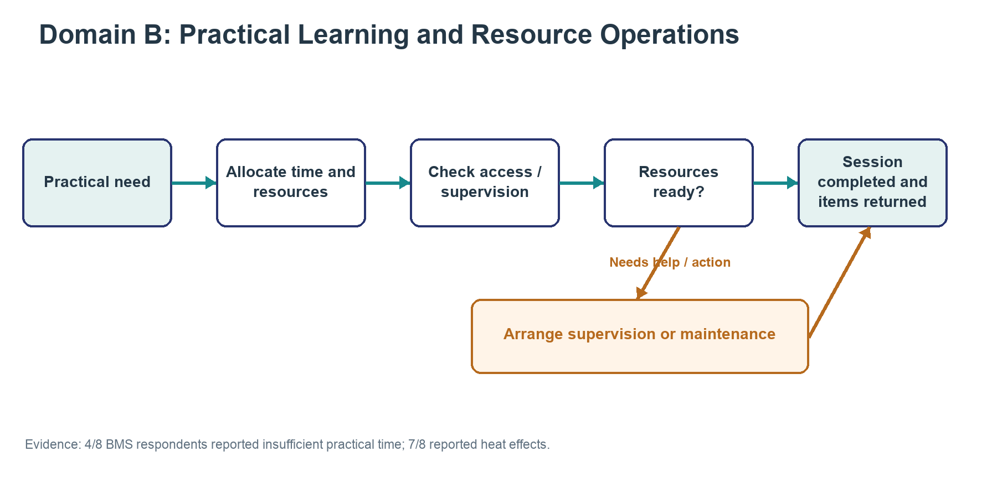
Figure 6. Practical Learning process map
Source: Reconstructed process for validation; survey counts describe n=8.
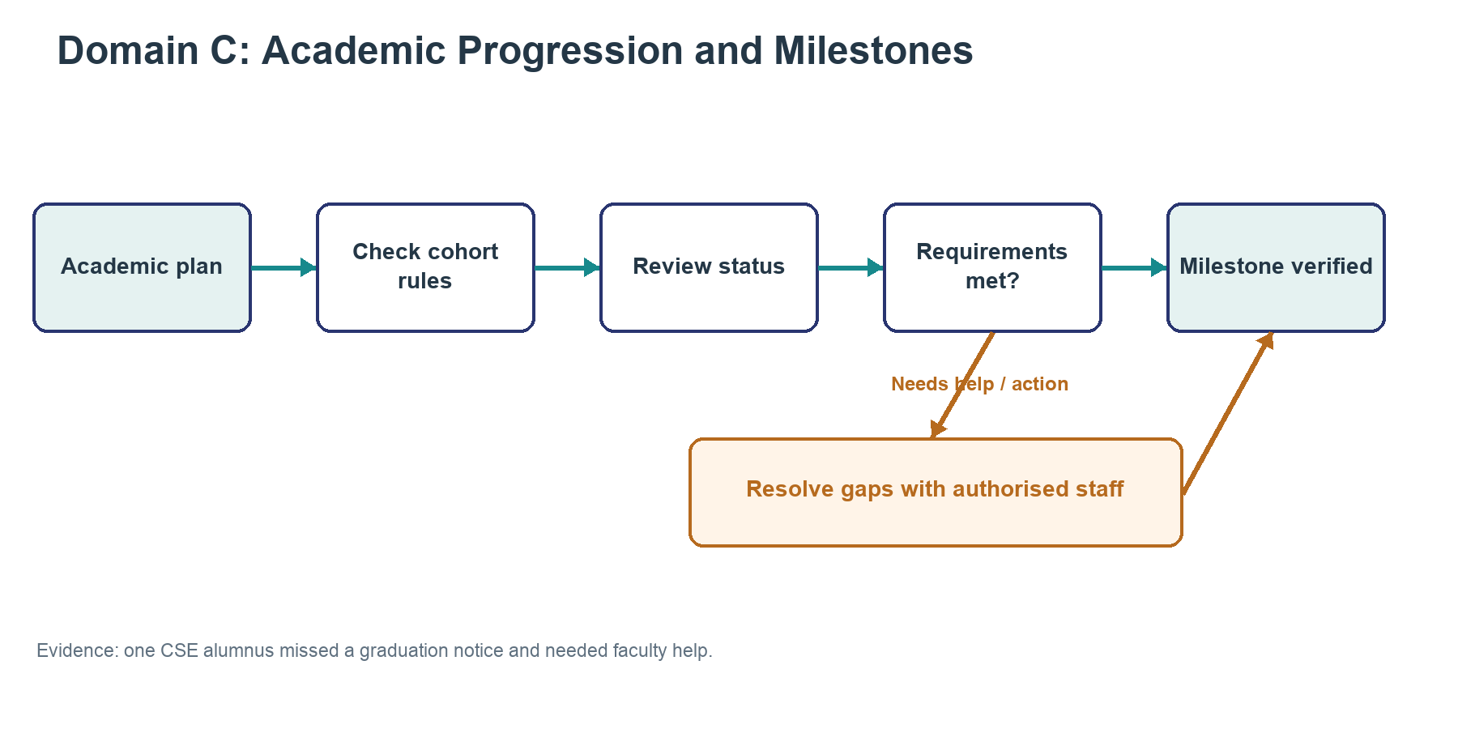
Figure 7. Academic Progression process map
Source: Reconstructed process for validation; individual interview evidence is not a population average.

3.5 Capability Assessment
The six dimensions follow the Week 3 workshop. Partial means some capability is evidenced; gap indicates a reported shortfall; unknown means insufficient evidence. Ratings are qualitative judgments, not maturity scores (DBB43005 teaching team, 2026a).
Capability | A Student support | B Practical learning | C Progression
Roadmap | Unknown owner and targets | Unknown plan and funding | Unknown cross-unit ownership
Talent | Partial expertise and capacity | Partial expertise, coverage unclear | Partial roles, delivery time unclear
Operating model | Gap in guidance and routing | Gap in access coordination | Gap in checks and follow-up
Technology | Partial channels, tracking unclear | Unknown tools and inventory | Partial portal, reported friction
Data | Gap in organised guidance | Unknown usage and capacity records | Partial records, quality unclear
Adoption | Partial and uneven use | Unknown shared workflow use | Partial with workarounds

Source: team assessment based on Customer Experience project teams (2026a; 2026b). The assessment adapts the framework to departmental service delivery: the most immediate dependencies are an accountable owner, allocated staff time and reliable process information. Proposed systems in earlier research are not counted as existing capability.
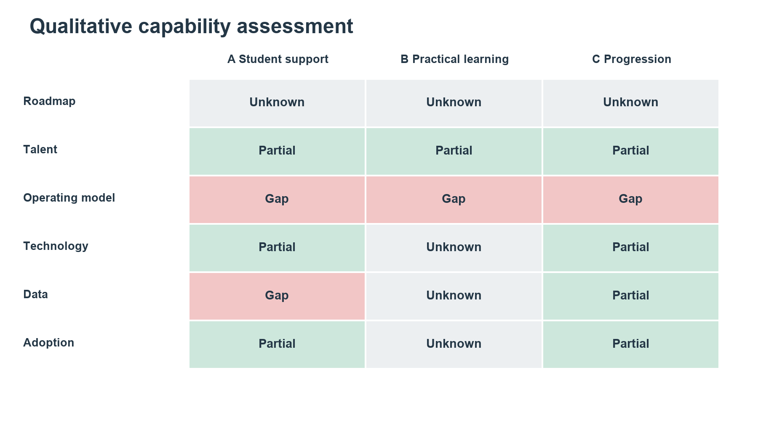
Figure 8. Capability assessment heatmap
Source: Group 1 qualitative assessment. Partial, gap and unknown are not maturity scores.

3.6 Consistent Prioritisation and Decision
The workshop criteria assign 30% to value, 25% to feasibility, 20% to strategic relevance, 15% to urgency and 10% to learning. Scores range from one, low, to five, high. Value reflects the potential student and operational benefit. Feasibility reflects the dependencies of a bounded entry project. All candidates receive four for strategy and urgency because comparative leadership priorities and time-critical evidence are unavailable (DBB43005 teaching team, 2026a).
Criterion and weight | A Support | B Practical | C Progression
Value 30% | 4 | 4 | 5
Feasibility 25% | 4 | 2 | 2
Strategy 20% | 4 | 4 | 4
Urgency 15% | 4 | 4 | 4
Learning 10% | 5 | 4 | 4
Weighted total | 4.10 | 3.50 | 3.80

Source: proposed team scores, not survey results. Weighted total equals the sum of each score multiplied by its criterion weight.
Support receives higher feasibility because a guidance pilot can begin without integrating personal academic records. Its learning score reflects reusable content and routing practices. Practical learning faces physical-resource dependencies. Progression has broader potential value but requires authoritative records and approval processes. The numerical separation should not conceal uncertainty: if A’s feasibility falls to two, its total becomes 3.60 and C becomes the leading candidate. We therefore select A conditionally, subject to named ownership, approved content and staff capacity. The strength of BMS complaints does not by itself establish that an AI support service addresses them.
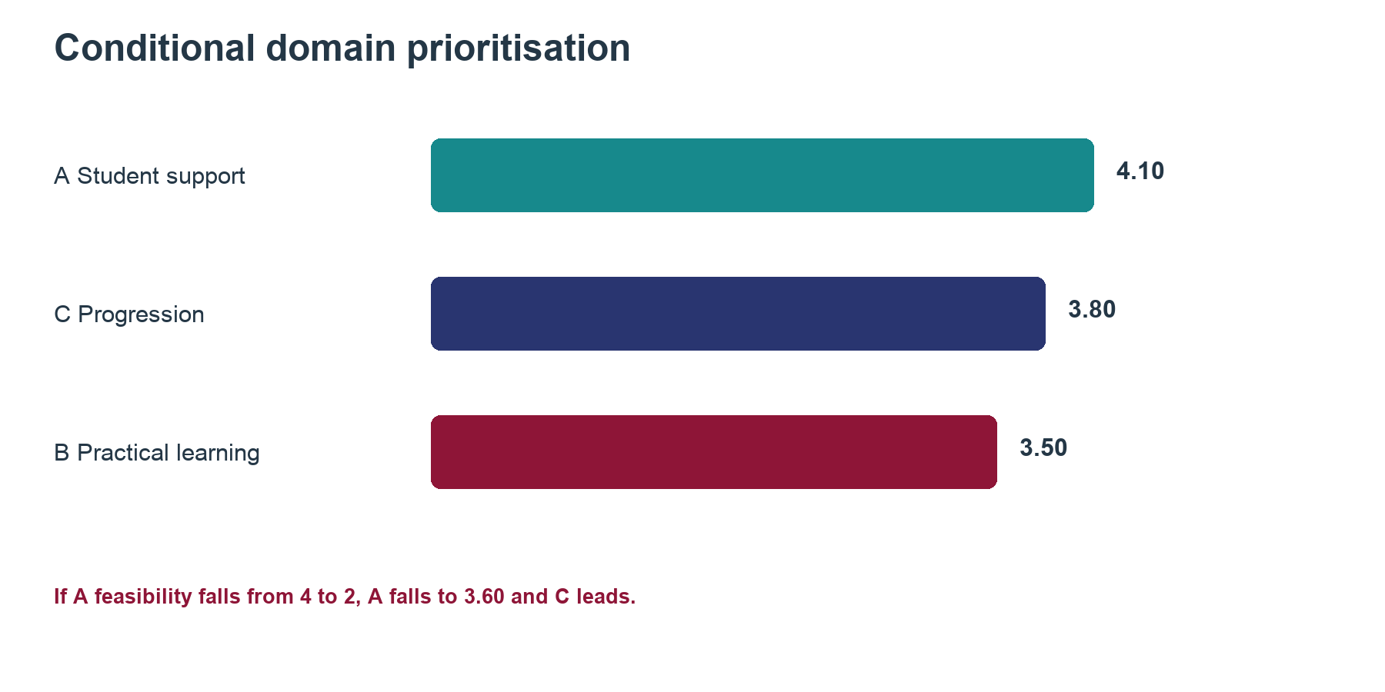
Figure 9. Conditional prioritisation results
Source: Group 1 proposed scores using the workshop weighting; scores are not measured ROI.

4 Transformation Vision, Value Logic and Solution Portfolio

4.1 Vision and Future State
The vision is a dependable student-support service where students can find approved guidance, understand the next action and obtain staff help without repeatedly searching across channels. The future journey begins with a question and minimal programme context. The service retrieves relevant guidance, shows its source and explains the next step. If it cannot resolve the need, an accountable team receives a case and the student can see its status. Authorised staff retain academic decisions.
The initial use case is CSE registration guidance. For example, a student who asks whether course selection means registration is complete receives the approved verification instructions. Without access to the official record, the service explicitly states that it cannot confirm live status and offers referral. The intended organisational change is shared content ownership and visible case responsibility, supported by technology.
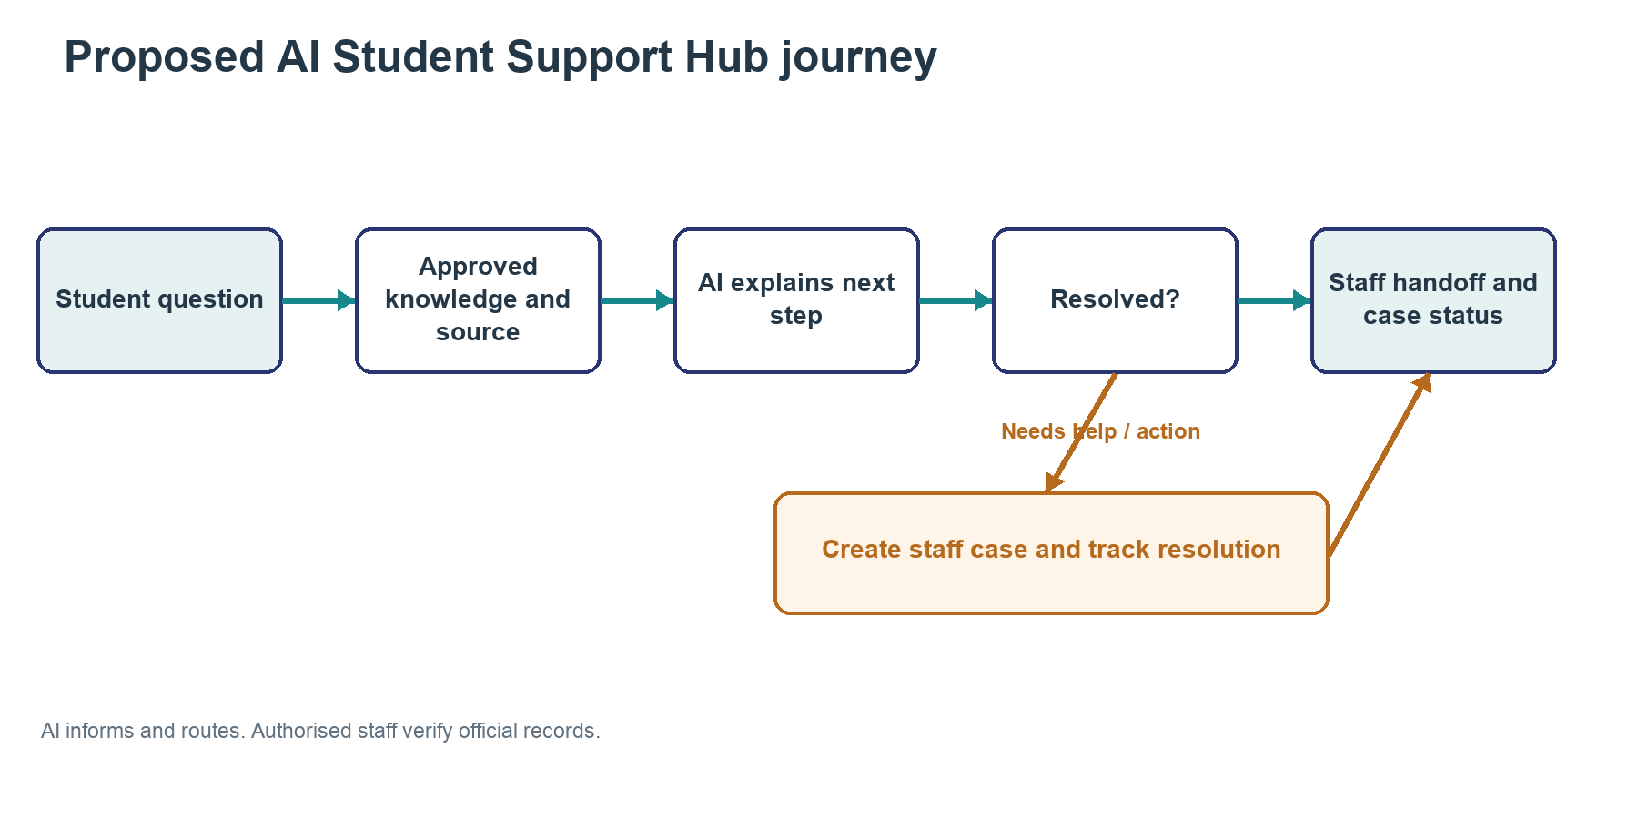
Figure 10. Proposed future-state student-support flow
Source: Group 1 proposal. Staff remain responsible for official records and decisions.

4.2 Objectives and Value Logic
The proposed value chain is: maintained guidance improves answer consistency; clear checklists reduce avoidable confusion; accountable handoff supports resolution; and feedback identifies recurring process defects. Student value is less effort and uncertainty. Operational value is potentially less repeated contact and more staff time for complex matters. Educational and financial benefits remain hypotheses until measured.
Objective | Metric and baseline | Proposed pilot decision rule
Accurate guidance | Staff-reviewed correct answers / assessed answers | At least 95% on an approved test set of at least 100 cases; no critical wrong eligibility guidance
Lower student effort | Repeat-contact rate for the same issue within 7 days | Aim for a 20% relative reduction against comparable baseline cases
Faster resolution | Median time from request to confirmed resolution | Aim for a 20% reduction without increasing unresolved cases
Sustainable staff workload | Total handling and review minutes per resolved case | No increase after including content upkeep and escalation
Accountable content | Published items with owner, source and review date | 100% before student access

All thresholds are proposed team criteria requiring institutional agreement, not existing results or statistically established guarantees. Establish a baseline over a comparable registration period before the pilot, using the same case definitions. Separate automated acknowledgements from substantive answers and confirmed resolution. Report case counts alongside rates. A suggested evaluation is four weeks of limited use after preparation, with extension if volume is too low to support comparison.

4.3 Coherent Solution Portfolio
Initiative 1 is an approved knowledge base and content governance process. Each entry needs an owner, applicable programme or cohort, source and review date. This is the first priority because it supports both ordinary search and AI. Initiative 2 is structured handoff and case tracking, with assigned staff and a defined closure condition. It addresses unresolved enquiries and should be tested with staff before student launch.
Initiative 3 is the AI guidance layer, limited initially to approved CSE registration material. It should cite sources, request clarification when context is missing and escalate unsupported questions. Initiative 4 adds task checklists and, only where deadlines are verified, opt-in reminders. Initiative 5 is service analytics using aggregated enquiry categories and resolution measures to identify content gaps and recurrent process failures. Personal conversations should not become a general research dataset by default.
The portfolio sequence is dependencies-first: content and ownership; staff workflow; tested AI guidance; then reminders and broader coverage. A searchable FAQ with the same staff handoff is the principal alternative. If AI does not improve task completion or effort sufficiently to justify extra cost and risk, retain the simpler service. A full student-information-system replacement is outside the initial scope. BMS resource coordination remains a separate candidate requiring operational assessment, not an assumed extension of the chatbot.

4.4 Assumptions, Dependencies and Implementation Path
The proposal assumes that an authorised programme representative can approve guidance, that staff have time to resolve escalations and that a bounded set of common questions exists. These assumptions require validation. No access to personal records, paid vendor contract or IT integration is assumed to be approved.
The initial path has three gates. First, validate demand, nominate owners and approve a content set while measuring baseline service performance. Second, test search, routing and AI against staff-approved cases, including ambiguous questions and outdated-cohort scenarios. Third, run a limited student pilot and evaluate the stated measures. Expansion requires useful outcomes, sustainable staff effort and an acceptable data-handling arrangement. Critical misleading guidance, inability to maintain content or unmanageable escalations should pause the AI component while preserving staff support.

4.5 Initial Business Case
The business case is conditional because enquiry volume, labour costs and implementation quotations are not yet verified. Let N be eligible enquiries per month, p the proportion successfully resolved without staff handling, t the avoided handling minutes per resolved enquiry, and w the loaded staff cost per hour. Let M be monthly content and quality-review cost and R the monthly technology and operating cost. Estimated monthly capacity value is N × p × t × w / 60. Net monthly value is that amount minus M and R. This estimates the value of released capacity, not automatic cash savings.
For an illustrative scenario only, assume N = 500, p = 0.40, t = 8 minutes, w = VND 100,000, M = VND 1,000,000 and R = VND 1,000,000. Gross capacity value is approximately VND 2.67 million per month and net value VND 0.67 million. If initial setup cost is VND 12 million, indicative payback is 18 months, assuming those conditions persist. These round assumptions are sensitivity inputs, not VNUK costs, vendor quotes or expected results.
At 200 enquiries per month, the same assumptions produce a monthly loss of approximately VND 0.93 million. Operating break-even is 375 eligible enquiries per month. Recovering VND 12 million of setup cost within 12 months would require approximately 563 monthly enquiries under the same assumptions. This demonstrates why demand validation matters before building. Avoided effort must include any checking or rework created by the service, and lower repeat contact must not be monetised twice.
The initial cost scope should include content preparation, staff training, workflow configuration, testing, hosting or model usage, maintenance and evaluation. Student time saved and more consistent access may justify a pilot even when cash savings are limited, but they should be presented separately from monetised staff capacity. The immediate decision is therefore a small, supervised validation exercise. Institution-wide investment should wait for measured demand, quotations and evidence that the AI layer outperforms the simpler alternative.

References
Customer Experience project teams (2026a) Customer Experience module research on CSE student journeys. Unpublished interview records and project analyses, VNUK. Research conducted approximately December 2025 to January 2026.
Customer Experience project teams (2026b) Customer Experience module research on BMS student experience. Unpublished survey results and project report, VNUK. Research conducted approximately December 2025 to January 2026.
Group 1 (2026) Follow-up validation of BMS and CSE issue status. Team communication with departmental contacts, October 2026. No repeat survey conducted.
NIST (2023) AI Risk Management Framework. Available at: https://www.nist.gov/itl/ai-risk-management-framework (Accessed: 11 October 2026).
UNESCO (2023) Guidance for generative AI in education and research. Available at: https://www.unesco.org/en/articles/guidance-generative-ai-education-and-research (Accessed: 11 October 2026).
VNUK (n.d.a) About VNUK. Available at: https://vnuk.udn.vn/en/about/ (Accessed: 11 October 2026).
VNUK (n.d.b) Biomedical Science. Available at: https://vnuk.udn.vn/en/major/biomedical-science/ (Accessed: 11 October 2026).

