
THE UNIVERSITY OF DANANG
VNUK INSTITUTE FOR RESEARCH AND EXECUTIVE EDUCATION

DIGITAL INNOVATION AND TRANSFORMATION
ACADEMIC YEAR 2026 – 2027
VNUK DIGITAL TRANSFORMATION STRATEGY
AI STUDENT SUPPORT HUB

Group Name: | Group 1
Group Members: | Liu Yu Han – 23060013  Le Nguyen Thanh Hang – 22060016  Tamás Pieskó  Zsombi Mester
Institutional affiliation: | VN-UK Institute for Research and Executive Education, the University of Danang
Lecturer | Dr. Đặng Trung Thành

October 2026

Sections 1–4

1 Executive Summary
We recommend Student Support and Academic Navigation as VNUK’s initial transformation domain. The proposed VNUK Student Support Hub would serve IBM, BMS and CSE students through approved guidance, process checklists and accountable staff handoff. The first pilot would use an HTML prototype with 30 students, ten from each programme, over three months. Its purpose is to improve routing and task completion before VNUK considers live system integration or autonomous AI.
The diagnosis combines Customer Experience module research from approximately December 2025 to January 2026 with two October 2026 staff interviews: one participant from Admissions and one from Administration. The staff interviews provide current process descriptions and operational estimates. They are qualitative and directional; they do not represent audited institutional records, measured service levels or a representative staff sample. The reported CSE study included 15 students and five faculty members; the material reviewed covers ten students or alumni and one faculty member. BMS survey results cover eight respondents. No new student survey was administered, so the historical sample counts remain baseline evidence (Customer Experience project teams, 2026a; 2026b; Group 1, 2026).
The two staff interviews indicate that email remains the main administrative channel for a student population estimated at more than 1,200 across IBM, BMS and CSE. General administrative responses are usually expected within one working day, while requests involving supervisors, schedules, EMS or other systems may take one to three working days. Peak periods are estimated to raise enquiry demand by 70–80 percent. Some complex credit-registration cases reportedly require more than five follow-up emails. Absolute weekly volume, correct-routing rate, repeat-contact rate and staff handling time have not yet been measured.
Three domains were compared using common value and feasibility criteria. Student support ranks first at 4.10 out of five, ahead of academic progression at 3.80 and practical learning operations at 3.50. These are transparent team judgments rather than measured returns. The ranking depends on approved content and available staff: reducing support feasibility from four to two lowers its score to 3.60 and changes the preferred domain.
The requested decision is permission to validate a bounded service rather than commit to university-wide deployment. Initial work should confirm a service owner, obtain approved procedures and establish baseline enquiry performance. A searchable knowledge base and staff workflow should precede student-facing AI. Major risks are incorrect guidance, outdated content, inappropriate disclosure and shifting work onto already busy staff. The business case therefore remains measurement-led and does not claim verified savings. Detailed delivery, architecture and change plans belong to subsequent report sections.

1.1 Executive Evidence Index
The links below connect the recommendation to the evidence, analytical choices and delivery assumptions used in this report. Operational figures from October 2026 remain approximate qualitative estimates from two staff interviews unless stated otherwise.
Decision question | Current indication | Linked evidence
Research basis | Historical Customer Experience research plus two October 2026 staff interviews | Figure 1
Service scale and pressure | More than 1,200 students; peak demand index estimated at 170–180 compared with 100 in a normal period; response indication of one to three working days by case type | Figure 2
Current process issue | Email routing, missing information and revision can create repeated follow-up | Figure 5
Domain selection | Ten operational domains grouped into Student Support, Practical Operations and Academic Progression | Figure 8
Priority recommendation | Student Support scores 4.10 out of 5 under the proposed workshop weighting | Figure 10
MVP design | Three-month HTML pilot with 30 students: 10 CSE, 10 IBM and 10 BMS | Figure 11
First Sprint capacity | 160 student-team hours across four delivery roles over two weeks | Figure 13

2 Organisational, Industry and Technology Context

2.1 Organisation and Value Proposition
VNUK is the VN-UK Institute for Research and Executive Education within the University of Danang. Its public positioning emphasises international higher education and cooperation between Vietnam and the United Kingdom (VNUK, n.d.a). This report studies the student-support journey across International Business and Management (IBM), Biomedical Science (BMS) and Computer Science and Engineering (CSE). The operational estimates cover VNUK broadly, while the historical research evidence is strongest for CSE and BMS.
VNUK’s value proposition connects academic learning with internationally oriented education and practical capability. Its BMS programme explicitly includes English-medium teaching and practical scientific preparation (VNUK, n.d.b). Our analysis treats reliable guidance, access to resources and clear academic milestones as operational conditions that help students realise that educational value. It does not assume that a support tool directly increases learning outcomes, retention or revenue.
Students are the primary service users. Admissions, Administration, Training, Finance, academic advisors and programme staff provide guidance or make authorised decisions. Programme leaders should approve programme-specific rules, while IT and relevant institutional data owners should control access and technical arrangements. Lab and technical staff remain central to practical-resource operations. Families are relevant stakeholders because seven of eight BMS respondents reported family tuition pressure, although they should not automatically receive access to student records (Customer Experience project teams, 2026b).

2.2 Industry Pressures and Strategic Fit
The relevant pressures are the need to support more than 1,200 students across seasonal academic processes, maintain coherent information across departments and preserve staff capacity for complex cases. The October 2026 interviews suggest that students must identify the correct email address before a request can be resolved. Incorrect routing can delay or lose a case, and peak periods may increase demand by an estimated 70–80 percent. Historical student interviews also show that having a portal or communication channel does not guarantee that a student understands the next action. BMS evidence shows that digital coordination must coexist with physical teaching requirements. No market-share trend, competitor ranking or institutional budget trend is assumed.
Generative AI creates an opportunity to offer conversational access to institutional guidance, but educational use requires attention to privacy, human agency and suitability for learners. UNESCO (2023) recommends a human-centred approach to its adoption. For VNUK, the strategic implication is to retain staff authority and an accessible non-AI route while testing whether conversational guidance adds value beyond ordinary search.

2.3 Relevant Technologies and Realistic Capability
A controlled knowledge repository, search, structured forms and case tracking are the foundation. The first content set should cover admissions, tuition, credit registration, graduation, scholarships, timetable changes, full-class requests, university-system issues and correct department contacts. A retrieval-based AI interface could explain approved material and display its source. Programme and cohort information would help select relevant guidance. The initial service should not require direct access to grades or official registration records. Verified reminders are a later option once a responsible owner maintains deadlines.
Existing channels and academic expertise provide a starting point, but the evidence does not establish integration readiness, dedicated development capacity or an approved budget. Accordingly, a configurable service using approved institutional tools should be evaluated before custom development. The AI component should be compared with a simpler searchable FAQ using the same content and questions. Selection of a vendor or model requires separate evaluation of cost, accuracy and data handling.

2.4 Ethics, Privacy, Security and Major Risks
The pilot should collect only the context needed to answer or route a request. It should separate public guidance from identifiable case records, restrict staff access by role and define retention and deletion rules before collecting student data. Students must understand when they are interacting with AI and how to reach staff. No live registration status or eligibility decision should be inferred from a conversational answer.
Wrong-cohort guidance, expired instructions and fabricated answers are material risks. The proposed controls are content ownership, review dates, visible sources, staff-tested questions and a refusal or escalation route where evidence is insufficient. These are project design choices informed by the need to manage AI risk across its lifecycle (NIST, 2023). Before procurement or deployment, VNUK’s authorised institutional reviewer should confirm the applicable Vietnamese data-protection, education-record and procurement requirements, including any vendor processing or cross-border transfers. This report does not claim legal clearance or technical compliance.

3 Current State Diagnosis and Priority Domain Selection

3.1 Evidence Base and Limitations
The evidence combines interviews, survey charts and student journey analyses from the Customer Experience module with two staff interviews conducted in October 2026. One current participant works in Admissions and one works in Administration. These interviews update the operating context and provide estimates about channels, response times, seasonal demand, follow-up and staffing. With only two role-based participants and no system extract, the estimates are qualitative and directional. They must not be treated as measured institutional KPIs or generalised to every department.
The Customer Experience research dates are approximately December 2025 to January 2026; two interview records are dated December 2025. The student survey was not repeated, so its numerical results remain historical baseline evidence. Sample coverage is shown below. The reviewed CSE material is a subset of the reported study and must not be added to it.
Evidence source | Reported coverage | Material assessed
CSE interviews | 15 students and 5 faculty | 10 students or alumni and 1 faculty
BMS survey | 8 respondents | Aggregate response charts
BMS faculty interviews | Conducted according to the team | Completed transcript not available for this assessment
October 2026 operational update | 2 staff participants | 1 Admissions and 1 Administration interview; qualitative estimates only

Source: Customer Experience project teams (2026a; 2026b) and Group 1 staff interviews (2026). The material contains researcher interpretations as well as participant accounts. No representative sampling claim is made. Weekly enquiry volume, repeat-contact rate, correct-routing rate, handling time, staffing costs and system availability have not been established through administrative data.

3.2 Recorded Findings
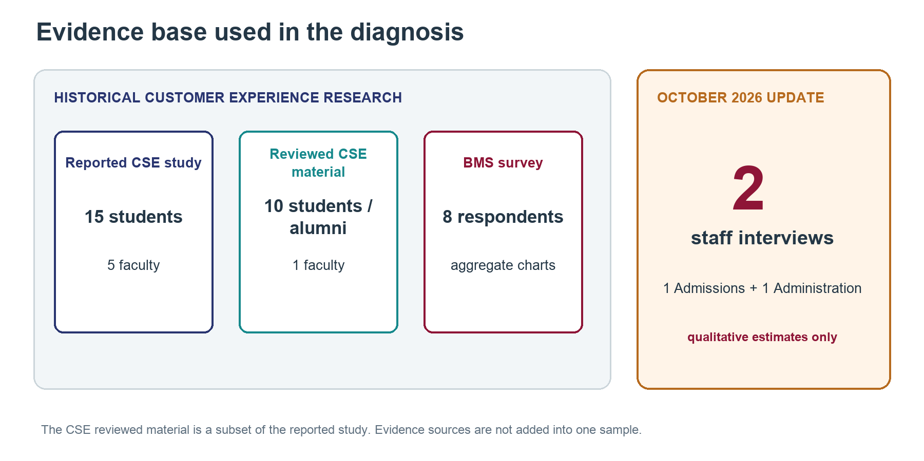
Figure 1. Research coverage and evidence reviewed
Source: Customer Experience module research and two October 2026 staff interviews. Samples are small, separate and non-representative.
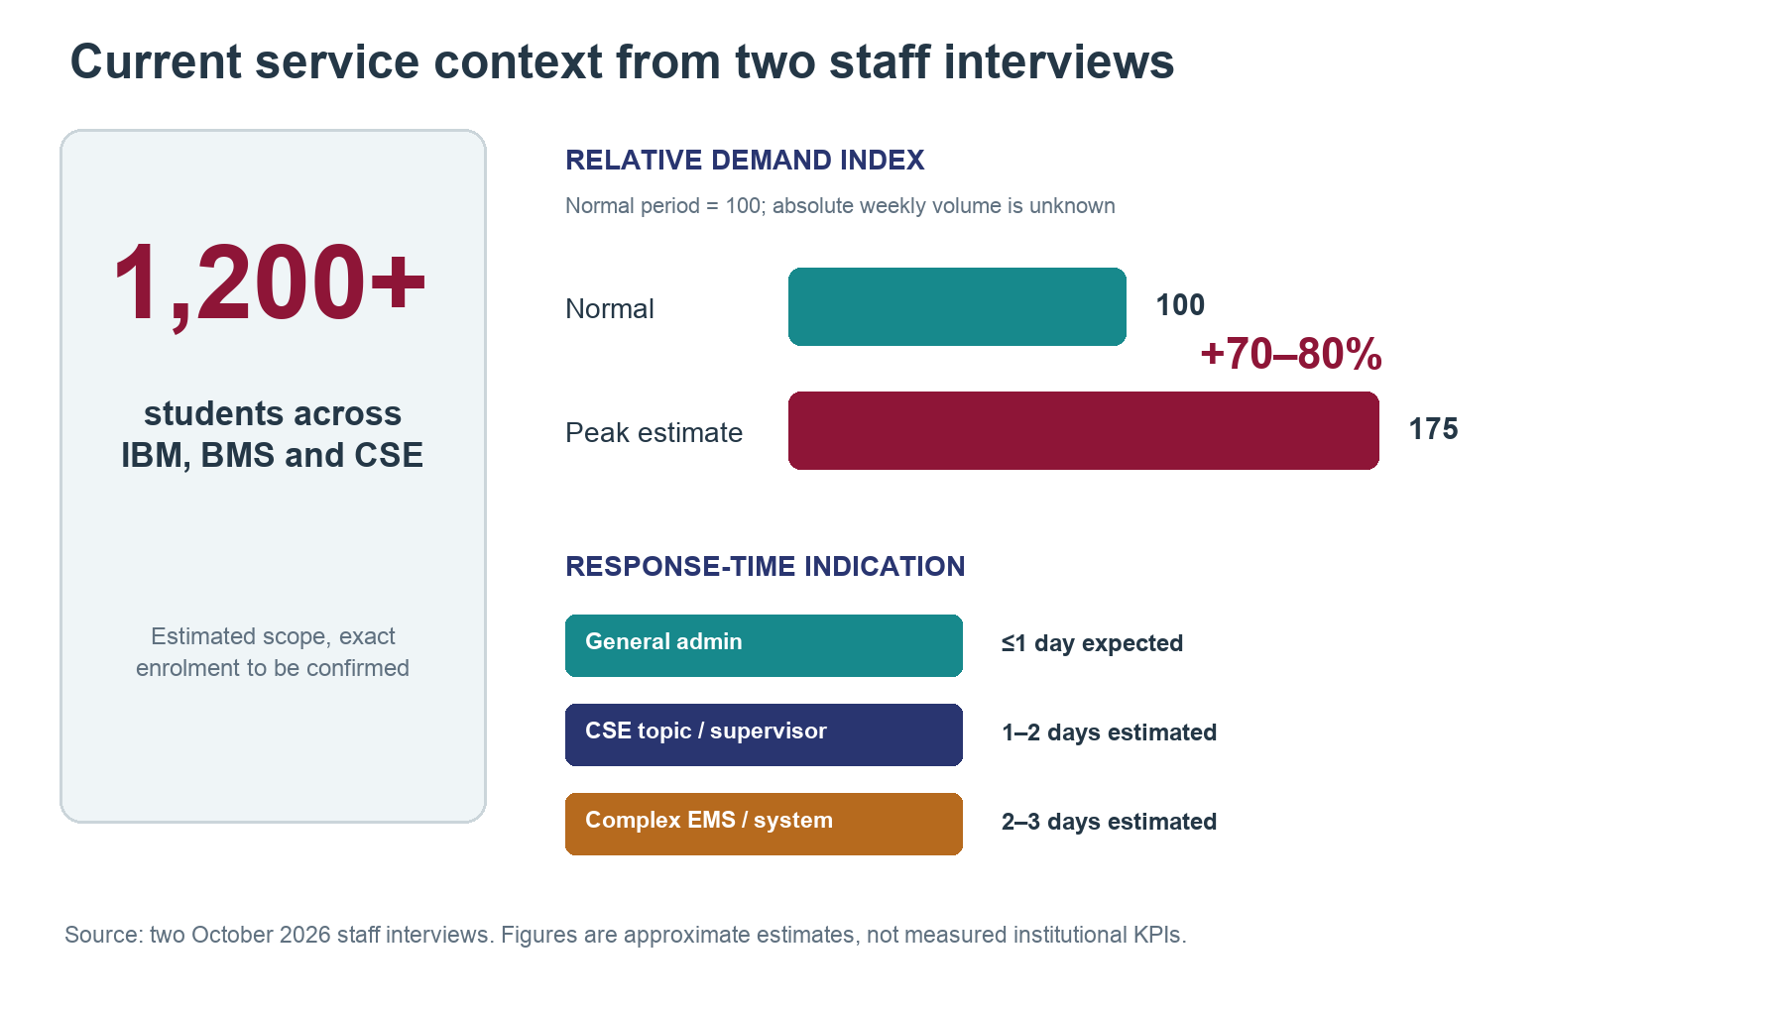
Figure 2. Estimated service scale, demand and response context
Source: Group 1 qualitative interviews with one Admissions and one Administration staff member, October 2026. Figures are approximate operational estimates, not measured institutional KPIs.
The October 2026 interviews describe email as the main administrative channel. General administrative responses are usually expected within one working day. CSE topic or supervisor requests are estimated at one to two working days, while complex requests involving timetables, EMS or other university systems may require two to three working days. These are staff estimates rather than measured response-time distributions.
Peak demand is estimated at 70–80 percent above normal periods. Typical peaks include admissions, tuition, credit registration, graduation registration and scholarship applications. CSE has additional two-to-three-month peaks during the Year 3 project period in each semester. Absolute weekly enquiry volume is unknown. Some complex credit-registration cases reportedly require more than five follow-up emails because of missing credits, class changes, schedule rearrangement, full classes or requests for additional capacity. This observation describes case complexity; it is not a repeat-enquiry rate because no denominator is available.
CSE research evidence also shows service variability. One student recalled four to five LMS login attempts and a four-to-five-day advising email response. One alumnus reported missing a graduation notice and receiving faculty help, while also describing weekly thesis supervision. These individual accounts identify possible failure points and existing strengths; they are not institution-wide averages or prevalence estimates (Customer Experience project teams, 2026a).
BMS finding | Count | Interpretation
Heat-related fatigue or productivity effects | 7 of 8 | Physical learning conditions matter
Heavy academic workload | 6 of 8 | Reported pressure, not a measured staffing problem
Rushing to leave the hot lab | 5 of 8 | Potential disruption to practical experience
Insufficient practical time | 4 of 8 | Access or session capacity needs investigation
Specialist English difficulties | 2 of 8 | Guidance may need clearer terminology
Stress rated 7 or 8 out of 10 | 5 of 8 | Self-reported stress, not a clinical diagnosis

Source: Customer Experience project teams (2026b), survey figures 2–6. Responses to different questions may overlap and should not be summed into a combined total.
The laboratory satisfaction distribution is more positive than the report narrative suggests. Ratings from one to five have counts of zero, one, three, two and two respectively. The weighted mean is 29/8 = 3.625, reported as 3.63/5. Four respondents rated the lab four or five. This calculation supersedes the narrative’s approximate 2/5 statement. Overall satisfaction can coexist with specific complaints, so the diagnosis should target the recorded issues rather than portray every aspect of the laboratory negatively (Customer Experience project teams, 2026b, figure 1).

3.3 Journeys, Processes and Causal Hypotheses
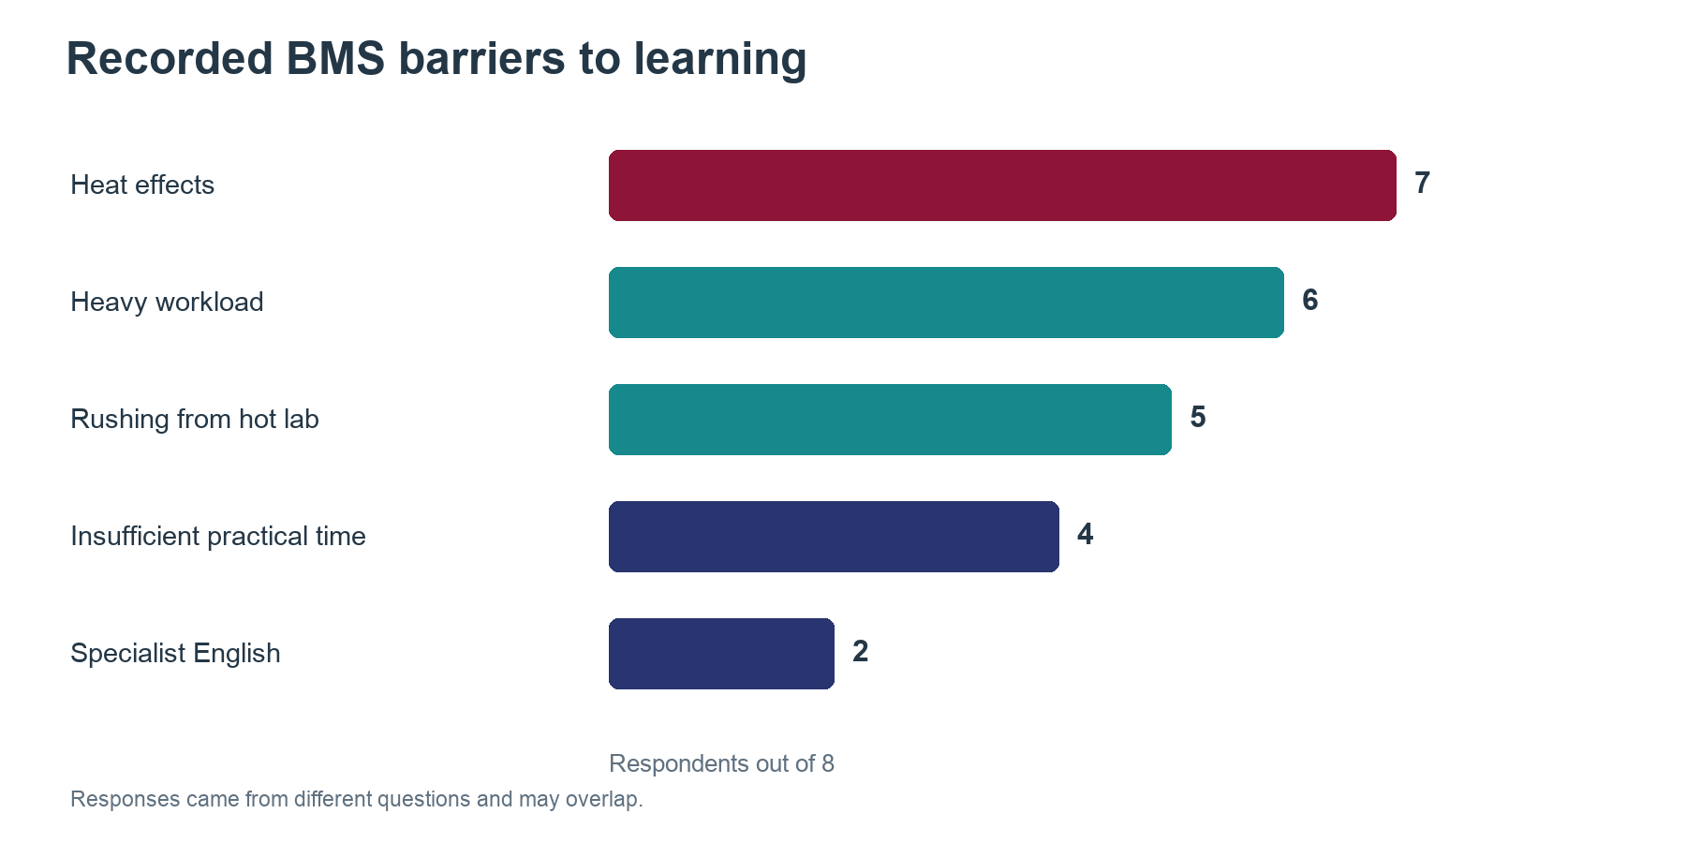
Figure 3. Recorded BMS barriers to learning
Source: BMS survey, n=8. Multiple responses permitted.
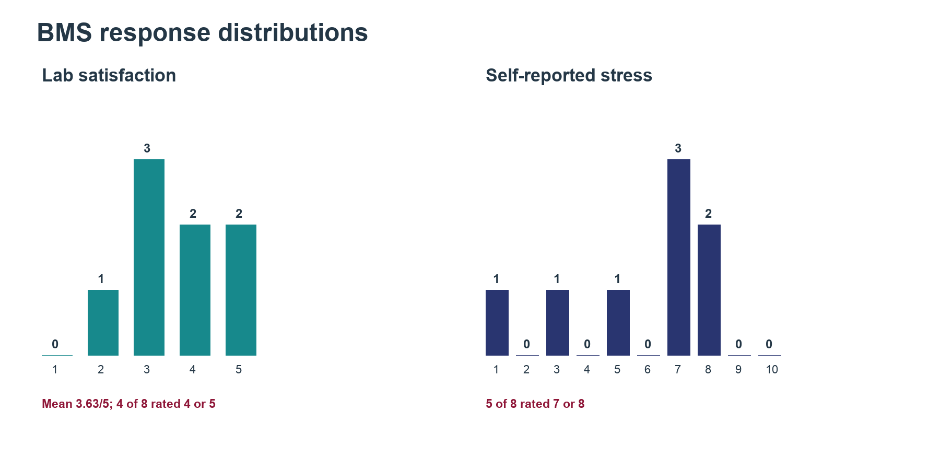
Figure 4. BMS satisfaction and stress distributions
Source: BMS survey, n=8. Historical baseline data.
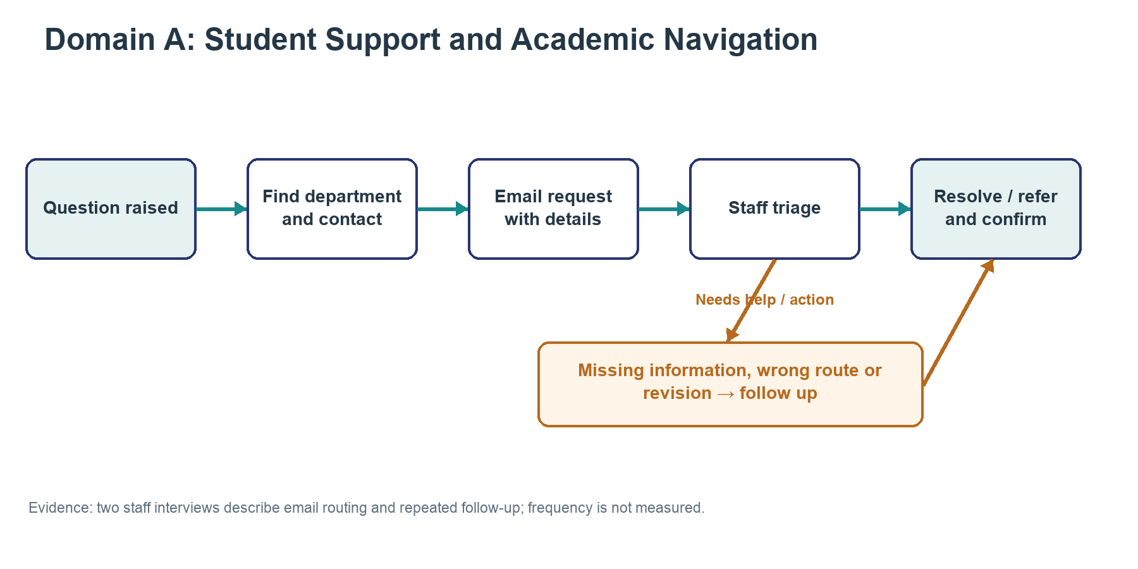
Figure 5. Student Support process map
Source: Reconstructed from two qualitative staff interviews; routing and repeat-contact rates are unknown.
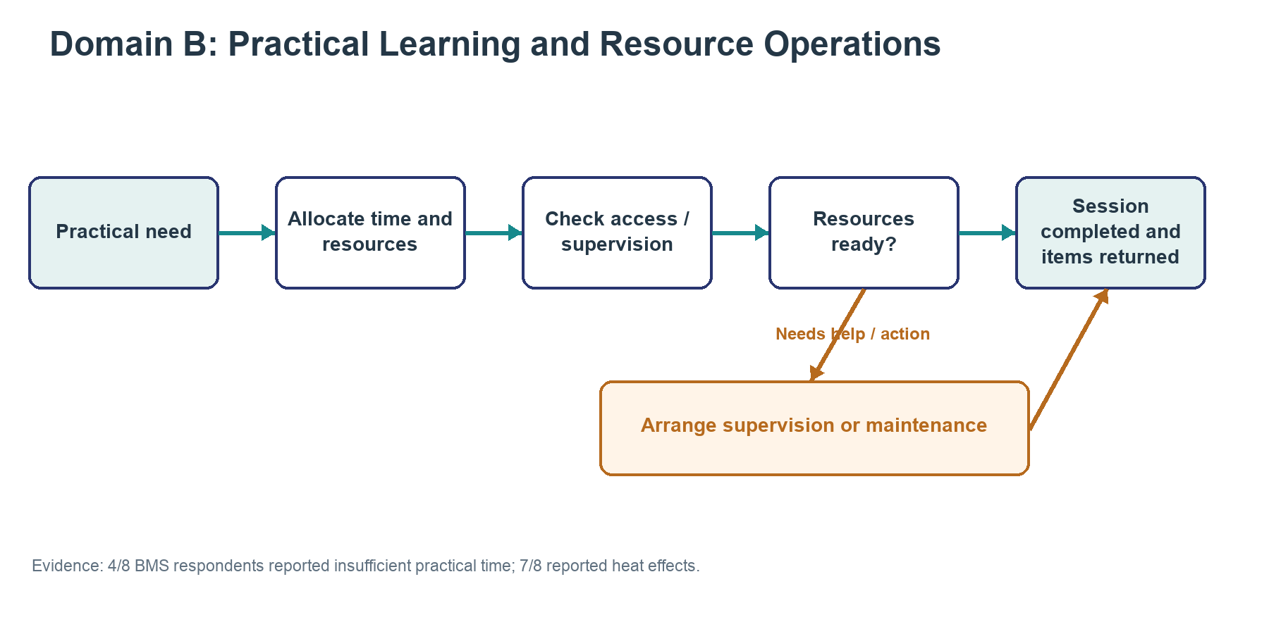
Figure 6. Practical Learning process map
Source: Reconstructed process for validation; survey counts describe n=8.
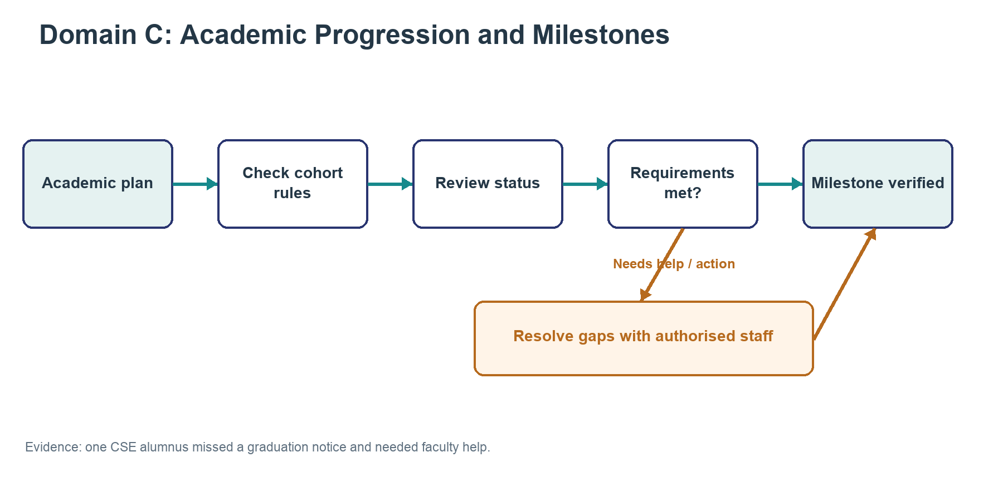
Figure 7. Academic Progression process map
Source: Reconstructed process for validation; individual interview evidence is not a population average.
For student support, the reconstructed journey is: a student identifies a need, searches for instructions, chooses a department and email address, sends the request, receives guidance or referral, and follows up until the task is complete. The October 2026 interviews indicate that routing is an important point of failure because a student may contact the wrong unit. Dispersed information, missing request details and unclear ownership can create repeated contact. A delay may also reflect case complexity, system dependencies or staff workload; the available evidence does not isolate their effects.
For practical learning, the journey begins with a learning need and proceeds through resource allocation, access and supervision checks, session completion and resource return. Reported insufficient practice may arise from scheduling, physical capacity or supervision. A digital booking interface alone cannot resolve shortages or heat. For academic progression, the journey checks cohort rules and milestone status, resolves exceptions and confirms completion. Unclear status and missed notices suggest coordination issues, but current error rates and responsibilities require validation.

3.4 Candidate Domains and Curated Shortlist
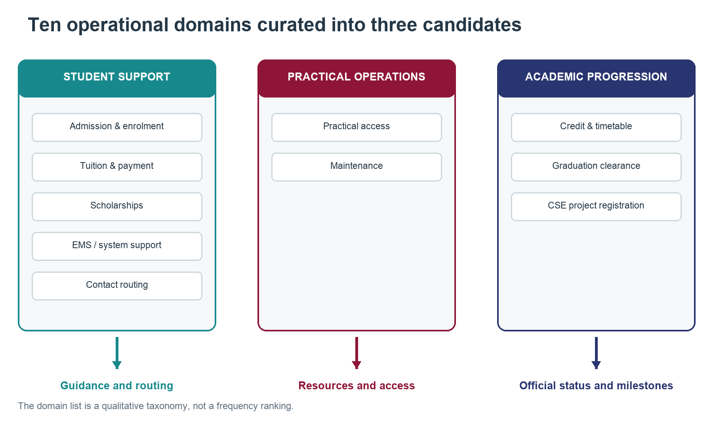
Figure 8. Operational domains and curated candidates
Source: Group 1 analytical mapping from Customer Experience research and two October 2026 staff interviews; categories are not frequency-ranked.
Ten operational domains were mapped before selecting broader candidates. This prevents choosing a technology before defining the outcome it should improve.
Operational domain | Intended outcome
Admission and enrolment | Required application or enrolment step completed
Tuition and payment | Correct payment guidance or Finance referral confirmed
Credit registration and timetable changes | Valid registration or exception route confirmed
Graduation registration and clearance | Requirements and exceptions resolved
Scholarship guidance | Eligible route, evidence and deadline understood
EMS and university-system support | Issue resolved or routed with required details
Department and contact routing | Request reaches the responsible unit
CSE project topic and supervisor registration | Topic, supervisor and required documents confirmed
Practical learning resource access | Practical session completed
Facility and equipment maintenance | Resource availability restored

Source: analytical mapping from Customer Experience project teams (2026a; 2026b) and two October 2026 staff interviews. The list is a qualitative taxonomy, not a frequency ranking.
Three candidates combine related activities. A, Student Support and Academic Navigation, owns guidance and referral from question to resolution across IBM, BMS and CSE. B, Practical Learning and Resource Operations, coordinates resources, supervision and maintenance through completed sessions. C, Academic Progression and Milestone Management, owns formal course, thesis and graduation checks. Support may explain a rule, but progression verifies a student’s official status. This boundary prevents counting the same benefit twice. Curriculum redesign, clinical counselling and major capital approvals are outside these candidates.

3.5 Capability Assessment
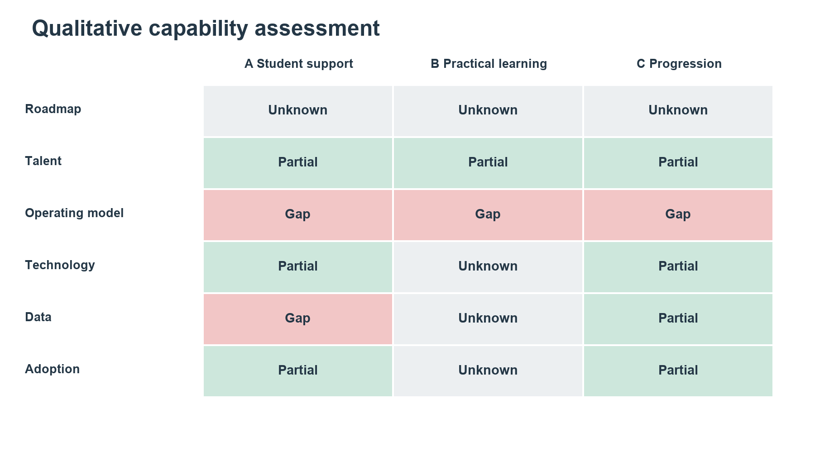
Figure 9. Capability assessment heatmap
Source: Group 1 qualitative assessment. Partial, gap and unknown are not maturity scores.
The six dimensions follow the Week 3 workshop. Partial means some capability is evidenced; gap indicates a reported shortfall; unknown means insufficient evidence. Ratings are qualitative judgments, not maturity scores (DBB43005 teaching team, 2026a). The staff interviews estimate approximately 17–18 administrative staff, five Finance staff and 70–80 non-teaching employees overall. These headcounts provide organisational context; they do not show how much capacity is available for the product.
Capability | A Student support | B Practical learning | C Progression
Roadmap | Unknown owner and targets | Unknown plan and funding | Unknown cross-unit ownership
Talent | Partial expertise; product capacity unconfirmed | Partial expertise, coverage unclear | Partial roles, delivery time unclear
Operating model | Gap in guidance and routing | Gap in access coordination | Gap in checks and follow-up
Technology | Partial channels, tracking unclear | Unknown tools and inventory | Partial portal, reported friction
Data | Gap in organised guidance | Unknown usage and capacity records | Partial records, quality unclear
Adoption | Partial and uneven use | Unknown shared workflow use | Partial with workarounds

Source: team assessment based on Customer Experience project teams (2026a; 2026b) and two October 2026 staff interviews. The assessment adapts the framework to student-service delivery: the most immediate dependencies are an accountable owner, allocated staff time, approved procedures and reliable process information. Estimated organisational staffing is not counted as committed product capacity. Proposed systems in earlier research are not counted as existing capability.

3.6 Consistent Prioritisation and Decision
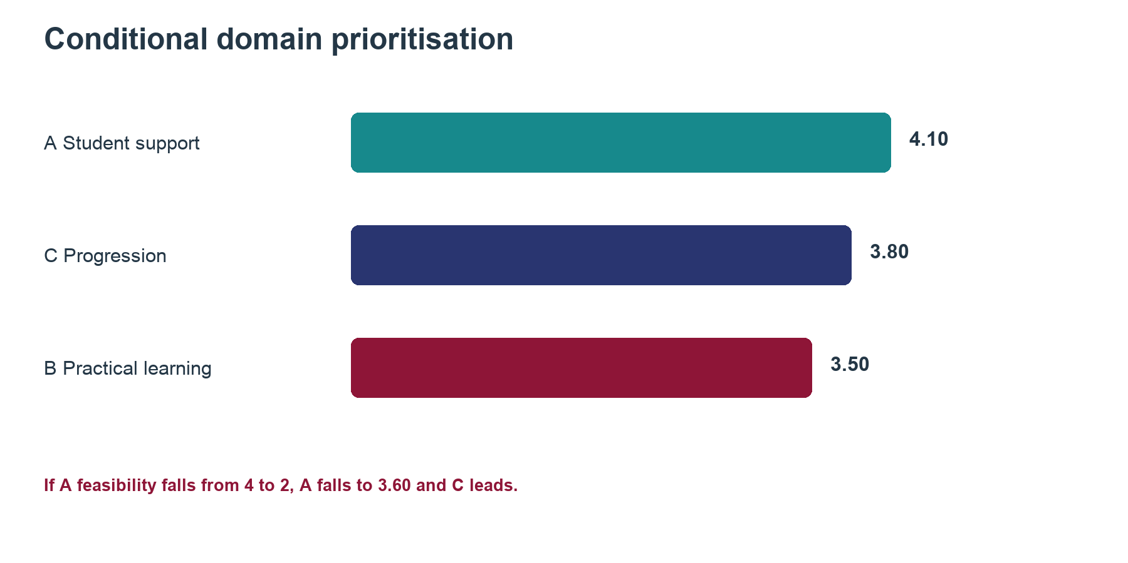
Figure 10. Conditional prioritisation results
Source: Group 1 proposed scores using the workshop weighting; scores are not measured ROI.
The workshop criteria assign 30% to value, 25% to feasibility, 20% to strategic relevance, 15% to urgency and 10% to learning. Scores range from one, low, to five, high. Value reflects the potential student and operational benefit. Feasibility reflects the dependencies of a bounded entry project. All candidates receive four for strategy and urgency because comparative leadership priorities and time-critical evidence are unavailable (DBB43005 teaching team, 2026a).
Criterion and weight | A Support | B Practical | C Progression
Value 30% | 4 | 4 | 5
Feasibility 25% | 4 | 2 | 2
Strategy 20% | 4 | 4 | 4
Urgency 15% | 4 | 4 | 4
Learning 10% | 5 | 4 | 4
Weighted total | 4.10 | 3.50 | 3.80

Source: proposed team scores, not survey results. Weighted total equals the sum of each score multiplied by its criterion weight.
Support receives higher feasibility because a guidance pilot can begin without integrating personal academic records. Its learning score reflects reusable content and routing practices. Practical learning faces physical-resource dependencies. Progression has broader potential value but requires authoritative records and approval processes. The October 2026 interviews strengthen the problem hypothesis by identifying email dependence, routing friction, seasonal peaks and repeated follow-up. They do not establish issue prevalence or financial value. The numerical separation should not conceal uncertainty: if A’s feasibility falls to two, its total becomes 3.60 and C becomes the leading candidate. We therefore select A conditionally, subject to named ownership, approved content and staff capacity. The strength of BMS complaints does not by itself establish that an AI support service addresses them.

4 Transformation Vision, Value Logic and Solution Portfolio

4.1 Vision and Future State
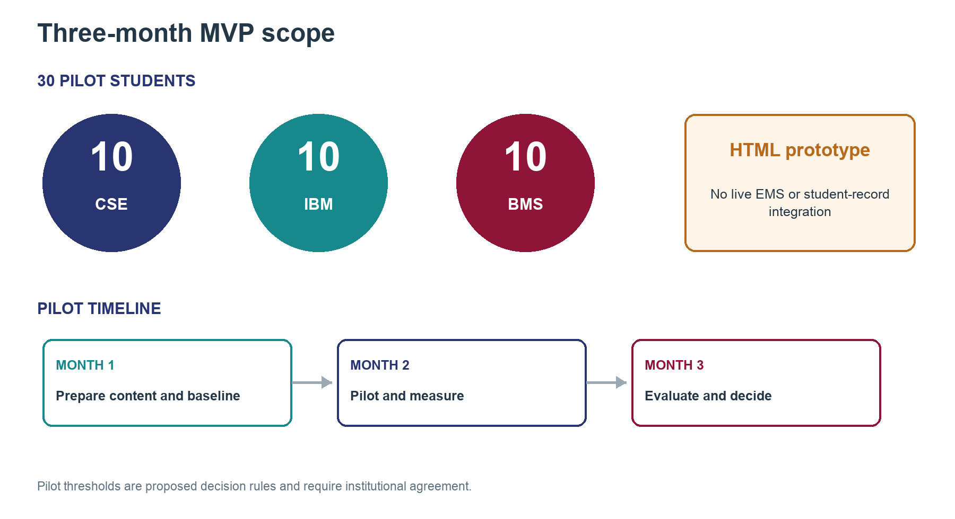
Figure 11. Three-month MVP scope and timeline
Source: Group 1 product proposal. The 30-student split and three-month duration are planned pilot parameters, not completed results.
The vision is a dependable VNUK student-support service where IBM, BMS and CSE students can find approved guidance, understand the next action and obtain staff help without repeatedly searching across channels. The future journey begins with a question and minimal programme context. The service retrieves relevant guidance, shows its source and explains the next step. If it cannot resolve the need, it routes the request to the responsible unit with the information needed for review. Authorised staff retain academic, financial and administrative decisions.
The first pilot covers common administrative guidance across all three programmes, using 30 students: ten CSE, ten IBM and ten BMS. CSE registration and project processes remain priority test cases because the existing research base is strongest there. For example, a student who asks whether course selection means registration is complete receives approved verification instructions. Without access to the official record, the service states that it cannot confirm live status and offers referral. The intended organisational change is shared content ownership and visible case responsibility, supported by technology.

4.2 Objectives and Value Logic
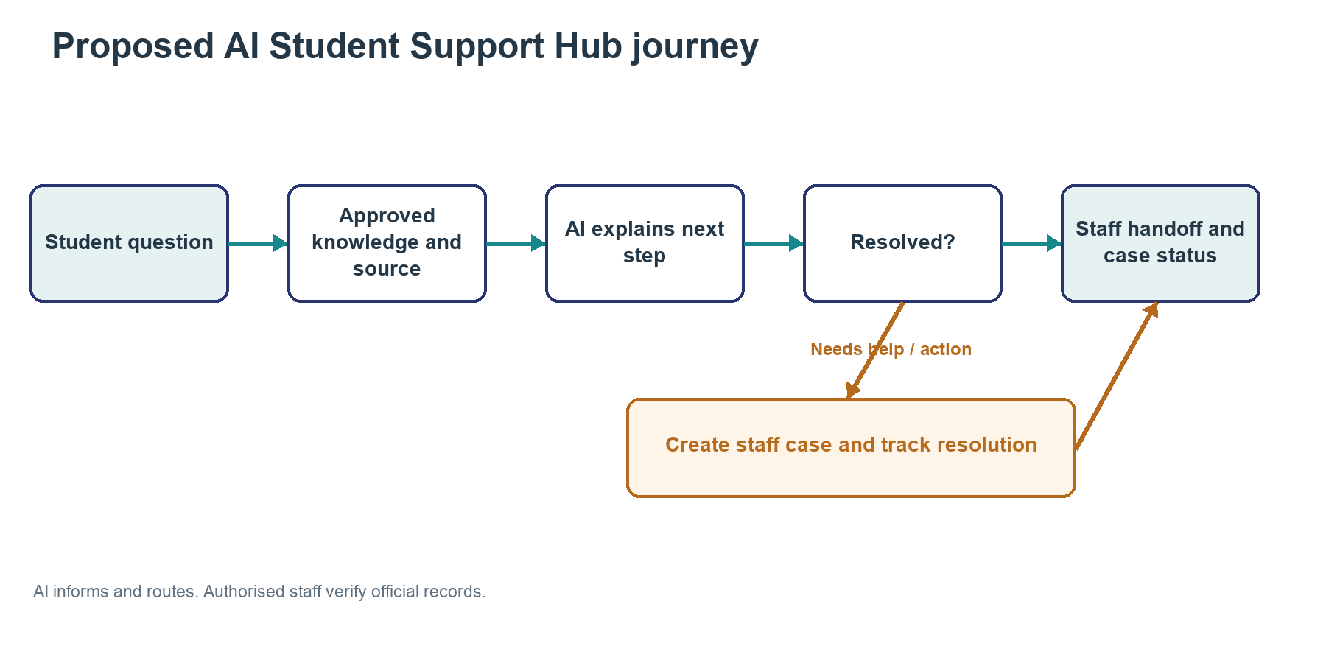
Figure 12. Proposed future-state student-support flow
Source: Group 1 proposal. Staff remain responsible for official records and decisions.
The proposed value chain is: maintained guidance improves answer consistency; clear checklists reduce avoidable confusion; accountable handoff supports resolution; and feedback identifies recurring process defects. Student value is less effort and uncertainty. Operational value is potentially less repeated contact and more staff time for complex matters. Educational and financial benefits remain hypotheses until measured.
Objective | Metric and baseline | Proposed pilot decision rule
Accurate guidance | Staff-reviewed correct answers / assessed answers | At least 95% on an approved test set of at least 100 cases; no critical wrong eligibility guidance
Correct routing | Requests sent to the staff-confirmed responsible unit | At least 80% during the early pilot
Lower student effort | Repeat-contact rate for the same issue within 7 days | Aim for a 20% relative reduction against comparable baseline cases
Faster resolution | Median time from request to confirmed resolution | Aim for a 20% reduction without increasing unresolved cases
Response guardrail | Substantive response where the current process allows | Within one working day; validate against operational data
Sustainable staff workload | Total handling and review minutes per resolved case | No increase after including content upkeep and escalation
Accountable content | Published items with owner, source and review date | 100% before student access

All thresholds are proposed team criteria requiring institutional agreement, not existing results or statistically established guarantees. Establish a baseline over a comparable normal and peak period before evaluating the pilot, using the same case definitions. Separate automated acknowledgements from substantive answers and confirmed resolution. Report case counts alongside rates. The staff estimate of a one-working-day general response is a service expectation, not a measured baseline. The proposed pilot lasts three months so the team can collect enough cases across programmes and observe at least one meaningful service period.

4.3 Coherent Solution Portfolio
Initiative 1 is an approved knowledge base and content governance process. Each entry needs an owner, applicable programme or cohort, source and review date. This is the first priority because it supports both ordinary search and AI. Initiative 2 is structured handoff and case tracking, with assigned staff and a defined closure condition. It addresses unresolved enquiries and should be tested with staff before student launch.
Initiative 3 is the guidance interface. The initial HTML prototype should test structured search and Wizard-of-Oz responses across common administrative topics, with CSE registration and project cases used as deeper scenarios. An AI layer may be added only after approved content and escalation rules are working. It should cite sources, request clarification when context is missing and escalate unsupported questions. Initiative 4 adds task checklists and, only where deadlines are verified, opt-in reminders. Initiative 5 is service analytics using aggregated enquiry categories and resolution measures to identify content gaps and recurrent process failures. Personal conversations should not become a general research dataset by default.
The portfolio sequence begins with content and ownership, followed by staff workflow, tested guidance, reminders and broader coverage. A searchable FAQ with the same staff handoff is the principal alternative. If AI does not improve task completion or effort enough to justify extra cost and risk, retain the simpler service. A full student-information-system replacement is outside the initial scope. BMS resource coordination remains a separate candidate requiring operational assessment, not an assumed extension of the support hub.

4.4 Assumptions, Dependencies and Implementation Path
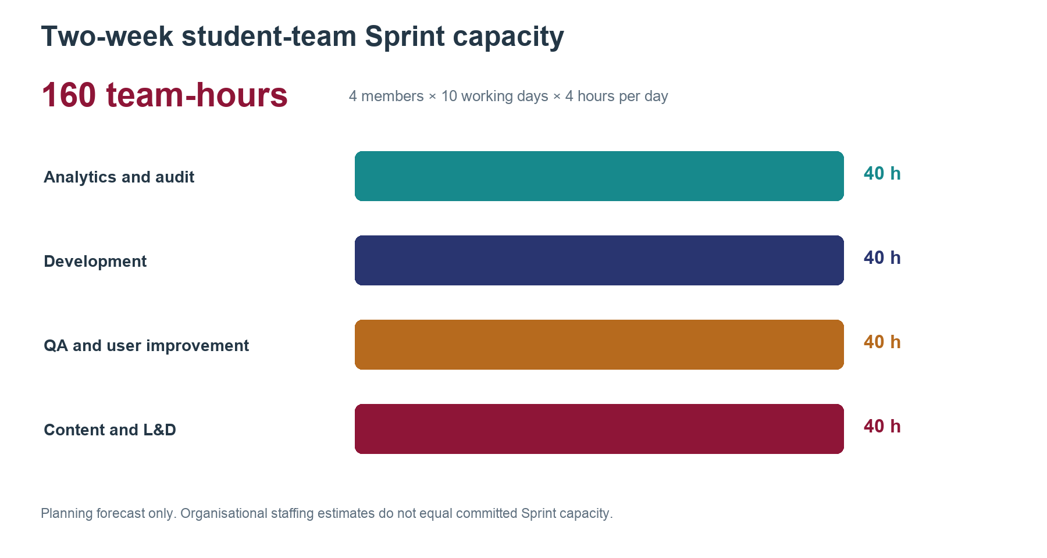
Figure 13. Two-week student-team capacity forecast
Source: Group 1 planning assumption: four members, ten working days and four hours per member per day. Organisational capacity is not inferred.
The proposal assumes that authorised service and programme representatives can approve guidance, that staff have time to resolve escalations and that a bounded set of common questions exists. Suggested reviewers are one CSE administrator and one Training Department representative, with IBM and BMS representatives reviewing programme-specific content. Administration is the likely service owner and IT the likely platform partner, but named accountability and availability still require confirmation. No access to personal records, paid vendor contract or IT integration is assumed to be approved.
The initial path has three gates. First, validate demand, nominate owners and approve a content set while measuring baseline service performance. Second, build and test the HTML prototype, routing workflow and guidance against staff-approved cases, including ambiguous questions and outdated-cohort scenarios. Third, run the three-month pilot with 30 students and evaluate the stated measures. Expansion requires useful outcomes, sustainable staff effort and an acceptable data-handling arrangement. Critical misleading guidance, inability to maintain content or unmanageable escalations should pause the AI component while preserving the knowledge base and staff support.
The student project team forecasts 160 hours for the first two-week Sprint: four members working four hours per day for ten working days. The planning allocation is 40 hours each for product analytics and audit, development, quality assurance and user-centred improvement, and content with learning enablement. This is a team forecast rather than VNUK staff capacity. Actual hours and completed acceptance criteria should be recorded at the end of the Sprint.

4.5 Initial Business Case
The two staff interviews do not provide enough evidence for a credible return-on-investment claim. Weekly enquiry volume, staff handling time, loaded labour cost, technology cost and implementation quotations remain unknown. The estimated 70–80 percent peak uplift describes relative demand only and cannot be converted into monthly volume. The initial business case is therefore a measurement plan rather than a savings forecast.
The pilot should record normal and peak weekly enquiry volume, category and programme, initial routing, repeat contact, response time, confirmed resolution time and staff handling minutes. It should also record content preparation, review, training, workflow configuration, hosting or model usage, maintenance and evaluation effort. These measures allow VNUK to compare an HTML guidance hub, an AI-assisted version and the current email journey using the same definitions.
Once the baseline exists, monthly capacity value can be estimated as eligible enquiries multiplied by the proportion resolved with less staff effort, avoided handling minutes and loaded staff cost per hour, divided by 60. Content-review and technology operating costs must then be deducted. This calculation estimates released capacity rather than automatic cash savings. Student time saved, improved routing and more consistent access should be reported separately from financial value.
The immediate decision is a small, supervised validation exercise. Institution-wide investment should wait for measured demand, cost quotations, sustainable staff effort and evidence that the AI layer improves outcomes beyond the simpler knowledge base and routing service.

References
Customer Experience project teams (2026a) Customer Experience module research on CSE student journeys. Unpublished interview records and project analyses, VNUK. Research conducted approximately December 2025 to January 2026.
Customer Experience project teams (2026b) Customer Experience module research on BMS student experience. Unpublished survey results and project report, VNUK. Research conducted approximately December 2025 to January 2026.
Group 1 (2026) Qualitative follow-up interviews with two staff members working in Admissions and Administration, VNUK, October 2026. Operational figures are approximate participant estimates; no repeat survey, administrative-log extraction or system-performance audit was completed.
NIST (2023) AI Risk Management Framework. Available at: https://www.nist.gov/itl/ai-risk-management-framework (Accessed: 14 October 2026).
UNESCO (2023) Guidance for generative AI in education and research. Available at: https://www.unesco.org/en/articles/guidance-generative-ai-education-and-research (Accessed: 14 October 2026).
VNUK (n.d.a) About VNUK. Available at: https://vnuk.udn.vn/en/about/ (Accessed: 14 October 2026).
VNUK (n.d.b) Biomedical Science. Available at: https://vnuk.udn.vn/en/major/biomedical-science/ (Accessed: 14 October 2026).

