**CODE:**

ODS HTML FILE="/folders/myfolders/sasuser.v94/Madhuri/Midterm2016.html";

DATA patel_madhuri_16230;

INFILE "/folders/myfolders/sasuser.v94/Madhuri/Midterm Raw Data for SAS Summer 2016.txt";

INPUT ID 1-6 Suffix $ 7-10 name $ 11-38 stream $ 39-43;

RUN;

PROC PRINT DATA = patel_madhuri_16230;

RUN;

ODS HTML CLOSE;

**LOG:**

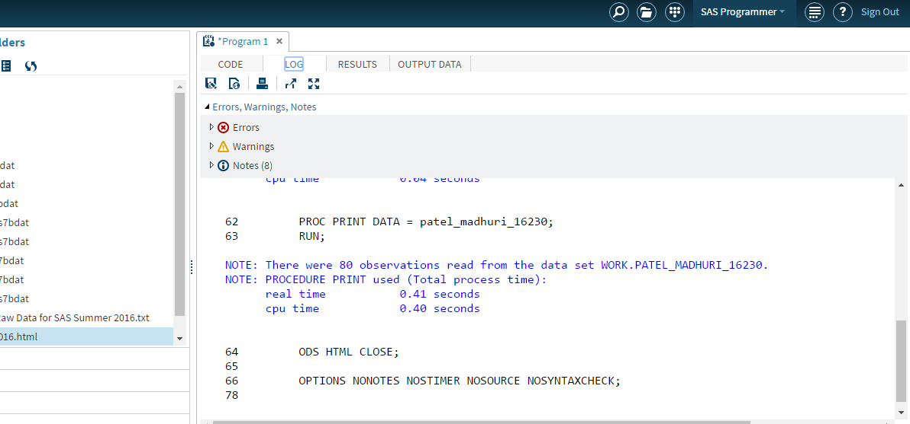

**RESULT:**

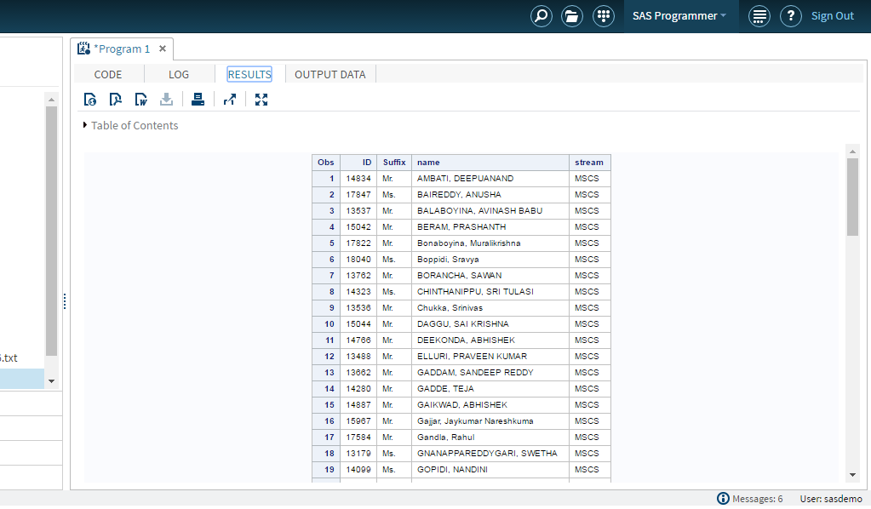

**HTML OUTPUT:**

