**ABB Java Development Training**

**Ant-Ivy-Spring MVC framework**

**Training Instructions**

1. ***Clone*** the ABB-JavaDev-Training001 source code from: <https://github.com/made-eka/ABB-JavaDevTraining-001>
2. Create a new ***Git branch*** on your local environment
3. Start working on that branch to complete the task (please refer to the **Task** and **Modifications** parts below)
4. When you finished the **Modifications**, ***commit-push*** your changes to Github
5. Create a new ***pull-request*** and assign: Made Eka (*made-eka*), Rizki (*rizkiabrar45*), and Kristianto (*kristiantoyanuar*) as the reviewers

**Task**

Execute the Ant task to perform WAR file deployment to your Standalone JBoss deployment folder.

If your WAR file deployment is successful.

* Start your JBoss Application Server on Standalone mode
* Open following URL with your web browser: <http://localhost:8080/ABBJavaDev-SpringMVC> or <http://127.0.0.1:8080/ABBJavaDev-SpringMVC>

Following **Welcome Page** will be presented.

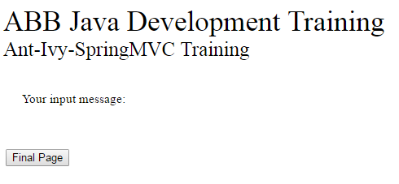

* Now type following URL: <http://localhost:8080/ABBJavaDev-SpringMVC/Guest> or <http://127.0.0.1:8080/ABBJavaDev-SpringMVC/Guest>

The page will display following message.

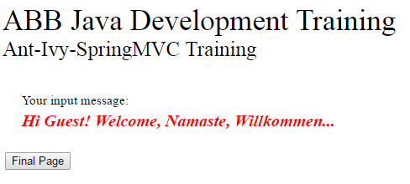

* Now click button **Final Page**. The screen will be navigated to the **Final Page.**

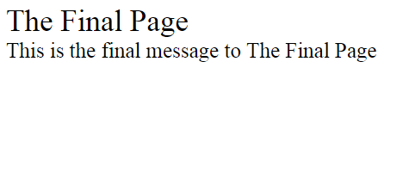

**Modifications**

1. Add new button: **Back** on the **Final Page**, so that if it is clicked, the screen will be navigated to the **Welcome Page.**
2. Create a new **.jsp** page named **Error Page**.

Any additional phrase typed by user on URL <http://localhost:8080/ABBJavaDev-SpringMVC> or <http://127.0.0.1:8080/ABBJavaDev-SpringMVC>

For instance:

<http://localhost:8080/ABBJavaDev-SpringMVC/Guest> or <http://127.0.0.1:8080/ABBJavaDev-SpringMVC/Guest>

Should navigate the screen to the **Error Page**.

Add new button: **Back** on the **Error Page**, so that if it is clicked, the screen will be navigated to the **Welcome Page.**

Good luck!

Regards,

-Made Eka-