TerraJ
Fractal Terrain and Stellar System Generation ports to Java
Version 0.2 beta
July 6, 2006
Copyright © 2006 Martin H. Smith
(martin at spamcop dot net)
TerraJ is released under the GNU General Public License

Contents
1 Introduction and FAQ 4
1.1 What is TerraJ? 4
1.2 What Might it be Used For? 4
1.3 What is Included? 4
1.4 What is Required to Run These Programs? 4
1.5 What License is TerraJ Released Under? 5
1.6 What about Contributions? 5
1.7 I Found a Bug ... 6
2 Credits and Original Sources 7
2.1 Stargen 7
2.2 Planetary Terrain Generator 7
2.3 Fracplanet 7
2.4 Other 7
3 The Launcher 8
4 Fracplanet Terrain Generator 9
4.1 Using Fracplanet 9
4.1.1 Initial Display 9
4.1.2 Tilting and Rotating 9
4.1.3 The Controls 9
4.1.4 Fly Mode and an Example 18
4.1.5 Saving and Loading Settings 26
4.1.6 Importing Settings 26
4.1.7 Save Screenshot 27
4.1.8 Rendering to POV-Ray 27
4.1.9 Rendering to Rings 28
4.1.10 JavaScript 28
4.2 Some Notes on the Fracplanet Source 30
5 Planetary Terrain Generator 32
5.1 Using the Program 32
5.1.1 Initial Display 32
5.1.2 The Controls 33
5.1.3 A Few Examples 35
5.1.4 Saving and Printing 37
5.1.5 Heightfield Output 38
5.2 Command Line Version 38
5.3 Some Notes on the Source 39
6 Stargen Stellar System Generator 41
6.1 Introduction 41
6.2 Using Stargen 41
6.2.1 Initial Display 41
6.2.2 Controls 42
6.2.3 Generating Systems 43
6.2.4 Solar System Details 45
6.2.5 Saving and Loading Parameters 46
6.2.6 Exporting HTML 46
6.2.7 Exporting Text 46
6.2.8 Exporting to Celestia 46
6.2.9 Custom Export with Templates 47
6.3 Some Notes on The Source 47
7 Dole Accretion Star System Generator 49
8 Notes on Building 50
8.1 Building The Project 50
8.2 Libraries Used 50
9 GNU General Public License 52

Introduction and FAQ

What is TerraJ?
TerraJ is a set of fractal terrain and solar system generation programs that have been ported from C/C++ to Java.
The port has included extensive refactoring, the creation of a documented API to enable reuse of parts of them in other programs and extensions to the originals such as new Swing user interfaces. Full javadoc for the classes in the project is available.

What Might it be Used For?
I hope that this software will be useful both for learning purposes and as part of other programs such as games and simulations. Go on, surprise me!
The updated user interfaces mean that everyone should be able to play around with it and the refactoring has aimed to separate out code that might be useful to other projects.

What is Included?
The TerraJ suite currently contains the following software:
- Fracplanet – Generates fractal planets and terrains with a wide range of user controlled parameters. Has an OpenGL rendering preview using JOGL and can export to POVRay format for rendering. Also includes experimental support for rendering with with the Rings raytracing engine, which is written in Java. Now includes Javascript control of the camera and rendering parameters.
- Stargen – Creates realistic planetary systems and stars using an accretion simulation. The resulting text and HTML output is template based and configurable.
- Planetary Terrain Generator – A second fractal terrain generation program. This one does not do 3D rendering but can output images using many different map projections.
- Dole Accretion – An older and slightly less complex star system generator included for reference and completeness.

What is Required to Run These Programs?
Most of the programs will run on any Java J2SE 1.5 runtime environment. Additionally to run Fracplanet you must have a platform that is supported by the JOGL OpenGL bindings library. This is currently Windows, Linux and OS X.
Some Linux systems will already have Java or you may have installed it to run other programs. To download a Java runtime for Windows and Linux go to: http://java.com/en/download/index.jsp.
To obtain Java 1.5 for OS X you will need to go to the Apple downloads site and search for the latest version.
To build and extend these programs you will need a suitable JDK. These can normally be downloaded from the same place as the JRE.
Note to run Fracplanet you will need to make sure the JOGL native libraries are available on your library path. The details of how to do this vary by platform. If you get an error that mentions UnsatisfiedLinkException then this is probably what is wrong.
Update: The program now attempts to extract the JOGL libraries from the jar file to the users home directory and load them from there. The files are then removed when the program exits. In most cases this should remove the need to specify absolute paths to native libraries, one of the biggest current annoyances in Java.
However, if these problems persist then the library directory property can be set explicitly from the command line. On Windows this might look something like:
java -jar stargen.jar -Djava.library.path=c:/java/projects/stargen/lib/natives-win32

On Linux it would probably be something like:
java -jar stargen -Djava.library.path=/opt/stargen/lib/natives-linux

Obviously the paths will depend on where the program has been installed.
To generate large terrains you may need to increase the amount of memory available to the Java runtime system. To do this include -Xmx=size in the options passed to java. For example -Xmx=512m allocates up to 512 Mb. If you do not increase the memory size appropriately then you may get Out Of Memory errors with large terrains. This is not a bug in the program, honest!

What License is TerraJ Released Under?
TerraJ is released under the GNU General Public License. This is one of the most widely used free software licenses. Everyone is welcome to modify and extend the software as it stands and I hope some people will find uses for it in their own applications. Disclaimer: There is no warranty with this software and you use it at your own risk. For full details consult the license text at the end of this document.
Note: The original code was issued under a variety of licenses and some of it predates the existence of standard software licenses. If you wish to use the original C code you should refer to the corresponding original source files and documentation to ensure compliance.
Note: The license terms used for this program include a custom exception to allow the use of various libraries under the terms of their respective licenses. The text of the exception can be found in every Java source file and you can find further information on this at the Free Software Foundation. I hope that when GPL V3 is released this issue will go away as it seems that it will be compatible with a wider set of licenses.

What about Contributions?
This is an open source project and contributions are welcome. Some of the things that would be good to have are:
- New features or enhancements to existing ones
- Better integration of the programs
- Details of software that should be added to this collection, whether or not a Java version already exists.
- More Junit test cases. There are some but it was just too much work to write them for all the code. Help would be appreciated here.
- Fixes for the actual issues reported by Checkstyle, as opposed to the noise it generates.
- A reason why Jalopy won't format the source code any more. It used to work, now it just throws NullPointerExceptions.
- Advice on fixing the Jalopy formatting. It creates some really ugly results on long lines and I can't see how to set the options correctly to avoid this.
- Offers of collaboration from the authors of related software

I Found a Bug ...
I'm sure there are quite a few. Its pretty unlikely to release 60,000 lines of code and for there not to be any problems with it. Testing this sort of application is quite hard both because of the complexity and because most of the output is based on things that are generated randomly.
If you do find problems with it then let me know, particularly differences from the ranges of values produced by the C code for programs like Stargen.

Credits and Original Sources
These programs would not have been possible without the work of those who produced the original versions. I would like to thank them for making the source code of their work available and the inspiration it gave me to complete this project.

Stargen
Stargen was originally written by Jim Burrows. The main page for information and downloads of the C version is:
http://home.comcast.net/~brons/NerdCorner/StarGen/StarGen.html

Planetary Terrain Generator
The original version was written by Torben Ægidius Mogensen with contributions from Jim Burrows. Their pages are:
http://www.diku.dk/users/torbenm/
http://home.comcast.net/~brons/NerdCorner/Planet.html

Fracplanet
The C version was originally written by Tim Day. The home page including links to the source code is at:
http://www.bottlenose.demon.co.uk/share/fracplanet/index.htm

Other
Thanks to Stephen Manley for the original C++ version of the OpenGL Camera class that has been ported to form part of this application.
Thanks to Mike M for making changes to Rings to improve the support for rendering large terrains. I'm sorry I haven't managed to get a properly working version of Rings support in this release and I hope to do so soon.
Thanks to the people behind FreeMarker for coming up with a template library that did exactly what I needed. When I started I'd assumed I'd have to write a lot of tedious code for formatting but it's all in the template, including the maths for converting units.
Thanks to the other library authors who provided useful functionality and made this easier to write. A list of the libraries used appears in section 8.2.

The Launcher
When you start the program by running the main jar file. It will bring up the launcher window that allows any of the three main programs to be started. It will look something like this (maybe a bit different depending on your platform).

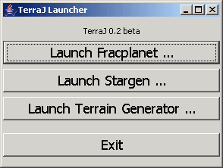
Pressing the buttons starts the corresponding program, which will start in a new window. There is a section in this document detailing how each of these programs work.
If you start the program from a script, batch file, link, shortcut or whatever terminology your platform uses you can start the programs directly by including their name on the command line or target of the link. E.g something like java -jar stargen.jar fracplanet will start Fracplanet directly instead of bringing up the launcher window.

Fracplanet Terrain Generator

Using Fracplanet

Initial Display
On starting the program the terrain viewer will appear and generate a planetary terrain using all the default parameters. Assuming all the OpenGL initialization etc. is successful then a window will appear that looks similar to the one below. Note the screenshots below were taken on Windows or with the cross platform look and feel, but the program will look very similar when running on Linux, and presumably on OS X though I have no way to test this.

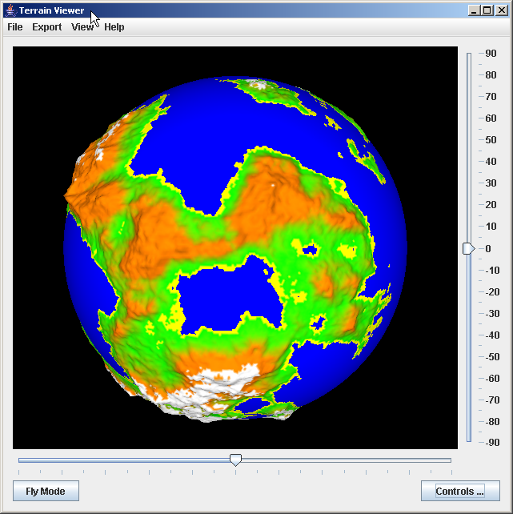
The program operates in two basic display modes. The default when the program starts is in Control mode. The other mode is Fly mode, which gives you a free camera over the rendered terrain.

Tilting and Rotating
The sliders allow the terrain to be tilted or to set it rotating. The slider at the right tilts the planet up or down. The slider at the bottom starts the planet rotating in either direction. Drag it further to each side to increase the rotation speed.

The Controls
Pressing the Controls button at the bottom right will bring up the dialog that lets you control all the terrain generation and display parameters. In this section we will walk through all the options. The first tab of it will look like this.
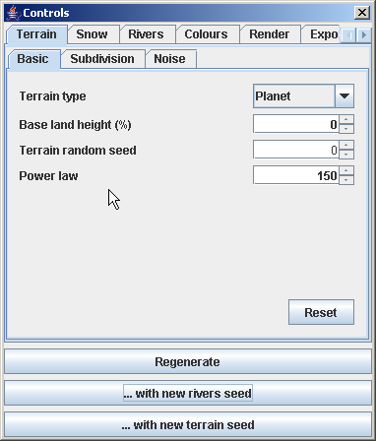
The parameters on this basic page let you generate either a planet or a flat terrain of several shapes, adjust the base land height, change the terrain seed and power law used to generate the terrain. All the pages have a reset button that will reset the values on that page to their defaults.
To generate a different terrain you need to change the random seed. Pressing the regenerate button uses the current values, the other two buttons do the same but after incrementing either the terrain or rivers (see later) seed by one.

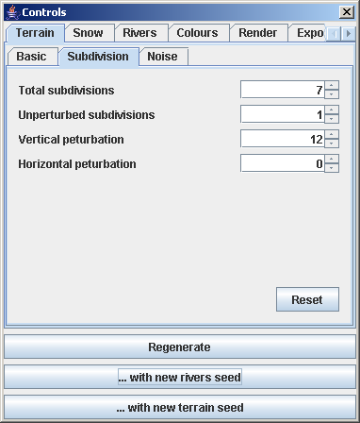
The parameters on the subdivision page control the level of detail that will be used in the terrain and the amount of randomness it has. Increasing the number of subdivisions will increase the detail level of the terrain but will increase the time it takes to generate and the amount of memory consumed in doing so. Note because this is a fractal generation process you can work at a low detail and then increase the detail for export.
The number of unperturbed subdivisions is the number that will be carried out without adding randomness. This is typically set to one.
The perturbation parameters control how much randomness is applied to the terrain vertices at each subdivision.
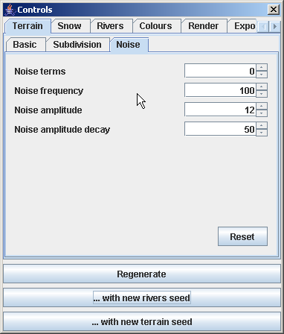
The noise parameters allow additional randomness to be added to the terrain via Perlin noise functions, which can increase realism. Noise is off by default. To enable it, increase the number of noise terms above zero and adjust the other parameters as desired.
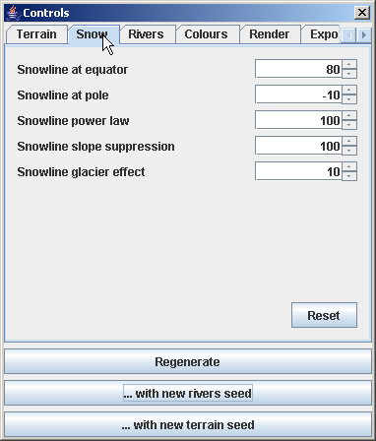
The snow settings control how snow is generated. The snowline heights are percentages. The slope suppression parameter breaks up snow on steep slopes. If the glacier effect is set to a positive value then rivers will tend to freeze up.
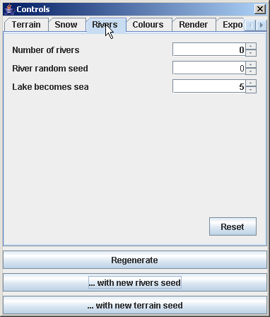
Moving on to the rivers tab. These are off by default. To enable them increase the number of rivers above zero. The random seed controls river generation and the lake parameter sets the percentage of the terrain that will be considered an inland sea if a lake arises during river generation.
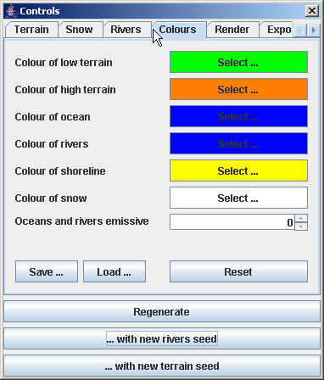
The colours tab controls the colouring of the terrain after generation. Clicking on each colour will bring up a standard colour picker that will allow it to be changed. Enabling the emissive parameter will allow for lava type effects to be created as it will cause the 'water' to emit light (the parameter is set on a scale of 0-100%). This may slow down rendering on some OpenGL implementations.

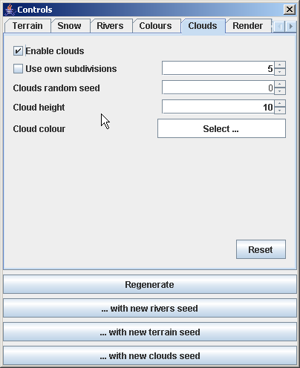
The clouds tab allows an alpha blended clouds layer to be added to the planet. By default this mesh will be subdivided to the same level as the terrain but this can be over-ridden with the 'use own subdivisions' check box. The height and colour of the cloud layer can also be selected. The clouds are generated from their own seed, which can be specified here. The following image shows an example of the result with the above parameters.

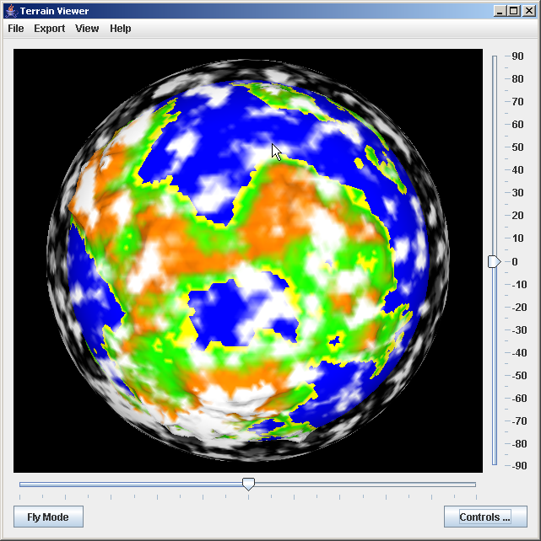
Moving on to the render tab next as shown below.

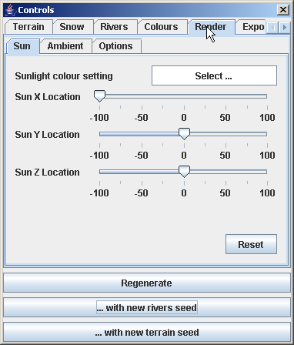
The rendering options comprise three separate panes. The first of these controls the position of the sun in the render and its colour. Drag the sliders to change where the sun is. Suitable positioning can create some nice looking shade effects. To make these work it is normally necessary to reduce the ambient light in the scene.

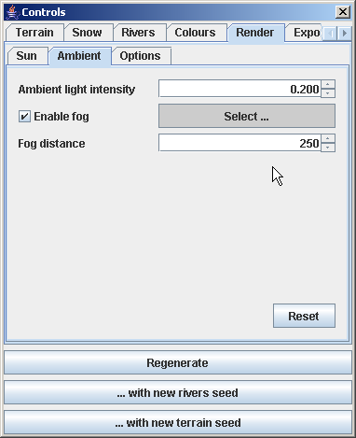
The ambient page controls the amount of light in the scene. Fog can also be enabled and coloured from this page. This fog is useful when rendering flat terrains as it hides the edges of the terrain a well as increasing realism.
Experimentation will be needed with fog distance and there are currently problems with this in relation to the rendering export due to different fog models. The amount of fog you get in a POV render may not exactly match that seen on screen in the OpenGL preview.
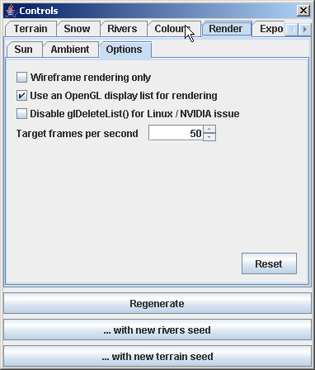
The rendering option page contains a couple of controls. Turning on wireframe rendering will display the underlying vertices. Using a display list can increase the performance of rendering on some systems.
The disable glDeleteList() is a workaround for the combination of Linux and Nvidia OpenGL where calling this function seems to crash the program. This will be enabled by default for that particular platform combination. Turning it off manually may cause the program to crash. A better solution may become available in future.
The target FPS controls the display animation. The viewer will attempt to maintain this number of frames per second at all times. If your system is slow or has a software OpenGL implementation then it may be advisable to reduce this value.
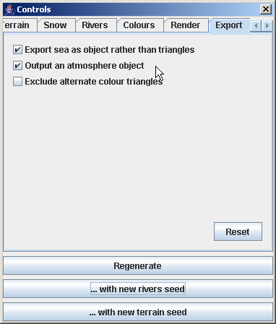
The export page controls rendering export for POV ray. A controls page for Rings rendering will be added in the next version.
If the 'export sea as object' option is enabled then the sea triangles will not get exported, a sphere or plane will be used to represent the water at sea level. This can speed up rendering.
To get atmospheric effects turn on the second option. This will export a translucent sphere to represent the atmosphere.
The final 'exclude alternate colour' option is not currently used.
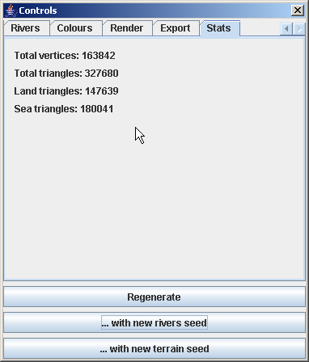
The stats page simply displays the number of vertices and triangles in the current terrain mesh. The image above was with seven subdivisions. The size of the mesh increases quite rapidly when the number of subdivisions is increased.

Fly Mode and an Example
This section demonstrates fly mode and provides a few basic examples of changing terrain parameters. To begin with start from a default startup set of settings and change the terrain type under the basic tab to a hexagonal terrain. On regenerating the terrain and setting the tilt slider to around +fifty the display should look similar to the one below.
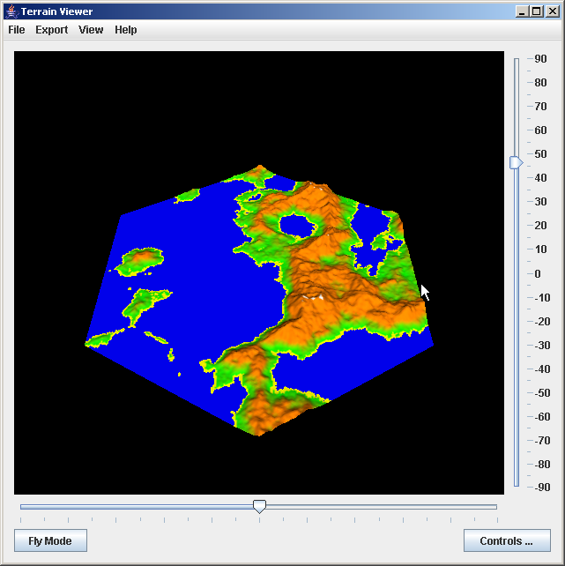
Now press the Fly Mode button. This will cancel the tilt / rotate slider settings and you will see the display below, proving that the terrain is actually on a plane rather than a sphere.
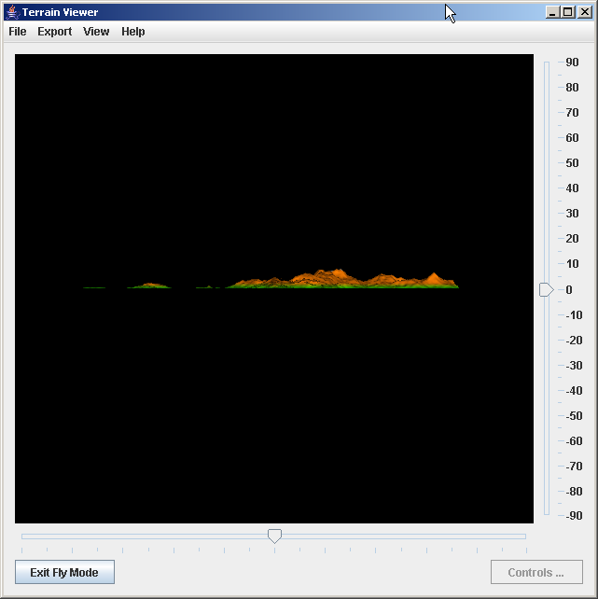
From the View menu you can bring up the list of camera movement keys that are available in this mode.
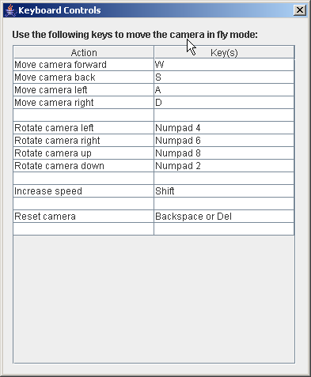
Hold down the '2' key on the numeric pad (you may need to turn on NumLock first) to rotate the camera so you can see the terrain properly. Now use the camera movement keys (W, A, S, D) to position the camera so you get an interesting view of the terrain, perhaps something like the one shown below.
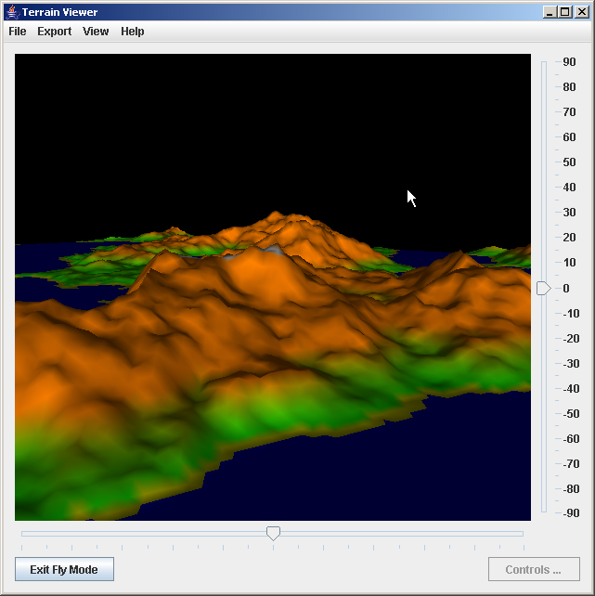
If you get the camera to an interesting position then you can save it for future use. Bring up the camera positions dialog from the View menu.
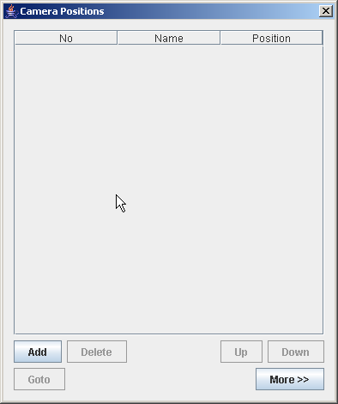
And press the Add button to save the current position of the camera.
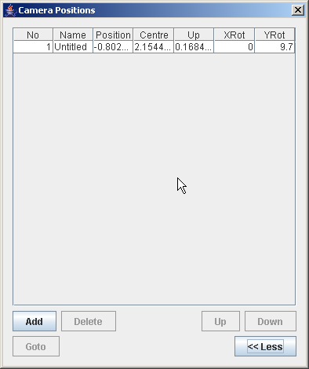
Toggling the More / Less button displays all the camera rows. You can edit the name of the camera position by double clicking this column.
Hit the delete key to reset the camera. Now select the first row on the camera dialog and press 'Goto'. The camera should jump back to your saved position. You can save additional camera positions in the same way.
Now exit Fly Mode with the button at the bottom left and go to the ambient rendering settings page to enable fog as shown.

This should produce an image like the following one.
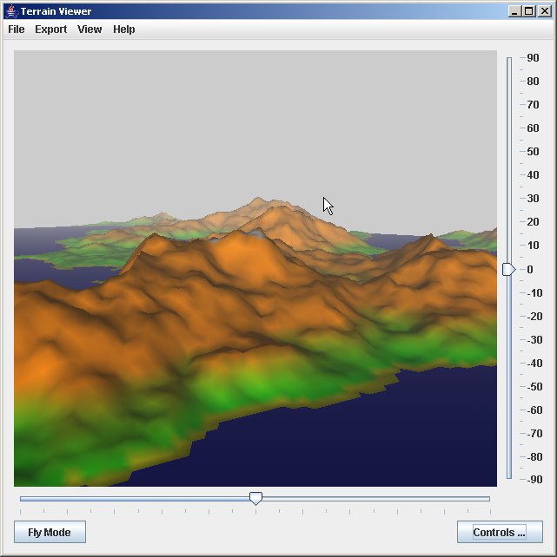
To see the underling terrain mesh switch on the wireframe option. This will give something like the following (note: fog was turned off in this capture)
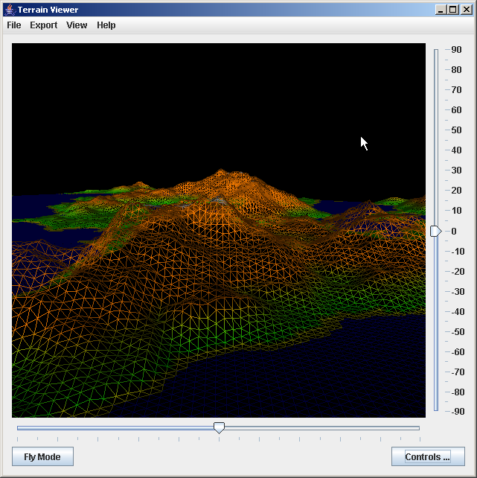
Now change the sun to be red using the colour controls.
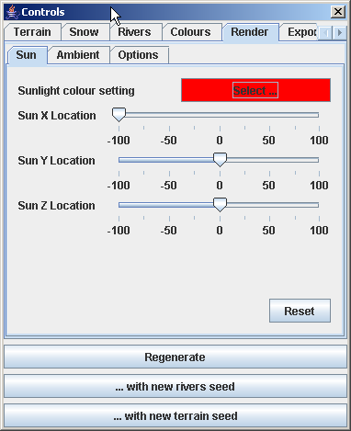
The result should be something like the image shown below.
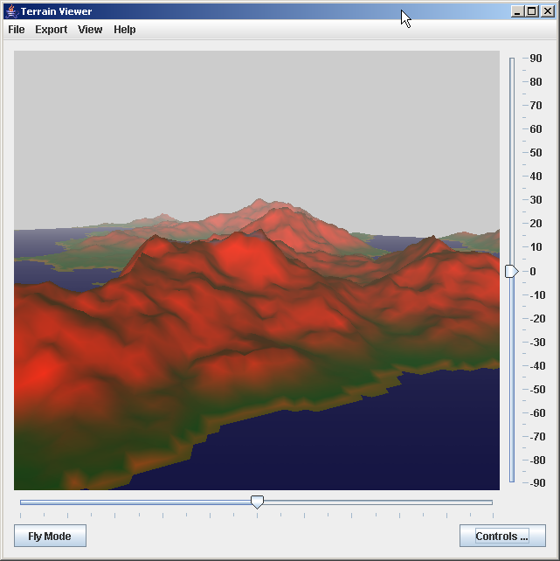
To get a more other-worldly effect make the fog a pink or purple colour from the appropriate settings page.
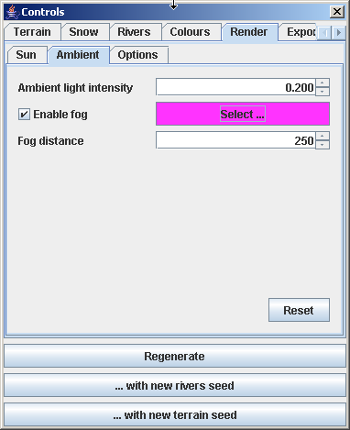
This should give a scene that looks similar to the one below.
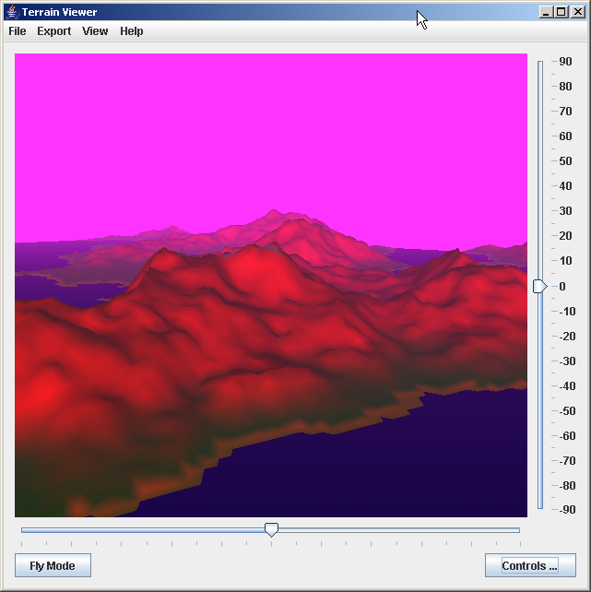

To see what this looks like as a planet change the terrain type back to Planet in the basic settings tab. Then reset the camera position by pressing Delete while in Fly Mode and then press the regenerate button. The result will be something like the next image.

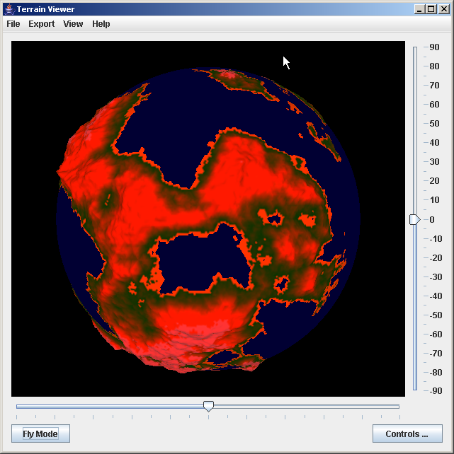

Saving and Loading Settings
The File menu allows the current settings to be saved for future use. This includes all terrain and rendering parameters and saved camera positions. The settings are saved to an XML document using standard Java bean persistence. It would be possible to generate these documents by other means if required. The document format is not complex as the parameter objects are simple beans.

Importing Settings
You can import selected settings from a previously saved XML document created by the program. After selecting this option from the menu you must first pick a file.

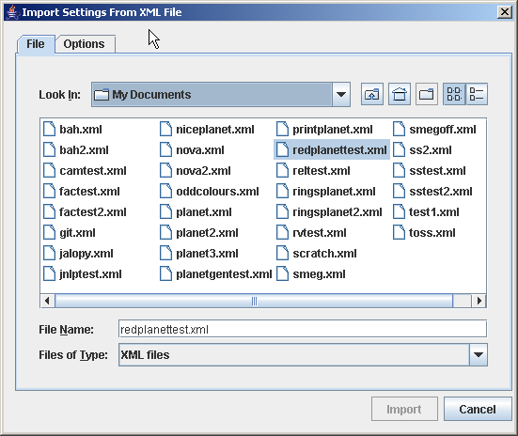
Next you must specify which values are to be imported. This is done on the second tab of the import form.
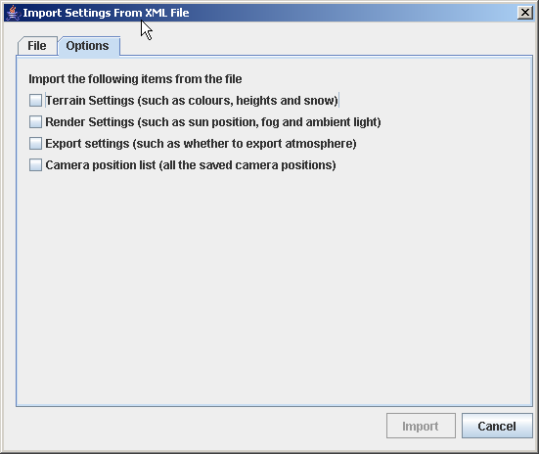
The categories you select will be brought into the current session when the Import button is pressed. This will overwrite any changes you have made. For example if you import the camera positions from a previous project then you will lose any you have created in the current session and not saved somewhere else.

Save Screenshot
You can save the image shown in the window by using the appropriate option in the Export menu. The saved file can be in any of the Java ImageIO formats (chosen by extension) so this can be .JPG, .PNG or .BMP.

Rendering to POV-Ray
This option on the export menu causes a script to be generated that can be used to create a high quality terrain render in POV-Ray. Note that the camera position and fog settings may not be an exact match due to differences between the ray tracer and OpenGL. You may have to do some experimenting to get everything correct. This is being investigated for future versions and will hopefully be improved.
You can download POV-Ray from http://povray.org
An example output render from POV-Ray is shown below.
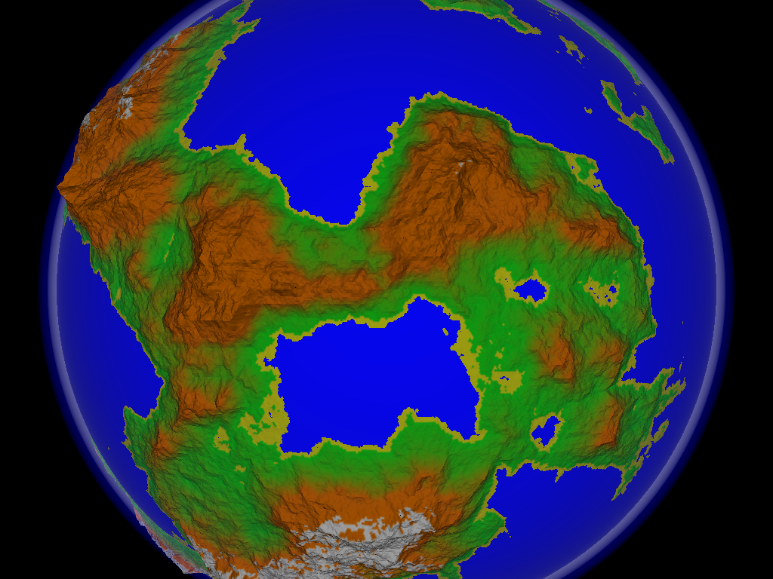

Rendering to Rings
This is currently included as a proof of concept only and is not currently intended for production use. Rings looks very promising though and full support will be introduced in a later version, allowing detailed renders to be produced without additional software.

JavaScript
A version of the Mozilla Rhino JavaScript interpreter is included. This allows the user to write scripts to control some aspects of the terrain, rendering parameters and camera. This functionality may be extended in future versions.
To bring up the JavaScript console use the option on the View menu. This presents the same interface as is exposed to scripts so you can type commands in here to see what they do.
To run a previously prepared script use the option on the File menu.
There are five top level objects exposed to JavaScript. These are camera, mesh, cloudMesh, params and control.
The parameters object is an instance of AllFracPlanetParameters and is a bean that holds all the properties available via the GUI settings dialogs. Refer to the class javadoc for the full list of settings.
The control object provides a few useful utility functions. These methods are:
- recolour(). This will apply the current colour scheme to the terrain and is needed if heights have been changed.
- forceRedraw(). This will discard any OpenGL display list and force it to be rebuilt. This is needed if the terrain is changed.
- rebuild(). This will cause the terrain to be regenerated using the current parameters.
The camera object allows the camera to be modified. It is an object that implements the Camera interface. Refer to the full javadoc for details of this class.
The mesh object is an instance of TriangleMesh. Refer to the javadoc for the full list of methods that can be called on this object.
The cloudMesh object is also a TriangleMesh. If there was no clouds layer enabled when the terrain was generated then this object will be a dummy that contain zero vertices and zero triangles. This can be tested within a script.
The following example script moves the camera and then puts it back after a delay:
camera.moveBackward(-0.5);
java.lang.Thread.sleep(2000);
camera.moveBackward(0.5);

The following example changes each triangle in the terrain to a random colour:
var vertices = mesh.getVertexCount();

for (var v = 0; v < vertices; ++v)
{
mesh.getVertices().get(v).
setColour(0, Math.random(), Math.random(), Math.random());
}

// now we need to make sure the display is updated and using
// correct colours for the new altitudes.

control.recolour();
control.forceRedraw();

The following example script will pertub the terrain by a random (though large) amount when it is run.
var vertices = mesh.getVertexCount();

// loop over the current vertices

for (var v = 0; v < vertices; ++v)
{
// get and update the height

var h = mesh.getVertexHeight(v);

var p = Math.random() - 0.5;

mesh.setVertexHeight(v, h + (p / 50));
}

// now we need to make sure the display is updated and using // correct colours for the new altitudes

control.recolour();
control.forceRedraw();

Some Notes on the Fracplanet Source
One of the aims of this project is to make the functionality usable by other software. In the case of Fracplanet the rendering is separate from the terrain generation. It is straightforward to generate a terrain mesh for use by other software or rendering pipelines.
There is full javadoc available for all the code and it is split into a logical set of packages. These notes are meant as an aid to help people get started.
There is a bean object that holds all the terrain parameters defined in the TerrainParameters class. One of these needs to be created and populated by whatever mechanism is desired.
Once this has been done the parameters can be passed to the constructor of the appropriate flat or spherical terrain object. There is an example class in the source distribution that shows how to create a terrain called TerrainExample. The following is an extract from this example to illustrate how simple it is:
final TerrainParameters tp = new TerrainParameters();
final Progress p = new DummyProgress();
final MathUtils utils =
new MathUtils(new Random(tp.getTerrainSeed()));

// set any options you like on the parameters object. These
// are just examples

tp.setSubdivisions(DEFAULT_SUBDIVISIONS);
tp.setOceansAndRiversEmissive(0.0f);

// uncomment one of the following lines to generate a flat or
// spherical terrain

//final TriangleMeshTerrainPlanet terrain =
// new TriangleMeshTerrainPlanet(tp, p, utils);

final TriangleMeshTerrainFlat terrain =
new TriangleMeshTerrainFlat(tp, p, utils);

Code in the shell package may be useful to other programs using Rhino. This is a modified version of the console that behaves better as part of a larger application.
In the render package is a set of classes that implement an abstract Camera class and then one specialized for rendering using JOGL. This is a port of the OpenGL Camera class originally written in C++ by Stephen Manley. You can get the original code from his website at: http://www.nyx.net/~smanley/graphics/opengl.html along with many other interesting OpenGL things.
The rendering also serves as a fairly complex JOGL example with the use of display lists and using java.nio buffers to pass application objects directly to OpenGL.
The geom package includes a vector maths library that may be useful for other purposes, as well as all the terrain mesh objects.
The FileUtils class has a couple of methods for adding and changing file extensions.
The EnumDelegate class shows how to save and load Java 1.5 Enum values via the standard XML persistence mechanism.

Planetary Terrain Generator

Using the Program

Initial Display
On starting the planetary terrain generator a window will be displayed that should look similar to the one below. It may vary in appearance on different platforms.
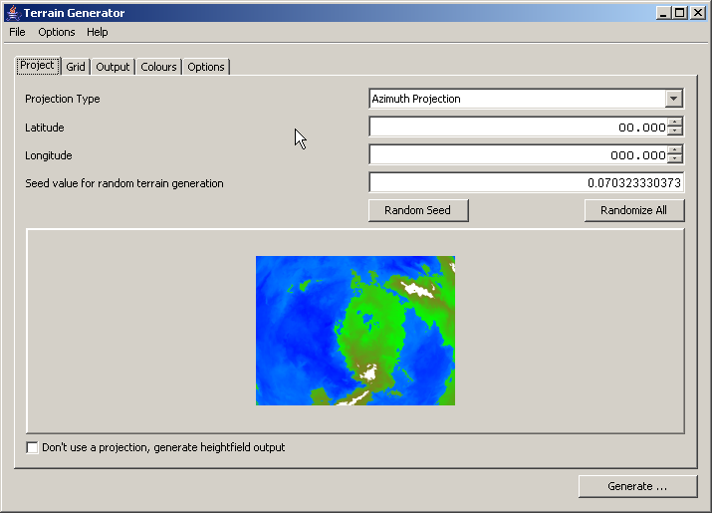
The basic mode of operation is to set up the parameters on the pages and then press the Generate button to generate a new fractal terrain.

The Controls
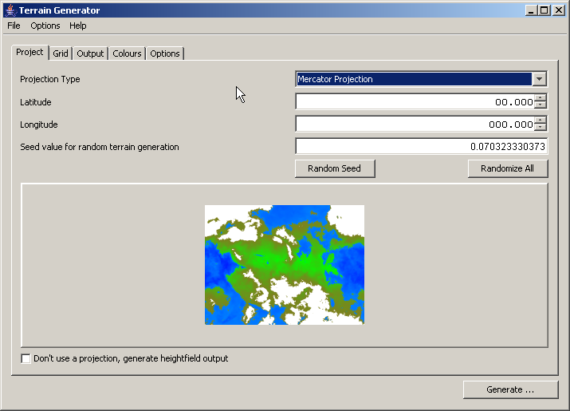
This section will walk through the parameters that can be set. Starting with the projection parameters in the screen shown above. There are many available map projects, when one is selected the preview image will change to illustrate the projection. This preview doesn't show how your terrain will turn out, its just meant to demonstrate what the projection looks like. An article explaining map projections can be found at: http://en.wikipedia.org/wiki/Map_projections
The latitude and longitude parameters allow the centre of the region being projected to be changed.
The terrain seed is the initial value for the random number generator. If the same value is used here then the same terrain will be generated. Either just the seed or all the parameters on this page can be randomized by pressing the appropriate button.
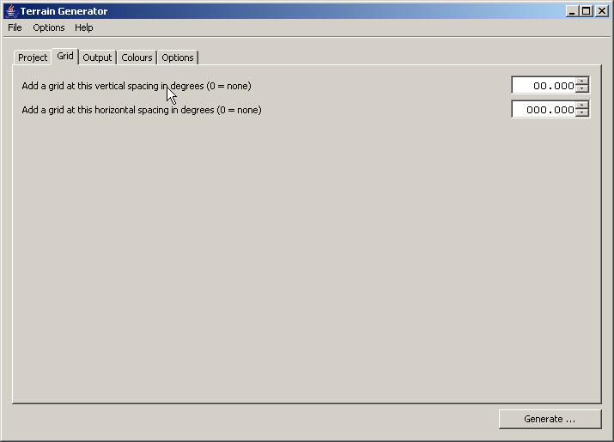
Instead of generating an image output you can obtain the raw height data. Enabling this check box disables the projection option. There are more details on this in section 5.1.5.
The grid page allows a grid to be superimposed on the terrain at the given interval in degrees either horizontally, vertically or both.
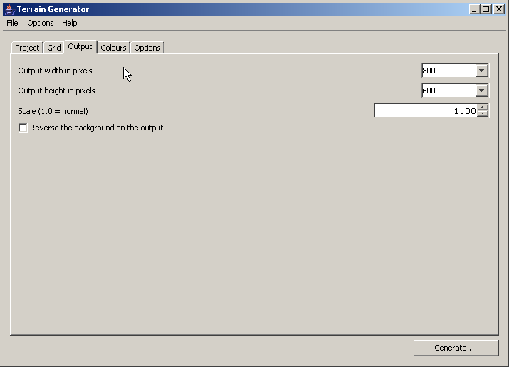
The output page allows the size of terrain to be configured and also the scale. Values larger than 1.0 will zoom into the terrain. If the check box is selected the the background will be made white, rather than the default black.
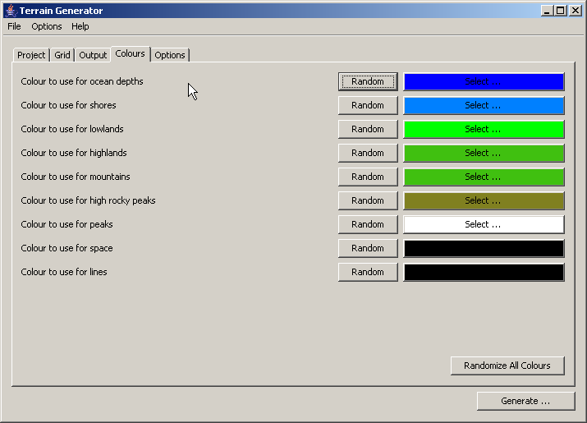
The colours page allows all the colours used to be configured. Colours can also be individually randomized or a completely random colour scheme can be used.
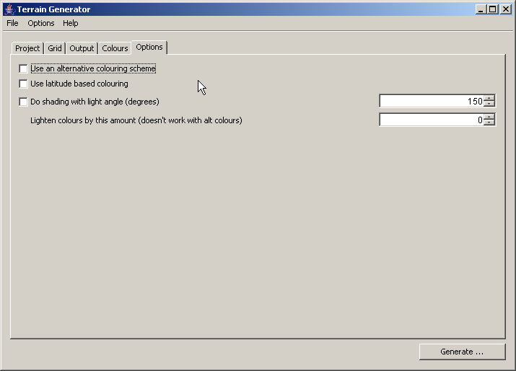
The options page allows some other options to be set. An alternative colouring scheme is available. There is also the option to colour by latitude, which will generate more real looking polar caps. Shading can also be enabled, which can give the illusion of depth. Finally, the colours can be lightened by increasing the value above zero.

A Few Examples
This is an image with an Orthographic projection and standard colouring.
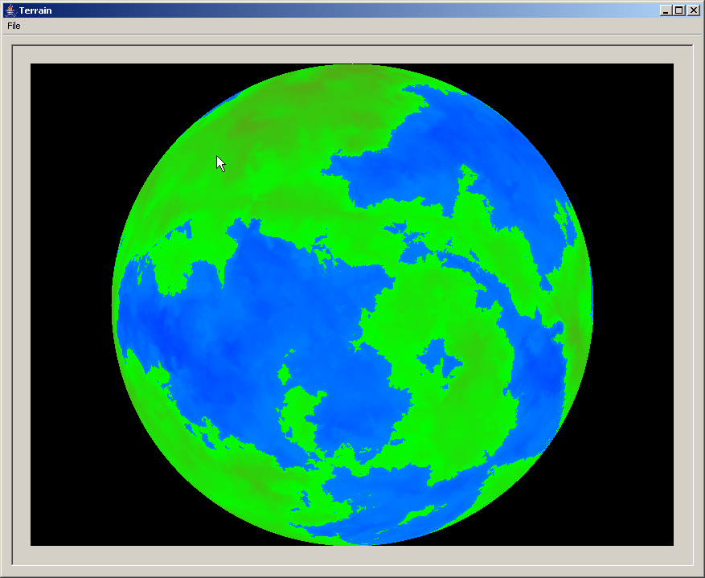
This is the same terrain, but with latitude based colouring turned on.
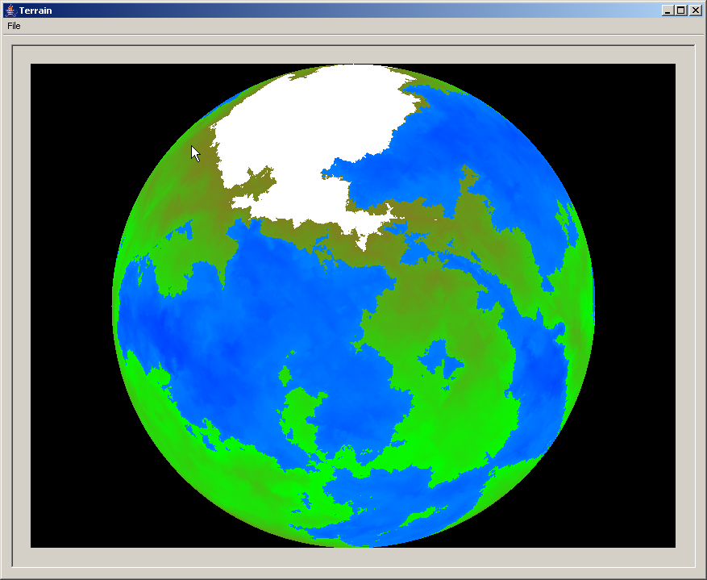
And this is the same terrain with shading enabled.

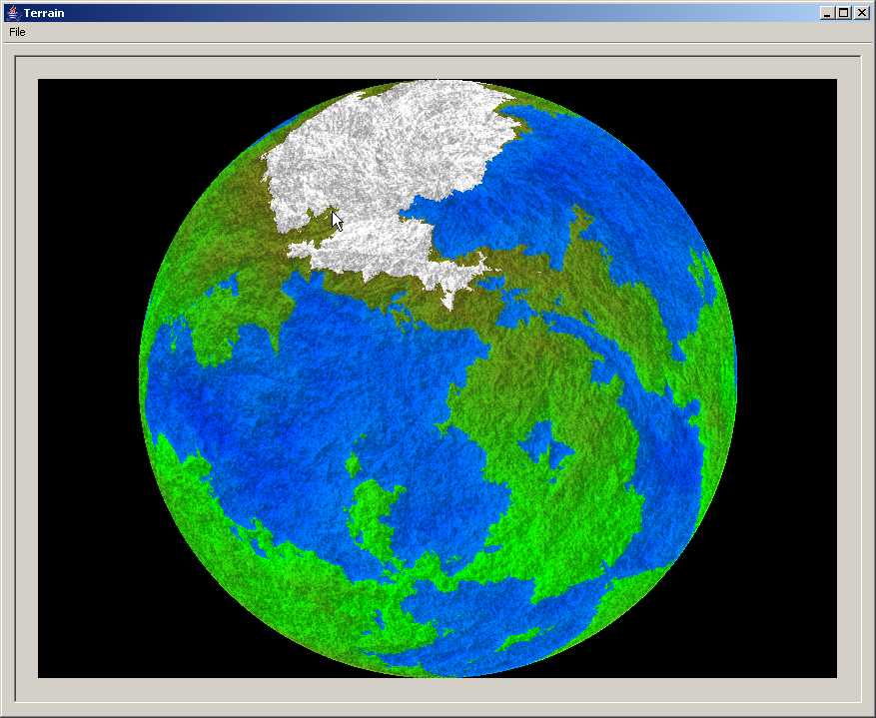
This image shows the grid option being used.
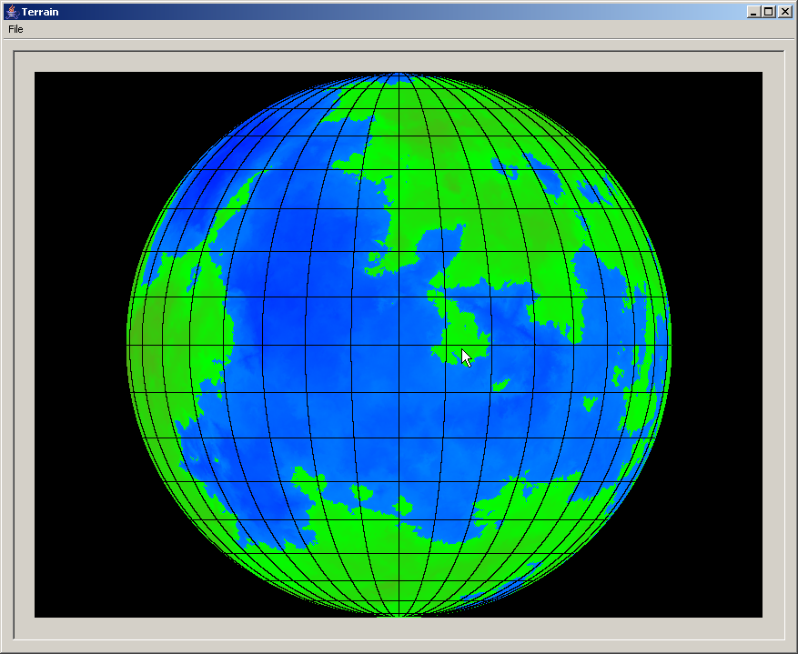
And the final example demonstrates that even random colour schemes sometimes work out ok.
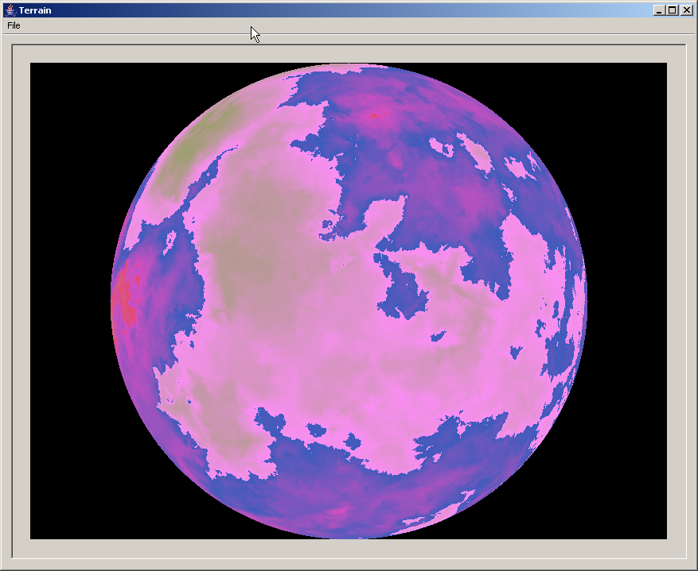

Saving and Printing
All the parameters used to generate the planet can be saved to an XML file by the option in the File menu. They can then be loaded at a future date to allow a particular planet to be regenerated.
Once a terrain has been generated it can be printed and saved via options in the File menu of the Terrain window.
Images can be saved in BMP, JPG or PNG format by appending the suitable extension to the filename.

Heightfield Output
If the heightfield option is enabled in the first options page then a text file is written out instead of displaying a terrain image.
Each line in this file will have the heights of the terrain for one line. The lines are ordered by increasing Y coordinate.
Each line contains a number of entries separated by spaces. Each is an integer representing the height of the terrain at that point. Negative heights are below sea level, positive heights are above it.
The text file is in the same format as those produced by the original C program. Consult the source for more details.

Command Line Version
The PlanetCLI class allows terrains to be generated from the command line and operates in a similar manner to the original C program.
The following arguments are accepted by the program:
Argument | Short Form | Effect
-seed x | -s x | Sets the random terrain seed value to the given value
-width x | -w x | Sets the output width in pixels to x
-height x | -h x | Sets the output height in pixels to x
-magnification x | -m x | Sets the output scaling to x (default is 1.0)
-output f | -o f | Sets the output file name to f
-longitude x | -l x | Sets the longitude value to x
-latitude x | -L x | Sets the latitude value to x
-vgrid x | -g x | Sets the vertical grid value to x
-hgrid x | -G x | Sets the horizontal grid value to x
-initialaltitude x | -i x | Sets the terrain initial altitude to x
-latitudecolour | -c | Enables latitude based colouring
-lighten | -C | Makes the colour lighter (can be repeated more than once)
-nocols x | -N x | The maximum number of colours to use in the output
-altcolours | -a | Use the alternative colouring scheme
-colourfile f | -M f | Read the colours from the specified file (see C source for format)
-outline | -O | Draw an outline of the coasts only
-edges | -E | Draw the edges of the terrain in black
-bumpmap | -B | Enable bumpmap shading
-shadangle x | -A x | Set the shade angle for bumpmap shading
-reversebackground | -b | Reverse the background colour
-distancecontrib x | -V x | Set the distance contribution value (see original source)
-altcontrib x | -v x | Set the altitude contribution value for terrain generation (see original source)
-projection p | -p p | Sets the projection to the specified one e.g. -p Mercator

Some Notes on the Source
As with the Fracplanet port it is straightforward to generate terrains with this code. Examining the CLI version is probably a good way to get started. The following code is an example based on that class.
AllPlanetParameters params = new AllPlanetParameters();

// Real code would now set parameters on the bean object as
// required

ProjectionManager mgr = new ProjectionManager();

Projector proj = mgr.findByName(params.getProjectionParameters().
getProjectionName());

if (proj == null)
{
System.err.println("Error. Unknown projection name: " +
params.getProjectionParameters().getProjectionName());

System.exit(1);
}

final BufferedImage image = me.generateTerrain(proj, params);

As can be seen from the example the sequence of steps is:
- Create a parameters object and populate its values by whatever means is desired.
- Obtain a projection object of the correct type from the Projection Manager.
- Use the projection to generate a terrain
- Save the generated image to a file, or do whatever is necessary with it.
Another class that might be useful is the ImageBuilder class. It's an example of how to create a BufferedImage from pixel data.
The ImagePrinter class is an example of how to print a BufferedImage with automatic scaling for the printer.
The CLI version of the program is also an example of how to use Getopt in Java.
The HeightfieldProjector class shows how to get the terrain height values instead of a map projection to a bitmap image.

Stargen Stellar System Generator

Introduction
The Stargen program allows for the creation of believable planetary systems around fictional stars. Some of the features of this version are:
- User interface using Swing
- All parameters can be set by the user or at random
- Can output HTML, text or a star and planet description for Celestia
- Template driven output, can be customized by the user for additional formats
- Printing capability for the solar system details

Using Stargen

Initial Display
When the program is started a window like the following will be displayed. It may look slightly different depending on the platform.

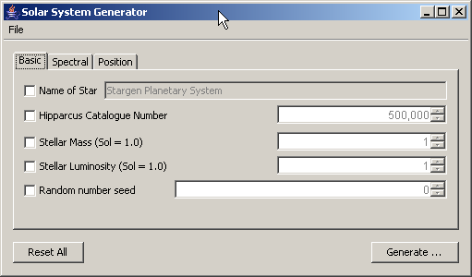
The basic mode of usage is to set up the parameters as desired and press the Generate button to generate a new solar system.
By default all of the parameters will be selected randomly. You do not need to change any settings to enable generation. If you wish to override a setting turn on the appropriate check box and set the corresponding value accordingly. For example if you want to set the name and luminosity of the star set the options like this before pressing Generate:
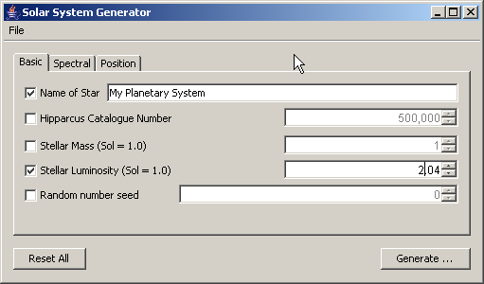

Controls
This section runs through the option pages listing the parameters that can be set. The first option page shown above controls basic parameters for the star.
Setting the name and catalogue number is only really important for Celestia output, though it can be useful to distinguish between systems. Choosing a high value for the catalogue number avoids conflicts with existing real stars.
The stellar mass and luminosity settings are set relative to the sun. For example 2.0 in the mass field means a star twice as massive as Sol.
The random number seed field can be set to generate a particular system. The same value in this field will always result in the same solar system being generated. If you get a system you like then the parameters including the seed can be saved for future use.

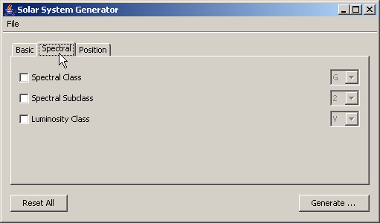
The spectral parameters allow the type of the star to be set up. This is mainly useful for Celestia output. The default of G2V corresponds to the characteristics of our Sun. An article on what the different types mean can be found at http://en.wikipedia.org/wiki/Stellar_classification.

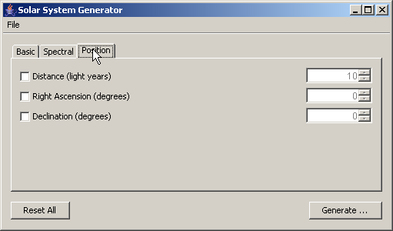
The position parameters are again used for Celestia output. They can be set to place the star at a particular point or left unset to allow a position to be randomly generated.

Generating Systems
When all the parameters have been set pressing the Generate button will create a solar system and display an overview window as shown below. On fast systems this will take a couple of seconds.

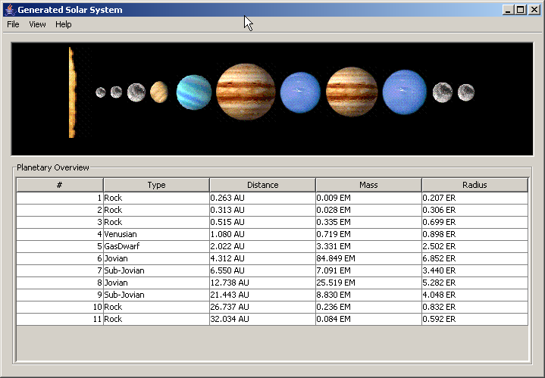
The image at the top shows a representation of the planets in the system. They will be shown proportional to their real size. Note the distance from the star is not shown proportionally for obvious reasons. The overview pane at the bottom shows the basic details for each planet.
A key to the planet types can be displayed from the Help menu. It looks like the image below.

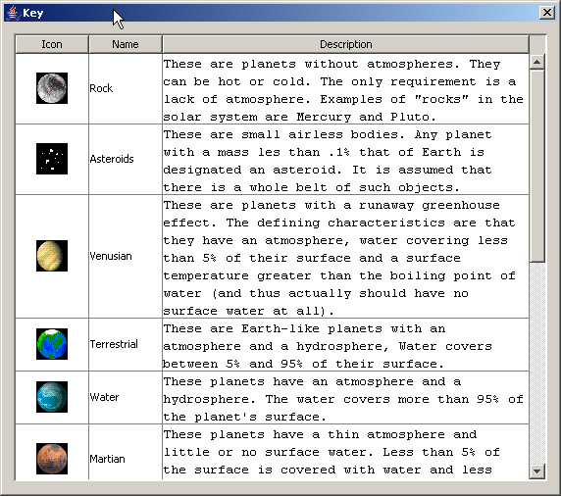
The solar system image can be saved from the File menu or the details of the solar system can be displayed from the View menu. This brings up a new window that is described in the next section.

Solar System Details
The details option from the solar system window will bring up a new window that looks something like the following:

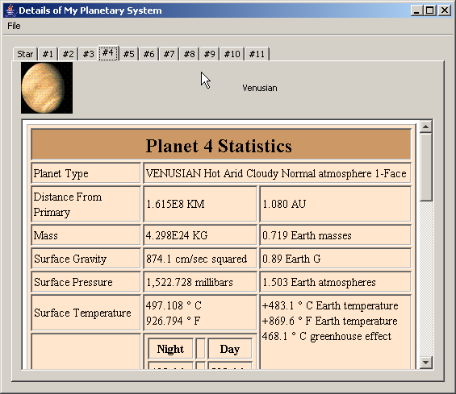
There will be a tab for the star details and a tab for each planet in the solar system. Each tab gives detailed information on the star or planet.
The File menu contains the export functionality, described later and an option to print the combined details of the star and all the planets. Using the print preview option brings up a window with the complete document that will be printed. This can then be reviewed and sent to the printer if desired. This window looks like:

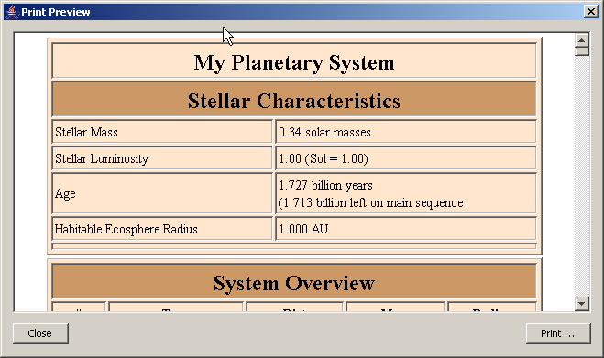

Saving and Loading Parameters
As with the other programs, the current parameters can be saved and loaded to XML files using the options in the File menu of the main window.
This allows the same solar systems to be regenerated in future.

Exporting HTML
The export to HTML option on the solar system details window has two variants. The first saves the HTML in a single document file that references no other files or images. This document will contain data that looks exactly like what is shown in the Print Preview window.
The second option writes out a zip file that includes images and a page including the key to the image types. This will include a graphical overview of the solar system similar to that shown on screen.
The resulting zip file can be unpacked and viewed either on the local file system or placed onto a web server. All links are relative references.

Exporting Text
The export as text option produces similar contents to the export HTML option but with all the formatting stripped out. The output is a single text file.
Note that this may produce some long lines for the solar system overview section. If you're on Windows don't view it in Notepad, use a proper editor.

Exporting to Celestia
Choosing this option will generate two output files one will be called file.STC and will include details of the generated star. The other will be called file.SSC and will contain the planetary information.
To use these files put them in the 'extras' directory of your Celestia installation (or export them to that directory).
The export has been tested with Celestia version 1.4.1, which was current at the time of development. It will not work correctly on versions earlier than 1.4.

Custom Export with Templates
All of the above output is generated via templates. It is possible to specify your own template and thereby generate any textual output format that is required.
To do this you must write a FreeMarker template. To make this process easier the default templates are supplied as examples so you can see how they work and the objects that they have access to. A full description of the template language can be found at the FreeMarker web site.
Before exporting use the menu option to select your template file. Once this has been done the custom export option will be enabled and will generate the output file.
For an example of how to do this place the following text into a file called test.ftl:
Stellar Characteristics

Stellar Mass: ${star.mass?string("0.00")} solar masses
Stellar Luminosity: ${star.luminosity?string("0.00")} (Sol = 1.00)
Age: ${(star.age / 1000000000)?string("0.000")} billion years

Now select this as a custom template and generate an output file. The result should be text similar to the following:

Stellar Characteristics

Stellar Mass: 0.73 solar masses
Stellar Luminosity: 0.25 (Sol = 1.00)
Age: 4.881 billion years

By examining the supplied templates it should hopefully be clear how to generate other types of output and refer to properties of the star and its planets to do so.

Some Notes on The Source
Again the UI code is separate from the solar system generation classes. There are interfaces Primary for star objects and Planet for planets backed by bean implementations.
There is an example class AccreteTest that shows how a solar system can be generated. An extract from this class is shown below.
final MathUtils utils = new MathUtils();
final Generator gen = new Generator(utils);
final Display display = new Display();

Primary sun = new BasicPrimary();

//sun.setMass(1.0);
//sun.setMass(0.69999999);
//sun.setAge(5e9);
gen.setGenerateMoons(true);
gen.setMoonMinMassLimit(.001);

gen.generate(sun, 0, "Test");

final List<Planet> planets = sun.getPlanets();

System.out.println("Generated " + planets.size() + " planets.");

for (Planet p : planets)
{
System.out.println(
"a = " + p.getA() + ", e=" + p.getE() + " , mass=" +
p.getMass());
}

A more realistic scenario can be seen in the GenerateAction class, part of the UI package.
This program is an example of how to use FreeMarker to generate complex output, including calculations.

Dole Accretion Star System Generator
This code is contained in the stargen.dole package. It currently doesn't have a UI though it is functional and shows an alternative implementation of the accretion method.
There is a class called DoleAccreteTest that shows it in action. There is also full javadoc for the package but I'm afraid that's all I have on this at the moment.

Notes on Building

Building The Project
The unpacked tar file or a CVS checkout should contain the correct structure for building the programs. Source releases include all the library dependencies.
A NetBeans 5.0 project is included which can be opened and in the IDE and built by this means.
If you don't have NetBeans then it can be built using Ant. The NetBeans build system is based on Ant so its the exact same script that is being used in this case. To build with Ant go to the top level of the structure where the build.xml file is. After ensuring that your environment is set up correctly for Java 5.0 just type 'ant'.
All of the UI forms were built with the NetBeans Matisse layout editor. It might be difficult to use other tools to edit these dialogs.
Note: In a couple of places the code refers to the Sun JNLP library. I have currently disabled this code because of doubts about GPL compatibility. The JNLP jar file is not required to build or run this application in its current form and is not distributed.

Libraries Used
The following libraries have been used in this software and are required to build / run it.
Some of these libraries have licenses other than the GPL. You should consult the documentation for each library to determine the appropriate licenses. A special exception to the GPL has been granted in the TerraJ code to allow the use of these libraries under their respective licenses.
Library Name | Version | Available From
JOGL | Current dev. Use recent beta if problems occur | https://jogl.dev.java.net/
Commons Logging | 1.0.4 | http://jakarta.apache.org/commons/logging/
Log4J | 1.2.13 | http://logging.apache.org/log4j/docs/index.html
Rhino (JavaScript) | 1.6R2 | http://www.mozilla.org/rhino/
Rings (rendering) | Current dev. | http://j3d.sourceforge.net/
Getopt | 1.0.12 | http://www.urbanophile.com/arenn/hacking/download.html
FreeMarker | 2.3.6 | http://www.freemarker.org/

Note: The Rhino library Shell has been modified by me to behave better as part of a larger Swing application. This has meant removing the console tendencies to exit the application when the window is closed etc.
The modifications are in the form of a new Shell package available in my source tree under the GPL. The library jar file distributed with the program has not been modified and is as released.
Note: Some development versions of JOGL may contain bugs. In particular I've had cases where it breaks on Linux with an 'Xlib: unexpected async reply' error. Use caution when updating to a new version of JOGL.

GNU General Public License
For reference, this is a copy of the license under which this software and associated documentation is released.
Note: A special exception has been granted in the license statements in each source file allowing use of this code with LGPL libraries, and with the specific libraries under the BSD and Apache licenses used to build and run it. Please see the source code for full details.

GNU GENERAL PUBLIC LICENSE
Version 2, June 1991

Copyright (C) 1989, 1991 Free Software Foundation, Inc.
51 Franklin Street, Fifth Floor, Boston, MA 02110-1301 USA
Everyone is permitted to copy and distribute verbatim copies
of this license document, but changing it is not allowed.

Preamble

The licenses for most software are designed to take away your
freedom to share and change it. By contrast, the GNU General Public
License is intended to guarantee your freedom to share and change free
software--to make sure the software is free for all its users. This
General Public License applies to most of the Free Software
Foundation's software and to any other program whose authors commit to
using it. (Some other Free Software Foundation software is covered by
the GNU Lesser General Public License instead.) You can apply it to
your programs, too.

When we speak of free software, we are referring to freedom, not
price. Our General Public Licenses are designed to make sure that you
have the freedom to distribute copies of free software (and charge for
this service if you wish), that you receive source code or can get it
if you want it, that you can change the software or use pieces of it
in new free programs; and that you know you can do these things.

To protect your rights, we need to make restrictions that forbid
anyone to deny you these rights or to ask you to surrender the rights.
These restrictions translate to certain responsibilities for you if you
distribute copies of the software, or if you modify it.

For example, if you distribute copies of such a program, whether
gratis or for a fee, you must give the recipients all the rights that
you have. You must make sure that they, too, receive or can get the
source code. And you must show them these terms so they know their
rights.

We protect your rights with two steps: (1) copyright the software, and
(2) offer you this license which gives you legal permission to copy,
distribute and/or modify the software.

Also, for each author's protection and ours, we want to make certain
that everyone understands that there is no warranty for this free
software. If the software is modified by someone else and passed on, we
want its recipients to know that what they have is not the original, so
that any problems introduced by others will not reflect on the original
authors' reputations.

Finally, any free program is threatened constantly by software
patents. We wish to avoid the danger that redistributors of a free
program will individually obtain patent licenses, in effect making the
program proprietary. To prevent this, we have made it clear that any
patent must be licensed for everyone's free use or not licensed at all.

The precise terms and conditions for copying, distribution and
modification follow.

GNU GENERAL PUBLIC LICENSE
TERMS AND CONDITIONS FOR COPYING, DISTRIBUTION AND MODIFICATION

0. This License applies to any program or other work which contains
a notice placed by the copyright holder saying it may be distributed
under the terms of this General Public License. The "Program", below,
refers to any such program or work, and a "work based on the Program"
means either the Program or any derivative work under copyright law:
that is to say, a work containing the Program or a portion of it,
either verbatim or with modifications and/or translated into another
language. (Hereinafter, translation is included without limitation in
the term "modification".) Each licensee is addressed as "you".

Activities other than copying, distribution and modification are not
covered by this License; they are outside its scope. The act of
running the Program is not restricted, and the output from the Program
is covered only if its contents constitute a work based on the
Program (independent of having been made by running the Program).
Whether that is true depends on what the Program does.

1. You may copy and distribute verbatim copies of the Program's
source code as you receive it, in any medium, provided that you
conspicuously and appropriately publish on each copy an appropriate
copyright notice and disclaimer of warranty; keep intact all the
notices that refer to this License and to the absence of any warranty;
and give any other recipients of the Program a copy of this License
along with the Program.

You may charge a fee for the physical act of transferring a copy, and
you may at your option offer warranty protection in exchange for a fee.

2. You may modify your copy or copies of the Program or any portion
of it, thus forming a work based on the Program, and copy and
distribute such modifications or work under the terms of Section 1
above, provided that you also meet all of these conditions:

a) You must cause the modified files to carry prominent notices
stating that you changed the files and the date of any change.

b) You must cause any work that you distribute or publish, that in
whole or in part contains or is derived from the Program or any
part thereof, to be licensed as a whole at no charge to all third
parties under the terms of this License.

c) If the modified program normally reads commands interactively
when run, you must cause it, when started running for such
interactive use in the most ordinary way, to print or display an
announcement including an appropriate copyright notice and a
notice that there is no warranty (or else, saying that you provide
a warranty) and that users may redistribute the program under
these conditions, and telling the user how to view a copy of this
License. (Exception: if the Program itself is interactive but
does not normally print such an announcement, your work based on
the Program is not required to print an announcement.)

These requirements apply to the modified work as a whole. If
identifiable sections of that work are not derived from the Program,
and can be reasonably considered independent and separate works in
themselves, then this License, and its terms, do not apply to those
sections when you distribute them as separate works. But when you
distribute the same sections as part of a whole which is a work based
on the Program, the distribution of the whole must be on the terms of
this License, whose permissions for other licensees extend to the
entire whole, and thus to each and every part regardless of who wrote it.

Thus, it is not the intent of this section to claim rights or contest
your rights to work written entirely by you; rather, the intent is to
exercise the right to control the distribution of derivative or
collective works based on the Program.

In addition, mere aggregation of another work not based on the Program
with the Program (or with a work based on the Program) on a volume of
a storage or distribution medium does not bring the other work under
the scope of this License.

3. You may copy and distribute the Program (or a work based on it,
under Section 2) in object code or executable form under the terms of
Sections 1 and 2 above provided that you also do one of the following:

a) Accompany it with the complete corresponding machine-readable
source code, which must be distributed under the terms of Sections
1 and 2 above on a medium customarily used for software interchange; or,

b) Accompany it with a written offer, valid for at least three
years, to give any third party, for a charge no more than your
cost of physically performing source distribution, a complete
machine-readable copy of the corresponding source code, to be
distributed under the terms of Sections 1 and 2 above on a medium
customarily used for software interchange; or,

c) Accompany it with the information you received as to the offer
to distribute corresponding source code. (This alternative is
allowed only for noncommercial distribution and only if you
received the program in object code or executable form with such
an offer, in accord with Subsection b above.)

The source code for a work means the preferred form of the work for
making modifications to it. For an executable work, complete source
code means all the source code for all modules it contains, plus any
associated interface definition files, plus the scripts used to
control compilation and installation of the executable. However, as a
special exception, the source code distributed need not include
anything that is normally distributed (in either source or binary
form) with the major components (compiler, kernel, and so on) of the
operating system on which the executable runs, unless that component
itself accompanies the executable.

If distribution of executable or object code is made by offering
access to copy from a designated place, then offering equivalent
access to copy the source code from the same place counts as
distribution of the source code, even though third parties are not
compelled to copy the source along with the object code.

4. You may not copy, modify, sublicense, or distribute the Program
except as expressly provided under this License. Any attempt
otherwise to copy, modify, sublicense or distribute the Program is
void, and will automatically terminate your rights under this License.
However, parties who have received copies, or rights, from you under
this License will not have their licenses terminated so long as such
parties remain in full compliance.

5. You are not required to accept this License, since you have not
signed it. However, nothing else grants you permission to modify or
distribute the Program or its derivative works. These actions are
prohibited by law if you do not accept this License. Therefore, by
modifying or distributing the Program (or any work based on the
Program), you indicate your acceptance of this License to do so, and
all its terms and conditions for copying, distributing or modifying
the Program or works based on it.

6. Each time you redistribute the Program (or any work based on the
Program), the recipient automatically receives a license from the
original licensor to copy, distribute or modify the Program subject to
these terms and conditions. You may not impose any further
restrictions on the recipients' exercise of the rights granted herein.
You are not responsible for enforcing compliance by third parties to
this License.

7. If, as a consequence of a court judgment or allegation of patent
infringement or for any other reason (not limited to patent issues),
conditions are imposed on you (whether by court order, agreement or
otherwise) that contradict the conditions of this License, they do not
excuse you from the conditions of this License. If you cannot
distribute so as to satisfy simultaneously your obligations under this
License and any other pertinent obligations, then as a consequence you
may not distribute the Program at all. For example, if a patent
license would not permit royalty-free redistribution of the Program by
all those who receive copies directly or indirectly through you, then
the only way you could satisfy both it and this License would be to
refrain entirely from distribution of the Program.

If any portion of this section is held invalid or unenforceable under
any particular circumstance, the balance of the section is intended to
apply and the section as a whole is intended to apply in other
circumstances.

It is not the purpose of this section to induce you to infringe any
patents or other property right claims or to contest validity of any
such claims; this section has the sole purpose of protecting the
integrity of the free software distribution system, which is
implemented by public license practices. Many people have made
generous contributions to the wide range of software distributed
through that system in reliance on consistent application of that
system; it is up to the author/donor to decide if he or she is willing
to distribute software through any other system and a licensee cannot
impose that choice.

This section is intended to make thoroughly clear what is believed to
be a consequence of the rest of this License.

8. If the distribution and/or use of the Program is restricted in
certain countries either by patents or by copyrighted interfaces, the
original copyright holder who places the Program under this License
may add an explicit geographical distribution limitation excluding
those countries, so that distribution is permitted only in or among
countries not thus excluded. In such case, this License incorporates
the limitation as if written in the body of this License.

9. The Free Software Foundation may publish revised and/or new versions
of the General Public License from time to time. Such new versions will
be similar in spirit to the present version, but may differ in detail to
address new problems or concerns.

Each version is given a distinguishing version number. If the Program
specifies a version number of this License which applies to it and "any
later version", you have the option of following the terms and conditions
either of that version or of any later version published by the Free
Software Foundation. If the Program does not specify a version number of
this License, you may choose any version ever published by the Free Software
Foundation.

10. If you wish to incorporate parts of the Program into other free
programs whose distribution conditions are different, write to the author
to ask for permission. For software which is copyrighted by the Free
Software Foundation, write to the Free Software Foundation; we sometimes
make exceptions for this. Our decision will be guided by the two goals
of preserving the free status of all derivatives of our free software and
of promoting the sharing and reuse of software generally.

NO WARRANTY

11. BECAUSE THE PROGRAM IS LICENSED FREE OF CHARGE, THERE IS NO WARRANTY
FOR THE PROGRAM, TO THE EXTENT PERMITTED BY APPLICABLE LAW. EXCEPT WHEN
OTHERWISE STATED IN WRITING THE COPYRIGHT HOLDERS AND/OR OTHER PARTIES
PROVIDE THE PROGRAM "AS IS" WITHOUT WARRANTY OF ANY KIND, EITHER EXPRESSED
OR IMPLIED, INCLUDING, BUT NOT LIMITED TO, THE IMPLIED WARRANTIES OF
MERCHANTABILITY AND FITNESS FOR A PARTICULAR PURPOSE. THE ENTIRE RISK AS
TO THE QUALITY AND PERFORMANCE OF THE PROGRAM IS WITH YOU. SHOULD THE
PROGRAM PROVE DEFECTIVE, YOU ASSUME THE COST OF ALL NECESSARY SERVICING,
REPAIR OR CORRECTION.

12. IN NO EVENT UNLESS REQUIRED BY APPLICABLE LAW OR AGREED TO IN WRITING
WILL ANY COPYRIGHT HOLDER, OR ANY OTHER PARTY WHO MAY MODIFY AND/OR
REDISTRIBUTE THE PROGRAM AS PERMITTED ABOVE, BE LIABLE TO YOU FOR DAMAGES,
INCLUDING ANY GENERAL, SPECIAL, INCIDENTAL OR CONSEQUENTIAL DAMAGES ARISING
OUT OF THE USE OR INABILITY TO USE THE PROGRAM (INCLUDING BUT NOT LIMITED
TO LOSS OF DATA OR DATA BEING RENDERED INACCURATE OR LOSSES SUSTAINED BY
YOU OR THIRD PARTIES OR A FAILURE OF THE PROGRAM TO OPERATE WITH ANY OTHER
PROGRAMS), EVEN IF SUCH HOLDER OR OTHER PARTY HAS BEEN ADVISED OF THE
POSSIBILITY OF SUCH DAMAGES.

END OF TERMS AND CONDITIONS

How to Apply These Terms to Your New Programs

If you develop a new program, and you want it to be of the greatest
possible use to the public, the best way to achieve this is to make it
free software which everyone can redistribute and change under these terms.

To do so, attach the following notices to the program. It is safest
to attach them to the start of each source file to most effectively
convey the exclusion of warranty; and each file should have at least
the "copyright" line and a pointer to where the full notice is found.

<one line to give the program's name and a brief idea of what it does.>
Copyright (C) <year> <name of author>

This program is free software; you can redistribute it and/or modify
it under the terms of the GNU General Public License as published by
the Free Software Foundation; either version 2 of the License, or
(at your option) any later version.

This program is distributed in the hope that it will be useful,
but WITHOUT ANY WARRANTY; without even the implied warranty of
MERCHANTABILITY or FITNESS FOR A PARTICULAR PURPOSE. See the
GNU General Public License for more details.

You should have received a copy of the GNU General Public License
along with this program; if not, write to the Free Software
Foundation, Inc., 51 Franklin Street, Fifth Floor, Boston, MA 02110-1301 USA

Also add information on how to contact you by electronic and paper mail.

If the program is interactive, make it output a short notice like this
when it starts in an interactive mode:

Gnomovision version 69, Copyright (C) year name of author
Gnomovision comes with ABSOLUTELY NO WARRANTY; for details type `show w'.
This is free software, and you are welcome to redistribute it
under certain conditions; type `show c' for details.

The hypothetical commands `show w' and `show c' should show the appropriate
parts of the General Public License. Of course, the commands you use may
be called something other than `show w' and `show c'; they could even be
mouse-clicks or menu items--whatever suits your program.

You should also get your employer (if you work as a programmer) or your
school, if any, to sign a "copyright disclaimer" for the program, if
necessary. Here is a sample; alter the names:

Yoyodyne, Inc., hereby disclaims all copyright interest in the program
`Gnomovision' (which makes passes at compilers) written by James Hacker.

<signature of Ty Coon>, 1 April 1989
Ty Coon, President of Vice

This General Public License does not permit incorporating your program into
proprietary programs. If your program is a subroutine library, you may
consider it more useful to permit linking proprietary applications with the
library. If this is what you want to do, use the GNU Lesser General
Public License instead of this License.

Note: This support is currently incomplete and will be improved in a later version.
The code makes use of the 1.5 features such as type safe lists and improved iterators to improve readability. A port back to Java 1.4 would be feasible if it was really required.
Note: Some distributions include 3rd party Java implementations that may be problematic with certain applications. If you encounter problems try running the software with a standard J2SE runtime.

