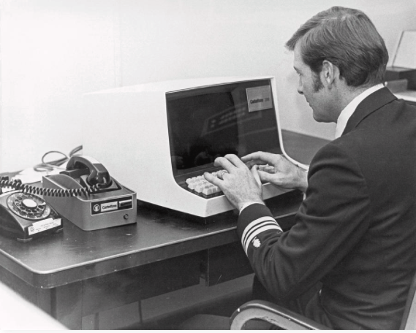

Salvino | 01234567 | helloworld@demotest.net

# About Me

is simply dummy text of the printing and typesetting industry. Lorem Ipsum has been the industry's standard dummy text ever since the 1500s, when an unknown printer took a galley of type and scrambled it to make a type specimen book. I

# Work Experiance

**Demo-Company1** *2020 - 2022*network admin  
  
**Demo-Company2** *2018 - 2020*IT support

# Key Skills

* hardworking
* good communicator
* passionate about technology
* python / linux / cloud technology