ITSAR2 313 – SYSTEM INTEGRATION AND ARCHITECTURE 2
LABORATORY REPORT: EXERCISE 1 — MONOLITH VS MICROSERVICE
Andura, Carla, Bermejo, Kate Nicole, Garcia, Sophia Christi, Labrador, Mariene, Roma, Sean Justin

SECTION 1—Monolithic Architecture
The monolithic implementation is a single Node.js application running on an Express.js server (Port 3000). It follows a layered structure where routes, controllers, and middleware are handled within one unified process. The application contains separate routers for students, courses, and enrollments, each connected to their respective controllers. These controllers interact with shared models responsible for all data operations. All data is stored in a single in-memory database, where students, courses, and enrollments are maintained as arrays. Because everything runs in one codebase and process, communication between components happens through direct function calls, making the system simple to develop and deploy. However, all components are tightly coupled, meaning any failure or change can affect the entire system
Figure 1: Monolithic Application Architecture Diagram
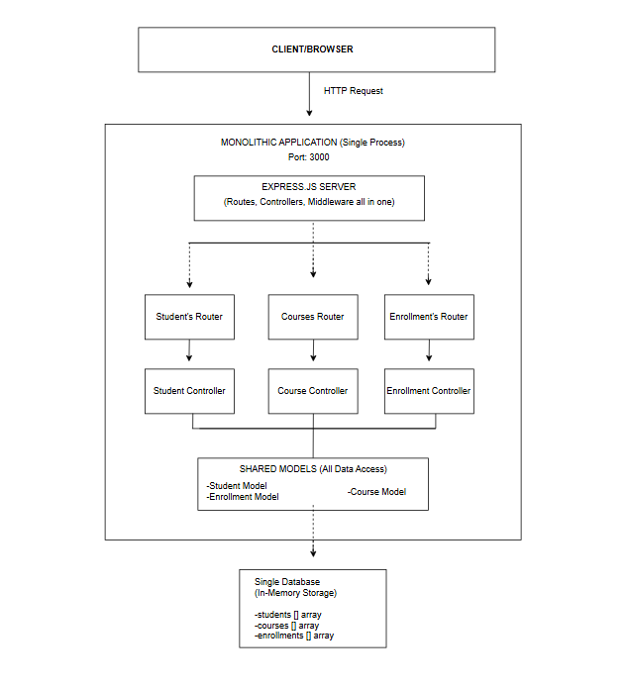

SECTION 2—Microservices Architecture
The microservices implementation separates the system into independent services: student-service (Port 4001), course-service (Port 4002), and enrollment-service (Port 4003). Each service runs as its own application and manages its own database (students.db, courses.db, enrollments.db). A central dashboard service acts as the frontend server, receiving client requests and forwarding them to the appropriate service via HTTP. The enrollment service performs internal validation by communicating with the student and course services to verify related data. Since services communicate over the network, failures such as connection issues or timeouts must be handled explicitly. This architecture improves scalability and fault isolation, as each service can be deployed and scaled independently. However, it introduces additional complexity in managing inter-service communication, data consistency, and system monitoring.

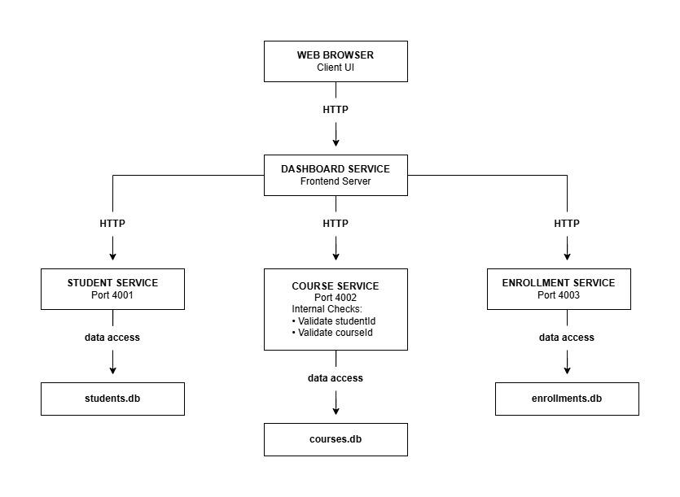
Figure 2: Microservices Application Architecture Diagram

