ITSAR2 313 – SYSTEM INTEGRATION AND ARCHITECTURE 2
LABORATORY REPORT: EXERCISE 2 — MICROSERVICES EDGE CASE TESTING

Members: Andura, Carla C.
Bermejo, Kate Nicole
Garcia, Sophia Christi
Labrador, Mariene E.
Roma, Sean Justin E.
Abstract
This laboratory exercise tested three Express.js-based microservices—student-service (port 4001), course-service (port 4002), and enrollment-service (port 4003)—against a 27-step sequential test suite covering HTTP status codes 200, 201, 400, 404, 409, 503, and 504. All tests were executed using Windows PowerShell and curl.exe -i to capture both response headers and JSON bodies in a deterministic order, ensuring each step had the required data before proceeding to the next. The key finding is that the enrollment-service correctly identifies and handles external HTTP dependency failures, successfully returning 503 (Service Unavailable) for offline dependencies and 504 (Gateway Timeout) for slow dependencies. All 27 test steps were confirmed to return the correct HTTP status codes and consistent error messages across all services.

I. INTRODUCTION
Edge case testing verifies that a system handles abnormal inputs and failure conditions correctly. Testing only the "happy path"—valid inputs producing expected outputs—is insufficient for production systems. Real-world APIs receive malformed requests, reference nonexistent resources, and depend on services that can fail or respond slowly. Each of these scenarios must return a meaningful HTTP status code and a structured error response that clients can parse and handle programmatically.
HTTP status codes communicate the outcome of every API request:
- 2xx codes indicate success: 200 OK for reads and updates, 201 Created for new resources.
- 4xx codes indicate client errors: 400 Bad Request for invalid input, 404 Not Found for missing resources, 409 Conflict for duplicate entries.
- 5xx codes indicate server-side failures: 503 Service Unavailable when a dependency is offline, 504 Gateway Timeout when a dependency is too slow.
Microservices introduce 503 and 504 scenarios that monolithic systems never face. Because a monolith has no external HTTP dependencies, connection failures and timeouts are architecturally impossible.
The test suite in this report is ordered sequentially so that each step builds on the data created by previous steps. This deterministic approach ensures reproducible results and eliminates test failures caused by missing or inconsistent data. A fresh database reset is performed before every full run to establish a known baseline of four member records, two default courses, and two default enrollments.
II. METHODOLOGY/IMPLEMENTATION
All three services were started in separate PowerShell terminal windows before testing began using the node src/server.js command. The enrollment-service depends on the student-service and course-service for cross-service validation, so all three must be running simultaneously. A fourth terminal was used exclusively for curl.exe commands.
The following table lists every edge case scenario implemented and tested in the Express.js environment:
Status | Error Response | Trigger | Service
201 | N/A (Success) | Successful creation | All
200 | N/A (Success) | Successful read / update / delete | All
400 | {"error": "... are required"} | Missing or invalid input fields | All
404 | {"error": "[Resource] not found"} | Resource ID does not exist | All
404 | {"error": "Student does not exist"} | Invalid studentId on enroll | Enrollment
404 | {"error": "Course does not exist"} | Invalid courseId on enroll | Enrollment
409 | {"error": "Student email already exists"} | Email already registered | Student
409 | {"error": "Student is already enrolled..."} | Student already in course | Enrollment
503 | {"error": "Student service unavailable"} | Dependency service offline | Enrollment
504 | {"error": "Student service unavailable (timeout)"} | Dependency response too slow | Enrollment
A. Reset and Pre-conditions
Before starting, SQLite databases (students.db, courses.db, enrollments.db) and previous text evidence files were removed to ensure a clean state. The backend automatically seeds initial dummy data representing the team members upon startup.
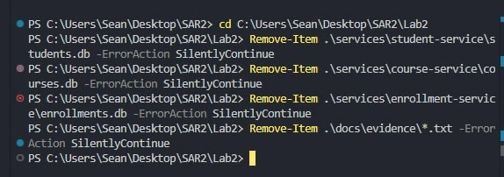

Baseline after reset:

- students: pre-seeded with 4 member records
- courses: pre-seeded with 2 default records
- enrollments: pre-seeded with 2 default records

Default seeded IDs used by the sequence:

- students: IDs 1-4 (member records), new test student becomes ID 5
- courses: IDs 1-2 (default records), new test course becomes ID 3
- enrollments: IDs 1-2 (default records), new test enrollment becomes ID 3

B. Start Services Open four separate terminal window

Terminal 1:
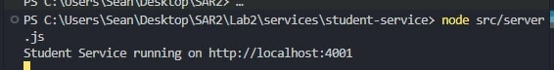
Terminal 2
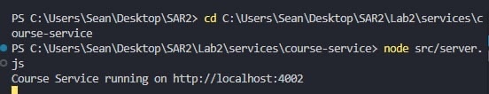
Terminal 3
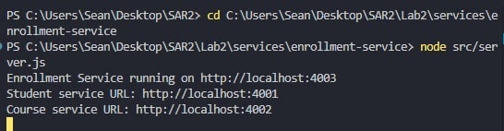

C. Sequential Test Flow
Use Terminal 4 for all curl commands. Execute steps in order — do not skip steps.

Step 1 - GET all students (200)

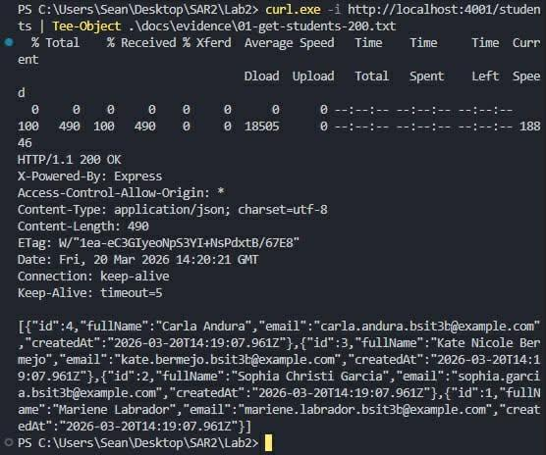

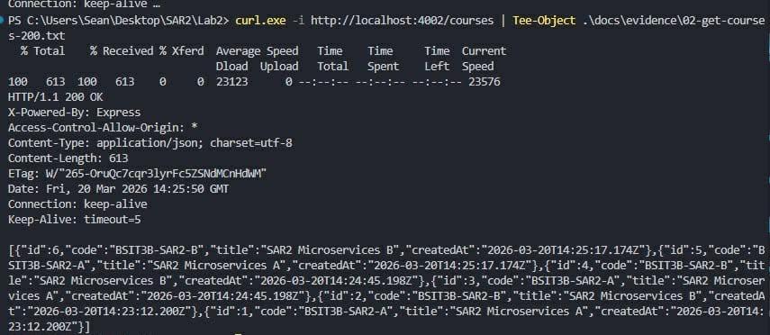
Step 2 - GET all courses (200)
Step 3 - POST student (201)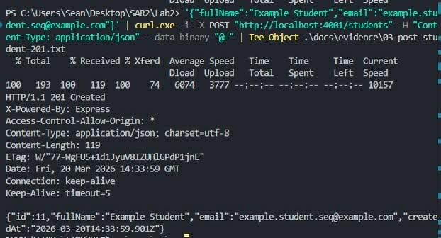
Use the returned student id from Step 3 for Steps 4, 5, 25, and 27. If you get id 11 in Step 3, replace /students/5 with /students/11 in those steps.

Step 4 - GET created student by ID (200)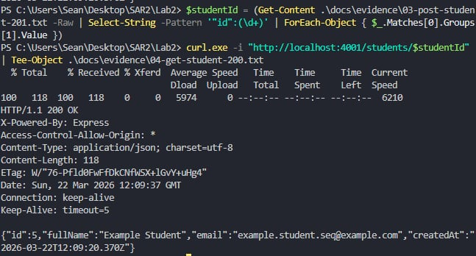

Step 5 - PUT update student (200)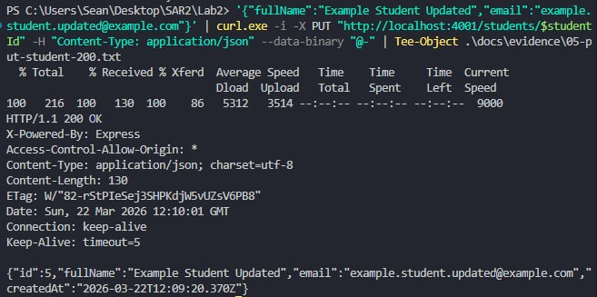

Step 6 - POST course (201)
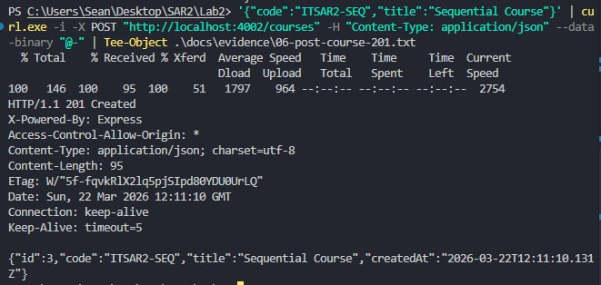

Step 7 - GET created course by ID (200)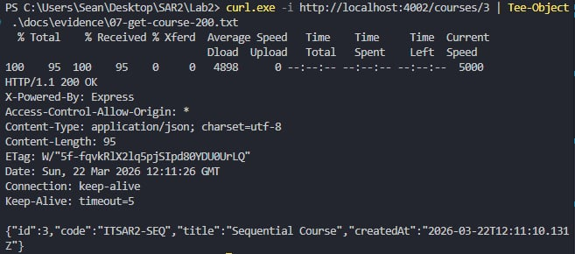

Step 8 - PUT update course (200)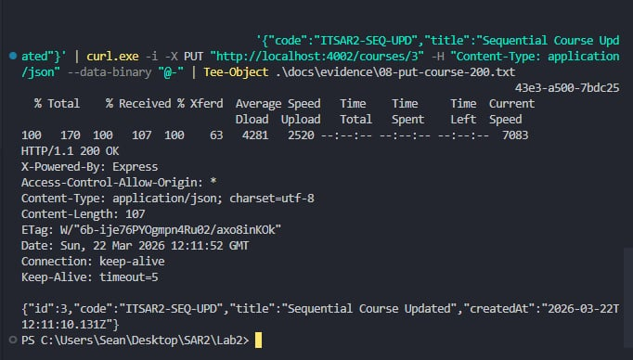

Step 9 - POST enrollment (201)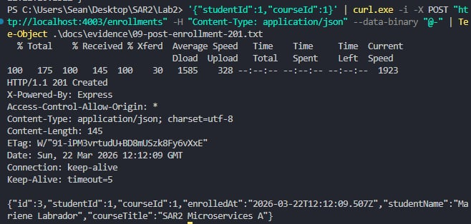

Step 10 - GET enrollment by ID (200)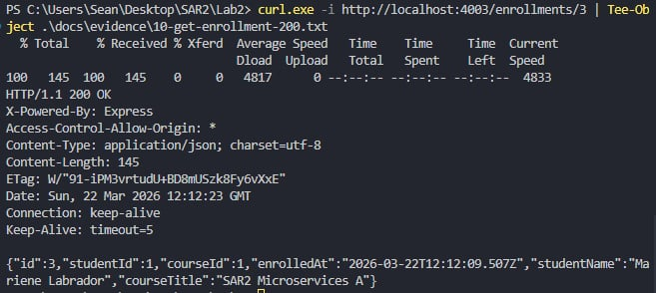

Step 11 - GET enrollments list (200)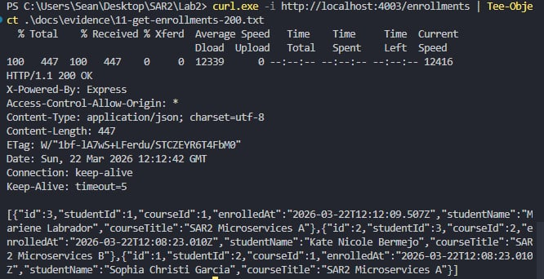

Step 12 - Validation: POST student missing fullName (400)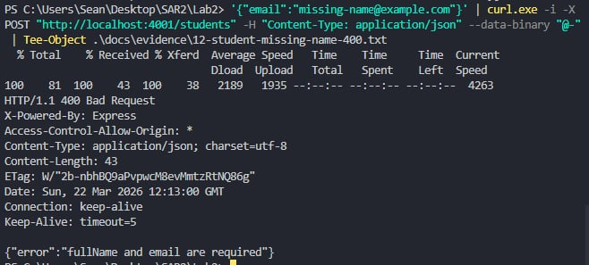

Step 13 - Validation: POST student missing email (400)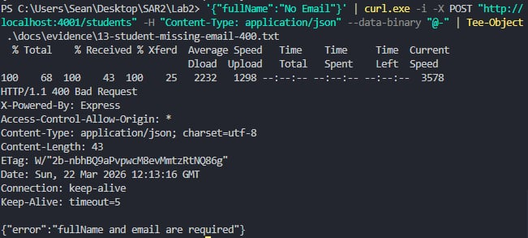

Step 14 - Validation: POST enrollment missing courseId (400)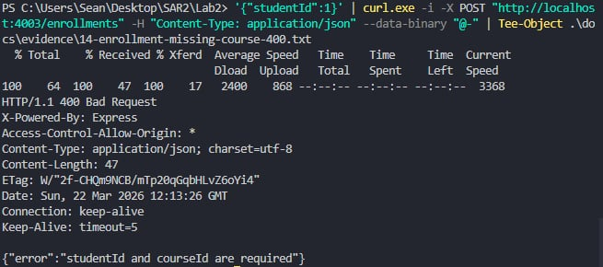

Step 15 - Not Found: GET nonexistent student (404)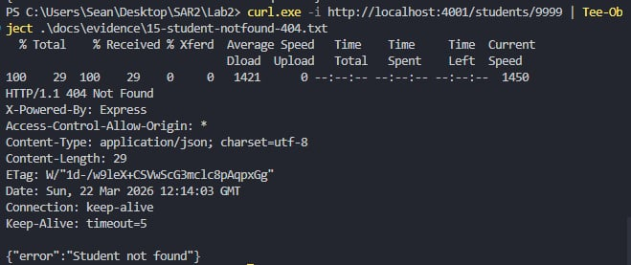

Step 16 - Not Found: GET nonexistent course (404)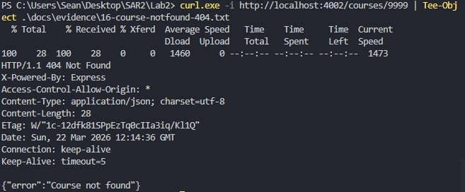

Step 17 - Not Found: GET nonexistent enrollment (404)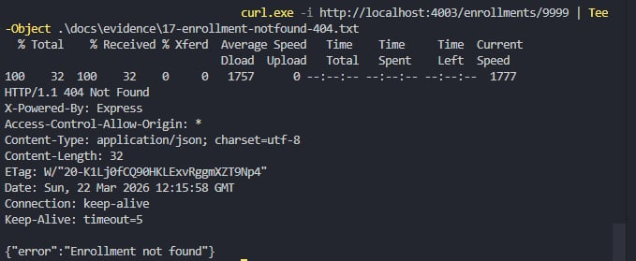

Step 18 - Duplicate: POST student with existing email (409)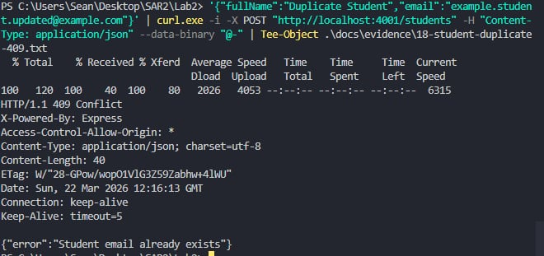

Step 19 - Duplicate: POST enrollment already enrolled (409)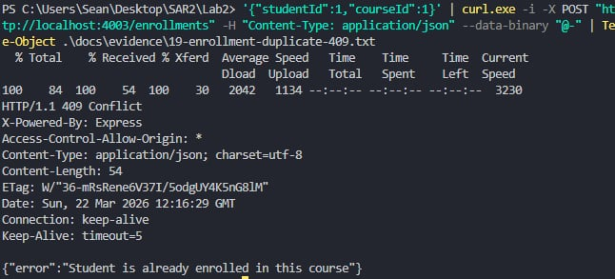

Step 20 - Cross-service Not Found: nonexistent studentId (404)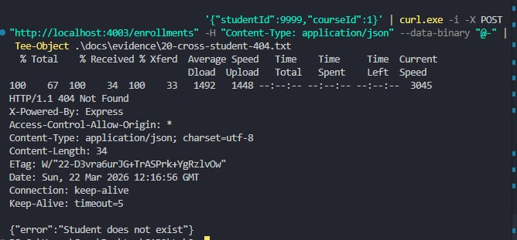

Step 21 - Cross-service Not Found: nonexistent courseId (404)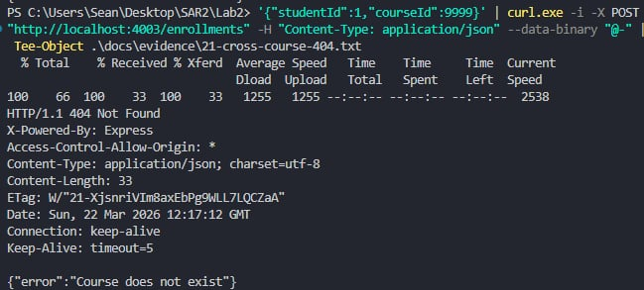

Step 22 - Dependency Down simulation

Terminal 5: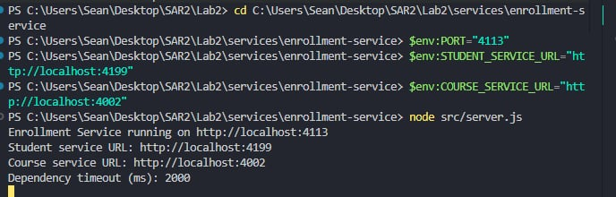

Terminal 4: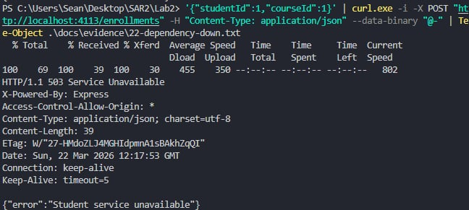
Expected after update: 503 Service Unavailable with error about student service unavailable.

Step 23 - Timeout simulation

Terminal 6:
No command needed. Keep the main student-service running on port 4001 in Terminal 1.

Terminal 7: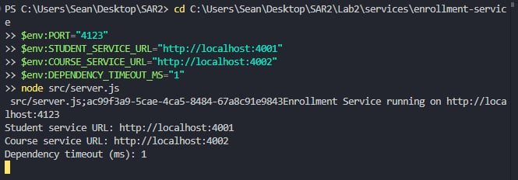

Terminal 4: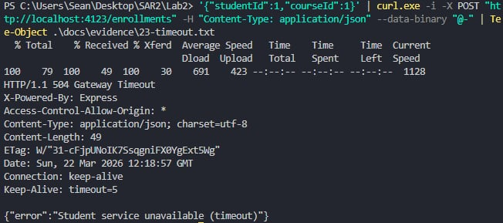
Expected after update: 504 Gateway Timeout with error about student service unavailable (timeout).

Step 24 - DELETE enrollment by student (200)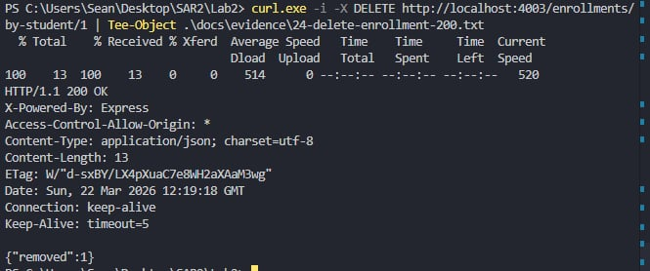
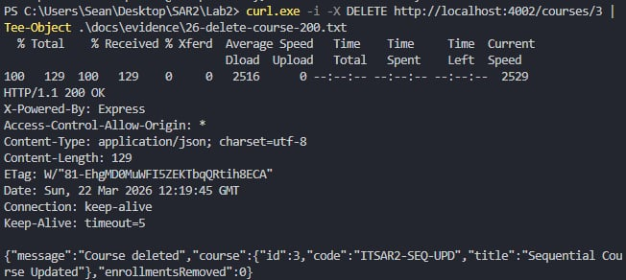
Step 25 - DELETE student (200)

Step 26 - DELETE course (200)

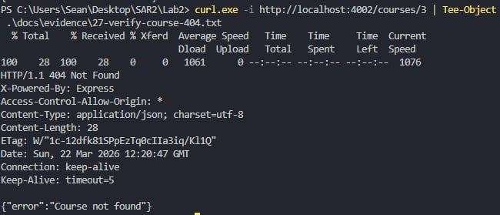
Step 27 - Verify cleanup returns 404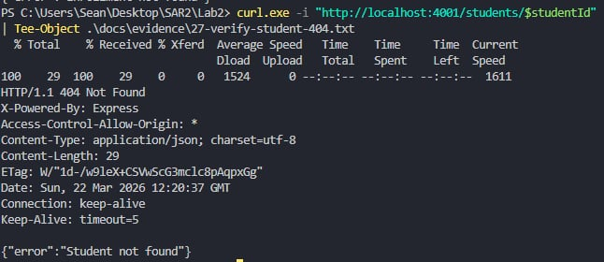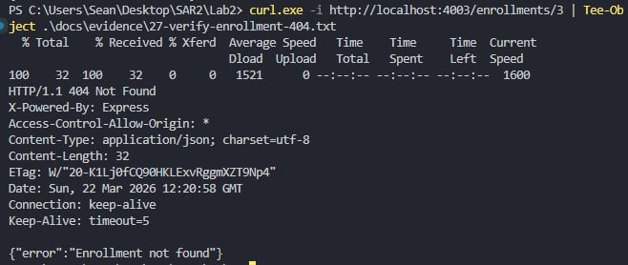

Member Dummy Data (Our Team)

These records are now seeded automatically on service start. Running the commands below may return 409 duplicate responses.

'{"fullName":"Mariene Labrador","email":"mariene.labrador.bsit3b@example.com"}' | curl.exe -i -X POST "http://localhost:4001/students" -H "Content-Type: application/json" --data-binary "@-" '{"fullName":"Sophia Christi Garcia","email":"sophia.garcia.bsit3b@example.com"}' | curl.exe -i -X POST "http://localhost:4001/students" -H "Content-Type: application/json" --data-binary "@-" '{"fullName":"Kate Nicole Bermejo","email":"kate.bermejo.bsit3b@example.com"}' | curl.exe -i -X POST "http://localhost:4001/students" -H "Content-Type: application/json" --data-binary "@-" '{"fullName":"Carla Andura","email":"carla.andura.bsit3b@example.com"}' | curl.exe -i -X POST "http://localhost:4001/students" -H "Content-Type: application/json" --data-binary "@-"

III. EXPERIMENTAL FINDINGS / OBSERVATIONS
All 27 test steps executed in sequential order returned the correct HTTP status codes in the Node.js/Express environment.
Steps 1 through 11 confirmed that all three services respond correctly to valid CRUD operations. The responses successfully returned JSON objects containing the id, createdAt, and relevant data fields.
Steps 12 through 14 confirmed that validation errors effectively catch missing parameters, returning HTTP 400 with specific messages such as {"error":"fullName and email are required"}. Steps 15 through 17 successfully demonstrated standard not-found handling, returning HTTP 404 with messages like {"error":"Student not found"}.
Steps 20 and 21 validated cross-service communication capabilities. The enrollment-service correctly queried the upstream student and course services, mapping their empty or failing responses to proper 404 errors ({"error":"Student does not exist"}).
Duplicate detection functioned flawlessly in Steps 18 and 19, halting duplicate data entry and throwing 409 Conflict errors.
The dependency failure tests in Steps 22 and 23 successfully demonstrated fault tolerance and proper error mapping. By using environment variables to point to a dead port, the service triggered a connection refusal and returned HTTP 503. By drastically lowering the timeout threshold (DEPENDENCY_TIMEOUT_MS="1"), the system triggered a timeout exception and correctly returned HTTP 504 {"error": "Student service unavailable (timeout)"}.
IV. DISCUSSIONS
Consistent error string contracts across all three Express services are essential for predictable frontend error handling. Because all three services reliably output the {"error": "..."} format when failing, client applications can easily parse and display these messages without requiring complex, service-specific logic.
Only the enrollment-service is capable of returning 503 and 504 errors because it is the only microservice in this architecture with external HTTP dependencies. When creating an enrollment, the service makes outbound network requests to verify both the student and the course. The student and course services only query their local SQLite databases and make no outbound calls; therefore, network timeouts and unavailable upstream dependencies are architecturally impossible for them.
The clever use of environment variables (PORT, STUDENT_SERVICE_URL, DEPENDENCY_TIMEOUT_MS) in PowerShell to simulate dependency failures (Steps 22 and 23) highlights the flexibility of Node.js microservices. Instead of modifying source code (like injecting sleep() functions), manipulating the environment allowed for rapid, configuration-driven edge case testing.
V. CONCLUSION
All 27 sequential test steps were executed via Windows PowerShell and confirmed to return the correct HTTP status codes and JSON error bodies. The test suite thoroughly covered every endpoint across the Node.js microservices: happy path CRUD, input validation errors, not-found scenarios, duplicate detection, cross-service communication, dependency failures, and resource cleanup.
Microservices introduce unique failure modes, specifically 503 Service Unavailable and 504 Gateway Timeout, that monolithic applications do not face. Testing confirmed that the enrollment-service—acting as the single point of cross-service communication—successfully implemented resilience handling to catch and format these network exceptions.
Future production improvements could include adding circuit breakers to prevent cascade failures when upstream services are down, implementing retry logic with exponential backoff for transient timeouts, and centralizing logs to trace requests as they jump between the isolated Express APIs.
References
Express.js Documentation. (2024). Fast, unopinionated, minimalist web framework for Node.js. https://expressjs.com/
Fowler, M. (2002). Patterns of Enterprise Application Architecture. Addison-Wesley.
Richardson, C. (2018). Microservices Patterns. Manning Publications.
Mozilla Developer Network. (2024). HTTP Status Codes. https://developer.mozilla.org/en-US/docs/Web/HTTP/Status
curl Documentation. (2024). curl command line tool and library. https://curl.se/docs/

