SMART School Management System

Entity Relationship Diagram (ERD)
Technical Documentation

Database: PostgreSQL | ORM: Prisma
Source: server/prisma/schema.prisma
Total Entities: 29 | Total Relationships: 34 | Enumerations: 16
Modules: 10 (Auth, Students, Academic, Teaching, Grades, Attendance,
Remedial, System Config, Atlas Integration, Audit & Sync)

Table of Contents
1. System Overview
2. ERD Diagrams by Module
3. Entity Field Definitions
4. Relationships Summary
5. Enumeration Types

1. System Overview
The SMART School Management System is a DepEd-aligned secondary education records platform built on PostgreSQL (via Prisma ORM). It handles student records, academic structure, grading, attendance, scheduling, and integration with companion systems (EnrollPro and Atlas).
- Auth & Users: Role-based user accounts (Admin, Teacher, Registrar) with refresh token rotation and reverse SSO to EnrollPro via CompanionSsoCode.
- Students: Student master records with extended DepEd profile fields, transferee tracking, and prior-school academic records (ExternalSchoolRecord).
- Academic Structure: Sections, subjects, and enrollments. Tracks promotion, retention, and enrollment lifecycle (dropped, transferred, archived).
- Teaching: ClassAssignment links Teacher+Subject+Section per school year. ScheduleEntry stores Atlas-synced timetables. WorkloadEntry tracks advisory load.
- Grades: Term-based (T1/T2/T3) grading with written work, performance tasks, QA. GradeSnapshot for history. AimsScore ingests AIMS quiz/task data. GradeEditRequest enables admin-controlled unlock workflow.
- Attendance: Daily per-student-per-section attendance with PRESENT/ABSENT/LATE/EXCUSED statuses.
- Remedial: RemedialClass records for EOSY remedial interventions per enrollment.
- System & Config: SchoolYear management with YearGradeLock and TermGradeLock. SystemSettings (singleton). GradingConfig weights. TransmutationEntry table. ExcelTemplate for SF form uploads.
- Atlas Integration: AtlasCrosswalk maps Atlas surrogate IDs to SMART entities. AtlasScheduleMeta caches published schedule provenance per school year.
- Audit & Sync: AuditLog captures every user action with device/network metadata. SyncHistory records EnrollPro and Atlas sync runs.

2. ERD Diagrams by Module

2.1 Auth & Users
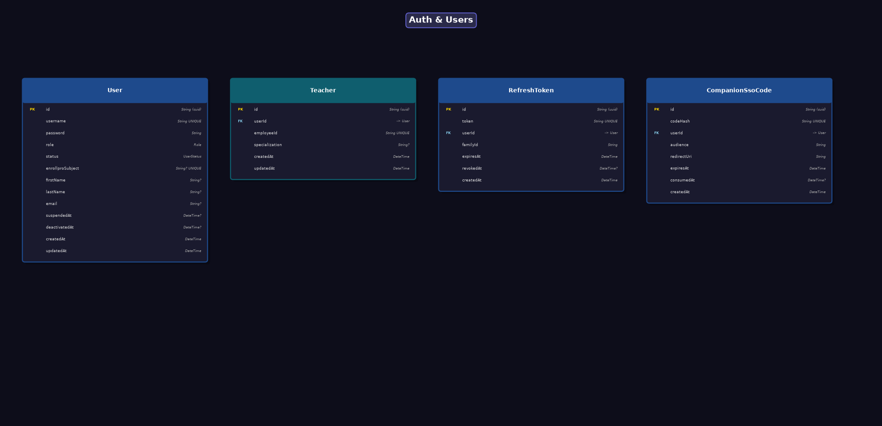

2.2 Students
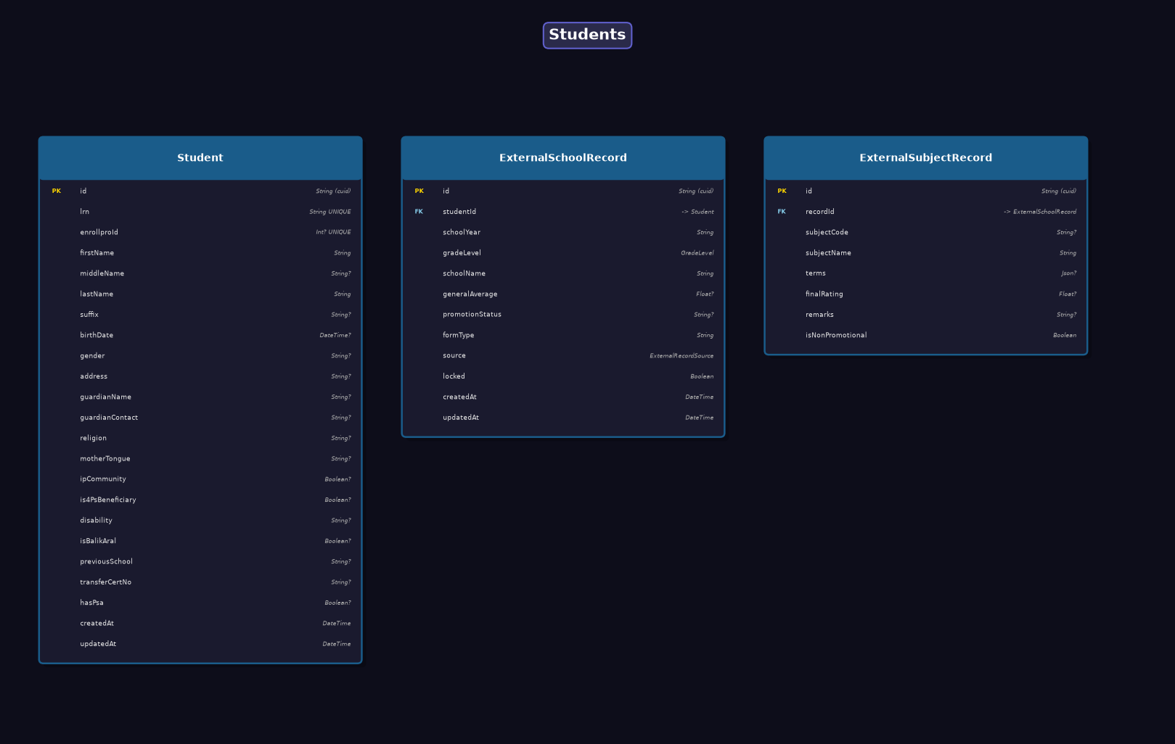

2.3 Academic Structure
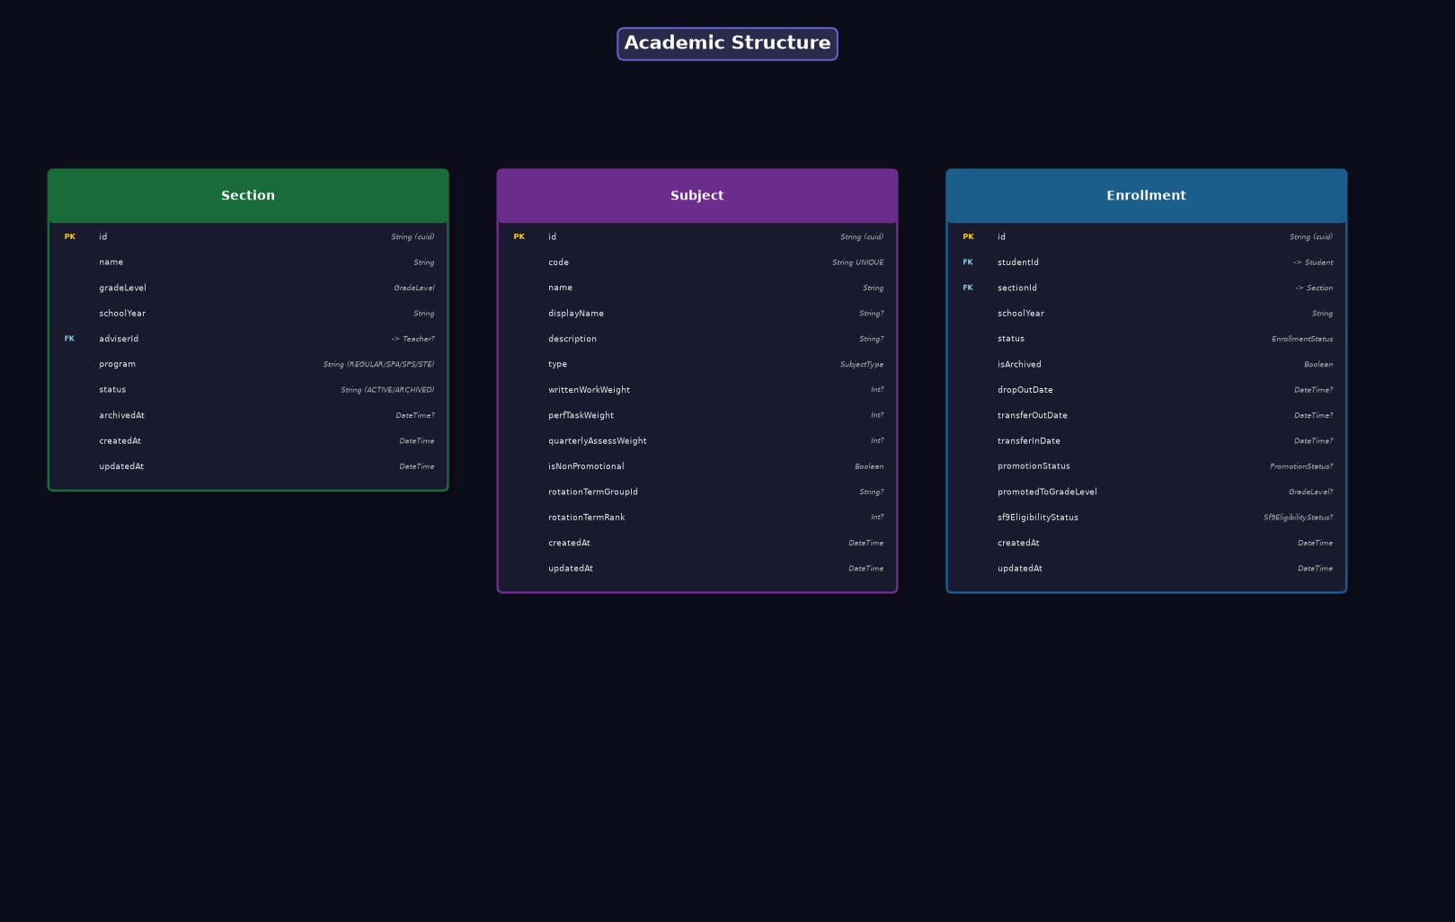

2.4 Teaching
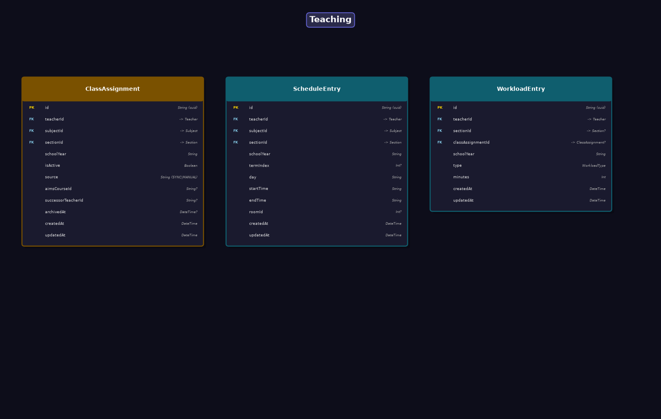

2.5 Grades
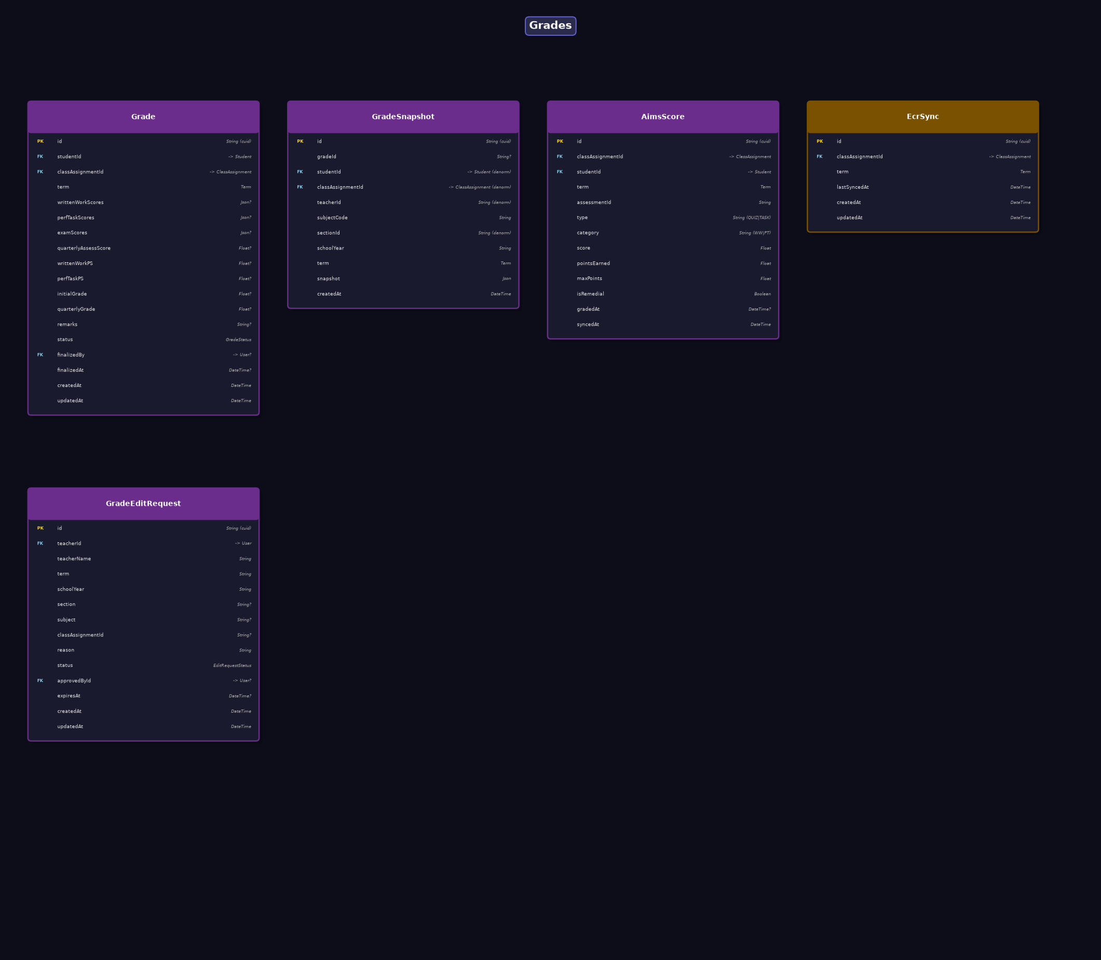

2.6 Attendance
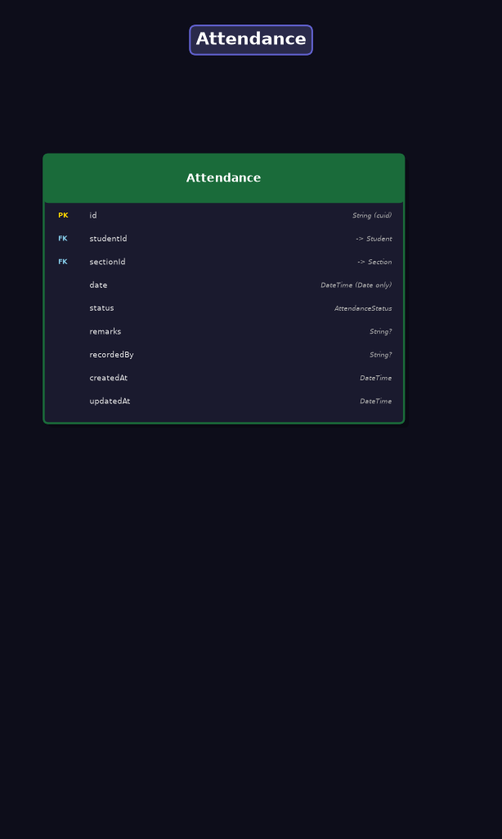

2.7 Remedial
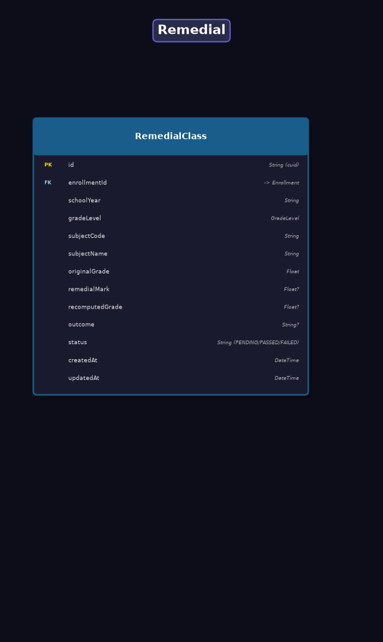

2.8 System & Config
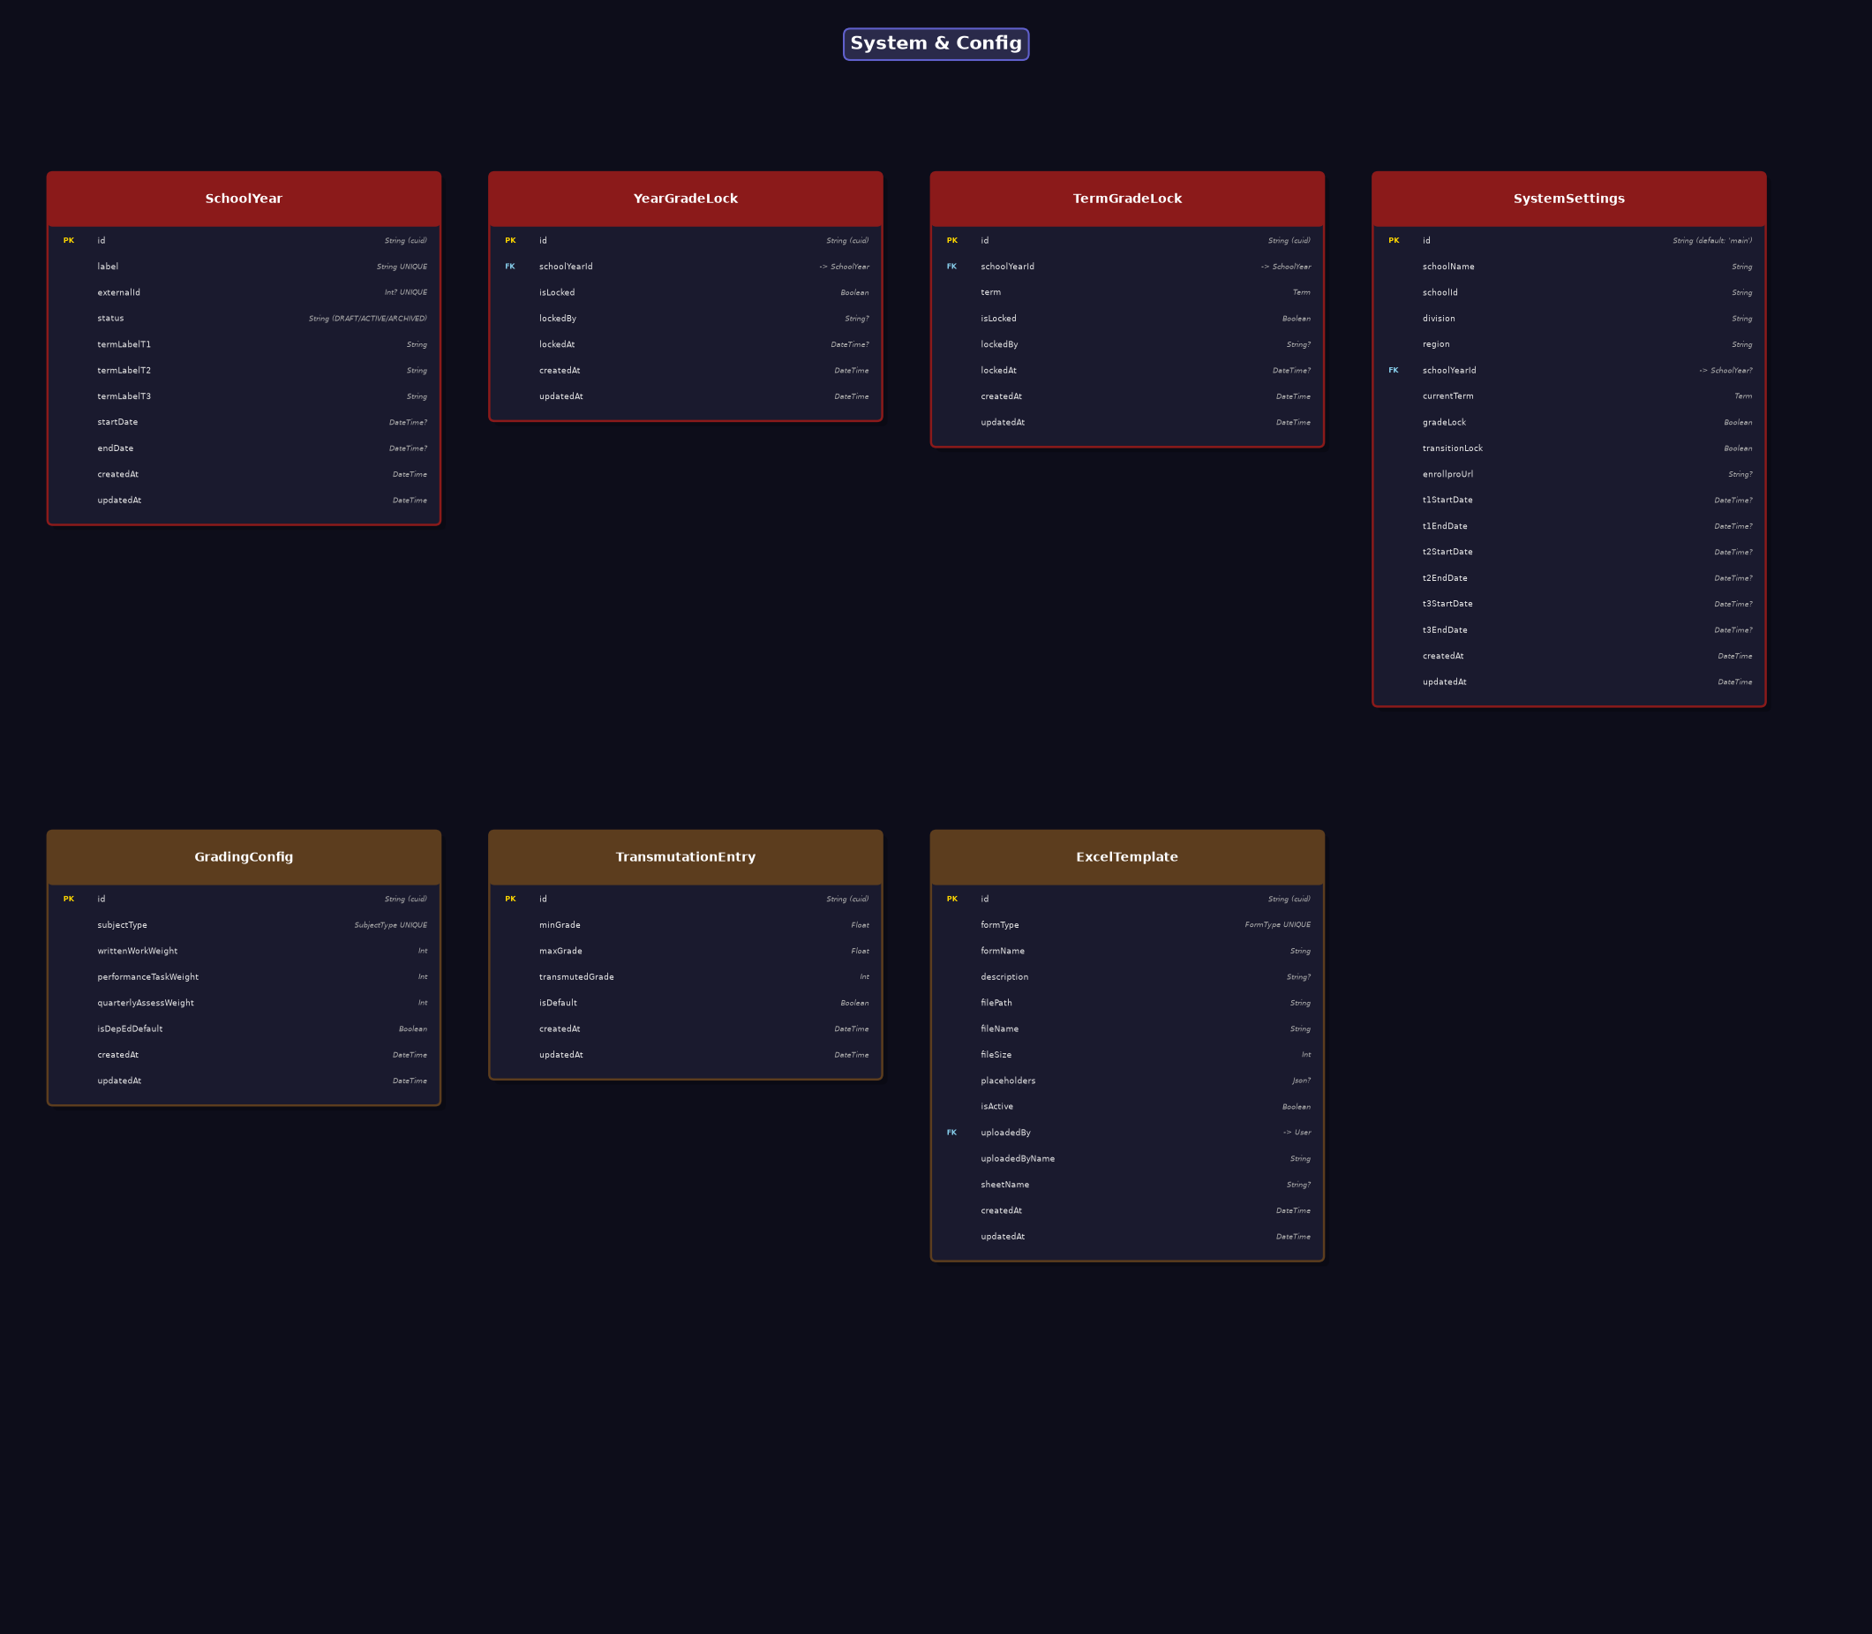

2.9 Atlas Integration
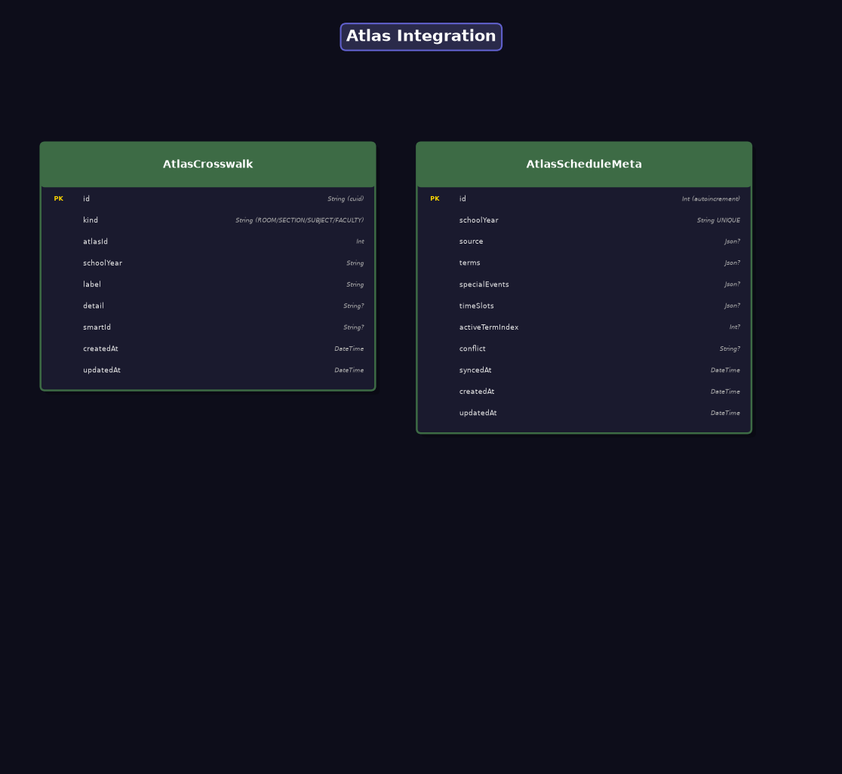

2.10 Audit & Sync
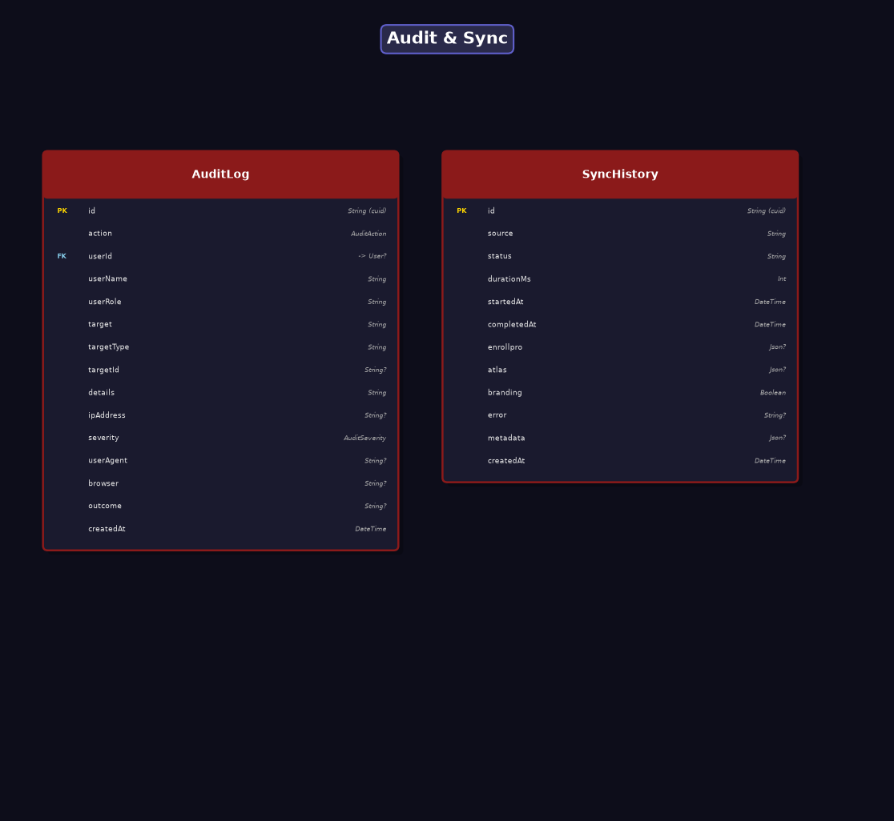

3. Entity Field Definitions
Every entity (database table) and its fields are listed below. PK = Primary Key, FK = Foreign Key. Field types follow Prisma schema conventions.

Auth & Users

User
Key | Field Name | Type / Constraint | Notes
PK | id | String (cuid) | Primary Key
 | username | String UNIQUE
 | password | String
 | role | Role
 | status | UserStatus
 | enrollproSubject | String? UNIQUE
 | firstName | String?
 | lastName | String?
 | email | String?
 | suspendedAt | DateTime?
 | deactivatedAt | DateTime?
 | createdAt | DateTime
 | updatedAt | DateTime

Teacher
Key | Field Name | Type / Constraint | Notes
PK | id | String (cuid) | Primary Key
FK | userId | -> User | Foreign Key
 | employeeId | String UNIQUE
 | specialization | String?
 | createdAt | DateTime
 | updatedAt | DateTime

RefreshToken
Key | Field Name | Type / Constraint | Notes
PK | id | String (uuid) | Primary Key
 | token | String UNIQUE
FK | userId | -> User | Foreign Key
 | familyId | String
 | expiresAt | DateTime
 | revokedAt | DateTime?
 | createdAt | DateTime

CompanionSsoCode
Key | Field Name | Type / Constraint | Notes
PK | id | String (cuid) | Primary Key
 | codeHash | String UNIQUE
FK | userId | -> User | Foreign Key
 | audience | String
 | redirectUri | String
 | expiresAt | DateTime
 | consumedAt | DateTime?
 | createdAt | DateTime

Students

Student
Key | Field Name | Type / Constraint | Notes
PK | id | String (cuid) | Primary Key
 | lrn | String UNIQUE
 | enrollproId | Int? UNIQUE
 | firstName | String
 | middleName | String?
 | lastName | String
 | suffix | String?
 | birthDate | DateTime?
 | gender | String?
 | address | String?
 | guardianName | String?
 | guardianContact | String?
 | religion | String?
 | motherTongue | String?
 | ipCommunity | Boolean?
 | is4PsBeneficiary | Boolean?
 | disability | String?
 | isBalikAral | Boolean?
 | previousSchool | String?
 | transferCertNo | String?
 | hasPsa | Boolean?
 | createdAt | DateTime
 | updatedAt | DateTime

ExternalSchoolRecord
Key | Field Name | Type / Constraint | Notes
PK | id | String (cuid) | Primary Key
FK | studentId | -> Student | Foreign Key
 | schoolYear | String
 | gradeLevel | GradeLevel
 | schoolName | String
 | generalAverage | Float?
 | promotionStatus | String?
 | formType | String
 | source | ExternalRecordSource
 | locked | Boolean
 | createdAt | DateTime
 | updatedAt | DateTime

ExternalSubjectRecord
Key | Field Name | Type / Constraint | Notes
PK | id | String (cuid) | Primary Key
FK | recordId | -> ExternalSchoolRecord | Foreign Key
 | subjectCode | String?
 | subjectName | String
 | terms | Json?
 | finalRating | Float?
 | remarks | String?
 | isNonPromotional | Boolean

Academic Structure

Section
Key | Field Name | Type / Constraint | Notes
PK | id | String (cuid) | Primary Key
 | name | String
 | gradeLevel | GradeLevel
 | schoolYear | String
FK | adviserId | -> Teacher? | Foreign Key
 | program | String (REGULAR/SPA/SPS/STE)
 | status | String (ACTIVE/ARCHIVED)
 | archivedAt | DateTime?
 | createdAt | DateTime
 | updatedAt | DateTime

Subject
Key | Field Name | Type / Constraint | Notes
PK | id | String (cuid) | Primary Key
 | code | String UNIQUE
 | name | String
 | displayName | String?
 | description | String?
 | type | SubjectType
 | writtenWorkWeight | Int?
 | perfTaskWeight | Int?
 | quarterlyAssessWeight | Int?
 | isNonPromotional | Boolean
 | rotationTermGroupId | String?
 | rotationTermRank | Int?
 | createdAt | DateTime
 | updatedAt | DateTime

Enrollment
Key | Field Name | Type / Constraint | Notes
PK | id | String (cuid) | Primary Key
FK | studentId | -> Student | Foreign Key
FK | sectionId | -> Section | Foreign Key
 | schoolYear | String
 | status | EnrollmentStatus
 | isArchived | Boolean
 | dropOutDate | DateTime?
 | transferOutDate | DateTime?
 | transferInDate | DateTime?
 | promotionStatus | PromotionStatus?
 | promotedToGradeLevel | GradeLevel?
 | sf9EligibilityStatus | Sf9EligibilityStatus?
 | createdAt | DateTime
 | updatedAt | DateTime

Teaching

ClassAssignment
Key | Field Name | Type / Constraint | Notes
PK | id | String (cuid) | Primary Key
FK | teacherId | -> Teacher | Foreign Key
FK | subjectId | -> Subject | Foreign Key
FK | sectionId | -> Section | Foreign Key
 | schoolYear | String
 | isActive | Boolean
 | source | String (SYNC|MANUAL)
 | aimsCourseId | String?
 | successorTeacherId | String?
 | archivedAt | DateTime?
 | createdAt | DateTime
 | updatedAt | DateTime

ScheduleEntry
Key | Field Name | Type / Constraint | Notes
PK | id | String (cuid) | Primary Key
FK | teacherId | -> Teacher | Foreign Key
FK | subjectId | -> Subject | Foreign Key
FK | sectionId | -> Section | Foreign Key
 | schoolYear | String
 | termIndex | Int?
 | day | String
 | startTime | String
 | endTime | String
 | roomId | Int?
 | createdAt | DateTime
 | updatedAt | DateTime

WorkloadEntry
Key | Field Name | Type / Constraint | Notes
PK | id | String (cuid) | Primary Key
FK | teacherId | -> Teacher | Foreign Key
FK | sectionId | -> Section? | Foreign Key
FK | classAssignmentId | -> ClassAssignment? | Foreign Key
 | schoolYear | String
 | type | WorkloadType
 | minutes | Int
 | createdAt | DateTime
 | updatedAt | DateTime

Grades

Grade
Key | Field Name | Type / Constraint | Notes
PK | id | String (cuid) | Primary Key
FK | studentId | -> Student | Foreign Key
FK | classAssignmentId | -> ClassAssignment | Foreign Key
 | term | Term
 | writtenWorkScores | Json?
 | perfTaskScores | Json?
 | examScores | Json?
 | quarterlyAssessScore | Float?
 | writtenWorkPS | Float?
 | perfTaskPS | Float?
 | initialGrade | Float?
 | quarterlyGrade | Float?
 | remarks | String?
 | status | GradeStatus
FK | finalizedBy | -> User? | Foreign Key
 | finalizedAt | DateTime?
 | createdAt | DateTime
 | updatedAt | DateTime

GradeSnapshot
Key | Field Name | Type / Constraint | Notes
PK | id | String (cuid) | Primary Key
 | gradeId | String?
FK | studentId | -> Student (denorm) | Foreign Key
FK | classAssignmentId | -> ClassAssignment (denorm) | Foreign Key
 | teacherId | String (denorm)
 | subjectCode | String
 | sectionId | String (denorm)
 | schoolYear | String
 | term | Term
 | snapshot | Json
 | createdAt | DateTime

AimsScore
Key | Field Name | Type / Constraint | Notes
PK | id | String (cuid) | Primary Key
FK | classAssignmentId | -> ClassAssignment | Foreign Key
FK | studentId | -> Student | Foreign Key
 | term | Term
 | assessmentId | String
 | type | String (QUIZ|TASK)
 | category | String (WW|PT)
 | score | Float
 | pointsEarned | Float
 | maxPoints | Float
 | isRemedial | Boolean
 | gradedAt | DateTime?
 | syncedAt | DateTime

EcrSync
Key | Field Name | Type / Constraint | Notes
PK | id | String (cuid) | Primary Key
FK | classAssignmentId | -> ClassAssignment | Foreign Key
 | term | Term
 | lastSyncedAt | DateTime
 | createdAt | DateTime
 | updatedAt | DateTime

GradeEditRequest
Key | Field Name | Type / Constraint | Notes
PK | id | String (cuid) | Primary Key
FK | teacherId | -> User | Foreign Key
 | teacherName | String
 | term | String
 | schoolYear | String
 | section | String?
 | subject | String?
 | classAssignmentId | String?
 | reason | String
 | status | EditRequestStatus
FK | approvedById | -> User? | Foreign Key
 | expiresAt | DateTime?
 | createdAt | DateTime
 | updatedAt | DateTime

Attendance

Attendance
Key | Field Name | Type / Constraint | Notes
PK | id | String (cuid) | Primary Key
FK | studentId | -> Student | Foreign Key
FK | sectionId | -> Section | Foreign Key
 | date | DateTime (Date only)
 | status | AttendanceStatus
 | remarks | String?
 | recordedBy | String?
 | createdAt | DateTime
 | updatedAt | DateTime

Remedial

RemedialClass
Key | Field Name | Type / Constraint | Notes
PK | id | String (cuid) | Primary Key
FK | enrollmentId | -> Enrollment | Foreign Key
 | schoolYear | String
 | gradeLevel | GradeLevel
 | subjectCode | String
 | subjectName | String
 | originalGrade | Float
 | remedialMark | Float?
 | recomputedGrade | Float?
 | outcome | String?
 | status | String (PENDING/PASSED/FAILED)
 | createdAt | DateTime
 | updatedAt | DateTime

System & Config

SchoolYear
Key | Field Name | Type / Constraint | Notes
PK | id | String (cuid) | Primary Key
 | label | String UNIQUE
 | externalId | Int? UNIQUE
 | status | String (DRAFT/ACTIVE/ARCHIVED)
 | termLabelT1 | String
 | termLabelT2 | String
 | termLabelT3 | String
 | startDate | DateTime?
 | endDate | DateTime?
 | createdAt | DateTime
 | updatedAt | DateTime

YearGradeLock
Key | Field Name | Type / Constraint | Notes
PK | id | String (cuid) | Primary Key
FK | schoolYearId | -> SchoolYear | Foreign Key
 | isLocked | Boolean
 | lockedBy | String?
 | lockedAt | DateTime?
 | createdAt | DateTime
 | updatedAt | DateTime

TermGradeLock
Key | Field Name | Type / Constraint | Notes
PK | id | String (cuid) | Primary Key
FK | schoolYearId | -> SchoolYear | Foreign Key
 | term | Term
 | isLocked | Boolean
 | lockedBy | String?
 | lockedAt | DateTime?
 | createdAt | DateTime
 | updatedAt | DateTime

SystemSettings
Key | Field Name | Type / Constraint | Notes
PK | id | String (default: 'main') | Primary Key
 | schoolName | String
 | schoolId | String
 | division | String
 | region | String
FK | schoolYearId | -> SchoolYear? | Foreign Key
 | currentTerm | Term
 | gradeLock | Boolean
 | transitionLock | Boolean
 | enrollproUrl | String?
 | t1StartDate | DateTime?
 | t1EndDate | DateTime?
 | t2StartDate | DateTime?
 | t2EndDate | DateTime?
 | t3StartDate | DateTime?
 | t3EndDate | DateTime?
 | createdAt | DateTime
 | updatedAt | DateTime

GradingConfig
Key | Field Name | Type / Constraint | Notes
PK | id | String (cuid) | Primary Key
 | subjectType | SubjectType UNIQUE
 | writtenWorkWeight | Int
 | performanceTaskWeight | Int
 | quarterlyAssessWeight | Int
 | isDepEdDefault | Boolean
 | createdAt | DateTime
 | updatedAt | DateTime

TransmutationEntry
Key | Field Name | Type / Constraint | Notes
PK | id | String (cuid) | Primary Key
 | minGrade | Float
 | maxGrade | Float
 | transmutedGrade | Int
 | isDefault | Boolean
 | createdAt | DateTime
 | updatedAt | DateTime

ExcelTemplate
Key | Field Name | Type / Constraint | Notes
PK | id | String (cuid) | Primary Key
 | formType | FormType UNIQUE
 | formName | String
 | description | String?
 | filePath | String
 | fileName | String
 | fileSize | Int
 | placeholders | Json?
 | isActive | Boolean
FK | uploadedBy | -> User | Foreign Key
 | uploadedByName | String
 | sheetName | String?
 | createdAt | DateTime
 | updatedAt | DateTime

Atlas Integration

AtlasCrosswalk
Key | Field Name | Type / Constraint | Notes
PK | id | String (cuid) | Primary Key
 | kind | String (ROOM/SECTION/SUBJECT/FACULTY)
 | atlasId | Int
 | schoolYear | String
 | label | String
 | detail | String?
 | smartId | String?
 | createdAt | DateTime
 | updatedAt | DateTime

AtlasScheduleMeta
Key | Field Name | Type / Constraint | Notes
PK | id | Int (autoincrement) | Primary Key
 | schoolYear | String UNIQUE
 | source | Json?
 | terms | Json?
 | specialEvents | Json?
 | timeSlots | Json?
 | activeTermIndex | Int?
 | conflict | String?
 | syncedAt | DateTime
 | createdAt | DateTime
 | updatedAt | DateTime

Audit & Sync

AuditLog
Key | Field Name | Type / Constraint | Notes
PK | id | String (cuid) | Primary Key
 | action | AuditAction
FK | userId | -> User? | Foreign Key
 | userName | String
 | userRole | String
 | target | String
 | targetType | String
 | targetId | String?
 | details | String
 | ipAddress | String?
 | severity | AuditSeverity
 | userAgent | String?
 | browser | String?
 | outcome | String?
 | createdAt | DateTime

SyncHistory
Key | Field Name | Type / Constraint | Notes
PK | id | String (cuid) | Primary Key
 | source | String
 | status | String
 | durationMs | Int
 | startedAt | DateTime
 | completedAt | DateTime
 | enrollpro | Json?
 | atlas | Json?
 | branding | Boolean
 | error | String?
 | metadata | Json?
 | createdAt | DateTime

4. Relationships Summary
This table summarizes all foreign key relationships in the SMART database schema. Cardinality: 1:1 = one-to-one, N:1 = many-to-one (many on the left, one on the right).

From Entity | FK Field | To Entity | Cardinality | Description
Teacher | userId | User | 1:1 | A Teacher has one User account
RefreshToken | userId | User | N:1 | Many refresh tokens per user
CompanionSsoCode | userId | User | N:1 | Many SSO codes per user
Section | adviserId | Teacher | N:1 | Section has one adviser (Teacher)
ClassAssignment | teacherId | Teacher | N:1 | Teacher has many class assignments
ClassAssignment | subjectId | Subject | N:1 | Subject has many class assignments
ClassAssignment | sectionId | Section | N:1 | Section has many class assignments
Enrollment | studentId | Student | N:1 | Student has many enrollments
Enrollment | sectionId | Section | N:1 | Section has many enrollments
Grade | studentId | Student | N:1 | Student has many grades
Grade | classAssignmentId | ClassAssignment | N:1 | ClassAssignment has many grades
Grade | finalizedBy | User | N:1 | User finalizes many grades
Attendance | studentId | Student | N:1 | Student has many attendance records
Attendance | sectionId | Section | N:1 | Section has many attendance records
AuditLog | userId | User | N:1 | User generates many audit logs
ExcelTemplate | uploadedBy | User | N:1 | User uploads many excel templates
ScheduleEntry | teacherId | Teacher | N:1 | Teacher has many schedule entries
ScheduleEntry | subjectId | Subject | N:1 | Subject has many schedule entries
ScheduleEntry | sectionId | Section | N:1 | Section has many schedule entries
WorkloadEntry | teacherId | Teacher | N:1 | Teacher has many workload entries
WorkloadEntry | sectionId | Section | N:1 | Section has many workload entries
WorkloadEntry | classAssignmentId | ClassAssignment | N:1 | ClassAssignment has many workload entries
AimsScore | classAssignmentId | ClassAssignment | N:1 | ClassAssignment has many AIMS scores
AimsScore | studentId | Student | N:1 | Student has many AIMS scores
EcrSync | classAssignmentId | ClassAssignment | N:1 | ClassAssignment has many ECR syncs
RemedialClass | enrollmentId | Enrollment | N:1 | Enrollment has many remedial classes
ExternalSchoolRecord | studentId | Student | N:1 | Student has many external records
ExternalSubjectRecord | recordId | ExternalSchoolRecord | N:1 | External record has many subject records
GradeSnapshot | classAssignmentId | ClassAssignment | N:1 | ClassAssignment has many grade snapshots
YearGradeLock | schoolYearId | SchoolYear | 1:1 | SchoolYear has one year grade lock
TermGradeLock | schoolYearId | SchoolYear | N:1 | SchoolYear has many term grade locks
SystemSettings | schoolYearId | SchoolYear | N:1 | SchoolYear referenced in system settings
GradeEditRequest | teacherId | User | N:1 | Teacher (User) makes many edit requests
GradeEditRequest | approvedById | User | N:1 | Admin (User) approves many edit requests

5. Enumeration Types
Enumerations define the fixed set of allowed values for specific fields, enforced at the PostgreSQL database level through Prisma.

Enum Name | Allowed Values
Role | TEACHER, ADMIN, REGISTRAR
UserStatus | ACTIVE, SUSPENDED, DEACTIVATED
GradeStatus | DRAFT, FINALIZED, LOCKED
Term | T1, T2, T3
GradeLevel | GRADE_7, GRADE_8, GRADE_9, GRADE_10
SubjectType | CORE, MAPEH, TLE, MATH_SCIENCE
WorkloadType | ADVISORY_ROLE
AttendanceStatus | PRESENT, ABSENT, LATE, EXCUSED
EnrollmentStatus | ENROLLED, PENDING, DROPPED, TRANSFERRED
PromotionStatus | PROMOTED, CONDITIONALLY_PROMOTED, RETAINED, JHS_COMPLETER
Sf9EligibilityStatus | PROMOTED, CONDITIONALLY_PROMOTED, RETAINED
AuditAction | CREATE, UPDATE, DELETE, LOGIN, LOGOUT, CONFIG
AuditSeverity | INFO, WARNING, CRITICAL
FormType | SF1, SF2, SF3, SF4, SF5, SF6, SF7, SF8, SF9, SF10
EditRequestStatus | PENDING, APPROVED, REJECTED, EXPIRED
ExternalRecordSource | MANUAL, SF10_SCAN, SF9_SCAN, SF10_XLSX

End of SMART ERD Technical Document
Source: server/prisma/schema.prisma | PostgreSQL + Prisma ORM

