Databases with Python

Documentation

Author: Michał Deć

Nowy Sącz, 2024

List of contents
1. Project Scope 4
2. Installing Linux Debian Virtual Machine 5
2.1 Downloading image 5
2.2 Creating new Virtual Machine 5
2.3 Installing Debian 6
2.4 Viewing Debian 7
3. Setting up Debian environment 8
3.1 Network interface configuration 8
3.2 Installing Database Server 12
3.3 Confiuring MariaDB 14
4. Python application 17
4.1 Client control panel 17
4.1.1 main() function 17
4.2 Adding client 18
4.2.1 is_email() function 18
4.2.2 hash_password() function 18
4.2.3 add_client function() 19
4.2.4 create_client() function 20
4.3 Client login 21
4.4 Client Functions 22
4.4.1 Choice 1 22
4.4.2 Choice 2 22
4.4.3 Choice 3 23
4.4.4 Choice 4 23
4.5 Admin Panel 24
4.6 Add Car 25
4.7 View Orders 26
5. Testing 27
5.1 Adding a client 27
5.2 Logging in as a client 28
5.3 Adding a new car 29
5.4 Viewing all clients orders 30
6. Materials and resources used for the need of this report 31

1. Project Scope

We will code simple application in Python. This application will map car dealer. All the data will be stored in database. Application will allow for creating new clients, adding new cars, and order fulfillment.

Using Virtual Box, we will create new Linux Debian virtual machine. We will install MariaDB database server. In Python application we will write scripts to database, which will allow for registering new clients, adding new cars, and processing orders. All the registered data will be stored in database.

In Python application we will implement basic defense mechanisms. Passwords will be hashed before stored in database. Client will have to login to application before he can add new order. Only administrator will have rights to viewing all orders from database. We will also implement basic logic in application. For example, if price of car is higher than client’s budget, he cannot buy that car.

2. Installing Linux Debian Virtual Machine

2.1 Downloading image

We can downlad image of Linux Debian from site: https://www.debian.org/download

2.2 Creating new Virtual Machine

Once we downloaded image, we can start creating new virtual machine. In Virtual Box, we have to import downloaded image and create new virtual machine. We have to specify of CPU and RAM allocation.

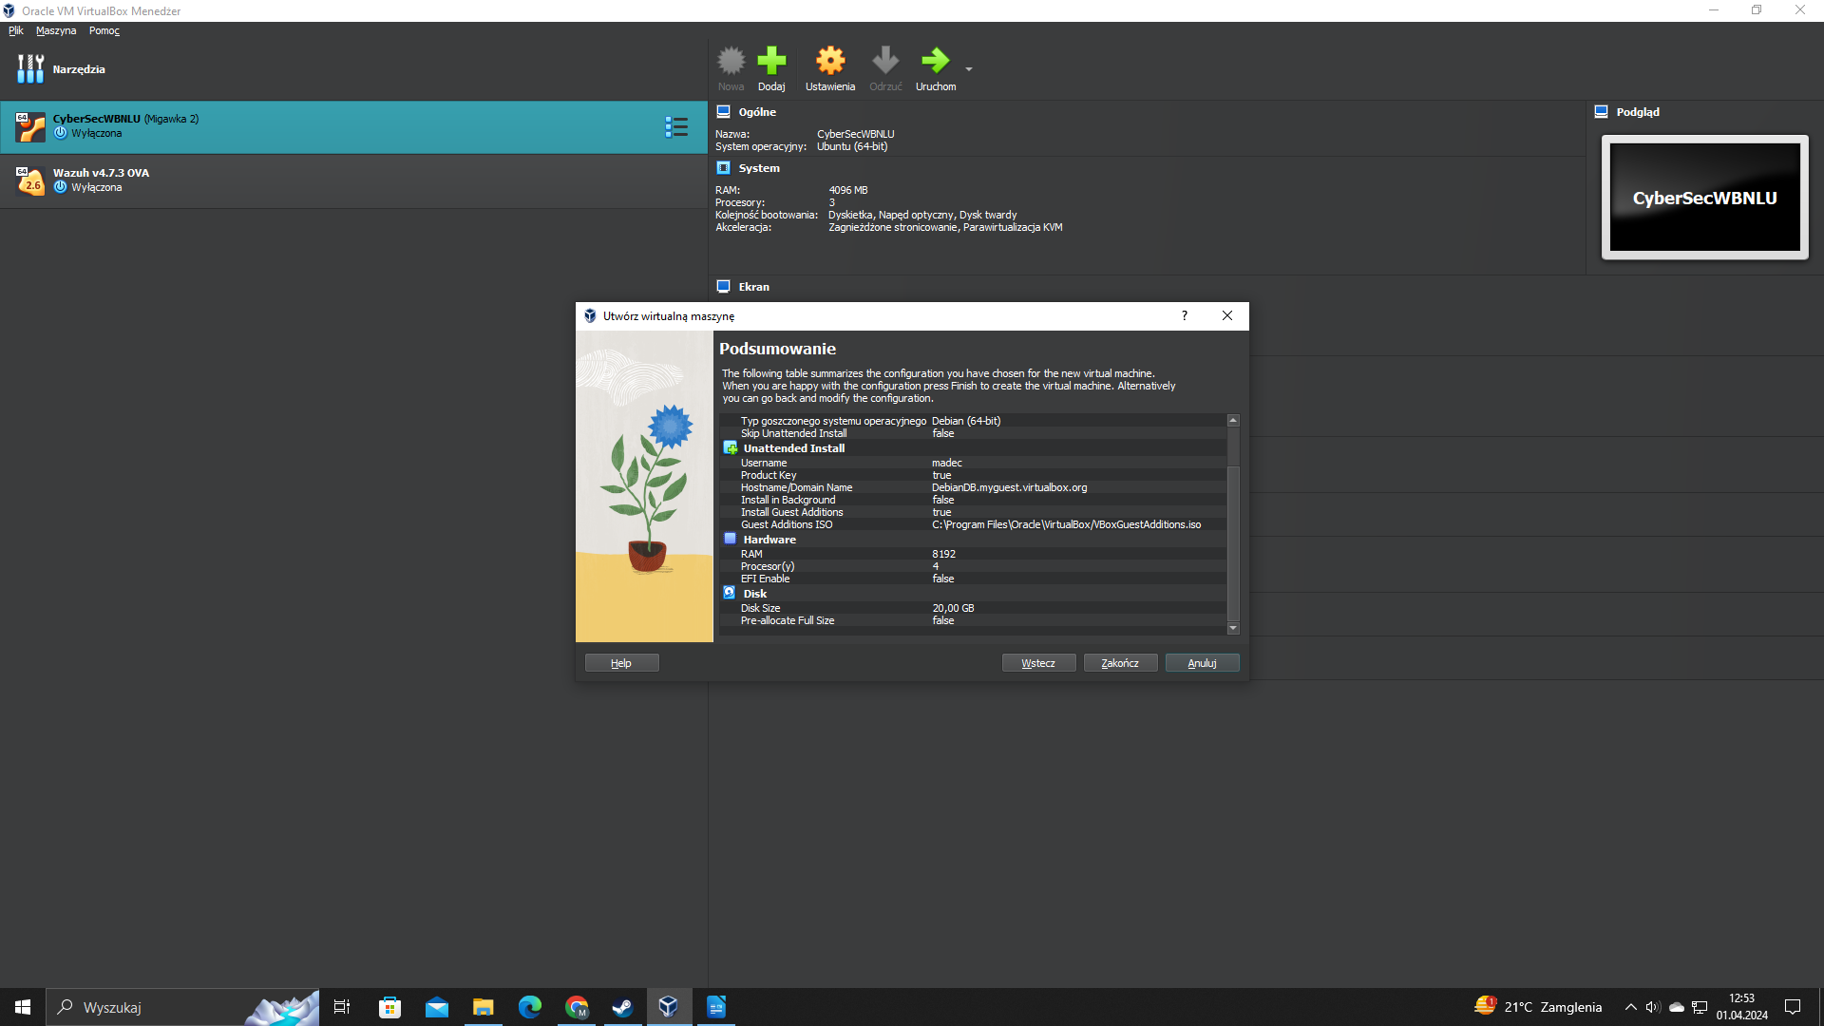

2.3 Installing Debian

Once we created new virtual machine, the installation process will automatically boot up. It will automatically install all packages and folders needed to run Linux.

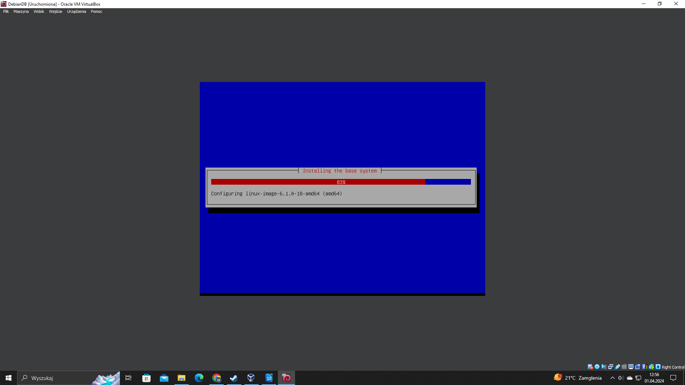

2.4 Viewing Debian

After successfull installation, we can login to newly created virtual machine. We can login with credentails defined during creating new virtual machine.

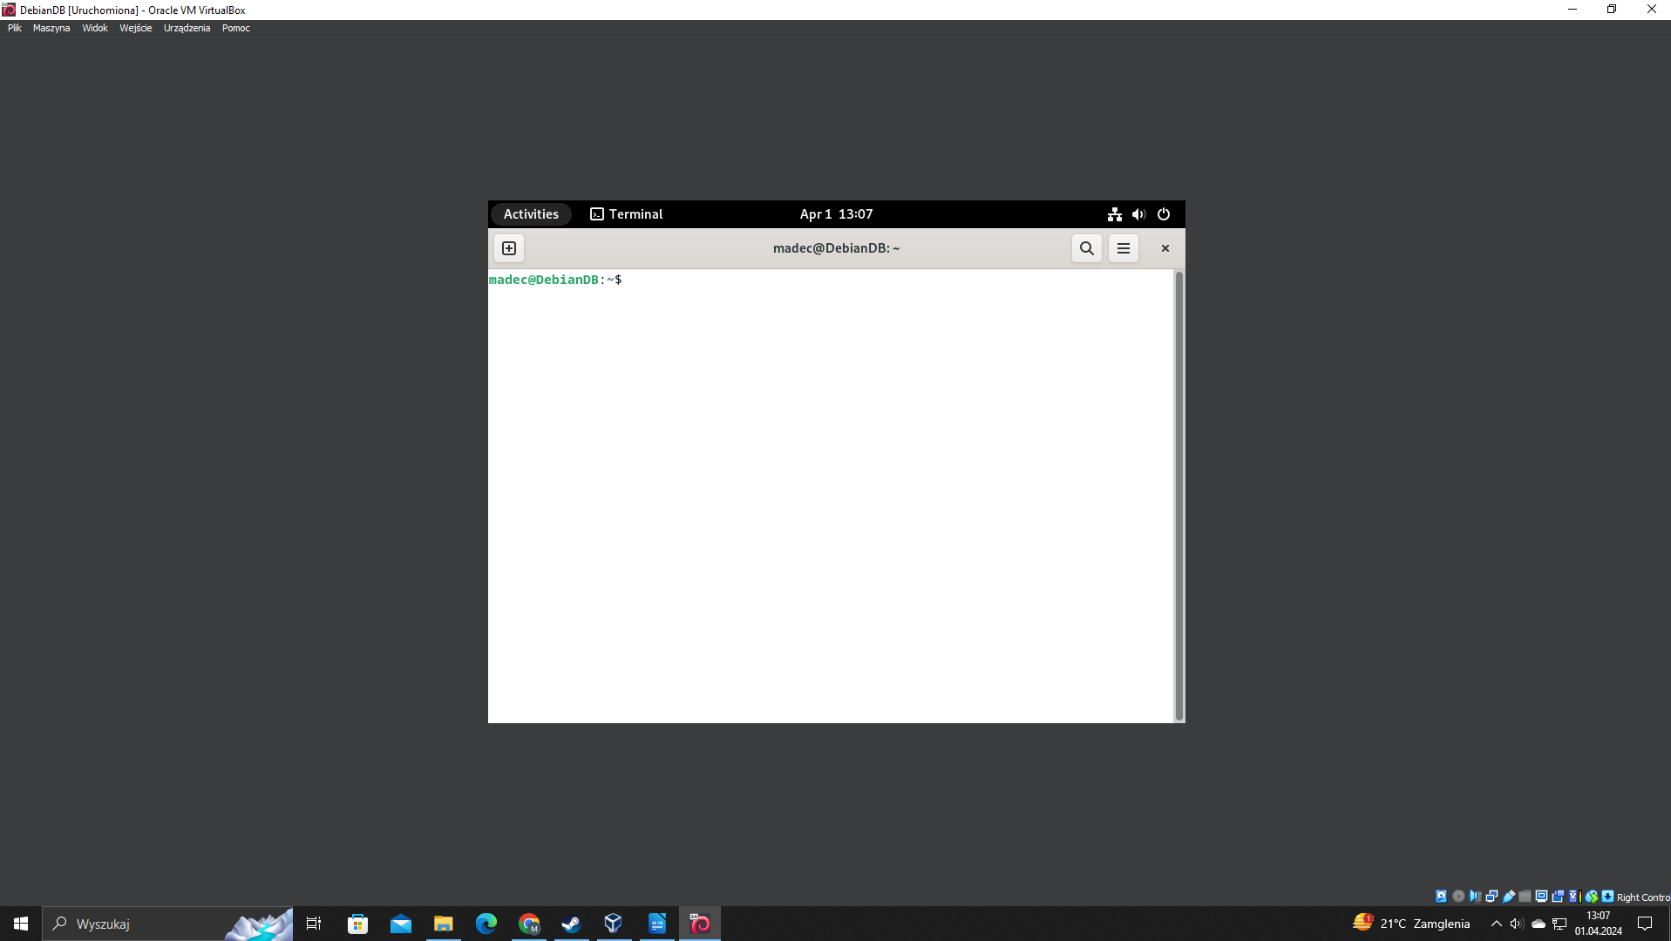

3. Setting up Debian environment

3.1 Network interface configuration

We will configure nework interface in Debian. We will implement static IP address and default gateway, which will be our local router in this case. Before we can do it, we have to make sure that network card of virtual machine is set to bridged mode.

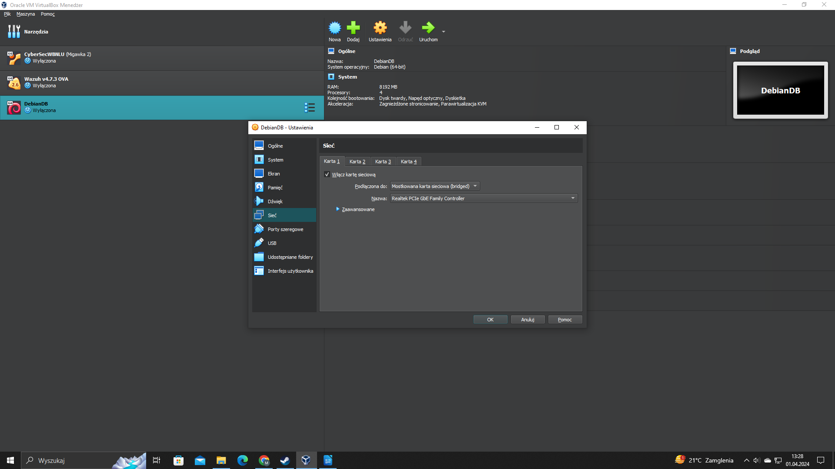

Once we made sure, we can start configuring network interface. To do that we have to switch to /etc/network/interfaces and edit it with nano. We can do it by issuing command in terminal: sudo nano /etc/network/interfaces

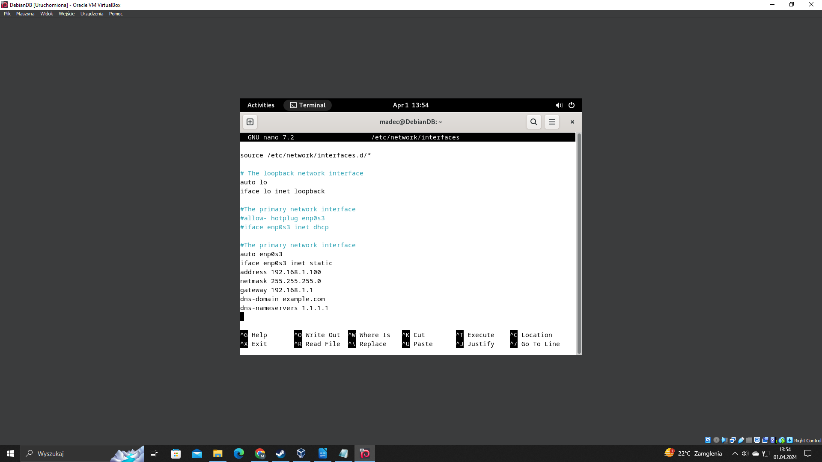

Once we configured interfaces file, we have to restart networking. We can do it by issuing command: sudo systemctl restart networking. After that we can check if new address is loaded, by issuing command: ip address.

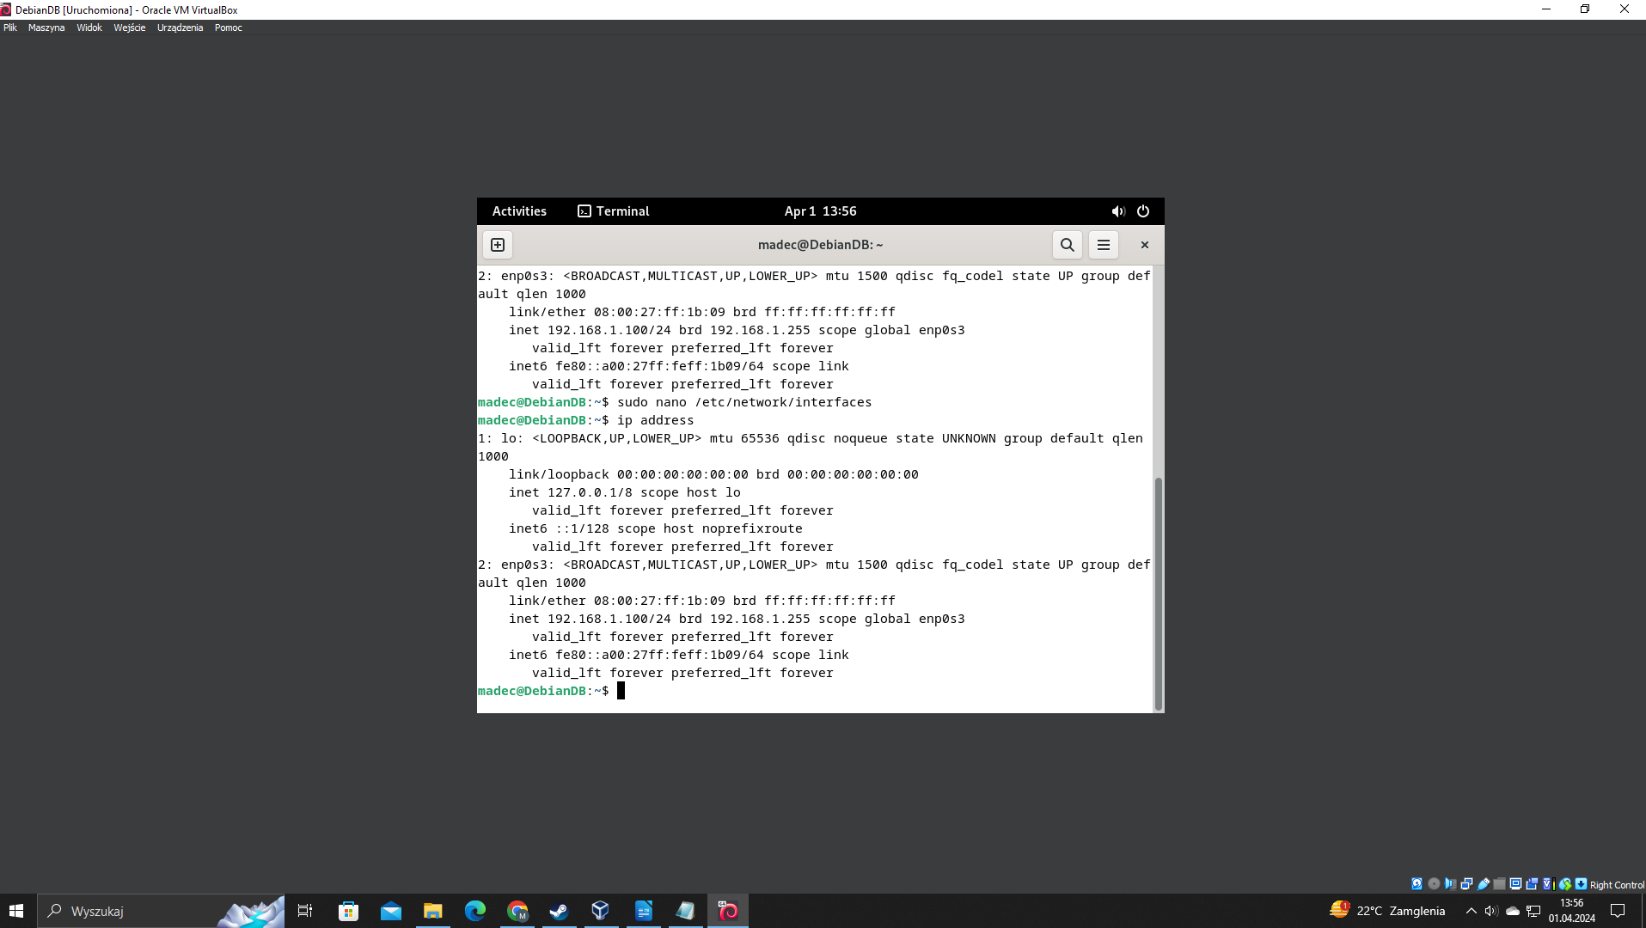

Last step in this section is to verify connection. We can test commenction by pinging virtual machine from our local Windows machine. To do it, we have to enter to command prompt in Windows and issue: ping 192.168.1.100, which is local IP address of our Debian server.

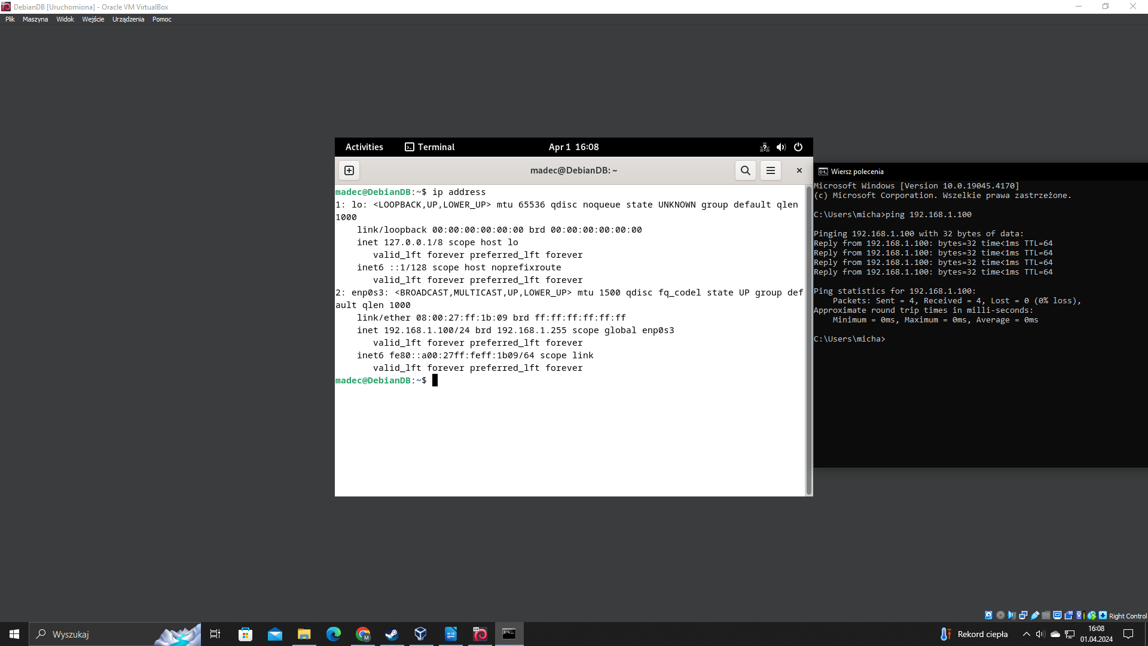

3.2 Installing Database Server

In this section we will install MariaDB database server on Debian machine. Before we do it, we have to update all packages by issuing command: sudo apt-get update.

Next we have to install MariaDB. We can do it by command: sudo apt install mariadb-server. Next we have to configure access to database server. We issue command in terminal: sudo mysql_secure_installation. In this step we configure password for root access and we can disable remote access if needed.

Once done we can connect to MariaDB by command: mysql -u root -p. After successfull login, we can view all available databases and remove them if not needed.

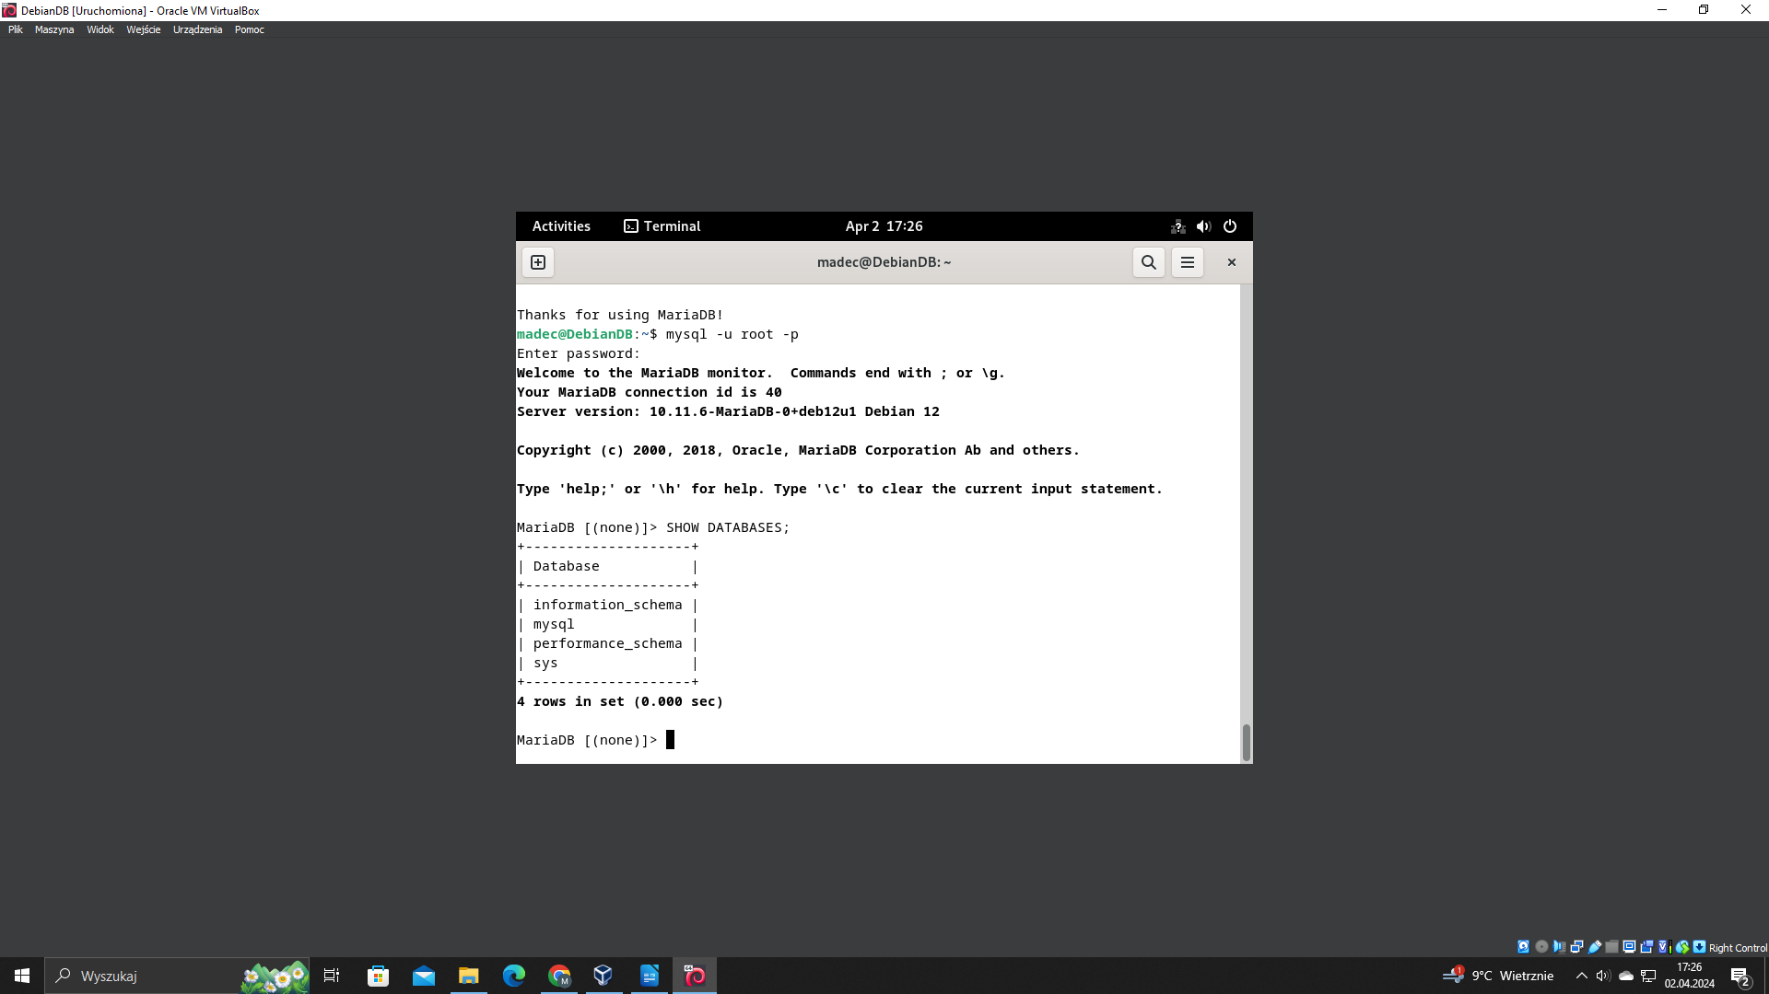

One last thing we need to do is to configure bind address. By default in file /etc/mysql/mariadb.conf.d/50-server.cnf bind address is set to 127.0.0.1, which is localhost. We need to change it to 0.0.0.0, so our database server could listen on all addresses. We can perform this operation by opening this file in nano with sudo command:

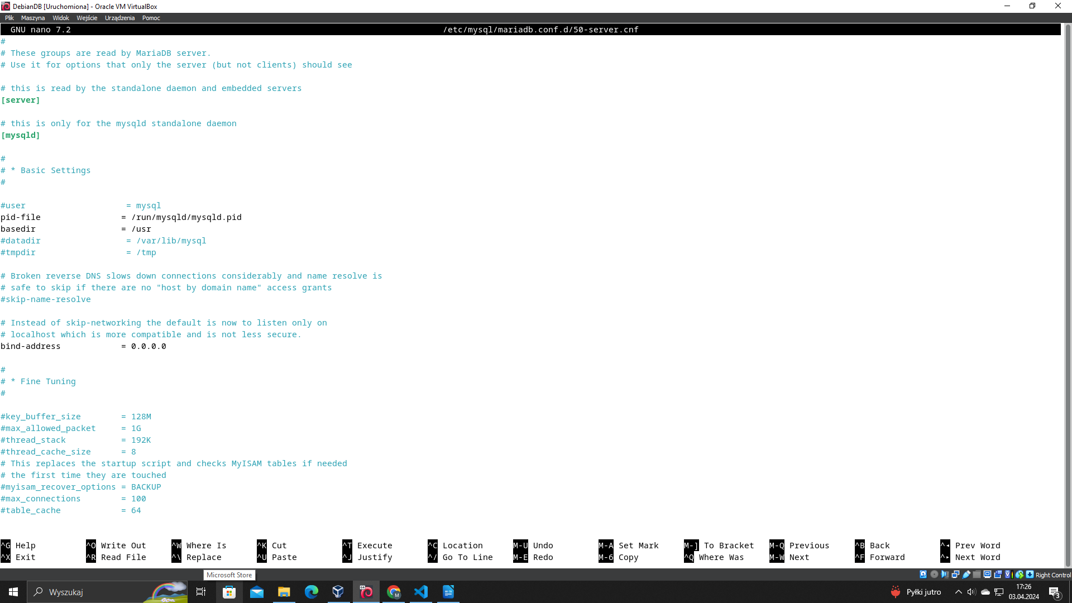

3.3 Confiuring MariaDB

Before we can store information, we have to create new database. We will name it used_car_dealer. To do it we can issue command in MariaDB: CREATE DATABASE used_car_dealer;.

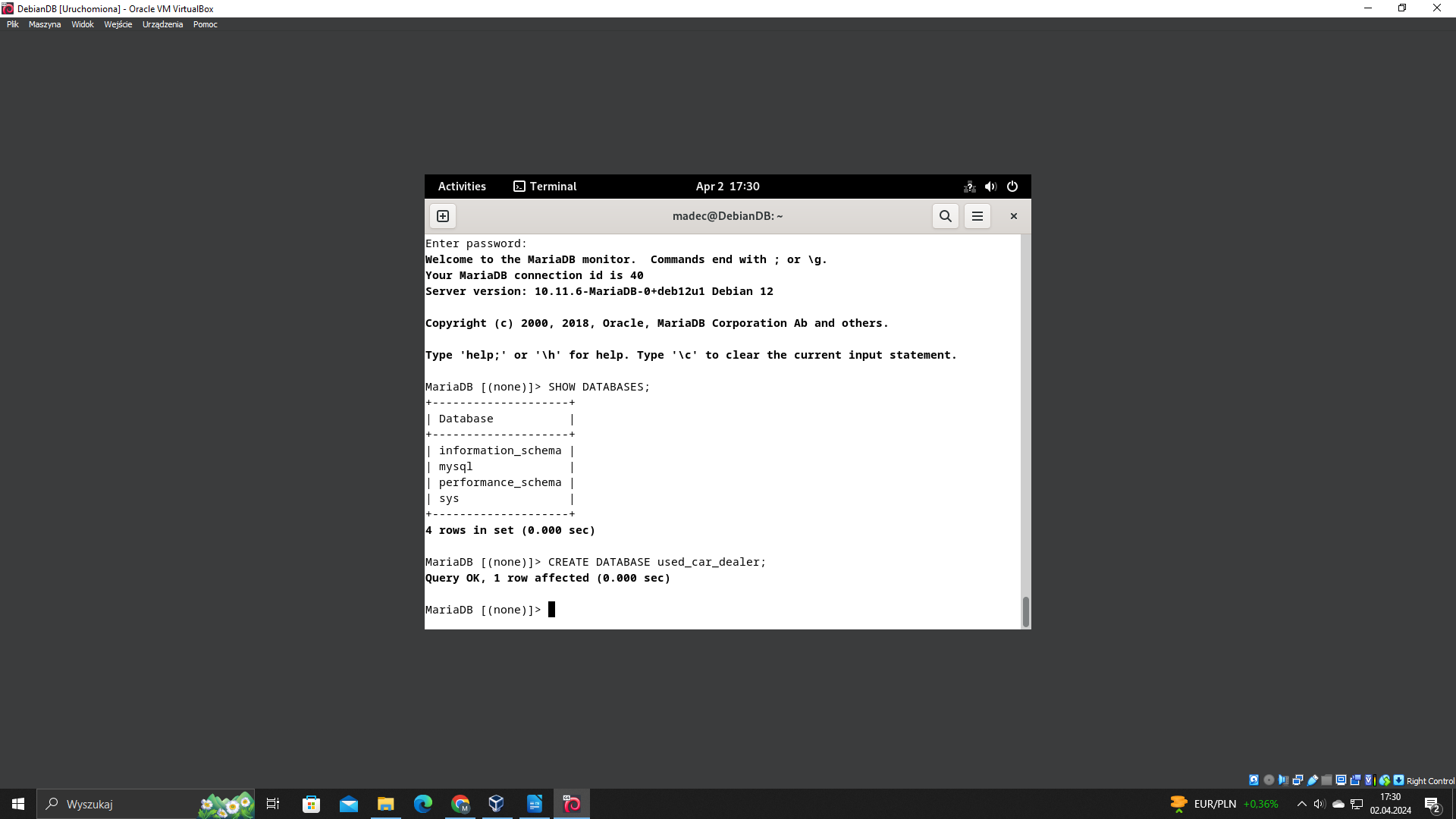

Now we can switch to newly created database by command: USE used_car_dealer;. Once done, we will create first table for storing clients information. The table will contain following fields: client id, client name, client surname, client login, client password, client e-mail, and client budget. Field client_id will be primary key. Fields email and login will be unique. We can perform this operation by command:
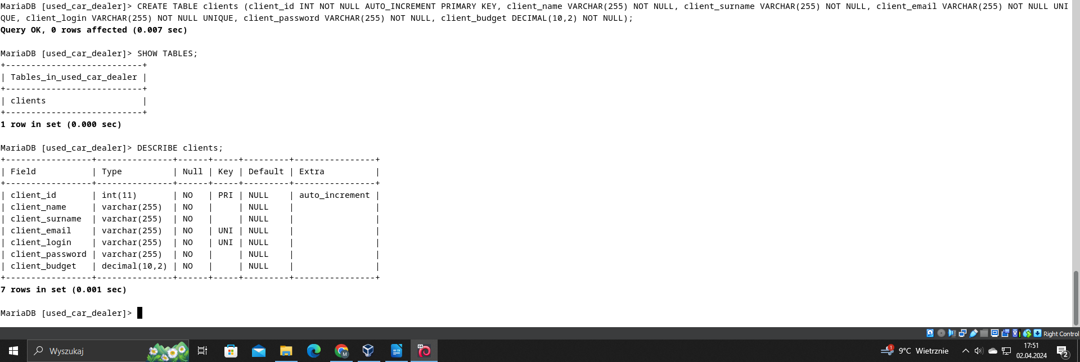

Now we will create user, who we will use to connect remotely to our database. We will define him on local IP address: 192.168.1.15, which is local IP address of our Windows machine. On this machine we will write scripts in Python. We can do it by:

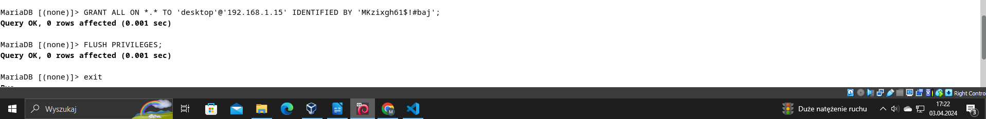

Now we will create new table in database. We will name it „cars”. This table will store fields like: car_id, car_mark, car_model, car_vin, car_value, and is_sold. Field is_sold will be bool value. We will need this to list all available cars for client. When car is sold, this field will change to yes. We can achive that by issuing command in MariaDB:

We will create last table named „orders”. There will be field like: order_id, ordering_client_id, and ordered_car_id. Field order_id will be primary key. Fields ordering_client_id and ordered_car_id will be foreigns keys from tables „clients” and „cars”. We can make that by command:

4. Python application

4.1 Client control panel

4.1.1 main() function

In this module we have defined main() function. It is control panel for client. Based on choice it allows either to register or to login. If there is not matched choice it outpust that choice is not recognized and asks us to enter the choice again. If user enters 0, the program stops.

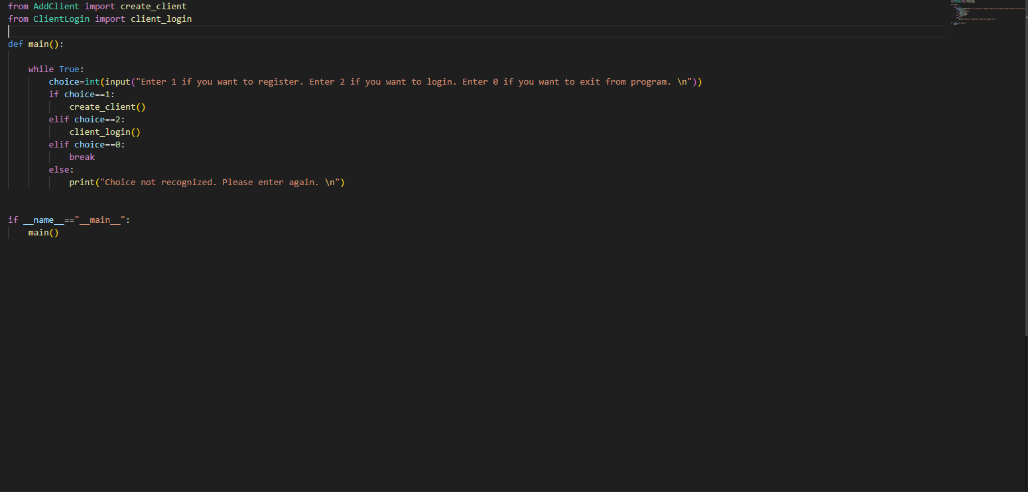

4.2 Adding client

4.2.1 is_email() function

In module AddClient we have defined function is_email(). This function checks if symbol @ is included in e-mail entered by client. If yes, returns true, otherwise false.

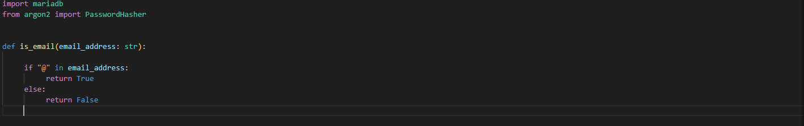

4.2.2 hash_password() function

This function hashes entered password by user with Argon2. It returns hashed password. Argon2 is a key derivation function that was selected as the winner of the 2015 Password Hashing Competition.

4.2.3 add_client function()

This function inserts entered client data to the table „clients” in „used_car_dealer” database. We have defined exceptions that might raise. Fileds e-mail and login are unique in our table. If the client enters login or e-mail that is already stored in database, an exception is catched and says that user has to use different e-mail or login.

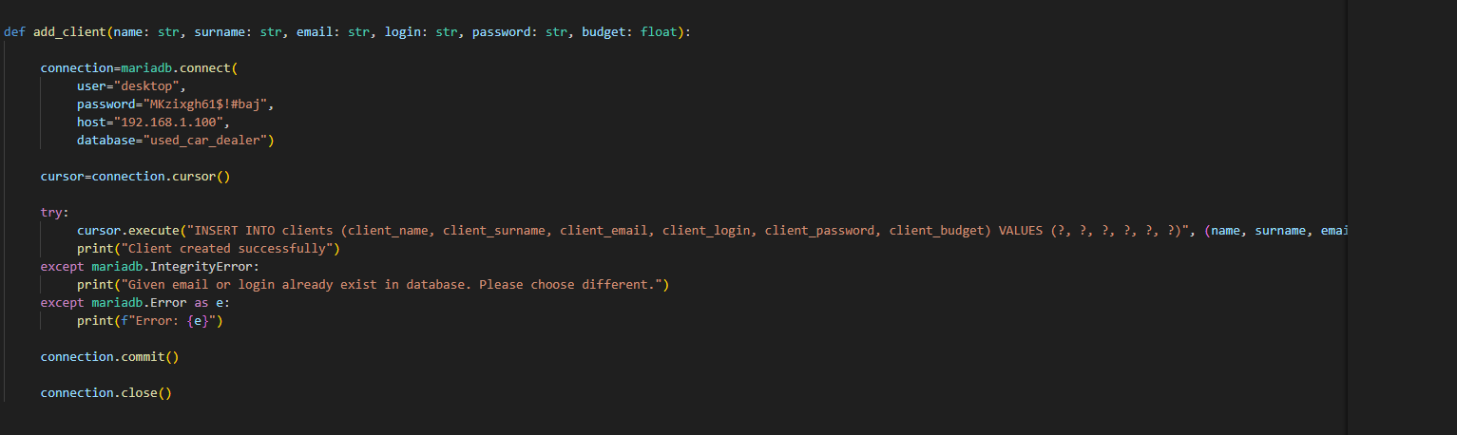

4.2.4 create_client() function

This function loads data that was entered by client. There is a logic condition that e-mail address has to contaion @ symbol. Name and surname have to contain only letters. If the logic condition is passed, a password is hashed with the use of hash_password() function and then all the data is passed to function add_client().

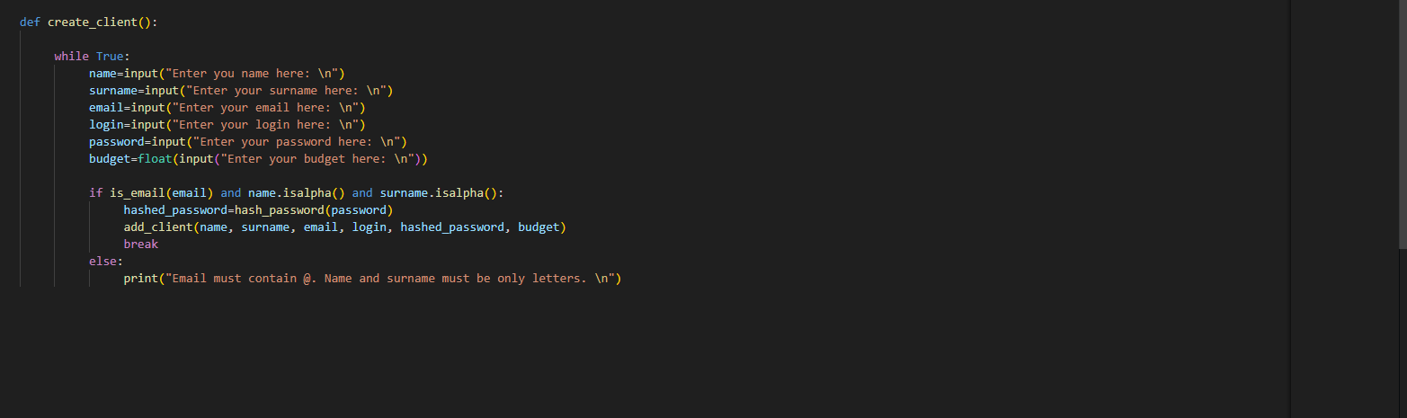

4.3 Client login

In module ClientLogin we have function client_login(). In this function client passes his login and password. Based on login we have SELECT query and this query downloads client’s password stored in database. Client’s login is unique field in our database. Next, the downloaded client’s password is compared with passed client’s password in function. As we described previously, client’s password is hashed with the use of Argon2. If the password, which client passed in function matches with stored password, then client can have access to control panel, which allows for order processing. All this operation is written in try-except block. We can get two exceptions here. First – passed client’s password does not match with stored. Second – login, which client passed in function does not occur in database.

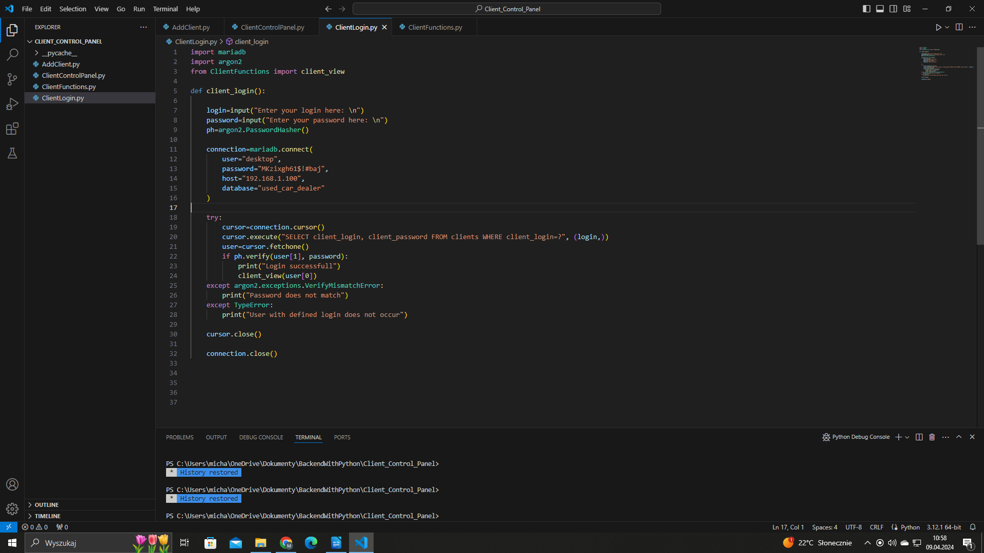

4.4 Client Functions

In module ClientFunctions we have defined function client_view(). We pass client’s login to this function as an argument. Based on this login we can write SQL queries, beacuse this field is unique.

4.4.1 Choice 1

In control panel we have defined infinite while loop. What program will do depends on client’s choice. In choice 1 we have cursor that downloads client’s data from database from table clients.

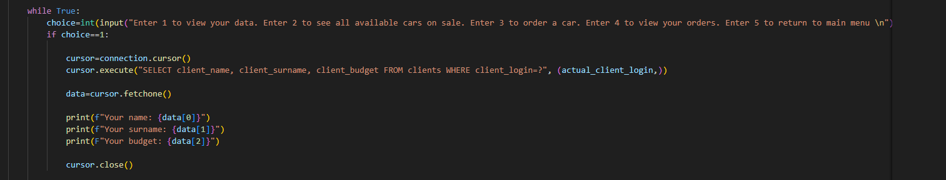

4.4.2 Choice 2

In choice 2 we have written query for our database. This query show us all available cars on sale. We can do that, beacuse table cars has boolean field is_sold. This SQL query shows us all available cars with WHERE condition based on False.

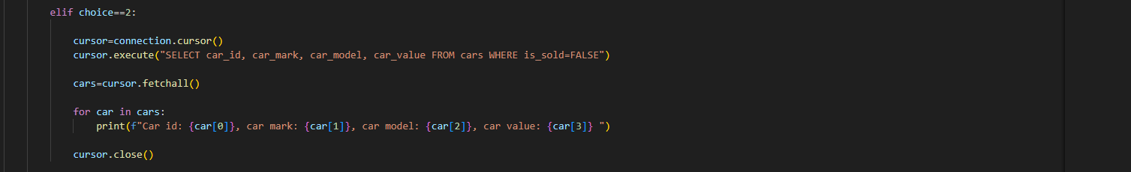

4.4.3 Choice 3

In choice 3 we have defined order processing. Client can buy a car based on ID. All the operation is defined in try-except statement. We can get an exception here – client can pass ID, which does not occur in database. Client can buy a car only when his budget is greater than car’s value. When the order is processed, client’s budget is updated and field is_sold from cars table is changed to True.

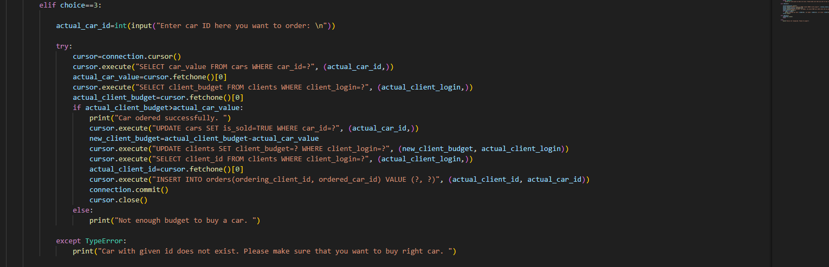

4.4.4 Choice 4

In choice 4, a client can view his all orders. In table orders we have two foreign keys – ordering_client_id as client_id from clients table and ordered_car_id as car_id from cars table. In this SQL query defined inside this choice we use JOIN operator. We JOIN cars table. Every order id has its reference to the cars and clients table.

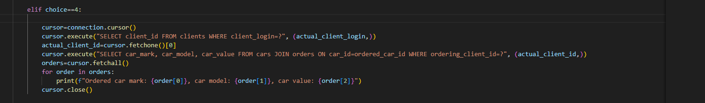
In choice 5 we have simple break statement. Inside this choice we also close connection to the database.

4.5 Admin Panel

In other directory named Admin_Control_Panel we have defined modules in Python for administrator. Only administrator can add a car to the database and list all orders from clients. Inside AdminPanel module we have defined main() function. Based on admin’s choice application can either add a car to the database or list all available orders from database.

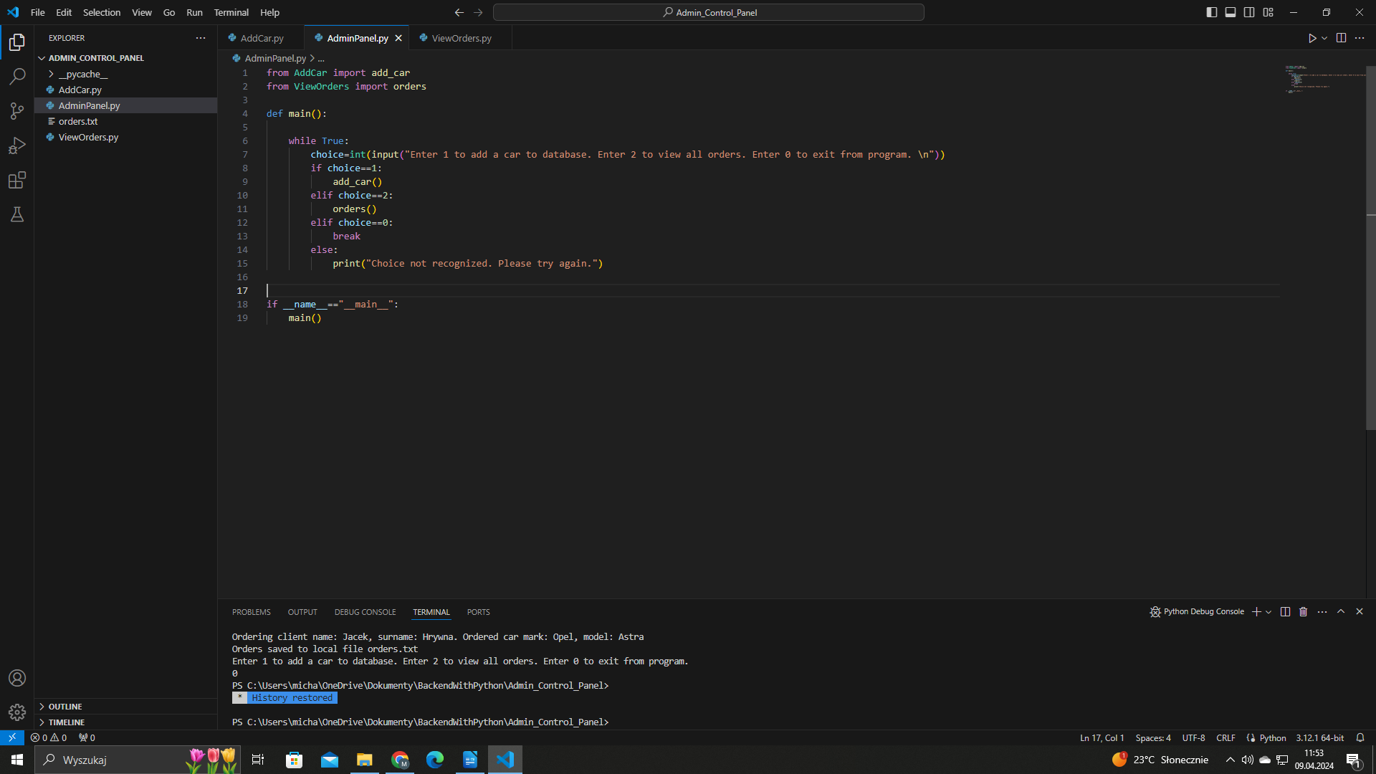

4.6 Add Car

Inside AddCar module we have defined add_car() function. Admin can add a car after when he logs in. Inside this function admin passes his login and password. We connect to the database based on these credentials. If they are wrong, we cannot connect to the database. If the creadentials are true, admin can add a car to the database.

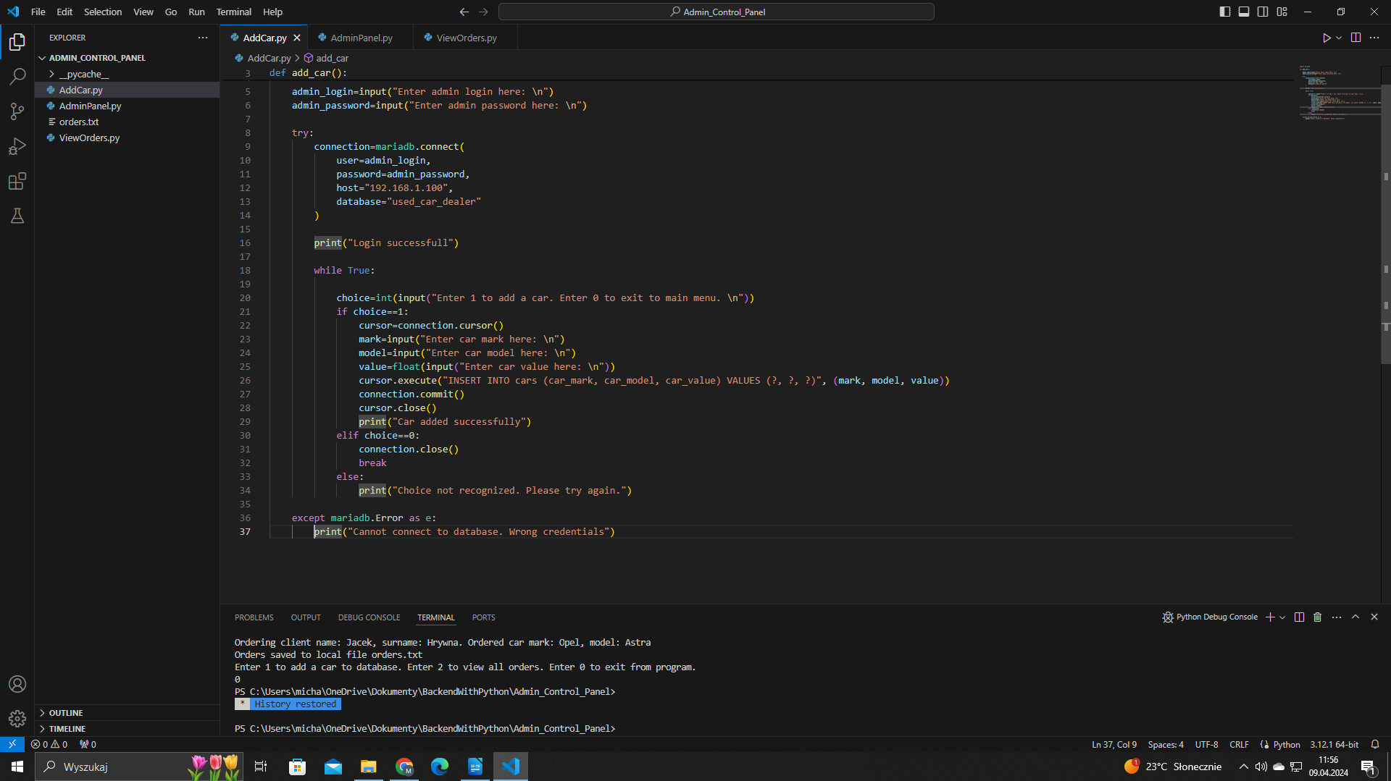

4.7 View Orders

Inside VieOrders module we have defined orders() function. In this function admin have to again pass his credentials. If they are correct, admin can list all available orders from database and save them to the local .txt file named orders.txt

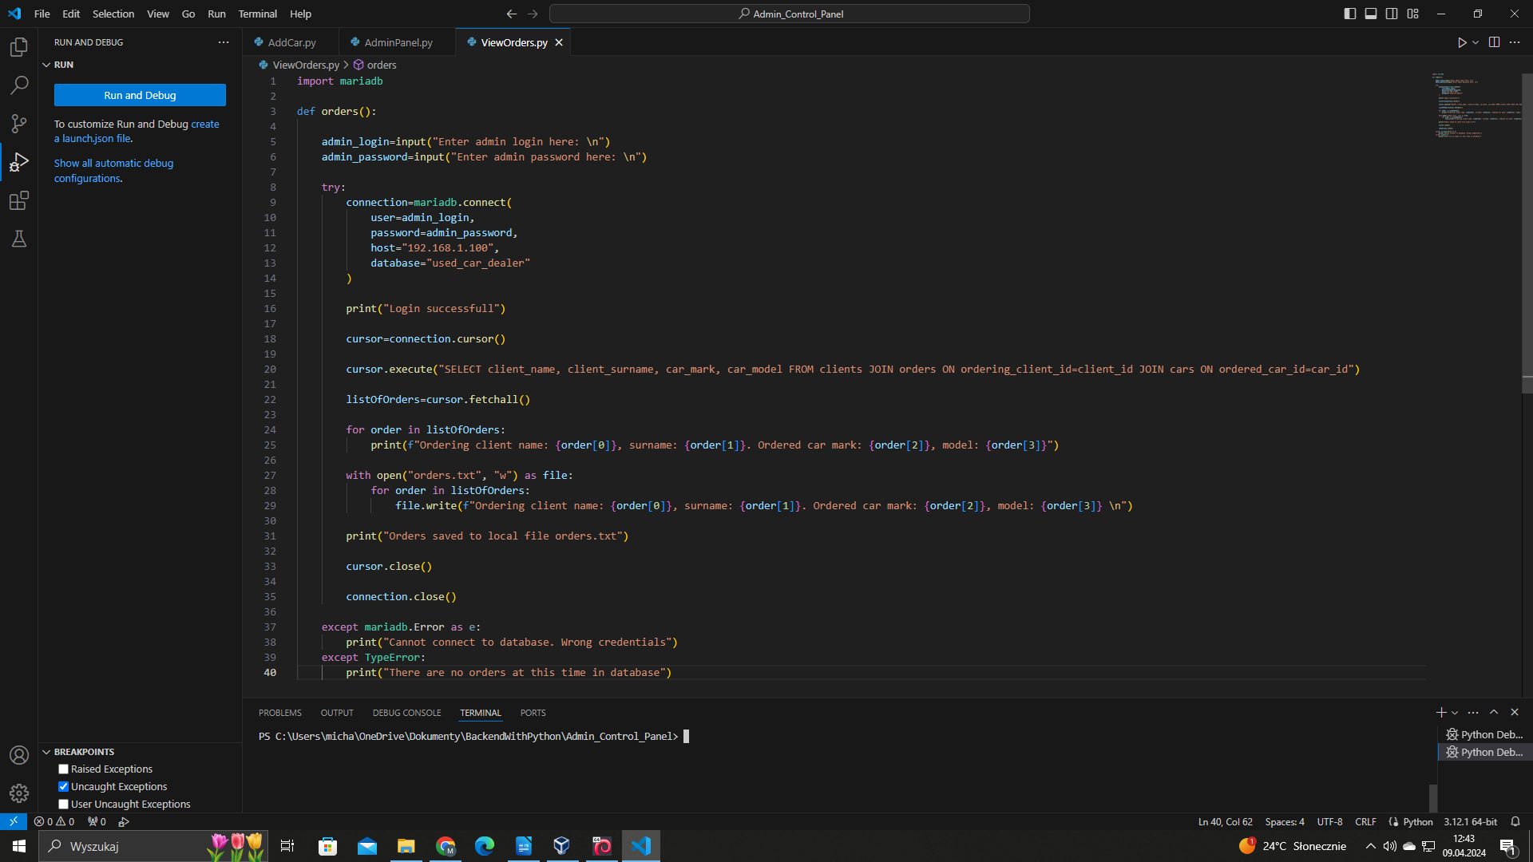

5. Testing

5.1 Adding a client

We will add client with defined credentials – login: jakob123 and password: jakob123123. We will set his budget to 50000 dollars.

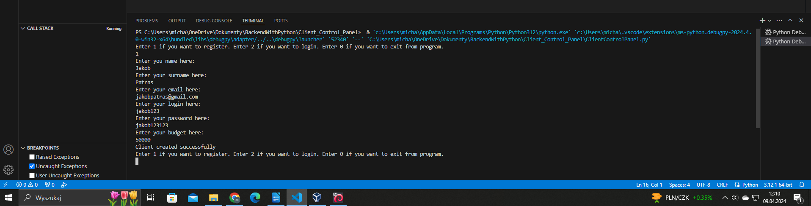
We can look to the database if client’s credentials were added successfully. We can do that by issuing: SELECT * FROM clients WHERE client_login=”jakob123”;.

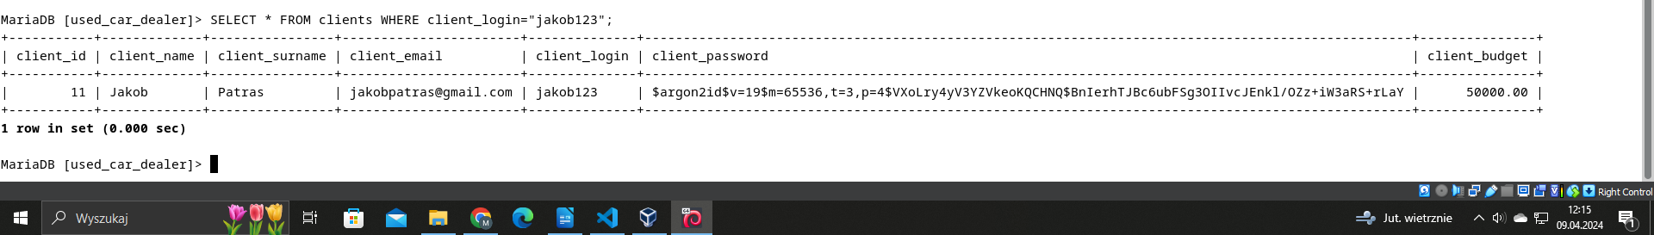

5.2 Logging in as a client

Now we will log in as a new created client and we will try to order a car. We will pass defined credentials jakob123 as a login and jakob123123 as a password.

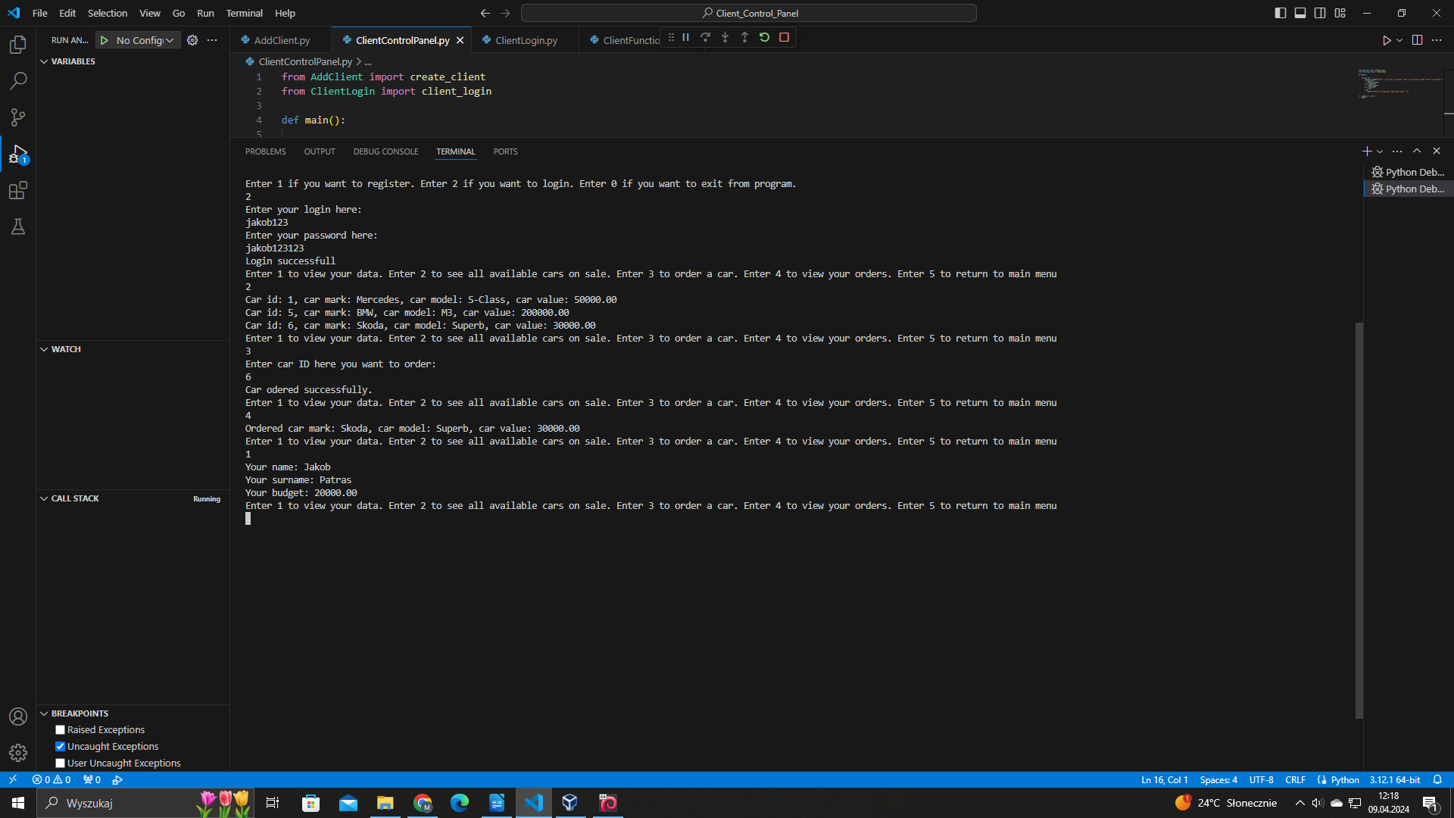
As we can see we logged in as a jakob123. We bought a Skoda car. Our budget has changed from 50000 dollars to 20000 dollars, beacuse car value was 30000 dollars. Also we can list our orders. In this case we have only one order, which is Skoda Superb car.

5.3 Adding a new car

We will add a new car from admin control panel. We will define new car as a Mercedes C63 AMG with car value set to 150000 dollars.

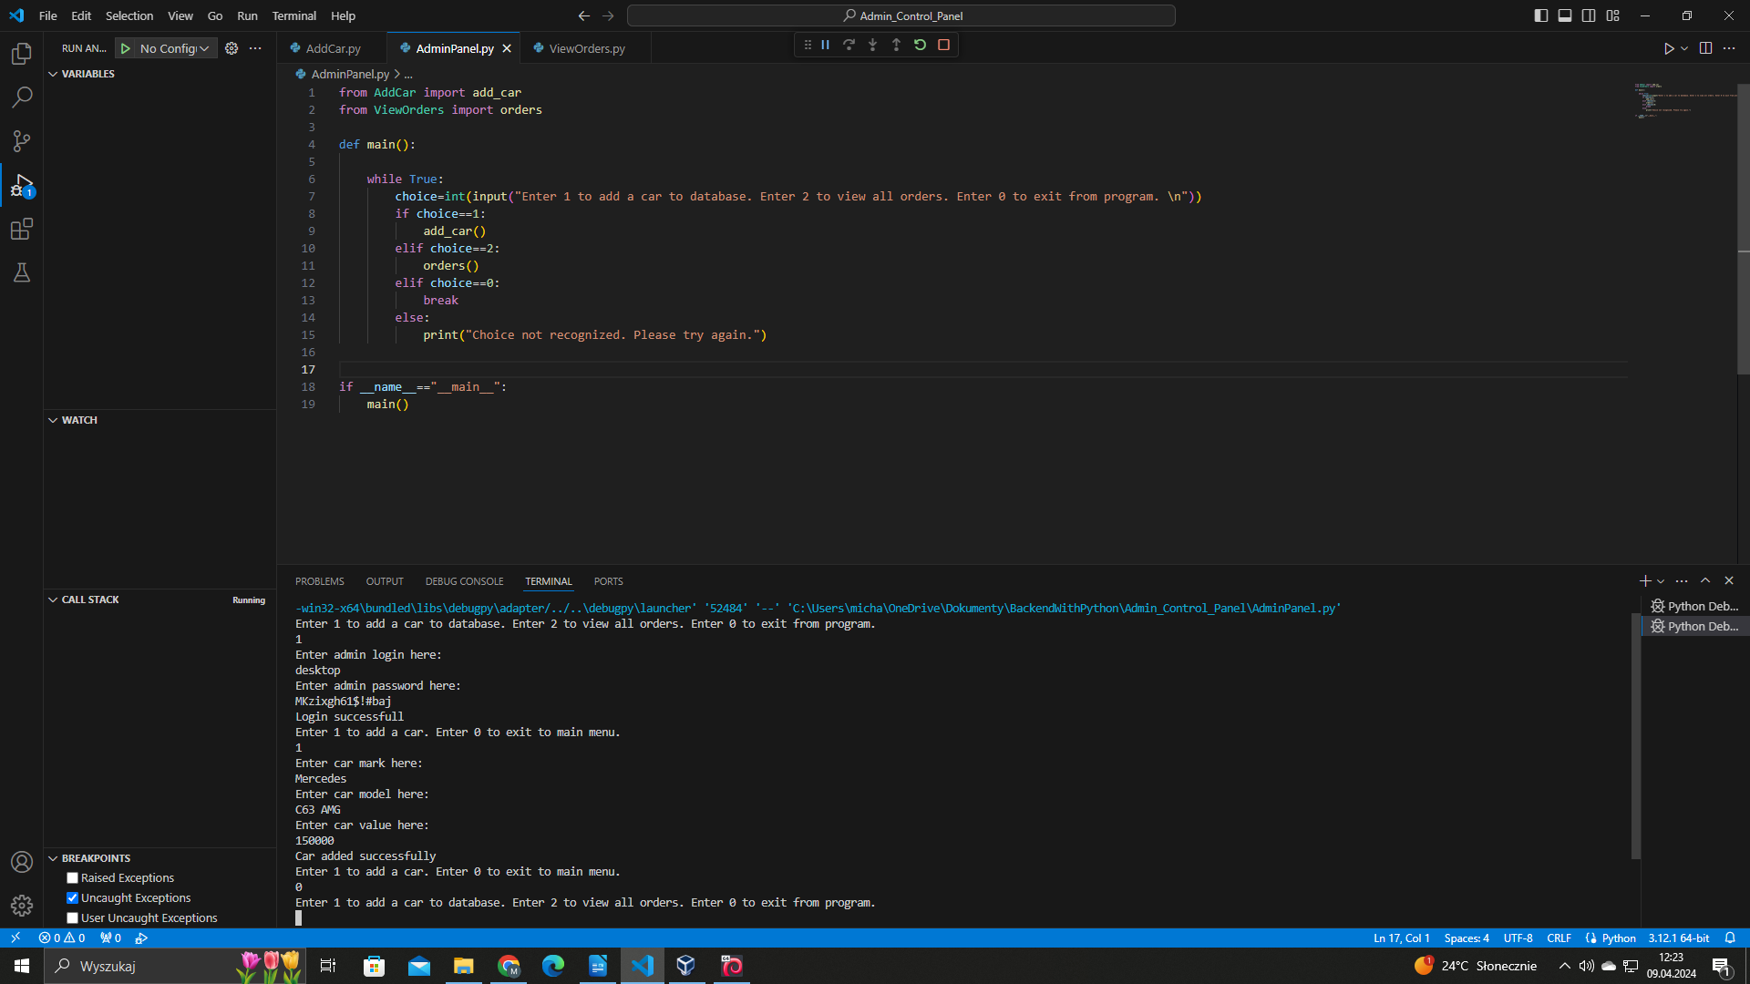
We can check if new car is added successfully to our database. We can achive that by SQL query: SELECT * FROM cars WHERE car_model=”C63 AMG”;.

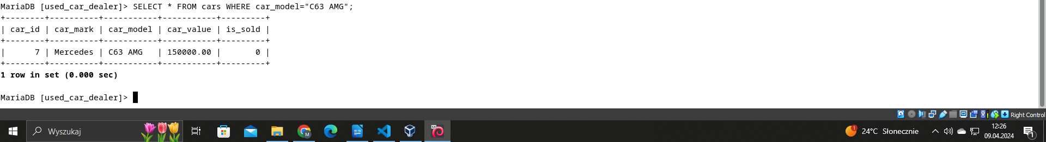

5.4 Viewing all clients orders

Now we will use orders() function from admin control panel. We will list all orders processed in database and save them to the local file named orders.txt.

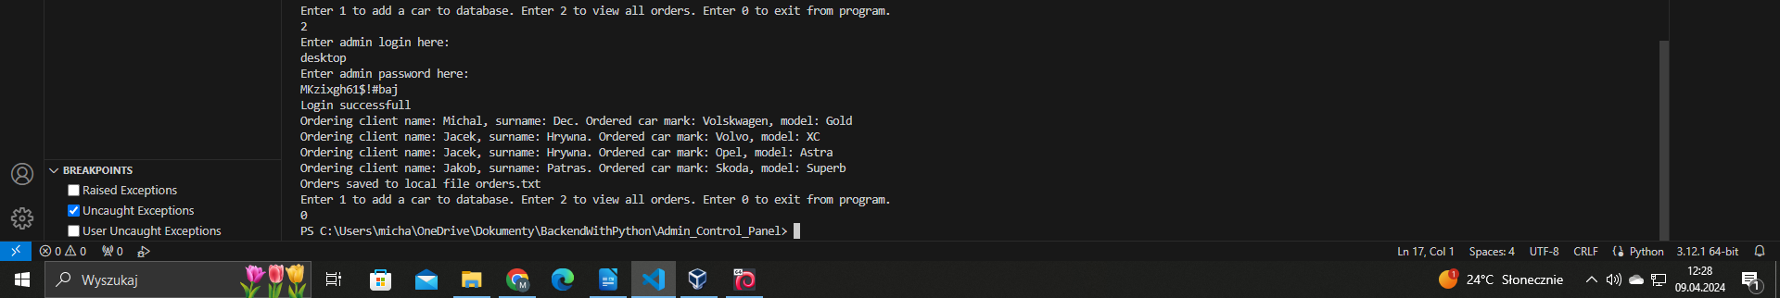
We can also check if the orders were saved successfully to the local file. We have to open directory in Windows with admin control panel and look for text file named orders.txt.



6. Materials and resources used for the need of this report

- IDE: Visual Studio Code - https://code.visualstudio.com/
- Python: Version 3.12.1 - https://www.python.org/downloads/
- MariaDB: How to connect Python programs to MariaDB - https://mariadb.com/resources/blog/how-to-connect-python-programs-to-mariadb/
- PyPi: Argon2 for Python - https://pypi.org/project/argon2-cffi/

