Прочитай еще раз правило и выполни упражнение письменно с переводом на русский язык.

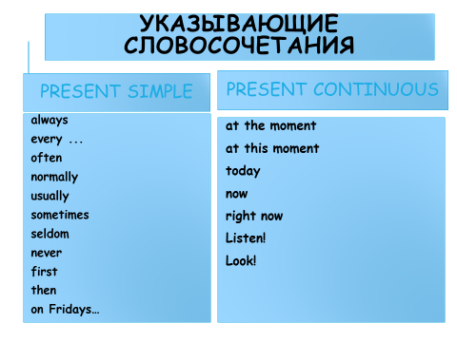

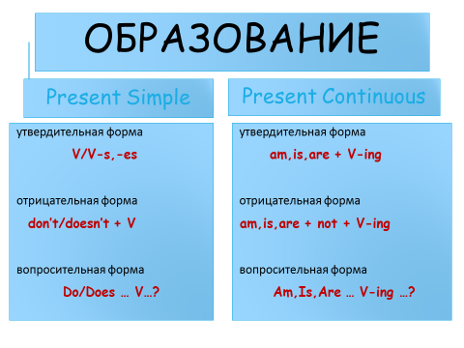

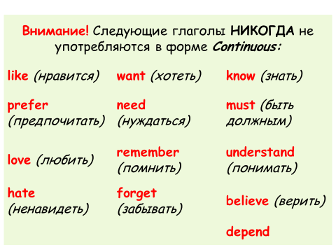

**Раскройте скобки, употребляя глаголы в форме Present Simple или Present Continuous. Предложения переведите на русский язык.**

1. He (to work) in the city centre.

____________________________________________________________

_______________________________________________________________  
2. I (to write) an essay now.

1. _______________________________________________________________________________________________________________________________  
   3. You (to go) to school on Sundays?
2. ________________________________________________________________________________________________________________________________  
   4. We (not to dance) every day.
3. _______________________________________________________________________________________________________________________________  
   5. They (to play) in the hall now?
4. ________________________________________________________________________________________________________________________________  
   6. Where he (to live)? – He (to live) in a village.
5. ____________________________________________________________________________________________________________________________  
   7. He (to sleep) now?
6. _____________________________________________________________________________________________________________________________  
   8. They (to read) many books.
7. ________________________________________________________________________________________________________________________________  
   9. The children (to eat) cakes now.
8. ____________________________________________________________________________________________________________________________  
   10. He (to help) his mother every day.

______________________________________________________________________________________________________________________________________  
11. You (to play) the piano well?

1. _________________________________________________________________________________________________________________________________  
   12. Look! Michael (to dance) now.

12_________________________________________________________________________________________________________________________________________________