






–––
Front End React JS Developer
S M Adeel
Github.com/madeel20
smaa.link@gmail.com
Block 16, Federal B Area, Karachi

ADDRESS
Recent college graduate with background in web and mobile app development. Excellent focus, communication, and ability to learn rapidly.
ABOUT ME
TECHNICAL SKILLS
Javascript / ES6
WORK
Present
Aug 2020
React and React Native Developer
Software Chimps
Implement UI for web and mobile projects
Implement Buisness logic on front-end.
Created Web Admin Panel of the Mobile App.
React.js,React Native, Firebase, Material UI, QR Code creation and scanning, React UI Dependencies.
July 2018
Dec 2018
MERN Stack Developer
Go Tech Innovation

Managing and Coding a Startup Project.
React js, Bootstrap, Mongo Db, Express js, Node js,
EDUCATION
Jan 2017
Present
BE Computer Engineering
Sir Syed University Of Engineering and Technology
Current Semester: 8th Semester
CGPA: 3.45
July 2015
Aug 2016
Intermediate / HSC
Adamjee Govt. Science College

Faculty: Computer Science

HOBBIES
Snooker - Cricket - Freelancing
+92-302-2383754
PHP and Android App Developer
Qurvex
April 2020
Feb 2020
Laravel Developer
Freelance Project
Mar 2019
July 2019
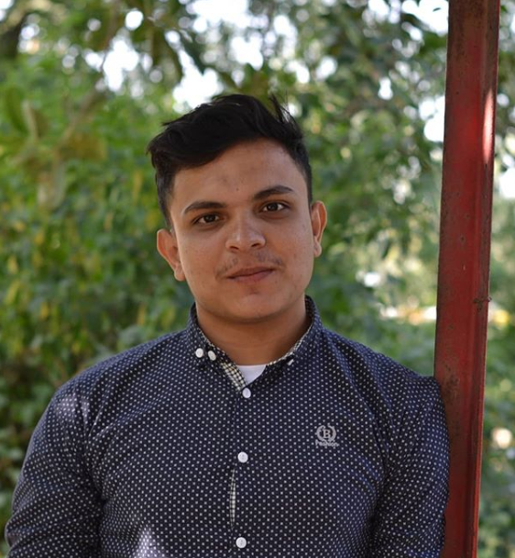
Aug 2020
Mar 2020
Associate Software Engineer
Scientise7 pvt. Ltd
Main Responsibilities:
- Write business Logic of SPA.
- Bind Api’s.
- Design UI Components for React based SPA.
- Implement UI designs from XD’s and figma.
- Collaborate with the Back-end team to resolve issues, bugs and implement functionalities.
- Write, Test and debug api’s.
Notable projects: Hikma Online( portals) , Hikma Online landing page.
React JS / JSX/ Redux
HTML / CSS / SCSS
UI Frameworks (Material UI, Ant design, Bootstrap)
Responsive / Adaptive Design
Firebase( Firestore,RT DB, Auth)
Node.js / Express JS / Mongo DB
React Native / Redux / UI/UX
Angular

