TRANSPORT MANAGEMENT SYSTEM
TransitPro
User Manual
A step-by-step guide to booking, tracking and billing shipments and managing the fleet
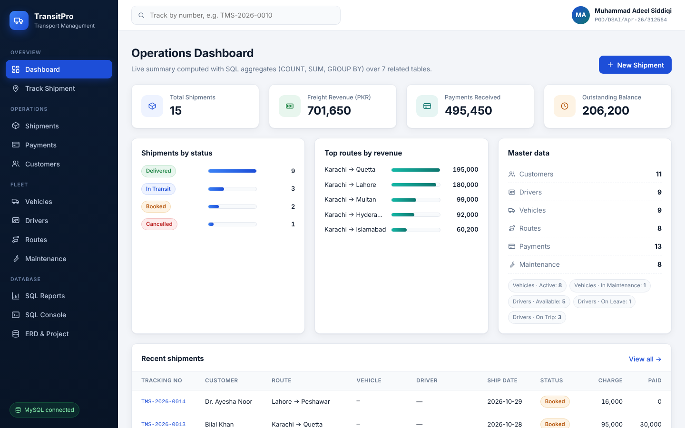
TransitPro operations dashboard
Document information
Product | TransitPro – Transport Management System
Document | User Manual, Version 1.0
Date | October 2026
Prepared by | Muhammad Adeel Siddiqi (PGD/DSAI/Apr-26/312564)
Program / Course | PGD – DSAI, Batch XIV · RDBMS – Database Management Systems
Instructor | Sajid Majeed
University | NED University of Engineering & Technology

Contents
In Microsoft Word, hold Ctrl and click a chapter title to jump to it.
1 Introduction 3
2 Getting Started 3
3 The Dashboard 5
4 Managing Shipments 6
5 Recording Payments 9
6 Managing Customers 9
7 Managing the Fleet: Vehicles, Drivers, Routes, Maintenance 10
8 Tracking a Shipment 12
9 SQL Reports and SQL Console 12
10 Messages and Troubleshooting 14
11 Frequently Asked Questions 15
A Appendix A: Glossary 16
B Appendix B: Database Quick Reference 16

1. Introduction

1.1 Purpose of this manual
This manual explains how to use TransitPro, the Transport Management System, for everyday work: booking shipments, assigning vehicles and drivers, tracking deliveries, recording payments and keeping fleet records. Each task has numbered steps, and every form has a field reference table.

1.2 Who should read it
- Operators and dispatchers: book and update shipments, assign vehicles and drivers.
- Accounts staff: record payments and check outstanding balances.
- Fleet managers: maintain vehicles, drivers, routes and service history.
- Evaluators and instructors: review the system and its database features (Chapters 9 and 10).

1.3 About TransitPro
TransitPro is a web application backed by a MySQL relational database. You use it in a web browser; every action you take (save, edit, delete, search) runs an SQL statement on the database. The database has seven related tables and enforces rules such as unique tracking numbers and positive weights, so invalid data cannot be saved.
Module | What you can do
Dashboard | See live totals: shipments, revenue, payments, outstanding balance, top routes
Shipments | Book, assign, update, track and cancel consignments
Payments | Record full or partial payments against a shipment
Customers | Keep customer and company contact details
Vehicles | Register trucks, vans, trailers and containers with capacity and status
Drivers | Keep driver licences, experience and availability
Routes | Define origin–destination routes with distance, time and rate per kg
Maintenance | Log services and repair costs for each vehicle
Track Shipment | Find any shipment instantly by its tracking number
SQL Reports / Console | View analytical reports and run read-only SQL queries

2. Getting Started

2.1 System requirements
Item | Requirement
Operating system | Windows 10 or 11 (one-click start). macOS and Linux are supported from the command line.
Python | Version 3.10 or newer, from python.org. During installation, choose Add python.exe to PATH.
Database | MySQL Server 8.0.16 or newer with MySQL Workbench (recommended). Without MySQL, the app uses a built-in SQLite database.
Browser | Microsoft Edge, Google Chrome or Mozilla Firefox (current versions)
Internet | Needed only on the first start, to download the Flask and PyMySQL packages

2.2 Starting TransitPro
- Extract the project ZIP: right-click it and choose Extract All.
- Open the extracted folder and double-click START_HERE.bat. A console window opens.
- On the first start only, wait 1–2 minutes while the app prepares its packages.
- When asked, type your MySQL root password (the one you use in MySQL Workbench) and press Enter. If MySQL is not installed, just press Enter.
- Your browser opens http://127.0.0.1:5000 and shows the dashboard.
Note: On the very first start, TransitPro creates the database transport_db in MySQL automatically, with all seven tables and sample data. You don't need to run any SQL scripts.

Important: Keep the console window open while you use the app. Closing it stops TransitPro, and the browser then shows "can't reach this page".

2.3 Checking the database connection
Look at the bottom-left corner of the sidebar. A green MySQL connected badge means TransitPro is using your MySQL database. A blue SQLite connected badge means MySQL could not be reached; the console window shows the reason (see Chapter 10).

2.4 The screen layout
Area | Description
Sidebar (left) | Main menu, grouped into Overview, Operations, Fleet and Database. The current page is highlighted in blue.
Top bar | Quick tracking box (type a tracking number and press Enter) and the user profile
Content area | The current page: dashboard, list, form or report
Messages | Green messages confirm success, red messages explain errors, and dark boxes show the SQL statement that ran.

2.5 Stopping and restarting
- To stop: close the console window.
- To start again: double-click START_HERE.bat. Later starts take only a few seconds.
- To restore the original sample data: stop the app, run DROP DATABASE transport_db; in MySQL Workbench, then start the app again. The database is rebuilt.

3. The Dashboard
The dashboard is the home page. Every number is calculated live from the database each time the page opens.
Figure 3.1 – Operations dashboard
Element | What it shows
Total Shipments | Number of shipments in the system, all statuses
Freight Revenue (PKR) | Sum of freight charges for all shipments except cancelled ones
Payments Received | Sum of all payments recorded
Outstanding Balance | Revenue minus payments received: money still to collect
Shipments by status | Count of Booked, In Transit, Delivered and Cancelled shipments
Top routes by revenue | The five routes that earned the most
Master data | Record counts for every table, plus vehicle and driver status counts
Recent shipments | The six latest shipments. Click a tracking number to open its detail page.

Tip: The New Shipment button at the top right of the dashboard is the fastest way to book a consignment.

4. Managing Shipments
A shipment is a consignment of goods for one customer, travelling on one route. A vehicle and a driver can be assigned at booking or later.

4.1 Viewing and searching shipments
- Click Shipments in the sidebar.
- Type a word in the search box (tracking number, customer, city, vehicle, driver or status) and click Search.
- To show one status only, choose it from the All status list.
- Click Clear to show all shipments again.
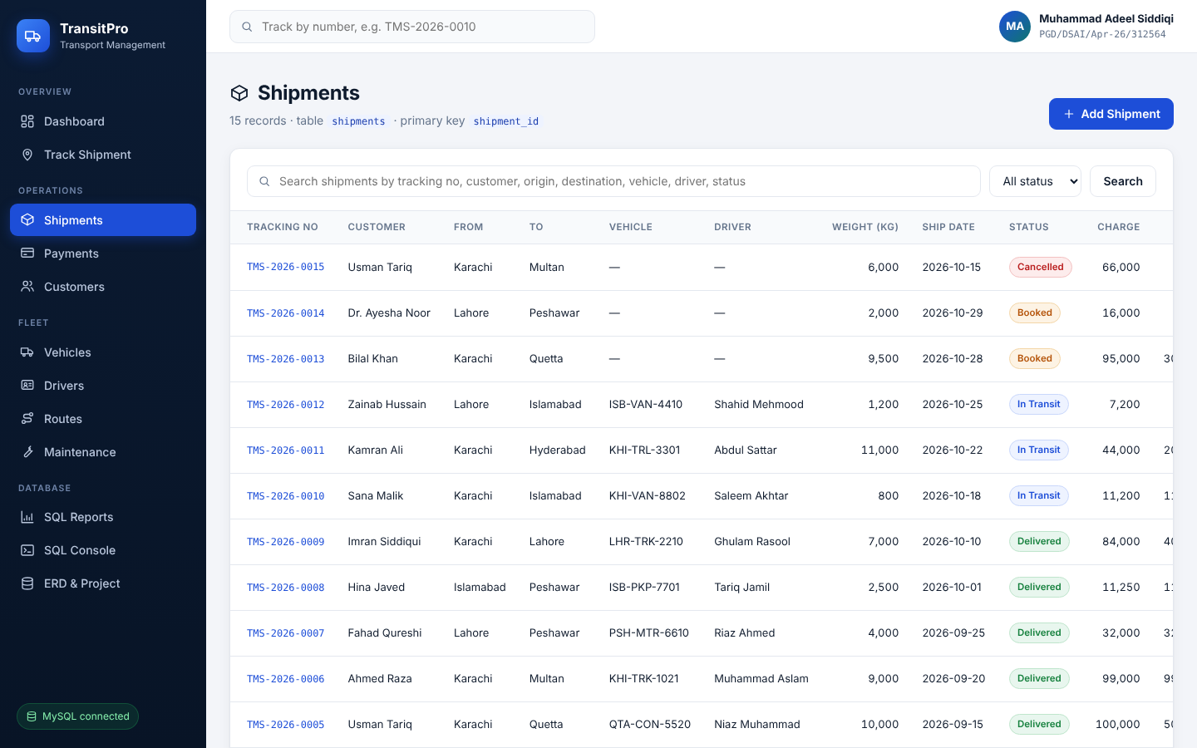
Figure 4.1 – Shipments list with search and status filter
The icons at the end of each row are: eye (view details), pencil (edit) and bin (delete).

4.2 Booking a new shipment
- Click Shipments → Add Shipment, or New Shipment on the dashboard.
- Keep the suggested Tracking No (for example TMS-2026-0016) or enter your own unique number.
- Select the Customer and the Route.
- Optionally select a Vehicle and a Driver. You can leave them as "not assigned" and assign them later.
- Enter the Goods Description and Weight (kg).
- Leave Freight Charge as 0 to have it calculated automatically, or type an agreed amount.
- Click Save Shipment. The shipment detail page opens with a green confirmation.
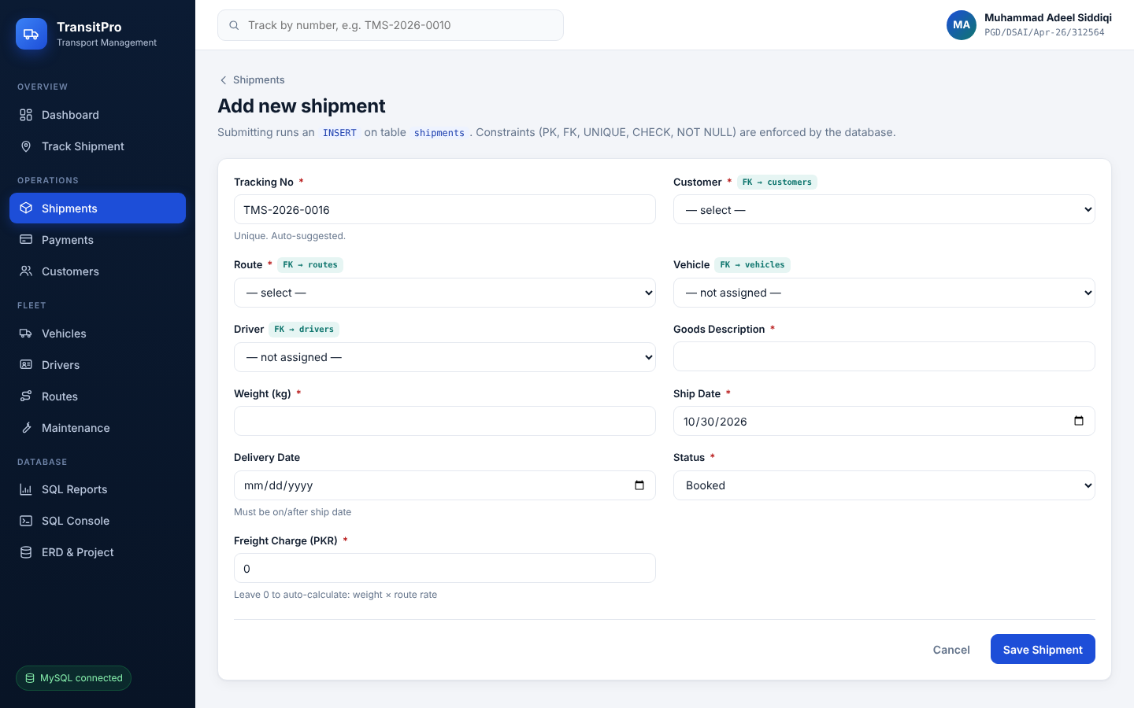
Figure 4.2 – Add new shipment form

Shipment fields
Field | Required | What to enter / rules
Tracking No | Yes | Unique reference, suggested automatically as TMS-YEAR-NNNN. Duplicates are refused.
Customer | Yes | Choose from existing customers. Add the customer first (Chapter 6) if they are not listed.
Route | Yes | Choose from existing routes (origin → destination).
Vehicle | No | Truck or van carrying the goods. The detail page warns if the weight exceeds its capacity.
Driver | No | Driver responsible for the trip.
Goods Description | Yes | What is being carried, for example "Textile rolls".
Weight (kg) | Yes | Must be greater than 0.
Ship Date | Yes | Defaults to today.
Delivery Date | No | Must be on or after the ship date. Filled automatically with today's date when the status is set to Delivered.
Status | Yes | Booked, In Transit, Delivered or Cancelled (see 4.3).
Freight Charge (PKR) | Yes | 0 or more. Enter 0 to calculate automatically: weight × route rate per kg.

4.3 Shipment status lifecycle
Status | Meaning | Typical next step
Booked | Order received; vehicle and driver may not be assigned yet | Assign vehicle and driver, then set In Transit
In Transit | Goods are on the road | Set Delivered on arrival
Delivered | Goods handed over; delivery date recorded | Collect any balance due
Cancelled | Order cancelled; excluded from revenue totals | None

4.4 Shipment detail page
Click a tracking number (or the eye icon) to open the detail page. It brings together information from five tables.
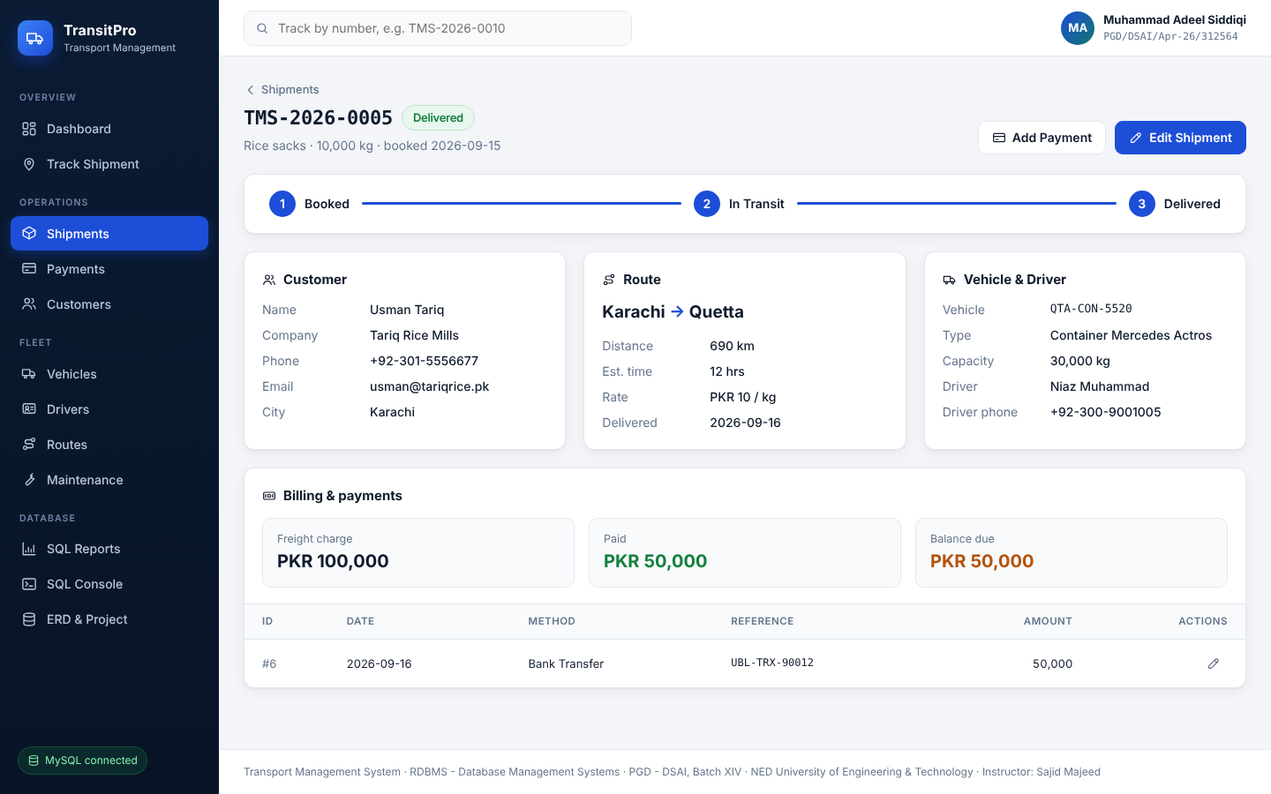
Figure 4.3 – Shipment detail page
- Progress bar: Booked → In Transit → Delivered.
- Customer, Route and Vehicle & Driver cards: contact details, distance, rate, capacity and driver phone.
- Billing & payments: freight charge, amount paid and balance due, plus a list of every payment.
- Add Payment and Edit Shipment buttons at the top right.

4.5 Updating a shipment
- Open the shipment and click Edit Shipment (or the pencil icon in the list).
- Change the fields you need, for example assign a vehicle and set the status to In Transit.
- Click Update Shipment.

4.6 Deleting a shipment
Click the bin icon in the list and confirm. All payments recorded for that shipment are deleted with it. To keep the history, set the status to Cancelled instead of deleting.

5. Recording Payments
A shipment can be paid in one or more instalments. The balance due is always freight charge minus the total of its payments.

5.1 Adding a payment
- Open the shipment detail page and click Add Payment. The shipment is pre-selected. (Or use Payments → Add Payment.)
- Enter the Amount, choose the Method and check the Payment Date.
- Optionally enter a bank or cheque Reference No.
- Click Save Payment.
Field | Required | What to enter / rules
Shipment | Yes | The shipment being paid for.
Amount (PKR) | Yes | Must be greater than 0.
Method | Yes | Cash, Bank Transfer, Card, Cheque or Online.
Payment Date | Yes | Defaults to today.
Reference No | No | Transaction or cheque number, for your records.

Tip: To find unpaid shipments, open SQL Reports → Outstanding balances.

6. Managing Customers
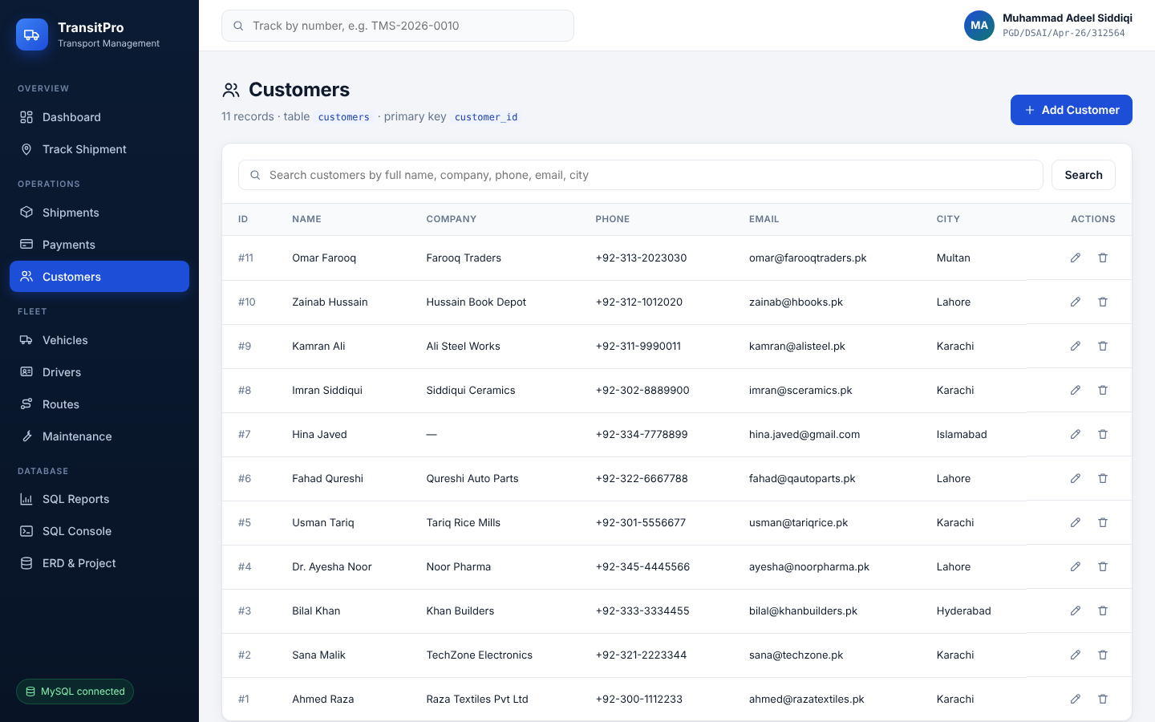
Figure 6.1 – Customers list

6.1 Adding a customer
- Click Customers → Add Customer.
- Fill in the fields below.
- Click Save Customer.
Field | Required | What to enter / rules
Full Name | Yes | Contact person's name.
Company | No | Business name.
Phone | Yes | Must be unique: two customers cannot share a phone number.
Email | No | Must be unique and in a valid format (name@domain.com).
City | Yes | Customer's city.
Address | No | Street address.

6.2 Editing and deleting
Use the pencil icon to edit. A customer who has shipments cannot be deleted: the database protects their history. Delete or reassign their shipments first.

7. Managing the Fleet: Vehicles, Drivers, Routes, Maintenance
All four fleet pages work the same way as Customers: a searchable list with Add, Edit and Delete.

7.1 Vehicles
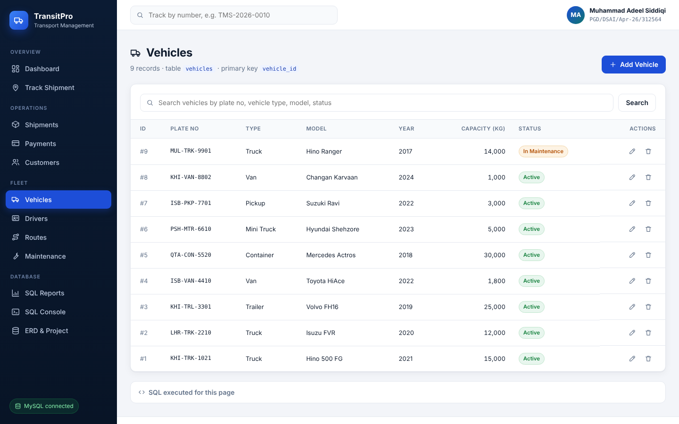
Figure 7.1 – Vehicles list
Field | Required | What to enter / rules
Plate No | Yes | Registration number; must be unique.
Vehicle Type | Yes | Truck, Mini Truck, Van, Pickup, Container or Trailer.
Model | Yes | For example Hino 500 FG.
Make Year | Yes | Between 1990 and 2035.
Capacity (kg) | Yes | Greater than 0. Used for the over-capacity warning.
Status | Yes | Active, In Maintenance or Retired.

Important: Deleting a vehicle un-assigns it from its shipments (they show "Not assigned") and deletes its maintenance history. To keep the history, set the status to Retired instead.

7.2 Drivers
Field | Required | What to enter / rules
Full Name | Yes | Driver's name.
License No | Yes | Must be unique.
Phone | Yes | Contact number.
License Expiry | Yes | Expiry date of the driving licence.
Experience (years) | Yes | Between 0 and 50.
Status | Yes | Available, On Trip or On Leave.

Deleting a driver un-assigns them from their shipments; the shipments themselves are kept.

7.3 Routes
Field | Required | What to enter / rules
Origin City | Yes | Starting city.
Destination City | Yes | Must be different from the origin. Each origin–destination pair can exist only once.
Distance (km) | Yes | Greater than 0.
Estimated Hours | Yes | Greater than 0.
Rate per kg (PKR) | Yes | 0 or more. Used to calculate freight automatically.

A route that is used by shipments cannot be deleted.

7.4 Maintenance
Field | Required | What to enter / rules
Vehicle | Yes | The vehicle that was serviced.
Service Date | Yes | Defaults to today.
Service Type | Yes | Oil Change, Tyre, Engine, Brakes, General Service or Body Work.
Description | No | Work done.
Cost (PKR) | Yes | 0 or more.

Tip: SQL Reports → Vehicle utilisation shows trips and total maintenance cost for every vehicle.

8. Tracking a Shipment
- Type the tracking number (for example TMS-2026-0010) in the search box at the top of any page and press Enter, or open Track Shipment in the sidebar.
- The shipment detail page opens, showing its progress, vehicle, driver and payment status.
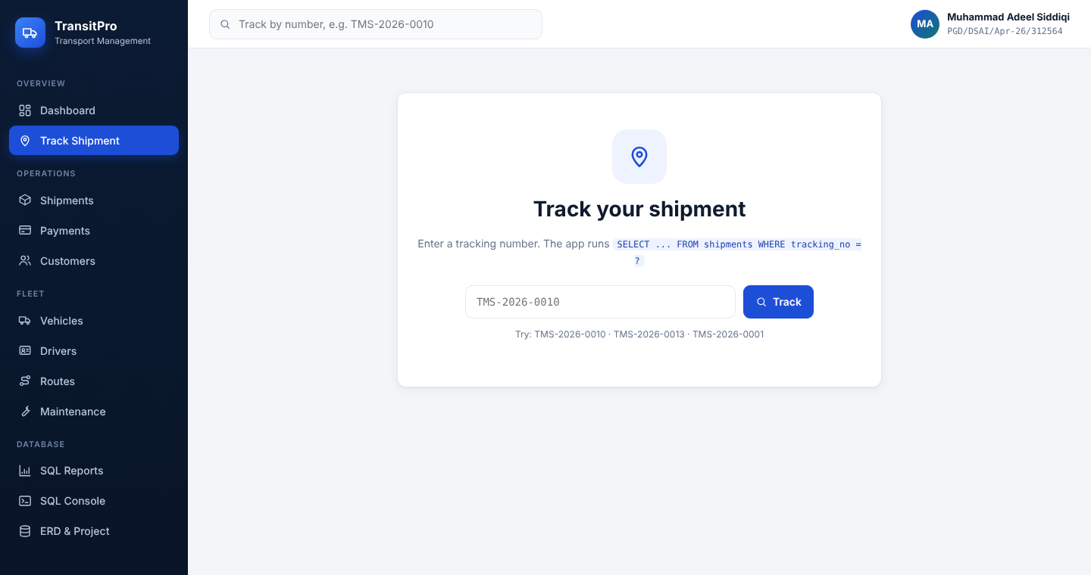
Figure 8.1 – Track Shipment page
If no shipment has that number, a red message says so. Check the number and try again.

9. SQL Reports and SQL Console

9.1 SQL Reports
Open SQL Reports and click a report on the left. The page shows the SQL query and its live result.
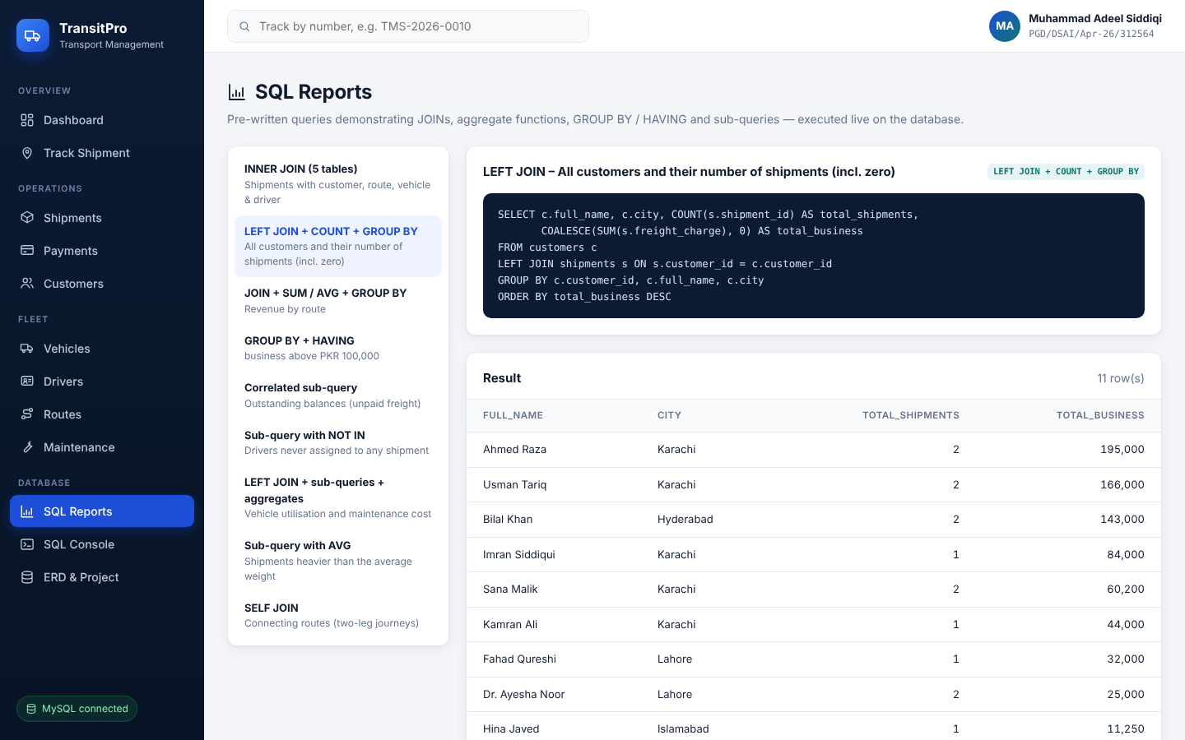
Figure 9.1 – SQL Reports page
Report | What it answers
INNER JOIN – shipment overview | Each shipment with its customer, route, vehicle and driver
LEFT JOIN – customers and shipments | Every customer, including those with no shipments yet
Revenue by route | Shipments, weight and revenue per route
Top customers (HAVING) | Customers with business above PKR 100,000
Outstanding balances | Shipments that are not fully paid, and how much is due
Idle drivers (NOT IN) | Drivers never assigned to a shipment
Vehicle utilisation | Trips and maintenance cost per vehicle
Heavy shipments | Shipments heavier than the average weight
Connecting routes (SELF JOIN) | Two-leg journeys, such as Karachi → Lahore → Islamabad

9.2 SQL Console
- Open SQL Console.
- Type a query, for example SELECT city, COUNT(*) FROM customers GROUP BY city, or click one of the example buttons.
- Click Run query.
Note: The console is read-only: it runs SELECT, SHOW and DESCRIBE only, one statement at a time. Use the forms (or MySQL Workbench) to change data.

10. Messages and Troubleshooting

10.1 Messages in the app
After every save, a green message confirms the action and a dark box shows the SQL statement that ran. A red message means the database refused the change; nothing was saved.
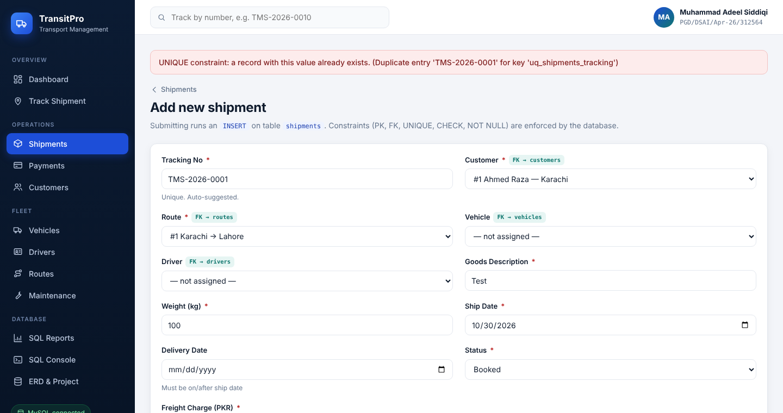
Figure 10.1 – Example: a duplicate tracking number is refused
Message begins with… | Meaning | What to do
"… is required." | A mandatory field is empty | Fill in the fields marked *
"UNIQUE constraint …" | That value already exists (tracking no., phone, email, plate, licence, route) | Use a different value
"CHECK constraint …" | A value is out of range (negative weight, delivery before ship date, same origin and destination) | Correct the value
"Cannot delete … still referenced …" | Other records depend on this one | Delete or reassign the related shipments first
"No shipment found …" | Wrong tracking number | Check the number
"The web console is READ-ONLY" | A write statement was typed in SQL Console | Use the forms or MySQL Workbench

10.2 Start-up problems
Problem | Solution
Console says "Python is NOT installed" | Install Python 3.10+ with Add python.exe to PATH, then run START_HERE.bat again.
Console says "WRONG PASSWORD" | Close the window, run START_HERE.bat again and type the MySQL Workbench password.
Console says "MySQL server is NOT RUNNING" | Press Windows, type Services, find MySQL80, right-click → Start.
Badge shows "SQLite connected" | MySQL was not reached. The app still works; read the console message to fix the MySQL connection.
Browser shows "can't reach this page" | The console window was closed. Start the app again, then refresh the page.
"Windows protected your PC" warning | Click More info → Run anyway. This appears for any downloaded .bat file.

11. Frequently Asked Questions
Q. Can I change a tracking number after saving?
A. Yes, edit the shipment. The new number must still be unique.
Q. Why is the freight charge different from what I typed?
A. It is only recalculated when you enter 0. Any other amount is kept exactly.
Q. Can a shipment be paid in parts?
A. Yes. Add as many payments as needed; the balance due updates automatically.
Q. Where is my data stored?
A. In the MySQL database transport_db on your computer. You can view it in MySQL Workbench under Schemas.
Q. Will data I add in the browser appear in MySQL Workbench?
A. Yes, immediately. Refresh the table in Workbench to see it.
Q. Can I use TransitPro on my phone?
A. Yes. The layout adapts to small screens; open the menu with the ☰ button.
Q. How do I start again with clean data?
A. Stop the app, run DROP DATABASE transport_db; in Workbench, then start the app again.

Appendix A: Glossary
Term | Meaning
CRUD | Create, Read, Update, Delete: the four basic data operations
ERD | Entity Relationship Diagram: the design of the tables and how they relate
Primary key | A column that uniquely identifies each row, such as shipment_id
Foreign key | A column that links to another table's primary key, such as shipments.customer_id
Constraint | A rule enforced by the database: NOT NULL, UNIQUE, CHECK, FOREIGN KEY
JOIN | Combining rows from related tables in one query
Freight charge | Price of transporting a shipment, in PKR
Tracking number | Unique reference of a shipment, such as TMS-2026-0010
MySQL Workbench | Desktop tool for viewing and querying the MySQL database

Appendix B: Database Quick Reference
Database name: transport_db. Full details are in README.md and the SQL scripts in the database folder.
Table | Primary key | Foreign keys | Linked from screen
customers | customer_id | – | Customers
drivers | driver_id | – | Drivers
vehicles | vehicle_id | – | Vehicles
routes | route_id | – | Routes
shipments | shipment_id | customer_id, route_id, vehicle_id, driver_id | Shipments
payments | payment_id | shipment_id | Payments
maintenance | maint_id | vehicle_id | Maintenance

The Entity Relationship Diagram is in docs/ERD.png and on the ERD & Project page of the app.

