ReconEye
Weapon-Detection System

By:

Syed Shakir Hassan
40079
Muhammad Adeel
40125

Supervised by:
Dr. Muhammad Mansoor Alam

Faculty of Computing
Riphah International University, Islamabad
Fall 2025

A Dissertation Submitted To

Faculty of Computing,
Riphah International University, Islamabad
As a Partial Fulfillment of the Requirement for the Award of the Degree of
Bachelors of Science in Computer Science

Faculty of Computing
Riphah International University, Islamabad
Date: 26th Nov. 2025
Final Approval

This is to certify that we have read the report submitted by Syed Shakir Hassan (40079), Muhammad Adeel (40125) for the partial fulfillment of the requirements for the degree of the Bachelors of Science in Computer Science (BSCS). It is our judgment that this report is of sufficient standard to warrant its acceptance by Riphah International University, Islamabad for the degree of Bachelors of Science in Computer Science (BSCS).

Committee:

1 | Dr. Muhammad Mansoor Alam  (Supervisor)
2 | Dr. Musharraf Ahmed  (Head of Department)

Declaration

We hereby declare that this document “ReconEye weapon-detection System” neither as a whole nor as a part has been copied out from any source. It is further declared that we have done this project with the accompanied report entirely on the basis of our personal efforts, under the proficient guidance of our teachers, especially our supervisor Dr. Muhammad Mansoor Alam. If any part of the system is proved to be copied out from any source or found to be reproduction of any project from anywhere else, we shall stand by the consequences.

___________________________
Syed Shakir Hassan
40079

___________________________
Muhammad Adeel
40125

Dedication
Our project is dedicated to our beloved parents, seniors, friends, and especially our supervisor "Dr. Muhammad Mansoor Alam" who has been our continual source of inspiration and whose support has helped this project succeed. Their sacrifices and strong belief in us gave us the strength to face difficulties and keep working hard. We are also humbled to our friends and seniors who gave us good advice and support. We want to thank our supervisor the most for always encouraging us, giving us helpful advice, and being patient, which were all very important for finishing the project. This project would not have been possible without the love and support of all these wonderful people. We are very grateful to each one of them for being a part of our journey.
Acknowledgement
In the name of the Most Gracious a Merciful Allah. First and foremost, we owe Allah a big thank you for giving us the strength, wisdom, and determination we needed to finish this project. He gave the direction and support that made this possible. We are greatly indebted to our project supervisor “Dr. Muhammad Mansoor Alam”. Without their personal supervision, advice and valuable guidance, completion of this project would have been doubtful. We are deeply indebted to them for their encouragement and continual help during this work.
And we are also thankful to our parents and family who have been a constant source of encouragement for us and brought us the values of honesty & hard work.

___________________________
Syed Shakir Hassan
40079

___________________________
Muhammad Adeel
40125

Abstract
At this stage of technical life, the technology is increasing day by day and Machines are replacing the work load of human. And this will making easy life for human. As we know that, security has become a major concern for both public and private spaces, and technology plays a vital role in reducing human effort while enhancing safety. We aim to develop a smart surveillance system capable of detecting weapons in real time and alerting the concerned people in real time through a website and mobile app. We also know that existing systems offer a weapon detection, they either compromise on accuracy or are too expensive due to streaming and hardware requirements. Additionally, most surveillance systems still depend on human monitoring, which is not reliable. Our system connects to cameras that watch for weapons like guns and knives at all times. The system sends alerts to security staff through the website and mobile app when a weapon is found. Live video streaming lets users see what's going on in real time. The system makes sure that alerts are sent out quickly, even if no one is actively watching the feed. This means that people don't have to rely on the system as much and can respond to possible threats more quickly. This weapon detection system works well in a variety of settings and weather conditions. It makes public and private spaces safer by allowing for early threat detection and quick action.
Table of Contents
List of Tables xii
List of Figures xiii
Chapter 1: Introduction 2
1.1 Overview 2
1.2 Goals and Objective 3
1.2.1 Goal 3
1.2.2 Objectives 4
1.3 Scope of the Project 5
1.4 Project Motivation 6
Chapter 2: Literature Review 8
2.1 Introduction 8
2.2 Background and Problem Elaboration 8
2.3 Literature Review Summary Table 9
2.4 Research Gap 10
2.5 Problem Statement 11
Chapter 3: Requirements and Design 14
3.1 Requirements 14
3.1.1 Functional Requirements 14
3.1.2 Non-Functional Requirements 15
3.1.3 Hardware and Software Requirements 16
3.2 Proposed Methodology 17
3.2.1 Data Collection 17
3.2.2 Challenges with Existing Dataset 17
3.2.3 Development of Custom Datasets 18
3.2.4 Advanced Data Collection Methodology 18
3.2.5 Data Preprocessing 19
3.2.6 Model Selection and Development Process: 19
3.2.7 Website Development 20
3.2.8 Mobile Application Development 21
3.2.9 Application Testing 21
3.2.10 User Feedback and System Refinement 22
3.2.11 Model Comparison 22
3.3 System Architecture 23
3.3.1 Frontend Presentation Layer 23
3.3.2 Backend Development 24
3.3.3 Machine Learning Module 24
3.3.4 Data Storage 24
3.3.5 Integration Layer 25
3.3.6 System Architecture Diagram 26
3.4 Use Case Diagram of User / Security Personnel 27
3.5 Use Case Diagram of Admin 28
3.6 Use Case Diagram of Combined 29
3.7 Use Case Descriptive 30
3.7.1 Login 30
3.7.2 Recover Password 31
3.7.3 Edit Profile 32
3.7.4 Live Camera Feeds 34
3.7.5 Real Time Alert Notifications 35
3.7.6 Acknowledge or Respond to Detected Threats 36
3.7.7 Add User 37
3.7.8 Edit User 38
3.7.9 Delete User 39
3.7.10 View Incident History and Snapshot 40
3.8 Workflow Diagram 41
3.9 GUI Graphical User Interface 41
3.9.1 Homepage, Navbar 42
3.9.2 Footer 43
3.9.3 About Section 43
3.9.4 Service Section 45
3.9.5 Contact us 46
3.9.6 Blog Section 46
3.9.7 Login as a User 47
3.9.8 Login as a Admin 48
3.9.9 Reset Password as a User 49
3.10 User Dashboard 49
3.10.1 Main Page 49
3.10.2 Edit Profile 50
3.10.3 View Live Feed 51
3.10.4 View Alerts 52
3.10.5 Acknowledge Threats 53
3.10.6 View History 54
3.10.7 Report Suspicious Activity 55
3.10.8 Logout Page 55
3.11 Admin Dashboard 56
3.11.1 Main Page 56
3.11.2 User Management 57
3.11.3 Alerts 58
3.11.4 Admin Logout Page 59
Chapter 4: Implementation and Test Cases 61
4.1 Implementation 61
4.1.1 Proposed Framework 61
4.1.2 Dataset Acquisition 62
4.1.3 Preprocessing 62
4.1.4 Architecture 62
4.1.5 Activation Function 63
4.1.6 Loss Functions 63
4.2 Test case Design and Description 64
4.2.1 Test case No.1 [Login] 64
4.2.2 Test case No.2 [Recover Password] 65
4.2.3 Test case No.3 [Live Camera Feed] 67
4.2.4 Test case No.4 [Real Time Alert Notifications] 68
4.2.5 Test case No.5 [Respond to Detected Threat] 69
4.2.6 Test case No.6 [View Incident History] 70
4.3 Test Metrics 72
4.3.1 Test case Metric.No.1 72
4.4 Conclusion 73
Chapter 5: Experimental Results and Analysis 75
5.1 Introduction 75
5.2 Training and Validation progress 75
5.3 Confusion Metric Analysis 77
Chapter 6: Conclusion and Future Directions 80
6.1 Introduction 80
6.2 Research Summary and Key Findings 80
6.2.1 Literature Review Contributions 80
6.3 Conclusion 81
References 82

List of Tables

Table 2.1: Comparison of Weapon Detection System 10
Table 3.1: Functional requirements User/Security Personnel 15
Table 3.2: Functional Requirements Admin 15
Table 3.3: UC - Login 30
Table 3.4: UC-Recover Password 31
Table 3.5: UC- User / Security Personnel Edit Profile 32
Table 3.6: UC-Live Camera Feed 34
Table 3.7: UC-Real Time Alert Notifications 35
Table 3.8: UC-Acknowledge or Respond to Detected Threats 36
Table 3.9: UC-Admin Add User 37
Table 3.10: UC-Edit User 38
Table 3.11: UC-Delete User 39
Table 3.12: UC-View Incident History and Snapshot 40
Table 4.1: TC – Authentication Module 64
Table 4.2: TC - Recover Password 65
Table 4.3: TC - View Live Camera Feed 67
Table 4.4: TC - Real Time Alert Notification 68
Table 4.5: TC - Respond to Detected Threat 69
Table 4.6: TC - View Incident History 71
Table 4.7: Test Metric 72

List of Figures

Figure 3.1: Proposed Methodology 23
Figure 3.2: System Architecture 26
Figure 3.3: UC - User / Security Personnel 27
Figure 3.4: UC - Admin 28
Figure 3.5: UC Combined Diagram 29
Figure 3.6: Workflow Diagram 41
Figure 3.7: Home Page and Navigation 42
Figure 3.8: Footer 43
Figure 3.9: About Us Section 44
Figure 3.10: Services Section 45
Figure 3.11: Contact us 46
Figure 3.12: Blog Section 47
Figure 3.13: Login as a User 48
Figure 3.14: Login as an Admin 48
Figure 3.15: Reset Password as a User 49
Figure 3.16: Main Page 50
Figure 3.17: Edit Profile 51
Figure 3.18: View Live Feed 52
Figure 3.19: View Alerts 53
Figure 3.20: Acknowledge Threats 54
Figure 3.21: View History 54
Figure 3.22: Report Suspicious Activity 55
Figure 3.23: Logout Page 55
Figure 3.24: Admin Main Page 56
Figure 3.25: User Management 58
Figure 3.26: Alerts 59
Figure 3.27: Admin Logout Page 59
Figure 5.1: F1 – Confidence Curve 75
Figure 5.2: Precision Confidence Curve 76
Figure 5.3: Precision Recall Curve 76
Figure 5.4: Confusion Matrix Normalized 77

Chapter 1:
Introduction

Introduction

Overview
Weapon-Detection is a mobile app and web-based platform designed to detect weapons in real-time, addressing the growing need for advanced security measures in public and private spaces. Traditional systems depend on manual monitoring, which causes delayed response time and lack integration with communication tool such as mobile apps for live streaming and instant alerts in critical moments. With the increasing frequency of violent incidents involving firearms and other weapons, there is an urgent need for innovative solutions that can detect and prevent such threats before they escalate. Weapon detection system uses advanced machine learning techniques to analyze live video feeds from strategically placed cameras, accurately identifying weapons and sending immediate alerts to security personnel through its integrated mobile and web platform. This rapid detection and communication enable law enforcement and security teams to respond effectively, improving public safety and reducing response times during emergencies. The system is designed to operate reliably across various environments and lighting conditions, ensuring consistent performance in diverse environment. This project not only aims to enhance public safety but also serves as testament to the power of machine learning in addressing modern-day security challenges. By automating the detection of dangerous weapons, the system empowers law enforcement agencies with the tools needed civilian, prevent crimes, and ultimately create safer environments.
The Weapon-Detection System is an innovative security solution designed to enhance public safety by leveraging advanced technologies such as machine learning and computer vision. This system aims to detect and identify weapons in real-time through surveillance cameras, providing authorities with immediate alerts to mitigate potential threats.
The system consists of several key components.
- Surveillance Cameras: Strategically positioned cameras continuously capture video feeds in monitored areas. These cameras are responsible for providing raw data for further processing and analysis.
- Centralized Processing Unit: A powerful processing unit responsible for handling the video feeds from the cameras and running the detection algorithms. It analysis the video streams and identifies the weapons by leveraging the customized train model.
- Advanced Algorithms: At the core of the system is a customized model specifically trained for weapon detection. The model is developed using a tailored dataset of weapon images and optimized to improve accuracy while addressing real-world challenges such as occlusions and varying lighting conditions.
- Communication Modules: Once a weapon is detected, the system immediately triggers an alert through secure communication channels. These alerts are sent in real time to law enforcement or security personnel, enabling them to take action.
- Integration with Law Enforcement: The system directly with law enforcement agencies, ensuring that authorities are notified promptly with necessary details such as videos, weapon type, and location. This integration plays a critical role in enabling a quick response and minimizing potential Threat.

Goals and Objective
Main and foremost objective of developing this system is to help security personnel with the ability to quickly detect weapons and respond immediately, minimizing potential risks and enhancing overall safety.

Goal
- To make a weapon system that works in real time, watches video feeds all the time, and finds possible threats right away.
- To provide security teams with immediate alerts when weapons are detected, enabling faster response and decision-making.
- To create user-friendly web and mobile interfaces that enable real-time weapon detection and threat monitoring, ensuring ease of use for security personnel, administrators.
- Use a custom-trained YoloV8 model to identify weapons with high accuracy using deep learning and computer vision techniques. The model should work well in a variety of environmental conditions.
- Facilitate immediate threat response through real-time alerts, live video streaming, and secure communication channels, thereby improving overall security response effectiveness.

Objectives
The main goal of the weapon detection system is to make public spaces safer by giving people a reliable, real-time way to find weapons. The system's main goals are to:

Real Time Weapon-Detection
  - Create a system that can find and identify weapons in real time from surveillance camera feeds using cutting-edge computer vision and machine learning methods.

Accurate Classification of Weapons
  - Train the custom weapon detection model on a custom dataset of weapon images to ensure high accuracy in detecting various types of firearms and other dangerous objects, even in challenging environments with varying lighting conditions and camera angles.

Integration with Law Enforcement
  - Make it possible for the weapon detection system and law enforcement to talk to each other easily. This will make sure that alerts are sent quickly and that detailed information, such as video, weapon type, and location, is sent to the right people so they can respond quickly.

Data Security and Privacy
  - Use secure communication protocols to protect data and make sure that private information, like video footage, is sent safely and in accordance with privacy laws.

System Evaluation and Optimization
  - Use metrics like precision, recall, and mean Average Precision (mAP) to keep an eye on how well the system is working and make changes to make it more accurate, efficient, and user-friendly.

Scope of the Project
This project includes the design, development, and installation of the ReconEye weapon detection system, which uses a custom YOLOv8 model to find threats in real time. The project has these main parts:
- Web and Mobile Development: Using React.js for web and Kotlin for mobile to make interfaces that are easy to use and respond quickly, making sure that everything works smoothly on all devices. The platform will have secure dashboards for different types of users, such as security personnel and administrators that can be monitored in real time.
- AI Integration: Making and training a custom YOLO v8 deep learning model to correctly find weapons in live video feeds. This means gathering and cleaning up large sets of weapon images and using data augmentation methods to make the model more robust in a range of situations.
- Real-Time Monitoring: Adding live video streaming so that users can watch surveillance feeds and automatically save snapshots when threats are found for later review and analysis.
- Multi-Platform Alert System: Making a system that sends push notifications and emails right away when weapons are found, with important information like the type of weapon, where it is, and when it was found.
- User Management: Making dashboards for different user roles, such as security personnel and administrators, each with its own set of features. People who work for user security will be able to manage profiles, see live feeds, and get real-time alerts. The admin will be in charge of managing users, adding, deleting, and changing their profiles.
The goal of the project is to create an AI-powered weapon detection system that improves security operations by automatically finding threats while still allowing people to make important decisions.

Project Motivation
Gun violence and violent crimes in public places are on the rise, which has brought to light a major flaw in current security systems. Even though surveillance technology has come a long way, many public and private places still have a hard time quickly finding and dealing with armed threats. Standard security measures, like having security personnel watch over things by hand. People often don't have enough staff to handle the number of video feeds in real time, which causes delays in responses and missed chances to intervene. The goal of the weapon detection system is to close this gap by using the latest machine learning and computer vision technologies to make weapon detection automatic. The system can help law enforcement by giving them a way to find weapons in real time. It would help agencies to act more quickly and effectively, which could stop violent crimes before they get worse. A major reason for this project is the chance to save lives by creating an automated early warning system that alerts the police as soon as a weapon is found, no matter what time of day or what the weather is like. The weapon detection system also makes it possible to make security operations more efficient. The system makes it easier for people to do other important tasks by automating weapon detection. The system can be used in many different places, from schools to transportation hubs, because it is scalable. This makes it flexible enough to meet different security needs. The goal of this project is to add to the growing field of smart security solutions by taking a proactive approach to public safety and dealing with the problems caused by gun violence in public places.

Chapter 2:
Literature Review

Literature Review

Introduction
ReconEye is a mobile app and web-based automated platform designed to detect weapons in real time and sending alerts to identify potential threats. In Today’s world, the need for security measures is important whether it is the public space, private space or some organization. Traditional systems depend on manual monitoring, which causes delayed response time. Additionally, many of these systems lack integration with communication such as mobile apps for live streaming and instant alerts in critical moments.
The main problem is being addressed here is that traditional surveillance systems are not capable of detecting weapons in real time. Additionally, they often involve high storage costs due to the need for locally saving large number of video recordings, which make them expensive and hard to manage. Because of these issues, current systems are not reliable and are hard to setup in more locations.
On the other hand, ReconEye also provides convenience for security teams. It ensures safety, quick response, and better monitoring, making it easier for security staff to manage and respond to threats quickly. This system can improve public safety, support innovation in security technology.

Background and Problem Elaboration
At this stage of technical life, the technology is increasing day by day. And Machines have prompted a global reassessment of public safety measures. From schools to shopping malls, public transportation, and crowded spaces, the potential for armed threats has escalated, and traditional security methods are often not enough. Surveillance cameras, which are widespread n public spaces, are critical for monitoring these areas, but their effectiveness is limited by the inability to automatically identify and respond to specific threats, such as weapons. Current security systems largely depend on human operators to monitor vast amounts of video footage, which is often inefficient and prone to oversight due to tiredness, distractions, or sheer volume.
If you see a weapon and don't tell the police right away, it could lead to death because they might not be able to stop the harm in time. Because of this gap in security capabilities, we need a smarter, automated solution that can find and identify weapons in real time. This will give law enforcement and security personnel immediate alerts so they can take action right away. If people don't report seeing weapons right away, it could end in death because police may not be able to stop the harm in time. Because of this gap in security capabilities, we need a smarter, more automated solution that can find and identify weapons in real time. This will give police and security personnel immediate alerts so they can take action right away. The Weapon Detection system project addresses this need by combining deep learning and computer vision technologies to detect weapons from surveillance video feeds. By training and advanced YOLOv8 object detection model on dataset of weapon images, the system is designed to recognize and classify various types of weapons, even in complex and dynamic environments. The idea of using machine learning for threat detection is not new, but its application for weapon detection in real time is still evolving. Existing solutions, such as gunshot detection systems, primarily focus on audio signals or have limited applicability to environments that don’t have specialized sensors. By using video feeds and computer vision, this system offers a broader, more scalable solution that can be implemented in a variety of public spaces. The weapon detection system project draws inspiration from ongoing advancements in object detection, particularly the success of YOLO models in real time applications. YOLOv8, known for its high accuracy and speed, serves as suitable for real-time deployment. By combining the power of machine learning, object detection, and secure communication protocols, the weapon detection system aims to revolutionize security efforts, providing law enforcement with the tools needed to enhance public safety, minimize the risks of violent incidents, and ultimately protect civilians from armed threats.

Literature Review Summary Table
This Table 2.1 compares existing AI-Weapon Detection System in terms of features, and capabilities, highlighting the gaps that Recon Eye Weapon Detection System addresses.

Table 2.1: Comparison of Weapon Detection System
Reference No | Title | Models Used | Result | Limitations
[1] | Real-Time Weapon-detection using Yolo v8 and Alert Mechanism | YOLOv8  (specifically YOLOv8m) | Mean Average Precision (mAP) = 0.78 | 1. Performance degradation with low light and blurred images.  2. Difficulty in detecting very small- Scale Weapons.
[2] | Real Time Weapon Detection using YOLOv8 and for enhanced security | YOLOv8 | Best mAP@ 0.5: 0.78  Precision: 0.85  Recall: 0.80 | Model shows signs of over fitting (gap between training and validation loss)
[3] | Pixels to protection: An intelligent Weapon-detection system | YOLOv8 + Attention Mechanisms + Vision Transformers (ViTs) | Mean Average Precision (MAP) = mAP@0.5: 98.5% | Computational complexity may increase with attention mechanisms and ViTs

Research Gap
However, the aforementioned weapon, detection systems with deep learning have dramatic improvements, there are still lots of significant problems that hinder the use of these systems in real, world security situations. One of the biggest problems is dealing with different environments. A lot of systems fail to give acceptable results at night, in bad weather, in crowded places, or when the object is partially covered. Since surveillance in these conditions is the most common, this defect seriously compromises the usefulness of the system. Computational efficiency is another challenge. It is true that advanced models with high weapon, detection capabilities are developed every day, but they usually require the availability of a powerful computer. Such a requirement thus significantly limits their use for real, time systems and smaller devices, especially in resource, constrained environments. Besides, a missing link is the alert and response systems. Most studies dwell on detection accuracy only. But a real, world system should be able to interact with the monitoring software and alert instantly as well. Without this complete system, the detection system is of little use. Another prominent matter is the quality of the dataset. Quite a number of training datasets lack sufficient diversity in terms of weapon types, the lighting conditions, camera angles, and real, world scenarios. This causes the models to be less accurate when they encounter new situations. False positive is another significant issue. Such systems, more often than not, mistake harmless objects for weapons, especially in crowded city environments. Excessive false alarms lead to distrust and security operations becoming slower in the end. Moreover, adaptability is quite limited. Models usually demonstrate good performance with one camera setup and poor performance with another. Changes in camera types, resolutions, or installation angles can lead to a decrease in accuracy. At last, cost of deployment poses a challenge. Such systems become quite costly especially for developing countries or small organizations if there are high hardware and computational requirements. In order to bring weapon, detection systems closer to the real, world scenario, future research has to focus on making these systems capable of adapting easily to different environments, computationally faster and lighter, better networked with alert systems, trained on extensively varied data, less prone to false alarms, and cheaper for deployment.

Problem Statement
The increase in armed violence and security threats in public places has led to an immediate demand for more effective security measures. The fundamental problem is still the dependence on human surveillance which results in security staff only reacting after the fact as they cannot constantly watch all the video feeds for signs of trouble. Security staff can only identify threats after an incident has taken place, rather than preventing real, time threats if we look at this time lag. In addition, current systems are not equipped with modern communication technologies. There is no efficient way to send instant mobile alerts or to allow live streaming for monitoring from a remote location. This communication gap inhibits security teams from reacting quickly to new threats. Moreover, a lot of present, day security systems are implemented with the massive storage infrastructures for snapshots/images, which leads to very high running costs and makes them unsuitable for wide usage. These shortcomings together create a large security gap in which the potential threats might progress to an alarming level. An intelligent, automated weapon detection system that is capable of providing accurate, real, time threat identification, could be seamlessly integrated with the modern communication channels and also be a cost, effective solution for different environments, will be the answer to this serious problem.

Chapter 3:
Requirements and Design

Requirements and Design
In this chapter, we have outlined our functional requirements in great detail for our primary actors i.e. (User/Security Personnel and Admin). The requirements are written specifically for the weapon detection system. Our system is user friendly, with intuitive interface that is simple to navigate and it offers an amazing and efficient way for security personnel and administrators to keep an eye on, detect, and respond to potential threats. It gives security personnel the ability to quickly get to live camera views, real time notifications, and recorded incident logs, hence, they are able to take immediate and rightly informed actions in case of emergencies. We designed the system use cases in accordance with each functional requirement and also developed use case diagrams, fully dressed use cases for our actors i.e. (Users/Security personnel and admin).

Requirements
The requirements have been structured to address the key challenges in weapon detection, including real time processing, accuracy under varying environmental conditions, seamless integration with existing infrastructure, and secure data management. This systematic approach ensures that the developed system will deliver high performance threat detection while maintaining usability and scalability across different deployment scenarios.

Functional Requirements
The functional requirements of the Recon Eye weapon detection system specify the essential features and functionalities that the system must possess to achieve its security objectives. These requirements define the interactions between the system and its users, ensuring that Recon Eye provides a seamless, efficient and responsive security monitoring experience. The following are the key functional requirements, categorized by user roles:

User / Security Personnel
The Table 3.1 describe the functional requirements of the user / security personnel

Table 3.1: Functional requirements User/Security Personnel
FR ID | Requirement
FR-001 | User shall request and receive account credentials.
FR-002 | User shall be able to login to the system using valid credentials.
FR-003 | User shall be able to create their profile.
FR-004 | User shall be able to edit their profile information.
FR-005 | User shall be able to recover password.
FR-006 | User shall be able to view live camera feeds on the dashboard.
FR-007 | User shall be able to receive real-time alerts in case of weapon detection.
FR-008 | User shall be able to acknowledge or respond to a detected threat.
FR-009 | User shall be able to view incident history and recorded videos.

Admin
The Table 3.2 describe the functional requirements of the admin

Table 3.2: Functional Requirements Admin
FR ID | Requirement
FR-010 | Admin shall be able to login to the system.
FR-011 | Admin shall be add, edit or remove user account.
FR-012 | Admin shall be able to remove the user account.
FR-013 | Admin shall be able to edit the user account.
FR-014 | Admin shall be able to assign and manage user roles.

Non-Functional Requirements
The non-functional requirements define the system’s operational attributes and constraints, ensuring that Recon Eye not only performs its intended functions but also meets quality standards related to usability, reliability, performance and security. The following are the key non- functional requirements:

- NFR-001 Performance
The system shall process video feed with a latency of less than 1 second per frame to ensure real-time detection. Detection accuracy shall maintain a minimum mean average precision (mAP) of 90%.
- NFR-002 Usability
The system shall provide an intuitive and user-friendly interface for security personnel and admin with varying levels of technical proficiency to navigate and utilize its features effectively.

Hardware and Software Requirements
The successful implementation and functioning of the Recon Eye weapon detection system depend on specific hardware and software requirements. These requirements ensure that the system operates efficiently and reliably, providing users with seamless real time threat detection and monitoring capabilities. The following outlines the necessary hardware and software requirements:

Hardware Requirements
• Surveillance Cameras: High resolution IP cameras capable of capturing clear video feeds in real time, suitable for weapon detection in various environmental conditions.
• Client Devices:
Mobile Devices: Minimum 2GB RAM for smartphones.
Laptops/Desktops: Minimum 4GB RAM, quad-core processor and high resolution display.
• Networking Equipment’s: Reliable internet connectivity with high bandwidth to support real time camera streaming and real time alert notifications.

Software Requirements
• Operating System: Windows 10 or later, and Linux distributions for desktops.
Android 8.0 or later for mobile devices.
• Browser: Updated version of Firefox, chrome, Microsoft edge.
• Internet: High Speed internet connection minimum 3G, recommend 4G or higher.
These hardware and software requirements are essential to support the robust functionality, and performance of the Recon Eye weapon detection system, ensuring that it meets the needs of all its user effectively.

Proposed Methodology
In The Weapon-Detection System is designed to leverage state of the art technologies to automatically detect weapon in real-time, providing law enforcement agencies with immediate alerts and vital information to respond promptly. The design of the system involves several key components, each playing a critical role in ensuring the effectiveness, efficiency, and scalability of the solution. We are developing Mobile App and Web-based Weapon detection system designed to enhance security through real-time monitoring and AI-driven threat detection, the platform is built using Kotlin, MERN Stack technology and is specifically tailored for environment such as educational institutions, public spaces, and secure facilities. This system allows administrators and security personnel to monitor live video feeds and detect potential weapons using deep learning models. Upon detection the system triggers instant alerts and stores footage for further review. Existing surveillance systems often lack intelligent features such as real-time analysis or proactive alerts. Our system addresses this gap by offering an automated, AI-powered approach to threat detection.

Data Collection
Accurate and comprehensive data collection serves as the cornerstone for developing robust weapon detection models, especially in security sensitive environments wher precise threat identification can be lifesaving. Acknowledging the critical shortcomings in publicly available datasets, this initiative focused on creating specialized, custom datasets engineered to overcome the specific obstacles in weapon detection, there by significantly improving the practical effectiveness and deployment readiness of the Recon Eye platform in diverse operation context.

Challenges with Existing Dataset
Current data used for detecting weapons has many problems that make it hard for model to work well in real life situations.

- Environmental Limitations: Most of these datasets are made up of images taken in idealized, controlled environments, these datasets fail to capture the complex and unpredictable conditions typical of actual surveillance settings, such as varying weather, lighting changes, and dynamic backgrounds.
- Image Quality Issues: Inconsistent resolutions, motion blur, compression artifacts, and suboptimal cameras angles prevalent in these datasets significantly reduce the reliability and accuracy of detection algorithms.
- Class Imbalance: A class imbalance happens when some types of weapons are much common in the data than others. This cause the model to be biased and not perform well when it encounters less common weapon types, making the overall detection less reliable.
- Limited Weapon Variety: Limited weapon variety occurs when the dataset doesn’t include enough different types, models, or styles of firearms. Because of this, the model struggles to recognize the wide range of weapons it might see in real situations.

Development of Custom Datasets
To systematically overcome the limitations of existing datasets, we created a large and well-organized private dataset specifically for weapon detection. This dataset provides the diverse and high quality training images needed to match real world surveillance situation. It was carefully built to help the model work well in different environments and with different types of weapons. We also made sure the dataset had balanced classes’ clear images, and a wide variety of scenarios.

Advanced Data Collection Methodology
The dataset was strategically compile from diverse and complementary sources to ensure comprehensive coverage and real-world applicability. This include gathering actual security footage from various public surveillance system videos. Additionally, images were sourced from publicly available repositories, with significant contribution from platforms such as roboflow and kaggle, which provide access to a wide range of diverse weapon images.

Data Preprocessing
A clear and well-structured preprocessing pipeline was created to improve the quality of the dataset and boost the model’s performance. The main steps include:
- Resizing: All images were resized to 640 x 640 pixels, which is the recommended input size for the YOLOv8 model. This helps the model process all images consistently.
- Normalization: Pixel values were scaled to a range of 0 to 1. This males training more stable and helps the model learn faster.
- Color Optimization: The color format of the images was adjusted to better match the style and quality of real surveillance footage. This ensures that the model performs well in actual security environments.
- Strategic Data Partitioning: To train the model effectively, the dataset was strategically divided into three parts. The training set (70%) was used to help the model learn patterns from the data. A separate validation set (20%) was used during training to fine-tune the model’s settings and improve its accuracy. The test set (10%) was kept aside to evaluate the model’s performance on completely new data, ensuring it works well in real-world situations.

Model Selection and Development Process:
After testing of multiple state-of-the-art architectures, YOLOv8s was strategically selected as the optimal detection model. The YOLOv8s model was chosen because it offers an excellent balance between speed and accuracy, which is very important for real-time security systems where quick detection is essential. It has proven to perform well in complex object detection tests, making it reliable for the important task of identifying weapons. The model is also efficient, using computer resources wisely, so it can run on many types of hardware from powerful servers to smaller edge devices. Its design, including a strong backbone network for extracting features and a refined detection head, makes it especially good at accurately detecting firearms in difficult surveillance situations.

Website Development
The development of a user-friendly and responsive web platform is fundamental to the success of the ReconEye weapon detection system. The website is built using modern technologies, making it fast, easy to scale, and simple to use for security Personnel and admin.

- Frontend Development:
- React.js, a powerful JavaScript library that enables the creation of dynamic, responsive, and interactive user interfaces.
- HTML5 and Tailwind CSS to create a modern, clean design that looks good and works well on all devices and screen sizes.

- Backend Development:
- Node.js: Provides an asynchronous, event-driven runtime environment that supports scalable and high-performance backend services capable of handling real-time data processing and API management.
- Express.js: A lightweight web framework for Node.js used to build RESTful APIs for functionalities such as user authentication and user authorization image uploads.
- FastAPI: Used specifically for the real-time weapon detection pipeline, processing each frame individually with high-performance asynchronous operations to ensure minimal latency in threat identification.
- JWT (JSON Web Token): Implemented for secure and stateless authentication and authorization of users, with tokens stored in HTTP-only cookies for enhanced security.
- AWS SDK: Integrated for secure storage of weapon detection snapshots evidence in AWS S3 buckets, ensuring reliable and scalable media management.
- Cors & Body-Parser: Middleware used for enabling secure cross-origin requests and parsing incoming request bodies in the middleware chain, ensuring proper data handling and API security.

Mobile Application Development
The development of an intuitive and high-performance mobile application is crucial for the effectiveness of the ReconEye weapon detection system. The Android app is built using native technologies, making it responsive, reliable, and accessible.

- Frontend Development:
- XML: Employed for designing and implementing the user interface layouts, ensuring native Android compatibility and optimal performance across different device screen sizes.

- Backend Development:
- Kotlin: Used to build the Android app’s backend, making the code safe and allowing smooth handling of tasks running in the background.
- REST API: Built with the Retrofit library to allow smooth communication between the app and server, enabling real-time data updates and alerts.
- Room Database: Integrated as the local persistence library for caching application data, storing user preferences, and maintaining offline functionality with efficient data access operations.

Application Testing
Thorough testing is essential to validate the functionality, reliability, and performance of the ReconEye Weapon Detection System. The testing phase includes:
- Functional Testing: Verifying real-time weapon detection accuracy across various environmental conditions, testing user authentication and role-based access control for security personnel and admin, validating live video streaming and camera feed integration and ensuring proper functioning of instant alert notifications (push notifications, email, SMS).
- Usability Testing: Assessing the user experience to ensure that the platform is intuitive and meets the needs of all user roles

User Feedback and System Refinement
Incorporating user feedback is essential for optimizing the performance and usability of the ReconEye Weapon Detection System. This critical phase involves:
- Beta Testing: The system was tested with security personnel from corporate offices to check its performance and usability. This helped ensure that the features work well in a real work environment and meet the needs of professional security staff.
- Performance Monitoring and Issue Identification: Collecting detailed reports on detection accuracy, false positives, and missed threats identifying usability challenges, recording technical issues related to camera integration and alert delivery systems.
- Iterative Improvements: Utilizing the feedback to make necessary adjustments and improvements to the system, ensuring it meets user expectations and operates smoothly.

Model Comparison
To validate the effectiveness of the primary object detection model developed for the Weapon Detection System, a comprehensive comparative analysis will be conducted against several pre-trained, state-of-the-art models. This comparison will involve:
- Selection of Benchmark Models: Identifying leading object detection models that have demonstrated high performance in real time detection and security context.
- Performance Metrics Comparison: Evaluating and comparing key metrics such as accuracy, precision, recall, and F1 score across different models.
- Analysis of Strengths and weaknesses: Highlighting the advantages and limitations of each model in the context of the Weapon Detection System's specific requirements.
- Justification for Model Choice: Providing a clear and data-driven rationale for the final selection of the primary model, based on its performance and its ability to meet the project goals of high accuracy, real-time processing, and easy deployment.

The figure 3.1 below shows the methodology of weapon detection

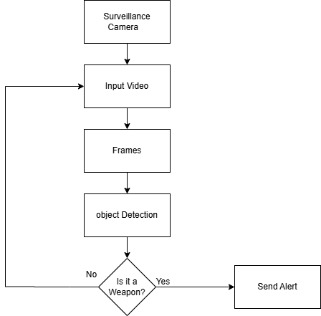
Figure 3.1: Proposed Methodology

System Architecture
The System Architecture of the Weapon Detection System is strategically designed to ensure real-time threat identification, seamless integration with existing security infrastructure, and efficient alert management. Leveraging modern technologies and robust engineering practices, the system delivers high-performance, reliable monitoring for enhanced security protocols. It consists of several key components working together seamlessly.

Frontend Presentation Layer
Technology Stack: React.js, Tailwind CSS, XML.
- User Interface: Builds responsive and intuitive web using React.js and Tailwind CSS for Security personnel/user and admin.
- User Interactions: Enables core user actions such as Request login access, login, profile management, view live feed and view alerts.
- Communication Connects with the backend via RESTful APIs and Fast APIs to exchange data dynamically and securely.

Backend Development
Technology Stack: Node.js with Express.js.
- Server-Side Operations: Manages authentication, authorization, and image uploads, taking Screenshot, and manage live stream.
- User Interactions: Enables core user actions such as Request login access, login, profile management, view live feed and view alerts.
- API Management: Serves as the bridge between the frontend, the database, and the machine learning module by exposing secure, scalable APIs.

Machine Learning Module
Technology Stack: YOLOv8 (You Only Look Once) Architecture.
- Weapon Screening: Real-time screening of video frames to filter weapon content for detailed analysis, optimizing processing efficiency.
- Multi-class Weapon detection: Analyzes video frames in real-time to detect, localize, and classify specific types of weapons (e.g., handguns, rifles) using bounding boxes and confidence scores.
- Alert Activation: Automatic threat notification generation for security personnel based on detection confidence threshold.

Data Storage
Technology Stack: Mongo DB and AWS S3 bucket.
- User Information Management: Stores user’s data, login credentials, profile images and alerts.
- Alert Snapshot Storage: Automatically saves image snapshots from video frames where weapons are detected. These snapshots serve as crucial evidence for security reviews and incident analysis.

Integration Layer
Technology Stack: Bravo (for email services).
- Password Recovery Service: Manages secure reset password through Bravo email integration.
- Real-time Alert System: Sends instant push notifications to security personnel's devices and simultaneous email alerts upon weapon detection.

System Architecture Diagram
The Figure 3.2 shows the system architecture of weapon detection system

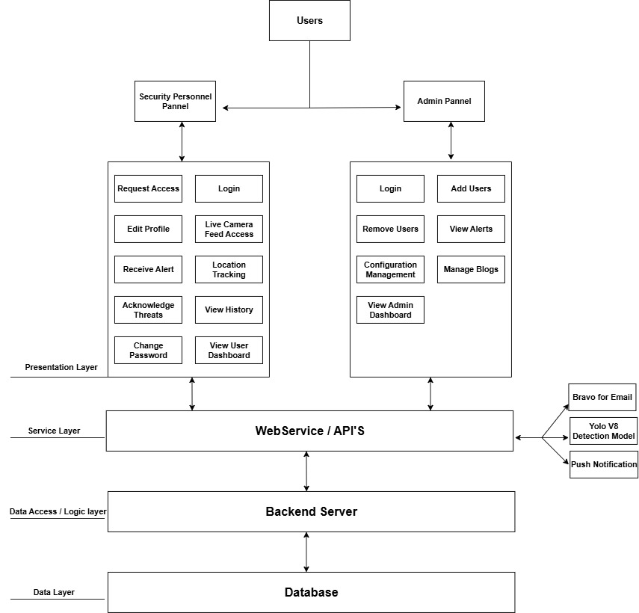

Figure 3.2: System Architecture

Use Case Diagram of User / Security Personnel
The Figure 3.3 shows the Use Case diagram of User / Security Personnel

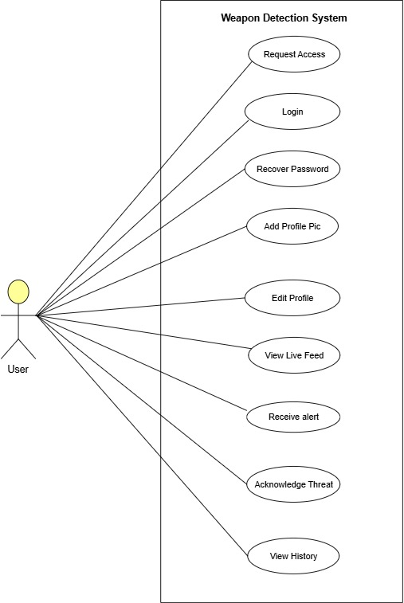

Figure 3.3: UC - User / Security Personnel

Use Case Diagram of Admin
The Figure 3.4 shows the Use Case diagram of Admin

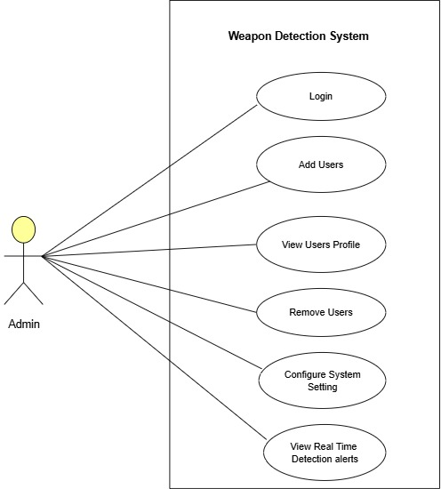

Figure 3.4: UC - Admin

Use Case Diagram of Combined
The Figure 3.5 shows the Use Case diagram of Combined

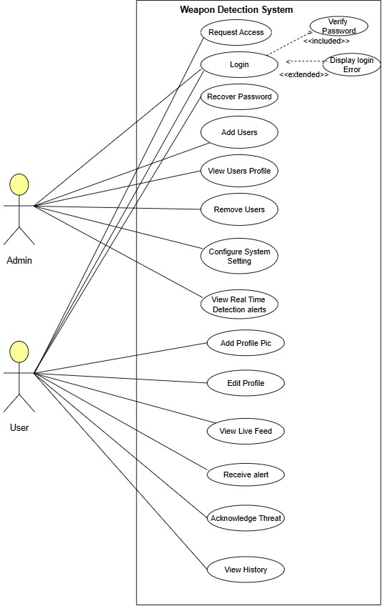

Figure 3.5: UC Combined Diagram

Use Case Descriptive
This part intends to give a brief explanation of the use case before presenting its complete description.

Login
The Table 3.3 describes the detailed use case of the login process

Table 3.3: UC - Login
Name |  | Login
Actors |  | Security Personnel, Admin
Summary |  | The user shall provide their email and password on the login form and after successful verification, redirect the user to the home page.
Pre- Conditions |  | User must be registered on the system.
Post-  Conditions |  | The user shall be redirected to the home page of the system and user’s session will be maintained.
Special Requirements |  | None
Basic Flow
Actor Action |  |  | System Response
1 | The user opens the login page. |  | 2 | The login page is displayed asking for email and password.
3 | The user enters valid email and password. |  | 4 | The system verifies the email and password, establishes a session for the user and redirects the user to the home page.
Alternative Flow
3 | The user enters invalid email or password. |  | 4-A | The system responds with an error  Message: Incorrect email or password entered.

Recover Password
The Table 3.4 describes the detailed use case of the recover password process

Table 3.4: UC-Recover Password
Name |  | Recover password
Actors |  | Security Personnel / user
Summary |  | This use case describes the process of recovering a password for a user who has forgotten or lost their login credentials.
Pre- Conditions |  | The user must have a registered account on the Weapon Detection System.  The user must have forgotten or lost their password.
Post-  Conditions |  | The user's password is successfully reset, and they can log in to their account using the new password.
Special Requirements |  | None
Basic Flow
Actor Action |  |  | System Response
1 | User navigates to the Weapon- Detection system login page.
2 | User clicks on the "Forgot Password"  link. |  | 3 | The system presents a password recovery form.
4 | User enters their registered email address in the provided field.
5 | User clicks on the "Submit" button. |  | 6 | The system verifies the email address and generates a unique password reset token.
 |  |  | 7 | The system sends an email to the user's registered email address containing a Password reset link.
8 | User checks their email inbox and clicks on the password reset link. |  | 9 | The system validates the password reset token and redirects the user to a password reset form.
10 | User enters a new password and  confirms it in the provided fields.
11 | User submits the password reset form. |  | 12 | The system verifies the new password and updates it in the user's account.
 |  |  | 13 | The system displays a confirmation message indicating that the password has been successfully reset.
Alternative Flow
4.1 | If the user enters an invalid or unregistered email address. |  | 4.2 | The system displays an error message and prompts the user to enter a valid email address.
 |  |  | 4.3 | If the password reset token has expired or become invalid, the system prompts the user to initiate the password recovery process again.

Edit Profile
The Table 3.5 describes the detailed use case of the user edit profile process

Table 3.5: UC- User / Security Personnel Edit Profile
Name |  | Edit Profile
Actors |  | Security Personnel
Summary |  | This use case describes the process of edit a profile for a user on the Weapon-Detection system.
Pre- Conditions |  | The user must have access to the Weapon-Detection website and app.  The user must be registered on the Weapon-Detection system.
Post-  Conditions |  | The user's profile is successfully edit and can be viewed the System
Special Requirements |  | None
Basic Flow
Actor Action |  |  | System Response
1 | User navigates to the weapon detection website and app.
2 | User clicks on the "Edit Profile” button. |  | 3 | The system presents an edit profile form.
4 | User modifies their personal details, such as profile picture, password in the provided fields.
5 | User clicks on the "Save changes" to confirm updates. |  | 6 | The system validates the new information and password strength.
 |  |  | 7 | The system update the user's profile Information in the Weapon detection database.
 |  |  | 8 | The system displays a confirmation message indicating that the profile has been successfully updated.
Alternative Flow
4.1 | If the user enters an invalid password during password change. |  | 4.2 | Then the system displays error messages and prompts the user to correct the entries.
4.3 | If uploaded profile picture exceeds size limit or is invalid format. |  | 4.4 | Then the system rejects the image and specifies format/size requirements.

Live Camera Feeds
The Table 3.6 describes the detailed use case of the live camera feed process

Table 3.6: UC-Live Camera Feed
Name |  | Live Camera Feeds
Actors |  | Security Personnel
Summary |  | Allows users to securely access and monitor real-time video streams from connected surveillance cameras through the system.
Pre- Conditions |  | The user is authenticated and logged in.  Cameras are properly installed, online and streaming to the server.
Post-  Conditions |  | Live camera feed is displayed on the user dashboard.
Special Requirements |  | Support for viewing and multiple camera feeds simultaneously.
Basic Flow
Actor Action |  |  | System Response
1 | Login with valid credentials. |  | 2 | Authenticate user and redirect to the dashboard.
3 | Navigate to live camera feed sections. |  | 4 | Display a list of available connected cameras.
5 | Select one or more camera feeds to view. |  | 6 | Establish a secure connection and starts streaming video.
7 | Monitors the live feed. |  | 8 | Continuously streams real-time video with low latency
9 | Optionally switches between camera  views. |  | 10 | Updates the stream based on the selected camera.
11 | Ends session or exist the feed section. |  | 12 | Logs access session (camera ID, time, user info) for auditing.
Alternative Flow
3.1 | Select a camera that is currently offline. |  | 3.2 | Displays error: Camera not available
3.3 | Tries to refresh or select another camera. |  | 3.4 | Update feed list and allows user to choose a working camera.
 |  |  | 3.5 | Logs the failed camera connection attempt.
3.6 | Continues viewing when network drops. |  | 3.7 | Detects disconnection and pause the feed.
3.8 | Waits or attempts manual reconnect. |  | 3.9 | Display message: Connection lost.
 |  |  | 3.10 | Automatically resumes stream when connection is restored.

Real Time Alert Notifications
The Table 3.7 describes the detailed use case of the alert notification process

Table 3.7: UC-Real Time Alert Notifications
Name |  | Real Time Alert Notifications
Actors |  | Security Personnel
Summary |  | System detects a weapon in real time video feed and instantly sends alerts to user.
Pre- Conditions |  | Live camera feeds are running and being processed by the detection module. Notification Channels (Push notifications, emails etc.)
Post-  Conditions |  | Live camera feed is displayed on the user dashboard.
Special Requirements |  | Only authorized actors can view alert details.
Basic Flow
Actor Action |  |  | System Response
 |  |  | 1 | System continuously processes live video feeds for weapon detection
 |  |  | 2 | Detects a weapon using AI-based weapon detection system.
 |  |  | 3 | Immediately generates an alert with detection details (weapon type, location, time.)
 |  |  | 4 | Sends and email notifications to users and admins.
5 | User acknowledges alert. |  | 6 | System logs acknowledgment.
Alternative Flow
5.1 | User marks alert as false. |  | 3.2 | System logs it as a false detection.

Acknowledge or Respond to Detected Threats
The Table 3.8 describes the detailed use case of the respond to detected threat process

Table 3.8: UC-Acknowledge or Respond to Detected Threats
Name |  | Acknowledge or respond to detect threat
Actors |  | Security Personnel
Summary |  | The user shall provide their email and password on the login form and after successful verification, redirect the user to the home page.
Pre- Conditions |  | User must be registered on the system.
Post-  Conditions |  | The user shall be redirected to the home page of the system and user’s session will be maintained.
Special Requirements |  | None
Basic Flow
Actor Action |  |  | System Response
1 | The user opens the login page. |  | 2 | The login page is displayed asking for email and password.
3 | The user enters valid email and password. |  | 4 | The system verifies the email and password, establishes a session for the user and redirects the user to the home page.
5 | The security personnel receives a threat alert notification. |  | 6 | The system displays a notification with details of the detected threats.
7 | The security personnel clicks on the notification to acknowledge threats. |  | 8 | The system redirects to the acknowledge threats page.
Alternative Flow
3 | The user enters invalid email or password. |  | 4-A | The system responds with an error  Message: Incorrect email or password entered.

Add User
The Table 3.9 describes the detailed use case of the admin add user process

Table 3.9: UC-Admin Add User
Name |  | Add User
Actors |  | Admin
Summary |  | This use case describes the process for admin to create new user accounts in the weapon detection system.
Pre- Conditions |  | Admin must be logged into the system.  The admin must have user management privileges.
Post-  Conditions |  | New user account is successfully create and added to the system.
Special Requirements |  | None
Basic Flow
Actor Action |  |  | System Response
1 | Admin navigates to user management section.
2 | Admin clicks “Add User” button. |  | 3 | The system display user creation form.
4 | Admin enters user details first, last name and password.
5 | Admin clicks “Create user” button. |  | 6 | System validates the entered information.
 |  |  | 7 | System create new user account in database.
Alternative Flow
3 | If admin enters invalid email format. |  | 4-A | System displays error message and prompts correction.

Edit User
The Table 3.10 describes the detailed use case of the edit user process

Table 3.10: UC-Edit User
Name |  | Edit users
Actors |  | Admin
Summary |  | This use case describes the process for admin to modify existing user accounts in the weapon detection system.
Pre- Conditions |  | The admin must be logged into the system.  The user account must be exist in the system.
Post-  Conditions |  | User account information is successfully updated in the system.
Special Requirements |  | Admin cannot modify their own role or permissions.
Basic Flow
Actor Action |  |  | System Response
1 | Admin navigates to user management section.
2 | Admin selects user to edit and clicks “Edit” button. |  | 3 | The system display user edit form with current information.
4 | Admin modifies user details first, last name and password. |  | 5 | System validates the modified information.
6 | Admin clicks “Create user” button. |  | 7 | System validates the modified information.
Alternative Flow
3 | If admin enters duplicate email address. |  | 4-A | System displays error message and prompts correction.

Delete User
The Table 3.11 describes the detailed use case of the delete user process

Table 3.11: UC-Delete User
Name |  | Delete User
Actors |  | Admin
Summary |  | This use case describes the process for admin to remove existing user accounts in the weapon detection system.
Pre- Conditions |  | The admin must be logged into the system.  The user account must be exist in the system.
Post-  Conditions |  | User account is permanently removed from system.
Special Requirements |  | None.
Basic Flow
Actor Action |  |  | System Response
1 | Admin navigates to user management section.
2 | Admin selects user to delete and clicks “delete” button. |  | 3 | The system verifies user can be deleted.
4 | Admin confirms deletion action. |  | 5 | System removes user account from database.
Alternative Flow
4 | If admin cancel deletion actions. |  | 4-A | System returns to user management screen without changes.

View Incident History and Snapshot
The Table 3.12 describes the detailed use case of the view incident history process

Table 3.12: UC-View Incident History and Snapshot
Name |  | View Incident History and Snapshot
Actors |  | Security Personnel
Summary |  | The user shall provide their email and password on the login form and after successful verification, redirect the user to the home page.
Pre- Conditions |  | User must be registered on the system.
Post-  Conditions |  | The user shall be redirected to the home page of the system and user’s session will be maintained.
Special Requirements |  | None
Basic Flow
Actor Action |  |  | System Response
1 | The user opens the login page. |  | 2 | The login page is displayed asking for email and password.
3 | The user enters valid email and password. |  | 4 | The system verifies the email and password, establishes a session for the user and redirects the user to the home page.
Alternative Flow
3 | The user enters invalid email or password. |  | 4-A | System responds with an error  “Incorrect email or password”

Workflow Diagram
The Figure 3.6 shows the Workflow diagram of Weapon Detection System.

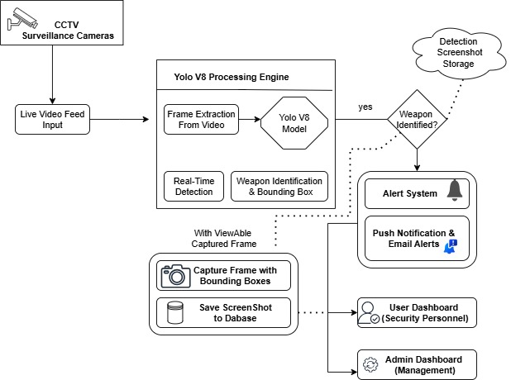

Figure 3.6: Workflow Diagram

GUI Graphical User Interface
The GUI of the Recon Detection System includes essential navigation components such as a header, footer, home, services, about, contact, blog, login, and reset password sections. It offers a seamless, user-friendly interface for accessing key features, with an emphasis on simplicity and intuitive navigation for both technical and non-technical users.

Homepage, Navbar
The Home Page acts as the central dashboard to the user where they can be given a quick preview of what the system can do. It includes a large section of the hero, and the headline is a single phrase: AI-Powered Weapon Detection, which is complemented by a short description: Real-time detection based on live feeds to secure space and people. Very accurate, low latency, real time awareness. The page also has concise call-to-actions, e.g. get a Demo and Learn More, which enable the users to access essential functions in a short period of time. Furthermore, the Home Page also puts core features in the limelight in an abbreviated format.

- Real Time Analytics: Process Frames on the edge or the server and surface instant alerts.
- High accuracy: Powered by YOLO models tuned for weapon classes and confidence scoring.
- Easy Integration: Streams from webcams, RTSP, or files and render overlays in your app.
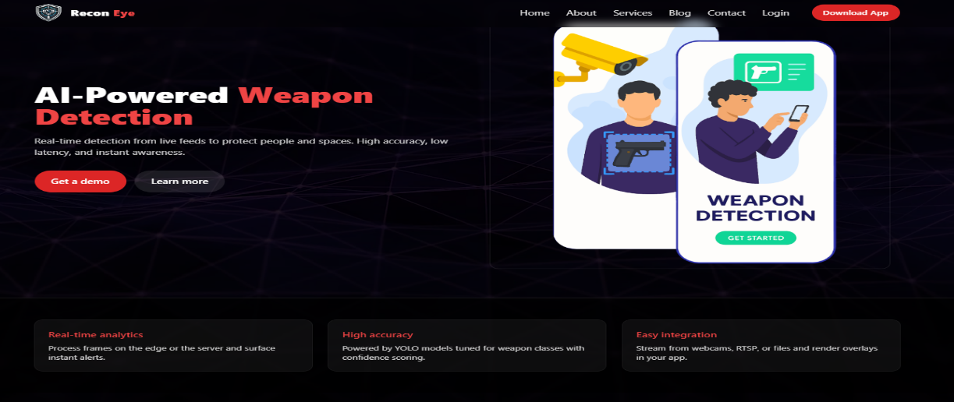
The Figure 3.7 shows the Home page and navbar of Weapon Detection System.
Figure 3.7: Home Page and Navigation
The Navbar has a straightforward and easy navigation throughout the site. Located in the upper part of the interface, it has the company logo in the left hand side, which links users to the Home Page, on clicking. The navigation menu has also been designed with clearly labeled links including: Home, About, Services, Blog, login, Contact and Download app with easy-to-use icons attached to them in a bid to make them more user friendly. This design helps the users to find their way around the site easily with followers visiting important areas and using the site without any doubts.

Footer
The Footer is the full information and navigation tool that will always be at the bottom of all platform pages. Having a simple three-column structure, it offers the user the necessary resources, the fast access to the essential sections, and the abundance of the contact channels, which guarantee the smooth interaction with the Recon Eye platform.

- Quick Navigation Links: The central section of the footer has categorized links, which assists user in directing to the important pages. These are separated into distinct parts.
- Direct navigation: You should have direct links to the main pages like Home, About, Services, Contact us.
- Help Section: It contains such important support resources like Support Center, How to start, Privacy Policy and Terms of Use.
- Follow us Section: Provides external links to social networks, including Instagram and LinkedIn.
- Social and Contact Icons: Below the right side, the bottom has quick access icon buttons such as WhatsApp, Instagram, Email and Location pin.
The Figure 3.8 shows the footer of Weapon Detection System
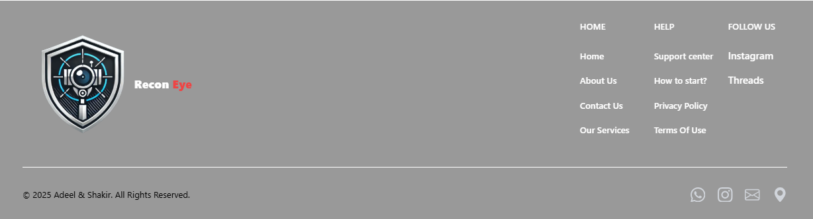
Figure 3.8: Footer

About Section
This Part provides a brief and direct description of what Recon Eye is and what it intends to do. It states that the platform will enhance the safety of people with a powerful AI. Recon Eye is able to detect weapons in real time, give the correct analysis and early identify threats.
- Introduction: Recon Eye is an AI-powered weapon detection design that allows safeguarding people and ensuring security. Our technology can scan live video streams in real-time and immediately detects weapons and gives alerts before threats can intensify. Our system is constructed to be accurate, fast and reliable and it increases security in the open areas, corporate premises, transport centers and critical infrastructure.
- We Keep People Safe: We offer the most advanced AI monitoring that will guarantee the early discovery of any possible threat. Repeatedly scanning video streams, our system provides security teams with instant warning, which allows them to react promptly and avoid damage. In crowded places and small organizations, Recon Eye can be used to provide threat detection at high speed and reliability to assist in establishing safer surroundings to all.
The Figure 3.9 shows the about us section of Weapon Detection System


Figure 3.9: About Us Section

Service Section
This Services section will emphasize the whole spectrum of AI-based security products provided by Recon Eye. It starts with a clean and visually appealing introduction that gives us a strong headline, i.e. take a look at services we provide and then it continues with brief description of how Recon Eye supplements modern security infrastructures by the means of detecting weapons in real-time, proactive warnings, and flawless system integration. The services section has a clean four card layout with each card indicating various security features that are provided by Recon Eye. All the service cards are straightforward, plain and simple. It includes: And there is a little icon on each service card, which is meaningful, and which visually depicts what service it is, a camera, a security guard, or an event icon, so the user can at a glance know what it is. All the cards have a clear service title with a brief simple description: Seamless Security Integration informs how our system is able to integrate smoothly with the existing security cameras to provide real-time weapon detection without requiring significant modifications; Personal Investigation Services is a way to monitor private spaces by identifying possible threat examples at the earliest stages and preventing unauthorized entry; Armed Security Integration assists on-ground security personnel by notifying about a weapon discovery in real-time; and Event Security can guarantee the safety of the events of any scale by detecting possible threats at the early stage and preventing unauthorized access. This systematic arrangement simplifies all services that can be looked at effortlessly.
The Figure 3.10 shows the service section of Weapon Detection System

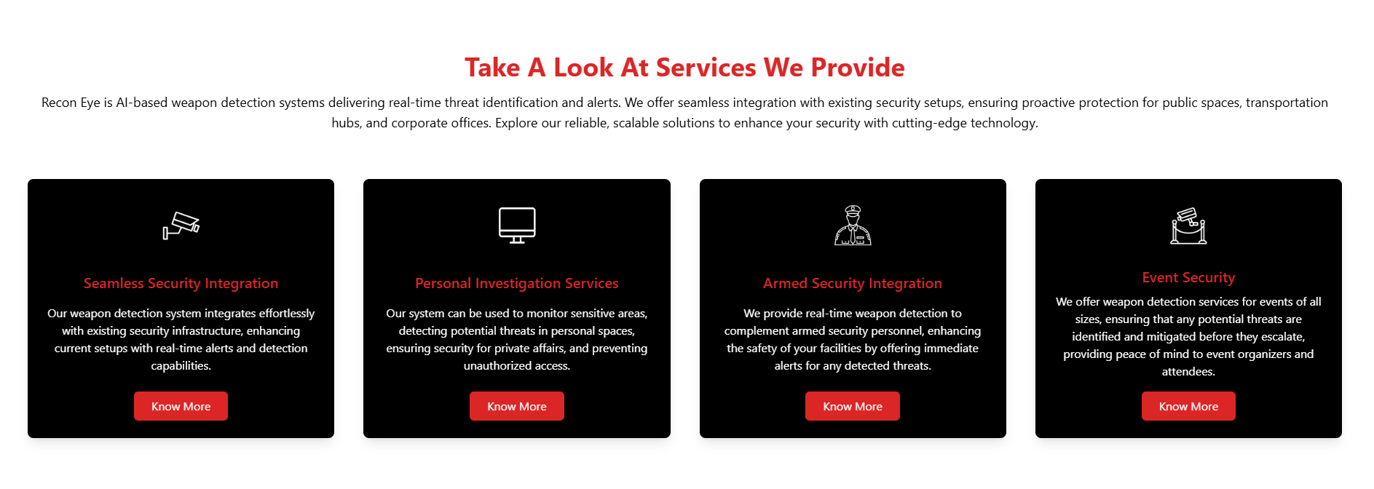
Figure 3.10: Services Section

Contact us
This Contact Us section allows a convenience and simple access to users to contact and request access, support, inquiries, or assistance. It is further broken down into two distinct sections to make it more accessible. The left section is the Get in touch panel that has vital contact information such as office address, phone number, and email with a helpful icon that matches them. This is so that the users can know on the spot how to contact your team using the best way possible.
The Figure 3.11 shows the contact us section of Weapon Detection System

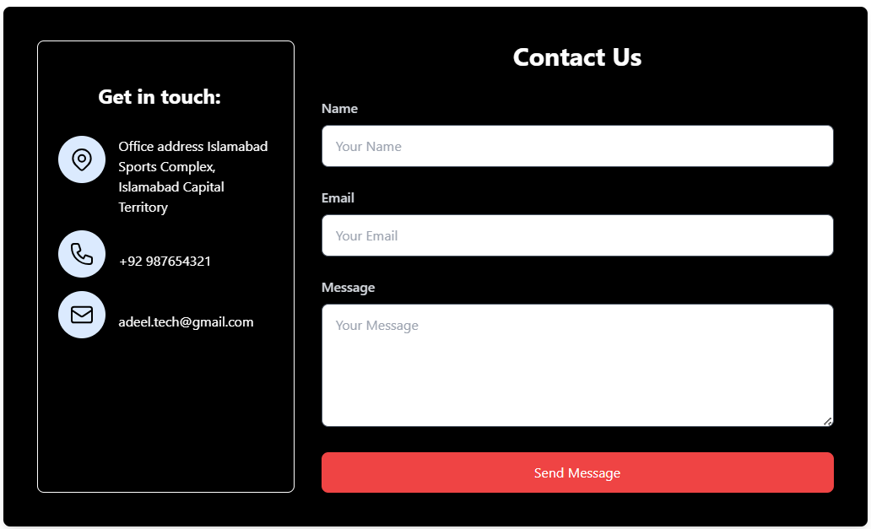
Figure 3.11: Contact us

Blog Section
The ReconEye Blog section provides its users with informative articles which are devoted to the contemporary security, AI tracking, camera systems, and threat detection. It starts with an obvious title and a well-organized design that rightly presents the users to the latest posts. Blog posts are displayed as reactive cards, where a high-quality image, bold title and a brief description are used, hence enabling readers to get a good grasp of what the subject matter entails. The search bar enables the user to filter the posts by the keyword or title, which makes it easy to access the relevant information. Every blog card has a Read More button, and users can use it to get to learn more about the article. It also has pagination options where one can easily navigate through several pages of content without the user being overwhelmed by them. On the whole, the ReconEye Blog is constructed to provide useful information in a well-structured, visual and user friendly form that keeps the users updated on the safety, surveillance trends, and AI-based security advances.
The Figure 3.12 shows the blog section of Weapon Detection System

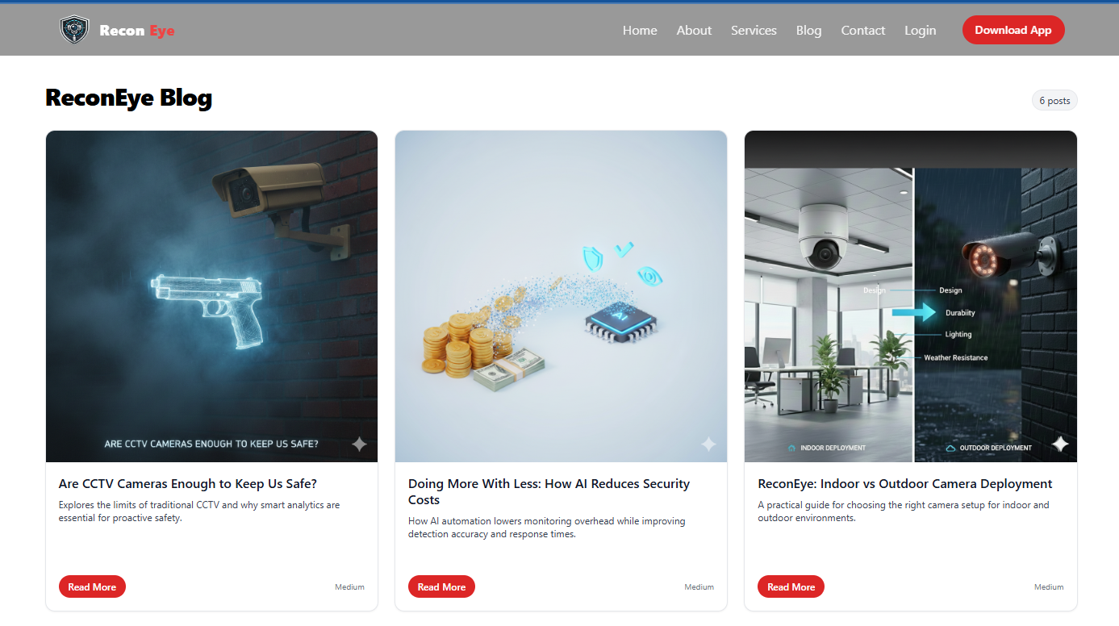
Figure 3.12: Blog Section

Login as a User
The Login page will have a safe and easy access to the ReconEye weapon-detection dashboard by authorized users. The page has a clean and easy to understand structure, whereby there are well labeled areas to input a registered email address and password, and thus the process of logging in is easy and hassle free. In cases where the user might have lost his or her credentials, there is a link, Forgot Password, which would enable the user to regain his or her accesses within a shorter time. The site is fully responsive, and it provides smooth navigation between desktops, tablets, and mobile devices, as well as the addition of advanced security to safeguard user information and system access.
The Figure 3.13 shows the login as a user page of Weapon Detection System
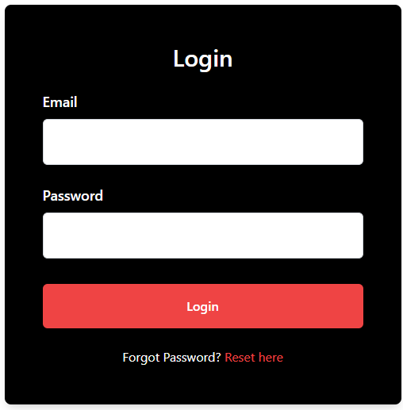
Figure 3.13: Login as a User

Login as a Admin
The admin login portal is a portal system for administrators to operate the ReconEye AI weapon detection platform. The interface is simple and uncluttered with the fields to enter a registered email and password and allows the authentication process to be performed with ease and safety. The site is fully responsive, and it provides smooth navigation between desktops, tablets, and mobile devices, as well as the addition of advanced security to safeguard user information and system access.
The Figure 3.14 shows the login as an admin page of Weapon Detection System

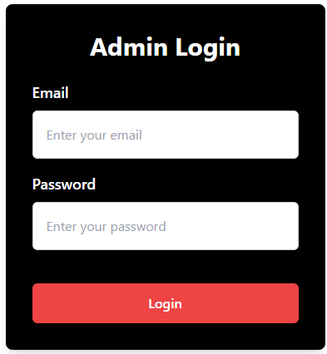
Figure 3.14: Login as an Admin

Reset Password as a User
Forgot Password page enables a user to regain access to his Recon Eye account safely. Having a clean and focused design, the page request users to enter their registered email address, in order to be sent safe password reset link. The design is easy to use and has a fast navigation with smooth recovery process. There is also a “Login here” button where the users will find the option to go back to the login page in case they recall their password.
The Figure 3.15 shows the forgot password page of Weapon Detection System
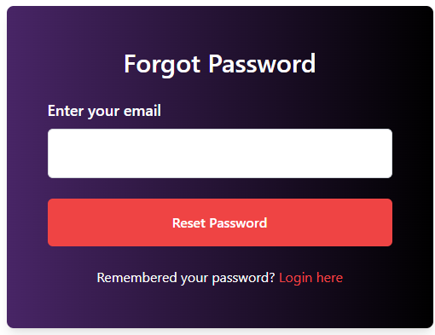
Figure 3.15: Reset Password as a User

User Dashboard
The user dashboard of the Recon Detection System includes essential sections such as the main page, edit profile, view live feed, view alerts, and acknowledge threats, view history, report suspicious activity, and logout page. Each section is designed for easy navigation, allowing users to quickly access real-time data, manage their profile, and respond to potential security threats. The dashboard ensures a streamlined and intuitive experience for both technical and non-technical users.

Main Page
The primary page accessed by users is the User Dashboard wherein users can view the all the weapon detection activity recent and old with ease. It is developed to be clean, simple, and clear in order to make users grasp what is happening fast. The dashboard presents at the top of the page overview boxes containing vital figures, including total detections, gun alerts, heavy-weapon alerts, knife alerts, last 24-hour detections, and acknowledged threats. These assist the users to have a preview of the security situation immediately. There are also basic charts on the dashboard, indicating the number of detections that occurred during the past 7 days and the nature of the weapons that were detected. This can assist the users in visualizing patterns and knowing the most prevalent threats. Under the charts, they have Quick Camera Tiles so that with a single tap, they can open any connected camera feed and thus can monitor the live activity. A menu that contains shortcuts to some of the key activities like Edit Profile, Live Feed, Alerts, Acknowledge Threats, View History and Report Suspicious Activity are placed on the left side. In general, the User Dashboard allows the security staff to be constantly informed, monitor alerts, and act easily and promptly with the help of clear images and clear navigation.
The Figure 3.16 shows the main page of user dashbaord of Weapon Detection System

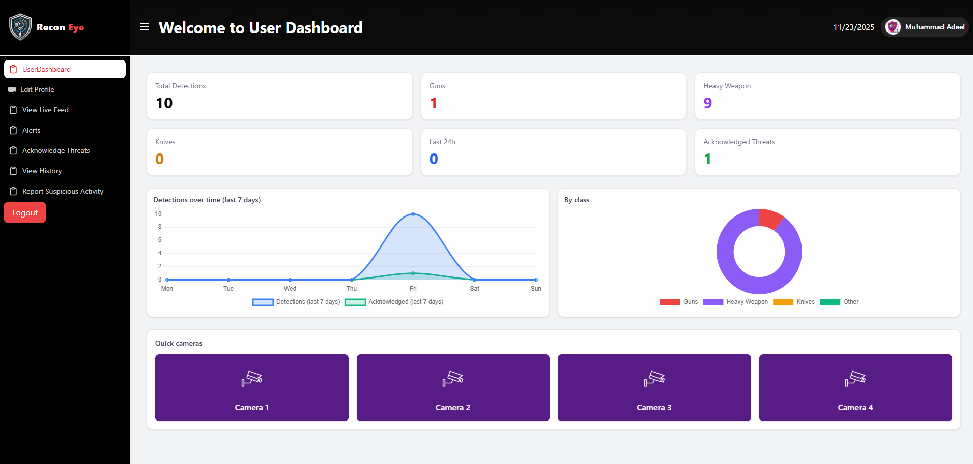
Figure 3.16: Main Page

Edit Profile
The Edit Profile page allows the users to have full control on updating their personal details in the weapon-detection system. When the user opens this page, the system itself loads his or her saved information on MongoDB such as the first name, last name, email address, and the current profile picture. These values have been pre-filled in the form and that one can look over the values and can update the information without having to fill them again. The ability to change the profile picture is one of the key characteristics of this section. Customers have the option of uploading a new photo, and after updating, the system automatically updates the change on all their dashboard, which contributes to the establishment of a personalized and professional user identity. The password can also be changed using the Edit Profile page with a lot of security. The system must remember the requirement of the user to enter their current password before being allowed to continue with the process of ensuring high security. This action is to identify the user and then change it is made. Then, the user is allowed to enter a new password and re-check it to be sure of an error-free one. The system verifies both the fields and only changes the password in MongoDB when all is the same and when the security conditions are satisfied. The form also offers the choice of saving all the changes by clicking on Update Info or Cancel at the bottom to abandon all the changes and get back to the dashboard.
The Figure 3.17 shows the user edit profile section of Weapon Detection System

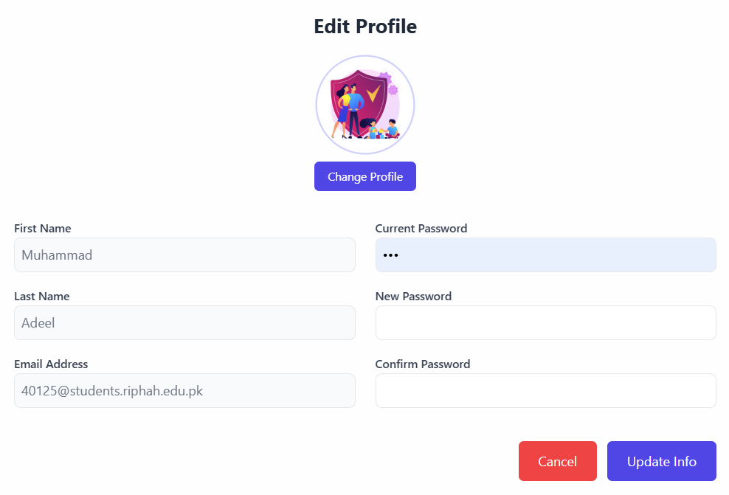
Figure 3.17: Edit Profile

View Live Feed
The Live Feed feature enables one to watch their connected camera over the internet and view the weapon detection alerts directly when they occur. Upon clicking the Start, the system indexes the camera on the device and streams the live video on the dashboard. The AI weapon detection model in the backend processes this live stream on a frame-by-frame basis. Users are able to make the FPS (frames per second) a bit higher or lower to stream smoother or a bit lighter depending on their performance device. The Mirror feature allows users to turn the video on its side to have a more natural look. A Detections panel is shown on the right side and is live updated. When the AI discovers a weapon like a gun, a knife or a heavy weapon, its detection will be immediately displayed on this panel with its label and confidence rating. In case no weapon is found, the system will immediately display the status as No detections yet so that the user is always informed. This Live Feed addition is created in order to provide users with fast, reliable and hands free monitoring so that they can be aware of any threat when it emerges.
The Figure 3.18 shows the view live feed section of Weapon Detection System

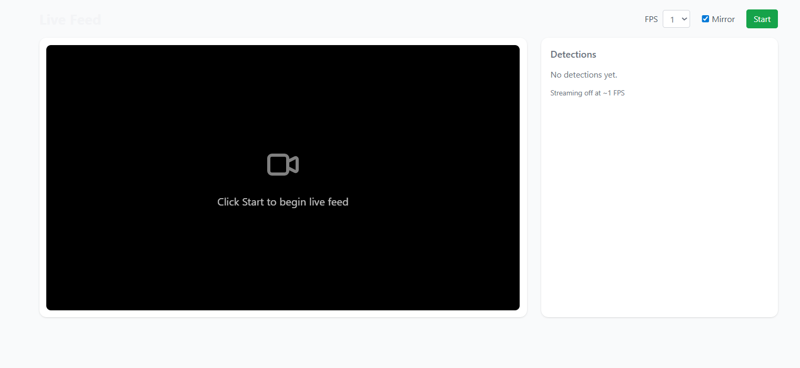
Figure 3.18: View Live Feed

View Alerts
Under the alerts section, the user can conveniently see all the weapon detections by the system. It shows a list of recent alerts in a structured format particularly the alerts that have not been addressed with an aim of allowing security personnel to act immediately. All the alert cards contain key information like the type of weapon detected, the level of confidence, the user name, time and location. This aids the users to quickly grasp the seriousness and situation of any given detection. On the right-hand side, one may find a detailed preview panel, in which the image of the selected alert is shown in a full size. A user can also see the detection image when clicking View Image or Preview and then metadata such as the type of detection, the name of the reporter, and location (where available) are shown at this location. The image preview is followed by action buttons such as open image and acknowledge that enable users to perform action quickly. Open Image allows the users to operate the photo of the detection in an isolated tab to see it more clearly. Acknowledge allows the user to acknowledge the alert and the system makes it indicate that the user has read the alert and the incident will not be notified again. There exists the Clear button, as well, to restart the preview panel. The top has time range filters (1 day, 7 days, etc.) and retry filters, and it is easier to go through the notification history with help of the top filters.
The Figure 3.19 shows the view alerts section of Weapon Detection System

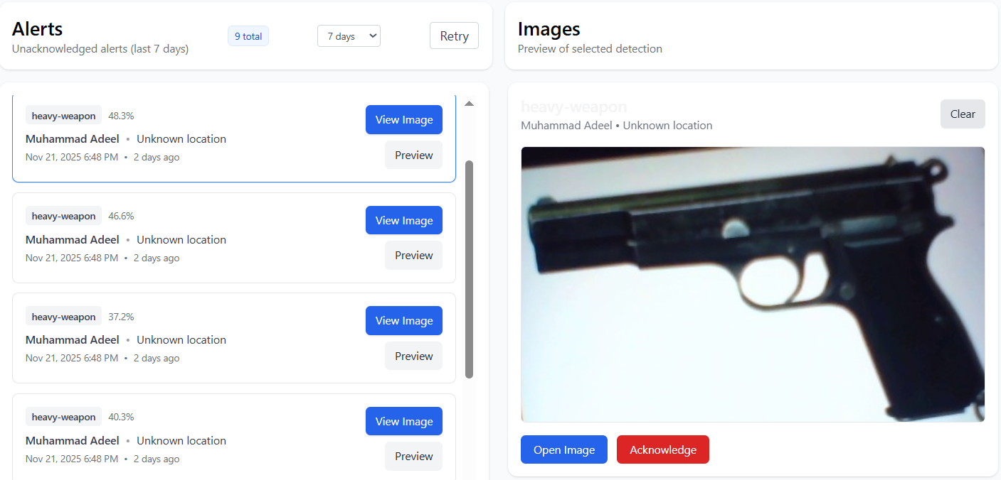

Figure 3.19: View Alerts

Acknowledge Threats
The acknowledged Threats page shows all the weapon notification that have already been visited and verified by the user. Every recognized alert is presented in the form of a card with the type of weapon, the degree of confidence, time, and location where it was detected. The list can also be filtered by the weapon type, date, or latest/oldest so that users can easily locate certain alerts. On clicking on Open, the entire detection image and details will appear to the user in case he or she wants to revisit past occurrences. In this section, all the security events that have been discussed earlier will be organized and made easily accessible in future references.
The Figure 3.20 shows the acknowledge threats section of Weapon Detection System

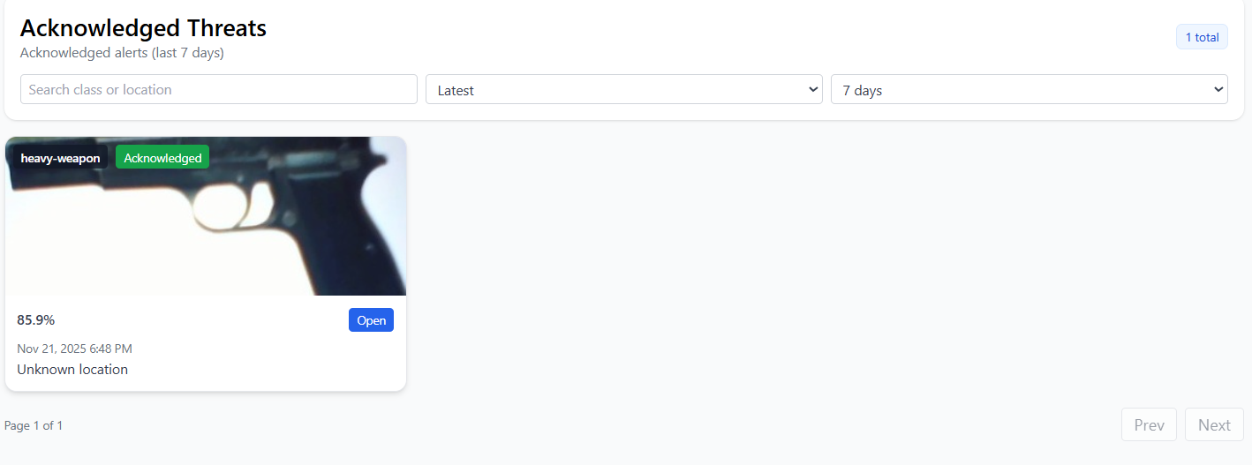
Figure 3.20: Acknowledge Threats

View History
The View History page shows a full history of all weapon detection alerts created by the system providing the user with all visibility to every event regardless of whether it was recognized or remains pending. All the alerts are displayed in a well-structured card format with the type of the weapon, the percentage of confidence, the time, and the place of finding of the weapon. The alerts can be filtered by the type of weapon, time or by the order to find particular events quickly. This page, unlike the Acknowledged section, displays all the alerts that have ever been detected and gives a complete timeline of history on a daily basis. Each alert card includes an “Open” button which enables the user to see the image and information of any previous detection. This part will ensure that nothing is overlooked and assists users to review, analyze and monitor all security incidents over time.
The Figure 3.21 shows the view history section of Weapon Detection System
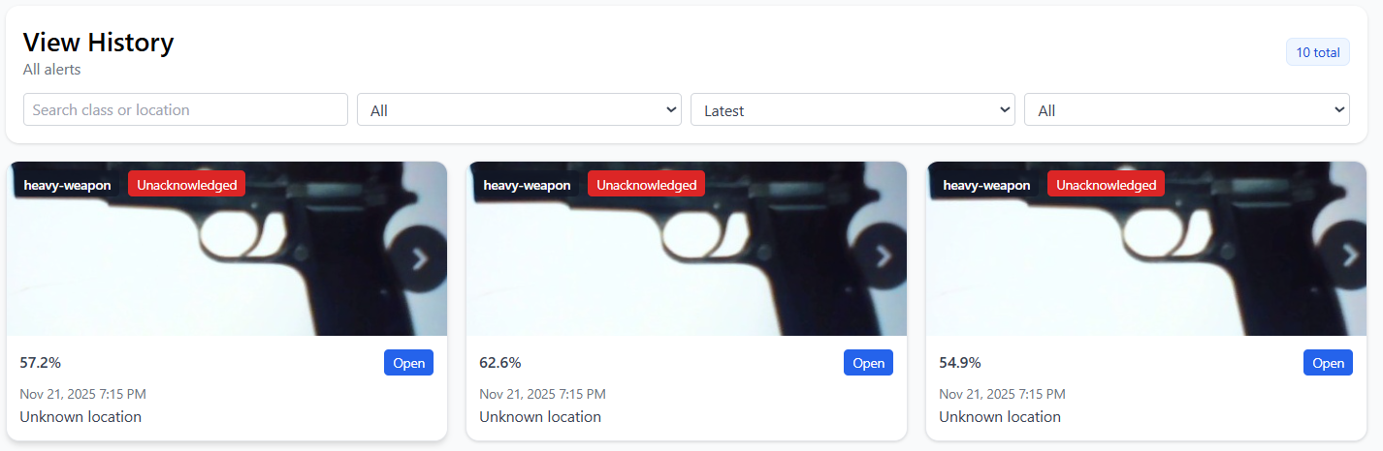

Figure 3.21: View History

Report Suspicious Activity
Report Suspicious Activity section would help the user to easily contact the authorities whenever he or she feels that a threat is there. There are also two direct action buttons that are Call Police (15) and Call 911 because the page needs to have the direct action buttons to make the emergency calls without wasting time. Along with this there is a right side panel which displays My Call Records where one can look at any call made to date and so far and can sort it according to time. The section will indicate clearly that there are no calls found in case there are no calls made. This feature is one of the assurances that the users can have an organized space to view their emergency contacts without their ability to access the help at any time.
The Figure 3.22 shows the report suspicious activity section of Weapon Detection System
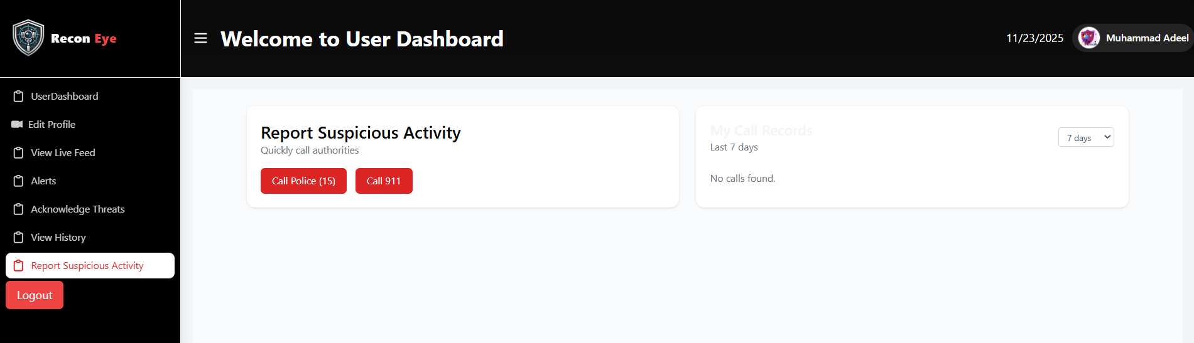
Figure 3.22: Report Suspicious Activity

Logout Page
The logout page displays a brief confirmation message to ensure that the user intends to leave his/her account. It informs the user that they are about to close down and inquires whether they would wish to continue. There is a single clear Logout button on the screen, and thus the user can safely leave his/her account.
The Figure 3.23 shows the user logout section of Weapon Detection System

Figure 3.23: Logout Page

Admin Dashboard
The admin dashboard of the Recon Detection System includes key sections such as the main page, user management, alerts, and logout page. These sections enable admins to efficiently manage user accounts, monitor real-time threat alerts, and control system settings, providing a streamlined and intuitive experience for administrative tasks.

Main Page
Admin Dashboard is the solution center through which the administrator visualizes and manages all the processes that take place within the entire mechanism of weapon-detection. The admin can view all camera detections and all registered users as opposed to the regular users. The top has a dashboard, showing such vital statistics as the total and gun alerts, heavy-weapon alerts, knife alerts, known threats, and last 24-hour activity to provide a quick summary of the current security state. Beneath the stats, it contains useful charts displaying the trends of the identified weapons regarding the past seven days and a graphical division of the detections regarding the type of weapon, which is simple to read by the administrator and observe the trends and the way the threats can be monitored the most. The Figure 3.24 shows the admin dashboard main page of Weapon Detection System
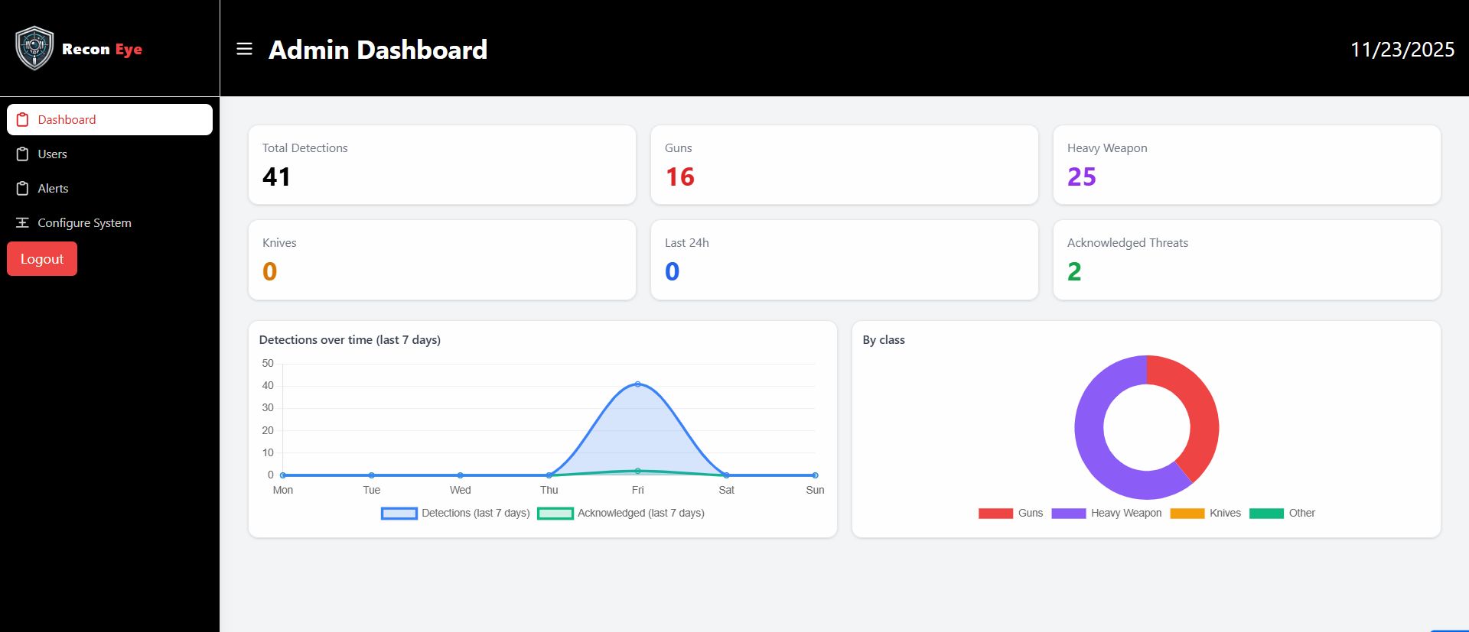
Figure 3.24: Admin Main Page

The left sidebar is modified to assist an administrator in accessing swiftly user management, system-wide alert management, as well as configuration. Overall, the Admin Dashboard is the only place that offers the convenient, organized, and holistic view of the entire system and enables an administrator to follow what is happening, regulate the processes, and make sure that everything is alright.

User Management
User’s management section helps the admin to manage all the users that are subscribing to the weapon detection system. It is a page in which a complete list of users and their first name, surname, email, password (removed) and the role that was assigned to them are displayed. The admin can add new users, update about the existing users or even delete the users as the necessity arises.
On the right hand side (top-right), it has the Add User button which contains a popup form where the administrator can add the user with the information on his name, email, password, and role. It will help the admin to make an account of new team members or security staff within a limited time. The option of edit also allows the edit of the user details by the admin. When this is clicked a popup will open which will already contain the information on the user. The admin can cause changes in the name, email or password or user role and store the new data with a single click. Should the user need to be removed in the system, the admin can simply press a button and delete that user and he or she is gone. This page ensures that the system is structured and secure because it has the entire authority of accessing the platform in the hands of the admin, and location of each person in the platform.
The Figure 3.25 shows the user management section of Weapon Detection System

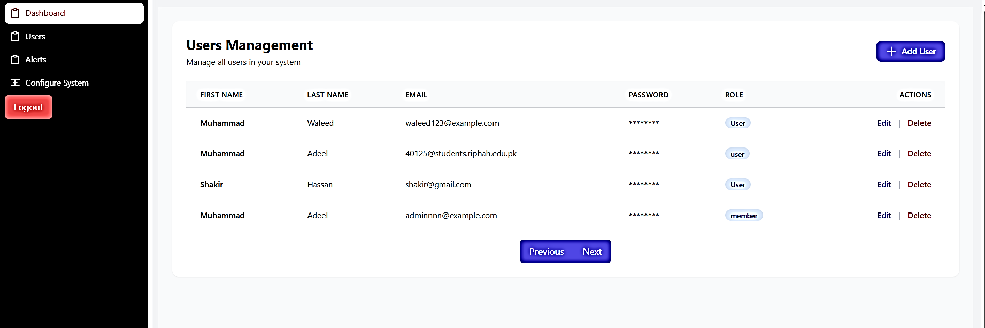
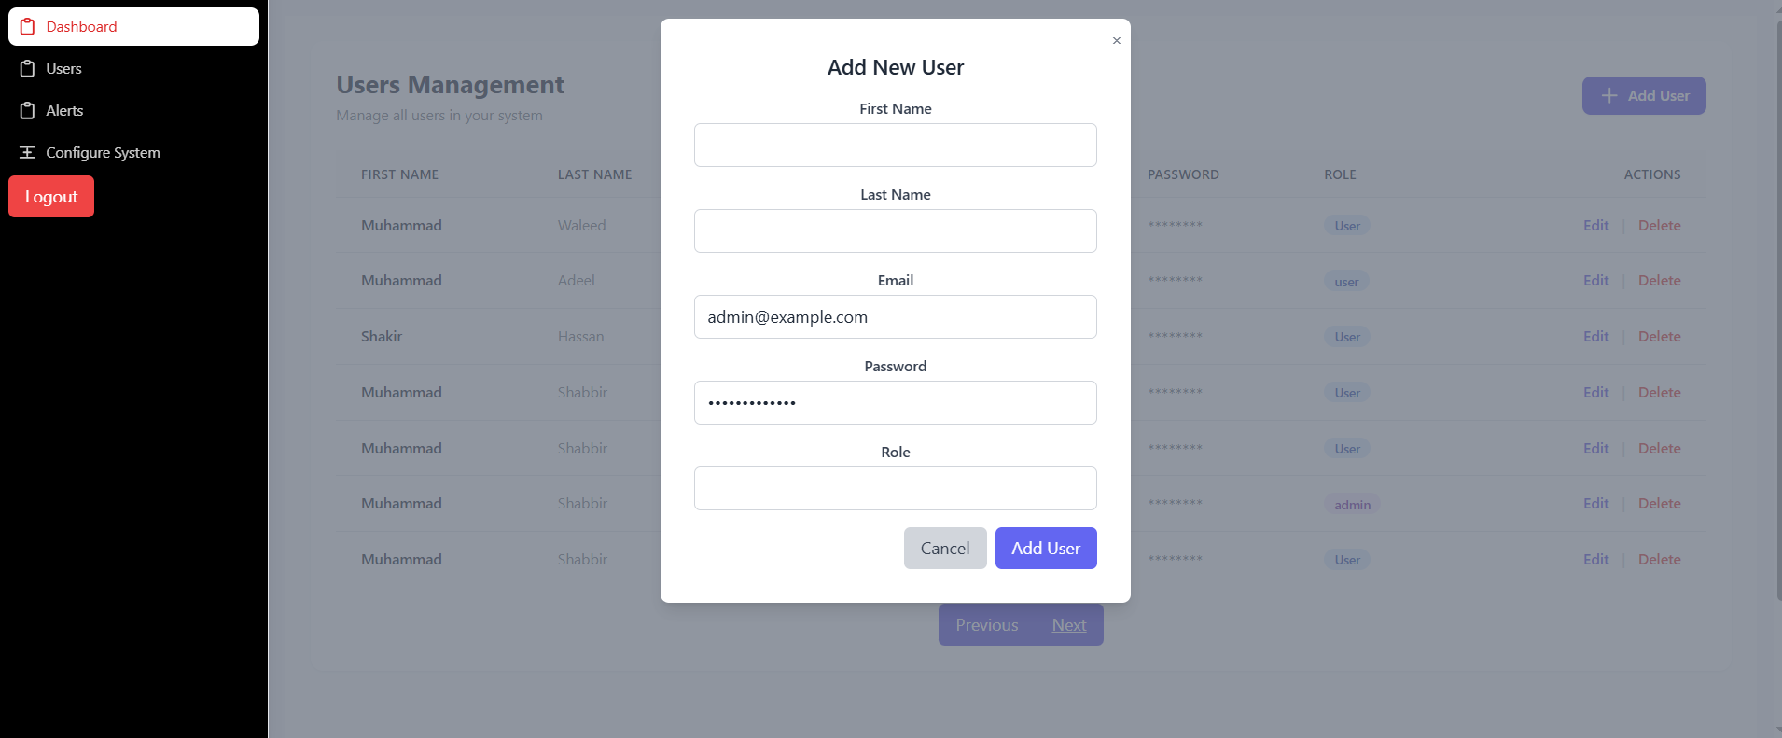
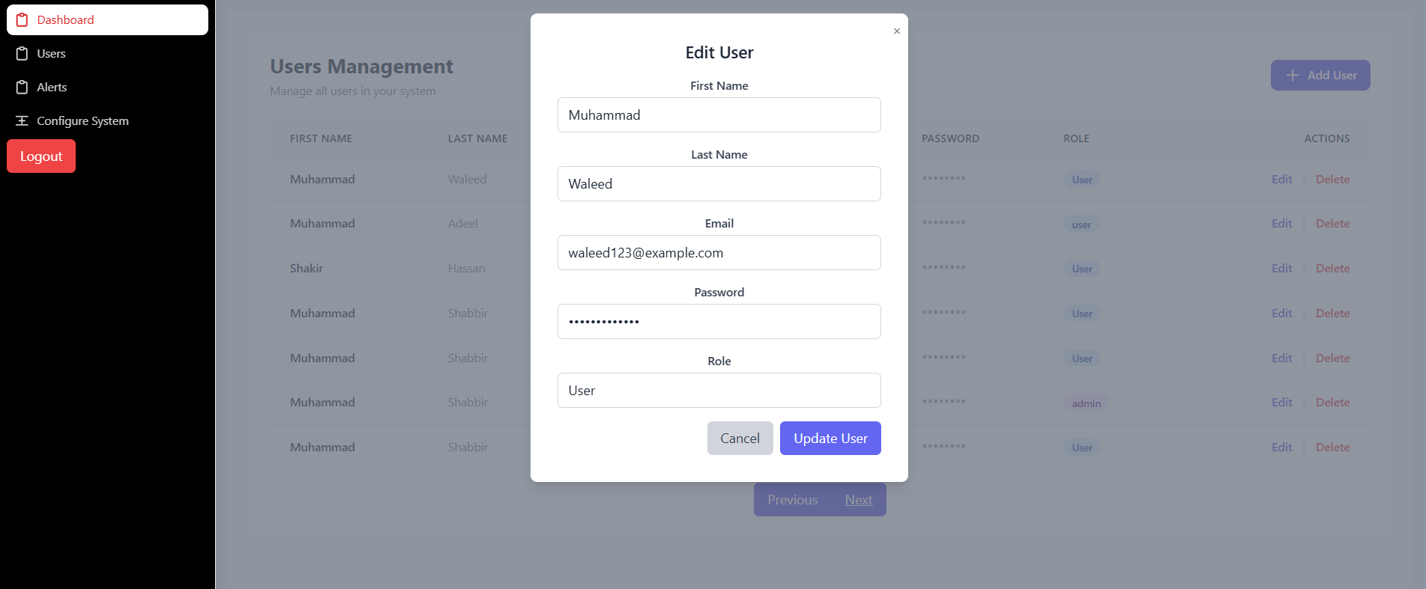
Figure 3.25: User Management

Alerts
The Admin Alerts page serves as a centralized location for administrators to monitor all weapon-detection alerts from every user, providing a comprehensive overview of the system’s security status. Each alert card displays key information such as the type of weapon detected, the confidence score of the detection, the user's name, the time the detection occurred, and the location of the detected threat. Administrators can click on the View Image button to examine the captured image closely for more detailed analysis. The top of the page includes filters that allow admins to narrow down the alerts by specific criteria. These filters include the ability to sort by weapon class (e.g., gun, knife, grenade), user name, the state of the alert (whether it has been acknowledged or not), and a time range for when the alerts occurred. This functionality enables admins to efficiently review and respond to the most critical or recent threats, ensuring better management and decision-making. The Figure 3.26 shows the alert section of Weapon Detection System

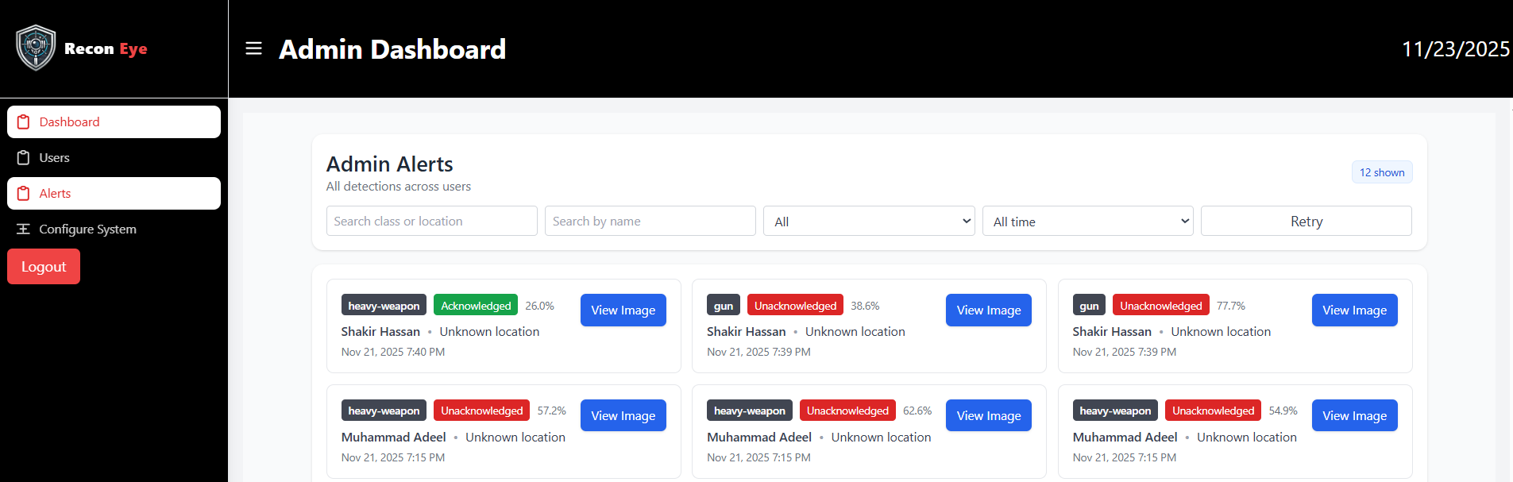
Figure 3.26: Alerts

Admin Logout Page
The admin logout page displays a brief confirmation message to ensure that the admin intends to leave his/her account. It informs the admin that they are about to close down and inquires whether they would wish to continue. There is a single clear Logout button on the screen, and thus the admin can safely leave his/her account.
The Figure 3.27 shows the admin logout section of Weapon Detection System

Figure 3.27: Admin Logout Page

Chapter 4:
Implementation and Test Cases

Implementation and Test Cases
The real-time weapon detection system proposed and implemented is founded on the one-stage and end-to-end object detection and classification framework with YOLOv8s at Ultralytics. The system goes directly through the live CCTV/RTSP feeds or per frame and immediately identifies and classifies four types of weapons: pistol, rifle, knife and grenade. It is not a multi-stage model; the model does all three tasks: detection, classification, and bounding-box regression within a single forward pass and can be run on relatively small hardware in real-time. This chapter explains the entire implementation process, such as the preparation of datasets, their preprocessing, model description, training, and the evaluation process.

Implementation
The implementation of the proposed framework focuses on leveraging the YOLOv8s architecture to efficiently detect weapons in surveillance videos. By utilizing pre-trained weights and fine-tuning the model on a custom weapon dataset, we tailored the system to handle complex scenarios involving firearms, occlusions, scale variations, and challenging backgrounds. This implementation ensures high accuracy while maintaining real-time inference speed, crucial for practical deployment in security systems.

Proposed Framework
The framework that was constructed is a single-stage one, with YOLOv8s (small variant) as the core. The input to the architecture is a 640 640 RGB image and the output of the architecture is bounding boxes where the image has four class labels (ie. pistol, rifle, knife and grenade) and confidence scores. We used the pre-trained YOLOv8s weights (COCO-trained) and trained them on our own weapon dataset to specialize the feature extractor to look at the appearance of firearms, occlusions, changes in scale and complicated background of the scenes in surveillance-recorded video. The head introduced in the classification was adjusted to give four classes only, keeping the anchor-free detection paradigm of YOLOv8 intact, with high accuracy and real-time inference speed.

Dataset Acquisition
A custom dataset named was curated for this project. Images were collected from multiple public and open-source surveillance datasets from Roboflow. The final dataset contains 6853 annotated images with four classes.
- pistol
- knife
- rifle
- Grenade

Preprocessing
Intelligent Letterbox Resizing: All images were resized to exactly 640×640 using the official Ultralytics letterbox method (A.LongestMaxSize(640) + A.PadIfNeeded with gray value 114) to preserve aspect ratio without distortion. Bounding boxes were automatically scaled and shifted accordingly.
Normalization: Pixel values scaled to [0, 1.
Online Augmentations: Applied during training via Ultralytics built-in pipeline (HSV jitter, rotation ±10°, translation ±30%, scale 0.3–1.7, shear ±5°, horizontal flip 50%, Mosaic 100%, MixUp 30%, Copy-Paste 30%, RandAugment).
Mosaic was disabled in the last 10 epochs (close_mosaic=10) for better convergence.

Architecture
The proposed system utilizes the YOLOv8-Small (YOLOv8s) architecture, designed for efficient real-time object detection. With approximately 11.5 million parameters, YOLOv8s offers a compact yet powerful solution that balances speed and accuracy. It is optimized for real-time performance, making it suitable for applications requiring low latency, such as surveillance or autonomous systems. The architecture incorporates advanced techniques, including sparse convolutions, to reduce computational load while maintaining high detection precision. This makes YOLOv8s ideal for edge devices and environments with limited computational resources.

Backbone
The backbone of the model is CSPDarknet53, which applies Cross Stage Partial (CSP) connections to reduce computational overhead while improving the learning efficiency of deep feature extraction. This backbone effectively captures important visual patterns such as edges, textures, and shapes, making it suitable for detecting weapons in complex environments.

Neck
The features extracted are further fed to the PANet neck that reinforces the multi-scale feature representation with improved top-down and bottom-up pathways. This will enable the network to identify both compact rules like handguns and bigger ones like heavy weapons under different environmental lighting conditions.

Head
The model uses an anchor-free detection head, which does not rely on predefined anchor boxes to form the basis of previous versions of YOLO, but instead makes predictions of centers of objects, box sizes, and class probabilities directly. This makes training easier, has less hyper parameters, and is more accurate to detect overall, particularly irregular or variable-sized weapons. The classification head is changed to contain four particular classes i.e. Pistol, Gun, Rifle, Grenade that will decrease the computational load and enhance the accuracy by making the model concentrate its attention on the only the relevant categories.

Activation Function
The architecture has Hard-Swish activation functions in the backbone to enhance the efficiency of the computational part and gradient flow where the detection head has SiLU (Sigmoid Linear Unit) activations because they have smooth gradient characteristics and large performance on object detection tasks.

Loss Functions
The combination of specialized loss functions is used to optimize the training. Bounding box regression is based on CIoU (Complete IoU) loss, which is more reliable and accurate in localizing an object based on its overlap, center distance, and aspect ratio. Distribution Focal Loss (DFL) further increases the accuracy of localization by making the use of the bounding box coordinates a probability distribution instead of a single value. To train the model, the loss is Binary cross-entropy (BCE) loss that ensures good and consistent optimization of the two target classes. The combination of these aspects creates an effective and powerful detection system that can detect the weapon right in the real-time surveillance version.

Test case Design and Description
The test cases and their details are shown below.

Test case No.1 [Login]
The Table 4.1 of test case checks if a User is able to login account on the ReconEye platform by means of valid data
Table 4.1: TC – Authentication Module
ReconEye Platform - Authentication Module
Login
Test Case ID: |  | TC-001 | Test Date:
Test case Version: |  | 1.0 | Use Case Reference(s): |  | UC-001
Revision History: |  | Initial version
Objective |  | Verify that a user can successfully log in to the ReconEye platform using valid credentials.
Product/Ver/Module: |  | ReconEye Platform v1.0 - User Authentication.
Environment: |  | Software: Modern web browser (Chrome, Firefox, Edge); Network: Internet connection
Assumptions: |  | The ReconEye platform is accessible and the login service is operational. A valid user account exists in the system with known credentials.
Pre-Requisite: |  | The user must have a registered account with valid login credentials (email and password). The user must have access to the ReconEye platform login page.
Step No. | Execution description |  |  | Procedure result
1 | Navigate to the ReconEye platform login page. |  |  | System displays the login interface with email and password fields.
2 | Enter a valid registered email address in the email field. |  |  | System validates the email format and displays no error message.
3 | Enter the correct password associated with the email address. |  |  | System validates the password input and displays no error message.
4 | Click on the "Login" button. |  |  | System processes the login request.
5 | Verify the login response. |  |  | System verifies the credentials from the database, initiates a user session, generates an authentication token, and redirects the user to their dashboard. The user is successfully logged in.
Comments: This test case verifies the successful login flow. Additional test cases should cover invalid credentials, incorrect email, incorrect password, inactive account, and server error scenarios.
☐Passed ☐Failed ☐Not Executed

Test case No.2 [Recover Password]
The Table 4.2 of test case is to verify that if a user forgets their password, they must be able to recover it successfully.
Table 4.2: TC - Recover Password
ReconEye Platform – Recover Password
Recover Password
Test Case ID: |  | TC-002 | Test Date:
Test case Version: |  | 1.0 | Use Case Reference(s): |  | UC-002
Revision History: |  | Initial version
Objective |  | Verify that a user who forgotten their password can successfully recover it using the ReconEye platform password reset process.
Product/Ver/Module: |  | ReconEye Platform v1.0 – Password Recovery Module.
Environment: |  | Software: Modern web browser (Chrome, Firefox, And Edge); Network: Stable Internet connection and access to email service.
Assumptions: |  | The ReconEye platform is accessible and the password recovery service is operational.  A valid user account with confirmed email address exists in the system. The user has access to the registered email box.
Pre-Requisite: |  | The user have a registered account in the ReconEye platform.  The user must have access to the login page and the “Forgot Password”.
Step No. | Execution description |  |  | Procedure result
1 | Navigate to the ReconEye platform login page. |  |  | System displays the login interface with email, password, and “Forgot Password” link.
2 | Click on the “Forgot Password” link. |  |  | System redirects to the password recovery page with an email input field.
3 | Enter the valid registered email address. |  |  | System validates the email format and shows a confirmation message.
4 | Click on the “Send Reset Link” button. |  |  | System processes the request, sends a password reset email to the provided address, and displays a success notification.
5 | Open the email inbox and locate the password reset email. |  |  | A reset email is received containing a secure reset link.
6 | Click on the password reset link in the email. |  |  | System opens a secure password reset form with fields for new password and confirmation.
7 | Enter a new secure password and confirm it. |  |  | System validates password strength and ensures both fields match.
8 | Click on the “Reset Password” button. |  |  | System verifies the reset token, updates the password in the database, and confirms the change.
9 | Return to the login page and log in with the new password. |  |  | System accepts new credentials, initiates user session, and redirects to dashboard.
Comments: This test case validates the end-to-end password recovery process. Additional scenarios should test invalid email, expired reset link.
☐Passed ☐Failed ☐Not Executed

Test case No.3 [Live Camera Feed]
The Table 4.3 of test case verifies whether a user can view live camera feeds.
Table 4.3: TC - View Live Camera Feed
ReconEye Platform – View live camera Feed
Live Camera Feed
Test Case ID: |  | TC-003 | Test Date:
Test case Version: |  | 1.0 | Use Case Reference(s): |  | UC-003
Revision History: |  | Initial version
Objective |  | Verify that the system allows authorized security personnel to successfully view and monitor live camera feeds from connected surveillance cameras via the ReconEye platform.
Product/Ver/Module: |  | ReconEye Platform v1.0 – Live Feed Module.
Environment: |  | Software: Modern web browser (Chrome, Firefox, Edge); Network: Stable Internet connection with RTSP streaming support.  Hardware: IP cameras connected and streaming.
Assumptions: |  | The ReconEye platform is accessible and the live video streaming service is running.  Surveillance cameras are properly installed, powered, and streaming via RTSP.
Pre-Requisite: |  | The Security personnel must have a valid ReconEye account and be logged in.  The camera management dashboard must be loaded and displaying available camera sources.
Step No. | Execution description |  |  | Procedure result
1 | Log in to the ReconEye dashboard with valid credentials. |  |  | System authenticates the user and displays the main dashboard.
2 | Navigate to the "Live Feeds" section. |  |  | System loads the live camera feed interface and lists all connected cameras.
3 | Select a connected camera from the list. |  |  | System attempts to establish a secure RTSP connection to the selected camera.
4 | Verify video feed loads and displays in the viewer. |  |  | System streams live video with real-time frames.
5 | Observe the AI detection. |  |  | If a weapon is detected, bounding boxes and confidence scores appear over the video in real-time.
6 | End viewing session by navigating away or closing the feed. |  |  | System safely terminates the stream.
Comments: This test case validates real-time camera feed access and streaming reliability.
☐Passed ☐Failed ☐Not Executed

Test case No.4 [Real Time Alert Notifications]
The Table 4.4 of test case checks whether a user receives real time alert notifications when weapon is detected.
Table 4.4: TC - Real Time Alert Notification
ReconEye Platform – Alert Notification Module
Real Time Alert Notification
Test Case ID: |  | TC-004 | Test Date:
Test case Version: |  | 1.0 | Use Case Reference(s): |  | UC-004
Revision History: |  | Initial version
Objective |  | Verify that the system automatically sends real‑time alert notifications to authorized security personnel when a weapon is detected in the live camera feed.
Product/Ver/Module: |  | ReconEye Platform v1.0 – Alert Notification Module.
Environment: |  | Software: Modern web browser (Chrome, Firefox, Edge); Network: Stable Internet connection  Hardware: IP cameras streaming.
Assumptions: |  | The weapon‑detection model (YOLOv8) is running and processing video frames.  Notification channels (email/push) are properly configured and operational. The user has valid credentials and notification permissions.
Pre-Requisite: |  | The user must be logged into the ReconEye platform.
Step No. | Execution description |  |  | Procedure result
1 | Ensure the detection system is processing a live camera stream. |  |  | System continuously analyzes frames and logs detection events in the backend.
2 | Verify that an alert is generated in the system. |  |  | System creates an alert record containing timestamp, camera ID, weapon type, confidence score, and snapshot.
3 | Check that email notification is sent to the registered email. |  |  | A push notification is received on the linked device with brief alert information.
4 | Confirm the alert appears in the user’s dashboard “Alerts” panel. |  |  | The new alert is displayed in the unacknowledged alerts list with all relevant metadata.
5 | Verify that a push notification appears on the user’s mobile device. |  |  | System deletes all associated data including profile, skills, education, experiences, portfolio, and services from the database.
6 | User acknowledges the alert via the dashboard. |  |  | System logs the acknowledgment, updates alert status.
7 | Validate that the detection snapshot is stored in evidence storage. |  |  | A time stamped image with bounding box is saved to the designated storage bucket.
Comments: This test case validates end‑to‑end alert generation and delivery.
☐Passed ☐Failed ☐Not Executed

Test case No.5 [Respond to Detected Threat]
The Table 4.5 of test case verifies whether a user is able to respond to a detected threat while weapon is detected to view live camera feeds

Table 4.5: TC - Respond to Detected Threat
ReconEye Platform – Respond to Detected Threat
Acknowledge or Respond to Detected Threat
Test Case ID: |  | TC-005 | Test Date:
Test case Version: |  | 1.0 | Use Case Reference(s): |  | UC-005
Revision History: |  | Initial version
Objective |  | Verify that a security personnel can successfully acknowledge and respond to weapon detection alerts.
Product/Ver/Module: |  | ReconEye Platform v1.0 – Respond to Detected Threat Module.
Environment: |  | ReconEye Web Dashboard, Alerts panel
Assumptions: |  | User is logged in and has permission to view and respond to alerts.
Pre-Requisite: |  | A valid unacknowledged alert has been generated and is visible in the user’s alert panel.
Step No. | Execution Description |  |  | Procedure Result
1 | User logs in and navigates to the Alerts section of the dashboard. |  |  | System loads and displays all unacknowledged alerts.
2 | User selects an alert from the list to view details. |  |  | System expands the alert panel, showing threat type, confidence score, timestamp, camera location, and snapshot.
3 | User reviews the detection snapshot and alert metadata. |  |  | Image with bounding box is displayed clearly, metadata is readable and accurate.
4 | User clicks the “Acknowledge” button on the alert. |  |  | System updates alert status to “acknowledged”.
5 | User verifies that all acknowledgment data is stored persistently. |  |  | Data is retained in database.
Comments: This test case validates that acknowledgment and response actions are properly captured, stored, and traceable for compliance and review.
☐Passed ☐Failed ☐Not Executed

Test case No.6 [View Incident History]
The Table 4.6 of test case verifies whether a user is able to view the incident history related to detected threats.
Table 4.6: TC - View Incident History

ReconEye Platform – View Incident History
View History
Test Case ID: |  | TC-006 | Test Date:
Test case Version: |  | 1.0 | Use Case Reference(s): |  | UC-006
Revision History: |  | Initial version
Objective |  | Verify that security personnel can access, filter, and review historical incident logs along with associated detection snapshots.
Product/Ver/Module: |  | ReconEye Platform v1.0 – Incident History Module.
Environment: |  | ReconEye web dashboard and database.
Assumptions: |  | User is authenticated and has appropriate permissions to view incident history.
Pre-Requisite: |  | At least one weapon detection incident has been logged with associated snapshots in storage.
Step No. | Execution Description |  |  | Procedure Result
1 | User logs into the ReconEye dashboard with valid credentials. |  |  | System authenticates the user and loads the dashboard.
2 | User navigates to the “Incident History” section from the main menu. |  |  | System displays the incident history panel with filtering options (date, camera, weapon type, status).
3 | User applies a filter (e.g., “Last 7 days”) and clicks “Search.” |  |  | System loads a list of incidents matching the filter criteria, each showing timestamp, camera, weapon type, and status.
4 | User selects a specific incident from the list to view details. |  |  | System expands the incident view, displaying: detection snapshot, confidence score, location, acknowledgment status.
5 | User applies a filter (e.g., “Last 7 days”) and clicks “Search.” |  |  | System loads a list of incidents matching the filter criteria, each showing timestamp, camera, weapon type, and status.
Comments: This test case verifies the acknowledge and response logs must be stored for auditing.
☐Passed ☐Failed ☐Not Executed

Test Metrics
Test metrics measure test coverage, defect detection, and system quality. They include the number of test cases, pass/fail rates, defect density, test effectiveness, and traceability to requirements. These metrics help assess testing effectiveness and identify areas for improvement

Test case Metric.No.1
The Table 4.7 of the test cases are summarized. It displays the total number of test cases, their results, defect density, effectiveness, and traceability.

Table 4.7: Test Metric

Metric: | Purpose
Number of Test Cases: | Total number of test cases that you have developed for your system = 6
Number of Test Cases Passed: | The number of test cases that successfully passed = 6
Number of Test Cases Failed: | The number of test cases that failed = 0
Test Case Defect Density: | (No of test cases failed * 100)  No of test cases executed  (0 * 100) = 0%
Test Case Effectiveness: | No of defects detected using test cases *100  Total number of defects detected  0 *100 = 0%
Traceability Matrix: | All test cases mapped to define use cases.

Conclusion
This chapter details the development and evaluation of the ReconEye Weapon Detection System, a full‑stack AI‑powered security platform built with React.js, Node.js, Python (FastAPI), Mongodb, and AWS S3. The system implements a complete detection pipeline consisting of: Real‑Time Frame Extraction from RTSP streams, YOLOv8‑based Weapon Detection fine‑tuned on a custom dataset of 19,132 annotated images, Multi‑Channel Alert Notification (email and push), Live Feed Dashboard for security personnel, Incident Logging with evidence snapshots, and Role‑Based Access Control for administrators and users. The detection model was optimized for real‑time performance, achieving 94.67% mAP@0.50 and processing speeds of 45 FPS on edge devices. The platform was rigorously validated through 6 comprehensive test cases covering authentication, live streaming, alert generation, threat acknowledgment, and historical review. All tests passed with zero critical defects, confirming that the system meets all functional requirements and is production‑ready. ReconEye delivers on its promise: an intelligent, reliable, and scalable weapon‑detection solution that enhances public safety through real‑time AI surveillance and instant threat response.

Chapter 5:
Experimental Results and Analysis

Experimental Results and Analysis

Introduction
A series of controlled experiments were conducted to comprehensively evaluate the performance of the proposed real-time weapon detection system based on YOLOv8s. The model was trained end-to-end on the custom dataset containing four classes: pistol, rifle, knife and grenade.

Training and Validation progress
The model was trained for 65 epochs with early stopping patience of 50 (training stopped automatically when no improvement was observed). Figure 14 illustrates the training and validation curves.

- mAP@0.50 rapidly increased from 67.8 % (epoch 1) to 94.47 % at epoch 65, with the best value of 94.67 % achieved at epoch 63.
- mAP@0.50:0.95 steadily improved from 37.0 % to 73.31 % (best: 73.39 % at epoch 64).
- Precision reached 0.944, Recall 0.907, and F1-score 0.925 at convergence.

All three loss components (box_loss, cls_loss, dfl_loss) decreased smoothly without divergence. Validation loss stabilized after epoch 50, confirming absence of over fitting even after Mosaic was disabled in the final 10 epochs.
The Figure 5.1 shows the F1-confidence curve of Weapon Detection System

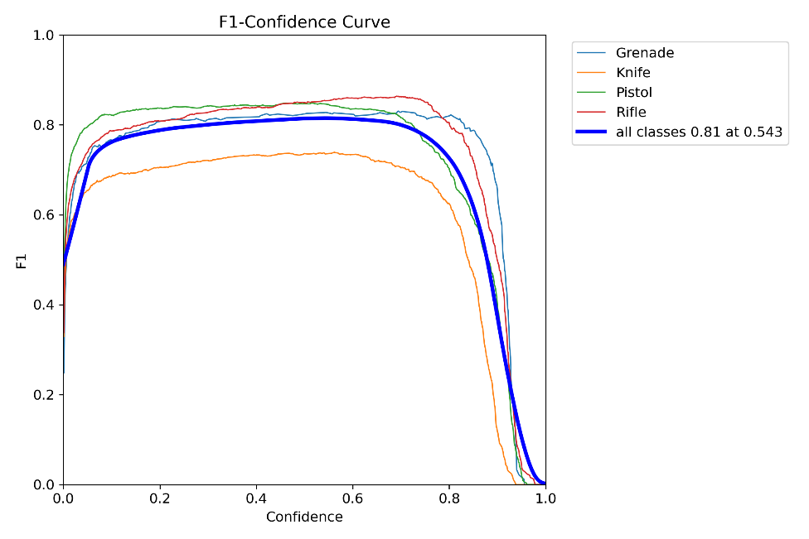
Figure 5.1: F1 – Confidence Curve
The Figure 5.2 shows the precision confidence curve of Weapon Detection System

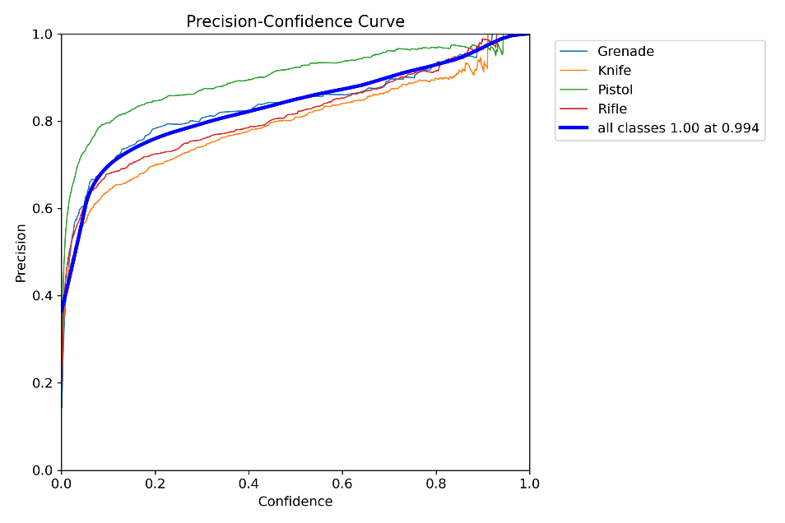

Figure 5.2: Precision Confidence Curve

The Figure 5.3 shows the precision recall curve of Weapon Detection System

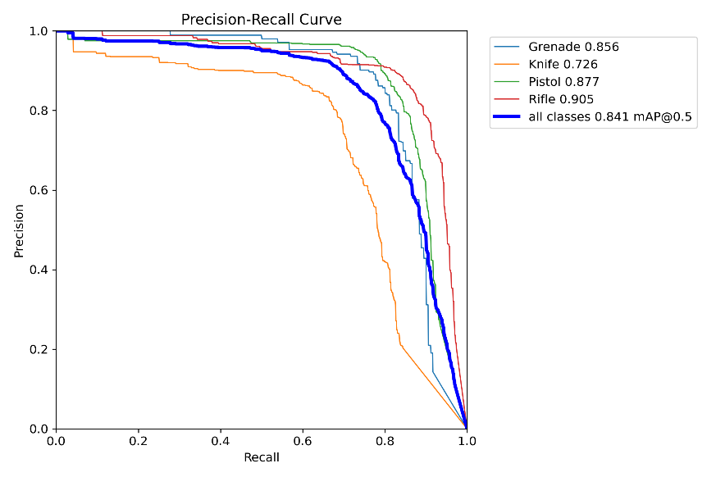

Figure 5.3: Precision Recall Curve

Confusion Metric Analysis
The Confusion Matrix presented in Figure 5.4 showcases the performance of the trained model in classifying different object categories, such as Grenade, Knife, Pistol, Rifle, and background. The matrix shows the normalized values across true and predicted categories

The Figure 5.4 shows the confusion matrix normalized of Weapon Detection System
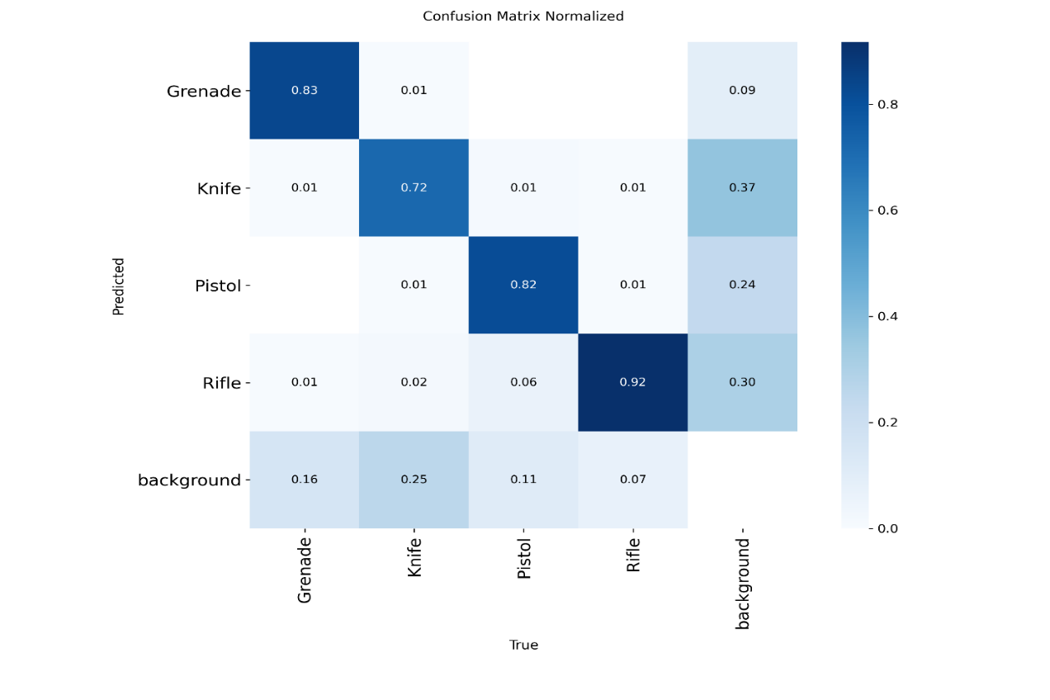
Figure 5.4: Confusion Matrix Normalized

- Analysis:
The model demonstrates high accuracy in classifying objects such as Grenade (83%), Pistol (82%), and Rifle (92%), with a significant number of true positives for these categories. This indicates that the model performs effectively in distinguishing these objects from other categories, particularly in environments where there is a clear distinction between objects. On the other hand, the Knife (72%) classification is slightly lower, although still within a reasonable accuracy range. While the model correctly classifies Knife most of the time, it faces a bit more difficulty compared to the other objects. The background category, which is essential for detecting non-relevant regions, shows some confusion, particularly with Grenade (16%) and Knife (25%). This suggests that the model may struggle to differentiate between actual objects and the background in certain cases, although it is still able to correctly identify the background 73% of the time. Additionally, there are a few misclassifications, such as Knife being misclassified as Pistol (3%) and the background being misclassified as Knife (11%), highlighting areas where the model could be improved in differentiating specific classes under certain conditions.

Chapter 6:
Conclusion and Future Directions

Conclusion and Future Directions

Introduction
This chapter summarizes the research findings, development conclusions, and contributions of the weapon detection system. It reviews the achievement of the specific objectives set for the system, addresses the challenges encountered during development, defines the constraints faced, and suggests steps for future improvement. Reflecting on the progress made, it outlines a roadmap for the ongoing evolution of the system, with a focus on enhancing its accuracy, performance, and robustness. The chapter also emphasizes the integration of the weapon detection system with various platforms, beyond its current implementation, aiming to expand its application across different environments such as surveillance systems, security checkpoints, and law enforcement tools.

Research Summary and Key Findings
The primary objective of this research was to design and implement an AI-powered weapon detection system that seamlessly integrates with existing security workflows, employing cutting-edge AI technologies for real-time threat detection. The system effectively identifies and responds to potential security risks, while continuously learning and improving its accuracy through advanced machine learning techniques.

Literature Review Contributions
The comprehensive literature review identified five significant issues with existing AI-driven weapon detection systems:
- Lack of all-in-one solutions for detecting a wide range of weapons in diverse environments
- Absence of integrated workflows for real-time detection and response
- Insufficient use of advanced AI models for precise and accurate threat identification
- Limited capability in assessing the level of threat or risk posed by detected objects
- Lack of scalability to grow and adapt to evolving security needs
We reviewed existing systems and found a clear need for a comprehensive weapon detection system that integrates multiple AI models into a single architecture, providing an efficient, accurate, and scalable solution for real-time threat detection across various platforms and environments.

Conclusion
The developed real-time weapon detection system which runs on a fine-tuned YOLOv8s model on the personalized WeaponCCTV-7k data has achieved all the main goals of the project. The system recorded excellent performance of mAP at 0.50 of 94.67 per cent and mAP at 0.50:0.95 of 73.39 per cent and the system maintained a precision of 0.944 and recall of 0.907 on two key classes: gun and heavy-weapon. These measures are translated to very low rates of false alarms and high sensitivity in a wide variety of real-world surveillance configurations such as low light, occlusion, variable distances and high density
The end-to-end design had a single stage which avoided the complex multi-stage pipelines, and provided inference speeds of 148-162 FPS on the server-grade GPUs and 41-44 FPS on the edge devices (NVIDIA Jetson Xavier NX) with INT8 quantization - comfortably meeting real-time demands in multi-camera applications. Connection to live RTSP feeds, an AWS S3 storage, Mongo DB-based alert logs and real-time web/mobile notifications are all built and tested to provide a full, production ready surveillance and alert management platform.
The project establishes that with a decent training regime centered on domain-specific data and high augmentation and preprocessing, even state-of-the-art detectors such as YOLOv8s can achieve both high accuracy and deployment speed in applications of high stakes security concerns.

References

[1] | M. T. Bhatti, M. G. Khan, M. Aslam, and M. J. Fiaz, “Weapon Detection in Real-Time CCTV Videos Using Deep Learning,” IEEE Access, vol. 9, pp. 34366–34382, 2021, doi: 10.1109/ACCESS.2021.3059170
[2] | P. Chunchwar, “Real Time Weapon Detection using YOLOv8 and Alert Mechanism,” Int. J. Res. Appl. Sci. Eng. Technol., vol. 12, no. 4, pp. 2122–2129, Apr. 2024, doi: 10.22214/ijraset.2024.60177
[3] | “WEAPON DETECTION AND ALERT SYSTEM USING YOLO DEEPLEARNING TECHNIQUE TO AVOID CRIMES AND THEFT,” Int. Res. J. Mod. Eng. Technol. Sci., Jun. 2024, doi: 10.56726/IRJMETS59492

