1. Install VS Code: <https://code.visualstudio.com/>
2. Install VS code Extensions:
   1. HTML CSS & JavaScript Snippet: For Fast Coding auto suggestions

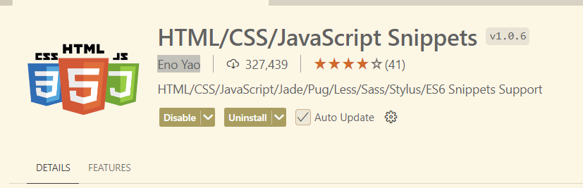

* 1. Prettier – Code Formatter: To make proper formatting of code

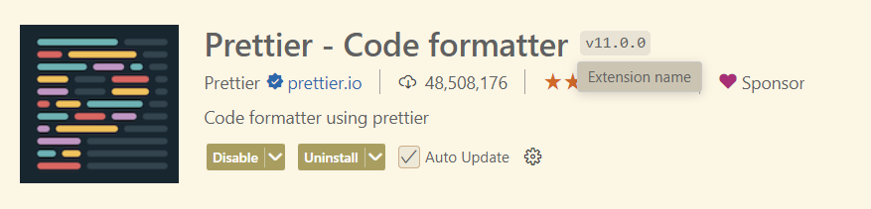

* 1. Live Server – To enable run HTML directly at browser without reloading to browser

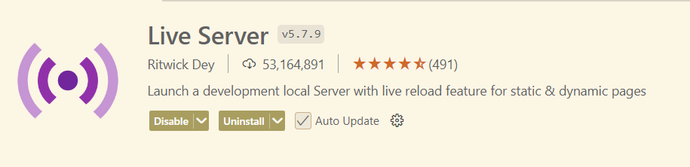

* 1. Create an Account at Free Hosting Provider eg. Netlify: <https://www.netlify.com/>

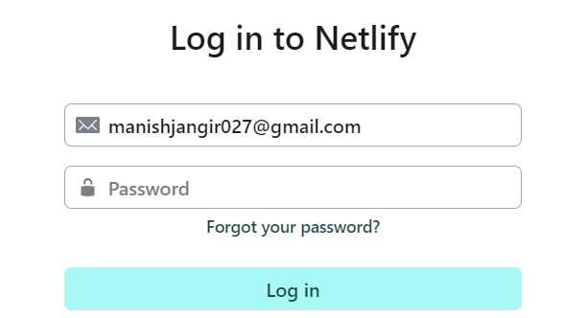

After Account Setup (Skip Deployment Steps at Netlify) you will see like below Screen:

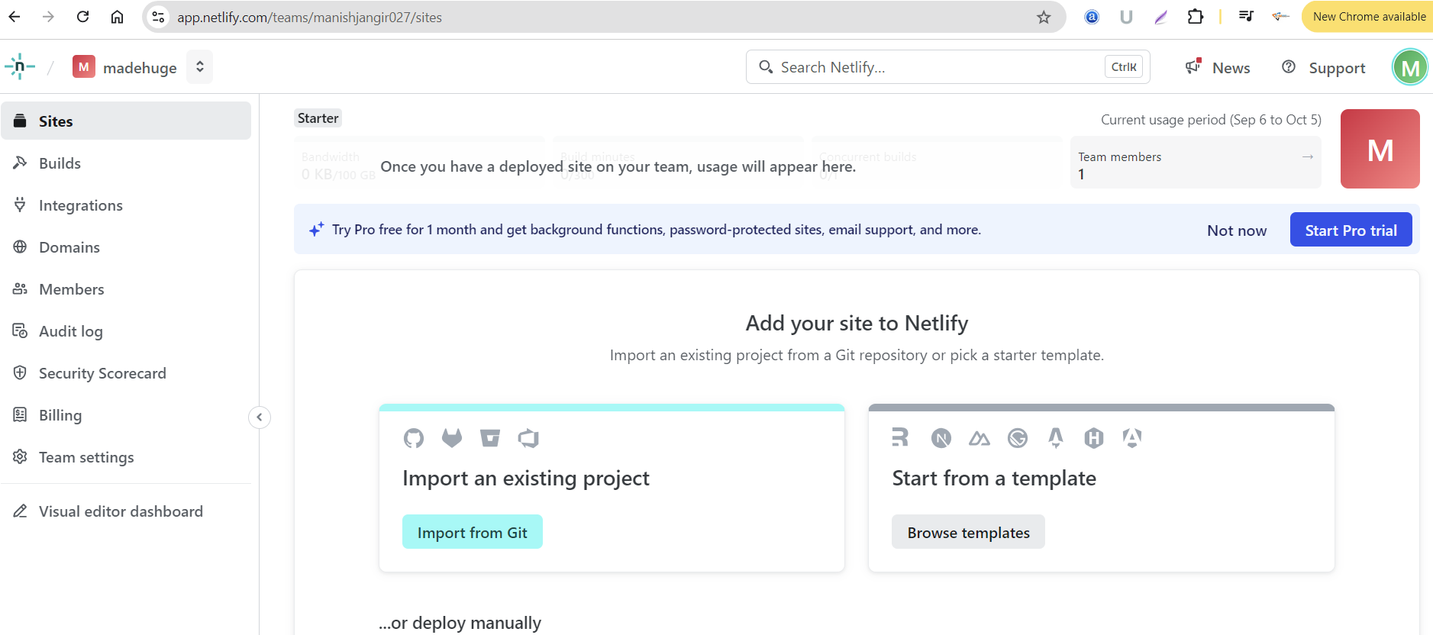

1. Install Google Chrome with following Extensions in it

* Wappalyzer Chrome Extension – To identify the tech stack of any global websites

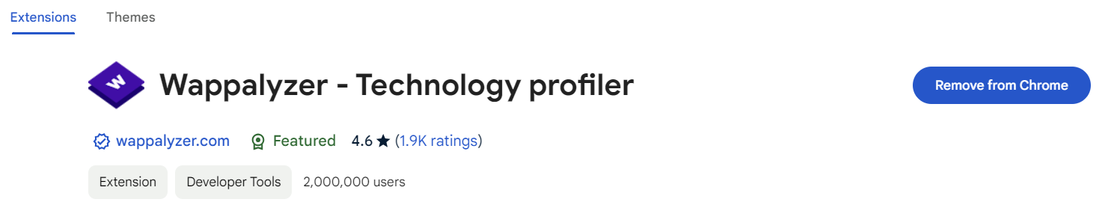

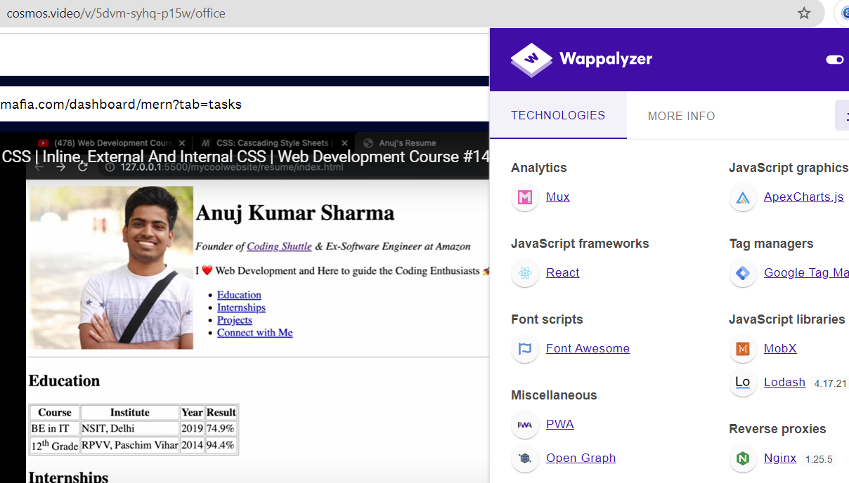

* SEO Meta in One Click – To track any webpage SEO Report (Tags, Title, Descriptions)

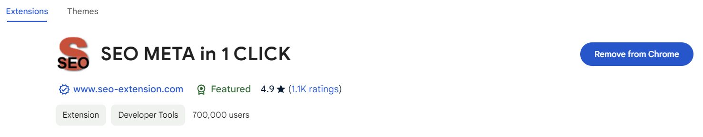

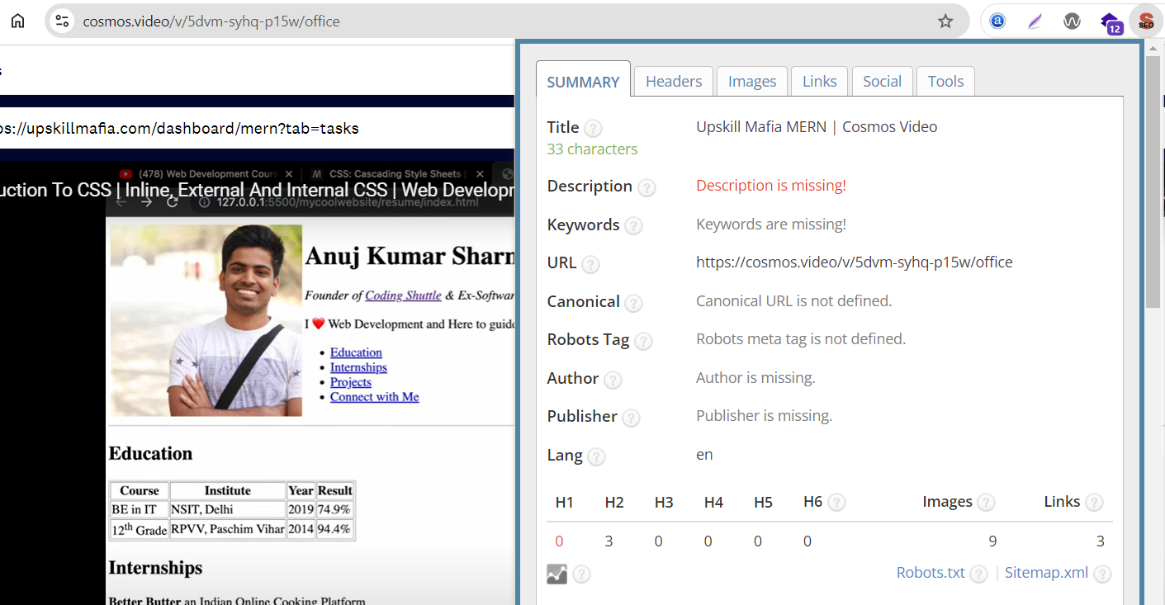

* WAVE Chrome Extension – ADA Compatibility & Web Errors testing Use

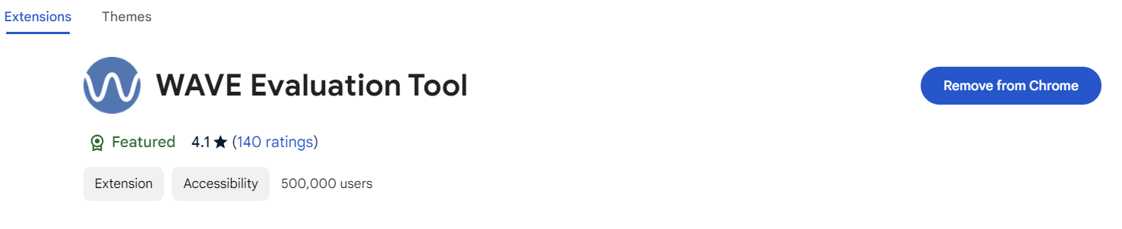

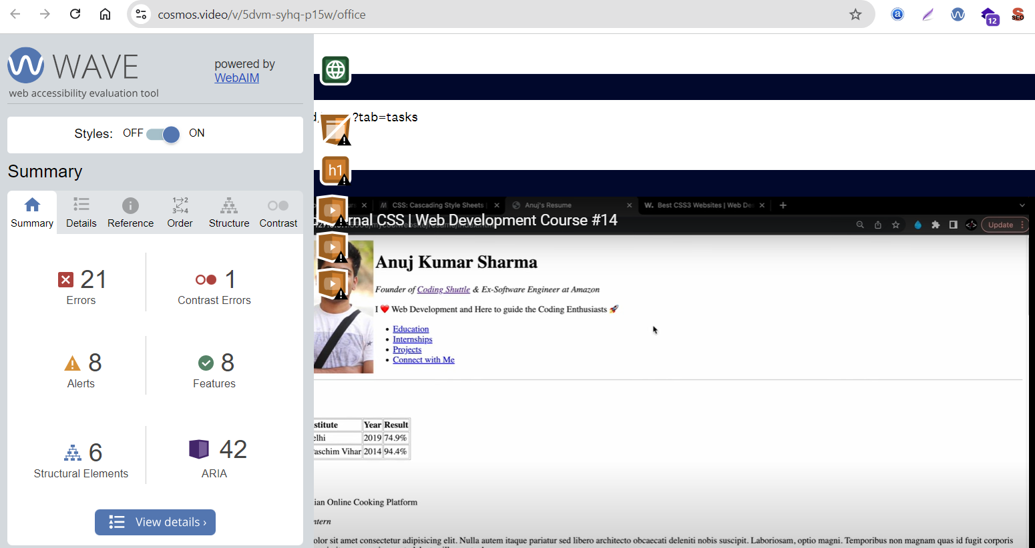

* Pesticide Chrome Extension – For Elements Inspecting Areas/Border

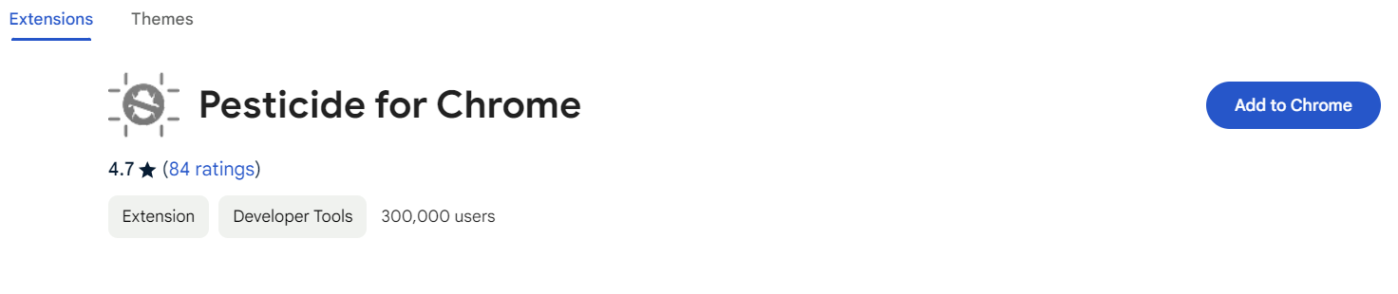

1. Useful tips/websites/reference to be used in dev cycle
   1. Always try to use placeholder images for our demo image to avoid the copyright & other compliance issues:
      1. https:via.placeholder.com/100 ( It will generate automatically 100X100 placeholder image for us )
      2. https:via.placeholder.com/200X100 ( It will generate automatically 200X100 placeholder image for us ) and so on
      3. This things will make a lot of benefits for testing, development & Time saving process.
   2. Always use Float (Left, Right, None, Inherit) properties to make image & content layout restructuring, although its not a global rule. But it is not a good practise to use float anywhere in HTML. Now we have to use (Display, Position properties for other kind of layout)
      1. Css-tricks.com to get more proper and align ideas.