1. Install VS Code: <https://code.visualstudio.com/>
2. Install VS code Extensions:
   1. HTML CSS & JavaScript Snippet: For Fast Coding auto suggestions

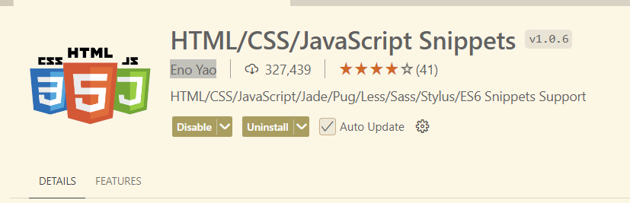

* 1. Prettier – Code Formatter: To make proper formatting of code

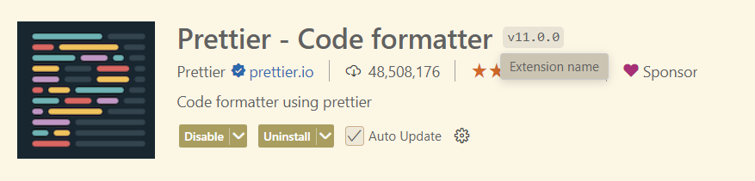

* 1. Live Server – To enable run HTML directly at browser without reloading to browser

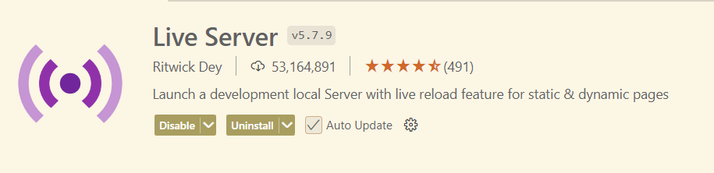

* 1. Create an Account at Free Hosting Provider eg. Netlify: <https://www.netlify.com/>

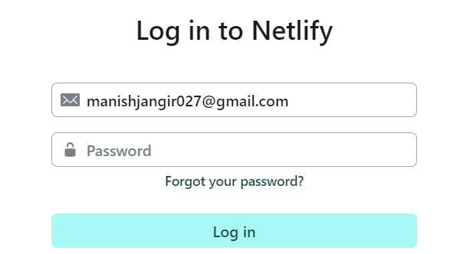

After Account Setup (Skip Deployment Steps at Netlify) you will see like below Screen:

