Sunday, September 15, 2019 at 4:00 pm

Cultural Arts Center

***The Lillibridge Ensemble***

***Madeleine Forte,*** *piano* ***Raphael Ryger,*** *violin*

***Karen Ryger,*** *cello*

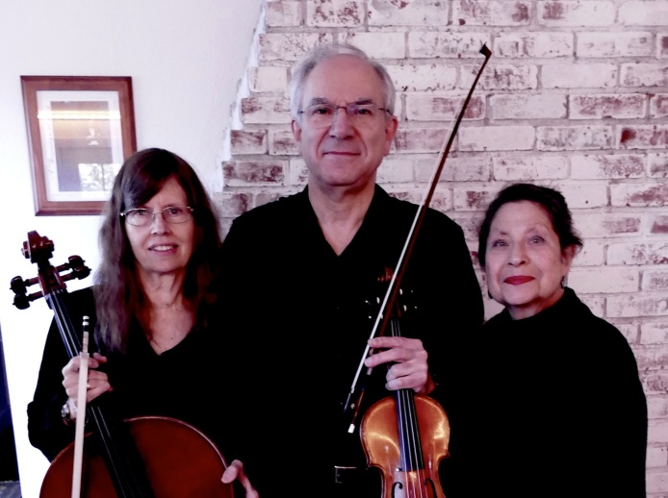

*Dedicated to Victoria DePalma*

**Johannes Brahms** (1833—1897)

Sonata No. 2 for Violin and Piano in A Major, Opus 100

*Allegro amabile*

*Andante tranquillo-Vivace-Andante-Vivace di piu-Andante-Vivace*

*Allegretto grazioso (quasi Andante)*

Trio No. 3 for Piano, Violin and Violincello, Opus 101

*Allegro energico*

*Presto non assai*

*Andante grazioso*

*Allegro molto*

Franco-American pianist **Madeleine Forte** has won prizes in many international competitions (Viotti, Italy; Maria Canals, Spain;

Guanabara, Brazil). As a girl she studied with Alfred Cortot and Wilhelm

Kempff. She holds an Artist Diploma from the Ecole Normale de Musique,

Paris, and the Frederic Chopin Academy in Warsaw. She also holds Bachelor

of Music and Master of Science degrees from the Juilliard School, where

she studied with Rosina Lhevinne and Martin Canin. When she earned her Ph.D. degree from New York University, her dissertation was on the music of Olivier Messiaen. Her book, *Olivier Messiaen: the Musical Mediator* was published in 1996. In 2011, she wrote her memoirs *Simply Madeleine:*

*The Memoir of a Post-World War II French Pianist.*

Madeleine Forte is a founding member of The Bel-Etre Ensemble and the Lillibridge Ensemble. She is a Fellow of Silliman College at Yale University,

and was a Visiting Hendon Fellow in 1996. She toured all over the world

with her late husband, Allen Forte, Battell Professor emeritus of the Theory of Music at Yale University.

**Raphael** and **Karen Ryger,** violinist and cellist, husband and wife, have been

playing together since their Juilliard School days as teenagers. While

there, they were assigned to the same quartet in a chamber music workshop mentored by the renowned Budapest Quartet. They have since studied and performed with fine ensembles, both in Israel and in the U.S.

**Raphael** has been concertmaster and soloist with orchestras in Israel and in

Connecticut, and is currently in his thirtieth season as Concertmaster of

Orchestra New England, based in New Haven.

**Karen**, previously a member of the Jerusalem String Quartet, the

Jerusalem Symphony and the Israel Chamber Orchestra, now appears

regularly with area orchestras and in smaller ensembles. Raphael and

Karen continue to perform together in a variety of ensembles, sometimes

with their daughter Yonitte, a brilliant violinist in her own right.