ARTICLE TITLE
Transgenerational plasticity in response to water limitation leads to maladaptation in Plantago patagonica, an arid-adapted annual plant.

Author Names: Madeleine Wallace ^{1,2}, Rachel M. Mitchell ¹
Affiliations: ¹ School of Natural Resources and the Environment, University of Arizona, Tucson, AZ, 85721
² Corresponding author: maddiewallace@arizona.edu

Abstract
Premise: Climate change is intensifying drought and increasing environmental variability, posing major challenges for plant populations in arid ecosystems. Transgenerational plasticity, where environmental conditions experienced by parent plants influence the phenotype of offspring generations, may be one mechanism by which species can cope with a rapidly changing climate. However, the presence, extent, and adaptive benefit of transgenerational plasticity remains unclear, especially within species populations. We evaluated how within-generation and transgenerational plasticity shape trait responses to water limitation across eleven climatically distinct populations of Plantago patagonica, a seed banking desert annual.

Methods: We used a fully factorial greenhouse experiment to assess the effects of parental collection environment and experimentally imposed water limitation on transgenerational plasticity in Plantago patagonica. We assessed phenotypic differences in several performance and fitness traits to determine 1) if there was evidence of transgenerational plasticity in response to water limitation, 2) if collection site climate variability affected the magnitude of the transgenerational response, and 3) if the response was adaptive.

Key Results: We found limited evidence for adaptive transgenerational plasticity. Instead, consecutive generations of water limitation significantly reduced seed production compared to mismatched or non-water limited histories, suggesting maladaptive transgenerational plasticity in this species. While most plasticity was within-generation, two traits—root biomass and relative growth rate—exhibited transgenerational plasticity dependent on seed source site climate. Additionally, transgenerational plasticity in root allocation was positively associated with flowering success, suggesting a link between plasticity in water-acquisition traits and fitness.

Conclusions: Our findings suggest that in P. patagonica, transgenerational plasticity may be constrained by environmental unpredictability and trade-offs associated with its ability to seed bank. These results highlight the context dependence of transgenerational plasticity and caution against assuming its adaptive benefit under future climate scenarios.

Keywords: climate change; desert annual; drought; environmental variability; phenotypic plasticity; Plantago patagonica; transgenerational plasticity

INTRODUCTION
Ecosystems around the world are facing rapid and unpredictable climatic changes (IPCC 2021). Over the past 50 years, many regions have faced decreased precipitation, increased temperatures, and longer durations between precipitation events (Spinoni et al., 2019) and this trend is expected to accelerate across many landscapes in the coming decade (Dai, 2011). These drought events, driven by climate change, pose a significant problem for plant populations and communities. In response to these changes, most organisms are expected to (1) migrate, (2) undergo adaptive genetic changes, and/or (3) exhibit phenotypic plasticity (Hoffmann & Sgrò, 2011). As sessile organisms, it is unlikely that most plant populations will be able to keep pace with these climatic changes on an evolutionary scale and may not migrate fast enough to persist (Song et al., 2021). Phenotypic plasticity, however, can allow plants to rapidly respond to variations in climate. Phenotypic plasticity is most often considered in the context of individuals responding to their immediate environment, with the range of expression limited by evolution and genetic factors. However, there is increasing evidence that environmental conditions experienced by parent plants can influence the phenotype and degree of plasticity in offspring generations (Bonduriansky, 2021; Herman & Sultan, 2011; Uller, 2008). Termed “transgenerational plasticity” (TGP), this mechanism may represent an additional process by which species cope with a shifting climate.
TGP may serve as a source of phenotypic variation with significant evolutionary consequences, particularly if it influences offspring fitness (Donelson et al., 2018; Herman & Sultan, 2011). In many cases, exposure to environmental stress across multiple generations can have a positive anticipatory effect, improving offspring performance under similar stressful conditions (Bonduriansky, 2021; J. Marshall & Uller, 2007; Yin et al., 2019). When this parental exposure to an environmental stressor enhances offspring fitness in response to the same stressor, TGP is considered adaptive (Bell & Hellmann, 2019; Colicchio & Herman, 2020; Donelson et al., 2018; Engqvist & Reinhold, 2016). Because adaptive TGP can induce beneficial phenotypic changes within just a single generation and affect many potential offspring, it may enhance population persistence in stressful environments that might otherwise reduce fitness (Herman & Sultan, 2011).
However, in the past two decades, it has become clear that the effects of TGP are diverse, not necessarily always adaptive, and complex (reviewed in Bonduriansky, 2021; Holeski et al., 2012; Mousseau & Fox, 1998; Sánchez-Tójar et al., 2020a; Uller, 2008; Yin et al., 2019). For example, when exposed to two generations of drought treatments, offspring of the perennial grass Secale sylvestre exhibited higher aboveground biomass and higher seed production compared to offspring of control (non-droughted) parental plants, displaying evidence of adaptive TGP (Mojzes et al., 2021). This adaptive effect is not always consistent, however. When the annual leguminous herb Lupinus angustifolius was exposed to two generations of drought, offspring from this treatment exhibited significantly reduced seed mass and lower reproductive biomass (Matesanz et al., 2022). While the number of studies investigating TGP in the past two decades have risen exponentially, no clear patterns have emerged as to the adaptive benefit of transgenerational effects, and several published meta-analyses have reached opposite conclusions on the perceived beneficial effects of TGP (Sánchez-Tójar et al., 2020b; Uller et al., 2013; Yin et al., 2019).
Despite the large number of studies examining the effects of TGP in plants, fewer studies have considered how environmental conditions influence the degree of TGP across populations of species (Groot et al., 2017; Lampei et al., 2017; Riginos et al., 2023; Wadgymar et al., 2018), and among genotypes within populations (Galloway, 2001; Holeski, 2007; Latzel et al., 2014). Variation in local climate conditions and interannual environmental heterogeneity may modulate the expression of TGP across populations, resulting in outcomes that are adaptive, maladaptive, or altogether absent. Experiments designed to include climatically distinct populations may offer valuable insight on the role of local climate regimes on the evolution of TGP between populations (Groot et al., 2017).
TGP is more likely to arise within a population when environmental variation occurs more predictably across generations, when expressing plasticity entails minimal energetic or fitness costs, and when environmental cues are reliable indicators of future conditions (Colicchio & Herman, 2020; Hoyle & Ezard, 2012; Räsänen & Kruuk, 2007; Reed et al., 2010; Uller, 2008). TGP is particularly favored when parental and offspring environments are correlated or vary predictably over time, allowing parents to adjust offspring phenotypes in ways that can enhance both their own fitness and offspring fitness (Burgess & Marshall, 2014; J. Marshall & Uller, 2007; Kuijper & Hoyle, 2015). However, when future conditions are uncertain—when environmental variability is higher—parent plants may prioritize their own fitness over their offspring, or may produce more diverse offspring phenotypes to reduce fitness variability via strategies like bet hedging (Fischer et al., 2011; J. Marshall & Uller, 2007). While TGP can enhance offspring fitness, its expression likely depends on the environmental context of a population or species’ seed source site.
Quantifying the impact of population seed source environment on TGP expression is imperative to understanding parental effects on fitness and performance. This is one confounding factor that may account for obscure results in transgenerational studies as mentioned above—variance in TGP in populations collected from environmentally distinct sites, or lack of variance in plants collected from the same genetic pool (Nicotra et al., 2010; Sultan, 1987). For example, Latzel et al. found strong evidence for parental effects in Arabidopsis thaliana in response to a wide variety of abiotic stressors, with the effects being strongly dependent on genotype and often acting in different directions and magnitudes depending on the genotype (2023). Wadgymar et al. found that in populations of Boechera stricta distributed across an elevational gradient, low elevation populations had greater TGP than within generational plasticity (WGP) in germination success than higher-elevation populations (2018). TGP and WGP likely mediate fitness and performance across genetically distinct populations. Understanding how the climate of the seed source location influences TGP across gradients may offer valuable insights into understanding how plant populations may respond to a future changes in climate.
One key environmental factor influencing the potential for TGP is water availability, a critical determinant of plant performance and a major driver of global plant species distributions (Bartlett et al., 2012; Cornwell & Ackerly, 2009; Louthan et al., 2015). As climate change intensifies, rising temperatures and shifting precipitation patterns are increasing aridity, reducing water availability and exacerbating water stress in plants. This water stress can potentially alter selective pressures and may drive changes in species distributions or even lead to local extinction events. In this context, TGP may play a crucial role in shaping how plant populations respond to increasing water stress, potentially buffering against rapid environmental change or, conversely, constraining adaptation and contributing to local extinctions.
Aridity is associated with higher temperatures and drier conditions, both of which act together to increase physiological stress and affect plant growth and reproduction. One integrative and physiologically relevant measure of this physiological stress is vapor pressure deficit (VPD), which reflects the difference in the amount of moisture in the air and the amount it can hold when fully saturated. With increasing VPD, transpiration increases, increasing the water demand needed to maintain turgor pressure and generally negatively impacting plant survival, growth, and reproduction. Because VPD incorporates both temperature and humidity, it provides a powerful metric for capturing the intensifying drought stress plants face under climate change. As the frequency and severity of droughts continues to rise (Dai, 2011), understanding how multi-year droughts affects potential TGP in performance and fitness traits is imperative for predicting plant population response to climate change.
In this study, we assessed the effects of seed source collection environment variability and experimentally imposed water limitation on TGP in the herbaceous plant Plantago patagonica, a seed banking arid adapted annual plant. We also sought to quantify whether any induced plasticity was adaptive, resulting in better performance in terms of survival, growth, and fecundity in populations exhibiting TGP. We used eleven populations collected from abiotically distinct and contrasting environments located across the southwestern portion of the US (Table 1) that differed in both growing season (spring) VPD and variation in spring VPD across a 30-year period. Seeds from these populations were grown under water limitation and control treatments prior to this experiment (see Klein and Mitchell 2025 for more detail). Using seeds derived from this previous experiment, we implemented a fully factorial greenhouse experiment, with watering limitation treatments that were early (10-14 days after germination) and strong (representing a 50% reduction in spring annual precipitation for our driest population). This resulted in cohorts of offspring that had experienced four different levels of generational water availability, ranging from no water limitation to two generations of water limitation in succession (Figure 2). To assess the presence and magnitude of transgenerational plasticity, and how it interacts with seed source site spring VPD variability, we measured several performance and fitness traits for each cohort. We asked the following questions: 1) Is there evidence of TGP in response to water limitation in P. patagonica? 2) Does collection site climate variability predict the magnitude of the TGP response to water limitation? and 3) Is TGP response to water limitation adaptive?

MATERIALS AND METHODS
Study species, source populations, and seed collection
Plantago patagonica (woolly plantain) is a small statured, fully self-pollinating annual forb (due to parenthesis cleistogamy; Sharma et al., 1992) with a broad biogeographic range extending across North America, into northern Mexico, and occurring in parts of South America. P. patagonica is characterized by a basal cluster of hairy, grass-like leaves with dense spikes of white and green flowers. In North America, P. patagonica is a common winter and spring annual that often forms dense mats (SEINet Portal Network, 2024). P. patagonica is a fitting plant to test the occurrence of transgenerational effects due to its wide natural range and reliable inbreeding. Within the southwestern portion of North America, P. patagonica has been identified as a priority restoration species by the Bureau of Land Management’s Colorado Platea Native Plant Program due to its high likelihood for establishment in large scale projects (Wood et al., 2015), high germination probability (Gremer & Venable, 2014), its ability to seed bank (Haight et al., 2019), and its potential role in promoting perennial establishment (Barak et al., 2015). We used plant material from 11 different populations of P. patagonica sourced from locations ranging in growing season VPD (spring VPD from 3.62 kPa to 2.02 kPa, see Figure 1). See Klein & Mitchell (2024) for a detailed description of seed sources and acquisition.
Water limitation experiments
F1 - Common garden experiment
This experiment leveraged seeds generated as part of 2021 study detailed in Klein & Mitchell et al. 2024. The F1 experiment was performed in a common garden located at the Petchesky Conservation Center on New Mexico Land Conservancy-owned land southwest of Santa Fe, New Mexico, U.S.A. (35.612602, −106.004360). The 262-acre conservation area is dominated by grasslands and pinyon–juniper woodlands, which is representative of the typical P. patagonica habitat in northern New Mexico. The common garden has a 30-year MAP of 331 mm and ranges annually in temperature from −0.30 to 22°C, which is intermediate in precipitation and temperature compared to collection conditions for our 11 populations.
During the F1 experiment, we used wild collected seed (collected from locations detailed in Figure 1) and grew them under one of two watering treatments: supplemental watering and ambient watering. Individuals grown under the supplemental watering treatment received 200% of the 30-year average at the common garden (~96mm), while the ambient watering received approximately 100% of the 30-year normal for the growing season (~48mm). For further details on the F1 common garden experiment, see Klein & Mitchell, 2024. The offspring seed (F2, Figure 2) of these plants were collected, cleaned, and stored for later use. For the purposes of our experiment, we considered individuals grown under ambient conditions to be “dry” and those under supplemental conditions to be “control”.
F2 - Greenhouse experiment
Seeds produced from the F1 common garden were used in a F2 greenhouse water limitation experiment (Figure 2) during the spring and summer of 2023 (April – August). Seeds from Population 2 were misplaced and not recovered, so only 11 populations were represented in F2. Seeds from each population and each watering treatment were scarified with 150-grit sandpaper, soaked for 24 hours in tap water, and planted in 2-in x 8-in “cone-tainers” (Stuewe & Sons, Tangent, OR, USA). The planting substrate was sterilized via an autoclave at 121 C for three consecutive days. We sowed five to eight seeds per pot in a 50-50 mixture of sterilized potting soil and sand and watered all pots to saturation for the first 14 days to ensure germination. The greenhouse was maintained between 64-85 F under ambient light conditions from April to August 2023. No fertilizer was applied over the course of the experiment. On day 14, we thinned each cone-tainer to a single individual per pot and randomly assigned plants to one of two watering treatment in a fully factorial fashion (Figure 1). The final experimental design was comprised of: 11 maternal populations X two F1 watering treatments (control and dry) X two F2 watering treatments (control x dry) X 48 individuals = 2112 plants, resulting in four treatment cohorts: DD (F1 dry / F2 dry), DC (F1 dry / F2 control), CD (F1 control / F2 dry), and CC (F1 control / F2 control) (Figure 2).
To maximize differences between our two watering treatments, plants in the control treatment received water equal to the 30-year mean spring (April - June) rainfall amounts for the wettest seed source location in our study (60ml/week). Beginning on day 14 of the experiment, plants in the dry treatment group were watered at a rate of 50% of the 30-year mean spring rainfall amount for the driest location in our study (15ml/week) (PRISM Climate Group). Plant stress (an observed and sustained loss of turgor pressure even with watering) was initially very high in the dry treatment, so watering was increased to 30ml/week on day 18 to ensure adequate survival and replication in the treatment group. Watering occurred twice per week at 15 ml (dry) and 30 ml (control) per watering using a graduated 100ml syringe.

Figure 1. a) Seed source site collection locations and b) growing season climate characteristics for each population of Plantago patagonica. Spring climate characteristics were averaged across 30 years (1989 – 2019, April – June). SVPD = spring VPD.
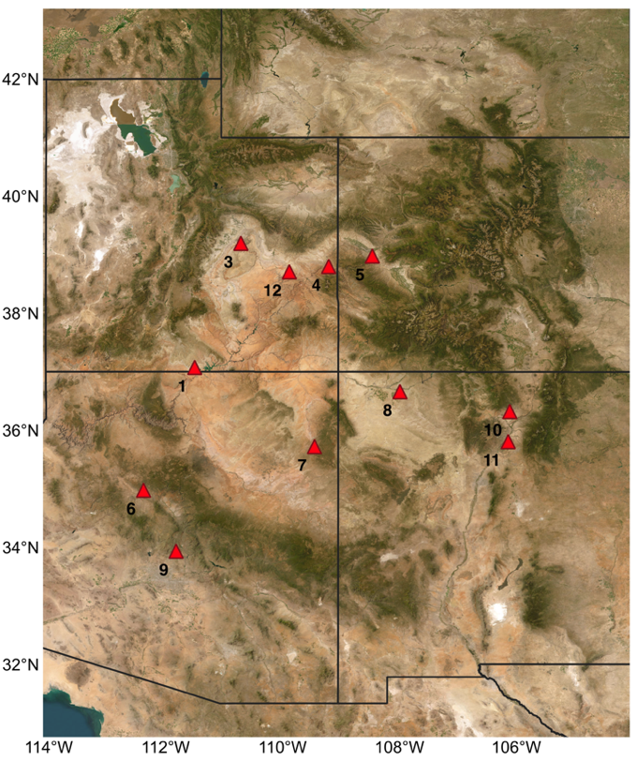
b)
a)

Figure 2. Schematic of the fully factorial experimental design detailing F1 and F2 generations. We collected seeds from individuals in natural Plantago patagonica populations across a climatic gradient in AZ, UT, NM, and CO (Figure 1). In F1, these seeds were reared in a common-garden experiment and exposed to two experimental watering conditions. In F2, seeds from F1 were reared in a greenhouse experimental and again exposed to two experimental watering conditions, resulting four cohort groups: CC, CD, DC, and DD, as outlined in the text.
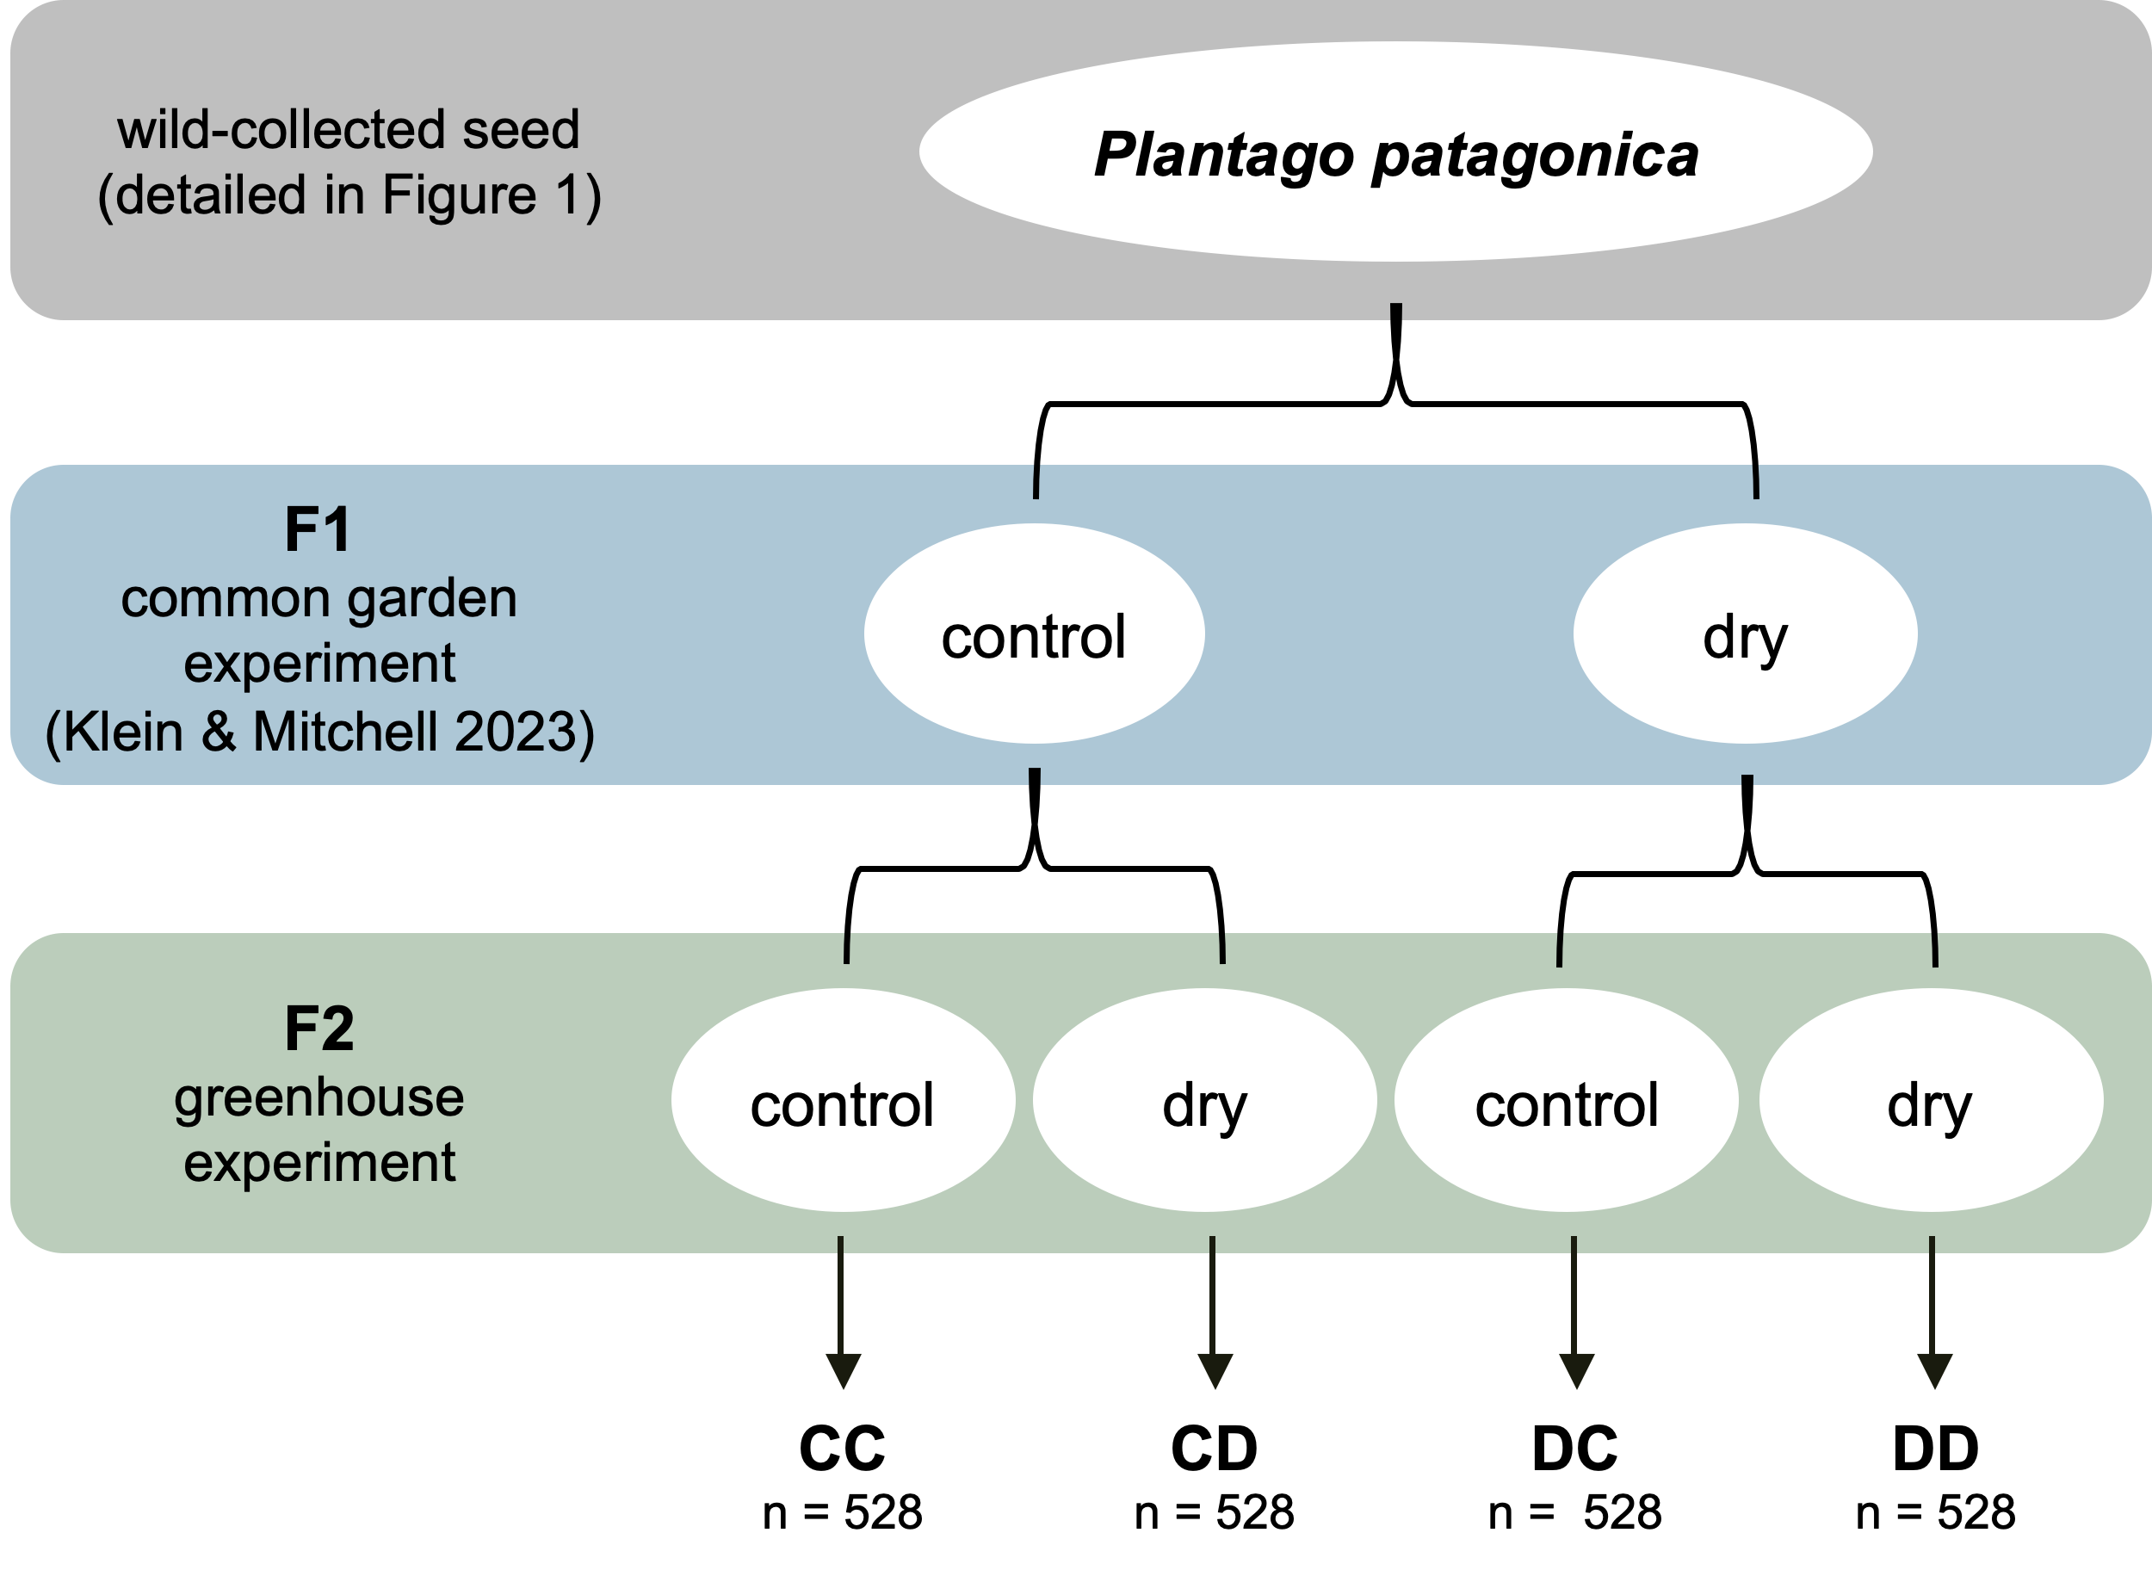

Trait data collection
To understand the transgenerational effects of water limitation in P. patagonica, we quantified traits related to growth (root biomass, shoot biomass, total biomass, and maximum vegetative height), resource allocation (root:shoot ratio, relative growth rate, SLA, and LDMC), survival, and reproduction (days to flower, number flowered, number of flowering structures per plant, and seed number) in the F2 generation in response to each multi-generational watering treatment. Germination was monitored daily for 20 days, with number of germinates per day recorded. Plant height (mm), indicative of a plant’s ability to compete for light (Westoby, 1998), was measured every seven days for four weeks, and then every 14 days for four weeks beginning on day 35. Final height was determined as the maximum vegetative tissue height on day 50.
To categorize P. patagonica on the leaf economics spectrum, which characterizes a species capacity for stress tolerance vs. resource acquisition (Wright et al., 2004), we measured relative growth rate (RGR), SLA, and LDMC. We calculated relative growth rate with the height data, using the following formula, where initial size was height on day 14 and final size was height on day 50 (Crawley, 2009):
RGR = ln (final size / initial size)
On day 60, we collected one to five mature, healthy leaves per individual to measure SLA and LDMC. Collected leaves were stored in zip lock bags with one water-saturated paper towel sheet and placed overnight in cool, dark conditions (35° F). After 12-14 hours, leaves were weighed with a microbalance (1-μg precision; Mettler Toledo) to obtain saturated weight. The leaves were then scanned using a LI-COR LI-3100C leaf scanner to quantify leaf area. Leaves were then dried for 48 hours in an oven at 60° C and then weighed again using the Mettler Toledo microbalance. Specific leaf area (SLA) was calculated as the area of fresh leaf divided by the oven dried mass. Leaf dry matter content was calculated as the leaf dry weight divided by the saturated leaf weight.
Plant mortality, presence of reproductive structures, and number of reproductive structures was monitored daily throughout the term of the experiment, from May 18th, 2023, to August 10th, 2023. Here, mortality represents proportion of plants alive on day 50. After each plant had finished flowering and the seed heads had begun to ripen but before the plant had fully senesced, seed heads were collected and stored for further drying. Root, shoot, and total biomass was collected immediately after seed collection. Biomass allocation was calculated as the root:shoot (R:S) ratio. The mass of removed leaves was added back to the total aboveground biomass for each individual for analysis.
The collected seedheads were placed in paper envelopes and dried for 3 months in a temperature-controlled laboratory room. Seedheads were then manually cleaned. We collected 10-25 seeds per plant and weighed them on a microbalance to obtain the mean individual seed mass per plant. We then weighed the total seed from each plant to obtain total seed mass per plant. We used these measurements to calculate total seed number using the following formula:
total number of seed per plant = (n number of seeds weighed * total seed weight of plant) / (weight of n seed)
Statistical analysis
Is there evidence of TGP in response to water limitation in P. patagonica?
To assess the effects of offspring (OT) and parental (PT) watering treatments on the phenotypic expression of functional and life history traits, we fit mixed effect models for each trait using the packages lme4 and glmmTMB (Bates et al., 2015; Brooks et al. 2017) (Table 1). We analyzed the plant response to water availability using the following response variables: 1) shoot biomass 2) root biomass 3) total biomass 4) max height 5) R:S ratio 6) RGR 7) SLA 8) LDMC 9) mortality 10) days to flower 11) number of plants flowered 12) number of flowering structures produced per plant and 13) seed number. Seed mass was excluded because it was highly correlated with seed number. For our continuous response variables (aboveground biomass, belowground biomass, total biomass, root:shoot ratio, RGR, maximum height, SLA, LDMC), binomial data (mortality, flowering), we used Gaussian and binomial error structures, respectively. Additionally, to assess number of plants that flowered, we used a zero-inflated model because, in some populations under some treatments, very few individuals produced reproductive structures. Thus, we used a zero-inflated hurdle model to represent the two biological processes: whether a plant initiated flowering at all, and among the plants that did flower, the number of structures produced. For days to flower and seed number, we used negative binomial distributions to account for overdispersion in the data.
To answer our first question, for all models detailed above, we included the offspring watering treatment (OT), parental watering treatment (PT), and their interaction as fixed effects. Population was included as a random effect to account for population-level differences in response traits. The significance of fixed effect factors was assessed using the function Anova (package car, Fox & Weisberg, 2019). For generalized linear models, we used a Wald chi-square test. For linear models, we used a type III sum of squares test to compute the F-statistic. To assess model fit, marginal R² (variance explained by fixed factors) and conditional R² (total variance explained) were calculated using r.squaredGLMM (package MuMIn, Bartoń 2023).
We verified assumptions of independence and normality of residuals by plotting residuals from each model. If transforming the response variable improved linearity and normality of the residuals, we used the transformed response variable. Root:shoot ratio, SLA, and LDMC were log transformed.
A significant effect of OT indicated that there were differences between plants grown in the two watering treatments (drought or control), e.g. evidence of WGP. A significant effect of PT indicated that there are phenotypic differences between plant grown from seeds produced under different parental treatments of watering, e.g. evidence of parental effects. A significant effect of the OT x PT interaction indicated that the effect of parental treatment on the phenotype depended on the offspring watering treatment, e.g. evidence of TGP (Table 1). When significant interactions were detected, post hoc tests were performed using the emmeans package with Tukey HSD adjustments, which accounts for multiple comparisons (Lenth, 2024).
Does collection site climate variability predict the magnitude of the TGP response to water limitation?
We used a different model structure to test if trait response and TGP was associated with site-specific patterns of environmental variation. Specifically, we tested if the climate at origin spring VPD variability (sVPD coefficient of variation, sVPD-CV) influenced the expression of TGP in response to water limitation. To assess the effects of offspring (OT), parental (PT) watering treatments, and climate at origin sVPD-CV on the phenotypic expression of functional and life history traits across generations, we fit mixed effect models for each trait using the lme4 and glmmTMB (Bates et al., 2015; Brooks et al. 2017) (Table 2). Using the same response variables and model structure as above, our models included the offspring watering treatment (OT), parental watering treatment (PT), growing season sVPD-CV (April – June from 1981 to 2019) of the initial collection site, and all possible interactions as fixed effects. Population was included as a random effect to account for population-level differences in response traits not captured by the fixed effects. We used the same statistical approach as detailed above.
Is TGP response to water limitation adaptive?
To test whether TGP was adaptive, we calculated the extent of plasticity between treatments CC (two generations of control watering) and DD (two generations of water limitation) using the relative distance plasticity index (RDPI) for traits related to performance (RGR, root biomass) using the rdpi function in the plasticity package (Valladares et al., 2006, Ameztegui 2017). This metric calculates pairwise distances among individuals within each population whose parents were grown under different environments (here, between CC – DD). The average distance within a population provides an estimate of the degree of TGP, ranging from 0 (no plasticity) to 1 (high plasticity). We then calculated Pearson correlations between these trait plasticity values, and three traits related to fitness (seed number, mortality proportion, and flowering proportion). Additionally, we also tested if climate at origin sVPD-CV was associated with TGP plasticity to assess if more environmentally autocorrelated environments produce plants capable of TGP (Colicchio & Herman, 2020).
All analyses were performed using R Statistical Software v4.3.1 (R Core Team 2023).

RESULTS
Evidence of transgenerational plasticity in response to water limitation
We found measurable phenotypic differences in one trait, seed number, affected by offspring and parental treatments (Table 1; significant OT x PT term, Figure 4), confirming expression of TGP across all 11 populations of P. patagonica in response to water limitation. Across all populations, in dry treatments, plant offspring of water limited parents (DD) produced 66% fewer seed than plant offspring of well-watered parents (CD) (difference significant at P <.0001). Offspring of parents grown in well-watered conditions that were also grown in well-watered conditions (CC) produced less seed than offspring of drought stressed parents (DC), but this result was non-significant (Figure 3I, Figure 4).
Additionally, for number of plants that flowered, there were measurable phenotypic differences affected by offspring and parental treatments, but not their interaction (Table 1; significant OT term, significant PT term), indicating independent effects of parental and offspring environment rather than interactive. Regardless of watering treatment in the parental generation, plants that experienced well-watered conditions in the offspring generation (CC, DC) flowered 57% more than plants that experienced water-limitation in the offspring generation (CD, DD) (P = 0.0001). However, comparing across parental treatment, plants from water limited parents (DC, DD) flowered 25% more often than plants from well-watered parents (CC, CD) (P = 0.0009) (Figure 3G).
Evidence of within generation plasticity in response to water limitation
We also found measurable phenotypic differences across a number of traits affected by just offspring treatment (Table 1; significant OT term), indicating that WGP in response to water limitations was very strong across all eleven populations of P. patagonica. The impacts of reduced plant biomass in water limited conditions (root, shoot, total biomass; Figure 3A, 3B, 3C) was partially offset by plastic increases in biomass allocation to roots (Figure 3D) and an increase in LDMC (Figure 3F). Irrespective of water availability in the parental generation, plants grown under water limited conditions had 37% less root biomass (P <.0001), 63% less shoot biomass (P <.0001), and 45% less total biomass (P <.0001). However, plants grown under water limited conditions increased their R:S ratio by 28.9% (P <.0001) and their LDMC by 13.5% (P = 0.0015) on average. These higher LDMC values resulted in a lower growth rate (RGR), where plants grown under water-limited conditions had a 13.1% lower RGR than plants grown in well-watered conditions (P <.0001, Figure 3E). Additionally, the number of flowering structures was reduced by 32.9% when plants experienced water limitation in the offspring generation (P = 0.0001, Figure 3H).
Climate at origin and transgenerational responses
To evaluate if transgenerational effects were related to the seed source climate at origin, we used a model that included the effects of offspring treatment, parental treatment, the 30-year mean spring VPD coefficient of variation (sVPD-CV) at the seed collection site, and their interactions. Plants originating from areas with a higher sVPD-CV are from environments where atmospheric drought variability is more pronounced across years during the growing season. Plants from areas with a lower sVPD-CV originate from environments where atmospheric drought variability was lower, or more stable, across years during the growing season.
We found evidence of TGP modulated by seed source site sVPD-CV in two traits, root biomass and RGR. A significant interaction between OT, PT and sVPD-CV indicated that the effects of TGP on root biomass were dependent on the gradient of variability. Specifically, offspring from water limited parents that experienced well-watered treatment (DC) showed in increasing trend in root biomass with higher sVPD-CV, while offspring from well-watered parents that experienced well-watered treatment (CC) decreased in root biomass across the sVPD-CV gradient (Figure 4A, right panel; P = 0.0487). However, for offspring exposed to water limitation in the offspring generation (CD, DD), root biomass slightly increased over the sVPD-CV gradient, but these two slopes were not significantly different. Offspring who experienced water limitation in the offspring generation (CD, DD) were relatively insensitive to changes in root biomass over the sVPD-CV gradient (Figure 4A, left panel).
The effects of TGP on RGR were also dependent on the sVPD-CV. When offspring were grown in well-watered conditions, there was little effect on RGR, regardless of if the plant experienced water limitation in the parental generation (Figure 4B, right panel; slopes not statistically different). However, when offspring experienced water limitation, their response is dependent on the experience of their parent (Figure 4B, left panel; slopes marginally different, P = 0.0511). Several traits had moderate evidence of TGP modulated by sVPD-CV, including total biomass, R:S ratio, and number flowered (Table 2; marginally significant OT x PT x sVPD-CV term). However, post hoc analysis indicated that most traits did not exhibit significant differences in slopes among treatments.
Two traits had significant evidence of parental effects modulated by sVPD-CV, including max height and number of plants that flowered in each treatment group (Table 2; significant PT x sVPD-CV term). Estimated slopes suggest that in offspring from water limited parents, height increased slightly with higher sVPD-CV, whereas in offspring from well-watered parents, height declined with increasing sVPD-CV (β = 0.47674 +/- 0.20108, P = 0.0179). Specifically, flowering probability declined with increasing sVPD-CV in offspring from well-watered parents whereas offspring from water limited parents had a weaker negative or slightly positive response, suggesting that parental water limitation exposure may buffer offspring against the negative effects of increasing sVPD variability on reproduction (β = 1.5450 +/- 0.4955, P = 0.00182).
R:S ratio had significant evidence of within generation plasticity modulated by sVPD-CV (Table 2; significant OT x sVPD-CV). Estimated slopes suggests that in well-watered plants, R:S ratio decreases with increasing sVPD-CV (β = 0.20447 +/- 0.08078, P = 0.01159). In water limited plants, the slope is shallower, suggesting reduced sensitivity to sVPD-CV.
3.4 Adaptive transgenerational plasticity
To assess the adaptive capacity of the TGP response, we calculated Pearson correlation coefficients between plasticity of traits related to performance that displayed evidence of TGP (RGR, root biomass) and traits related to fitness in annual plants (seed number, mortality rate, flowering rate). We found several performance plasticity – fitness correlations. RGR plasticity was weakly negatively correlated with mortality (R = -0.129, P = 0.0021; Table 3). Under drought, as plasticity decreases, mortality rates are lower (Figure 5A). Root biomass plasticity was more strongly positively correlated with flowering rate (R = 0.336, P = 2.2E-16; Table 3), indicating that under drought, as plasticity increases, the proportion of plants that flower also increases (Figure 5B). When relating trait plasticity to seed source site climate, we found a negative correlation between root biomass plasticity and seed source site spring VPD-CV (R = -0.292, P = 2.2E-16; Figure 5C); populations from more climatically variable sites tend to exhibit lower plasticity in root biomass.

Table 1. Results of mixed models testing the effects of offspring watering treatment (OT), parental watering treatment (PT), and their interactions on traits in Plantago patagonica. P values = 0.05 < #P < 0.1; *P < 0.05; **P < 0.01; ***P < 0.001. Signiﬁcant terms are shown in bold; terms in italics are marginally signiﬁcant. F-statistic (linear models) or Chi-squared statistic (generalized linear models), signiﬁcance levels and degrees of freedom (d.f.) are shown for each term. Zero inflated models were used for number flowered, and number of flowering structures produced per plant. Population was included as a random factor. R2m = marginal R2; R2c = conditional R2.

Trait | OT | PT | OT x PT | R²m | R²c
Growth
root biomass | F = 44.1209*** | F = 2.6995 | F = 0.9111 | 0.130 | 0.163
shoot biomass | F = 178.3746*** | F = 1.2064 | F = 0.5113 | 0.317 | 0.421
total biomass | F = 94.5629*** | F = 3.2213 # | F = 1.0857 | 0.225 | 0.287
max height | F = 2.1731 | F = 0.0069 | F = 1.1009 | 0.002 | 0.128
Resource Allocation
R:S ratio | F = 36.5018*** | F = 2.1155 | F = 0.6739 | 0.077 | 0.133
RGR | F = 12.1817*** | F = 0.0119 | F = 0.1523 | 0.017 | 0.055
SLA | F = 2.0644 | F = 0.5044 | ]=F = 0.1812 | 0.008 | 0.067
LDMC | F = 8.3839** | F = 1.2024 | F = 0.5974 | 0.030 | 0.067
Survival
mortality | X2 = 1.5009 | X2 = 2.5306 | X2 = 0.3944 | 0.017 | 0.048
Reproduction
days to flowering | X2 = 1.8167 | X2 = 0.8656 | X2 = 0.8667 | 0.047 | 0.112
number flowered
conditional model | X2 = 11.3193*** | X2 = 7.8754** | X2 = 0.0077 | 0.147 | 0.482
zero-inflation model | X2 = 0.204 | X2 = 0.8181
number of flowering structures
conditional model | X2 = 4.3122* | X2 = 0.6727 | X2 = 0.4926 | 0.482 | 0.482
zero-inflation model | X2 = 23.038*** | X2 = 10.265**
seed number | X2 = 5.0412* | X2 = 1.8286 | X2 = 7.1231** | 0.226 | 0.226
df | 1 | 1 | 1

Figure 3. Transgenerational plasticity and within generation plasticity across all eleven populations of P. patagonica for a) root biomass, b) shoot biomass, c) total biomass, d) R:S ratio, e) RGR, f) LDMC, g) number of plants that flowered, h) number of flowering structures per plant, and i) seed number. Each line shows the norm of reaction for a trait for offspring of control watering (blue, circle) vs. drought watering (red, triangle) parental plants. Observed means +/- SE for 11 populations, with 4-12 replicates per population and treatment, are represented. Significance levels: ns= not significant, * = P < 0.05; ** = P < 0.01; *** = P < 0.001. OT: offspring treatment, PT: parental treatment. An interaction between OT and PT indicates transgenerational plasticity, while a significant OT represents within generation plasticity. See Table 1 for full results.
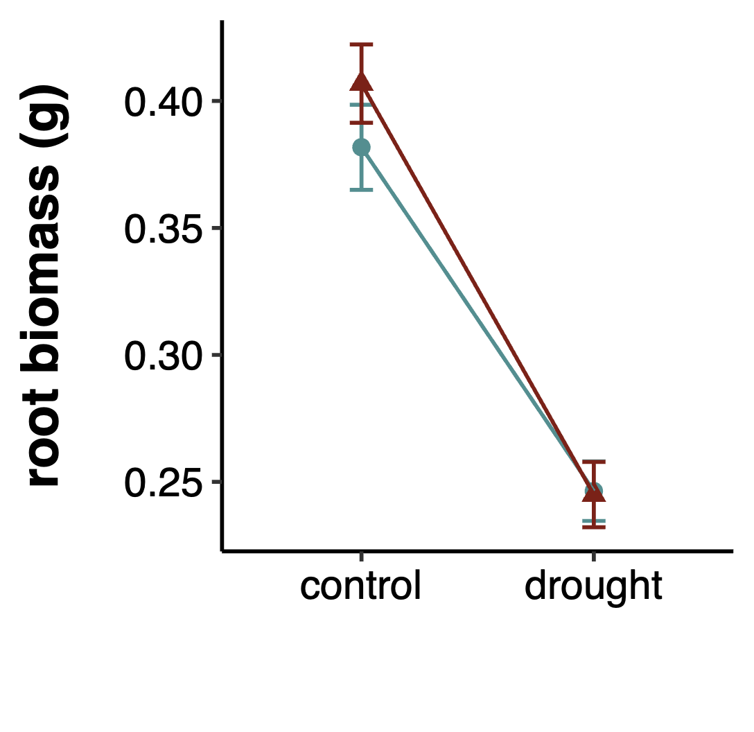
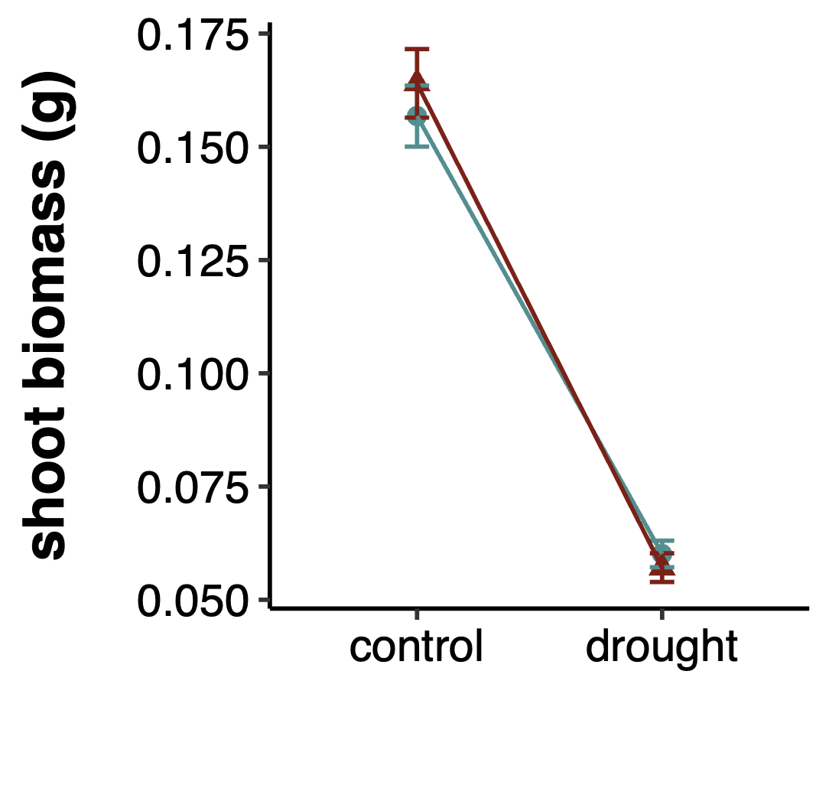
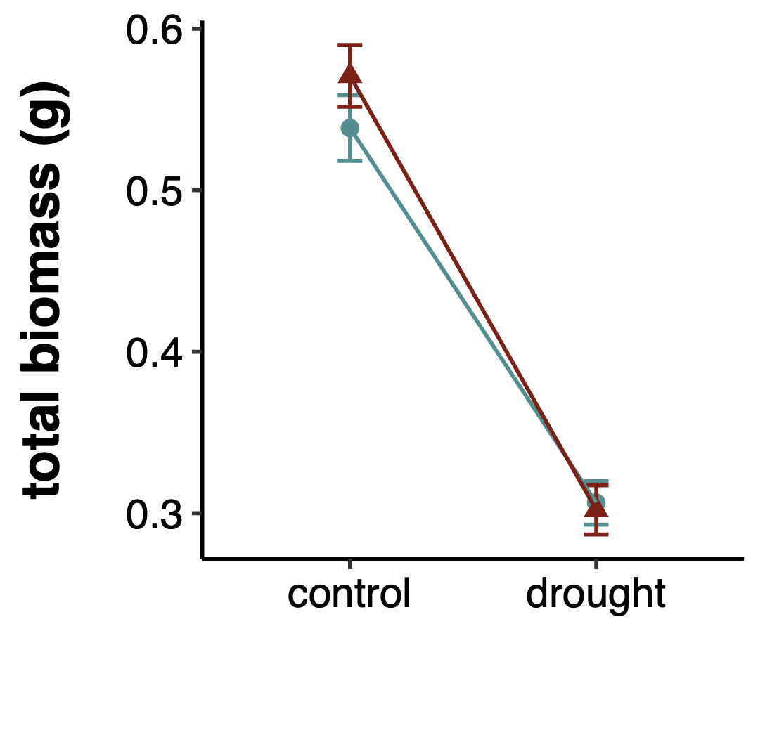
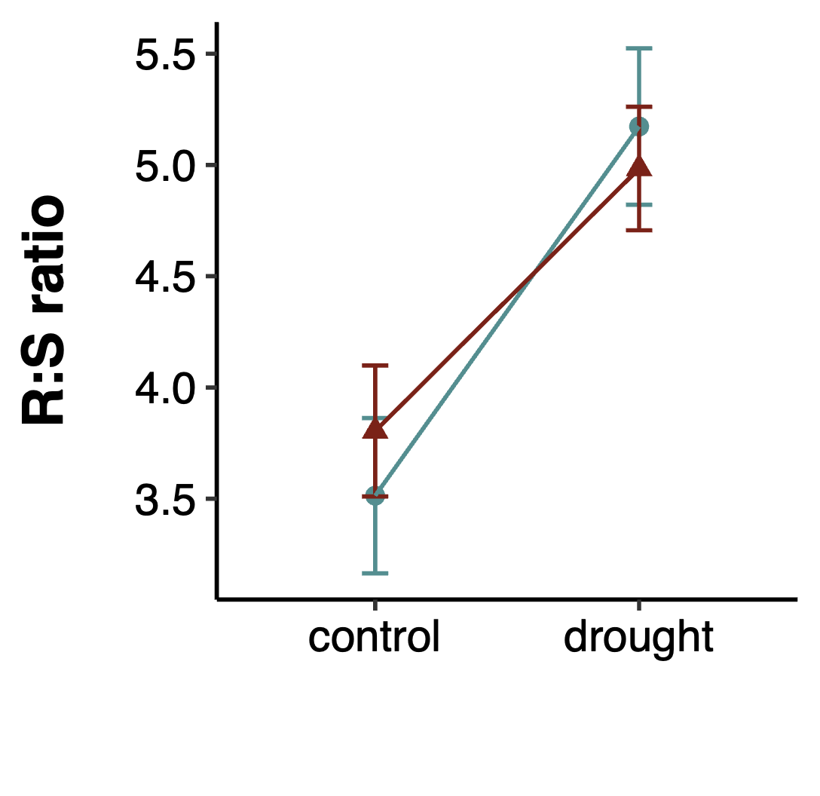
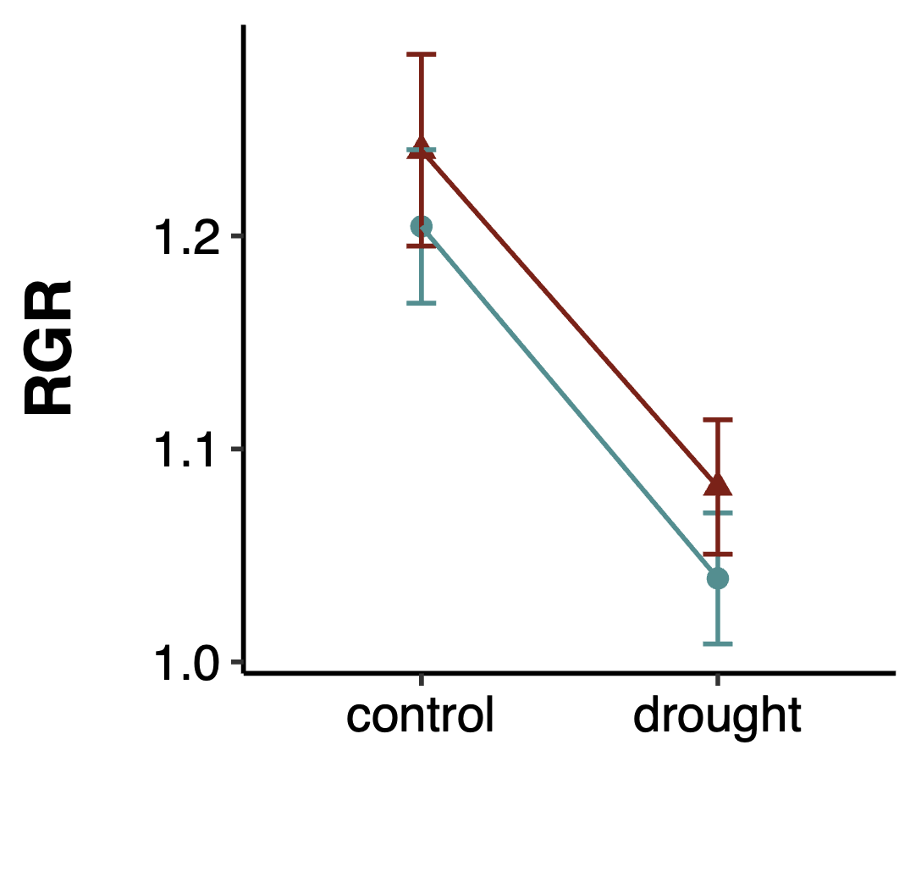
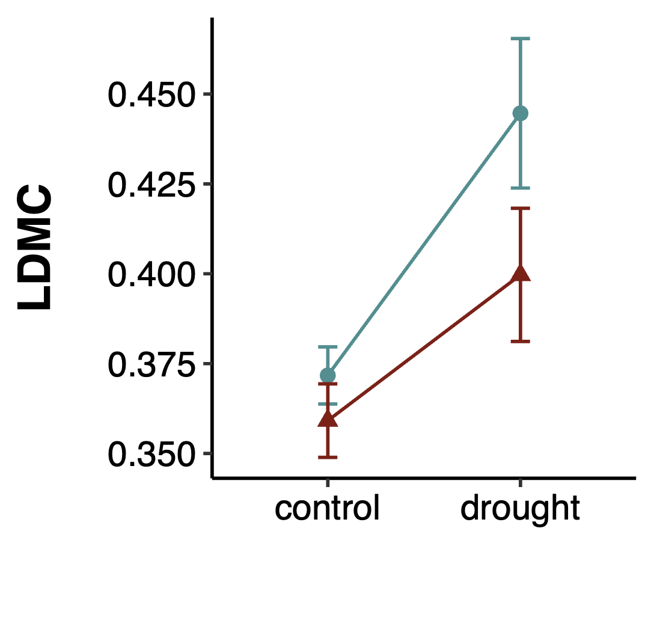
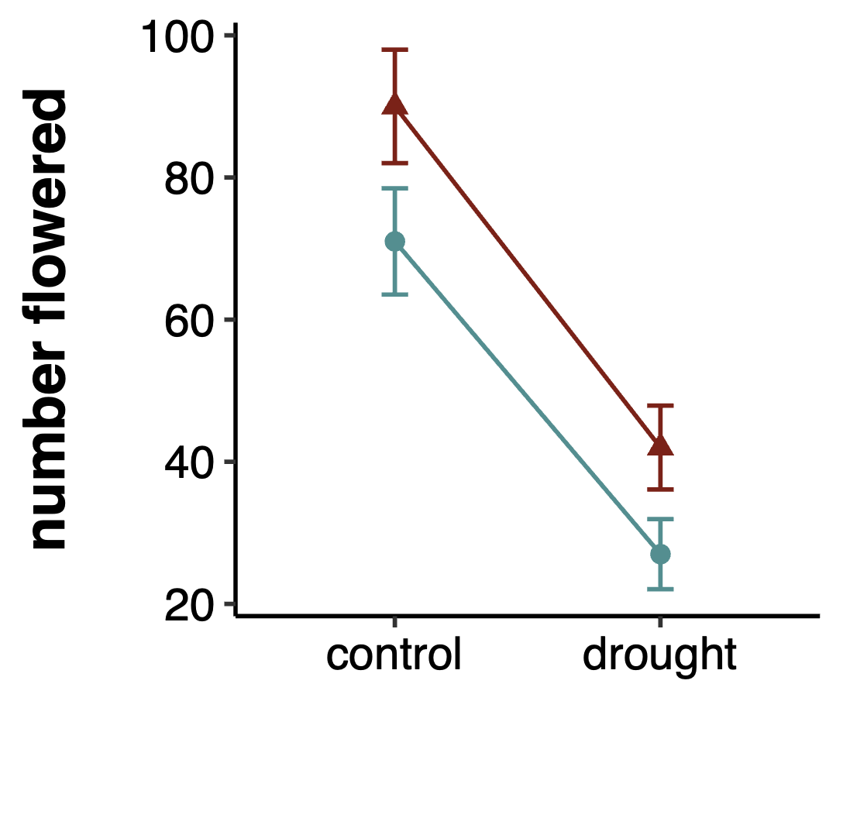
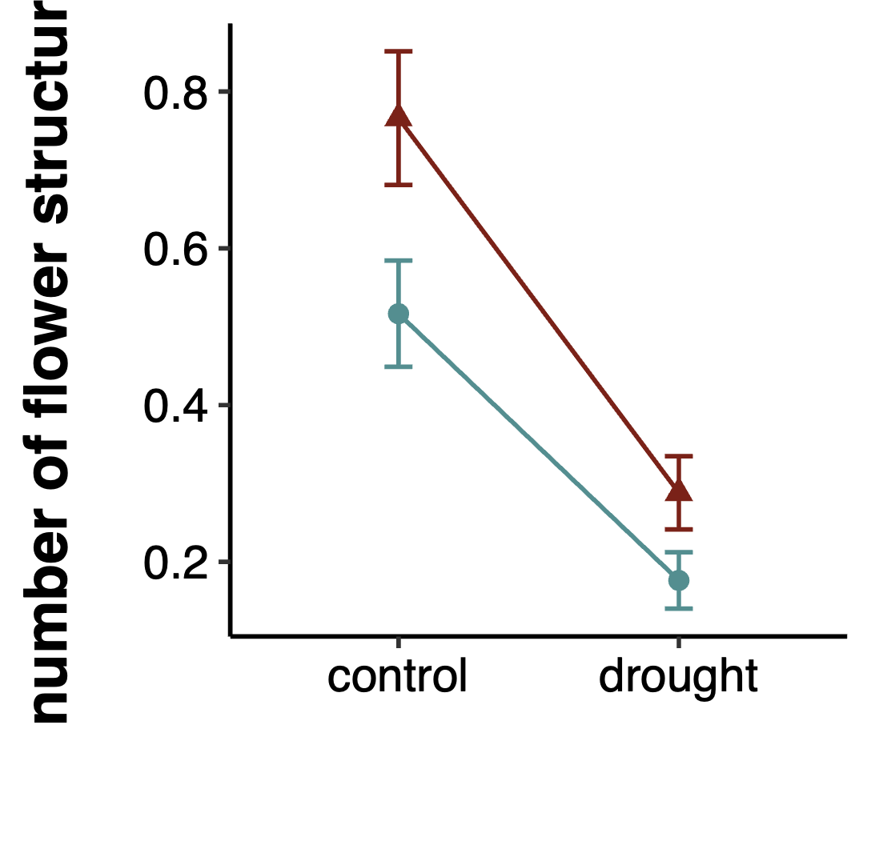
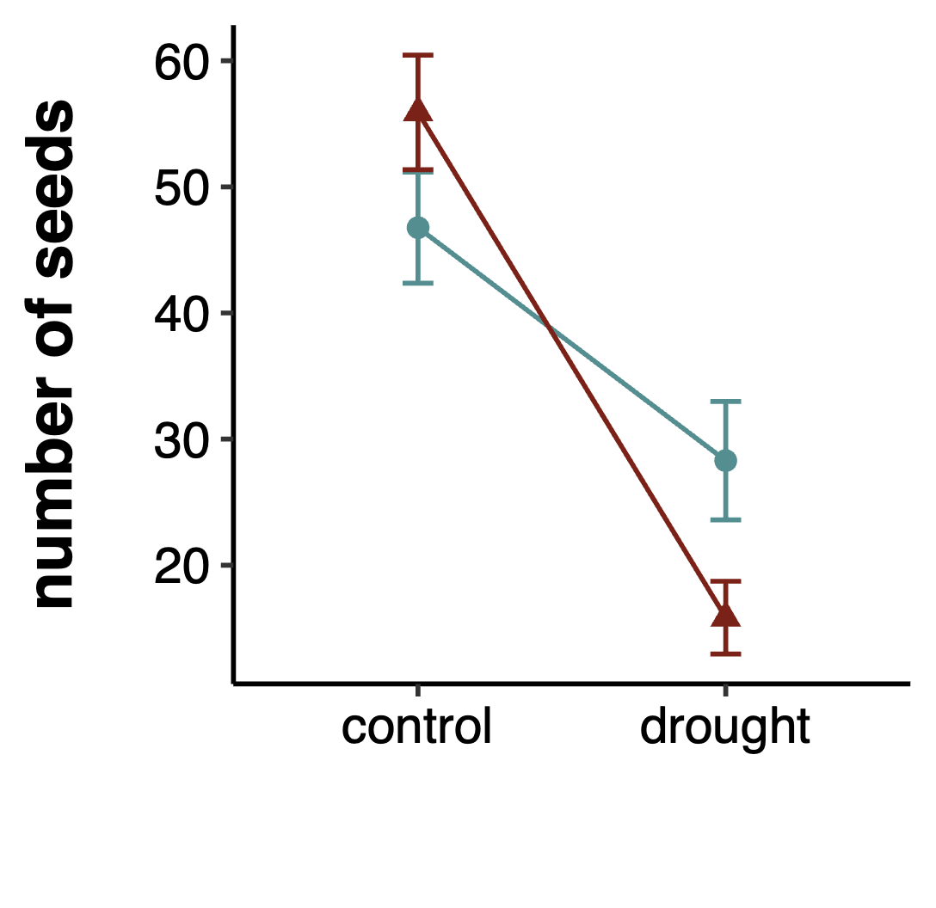
a)
b)
c)
d)
e)
f)
g)
h)
i)
OT: ***
PT: ns
OT x PT: ns
OT: ***
PT: ns
OT x PT: ns
OT: ***
PT: ns
OT x PT: ns
OT: ***
PT: ns
OT x PT: ns
OT: ***
PT: ns
OT x PT: ns
OT: **
PT: ns
OT x PT: ns
OT: **
PT: **
OT x PT: ns
OT: ***
PT: ns
OT x PT: ns
OT: *
PT: ns
OT x PT: **
parental treatment
control
drought
offspring treatment
offspring treatment
offspring treatment

Figure 4. Effects of transgenerational plasticity across all eleven populations of P. patagonica on number of seeds produced. Letters mark significant differences between each treatment cohort (DD = F1 dry / F2 dry, DC = F1 dry / F2 control, CD = F1 control / F2 dry, and CC = F1 control / F2 control). Error bars represent SE.

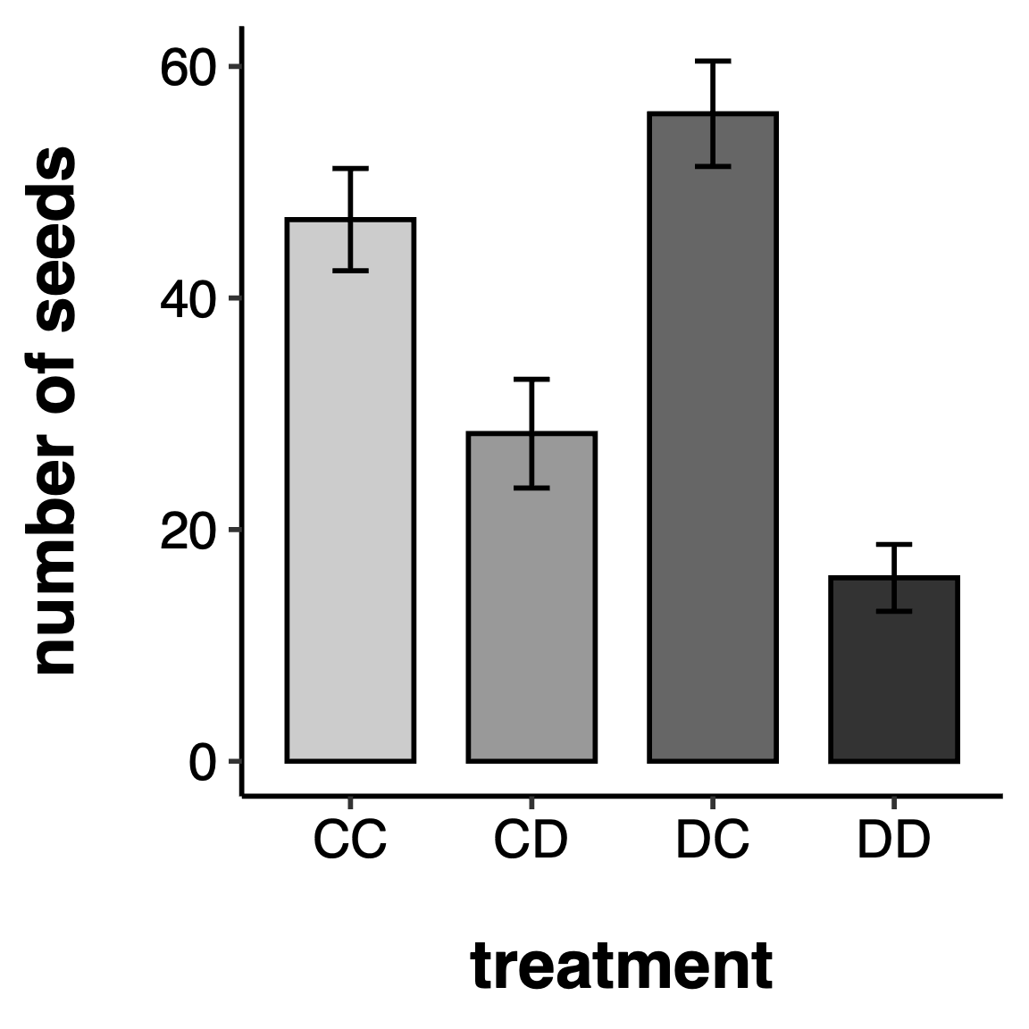
a
a
b
c

Table 2. Results of mixed models testing the effects of offspring watering treatment (OT), parental watering treatment (PT), and seed source climate at origin value: the 30-year mean annual spring VPDmax (kPa) coefficient of variation for each seed source location, and their interactions. P values = 0.05 < #P < 0.1; *P < 0.05; **P < 0.01; ***P < 0.001. F-statistic (linear models) or Chi-squared statistic (generalized linear models), signiﬁcance levels and degrees of freedom (d.f.) are shown for each term. Zero inflated models were used for number flowered, and number of flowering structures produced per plant. Population was included as a random factor. R2m = marginal R2; R2c = conditional R2.

*The conditional R2 could not be calculated because the random effect variance for (1|pop) was effectively zero, suggesting minimal variation in population-level differences. The random effect was retained in the model due to its conceptual importance.

Trait | OT | PT | sVPD-CV | OT x PT | OT x sVPD-CV | PT x sVPD-CV | OT x PT x sVPD-CV | R²m | R²c
Growth
root biomass | F = 42.1948*** | F = 3.1251 # | F = 2.0861 | F = 1.0453 | F = 6.6818** | F = 6.4877* | F = 6.9657** | 0.141 | 0.175
shoot biomass | F = 184.3293*** | F = 0.8007 | F = 8.7548** | F = 0.3128 | F = 4.0071* | F = 3.8151 # | F = 0.909 | 0.345 | 0.433
total biomass | F = 92.9724*** | F = 3.3317 # | F = 0.0065 | F = 1.0925 | F = 2.3834 | F = 2.2751 | F = 3.6949 # | 0.234 | 0.293
max height | F = 1.9401 | F = 0.0358 | F = 0.5302 | F = 1.0994 | F = 0.0117 | F = 5.6204* | F = 0.3554 | 0.009 | 0.147
Resource Allocation
R:S ratio | F = 38.6267*** | F = 2.6923 | F = 8.6016** | F = 0.8986 | F = 6.3966* | F = 2.5964 | F = 3.4765 # | 0.101 | 0.147
RGR | F = 12.7805*** | F = 0.0007 | F = 0.0786 | F = 0.3424 | F = 0.7966 | F = 0.5182 | F = 5.8834* | 0.025 | 0.069
SLA | F = 1.8832 | F = 0.4492 | F = 0.111 | F = 0.1753 | F = 0.2841 | F = 2.0341 | F = 0.1777 | 0.016 | 0.084
LDMC | F = 8.1292** | F = 1.2131 | F = 0.0856 | F = 0.5561 | F = 0.0461 | F = 0.0098 | F = 0.2471 | 0.031 | 0.071
Survival
mortality | X2 = 1.5818 | X2 = 1.9809 | X2 = 0.5622 | X2 = 0.3407 | X2 = 0.1891 | X2 = 3.7915 # | X2 = 0.2526 | 0.026 | 0.053
Reproduction
days to flowering | X2 = 2.4899 | X2 = 1.1826 | X2 = 0.4963 | X2 = 0.2623 | X2 = 0.8655 | X2 = 0.0651 | X2 = 0.864 | 0.058 | 0.120
number flowered
conditional model | X2 = 7.2036** | X2 = 10.0314** | X2 = 0.7833 | X2 = 0.3388 | X2 = 0.3699 | X2 = 9.7222** | X2 = 2.9813 # | 0.263 | 0.596
zero-inflation model | X2 = 0.0247 | X2 = 0.575 | X2 = 16.8902***
number of flowering structures
conditional model | X2 = 0.8824 | X2 = 3.3255 # | X2 = 6.1195* | X2 = 2.0336 | X2 = 1.1482 | X2 = 2.8731 # | X2 = 1.2142 | 0.305 | 0.000*
zero-inflation model | X2 = 23.078*** | X2 = 10.632** | X2 = 15.949***
seed number | X2 = 3.8636* | X2 = 1.879 | X2 = 0.0613 | X2 = 5.2154* | X2 = 0.0259 | X2 = 0.2191 | X2 = 0.6711 | 0.270 | 0.270
df | 1 | 1 | 1 | 1 | 1 | 1 | 1

Figure 5. Effects of spring VPD-CV of seed source origin and plasticity treatment on a) root biomass and b) RGR, traits where the response of the offspring to OT and PT was modulated by seed source spring VPD-CV (OT x PT x sVPD-CV = significant). Grey areas represent SE.
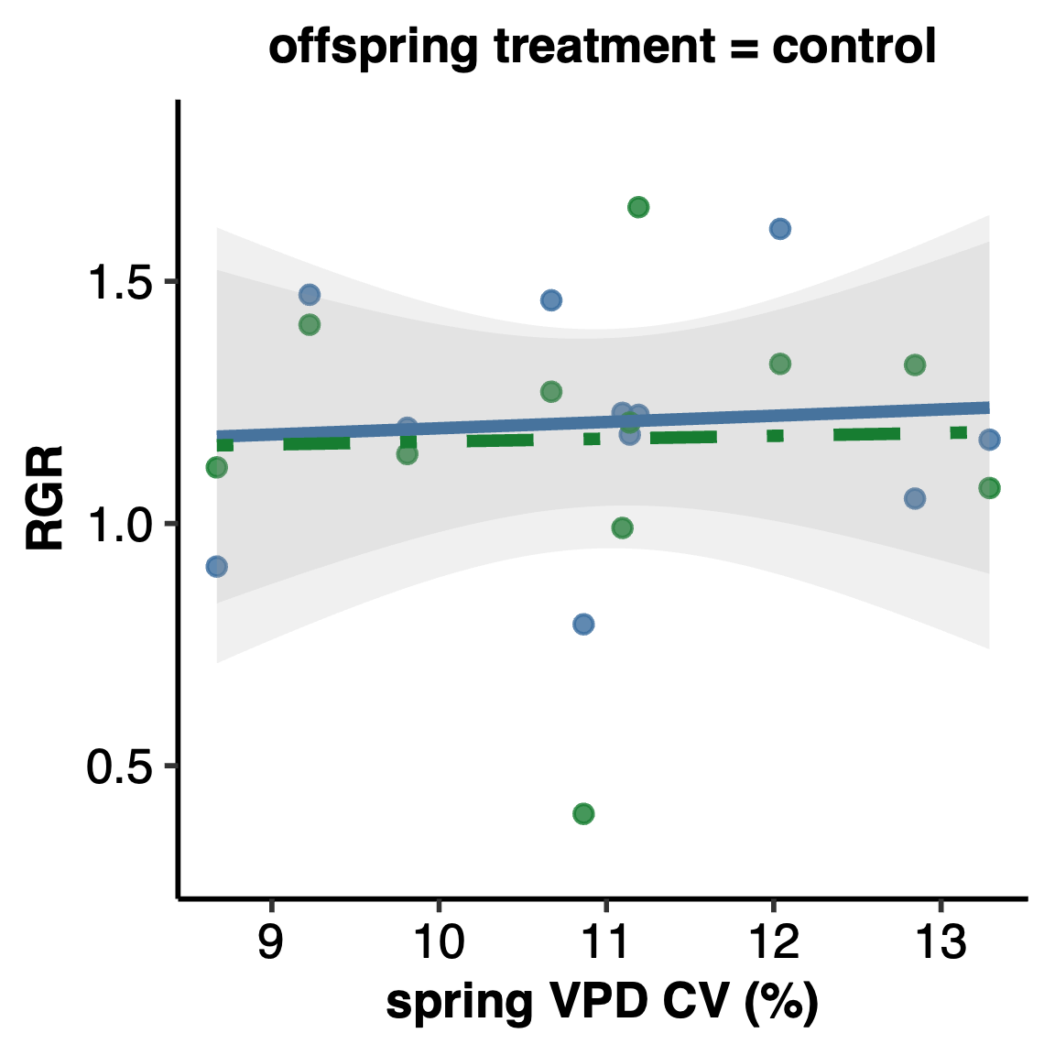
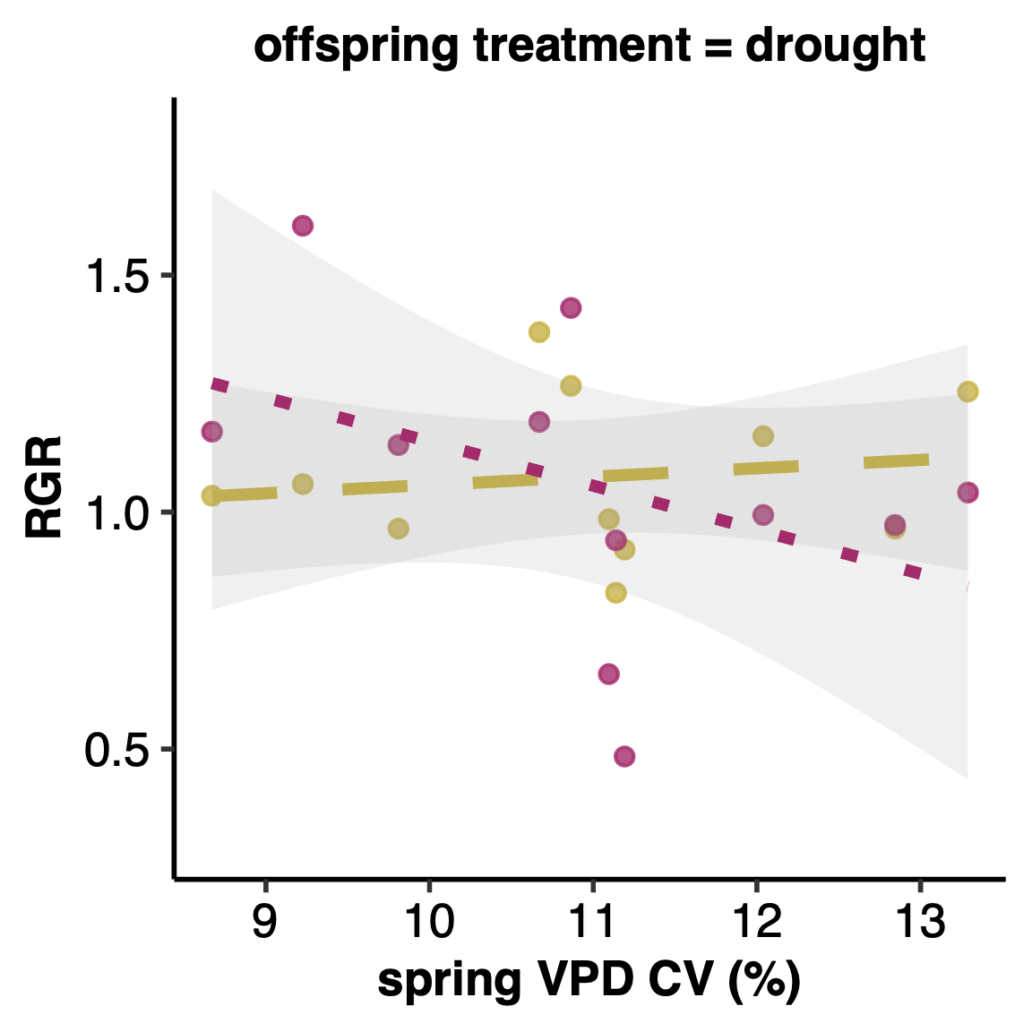
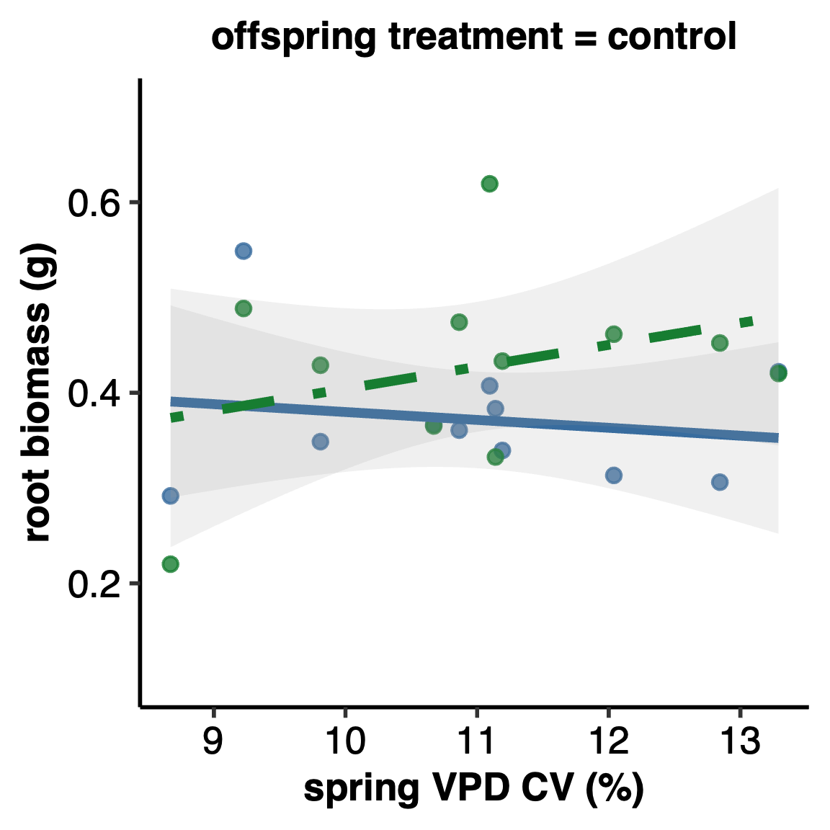
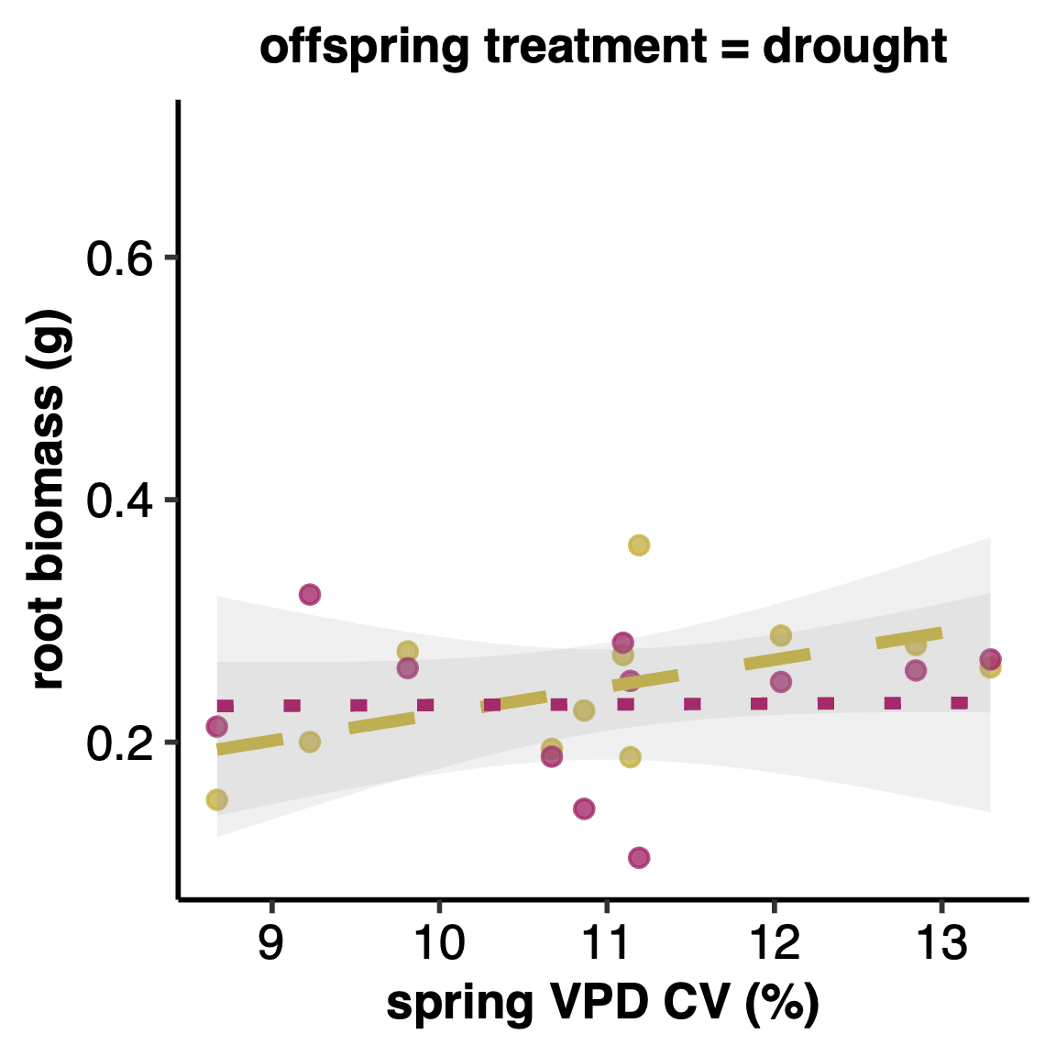
a)
b)
CC

DC

CD

DD

Table 3. Results of linear regressions testing for relationships between fitness traits and transgenerational RDPI (CC-DD) of a) performance traits and b) seed source site spring VPD-CV. Shown are the R²-values. P values = #P < 0.1< 0.1; *P < 0.05; **P < 0.01; ***P < 0.001. Signiﬁcant terms are shown in bold; terms in italics are marginally signiﬁcant.

 | a) seed number | mortality rate | flowering rate | b) sVPD-CV
RGR | -0.0604 | -0.129** | 0.007 | -0.034
root biomass | 0.105 | -0.051 | 0.336*** | -0.292***

Figure 6. Relationship between RGR plasticity (RDPI of CC-DD) and a) proportion alive, b) proportion flowered, and c) spring VPD-CV for eleven populations of P. patagonica. Proportion alive was measured on day 50. Grey areas indicate 95% confidence intervals.
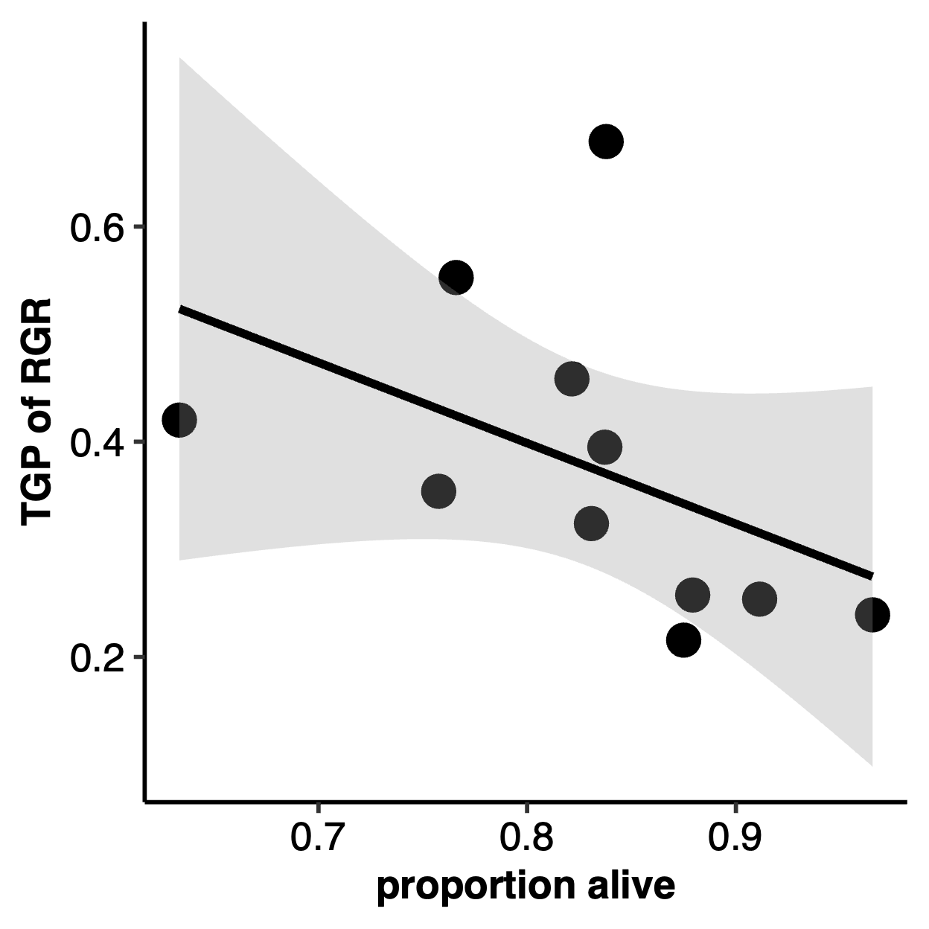
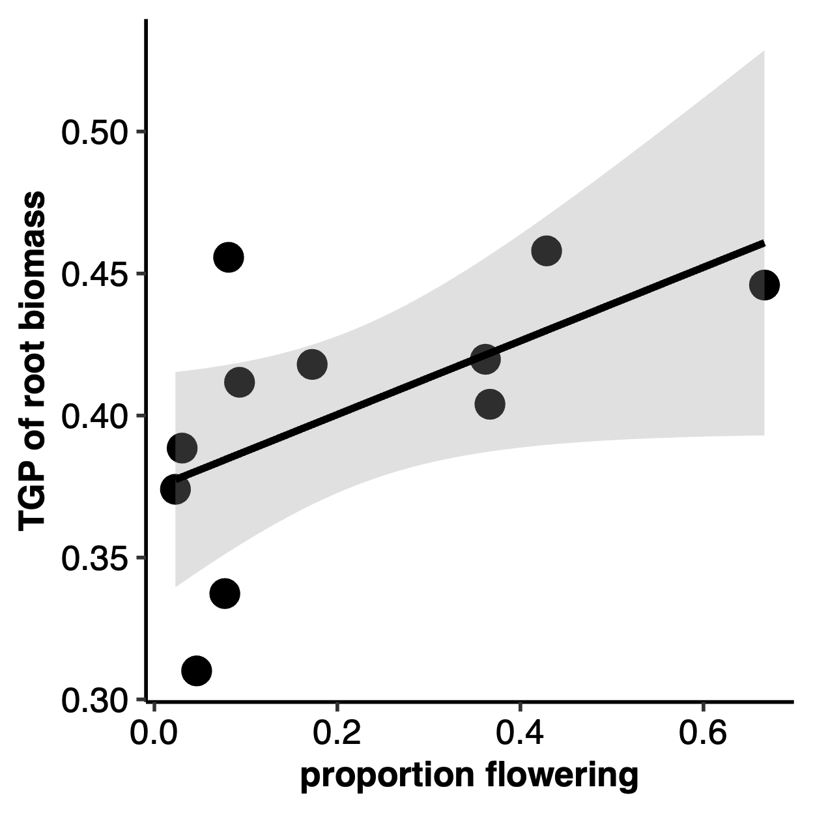
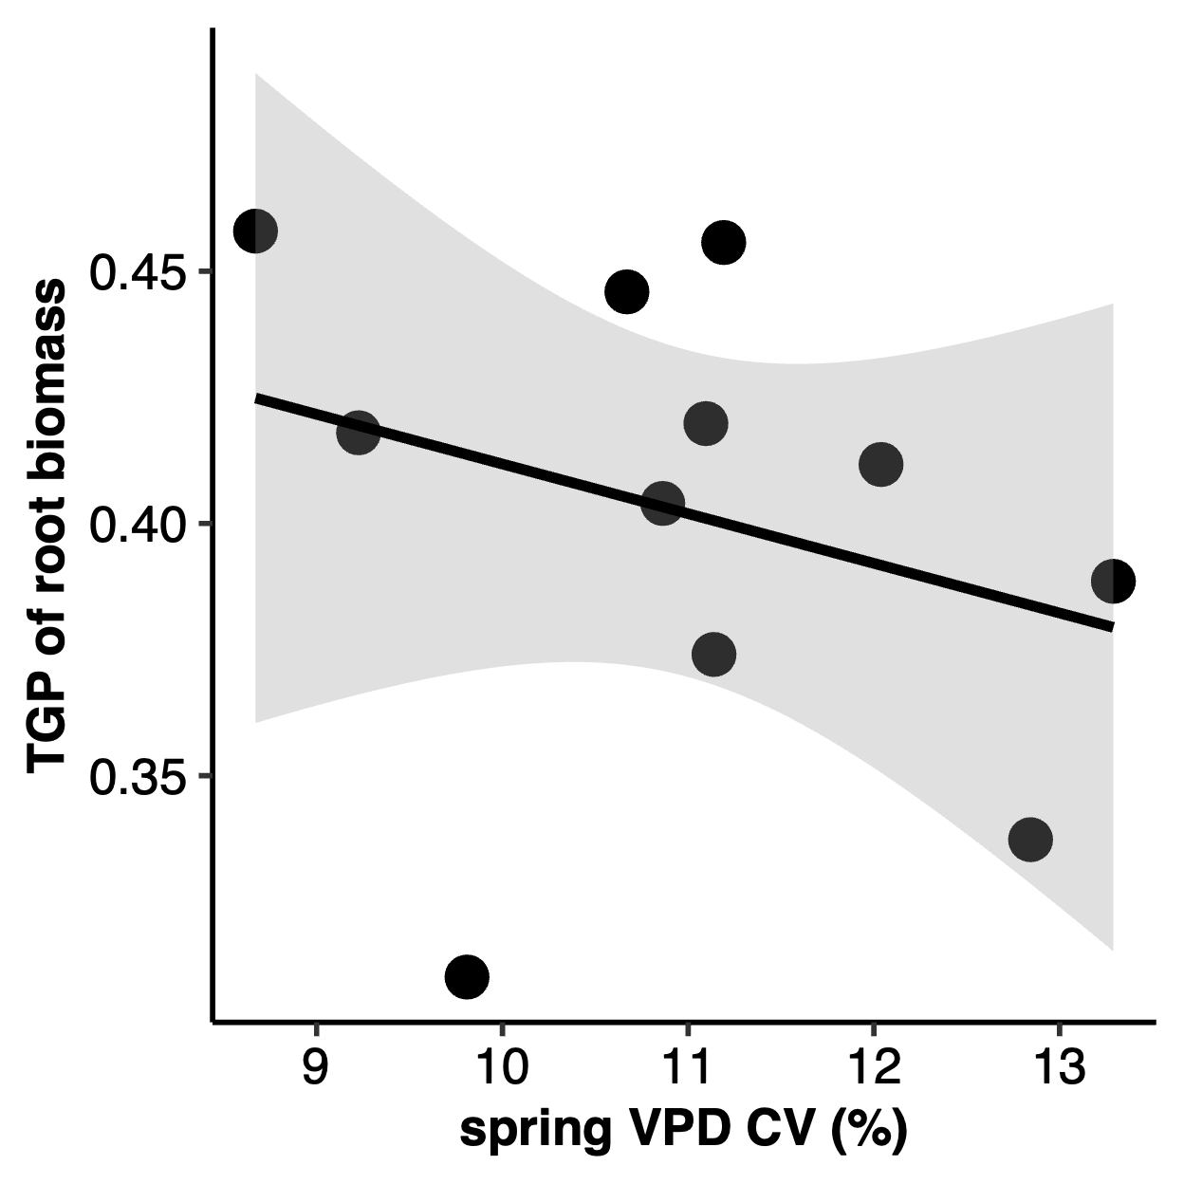
a)
R = -0.129, P = 0.0021
b)
R = 0.336, P = 2.2E-16
c)
R = -0.292, P = 2.2E-16

DISCUSSION
As climate change rapidly progresses, elevated aridity is an increasingly common phenomenon and can have profound consequence for the stability of plant populations and communities. Transgenerational plasticity may be one mechanism by which species can withstand rapidly changing environments (Herman & Sultan, 2011) and could be leveraged for restoration and revegetation in the face of this environmental change. Here, we used 11 populations of Plantago patagonica sourced across a gradient of spring VPD variability and exposed them to a fully factorial, multi-generation water limitation experiment to ask: 1) Is there evidence of TGP in response to water limitation in P. patagonica? 2) Does collection site climate variability predict the magnitude of the TGP response to water limitation? and 3) Is TGP response to water limitation adaptive?
We found evidence of TGP in P. patagonica that suggests water limitation over multiple generations has significant negative effects on the reproductive output regardless of seed source climate (Figure 5). Most of the trait plasticity in P. patagonica occurred in response to offspring water limitations (WGP, Figure 3). Additionally, we found that seed source site variability modulates transgenerational responses in traits related to growth and resource allocation (Figure 4), but not in reproductive traits (Table 2). Below, we discuss each of these results, the mechanisms that may have given rise to these patterns, and their implications.
Maladaptive transgenerational plasticity in P. patagonica
Seed number, a direct measure of reproductive success, is one of the best surrogates of lifetime fitness in annual plants (Primack & Kang, 1989). When plants were exposed to water limitations in the offspring generation, plants that also experienced water limitation in the parental generation (DD) produced fewer seeds than offspring of well-watered plants (CD) (Figure 5; Table 2). This finding suggests that TGP is not an adaptive strategy when exposed to consecutive generations of water limitation—in fact, this suggests that consecutive generations of water limitation may induce maladaptive TGP in P. patagonica, regardless of the seed source climate pattern (Kuijper & Hoyle, 2015). In addition to this reduction in seed number, our results also suggest that water limitation in both the parental and offspring generations increase the likelihood of producing zero flowering structures, increasing the odds of failure to flower. Consecutive generations of water limitation may limit the fitness of offspring, decreasing their ability to compete and persist, indicating that we may see future population declines in P. patagonica in areas that are increasingly experiencing spring droughts more frequently.
These results align with findings in other species showing reduced seed production under consecutive drought stresses, including in Amaranthus albus, a non-native annual species (Fenesi et al., 2014). However, contrasting responses have also been documented: Secale sylvestre showed increased seed production (Mojzes et al., 2021), while Helianthemum squamatum and Centaurea hyssopifolia exhibited no change in seed production (Ramos-Muñoz et al., 2024). Such variability highlights that the fitness consequences of multigenerational water limitation are likely species-specific, shaped by distinct life histories, ecological strategies, or physiological thresholds and may be difficult to predict.
Overall, we found low levels of TGP expression across all populations in P. patagonica. This contrasts with many other TGP studies that found matching parent-offspring environments produced adaptive transgenerational effects. For example, consecutive drought increased total biomass and root systems of Polygonum persicaria (Sultan et al., 2009); increased root carbohydrate storage in Plantago lanceolata (Latzel et al., 2014); and increased shoot biomass and seed production in Secale sylvestre (Mojzes et al., 2021)). There are several possible explanations for the absence of adaptive TGP in P. patagonica. Transgenerational cues are passed down epigenetically (Fitz-James & Cavalli, 2022), via mRNA, proteins, and hormones (Donohue, 2009; Jha et al., 2010; Rajjou et al., 2004), or through nutritive preparations of offspring (reviewed in (Herman & Sultan, 2011). These complex, multi-layered mechanisms may have only evolved in some species, or even in response to specific environmental stressors. For example, no evidence of TGP was found in Silene vulgaris under three separate types of stress (Sandner et al., 2018), while adaptive TGP has only been found in one of two closely related Polygonum species (Sultan et al., 2009). Our results indicate that adaptive transgenerational plasticity may not be universal or easily leveraged phenomenon, and should not necessarily be relied on to aid restoration and revegetation in the face of this environmental change (Sánchez-Tójar et al., 2020b; Uller et al., 2013).
One possible explanation for the lack of transgenerational response in P. patagonica is that fact that the species produces a seed bank, which strategy which typically buffers populations against environmental variability (Haight et al., 2019; Venable, 2007). Influencing offspring phenotypes through adaptive TGP is one strategy an annual plant can use to increase fitness (Mousseau & Fox, 1998), and usually occurs when parental and offspring environments are well correlated (Burgess & Marshall, 2014; Leimar & McNamara, 2015). When environmental conditions are unpredictable, however, annual plants may instead favor diversified het hedging, increasing the probability that at least some offspring phenotypes will match environmental conditions in a given year (J. Marshall & Uller, 2007; Philippi & Seger, 1989; Simons, 2011; Slatkin, 1974). In arid environments, where water availability is highly variable within and across seasons, bet hedging via seed banking or delayed germination is a common strategy, especially in desert annuals (Golodets et al., 2013; Gremer & Venable, 2014; Venable & Brown, 1988). By spreading germination over time, seed banks reduce the risk of population failure during climatically unfavorable years (Baskin & Baskin, 2000; Philippi, 1993). As a seed-banking species adapted to arid, unpredictable environments, P. patagonica likely invests in long-term persistence strategies that spread risk across time. In such systems, TGP mechanism may be disfavored if environmental conditions are not reliably correlated across generations. In future studies, P. patagonica may serve as a good candidate to further untangle the synergistic, antagonistic, or null effects of TGP on bet hedging strategies.
Within generation plasticity in P. patagonica
Despite limited evidence of TGP, we observed a far greater degree of WGP in P. patagonica (Table 1, Figure 3). This strong WGP response aligns with findings from other studies that imposed water limitations on annual plants across generations (Germain et al., 2013; Kalandyk et al., 2017; Sultan et al., 2009). P. patagonica plants exposed to water limitation in the offspring generation were smaller in root, shoot, and total biomass, devoted more resources to roots than shoots, had slower relative growth rates, and higher LDMC, reflecting a more resource-conservative strategy when faced with limited water availability. This suggests that P. patagonica is highly sensitive to water availability and capable of rapidly adjusting its phenotype to mitigate impacts of drought within a single generation.
Importantly, this capacity for WGP may represent a critical short-term buffer against the increasing frequency and severity of droughts expected under climate change in the American West. However, such phenotypic plasticity appears to come at a cost to overall growth, potentially limiting long-term population viability via reduced competition if stressful conditions persist. Our findings reinforce those of Christie et al. (2023), who found that P. patagonica populations from the Colorado Plateau, after 10 years of intense regional drought, has shifted resource allocation patterns, investing less in reproductive tissues and more in vegetative growth. Together, these results highlight that while P. patagonica can exhibit flexible responses to environmental stress, the direction of this plasticity may approve to lead to longer-term maladaptation and reduced population growth rates.
Some transgenerational responses are context-dependent on seed source site VPD variability
Contrary to many TGP studies that report substantial genotype- or population-by-environmental interactions in inherited responses (Groot et al., 2017; Lampei et al., 2017; Li et al., 2017; Münzbergová & Hadincová, 2017), we observed only two traits related to growth and resource allocation that changed based on seed source site spring VPD variability (Table 3, Figure 4). Plants from more climatically variable sites (higher sVPD-CV) produced greater root biomass when exposed to mismatched watering conditions across generations (Figure 4A, right panel, DC vs. CC). This suggests that plants from unpredictable environments may rely more on flexible biomass allocation, favoring water-acquiring tissues, as a strategy to cope with intergenerational environmental uncertainty.
Interestingly, plants that experienced two generations of water limitation (DD) showed decreasing relative growth rates with increasing seed source site VPD variability. Specifically, under water limitation, offspring of plants who experienced water limitation (DD) saw a significant decrease in their relative growth rate over the sVPD-CV gradient, where plants from less variable climates grew at a faster rate, and plants from more variable climates grew at a slower speed. Contrastingly, offspring of plants who did not experience water limitation but were grown under water limitation (CD) did not see a change in RGR over an sVPD-CV gradient. In other words, when offspring were exposed to water-limitation and came from water-limited parents, plants from less variable climates grew faster, while those from more variable climates grew slower (Figure 4B). These results aligns with theoretical and empirical work suggesting the adaptive value of TGP depends on the environmental predictability across generations (Badyaev & Uller, 2009; Colicchio & Herman, 2020; Leimar & McNamara, 2015). In relatively predictable climates (lower sVPD-CV), parental water limitation may prime plant offspring for similar stress in the offspring generation, resulting in higher relative growth rates in offspring plants under the same stressor. In more variable environments, where spring VPD conditions vary more unpredictably across years, transgenerational signals are more likely unreliable, resulting in a reliance on WGP and shifts towards more resource-conservative growth strategies under water limitation.
These results have important implications for understanding plants responses to increasing climate variability. P. patagonica individuals from more variable seed source sites appear to adopt a resource-conservative strategy under prolonged water limitation, limiting water loss at the expense of carbon gain and growth (Angert et al., 2007). In contrast, plants from more stable environments maintain faster growth under water limitation, likely employing a drought escape strategy, where rapid development enables reproduction before conditions deteriorate (Volaire, 2018). As climate change drives greater interannual variability in moisture availability, such divergent strategies may determine which annual plant populations persist and which are at risk of decline.
Relating performance plasticity, fitness, and seed source site VPD variability
P. patagonica populations with greater TGP in root biomass allocation were more likely to reach reproductive maturity, suggesting that populations able to adjust their allocation towards water-acquiring tissues across generations may maintain or enhance reproductive potential under persistent water limitation across generations (Figure 6B). However, this TGP capacity appears to be shaped by a population’s seed source site climate history. Specifically, we found a significant negative correlation between TGP in root biomass and seed source site sVPD-CV, suggesting that interannual predictability in atmospheric drought conditions at seed source locations may be an important factor influencing the evolution or maintenance of TGP in populations (Figure 6C). Populations from sites with higher sVPD-CV exhibited reduced TGP in their root biomass allocation, consistent with theoretical predictions that TGP is most common in environments where parental conditions are predictive of offspring environments (Colicchio & Herman, 2020; Kuijper & Hoyle, 2015; Badyaev & Uller, 2009; Leimar & McNamara, 2015).

CONCLUSIONS
Taken together, our results indicate that TGP is not a broadly used strategy across populations of P. patagonica. While we observed significant WGP in response to drought, transgenerational effects were weak and, in the case of seed production, maladaptive, suggesting that consecutive exposure to water limitation may reduce rather than enhance offspring fitness. These findings contrast with other species where TGP confers adaptive benefits, highlighting the species-specific nature of these responses and the challenges associated with predicting or leveraging TGP under climate change. In P. patagonica, adaptation to arid, unpredictab le climates may favor immediate plasticity and bet-hedging strategies over inherited environmental cues.

ACKNOWLEDGEMENTS
We thank Zoe Klein for the Plantago patagonica seeds used in the F2 greenhouse experiment.

AUTHOR CONTRIBUTIONS
MW and RMM conceived the concept for the research. RMM acquired funding. MW designed and performed the F2 greenhouse experiment using seeds grown, collected, and cleaned by Zoe Klein. MW collected and analyzed the data. MW wrote the original draft with substantial input from RMM. All authors contributed critically to the drafts and gave final approval for the publication.

DATA AVAILABILITY STATEMENT
Data can be accessed at:

Code can be accessed at:

LITERATURE CITED
Angert, A. L., Huxman, T. E., Barron-Gafford, G. A., Gerst, K. L., & Venable, D. L. (2007). Linking growth strategies to long-term population dynamics in a guild of desert annuals. Journal of Ecology, 95(2), 321–331. https://doi.org/10.1111/j.1365-2745.2006.01203.x
Badyaev, A. V., & Uller, T. (2009). Parental effects in ecology and evolution: Mechanisms, processes and implications. Philosophical Transactions of the Royal Society B: Biological Sciences, 364(1520), 1169–1177. https://doi.org/10.1098/rstb.2008.0302
Barak, R. S., Fant, J. B., Kramer, A. T., & Skogen, K. A. (2015). Assessing the Value of Potential “Native Winners” for Restoration of Cheatgrass-Invaded Habitat. Western North American Naturalist, 75(1), 58–69. https://doi.org/10.3398/064.075.0107
Bartlett, M. K., Scoffoni, C., & Sack, L. (2012). The determinants of leaf turgor loss point and prediction of drought tolerance of species and biomes: A global meta-analysis. Ecology Letters, 15(5), 393–405. https://doi.org/10.1111/j.1461-0248.2012.01751.x
Baskin, C. C., & Baskin, J. M. (2000). Seeds: Ecology, Biogeography, and, Evolution of Dormancy and Germination. Academic Press.
Bell, A. M., & Hellmann, J. K. (2019). An Integrative Framework for Understanding the Mechanisms and Multigenerational Consequences of Transgenerational Plasticity. Annual Review of Ecology, Evolution, and Systematics, 50(Volume 50, 2019), 97–118. https://doi.org/10.1146/annurev-ecolsys-110218-024613
Bonduriansky, R. (2021). Plasticity Across Generations. In Phenotypic Plasticity & Evolution. CRC Press. https://doi.org/10.1201/9780429343001
Burgess, S. C., & Marshall, D. J. (2014). Adaptive parental effects: The importance of estimating environmental predictability and offspring fitness appropriately. Oikos, 123(7), 769–776. https://doi.org/10.1111/oik.01235
Colicchio, J. M., & Herman, J. (2020). Empirical patterns of environmental variation favor adaptive transgenerational plasticity. Ecology and Evolution, 10(3), 1648–1665. https://doi.org/10.1002/ece3.6022
Cornwell, W. K., & Ackerly, D. D. (2009). Community assembly and shifts in plant trait distributions across an environmental gradient in coastal California. Ecological Monographs, 79(1), 109–126. https://doi.org/10.1890/07-1134.1
Crawley, M. J. (2009). Plant Ecology. John Wiley & Sons.
Dai, A. (2011). Drought under global warming: A review. WIREs Climate Change, 2(1), 45–65. https://doi.org/10.1002/wcc.81
Donelson, J. M., Salinas, S., Munday, P. L., & Shama, L. N. S. (2018). Transgenerational plasticity and climate change experiments: Where do we go from here? Global Change Biology, 24(1), 13–34. https://doi.org/10.1111/gcb.13903
Donohue, K. (2009). Completing the cycle: Maternal effects as the missing link in plant life histories. Philosophical Transactions of the Royal Society B: Biological Sciences, 364(1520), 1059–1074. https://doi.org/10.1098/rstb.2008.0291
Engqvist, L., & Reinhold, K. (2016). Adaptive trans-generational phenotypic plasticity and the lack of an experimental control in reciprocal match/mismatch experiments. Methods in Ecology and Evolution, 7(12), 1482–1488. https://doi.org/10.1111/2041-210X.12618
Fenesi, A., Dyer, A. R., Geréd, J., Sándor, D., & Ruprecht, E. (2014). Can transgenerational plasticity contribute to the invasion success of annual plant species? Oecologia, 176(1), 95–106. https://doi.org/10.1007/s00442-014-2994-7
Fischer, B., Taborsky, B., & Kokko, H. (2011). How to balance the offspring quality–quantity tradeoff when environmental cues are unreliable. Oikos, 120(2), 258–270. https://doi.org/10.1111/j.1600-0706.2010.18642.x
Fitz-James, M. H., & Cavalli, G. (2022). Molecular mechanisms of transgenerational epigenetic inheritance. Nature Reviews Genetics, 23(6), 325–341. https://doi.org/10.1038/s41576-021-00438-5
Galloway, L. F. (2001). Parental Environmental Effects on Life History in the Herbaceous Plant Campanula Americana. Ecology, 82(10), 2781–2789. https://doi.org/10.1890/0012-9658(2001)082[2781:PEEOLH]2.0.CO;2
Germain, R. M., Caruso, C. M., & Maherali, H. (2013). Mechanisms and Consequences of Water Stress–Induced Parental Effects in an Invasive Annual Grass. International Journal of Plant Sciences, 174(6), 886–895. https://doi.org/10.1086/670691
Golodets, C., Sternberg, M., Kigel, J., Boeken, B., Henkin, Z., Seligman, N. G., & Ungar, E. D. (2013). From desert to Mediterranean rangelands: Will increasing drought and inter-annual rainfall variability affect herbaceous annual primary productivity? Climatic Change, 119(3), 785–798. https://doi.org/10.1007/s10584-013-0758-8
Gremer, J. R., & Venable, D. L. (2014). Bet hedging in desert winter annual plants: Optimal germination strategies in a variable environment. Ecology Letters, 17(3), 380–387. https://doi.org/10.1111/ele.12241
Groot, M. P., Kubisch, A., Ouborg, N. J., Pagel, J., Schmid, K. J., Vergeer, P., & Lampei, C. (2017). Transgenerational effects of mild heat in Arabidopsis thaliana show strong genotype specificity that is explained by climate at origin. New Phytologist, 215(3), 1221–1234. https://doi.org/10.1111/nph.14642
Haight, J. D., Reed, S. C., & Faist, A. M. (2019). Seed bank community and soil texture relationships in a cold desert. Journal of Arid Environments, 164, 46–52. https://doi.org/10.1016/j.jaridenv.2019.01.008
Herman, J., & Sultan, S. (2011). Adaptive Transgenerational Plasticity in Plants: Case Studies, Mechanisms, and Implications for Natural Populations. Frontiers in Plant Science, 2(102). https://doi.org/10.3389/fpls.2011.00102
Hoffmann, A. A., & Sgrò, C. M. (2011). Climate change and evolutionary adaptation. Nature, 470(7335), Article 7335. https://doi.org/10.1038/nature09670
Holeski, L. M. (2007). Within and between generation phenotypic plasticity in trichome density of Mimulus guttatus. Journal of Evolutionary Biology, 20(6), 2092–2100. https://doi.org/10.1111/j.1420-9101.2007.01434.x
Holeski, L. M., Jander, G., & Agrawal, A. A. (2012). Transgenerational defense induction and epigenetic inheritance in plants. Trends in Ecology & Evolution, 27(11), 618–626. https://doi.org/10.1016/j.tree.2012.07.011
Hoyle, R. B., & Ezard, T. H. G. (2012). The benefits of maternal effects in novel and in stable environments. Journal of The Royal Society Interface, 9(75), 2403–2413. https://doi.org/10.1098/rsif.2012.0183
J. Marshall, D., & Uller, T. (2007). When is a maternal effect adaptive? Oikos, 116(12), 1957–1963. https://doi.org/10.1111/j.2007.0030-1299.16203.x
Jha, P., Norsworthy, J. K., Riley, M. B., & Jr, W. B. (2010). Shade and Plant Location Effects on Germination and Hormone Content of Palmer Amaranth (Amaranthus palmeri) Seed. Weed Science, 58(1), 16–21. https://doi.org/10.1614/WS-09-059.1
Kalandyk, A., Waligórski, P., & Dubert, F. (2017). Role of the maternal effect phenomena in improving water stress tolerance in narrow-leafed lupine (upinus angustifolius). Plant Breeding, 136(2), 167–173. https://doi.org/10.1111/pbr.12457
Klein, Z., & Mitchell, R. M. (2023). Seed source environment predicts response to water availability in Plantago patagonica. Restoration Ecology, 1–11. https://doi.org/10.1111/rec.14002
Kuijper, B., & Hoyle, R. B. (2015). When to rely on maternal effects and when on phenotypic plasticity? Evolution; International Journal of Organic Evolution, 69(4), 950–968. https://doi.org/10.1111/evo.12635
Lampei, C., Metz, J., & Tielbörger, K. (2017). Clinal population divergence in an adaptive parental environmental effect that adjusts seed banking. New Phytologist, 214(3), 1230–1244. https://doi.org/10.1111/nph.14436
Latzel, V., Fischer, M., Groot, M., Gutzat, R., Lampei, C., Ouborg, J., Parepa, M., Schmid, K., Vergeer, P., Zhang, Y., & Bossdorf, O. (2023). Parental environmental effects are common and strong, but unpredictable, in Arabidopsis thaliana. New Phytologist, 237(3), 1014–1023. https://doi.org/10.1111/nph.18591
Latzel, V., Janeček, Š., Doležal, J., Klimešová, J., & Bossdorf, O. (2014). Adaptive transgenerational plasticity in the perennial Plantago lanceolata. Oikos, 123(1), 41–46. https://doi.org/10.1111/j.1600-0706.2013.00537.x
Leimar, O., & McNamara, J. M. (2015). The Evolution of Transgenerational Integration of Information in Heterogeneous Environments. The American Naturalist, 185(3), E55–E69. https://doi.org/10.1086/679575
Li, R., Chen, L., Wu, Y., Zhang, R., Baskin, C. C., Baskin, J. M., & Hu, X. (2017). Effects of Cultivar and Maternal Environment on Seed Quality in Vicia sativa. Frontiers in Plant Science, 8, 1411. https://doi.org/10.3389/fpls.2017.01411
Louthan, A. M., Doak, D. F., & Angert, A. L. (2015). Where and When do Species Interactions Set Range Limits? Trends in Ecology & Evolution, 30(12), 780–792. https://doi.org/10.1016/j.tree.2015.09.011
Matesanz, S., Ramos-Muñoz, M., Rubio Teso, M. L., & Iriondo, J. M. (2022). Effects of parental drought on offspring fitness vary among populations of a crop wild relative. Proceedings of the Royal Society B: Biological Sciences, 289(1981), 20220065. https://doi.org/10.1098/rspb.2022.0065
Mojzes, A., Kalapos, T., & Kröel‑Dulay, G. (2021). Drought in maternal environment boosts offspring performance in a subordinate annual grass. Environmental and Experimental Botany, 187, 104472. https://doi.org/10.1016/j.envexpbot.2021.104472
Mousseau, T. A., & Fox, C. W. (1998). Maternal Effects As Adaptations. Oxford University Press.
Münzbergová, Z., & Hadincová, V. (2017). Transgenerational plasticity as an important mechanism affecting response of clonal species to changing climate. Ecology and Evolution, 7(14), 5236–5247. https://doi.org/10.1002/ece3.3105
Nicotra, A. B., Atkin, O. K., Bonser, S. P., Davidson, A. M., Finnegan, E. J., Mathesius, U., Poot, P., Purugganan, M. D., Richards, C. L., Valladares, F., & van Kleunen, M. (2010). Plant phenotypic plasticity in a changing climate. Trends in Plant Science, 15(12), 684–692. https://doi.org/10.1016/j.tplants.2010.09.008
Philippi, T. (1993). Bet-Hedging Germination of Desert Annuals: Beyond the First Year. The American Naturalist, 142(3), 474–487. https://doi.org/10.1086/285550
Philippi, T., & Seger, J. (1989). Hedging one’s evolutionary bets, revisited. Trends in Ecology & Evolution, 4(2), 41–44. https://doi.org/10.1016/0169-5347(89)90138-9
Primack, R. B., & Kang, H. (1989). Measuring Fitness and Natural Selection in Wild Plant Populations. Annual Review of Ecology, Evolution, and Systematics, 20(Volume 20, 1989), 367–396. https://doi.org/10.1146/annurev.es.20.110189.002055
Rajjou, L., Gallardo, K., Debeaujon, I., Vandekerckhove, J., Job, C., & Job, D. (2004). The Effect of α-Amanitin on the Arabidopsis Seed Proteome Highlights the Distinct Roles of Stored and Neosynthesized mRNAs during Germination. Plant Physiology, 134(4), 1598–1613. https://doi.org/10.1104/pp.103.036293
Ramos-Muñoz, M., Blanco-Sánchez, M., Pías, B., Escudero, A., & Matesanz, S. (2024). Transgenerational plasticity to drought: Contrasting patterns of non-genetic inheritance in two semi-arid Mediterranean shrubs. Annals of Botany, 134(1), 101–116. https://doi.org/10.1093/aob/mcae039
Räsänen, K., & Kruuk, L. E. B. (2007). Maternal effects and evolution at ecological time-scales. Functional Ecology, 21(3), 408–421. https://doi.org/10.1111/j.1365-2435.2007.01246.x
Reed, T. E., Waples, R. S., Schindler, D. E., Hard, J. J., & Kinnison, M. T. (2010). Phenotypic plasticity and population viability: The importance of environmental predictability. Proceedings of the Royal Society B: Biological Sciences, 277(1699), 3391–3400. https://doi.org/10.1098/rspb.2010.0771
Riginos, C., Veblen, K. E., Thacker, E. T., Gunnell, K. L., & Monaco, T. A. (2023). Resilience and Resistance Framework Predicts Regional Vegetation Responses to Shrub Reduction Treatments in the Sagebrush Ecosystem. Rangeland Ecology & Management, 86, 35–43. https://doi.org/10.1016/j.rama.2022.10.008
Sánchez-Tójar, A., Lagisz, M., Moran, N. P., Nakagawa, S., Noble, D. W. A., & Reinhold, K. (2020a). The jury is still out regarding the generality of adaptive ‘transgenerational’ effects. Ecology Letters, 23(11), 1715–1718. https://doi.org/10.1111/ele.13479
Sánchez-Tójar, A., Lagisz, M., Moran, N. P., Nakagawa, S., Noble, D. W. A., & Reinhold, K. (2020b). The jury is still out regarding the generality of adaptive ‘transgenerational’ effects. Ecology Letters, 23(11), 1715–1718. https://doi.org/10.1111/ele.13479
Sandner, T. M., van Braak, J. L., & Matthies, D. (2018). Transgenerational plasticity in Silene vulgaris in response to three types of stress. Plant Biology, 20(4), 751–758. https://doi.org/10.1111/plb.12721
Sharma, N., Koul, P., & Koul, A. K. (1992). Reproductive Biology of Plantago: Shift from Cross- to Self-pollination. Annals of Botany, 69(1), 7–11. https://doi.org/10.1093/oxfordjournals.aob.a088309
Simons, A. M. (2011). Modes of response to environmental change and the elusive empirical evidence for bet hedging. Proceedings of the Royal Society B: Biological Sciences, 278(1712), 1601–1609. https://doi.org/10.1098/rspb.2011.0176
Slatkin, M. (1974). Hedging one’s evolutionary bets. Nature, 250(5469), 704–705. https://doi.org/10.1038/250704b0
Song, Y., Zajic, C. J., Hwang, T., Hakkenberg, C. R., & Zhu, K. (2021). Widespread Mismatch Between Phenology and Climate in Human‐Dominated Landscapes. AGU Advances, 2(4). https://doi.org/10.1029/2021AV000431
Spinoni, J., Barbosa, P., De Jager, A., McCormick, N., Naumann, G., Vogt, J. V., Magni, D., Masante, D., & Mazzeschi, M. (2019). A new global database of meteorological drought events from 1951 to 2016. Journal of Hydrology: Regional Studies, 22, 100593. https://doi.org/10.1016/j.ejrh.2019.100593
Sultan, S. E. (1987). Evolutionary Implications of Phenotypic Plasticity in Plants. In M. K. Hecht, B. Wallace, & G. T. Prance (Eds.), Evolutionary Biology (pp. 127–178). Springer US. https://doi.org/10.1007/978-1-4615-6986-2_7
Sultan, S. E., Barton, K., & Wilczek, A. M. (2009). Contrasting patterns of transgenerational plasticity in ecologically distinct congeners. Ecology, 90(7), 1831–1839. https://doi.org/10.1890/08-1064.1
Uller, T. (2008). Developmental plasticity and the evolution of parental effects. Trends in Ecology & Evolution, 23(8), 432–438. https://doi.org/10.1016/j.tree.2008.04.005
Uller, T., Nakagawa, S., & English, S. (2013). Weak evidence for anticipatory parental effects in plants and animals. Journal of Evolutionary Biology, 26(10), 2161–2170. https://doi.org/10.1111/jeb.12212
Valladares, F., Sanchez-Gomez, D., & Zavala, M. A. (2006). Quantitative Estimation of Phenotypic Plasticity: Bridging the Gap between the Evolutionary Concept and Its Ecological Applications. Journal of Ecology, 94(6), 1103–1116.
Venable, D. L. (2007). BET HEDGING IN A GUILD OF DESERT ANNUALS. Ecology, 88(5), 1086–1090. https://doi.org/10.1890/06-1495
Venable, D. L., & Brown, J. S. (1988). The Selective Interactions of Dispersal, Dormancy, and Seed Size as Adaptations for Reducing Risk in Variable Environments. The American Naturalist, 131(3), 360–384. https://doi.org/10.1086/284795
Volaire, F. (2018). A unified framework of plant adaptive strategies to drought: Crossing scales and disciplines. Global Change Biology, 24(7), 2929–2938. https://doi.org/10.1111/gcb.14062
Wadgymar, S. M., Mactavish, R. M., & Anderson, J. T. (2018). Transgenerational and Within-Generation Plasticity in Response to Climate Change: Insights from a Manipulative Field Experiment across an Elevational Gradient. The American Naturalist, 192(6), 698–714. https://doi.org/10.1086/700097
Westoby, M. (1998). A leaf-height-seed (LHS) plant ecology strategy scheme. Plant and Soil, 199(2), 213–227. https://doi.org/10.1023/A:1004327224729
Wood, T. E., Doherty, K., & Padgett, W. (2015). Development of Native Plant Materials for Restoration and Rehabilitation of Colorado Plateau Ecosystems. Natural Areas Journal, 35(1), 134–150. https://doi.org/10.3375/043.035.0117
Wright, I. J., Reich, P. B., Westoby, M., Ackerly, D. D., Baruch, Z., Bongers, F., Cavender-Bares, J., Chapin, T., Cornelissen, J. H. C., Diemer, M., Flexas, J., Garnier, E., Groom, P. K., Gulias, J., Hikosaka, K., Lamont, B. B., Lee, T., Lee, W., Lusk, C., … Villar, R. (2004). The worldwide leaf economics spectrum. Nature, 428(6985), 821–827. https://doi.org/10.1038/nature02403
Yin, J., Zhou, M., Lin, Z., Li, Q. Q., & Zhang, Y.-Y. (2019). Transgenerational effects benefit offspring across diverse environments: A meta-analysis in plants and animals. Ecology Letters, 22(11), 1976–1986. https://doi.org/10.1111/ele.13373

TO ADD IN AT END:
SEINet Portal Network. 2024. http//:swbiodiversity.org/seinet/index.php. Accessed on August 22, 2024.

Stuewe & Sons. 2024. Tangent, OR, USA. Accessed on August 22, 2024.
PRISM Climate Group, Oregon State University, https://prism.oregonstate.edu, data created on Feb 4, 2022.

R Core Team (2023). R: A Language and Environment for Statistical Computing. R Foundation for Statistical Computing, Vienna, Austria. https://www.R-project.org/. R version 4.3.1 (2023-06-16).

Douglas Bates, Martin Maechler, Ben Bolker, Steve Walker (2015). Fitting Linear Mixed-Effects Models Using lme4. Journal of Statistical Software, 67(1), 1-48. doi:10.18637/jss.v067.i01.

Bartoń K (2023). MuMIn: Multi-Model Inference. R package version 1.47.5, <https://CRAN.R-project.org/package=MuMIn>.

Ameztegui, A (2017) Plasticity: An R package to determine several plasticity indices. GitHub repository, https://github.com/ameztegui/Plasticity

Mollie E. Brooks, Kasper Kristensen, Koen J. van Benthem, Arni Magnusson, Casper W. Berg, Anders Nielsen, Hans J. Skaug, Martin Maechler and Benjamin M. Bolker (2017). glmmTMB Balances Speed and Flexibility Among Packages for Zero-inflated Generalized Linear Mixed Modeling. The R Journal, 9(2), 378-400. doi: 10.32614/RJ-2017-066.

Lenth R (2024). _emmeans: Estimated Marginal Means, aka Least-Squares Means_. R package version 1.10.5, <https://CRAN.R-project.org/package=emmeans>.

Koller, D. (1972). “Environmental control of seed germination,” in Seed Biology, ed. T. T. Kozlowski (New York: Academic Press), 2–102.

TABLES
Table 1. Results of mixed models testing the effects of offspring watering treatment (OT), parental watering treatment (PT), and their interactions on traits in Plantago patagonica. P values = 0.05 < #P < 0.1; *P < 0.05; **P < 0.01; ***P < 0.001. Signiﬁcant terms are shown in bold; terms in italics are marginally signiﬁcant. F-statistic (linear models) or Chi-squared statistic (generalized linear models), signiﬁcance levels and degrees of freedom (d.f.) are shown for each term. Zero inflated models were used for number flowered, and number of flowering structures produced per plant. Population was included as a random factor. R2m = marginal R2; R2c = conditional R2.

 | OT | PT | OT x PT | R²m | R²c
GROWTH
root biomass | F = 44.1209*** | F = 2.6995 | F = 0.9111 | 0.130 | 0.163
shoot biomass | F = 178.3746*** | F = 1.2064 | F = 0.5113 | 0.317 | 0.421
total biomass | F = 94.5629*** | F = 3.2213 # | F = 1.0857 | 0.225 | 0.287
max height | F = 2.1731 | F = 0.0069 | F = 1.1009 | 0.002 | 0.128
RESOURCE ALLOCATION
R:S ratio | F = 36.5018*** | F = 2.1155 | F = 0.6739 | 0.077 | 0.133
RGR | F = 12.1817*** | F = 0.0119 | F = 0.1523 | 0.017 | 0.055
SLA | F = 2.0644 | F = 0.5044 | ]=F = 0.1812 | 0.008 | 0.067
LDMC | F = 8.3839** | F = 1.2024 | F = 0.5974 | 0.030 | 0.067
SURVIVAL
mortality | X2 = 1.5009 | X2 = 2.5306 | X2 = 0.3944 | 0.017 | 0.048
REPRODUCTION
days to flowering | X2 = 1.8167 | X2 = 0.8656 | X2 = 0.8667 | 0.047 | 0.112
number flowered
conditional model | X2 = 11.3193*** | X2 = 7.8754** | X2 = 0.0077 | 0.147 | 0.482
zero-inflation model | X2 = 0.204 | X2 = 0.8181
number of flowering structures
conditional model | X2 = 4.3122* | X2 = 0.6727 | X2 = 0.4926 | 0.482 | 0.482
zero-inflation model | X2 = 23.038*** | X2 = 10.265**
seed number | X2 = 5.0412* | X2 = 1.8286 | X2 = 7.1231** | 0.226 | 0.226
df | 1 | 1 | 1

Table 2. Results of mixed models testing the effects of offspring watering treatment (OT), parental watering treatment (PT), and seed source climate at origin value: the 30-year mean annual spring VPDmax (kPa) coefficient of variation for each seed source location, and their interactions. P values = 0.05 < #P < 0.1; *P < 0.05; **P < 0.01; ***P < 0.001. F-statistic (linear models) or Chi-squared statistic (generalized linear models), signiﬁcance levels and degrees of freedom (d.f.) are shown for each term. Zero inflated models were used for number flowered, and number of flowering structures produced per plant. Population was included as a random factor. R2m = marginal R2; R2c = conditional R2.

*The conditional R2 could not be calculated because the random effect variance for (1|pop) was effectively zero, suggesting minimal variation in population-level differences. The random effect was retained in the model due to its conceptual importance.

trait | OT | PT | sVPD-CV | OT x PT | OT x sVPD-CV | PT x sVPD-CV | OT x PT x sVPD-CV | R²m | R²c
GROWTH
root biomass | F = 42.1948*** | F = 3.1251 # | F = 2.0861 | F = 1.0453 | F = 6.6818** | F = 6.4877* | F = 6.9657** | 0.141 | 0.175
shoot biomass | F = 184.3293*** | F = 0.8007 | F = 8.7548** | F = 0.3128 | F = 4.0071* | F = 3.8151 # | F = 0.909 | 0.345 | 0.433
total biomass | F = 92.9724*** | F = 3.3317 # | F = 0.0065 | F = 1.0925 | F = 2.3834 | F = 2.2751 | F = 3.6949 # | 0.234 | 0.293
max height | F = 1.9401 | F = 0.0358 | F = 0.5302 | F = 1.0994 | F = 0.0117 | F = 5.6204* | F = 0.3554 | 0.009 | 0.147
RESOURCE ALLOCATION
R:S ratio | F = 38.6267*** | F = 2.6923 | F = 8.6016** | F = 0.8986 | F = 6.3966* | F = 2.5964 | F = 3.4765 # | 0.101 | 0.147
RGR | F = 12.7805*** | F = 0.0007 | F = 0.0786 | F = 0.3424 | F = 0.7966 | F = 0.5182 | F = 5.8834* | 0.025 | 0.069
SLA | F = 1.8832 | F = 0.4492 | F = 0.111 | F = 0.1753 | F = 0.2841 | F = 2.0341 | F = 0.1777 | 0.016 | 0.084
LDMC | F = 8.1292** | F = 1.2131 | F = 0.0856 | F = 0.5561 | F = 0.0461 | F = 0.0098 | F = 0.2471 | 0.031 | 0.071
SURVIVAL
mortality | X2 = 1.5818 | X2 = 1.9809 | X2 = 0.5622 | X2 = 0.3407 | X2 = 0.1891 | X2 = 3.7915 # | X2 = 0.2526 | 0.026 | 0.053
REPRODUCTION
days to flowering | X2 = 2.4899 | X2 = 1.1826 | X2 = 0.4963 | X2 = 0.2623 | X2 = 0.8655 | X2 = 0.0651 | X2 = 0.864 | 0.058 | 0.120
number flowered
conditional model | X2 = 7.2036** | X2 = 10.0314** | X2 = 0.7833 | X2 = 0.3388 | X2 = 0.3699 | X2 = 9.7222** | X2 = 2.9813 # | 0.263 | 0.596
zero-inflation model | X2 = 0.0247 | X2 = 0.575 | X2 = 16.8902***
number of flowering structures
conditional model | X2 = 0.8824 | X2 = 3.3255 # | X2 = 6.1195* | X2 = 2.0336 | X2 = 1.1482 | X2 = 2.8731 # | X2 = 1.2142 | 0.305 | 0.000*
zero-inflation model | X2 = 23.078*** | X2 = 10.632** | X2 = 15.949***
seed number | X2 = 3.8636* | X2 = 1.879 | X2 = 0.0613 | X2 = 5.2154* | X2 = 0.0259 | X2 = 0.2191 | X2 = 0.6711 | 0.270 | 0.270
df | 1 | 1 | 1 | 1 | 1 | 1 | 1

Table 3. Results of linear regressions testing for relationships between fitness traits and transgenerational RDPI (CC-DD) of a) performance traits and b) seed source site spring VPD-CV. Shown are the R²-values. P values = #P < 0.1< 0.1; *P < 0.05; **P < 0.01; ***P < 0.001. Signiﬁcant terms are shown in bold; terms in italics are marginally signiﬁcant.

 | a) seed number | mortality rate | flowering rate | b) sVPD-CV
RGR | -0.0604 | -0.129** | 0.007 | -0.034
root biomass | 0.105 | -0.051 | 0.336*** | -0.292***

FIGURE LEGENDS
Figure 1. a) Collection locations and b) growing season climate characteristics for each population of Plantago patagonica. Spring climate characteristics were averaged across 30 years (1989 – 2019, April – June). SVPD = spring VPD.

Figure 2. Schematic of the fully factorial experimental design detailing F1 and F2 generations. We collected seeds from individuals in natural Plantago patagonica populations across a climatic gradient in AZ, UT, NM, and CO (Figure 1). In F1, these seeds were reared in a common-garden experiment and exposed to two experimental watering conditions. In F2, seeds from F1 were reared in a greenhouse experimental and again exposed to two experimental watering conditions, resulting four cohort groups: CC, CD, DC, and DD, as outlined in the text.

Figure 3. Transgenerational plasticity and within generation plasticity across all eleven populations of P. patagonica for a) root biomass, b) shoot biomass, c) total biomass, d) R:S ratio, e) RGR, f) LDMC, g) number of plants that flowered, h) number of flowering structures per plant, and i) seed number. Each line shows the norm of reaction for a trait for offspring of control watering (blue, circle) vs. drought watering (red, triangle) parental plants. Observed means +/- SE for 11 populations, with 4-12 replicates per population and treatment, are represented. Significance levels: ns= not significant, * = P < 0.05; ** = P < 0.01; *** = P < 0.001. OT: offspring treatment, PT: parental treatment. An interaction between OT and PT indicates transgenerational plasticity, while a significant OT represents within generation plasticity. See Table 1 for full results.

Figure 4. Effects of transgenerational plasticity across all eleven populations of P. patagonica on number of seeds produced. Letters mark significant differences between each treatment cohort (DD = F1 dry / F2 dry, DC = F1 dry / F2 control, CD = F1 control / F2 dry, and CC = F1 control / F2 control). Error bars represent SE.

Figure 5. Effects of spring VPD-CV of seed source origin and plasticity treatment on a) root biomass and b) RGR, traits where the response of the offspring to OT and PT was modulated by seed source spring VPD-CV (OT x PT x sVPD-CV = significant). Grey areas represent SE.

Figure 6. Relationship between RGR plasticity (RDPI of CC-DD) and a) proportion alive, b) proportion flowered, and c) spring VPD-CV for eleven populations of P. patagonica. Proportion alive was measured on day 50. Grey areas indicate 95% confidence intervals.

Table 1. Results of mixed models testing the effects of offspring watering treatment (OT), parental watering treatment (PT), and their interactions on traits in Plantago patagonica. P values = 0.05 < #P < 0.1; *P < 0.05; **P < 0.01; ***P < 0.001. Signiﬁcant terms are shown in bold; terms in italics are marginally signiﬁcant. F-statistic (linear models) or Chi-squared statistic (generalized linear models), signiﬁcance levels and degrees of freedom (d.f.) are shown for each term. Zero inflated models were used for number flowered, and number of flowering structures produced per plant. Population was included as a random factor. R2m = marginal R2; R2c = conditional R2.

Table 2. Results of mixed models testing the effects of offspring watering treatment (OT), parental watering treatment (PT), and seed source climate at origin value: the 30-year mean annual spring VPDmax (kPa) coefficient of variation for each seed source location, and their interactions. P values = 0.05 < #P < 0.1; *P < 0.05; **P < 0.01; ***P < 0.001. F-statistic (linear models) or Chi-squared statistic (generalized linear models), signiﬁcance levels and degrees of freedom (d.f.) are shown for each term. Zero inflated models were used for number flowered, and number of flowering structures produced per plant. Population was included as a random factor. R2m = marginal R2; R2c = conditional R2.
*The conditional R2 could not be calculated because the random effect variance for (1|pop) was effectively zero, suggesting minimal variation in population-level differences. The random effect was retained in the model due to its conceptual importance.

Table 3. Results of linear regressions testing for relationships between fitness traits and transgenerational RDPI (CC-DD) of a) performance traits and b) seed source site spring VPD-CV. Shown are the R²-values. P values = #P < 0.1< 0.1; *P < 0.05; **P < 0.01; ***P < 0.001. Signiﬁcant terms are shown in bold; terms in italics are marginally signiﬁcant.

