Article Title: Transgenerational plasticity in response to water limitation leads to reductions in fitness in Plantago patagonica, an arid-adapted annual plant
Author Names: Madeleine Wallace ^{1,2}, Rachel M. Mitchell ¹
Affiliations: ¹ School of Natural Resources and the Environment, University of Arizona, Tucson, AZ, 85721
² Corresponding author: maddiewallace@arizona.edu

ACKNOWLEDGEMENTS
We thank Zoe Klein for the Plantago patagonica seeds used in the F2 greenhouse experiment.

COMPETING INTERESTS
The authors declare no competing interests.

AUTHOR CONTRIBUTIONS
MW and RMM conceived the concept for the research. RMM acquired funding. MW designed and performed the F2 greenhouse experiment using seeds grown, collected, and cleaned by Zoe Klein. MW collected and analyzed the data. MW wrote the original draft with substantial input from RMM. All authors contributed critically to the drafts and gave final approval for the publication.

DATA AVAILABILITY STATEMENT
The data that support the findings of this study are openly available in plantago-TGP at https://github.com/madeleinewallace/plantago-TGP

Abstract
- Transgenerational plasticity, where environmental conditions experienced by parent plants influence the phenotype of offspring generations, may help species cope with a rapidly changing climate. However, the presence, extent, and adaptive value of transgenerational plasticity remain unclear, especially within species populations.
- We evaluated how within-generation and transgenerational plasticity shape trait responses to water limitation across eleven climatically distinct populations of Plantago patagonica, a self-pollinating annual forb with a broad biogeographic range. We assessed phenotypic differences in several performance and fitness traits to determine if there was evidence of transgenerational plasticity, if collection site climate variability affected the magnitude of the transgenerational response, and if the response was adaptive.
- We found that consecutive generations of water limitation significantly reduced seed production, suggesting transgenerational costs rather than adaptive benefits. While most plasticity was within-generation, root biomass, total biomass, relative growth rate, and number of plants flowered exhibited transgenerational plasticity dependent on seed source site climate.
- Synthesis. Our findings suggest that in Plantago patagonica, transgenerational plasticity may be constrained by environmental unpredictability and trade-offs associated with its ability to seed bank. While the influence of parental environments on offspring is often viewed as a mechanism for rapid adaptation, our results challenge the assumption that this memory is universally beneficial. We demonstrate that for species in unpredictable environments, relying on immediate individual responses or survival strategies like dormancy may outweigh the benefits of generational inheritance. Consequently, future land management and conservation strategies should not rely on transgenerational plasticity as a guaranteed buffer against climate stress, but rather account for the potential costs and constraints of these effects in unpredictable environments.
Keywords: climate change; desert annual; drought; environmental variability; phenotypic plasticity; Plantago patagonica; transgenerational plasticity

INTRODUCTION
Ecosystems around the world are facing rapid and unpredictable climatic changes (IPCC 2021). Over the past 50 years, many regions have faced decreased precipitation, increased temperatures, and longer durations between precipitation events (Spinoni et al., 2019) and this trend is expected to accelerate across many landscapes in the coming decade (Dai, 2011). These drought events, driven by climate change, pose a significant problem for plant populations and communities. In response to these changes, most organisms are expected to (1) migrate, (2) undergo adaptive genetic changes, and/or (3) exhibit phenotypic plasticity (Alpert & Simms, 2002). As sessile organisms, it is unlikely that most plant populations will be able to keep pace with these climatic changes on an evolutionary scale and may not migrate fast enough to persist (Song et al., 2021). Phenotypic plasticity, however, can allow plants to rapidly respond to variations in climate. Phenotypic plasticity is most often considered in the context of individuals responding to their immediate environment, with the range of expression limited by evolution and genetic factors. However, there is increasing evidence that environmental conditions experienced by parent plants can influence the phenotype and degree of plasticity in offspring generations (Agrawal et al., 1999; Bonduriansky, 2021; Herman & Sultan, 2011; Uller, 2008). Termed “transgenerational plasticity” (TGP), this mechanism may represent an additional process by which species cope with a shifting climate.
TGP may serve as a source of phenotypic variation with significant evolutionary consequences, particularly if it influences offspring fitness (Donelson et al., 2018; Herman & Sultan, 2011). In many cases, exposure to environmental stress across multiple generations can have a positive anticipatory effect, improving offspring performance under similar stressful conditions (Bonduriansky, 2021; J. Marshall & Uller, 2007; Yin et al., 2019). When this parental exposure to an environmental stressor enhances offspring fitness in response to the same stressor, TGP is considered adaptive (Bell & Hellmann, 2019; Colicchio & Herman, 2020; Donelson et al., 2018; Engqvist & Reinhold, 2016). Because adaptive TGP can induce beneficial phenotypic changes within just a single generation and affect many potential offspring, it may enhance population persistence in stressful environments that might otherwise reduce fitness (Herman & Sultan, 2011). However, in the past two decades, it has become clear that the effects of TGP are diverse, not necessarily always adaptive, and complex (reviewed in Bonduriansky, 2021; Holeski et al., 2012; Mousseau & Fox, 1998; Sánchez-Tójar et al., 2020a; Uller, 2008; Yin et al., 2019). While the number of studies investigating TGP in the past two decades have increased, no clear patterns have emerged as to the adaptive benefit of transgenerational effects, and several published meta-analyses have reached opposite conclusions on the perceived beneficial effects of TGP (Sánchez-Tójar et al., 2020; Uller et al., 2013; Yin et al., 2019).
Despite the large number of studies examining the effects of TGP in plants, fewer studies have considered how environmental conditions influence the degree of TGP across populations of species (see Groot et al., 2017; Lampei et al., 2017; Riginos et al., 2007; Wadgymar et al., 2018), and among genotypes within populations (see Galloway, 2001; Holeski, 2007; Latzel et al., 2014). Variation in local climate conditions and interannual environmental heterogeneity may modulate the expression of TGP across populations, resulting in outcomes that are adaptive, maladaptive, or altogether absent. Experiments designed to include climatically distinct populations may offer valuable insight on the role of local climate regimes on the evolution of TGP between populations (Groot et al., 2017).
TGP is more likely to arise within a population when environmental variation occurs more predictably across generations, when expressing plasticity entails minimal energetic or fitness costs, and when environmental cues are reliable indicators of future conditions (Colicchio & Herman, 2020; Hoyle & Ezard, 2012; Räsänen & Kruuk, 2007; Reed et al., 2010; Uller, 2008). TGP is particularly favored when parental and offspring environments are correlated or vary predictably over time, allowing parents to adjust offspring phenotypes in ways that can enhance both their own fitness and offspring fitness (Burgess & Marshall, 2014; J. Marshall & Uller, 2007; Kuijper & Hoyle, 2015). However, when future conditions are uncertain—when environmental variability is higher—parent plants may prioritize their own fitness over their offspring, or may produce more diverse offspring phenotypes to reduce fitness variability via strategies like bet hedging (Colicchio & Herman, 2020; Fischer et al., 2011; J. Marshall & Uller, 2007). Thus, quantifying the impact of seed source environment on TGP expression is imperative to understanding parental effects on fitness and performance (Nicotra et al., 2010; Sultan, 1987). For example, Latzel et al. found strong evidence for parental effects in Arabidopsis thaliana in response to a wide variety of abiotic stressors, with the effects being strongly dependent on genotype and often acting in different directions and magnitudes depending on the genotype (2023). TGP and WGP likely mediate fitness and performance across genetically distinct populations. Understanding how the climate of the seed source location influences TGP across gradients may offer valuable insights into understanding how plant populations may respond to a future changes in climate.
One key environmental factor influencing the potential for TGP is water availability, a critical determinant of plant performance and a major driver of global plant species distributions (Bartlett et al., 2012; Cornwell & Ackerly, 2009; Louthan et al., 2015). As climate change intensifies, rising temperatures and shifting precipitation patterns are increasing aridity, reducing water availability and exacerbating water stress in plants. This water stress can potentially alter selective pressures and may drive changes in species distributions or even lead to local extinction events. In this context, TGP may play a crucial role in shaping how plant populations respond to increasing water stress, potentially buffering against rapid environmental change or, conversely, constraining adaptation and contributing to local extinctions. One integrative and physiologically relevant measure of this aridity is vapor pressure deficit (VPD), which reflects the difference in the amount of moisture in the air and the amount it can hold when fully saturated. With increasing VPD, transpiration increases, increasing the water demand needed to maintain turgor pressure and generally negatively impacting plant survival, growth, and reproduction. Because VPD incorporates both temperature and humidity, it provides a powerful metric for capturing the intensifying drought stress plants face under climate change.
In this study, we assessed the effects of seed source collection environment variability and experimentally imposed water limitation on TGP in the herbaceous plant Plantago patagonica, a seed banking arid adapted annual plant. We also sought to quantify whether any induced plasticity was adaptive, resulting in better performance in terms of survival, growth, and fecundity in populations exhibiting TGP. We used eleven populations collected from abiotically distinct and contrasting environments located across the southwestern portion of the US (Table 1) that differed in both growing season (spring) VPD and variation in spring VPD across a 30-year period. Seeds from these populations were grown under water limitation and control treatments prior to this experiment. Using seeds passed on from a previous experiment, we implemented a fully factorial greenhouse experiment, with watering limitation treatments that were early (10-14 days after germination) and strong (representing a 50% reduction in spring annual precipitation for our driest population). This resulted in cohorts of offspring that had experienced four different levels of generational water availability, ranging from no water limitation to two generations of water limitation in succession (Figure 1A). To assess the presence and magnitude of transgenerational plasticity, and how it interacts with seed source site spring VPD variability, we measured several performance and fitness traits for each cohort. We asked the following questions: 1) Is there evidence of TGP in response to water limitation in P. patagonica? 2) Does collection site climate variability influence the magnitude of the TGP response to water limitation? and 3) Is TGP response to water limitation adaptive?

MATERIALS AND METHODS
Study species, source populations, and seed collection
Plantago patagonica (woolly plantain) is a small statured, fully self-pollinating annual forb (due to parenthesis cleistogamy; Sharma et al., 1992) with a broad biogeographic range extending across North America, into northern Mexico, and occurring in parts of South America. P. patagonica is characterized by a basal cluster of hairy, grass-like leaves with dense spikes of white and green flowers. In North America, P. patagonica is a common winter and spring annual that often forms dense mats (SEINet Portal Network, 2024). P. patagonica is a fitting plant to test the occurrence of transgenerational effects due to its wide natural range and reliable inbreeding. We used plant material from 11 different populations of P. patagonica sourced from locations ranging in growing season VPD (spring VPD from 3.62 kPa to 2.02 kPa, see Figure 1B and 1C).
Water limitation experiments
F1 - Common garden experiment
This experiment leveraged seeds generated as part of 2021 study by Klein & Mitchell et al. 2023. The F1 experiment was performed in a common garden located at the Petchesky Conservation Center on New Mexico Land Conservancy-owned land southwest of Santa Fe, New Mexico, U.S.A. (35° 37′ 8″ N, 106° 00′ 00″ W). The 106-hectare conservation area is dominated by grasslands and pinyon–juniper woodlands, which is representative of the typical P. patagonica habitat in northern New Mexico. The common garden has a 30-year mean annual precipitation (MAP) of 331 mm and ranges annually in temperature from −0.30 to 22°C, which is intermediate in precipitation and temperature compared to collection conditions for our 11 populations.
During the F1 period, wild collected Plantago patagonica seed (collected from locations detailed in Figure 1B) were grown under two experimental watering treatments: supplemental watering and ambient watering. Individuals grown under the supplemental watering treatment received 200% of the 30-year MAP at the common garden (~96mm), while the ambient watering received approximately 100% of the 30-year MAP for the growing season (~48mm). The offspring seed (F2, Figure 1A) were collected, cleaned, and stored for later use. For the purposes of this experiment, we considered individuals grown under ambient conditions to be “low” and those under supplemental conditions to be “high”. Before employing these seeds in F2, we assessed if there was a difference in seed mass between low and high treatment, and no differences were found (see Supplemental Table S3).
F2 - Greenhouse experiment
Seeds produced from the F1 common garden were used in a F2 greenhouse water limitation experiment (Figure 1A) during the spring and summer of 2023 (April – August). Seeds from Population 2 were misplaced and not recovered, so only 11 populations were represented in F2. Seeds from each population and each watering treatment were scarified with 150-grit sandpaper, soaked for 24 hours in tap water, and planted in 5.08-cm x 20.32-cm “cone-tainers” (Stuewe & Sons, Tangent, OR, USA). The planting substrate was sterilized via an autoclave at 121°C for three consecutive days. We sowed five to eight seeds per pot in a 50-50 mixture of sterilized potting soil and sand and watered all pots to saturation for the first 14 days to ensure germination. The greenhouse was maintained between 17.8°C to 29.4°C under ambient light conditions from April to August 2023. No fertilizer was applied over the course of the experiment. On day 14, we thinned each cone-tainer to a single individual per pot and randomly assigned plants to one of two watering treatment in a fully factorial fashion. The final experimental design was comprised of: 11 maternal populations × two F1 watering treatments (control and dry) × two F2 watering treatments (control and dry) × 48 individuals = 2112 plants, resulting in four treatment cohorts: LL (F1 low / F2 low), LH (F1 low / F2 high), HL (F1 high / F2 low), and HH (F1 high / F2 high) (Figure 1A). Plants were grown in a greenhouse that was divided into two environmental sides: a low-watering side and a high-watering side. All F2 plants receiving the low water treatment were assigned to the low side, while all F2 high water plants were assigned to the high side. Each side contained four greenhouse benches, which were treated as blocks. Within each side and within each block, plants were randomly assigned to bench and block positions so that each bench contained a representative and random mixture of maternal populations and parental (F1) watering treatments. Both maternal population identity and parental treatment were randomized within each bench, preventing spatial clustering of any treatment or population. No rotation of plants occurred during the experiment, so benches served as fixed blocks throughout.
To maximize differences between our two watering treatments, plants in the high-water treatment received water equal to the 30-year mean spring (April - June) rainfall amounts for the wettest seed source location in our study (60mL/week). Beginning on day 14 of the experiment, plants in the low water treatment group were watered at a rate of 50% of the 30-year mean spring rainfall amount for the driest location in our study (15mL/week) (PRISM Climate Group). Plant stress (an observed and sustained loss of turgor pressure even with watering) was initially very high in the low water treatment, so watering was increased to 30mL/week on day 18 to ensure adequate survival and replication in the treatment group. Watering occurred twice per week at 15 mL (dry) and 30 mL (control) per watering using a graduated 100mL syringe.

Figure 1. a) Schematic of the fully factorial experimental design detailing F1 and F2 generations
b) seed source site collection locations and c) growing season climate characteristics for each population of Plantago patagonica. Spring climate characteristics were averaged across 30 years (1989 – 2019, April – June). SAP = spring annual precipitation, SAT = spring annual temperature, SVPD = spring VPD, SVPD CV = spring VPD coefficient of variation.

Trait data collection
To understand the transgenerational effects of water limitation in P. patagonica, we quantified traits related to growth (root biomass, shoot biomass, total biomass, and maximum vegetative height), resource allocation (root:shoot ratio, relative growth rate, specific leaf area, and leaf dry matter content), survival, and reproduction (days to flower, number flowered, number of flowering structures per plant, and seed number) in the F2 generation in response to each multi-generational watering treatment. Germination was monitored daily for 20 days, with number of germinates per day recorded. Plant height (mm), indicative of a plant’s ability to compete for light (Westoby, 1998), was measured every seven days for four weeks, and then every 14 days for four weeks beginning on day 35. Final height was determined as the maximum vegetative tissue height on day 50. Plant mortality, presence of reproductive structures, and number of reproductive structures was monitored daily throughout the term of the experiment, from May 18th, 2023, to August 10th, 2023. Here, mortality represents proportion of plants alive on day 50.
To categorize P. patagonica on the leaf economics spectrum, which characterizes a species capacity for stress tolerance vs. resource acquisition (Wright et al., 2004), we measured relative growth rate (RGR), specific leaf area (SLA), and leaf dry matter content (LDMC). We calculated relative growth rate with the height data, using the following formula, where initial size was height on day 14 and final size was height on day 50 (Crawley, 2009):
RGR = ln (final size / initial size)/(T₂-T₁)
On day 60, we collected between one to five mature, healthy leaves per individual to measure SLA and LDMC, depending on the number of total leaves on the plant. Collected leaves were stored in zip lock bags with one water-saturated paper towel sheet and placed overnight in cool, dark conditions (1.67°C). After 12-14 hours, leaves were weighed with a microbalance (1-μg precision; Mettler Toledo) to obtain saturated weight. The leaves were then scanned using a LI-COR LI-3100C leaf scanner to quantify leaf area. Leaves were then dried for 48 hours in an oven at 60° C and then weighed again using the Mettler Toledo microbalance. Specific leaf area (SLA) was calculated as the area of fresh leaf divided by the oven dried mass. Leaf dry matter content was calculated as the leaf dry weight divided by the saturated leaf weight.
After each plant had finished flowering and the seed heads had begun to ripen but before the plant had fully senesced, seed heads were collected and stored for further drying. Root, shoot, and total biomass was collected immediately after seed collection. Biomass allocation was calculated as the root:shoot (R:S) ratio. The mass of removed leaves was added back to the total aboveground biomass for each individual for analysis.
The collected seedheads were placed in paper envelopes and dried for 3 months in a temperature-controlled laboratory room. Seedheads were then manually cleaned. We collected 10-25 seeds per plant and weighed them on a microbalance to obtain the mean individual seed mass per plant. We then weighed the total seed from each plant to obtain total seed mass per plant. We used these measurements to calculate total seed number using the following formula:
total seeds per plant = (n seeds weighed * total seed weight of plant) / (weight of n seed)
Statistical analysis
Is there evidence of TGP in response to water limitation in P. patagonica?
To assess the effects of offspring (OT) and parental (PT) watering treatments on the phenotypic expression of functional and life history traits, we fit mixed effect models for each trait using the packages lme4 and glmmTMB (Bates et al., 2015; Brooks et al. 2017) (Table 1). We analyzed the plant response to water availability using the following response variables: 1) shoot biomass 2) root biomass 3) total biomass 4) max height 5) R:S ratio 6) RGR 7) SLA 8) LDMC 9) mortality 10) days to flower 11) number of plants flowered 12) number of flowering structures produced per plant and 13) seed number. Seed mass was measured but excluded because it was highly correlated with seed number. For our continuous response variables (aboveground biomass, belowground biomass, total biomass, root:shoot ratio, RGR, maximum height, SLA, LDMC), binomial data (mortality, flowering), we used Gaussian and binomial error structures, respectively. Additionally, to assess number of plants that flowered, we used a zero-inflated model because, in some populations under some treatments, very few individuals produced reproductive structures. Thus, we used a zero-inflated hurdle model to represent the two biological processes: whether a plant initiated flowering at all, and among the plants that did flower, the number of structures produced. For days to flower and seed number, we used negative binomial distributions to account for overdispersion in the data.
To answer our first question, for all models detailed above, we included the offspring watering treatment (OT), parental watering treatment (PT), and their interaction as fixed effects. Population was included as a random effect to account for population-level differences in response traits. The significance of fixed effect factors was assessed using the function Anova (package car, Fox & Weisberg, 2019). For generalized linear models, we used a Wald chi-square test. For linear models, we used a type III sum of squares test to compute the F-statistic. To assess model fit, marginal R² (variance explained by fixed factors) and conditional R² (total variance explained) were calculated using r.squaredGLMM (package MuMIn, Bartoń 2023). We verified assumptions of independence and normality of residuals by plotting residuals from each model. If transforming the response variable improved linearity and normality of the residuals, we used the transformed response variable. Root:shoot ratio, SLA, and LDMC were log transformed.
A significant effect of OT indicated that there were differences between plants grown in the two watering treatments (low or high), e.g. evidence of WGP. A significant effect of PT indicated that there are phenotypic differences between plant grown from seeds produced under different parental treatments of watering, e.g. evidence of parental effects. A significant effect of the OT x PT interaction indicated that the effect of parental treatment on the phenotype depended on the offspring watering treatment, e.g. evidence of TGP. When significant interactions were detected, post hoc tests were performed using the emmeans package with Tukey HSD adjustments, which accounts for multiple comparisons (Lenth, 2024).
Does collection site climate variability influence the magnitude of the TGP response to water limitation?
We used a different model structure to test if trait response and TGP was associated with site-specific patterns of environmental variation. Specifically, we tested if the climate at origin spring VPD variability (sVPD coefficient of variation, sVPD-CV) influenced the expression of TGP in response to water limitation. Spring climate characteristics were averaged across 30 years (1989 – 2019, April – June), using PRISM data (PRISM Climate Group). To assess the effects of offspring (OT), parental (PT) watering treatments, and climate at origin sVPD-CV on the phenotypic expression of functional and life history traits across generations, we fit linear models for each trait using the lme4 and glmmTMB packages (Bates et al., 2015; Brooks et al. 2017) (Table 2). Our models included the offspring watering treatment (OT), parental watering treatment (PT), growing season sVPD-CV (April – June from 1981 to 2019) of the initial collection site, and all possible interactions as fixed effects. Population was not included as a random effect to avoid collinearity, because each population is measured with a single VPD value. We used the same statistical approach as detailed above to assess models.
To interpret significant interactions between parental treatment and climate (PT x sVPD-CV), we visualized the divergence of reaction norms by estimating marginal trait slopes for each parental treatment across the climate gradient using the emtrends function in the emmeans package (Lenth, 2024). A significant difference in slopes between parental treatments indicated that the magnitude or direction of the transgenerational response varied predictably with the climatic variability of the source population.
Is TGP response to water limitation adaptive?
To test for immediate adaptive benefits (i.e. transgenerational priming), we examined the interaction between offspring and parental watering treatments (OT x PT) for fitness traits (mortality, days to flower, number of plants flowered, and seed number). A significant OT x PT interaction indicated that the fitness consequences of the offspring environment depended on the parental environment. Specifically, we assessed whether offspring performed better in low water conditions when their parents had also experienced limited water availability (e.g. LL > HL), which would indicate an adaptive matching response.
All analyses were performed using R Statistical Software v4.3.1 (R Core Team 2023).

RESULTS
Evidence of transgenerational plasticity in response to water limitation
We found measurable phenotypic differences in one trait, seed number, affected by offspring and parental treatments (Table 1; significant OT x PT term, Figure 3), confirming expression of TGP across all 11 populations of P. patagonica in response to water limitation. Across all populations, in dry treatments, plant offspring of water limited parents (LL) produced 66% fewer seed than plant offspring of well-watered parents (HL) (difference significant at P <.0001). Offspring of that experienced two generations of high-water availability (HH) produced less seed than offspring of water limited parents (LH), but this result was non-significant (Figure 3).
We analyzed flowering as a two-stage process: reproductive initiation (number of plants that flowered), and reproductive intensity (number of flower structures produced by plants). For number of plants that flowered, there were measurable phenotypic differences affected by offspring and parental treatments, but not their interaction (Table 1; significant OT term, significant PT term), indicating independent effects of parental and offspring environment rather than interactive effects (no transgenerational effect). Regardless of watering treatment in the parental generation, plants that experienced well-watered conditions in the offspring generation (HH, LH) flowered 57% more than plants that experienced water-limitation in the offspring generation (HL, LL) (Figure 2G; P = 0.0001). For number of flowering structures, there were measurable effects of offspring treatment but not parental treatment (Table 1; significant OT term, non-significant PT term). Regardless of parental history, plants that experienced water-limitation in the offspring generation produced significantly fewer flowering structures compared to those in well-watered conditions (P = 0.038).
Evidence of within generation plasticity in response to water limitation
We also found measurable phenotypic differences across several traits affected by just offspring treatment (Table 1; significant OT term), indicating that within generation plasticity (WGP) in response to water limitation was very strong across all eleven populations of P. patagonica. The impacts of reduced plant biomass in water limited conditions (root, shoot, total biomass; Figure 2A, 3B, 3C) was partially offset by plastic increases in biomass allocation to roots (Figure 2D) and an increase in LDMC (Figure 2F). Irrespective of water availability in the parental generation, plants grown under water limited conditions in the offspring generation had 37% less root biomass (P <.0001), 63% less shoot biomass (P <.0001), and 45% less total biomass (P <.0001). However, plants grown under water limited conditions also increased their R:S ratio by 28.9% (P <.0001) and their LDMC by 13.5% (P = 0.0015) on average (Figure 2D, Figure 2F). Additionally, plant grown under water limited conditions in the offspring generation had lower growth rates (RGR), with a 13.1% lower RGR than plants grown in well-watered conditions (P <.0001, Figure 2E). Additionally, the number of flowering structures was reduced by 32.9% when plants experienced water limitation in the offspring generation (P = 0.0001, Figure 2H).
Climate at origin and transgenerational responses
We found evidence of TGP modulated by seed-source spring VPD-CV in root biomass, total biomass, relative growth rate (RGR), and number of plants that flowered (Table 2; significant OT × PT × sVPD-CV term). For root biomass, a significant OT × PT × sVPD-CV interaction indicated that TGP effects depended on the gradient of environmental variability. Offspring from well-watered parents that experienced well-watered treatment (HH) showed a negative response across the sVPD-CV gradient (β = -0.0367 ± 0.0156), whereas offspring from water-stressed parents that experienced well-watered treatment (LH) increased in root biomass with higher sVPD-CV (β = 0.0213 ± 0.0143; Figure 4A, right panel). Slopes for offspring exposed to water limitation in the offspring generation (HL, LL) were near zero (HL: β = 0.0239 ± 0.0141; LL: β = 0.0029 ± 0.0139) and did not differ significantly. Pairwise comparisons confirmed that the slope for HH differed from LH (P = 0.032), while HL and LL did not differ (P = 0.712) (Figure 4A).
For RGR, slopes were generally smaller and differences were not significant. Offspring from well-watered parents in the well-watered treatment (HH) had a slightly negative slope (β = -0.0343 ± 0.0385), and offspring from water-stressed parents in the well-watered treatment (LH) were near zero (β = 0.0112 ± 0.0409). Slopes for offspring experiencing low water availability (HL, LL) were small (HL: β = 0.0099 ± 0.0354; LL: β = -0.1260 ± 0.0414), and pairwise comparisons indicated no significant differences (HH vs LH, P = 0.848; HL vs LL, P = 0.061; Figure 4B).
For number of plants that flowered, the OT × PT × sVPD-CV interaction was also significant. Offspring from water-limited parents experiencing water-limitation (LL) showed a slightly negative slope (β = -0.1083 ± 0.219), while offspring from water-limited parents experiencing well-watered conditions (HL) had a strongly positive slope (β = 5.7898 ± 1.560; Figure 4C, left panel). In the control offspring treatment, slopes were smaller (HH: β = 1.0269 ± 0.434; LH: β = 0.0162 ± 0.159). Pairwise comparisons showed that slopes differed significantly between HH and LH (P = 0.017; Figure 4C, right panel), while HL and LL did not differ (P = 0.952), indicating that TGP effects on flowering were most pronounced under well-watered offspring conditions.
For total biomass, a significant OT × PT × sVPD-CV interaction indicated that TGP effects depended on the gradient of environmental variability. Offspring from well-watered parents that experienced well-watered treatment (HH) showed a slightly negative response across the sVPD-CV gradient (β = -0.0173 ± 0.0189), whereas offspring from water-stressed parents that experienced well-watered treatment (LH) showed a positive slope (β = 0.0294 ± 0.0172). Offspring exposed to water limitation in the offspring generation (HL, LL) also exhibited positive but relatively small slopes (HL: β = 0.0349 ± 0.0170; LL: β = 0.0084 ± 0.0168), and pairwise comparisons indicated no significant differences between any OT × PT combination.
One trait had significant evidence of parental effects modulated by sVPD-CV: maximum vegetative height (Table 2; significant PT x sVPD-CV term). Estimated slopes suggest that in offspring from water limited parents, height increased slightly with higher sVPD-CV, whereas in offspring from well-watered parents, height declined with increasing sVPD-CV (β = 0.47674 ± 0.20108, P = 0.0179). Finally, R:S ratio had significant evidence of within generation plasticity modulated by sVPD-CV (Table 2; significant OT x sVPD-CV). Estimated slopes suggests that in well-watered plants, R:S ratio decreases with increasing sVPD-CV (β = 0.20447 ± 0.08078, P = 0.01159). In water limited plants, the slope is shallower, suggesting reduced sensitivity to sVPD-CV.
Adaptive transgenerational plasticity
We assessed the adaptive value of TGP by examining the immediate fitness consequences of parental stress across all populations of P. patagonica for mortality, days to flower, number of plants flowered, and seed number. We found a significant interaction between offspring and parental watering treatments for seed number (Table 1; OT × PT, X² = 7.1231, P < 0.01). However, this interaction did not provide evidence of adaptive transgenerational priming. Offspring from water-limited parents produced significantly fewer seeds in water-limited conditions compared to offspring from control parents (LL < HL; Figure 3), indicating that parental stress imposed a transgenerational cost rather than conferring a fitness advantage in matched environments.
Table 1. Results of mixed models testing the effects of offspring watering treatment (OT), parental watering treatment (PT), and their interactions on traits in Plantago patagonica. P values = 0.05 < #P < 0.1; *P < 0.05; **P < 0.01; ***P < 0.001. Signiﬁcant terms are shown in bold; terms in italics are marginally signiﬁcant. F-statistic (linear models) or Chi-squared statistic (generalized linear models), signiﬁcance levels and degrees of freedom (d.f.) are shown for each term. Zero inflated models were used for number flowered, and number of flowering structures produced per plant. Population was included as a random factor. R²m = marginal R2; R²c = conditional R².
Trait | OT | PT | OT x PT | R²m | R²c
Growth
root biomass | F = 44.1209*** | F = 2.6995 | F = 0.9111 | 0.130 | 0.163
shoot biomass | F = 178.3746*** | F = 1.2064 | F = 0.5113 | 0.317 | 0.421
total biomass | F = 94.5629*** | F = 3.2213 # | F = 1.0857 | 0.225 | 0.287
max height | F = 2.1731 | F = 0.0069 | F = 1.1009 | 0.002 | 0.128
Resource Allocation
R:S ratio | F = 36.5018*** | F = 2.1155 | F = 0.6739 | 0.077 | 0.133
RGR | F = 12.1817*** | F = 0.0119 | F = 0.1523 | 0.017 | 0.055
SLA | F = 2.0644 | F = 0.5044 | F = 0.1812 | 0.008 | 0.067
LDMC | F = 8.3839** | F = 1.2024 | F = 0.5974 | 0.030 | 0.067
Survival
mortality | X² = 1.5009 | X² = 2.5306 | X² = 0.3944 | 0.017 | 0.048
Reproduction
days to flowering | X² = 1.8167 | X² = 0.8656 | X² = 0.8667 | 0.047 | 0.112
number flowered
conditional model | X² = 11.3193*** | X² = 7.8754** | X² = 0.0077 | 0.147 | 0.482
zero-inflation model | X² = 0.204 | X² = 0.8181
number of flowering structures
conditional model | X² = 4.3122* | X² = 0.6727 | X² = 0.4926 | 0.482 | 0.482
zero-inflation model | X² = 23.038*** | X² = 10.265**
seed number | X² = 5.0412* | X² = 1.8286 | X² = 7.1231** | 0.226 | 0.226
df | 1 | 1 | 1

Figure 2. Transgenerational plasticity and within generation plasticity across all eleven populations of P. patagonica for a) root biomass, b) shoot biomass, c) total biomass, d) R:S ratio, e) RGR, f) LDMC, g) number of plants that flowered, h) number of flowering structures per plant, and i) seed number. Each line shows the norm of reaction for a trait for offspring of high-water availability (blue, circle) vs. low-water availability (red, triangle) parental plants. Observed means +/- SE for 11 populations, with 4-12 replicates per population and treatment, are represented. Significance levels: ns= not significant, * = P < 0.05; ** = P < 0.01; *** = P < 0.001. OT: offspring treatment, PT: parental treatment. An interaction between OT and PT indicates transgenerational plasticity, while a significant OT represents within generation plasticity. See Table 1 for full results.
parental treatment
high
low
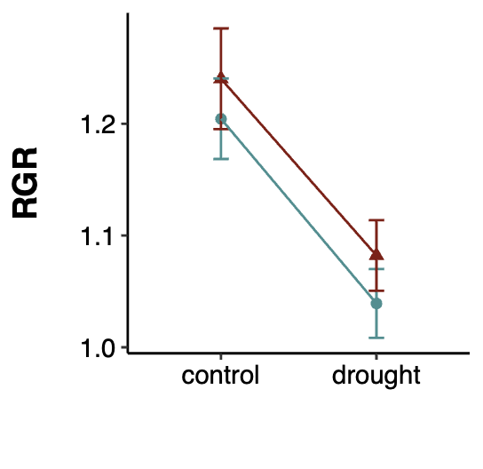

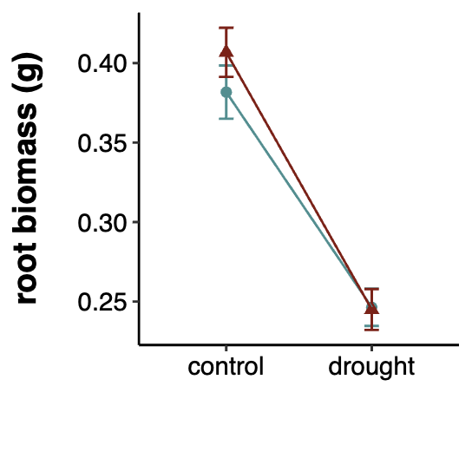
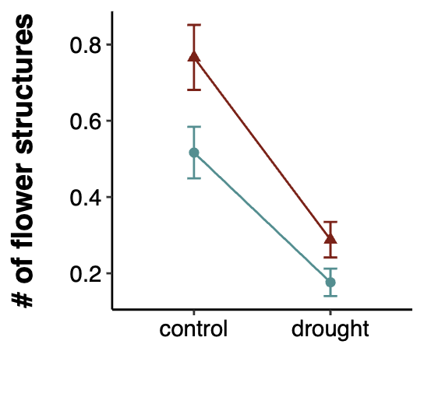
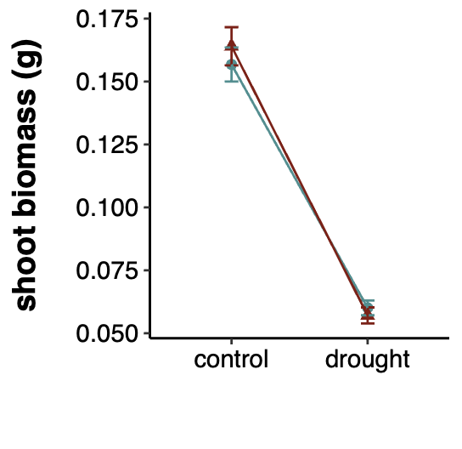
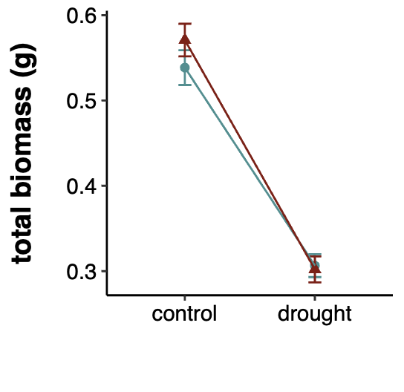
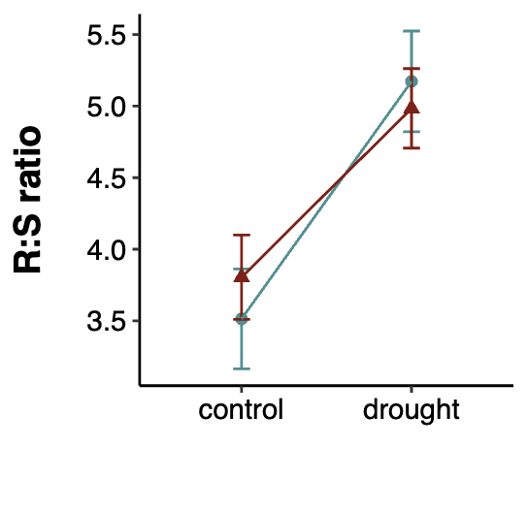
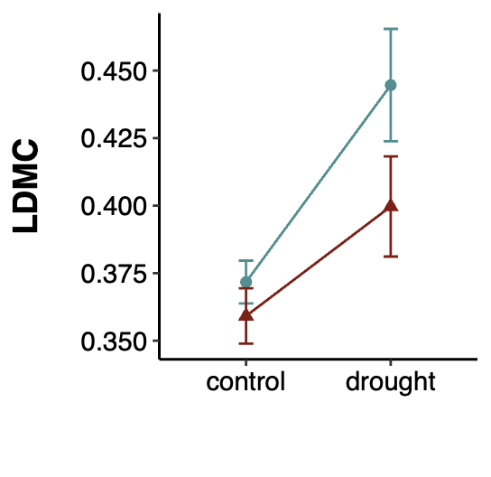
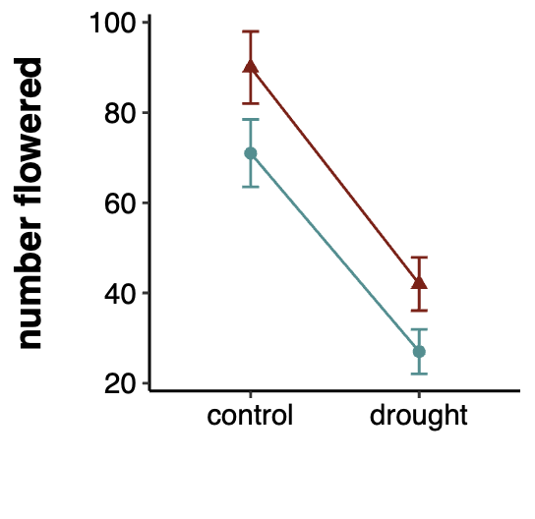
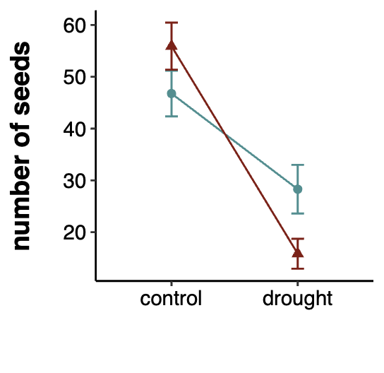
a)
b)
c)
d)
e)
f)
g)
h)
i)
OT: ***
PT: ns
OT x PT: ns
OT: ***
PT: ns
OT x PT: ns
OT: ***
PT: ns
OT x PT: ns
OT: ***
PT: ns
OT x PT: ns
OT: ***
PT: ns
OT x PT: ns
OT: **
PT: ns
OT x PT: ns
OT: **
PT: **
OT x PT: ns
OT: ***
PT: **
OT x PT: ns
OT: *
PT: ns
OT x PT: **
offspring treatment
offspring treatment
offspring treatment
high
low
high
low
high
low
high
low
high
low
high
low
high
low
high
low
high
low

Figure 3. Effects of transgenerational plasticity across all eleven populations of P. patagonica on number of seeds produced. Letters mark significant differences between each treatment cohort (LL = F1 low / F2 low, LH = F1 low / F2 high, HL = F1 high / F2 low, and HH = F1 high / F2 high). Error bars represent SE.

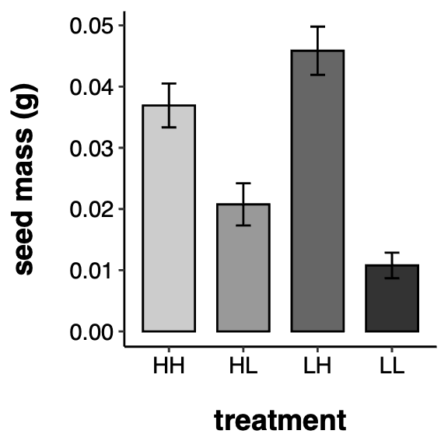
a
a
b
c

Table 2. Results of mixed models testing the effects of offspring watering treatment (OT), parental watering treatment (PT), and seed source climate at origin value: the 30-year mean annual spring VPDmax (kPa) coefficient of variation for each seed source location, and their interactions. P values = 0.05 < #P < 0.1; *P < 0.05; **P < 0.01; ***P < 0.001. F-statistic (linear models) or Chi-squared statistic (generalized linear models), signiﬁcance levels and degrees of freedom (d.f.) are shown for each term. Zero inflated models were used for number flowered, and number of flowering structures produced per plant. R²m = marginal R².

Trait | OT | PT | sVPD-CV | OT x PT | OT x sVPD-CV | PT x sVPD-CV | OT x PT x sVPD-CV | R²m
Growth
root biomass | F = 42.4606*** | F = 1.8285 | F = 1.8285* | F = 0.9618 | F = 7.5165** | F = 8.2865* | F = 7.4391** | 0.144
shoot biomass | F = 159.7348*** | F = 0.3574 | F = 10.3535** | F = 0.4701 | F = 1.9291 | F = 1.0722 | F = 0.2678 | 0.335
total biomass | F = 88.8741*** | F = 1.7169 | F = 0.8372 | F = 1.0625 | F = 3.3378 # | F = 4.2155* | F = 4.3817* | 0.236
max height | F = 0.5950 | F = 1.4054 | F = 3.4883 # | F = 0.3059 | F = 0.0252 | F = 4.4933* | F = 0.2774 | 0.013
Resource Allocation
R:S ratio | F = 35.0308*** | F = 1.9455 | F = 7.9171** | F = 0.5534 | F = 4.6119* | F = 1.4226 | F = 2.4940 | 0.089
RGR | F = 10.1860** | F = 0.4840 | F = 0.7944 | F = 0.0572 | F = 0.6570 | F = 0.7146 | F = 5.3827* | 0.026
SLA | F = 1.4348 | F = 0.6179 | F = 0.3209 | F = 0.1159 | F = 0.4244 | F = 1.1920 | F = 0.0356 | 0.015
LDMC | F = 6.8726** | F = 1.8894 | F = 0.6638 | F = 0.3039 | F = 0.0048 | F = 0.0503 | F = 0.2288 | 0.033
Survival
mortality | X² = 0.1506 | X² = 0.2551 | X² = 0.4672 | X² = 0.6217 | X² = 0.6921 | X² = 0.0505 # | X² = 0.6482 | 0.028
Reproduction
days to flowering | X² = 0.3058 | X² = 0.5372 | X² = 0.7888 | X² = 0.5337 | X² = 0.2954 | X² = 0.7747 | X² = 0.2606 | 0.037
number flowered
conditional model | X² = 0.0409* | X² = 0.0263* | X² = 0.0179* | X² = 0.0125* | X² = 0.0033** | X² = 0.0236* | X² = 0.0026** | 0.096
zero-inflation model | X² = 0.0057** | X² = 6.973e-5*** | X² = 6.266e-6 ***
number of flowering structures
conditional model | X² = 0.3476 | X² = 0.0682 # | X² = 0.0134* | X² = 0.1539 | X² = 0.2839 | X² = 0.0901 # | X² = 0.2705 | 0.092
zero-inflation model | X² = 1.555e-6*** | X² = 0.001111** | X² = 6.509e-5***
seed number | X² = 0.0494* | X² = 0.1704 | X² = 0.8044 | X² = 0.0224* | X² = 0.8723 | X² = 0.6397 | X² = 0.4127 | 0.270
df | 1 | 1 | 1 | 1 | 1 | 1 | 1

Figure 4. Effects of seed-source spring VPD-CV and plasticity treatment on a) root biomass, b) relative growth rate (RGR), and c) number of plants that flowered. Lines represent estimated marginal slopes for each offspring × parental treatment combination (OT × PT), with shaded areas showing ± SE. Slope comparisons were evaluated using Tukey-adjusted pairwise contrasts of trends. For root biomass, slopes differed between HH and LH (p = 0.032) but not between HL and LL (p = 0.71). For RGR, slopes did not differ for either comparison (HH vs LH, p = 0.85; HL vs LL, p = 0.061). For flower production, the HH vs LH comparison showed a significant difference (p = 0.017), whereas HL vs LL did not (p = 0.95). Significantly different slopes are denoted with an asterisk.

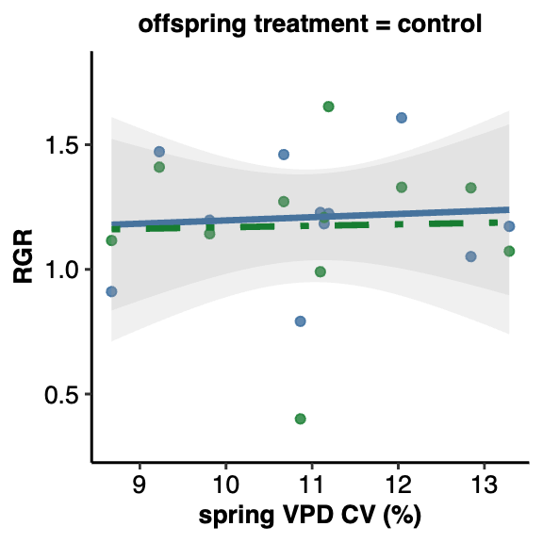
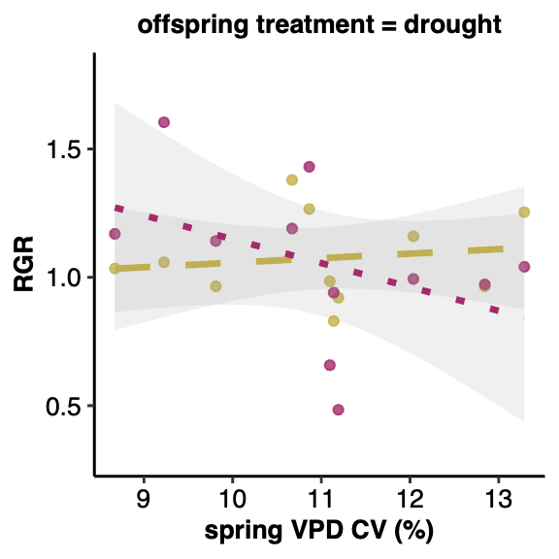
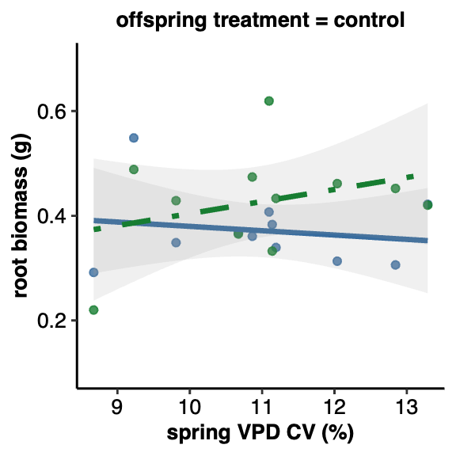
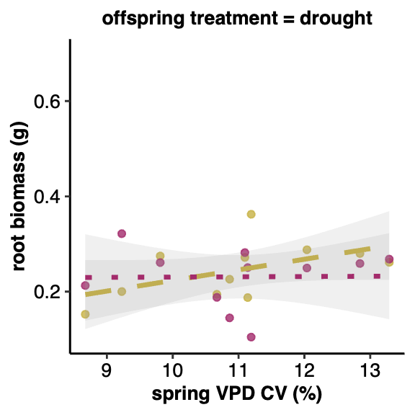
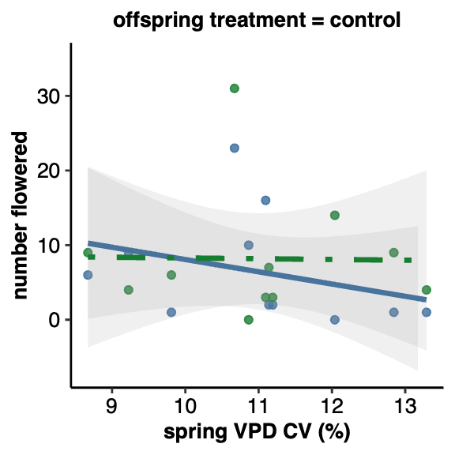
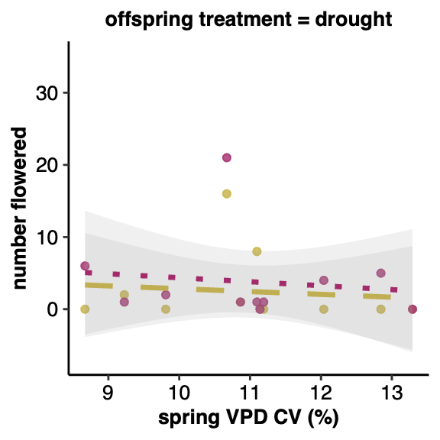
a)
b)
HH

LH

HL

LL
HH β = –0.0367 ± 0.0156
LH β = 0.0213 ± 0.0143
HH β = –0.0343 ± 0.0385
LH β = 0.0112 ± 0.0409
HL β = 0.0239 ± 0.0141
LL β = 0.0029 ± 0.0139
HL β = 0.0099 ± 0.0354
LL β = –0.1260 ± 0.0414
HH β = 1.0269 ± 0.4340
LH β = 0.0162 ± 0.1590
HL β = 5.7898 ± 1.5600
LL β = -0.1083 ± 0.2190
c)
*
*

DISCUSSION
Transgenerational plasticity may be one mechanism for persistence under rapid environmental change (Herman & Sultan, 2011). We found evidence of TGP in P. patagonica that suggests water limitation over multiple generations has negative effects on the reproductive output regardless of seed source climate (Figure 3). Most of the trait plasticity in P. patagonica occurred in response to offspring water limitations (WGP, Table 1, Figure 2). Additionally, we found that seed source site variability modulates transgenerational responses in traits related to growth and resource allocation, and in one reproductive trait (Table 2, Figure 4). Below, we discuss each of these results, the mechanisms that may have given rise to these patterns, and their implications.
Transgenerational costs in Plantago patagonica
Seed number is one of the best surrogates of lifetime fitness in annual plants (Primack & Kang, 1989). When plants were exposed to water limitations in the offspring generation, plants that also experienced water limitation in the parental generation (LL) produced fewer seeds than offspring of well-watered plants (HL) (Figure 3; Table 2). This finding suggests that TGP is not an adaptive strategy under consecutive generations of water limitation—in fact, consecutive generations of water limitation may induce maladaptive TGP in P. patagonica, regardless of the seed source climate pattern (Kuijper & Hoyle, 2015). We also found that water limitation in the offspring generation significantly increases the likelihood of failure to flower. Interestingly, parental water limitation had the opposite effect, slightly increasing the odds of flowering, potentially indicating a stress-escape strategy. These results align with findings in other species showing reduced seed production under consecutive drought stresses, (Fenesi et al., 2014). However, contrasting responses have also been documented: Secale sylvestre showed increased seed production (Mojzes et al., 2021), while Helianthemum squamatum and Centaurea hyssopifolia exhibited no change in seed production (Ramos-Muñoz et al., 2024). Such variability highlights that the fitness consequences of multigenerational water limitation are likely species-specific, shaped by distinct life histories, ecological strategies, or physiological thresholds and may be difficult to predict.
Overall, we found limited evidence for simple TGP expression across all populations in P. patagonica. While we detected complex, climate-modulated transgenerational responses in several traits, simple TGP was largely absent. This contrasts with many other TGP studies that found matching parent-offspring environments produced adaptive transgenerational effects (Mojzes et al., 2021; Sultan et al., 2009). There are several possible explanations for the absence of adaptive TGP in P. patagonica. Transgenerational cues are passed down epigenetically (Fitz-James & Cavalli, 2022), via mRNA, proteins, and hormones (Donohue, 2009; Jha et al., 2010; Rajjou et al., 2004), or through nutritive preparations of offspring (reviewed in (Herman & Sultan, 2011). These complex, multi-layered mechanisms may have only evolved in some species, or even in response to specific environmental stressors. For example, no evidence of TGP was found in Silene vulgaris under three separate types of stress (Sandner et al., 2018), and adaptive TGP has only been found in one of two closely related Polygonum species (Sultan et al., 2009). Our results contribute to the ideas that adaptive TGP is not a universal or reliable revegetation strategy in the face of this environmental change (Sánchez-Tójar et al., 2020; Uller et al., 2013).
One possible explanation for the lack of TGP in P. patagonica is that fact that the species produces a seed bank, a strategy which buffers populations against environmental variability (Haight et al., 2019; Venable, 2007). Adaptive TGP is one strategy an annual plant can use to increase fitness (Mousseau & Fox, 1998), and usually occurs when parental and offspring environments are well correlated (Burgess & Marshall, 2014; Leimar & McNamara, 2015). When environmental conditions are unpredictable, however, annual plants may instead favor diversified het hedging, increasing the probability that at least some offspring phenotypes will match environmental conditions in a given year (J. Marshall & Uller, 2007; Philippi & Seger, 1989; Simons, 2011; Slatkin, 1974). In arid environments bet hedging via seed banking or delayed germination is a common strategy, especially in desert annuals (Golodets et al., 2013; Gremer & Venable, 2014; Venable & Brown, 1988). In such systems, a TGP mechanism may be disfavored as environmental conditions are not reliably correlated across generations. In future studies, P. patagonica may serve as a good candidate to further untangle the synergistic, antagonistic, or null effects of TGP on bet hedging strategies.
Within generation plasticity in P. patagonica
We observed a far greater degree of WGP in P. patagonica (Table 1, Figure 2). This strong WGP response aligns with findings from other studies that imposed water limitations on annual plants across generations (Germain et al., 2013; Kalandyk et al., 2017; Sultan et al., 2009). P. patagonica plants exposed to water limitation in the offspring generation exhibited significantly reduced root, shoot, and total biomass and slower relative growth rates, consistent with stress-induced constraints on performance under resource limitation. Plants also demonstrated functional shifts in allocation: they devoted proportionally more resources to roots and increased LDMC. These allocational changes reflect a resource-conservative strategy, suggesting that while P. patagonica growth is constrained by water deficit, the species is capable of rapidly adjusting its phenotype to mitigate the impacts of drought.
Transgenerational responses are context-dependent on seed source site VPD variability
To evaluate if transgenerational effects were related to the seed source climate at origin, we used a model that included the effects of offspring treatment, parental treatment, the 30-year mean spring VPD coefficient of variation (sVPD-CV) at the seed collection site, and their interactions. Plants originating from areas with a higher sVPD-CV are from environments where atmospheric drought variability is more pronounced across years during the growing season. Plants from areas with a lower sVPD-CV originate from environments where atmospheric drought variability was lower, or more stable, across years during the growing season. Similar to many TGP studies that report substantial genotype- or population-by-environmental interactions in inherited responses (Groot et al., 2017; Lampei et al., 2017; Li et al., 2017; Münzbergová & Hadincová, 2017), we observed four traits related to growth, resource allocation, and reproduction that changed based on seed source site spring VPD variability (Table 2, Figure 4).
Plants from higher sVPD-CV sites produced greater root biomass when exposed to mismatched watering conditions across generations (Figure 4A, right panel, LH vs. HH). This suggests that plants from unpredictable environments may rely more on flexible biomass allocation as a strategy to cope with environmental uncertainty. Interestingly, plants that experienced two generations of water limitation (LL) showed decreasing relative growth rates with increasing seed source site VPD variability. Specifically, under water limitation, offspring of plants that experienced water limitation (LL) exhibited a marked decrease in relative growth rate over the sVPD-CV gradient: plants from less variable climates grew at a faster rate, while plants from more variable climates grew more slowly. In contrast, offspring of plants that did not experience water limitation but were grown under water limitation (HL) did not see a change in RGR over an sVPD-CV gradient. These results align with theoretical and empirical work suggesting the adaptive value of TGP depends on environmental predictability across generations (Badyaev & Uller, 2009; Colicchio & Herman, 2020; Leimar & McNamara, 2015). Here, the observed higher relative growth rates likely reflect a drought escape strategy, enabling plants to maximize development and reproduce before resources are depleted. Conversely, in more variable environments parental cues provide low informational value regarding the offspring environment.
Reproductive success (the number of plants that flowered) revealed a complex interaction between climate variability and transgenerational responses. In plants who experienced well-watered parental conditions but water-limited offspring conditions, the plants sourced from more variable spring VPD environments flowered more often than the plants sourced from less variable spring VPD environments (4C). Our results suggest that the reliability of transgenerational cues is conditioned by the historical predictability of the source environment. Populations sourced from environments with high spring VPD variability (where parental conditions are likely poor predictors of offspring environments) appeared to deprioritize optimistic parental cues in favor of immediate stress signals. When offspring from well-watered parents were exposed to water limitations, those from variable environments successfully triggered a drought escape strategy, transitioning to flowering despite the mismatch in parental priming. This aligns with predictions that in unpredictable environments, transgenerational plasticity may be down-regulated or overridden by within-generation plasticity to avoid maladaptive developmental trajectories (Burgess & Marshall, 2014; Herman & Sultan, 2011).
CONCLUSIONS
While Plantago patagonica exhibits robust within-generation plasticity to buffer against immediate water-deficits, our findings suggest that transgenerational plasticity is not a uniform mechanism for resilience but rather a complex response constrained by evolutionary history. While we observed significant WGP in response to low water availability, transgenerational effects were weak and, in the case of seed production, maladaptive, suggesting that consecutive exposure to water limitation may reduce rather than enhance offspring fitness. These findings contrast with other species where TGP confers adaptive benefits, highlighting the species-specific nature of these responses and the challenges associated with predicting or leveraging TGP under climate change. In P. patagonica, adaptation to arid, unpredictable climates may favor immediate plasticity and bet-hedging strategies over inherited environmental cues.

REFERENCES
Ameztegui, A (2017) Plasticity: An R package to determine several plasticity indices. GitHub repository, https://github.com/ameztegui/Plasticity
Agrawal, A. A., Laforsch, C., & Tollrian, R. (1999). Transgenerational induction of defences in animals and plants. Nature, 401(6748), 60–63. https://doi.org/10.1038/43425
Alpert, P., & Simms, E. L. (2002). The relative advantages of plasticity and fixity in different environments: When is it good for a plant to adjust? Evolutionary Ecology, 16(3), 285–297. https://doi.org/10.1023/A:1019684612767
Badyaev, A. V., & Uller, T. (2009). Parental effects in ecology and evolution: Mechanisms, processes and implications. Philosophical Transactions of the Royal Society B: Biological Sciences, 364(1520), 1169–1177. https://doi.org/10.1098/rstb.2008.0302
Bartlett, M. K., Scoffoni, C., & Sack, L. (2012). The determinants of leaf turgor loss point and prediction of drought tolerance of species and biomes: A global meta-analysis. Ecology Letters, 15(5), 393–405. https://doi.org/10.1111/j.1461-0248.2012.01751.x
Bell, A. M., & Hellmann, J. K. (2019). An Integrative Framework for Understanding the Mechanisms and Multigenerational Consequences of Transgenerational Plasticity. Annual Review of Ecology, Evolution, and Systematics, 50(Volume 50, 2019), 97–118. https://doi.org/10.1146/annurev-ecolsys-110218-024613
Bonduriansky, R. (2021). Plasticity Across Generations. In Phenotypic Plasticity & Evolution. CRC Press. https://doi.org/10.1201/9780429343001
Burgess, S. C., & Marshall, D. J. (2014). Adaptive parental effects: The importance of estimating environmental predictability and offspring fitness appropriately. Oikos, 123(7), 769–776. https://doi.org/10.1111/oik.01235
Colicchio, J. M., & Herman, J. (2020). Empirical patterns of environmental variation favor adaptive transgenerational plasticity. Ecology and Evolution, 10(3), 1648–1665. https://doi.org/10.1002/ece3.6022
Cornwell, W. K., & Ackerly, D. D. (2009). Community assembly and shifts in plant trait distributions across an environmental gradient in coastal California. Ecological Monographs, 79(1), 109–126. https://doi.org/10.1890/07-1134.1
Crawley, M. J. (2009). Plant Ecology. John Wiley & Sons.
Dai, A. (2011). Drought under global warming: A review. WIREs Climate Change, 2(1), 45–65. https://doi.org/10.1002/wcc.81
Donelson, J. M., Salinas, S., Munday, P. L., & Shama, L. N. S. (2018). Transgenerational plasticity and climate change experiments: Where do we go from here? Global Change Biology, 24(1), 13–34. https://doi.org/10.1111/gcb.13903
Donohue, K. (2009). Completing the cycle: Maternal effects as the missing link in plant life histories. Philosophical Transactions of the Royal Society B: Biological Sciences, 364(1520), 1059–1074. https://doi.org/10.1098/rstb.2008.0291
Engqvist, L., & Reinhold, K. (2016). Adaptive trans-generational phenotypic plasticity and the lack of an experimental control in reciprocal match/mismatch experiments. Methods in Ecology and Evolution, 7(12), 1482–1488. https://doi.org/10.1111/2041-210X.12618
Fenesi, A., Dyer, A. R., Geréd, J., Sándor, D., & Ruprecht, E. (2014). Can transgenerational plasticity contribute to the invasion success of annual plant species? Oecologia, 176(1), 95–106. https://doi.org/10.1007/s00442-014-2994-7
Fischer, B., Taborsky, B., & Kokko, H. (2011). How to balance the offspring quality–quantity tradeoff when environmental cues are unreliable. Oikos, 120(2), 258–270. https://doi.org/10.1111/j.1600-0706.2010.18642.x
Fitz-James, M. H., & Cavalli, G. (2022). Molecular mechanisms of transgenerational epigenetic inheritance. Nature Reviews Genetics, 23(6), 325–341. https://doi.org/10.1038/s41576-021-00438-5
Galloway, L. F. (2001). Parental Environmental Effects on Life History in the Herbaceous Plant Campanula Americana. Ecology, 82(10), 2781–2789. https://doi.org/10.1890/0012-9658(2001)082%255B2781:PEEOLH%255D2.0.CO;2
Germain, R. M., Caruso, C. M., & Maherali, H. (2013). Mechanisms and Consequences of Water Stress–Induced Parental Effects in an Invasive Annual Grass. International Journal of Plant Sciences, 174(6), 886–895. https://doi.org/10.1086/670691
Golodets, C., Sternberg, M., Kigel, J., Boeken, B., Henkin, Z., Seligman, N. G., & Ungar, E. D. (2013). From desert to Mediterranean rangelands: Will increasing drought and inter-annual rainfall variability affect herbaceous annual primary productivity? Climatic Change, 119(3), 785–798. https://doi.org/10.1007/s10584-013-0758-8
Gremer, J. R., & Venable, D. L. (2014). Bet hedging in desert winter annual plants: Optimal germination strategies in a variable environment. Ecology Letters, 17(3), 380–387. https://doi.org/10.1111/ele.12241
Groot, M. P., Kubisch, A., Ouborg, N. J., Pagel, J., Schmid, K. J., Vergeer, P., & Lampei, C. (2017). Transgenerational effects of mild heat in Arabidopsis thaliana show strong genotype specificity that is explained by climate at origin. New Phytologist, 215(3), 1221–1234. https://doi.org/10.1111/nph.14642
Haight, J. D., Reed, S. C., & Faist, A. M. (2019). Seed bank community and soil texture relationships in a cold desert. Journal of Arid Environments, 164, 46–52. https://doi.org/10.1016/j.jaridenv.2019.01.008
Herman, J., & Sultan, S. (2011). Adaptive Transgenerational Plasticity in Plants: Case Studies, Mechanisms, and Implications for Natural Populations. Frontiers in Plant Science, 2(102). https://doi.org/10.3389/fpls.2011.00102
Holeski, L. M. (2007). Within and between generation phenotypic plasticity in trichome density of Mimulus guttatus. Journal of Evolutionary Biology, 20(6), 2092–2100. https://doi.org/10.1111/j.1420-9101.2007.01434.x
Holeski, L. M., Jander, G., & Agrawal, A. A. (2012). Transgenerational defense induction and epigenetic inheritance in plants. Trends in Ecology & Evolution, 27(11), 618–626. https://doi.org/10.1016/j.tree.2012.07.011
Hoyle, R. B., & Ezard, T. H. G. (2012). The benefits of maternal effects in novel and in stable environments. Journal of The Royal Society Interface, 9(75), 2403–2413. https://doi.org/10.1098/rsif.2012.0183
J. Marshall, D., & Uller, T. (2007). When is a maternal effect adaptive? Oikos, 116(12), 1957–1963. https://doi.org/10.1111/j.2007.0030-1299.16203.x
Jha, P., Norsworthy, J. K., Riley, M. B., & Jr, W. B. (2010). Shade and Plant Location Effects on Germination and Hormone Content of Palmer Amaranth (Amaranthus palmeri) Seed. Weed Science, 58(1), 16–21. https://doi.org/10.1614/WS-09-059.1
Kalandyk, A., Waligórski, P., & Dubert, F. (2017). Role of the maternal effect phenomena in improving water stress tolerance in narrow-leafed lupine (upinus angustifolius). Plant Breeding, 136(2), 167–173. https://doi.org/10.1111/pbr.12457
Klein, Z., & Mitchell, R. M. (2023). Seed source environment predicts response to water availability in Plantago patagonica. Restoration Ecology, 1–11. https://doi.org/10.1111/rec.14002
Kuijper, B., & Hoyle, R. B. (2015). When to rely on maternal effects and when on phenotypic plasticity? Evolution; International Journal of Organic Evolution, 69(4), 950–968. https://doi.org/10.1111/evo.12635
Lampei, C., Metz, J., & Tielbörger, K. (2017). Clinal population divergence in an adaptive parental environmental effect that adjusts seed banking. New Phytologist, 214(3), 1230–1244. https://doi.org/10.1111/nph.14436
Latzel, V., Fischer, M., Groot, M., Gutzat, R., Lampei, C., Ouborg, J., Parepa, M., Schmid, K., Vergeer, P., Zhang, Y., & Bossdorf, O. (2023). Parental environmental effects are common and strong, but unpredictable, in Arabidopsis thaliana. New Phytologist, 237(3), 1014–1023. https://doi.org/10.1111/nph.18591
Latzel, V., Janeček, Š., Doležal, J., Klimešová, J., & Bossdorf, O. (2014). Adaptive transgenerational plasticity in the perennial Plantago lanceolata. Oikos, 123(1), 41–46. https://doi.org/10.1111/j.1600-0706.2013.00537.x
Leimar, O., & McNamara, J. M. (2015). The Evolution of Transgenerational Integration of Information in Heterogeneous Environments. The American Naturalist, 185(3), E55–E69. https://doi.org/10.1086/679575
Li, R., Chen, L., Wu, Y., Zhang, R., Baskin, C. C., Baskin, J. M., & Hu, X. (2017). Effects of Cultivar and Maternal Environment on Seed Quality in Vicia sativa. Frontiers in Plant Science, 8, 1411. https://doi.org/10.3389/fpls.2017.01411
Louthan, A. M., Doak, D. F., & Angert, A. L. (2015). Where and When do Species Interactions Set Range Limits? Trends in Ecology & Evolution, 30(12), 780–792. https://doi.org/10.1016/j.tree.2015.09.011
Mojzes, A., Kalapos, T., & Kröel‑Dulay, G. (2021). Drought in maternal environment boosts offspring performance in a subordinate annual grass. Environmental and Experimental Botany, 187, 104472. https://doi.org/10.1016/j.envexpbot.2021.104472
Mousseau, T. A., & Fox, C. W. (1998). Maternal Effects As Adaptations. Oxford University Press.
Münzbergová, Z., & Hadincová, V. (2017). Transgenerational plasticity as an important mechanism affecting response of clonal species to changing climate. Ecology and Evolution, 7(14), 5236–5247. https://doi.org/10.1002/ece3.3105
Nicotra, A. B., Atkin, O. K., Bonser, S. P., Davidson, A. M., Finnegan, E. J., Mathesius, U., Poot, P., Purugganan, M. D., Richards, C. L., Valladares, F., & van Kleunen, M. (2010). Plant phenotypic plasticity in a changing climate. Trends in Plant Science, 15(12), 684–692. https://doi.org/10.1016/j.tplants.2010.09.008
Philippi, T., & Seger, J. (1989). Hedging one’s evolutionary bets, revisited. Trends in Ecology & Evolution, 4(2), 41–44. https://doi.org/10.1016/0169-5347(89)90138-9
Primack, R. B., & Kang, H. (1989). Measuring Fitness and Natural Selection in Wild Plant Populations. Annual Review of Ecology, Evolution, and Systematics, 20(Volume 20, 1989), 367–396. https://doi.org/10.1146/annurev.es.20.110189.002055
Rajjou, L., Gallardo, K., Debeaujon, I., Vandekerckhove, J., Job, C., & Job, D. (2004). The Effect of α-Amanitin on the Arabidopsis Seed Proteome Highlights the Distinct Roles of Stored and Neosynthesized mRNAs during Germination. Plant Physiology, 134(4), 1598–1613. https://doi.org/10.1104/pp.103.036293
Ramos-Muñoz, M., Blanco-Sánchez, M., Pías, B., Escudero, A., & Matesanz, S. (2024). Transgenerational plasticity to drought: Contrasting patterns of non-genetic inheritance in two semi-arid Mediterranean shrubs. Annals of Botany, 134(1), 101–116. https://doi.org/10.1093/aob/mcae039
Räsänen, K., & Kruuk, L. E. B. (2007). Maternal effects and evolution at ecological time-scales. Functional Ecology, 21(3), 408–421. https://doi.org/10.1111/j.1365-2435.2007.01246.x
Reed, T. E., Waples, R. S., Schindler, D. E., Hard, J. J., & Kinnison, M. T. (2010). Phenotypic plasticity and population viability: The importance of environmental predictability. Proceedings of the Royal Society B: Biological Sciences, 277(1699), 3391–3400. https://doi.org/10.1098/rspb.2010.0771
Riginos, C., Heschel, M. S., & Schmitt, J. (2007). Maternal effects of drought stress and inbreeding in Impatiens capensis (Balsaminaceae). American Journal of Botany, 94(12), 1984–1991. https://doi.org/10.3732/ajb.94.12.1984
Sánchez-Tójar, A., Lagisz, M., Moran, N. P., Nakagawa, S., Noble, D. W. A., & Reinhold, K. (2020). The jury is still out regarding the generality of adaptive ‘transgenerational’ effects. Ecology Letters, 23(11), 1715–1718. https://doi.org/10.1111/ele.13479
Sandner, T. M., van Braak, J. L., & Matthies, D. (2018). Transgenerational plasticity in Silene vulgaris in response to three types of stress. Plant Biology, 20(4), 751–758. https://doi.org/10.1111/plb.12721
Sharma, N., Koul, P., & Koul, A. K. (1992). Reproductive Biology of Plantago: Shift from Cross- to Self-pollination. Annals of Botany, 69(1), 7–11. https://doi.org/10.1093/oxfordjournals.aob.a088309
Simons, A. M. (2011). Modes of response to environmental change and the elusive empirical evidence for bet hedging. Proceedings of the Royal Society B: Biological Sciences, 278(1712), 1601–1609. https://doi.org/10.1098/rspb.2011.0176
Slatkin, M. (1974). Hedging one’s evolutionary bets. Nature, 250(5469), 704–705. https://doi.org/10.1038/250704b0
Song, Y., Zajic, C. J., Hwang, T., Hakkenberg, C. R., & Zhu, K. (2021). Widespread Mismatch Between Phenology and Climate in Human‐Dominated Landscapes. AGU Advances, 2(4). https://doi.org/10.1029/2021AV000431
Spinoni, J., Barbosa, P., De Jager, A., McCormick, N., Naumann, G., Vogt, J. V., Magni, D., Masante, D., & Mazzeschi, M. (2019). A new global database of meteorological drought events from 1951 to 2016. Journal of Hydrology: Regional Studies, 22, 100593. https://doi.org/10.1016/j.ejrh.2019.100593
Sultan, S. E. (1987). Evolutionary Implications of Phenotypic Plasticity in Plants. In M. K. Hecht, B. Wallace, & G. T. Prance (Eds.), Evolutionary Biology (pp. 127–178). Springer US. https://doi.org/10.1007/978-1-4615-6986-2_7
Sultan, S. E., Barton, K., & Wilczek, A. M. (2009). Contrasting patterns of transgenerational plasticity in ecologically distinct congeners. Ecology, 90(7), 1831–1839. https://doi.org/10.1890/08-1064.1
Uller, T. (2008). Developmental plasticity and the evolution of parental effects. Trends in Ecology & Evolution, 23(8), 432–438. https://doi.org/10.1016/j.tree.2008.04.005
Uller, T., Nakagawa, S., & English, S. (2013). Weak evidence for anticipatory parental effects in plants and animals. Journal of Evolutionary Biology, 26(10), 2161–2170. https://doi.org/10.1111/jeb.12212
Venable, D. L. (2007). BET HEDGING IN A GUILD OF DESERT ANNUALS. Ecology, 88(5), 1086–1090. https://doi.org/10.1890/06-1495
Venable, D. L., & Brown, J. S. (1988). The Selective Interactions of Dispersal, Dormancy, and Seed Size as Adaptations for Reducing Risk in Variable Environments. The American Naturalist, 131(3), 360–384. https://doi.org/10.1086/284795
Wadgymar, S. M., Mactavish, R. M., & Anderson, J. T. (2018). Transgenerational and Within-Generation Plasticity in Response to Climate Change: Insights from a Manipulative Field Experiment across an Elevational Gradient. The American Naturalist, 192(6), 698–714. https://doi.org/10.1086/700097
Westoby, M. (1998). A leaf-height-seed (LHS) plant ecology strategy scheme. Plant and Soil, 199(2), 213–227. https://doi.org/10.1023/A:1004327224729
Wright, I. J., Reich, P. B., Westoby, M., Ackerly, D. D., Baruch, Z., Bongers, F., Cavender-Bares, J., Chapin, T., Cornelissen, J. H. C., Diemer, M., Flexas, J., Garnier, E., Groom, P. K., Gulias, J., Hikosaka, K., Lamont, B. B., Lee, T., Lee, W., Lusk, C., … Villar, R. (2004). The worldwide leaf economics spectrum. Nature, 428(6985), 821–827. https://doi.org/10.1038/nature02403
Yin, J., Zhou, M., Lin, Z., Li, Q. Q., & Zhang, Y.-Y. (2019). Transgenerational effects benefit offspring across diverse environments: A meta-analysis in plants and animals. Ecology Letters, 22(11), 1976–1986. https://doi.org/10.1111/ele.13373

