This study aims to determine how seed origin and exposure to drought affects offspring life history traits in *Plantago patagonica*.

1. Does drought experienced by parent plants trigger transgenerational effects, and if so, are those effects adaptive in offspring? (greenhouse)
2. Are there population level differences in these transgenerational effects in response to drought? (greenhouse)
3. How does drought relate to bet-hedging strategies in *Plantago patagonica*? (germina tion + TZ trial)
   1. Seed dormancy, seed size, days to flowering

H1.1: Droughted maternal plants will produce offspring that have higher performance when exposed to further drought conditions.

H1.2: Droughted offspring from a droughted maternal line will have the highest performance. Specifically, droughted offspring will have lower mortality, higher growth rates, higher flowering rates, and higher allocation to roots.

H2: Populations sourced from locations with more consistent rainfall regimes that were exposed to control conditions will have lower mortality rates and higher growth rates. Populations sourced from locations with more variable rainfall regimes that were exposed to control conditions will have higher mortality rates and higher flowering rates.

H3: Seeds produced from droughted maternal lines will have lower seed masses and lower germination rates, but high viability rates.

**Greenhouse Methods**

1. Scarify seeds with 150-grit sandpaper, rubbing seed between two pieces in circular motion for 10 seconds (Christie et al. 2022).
2. Soak seeds in tap water for 12 hours.
3. Plant one seed per cone-tainer.
   1. Soil mixture is a 50:50 mix of generic potting soil and sterilized sand. No fertilizer, no pesticides.
   2. Depending on source, cone-tainers should be sterilized with a 10% bleach solution and tap water rinse.
   3. Cotton ball in bottom of cone-tainer to prevent soil loss?
   4. Fill cone-tainer with soil mixture, saturate with water, allow soil mixture to settle, and top off with soil mixture.
   5. Create ~0.5 m indent in each cone-tainer.
   6. Using tweezers, transfer one seed per cone-tainer and top with a layer of soil.
   7. Top water to moisten seed and soil.
   8. Label cones with appropriate info (hidden? If labeling is necessary?), enter into data sheet, randomize according to greenhouse layout above.
      1. Population # – P:D/C (parent:drought/control) – F1:D/C
4. Maintain greenhouse around 77-79° F with ambient light conditions (accounting for average increase in temperatures across the US Southwest region, Gonzalez et al. 2018).
5. Water each cone-tainer to saturation daily for 10 days to ensure germination.
6. On day 10, begin drought and control watering treatments.
   1. Control treatments will be the 30-year mean spring rainfall amount for wettest seed source location in the populations (60mm/week) (PRISM Climate Group).
   2. Drought treatments will be 25% of the 30-year mean spring rainfall amount for the driest source location in the populations (6mm/week) (PRISM Climate Group).
7. Water twice a week: 3mm to drought treatment, 30mm to control treatment (Tuesday/Friday).
8. Measure plant height at day 7, 14, and 21. After day 21, measure plant height every two weeks.
9. Measure mortality rate, presence of reproductive structures, and number of reproductive structures once a week.
10. On day 65, collect one leaf per individual to measure SLA.
11. On day 65, measure above-ground, below-ground and total plant biomass.

*Traits: plant height (growth), mortality rate (growth), days to flowering (reproductive phenology), number of flowers (reproductive phenology), SLA (tissue construction, allocation), above-ground biomass, below-ground biomass, total biomass (allocation), germination rate, viability rate*

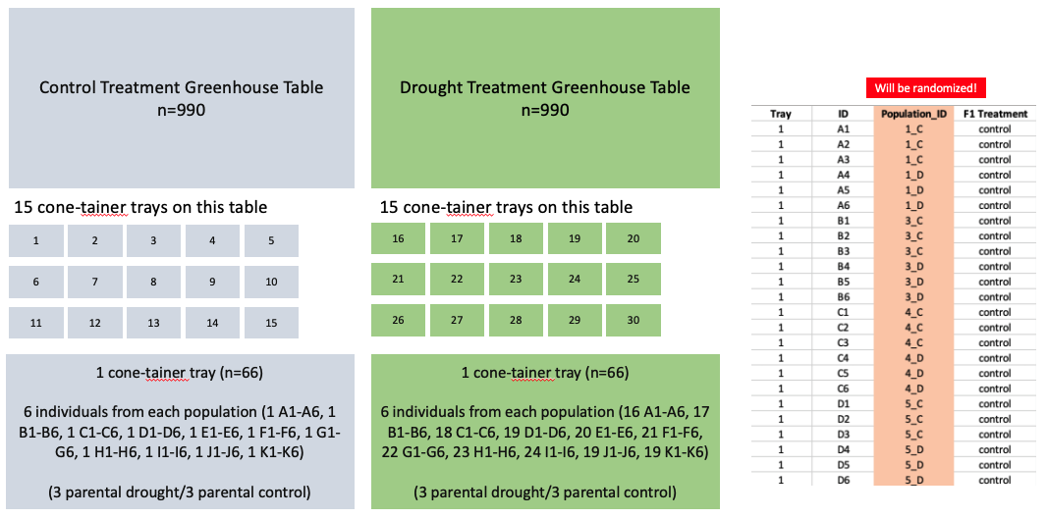**But, population 7 drought treatment only has ~99 seeds in total ☹

**Supply List**

* ~~150-grit sandpaper~~ **(in box!)**
* ~~Petri dishes (to soak seeds)~~ **(get from lab)**
* Paper towels – grocery store
* 1,980 cone-tainers – Arturo?
* 30 cone-tainer trays (hopefully the ones with 72 or 98 holders) – Arturo?
* Generic potting soil – Arturo
* Sterilized sand – Arturo
* 10% bleach solution in spray bottle – grocery store
* Cotton balls? – grocery store
* ~~Tweezers~~ **(somewhere in lab)**
* Tap water spray bottle – grocery store
* Popsicle sticks for labeling? Or duct tape? – grocery store
* ~~Sharpie~~
* Syringe x 2 (order this online? Maybe see what kind Zoë used)
* Ruler
* Ruler – grocery store
* Service agreement form
* Greenhouse key request

Greenhouse rates example:

|  |  |  |  |  |  |
| --- | --- | --- | --- | --- | --- |
| **Roger Rd** | **GH #** | **Sq Ft** | **Months** | **Rate** | **Totals** |
| Farm | 2078-4 | 1,152.00 | 1.00 | $   0.48 | $552.96 |

References

Cayan, D., M. Tyree, K. E. Kunkel, C. Castro, A. Gershunov, J. Barsugli, A. J. Ray, J. Overpeck, M. Anderson, J. Russell, B. Rajagopalan, I. Rangwala, and P. Duffy. 2013. “Future Climate: Projected Average.” In Assessment of Climate Change in the Southwest United States: A Report Prepared for the National Climate Assessment, edited by G. Garfin, A. Jardine, R. Merideth, M. Black, and S. LeRoy, 101–125. A report by the Southwest Climate Alliance. Washington, DC: Island Press.

Christie, K., N. R. Pierson, D. B. Lowry, and L. M. Holeski. 2022. Local adaptation of seed and seedling traits along a natural aridity gradient may both predict and constrain adaptive responses to climate change. American Journal of Botany 109:1529–1544.

Gonzalez, P., G.M. Garfin, D.D. Breshears, K.M. Brooks, H.E. Brown, E.H. Elias, A. Gunasekara, N. Huntly, J.K. Maldonado, N.J. Mantua, H.G. Margolis, S. McAfee, B.R. Middleton, and B.H. Udall, 2018: Southwest. In Impacts, Risks, and Adaptation in the United States: Fourth National Climate Assessment, Volume II [Reidmiller, D.R., C.W. Avery, D.R. Easterling, K.E. Kunkel, K.L.M. Lewis, T.K. Maycock, and B.C. Stewart (eds.)]. U.S. Global Change Research Program, Washington, DC, USA, pp. 1101–1184. doi: 10.7930/NCA4.2018.CH25

PRISM Climate Group. 2014. PRISM Climate Group, Oregon State University, Corvallis, Oregon, USA. Website: https://prism.oregonstate.edu [data created 4 February 2014, accessed December 2021].