North Carolina (NOC) NERR Water Quality Metadata
January 1, 2016 – December 31, 2016
Latest Update: March 22, 2018

I. Data Set and Research Descriptors

1) Principal investigator(s) and contact persons

Brandon Puckett, Research Coordinator
400 Commerce Ave.
Morehead City, NC 28557
Phone: (252) 838-0851
Fax: (252) 247-3330
Email: brandon.puckett(at)ncdenr.gov

Byron Toothman, Research Associate
5600 Marvin K. Moss Lane
Wilmington, NC 28409
Phone: (910) 962-2334
Fax: (910) 962-2410
Email: toothmanb(at)uncw.edu

Heather Wells, Research Associate
5600 Marvin K. Moss Lane
Wilmington, NC 28409
Phone: (910) 962-2335
Fax: (910) 962-2410
Email: wellsh(at)uncw.edu

2) Entry verification

Deployment data are uploaded from the YSI data logger to a Personal Computer (IBM compatible). Files are exported from EcoWatch in a comma-delimited format (.CDF) and uploaded to the CDMO where they undergo automated primary QAQC; automated depth/level corrections for changes in barometric pressure (cDepth or cLevel parameters); and become part of the CDMO’s online provisional database. All pre- and post-deployment data are removed from the file prior to upload. During primary QAQC, data are flagged if they are missing or out of sensor range. The edited file is then returned to the Reserve for secondary QAQC where it is opened in Microsoft Excel and processed using the CDMO’s NERRQAQC Excel macro. The macro inserts station codes, creates metadata worksheets for flagged data and summary statistics, and graphs the data for review. It allows the user to apply QAQC flags and codes to the data, remove any overlapping deployment data, append files, and export the resulting data file for upload to the CDMO. Upload after secondary QAQC results in ingestion into the database as provisional plus data, recalculation of cDepth or cLevel parameters, and finally tertiary QAQC by the CDMO and assimilation into the CDMO’s authoritative online database. Where deployment overlap occurs between files, the data produced by the newly calibrated sonde is generally accepted as being the most accurate. For more information on QAQC flags and codes, see Sections 11 and 12. All QA/QC by the Reserve are performed by Heather Wells and Byron Toothman.

3) Research objectives

Four long-term water quality monitoring stations have been established within the estuaries bordering Masonboro and Zeke’s Islands of North Carolina’s National Estuarine Research Reserve. Instruments are deployed vertically at all sites except East Cribbings, which was anchored to the bottom for the majority of 2012. The East Cribbings site was converted to a vertical deployment structure on December 4, 2012. Measurements are taken at 15-minute intervals for approximately two to four week periods continuously throughout the year. Parameters measured include Depth, Temperature, Salinity, Specific Conductivity, pH, Dissolved Oxygen, and Turbidity. The goal is to assess short-term variability and long-term changes (i.e., localized impacts of seasonal storm events, inter-annual differences from rainfall, magnitude of climatic influence from El Nino/La Nina events, etc.) in estuarine water parameters within relatively pristine sites.

4) Research methods

The Estuarine Water Quality Monitoring Program began on March 2, 1992 at the Research Creek site of the Masonboro Island component. A second Masonboro Island site, Loosin Creek, was added on February 26, 2002. Data collection started on May 19, 1994 at the Zeke's Island component (East Cribbings site) and an additional site, Zeke's Basin, was added March 1, 2002. The procedures described below were instituted in June 1995 and thus do not cover data recorded previously.

Two data loggers are assigned to each of the four permanent monitoring stations and are generally not interchanged among sites unless malfunctions occur. Before each YSI EXO2 or YSI 6600EDS sonde is deployed, calibration and maintenance is performed following the manufacturer's instructions. Calibration standards are required for pH, turbidity and salinity; all other parameter calibrations are performed as described in the manual. Buffer solutions for a two-point pH calibration (pH 7 and 10) are purchased pre-made from a scientific supply house. The conductivity and turbidity standards are obtained from YSI. Chlorophyll probes are calibrated with deionized water as single point calibration. The optical dissolved oxygen probes (ROX) require membrane changes yearly unless scratches or malfunctions occur prior to that time. All sites have been monitored using ROX dissolved oxygen probes since 2009, prior to that time rapid pulse dissolved oxygen probes were used. The rapid pulse membranes were replaced prior to each deployment and allowed to equilibrate prior to calibration.

Data sondes are wrapped in a wet, white towel and placed in a cooler for transport to the site. Monitoring stations are accessed using a small boat equipped with an outboard motor. During deployment the weather conditions and tide stage are recorded in the field observation log. The water quality instrument is placed inside a locked PVC tube that is attached to a piling if vertical deployment, and a steel cage if anchored horizontally approximately (15cm off the bottom). Every 15 minutes measurements are taken for Temperature, Specific Conductance, Salinity, Dissolved oxygen saturation, Dissolved oxygen concentration, Depth, pH, and Turbidity. All data are recorded in Eastern Standard Time. Vertical deployment structures were utilized at Research Creek beginning in 2008-2009, at Loosin Creek in 2009, and at Zeke’s Basin in August 2010.

During 2016, chlorophyll data was collected at East Cribbings and Loosin Creek stations. A one point (0 NTU) chlorophyll calibration using DI water was performed prior to sonde deployments. Chlorophyll spikes and negative values were rejected, while elevated values may be flagged as suspect depending on field conditions. We do not currently calibrate with a known concentration of phytoplankton from fluorometric analysis, Rhodamine solutions, or adjust the data with any correction.

At the end of the sample period the water quality instrument is exchanged with a freshly calibrated instrument and transported back to the laboratory wrapped in a wet, white towel. The weather and water quality measurements are again noted in the field observation log. The calibration drift and the effect of biofouling on the water quality instrument are documented by post-calibration protocols. The water quality data are then uploaded, and sent to CDMO for primary QAQC, and the instrument is cleaned and calibrated as noted previously.

A Sutron Sat-Link2 transmitter was installed at the Research Creek station on August 7, 2006, and at the Zeke’s Basin station on November 3, 2008. Both transmit data to the NOAA GOES satellite, NESDIS ID #3B032698. The transmissions are scheduled hourly and contain four (4) data sets reflecting fifteen minute data sampling intervals. Upon receipt by the CDMO, the data undergoes the same automated primary QAQC process detailed in Section 2 above. The “real-time” telemetry data become part of the provisional dataset until undergoing secondary and tertiary QAQC and assimilation in the CDMO’s authoritative online database. Provisional and authoritative data are available at http://cdmo.baruch.sc.edu.

5) Site location and character

The components of North Carolina's National Estuarine Research Reserve (from north to south) are: Currituck Banks, Rachel Carson, Masonboro Island, and Zeke's Island. They are located along the southeast Atlantic coast of the United States. Currently, only data from Masonboro Island and Zeke's Island components are transferred to the CDMO. The four monitoring sites are:

A. Research Creek, Masonboro Island
The first Masonboro Island site (formerly called Masonboro Island (MS)) is 0.72 km north east from the mouth of Whiskey Creek, and east of the Intracoastal Waterway (ICW), in a small navigable channel called Research Creek at 34°09'21.7" latitude and 77° 50'59.9" longitude. The site typically has a salinity range of 20-35 ppt and a tidal range that averages around 1.2 meters. The sole source of freshwater is rain and salinity values as little as 10 ppt have been recorded during periods of heavy rain. The creek bottom is characterized by sand and detritus based sediment with areas of soft mud with a depth ranging from 0.2 to 2.6 m. Spartina spp. marsh and dunes surround the site, which is relatively unimpacted by manmade perturbations and it is not accessible to road traffic. The site experiences minimal boat traffic.

B. Loosin Creek, Masonboro Island
The second Masonboro Island site (added in 2002) is 1.2 km east of the ICW, and 2.5 km south west of Masonboro Inlet, in a small navigable channel called Loosin Creek at 34° 10'20.0" latitude and 77° 49'58.1" longitude. The site generally has a salinity range of 22-35 ppt and a tidal range that averages 1.2 meters. The sole source of freshwater is rain and salinity values as little as 15 ppt have been recorded during periods of heavy rain. The creek bottom is characterized by sand and detritus based sediment with areas of soft mud with a depth ranging from 0.1 to 2.5 m. Spartina spp. marsh and dunes surround the site, which is relatively unimpacted by manmade perturbations and it is not accessible to road traffic. The site experiences minimal boat traffic.

C. East Cribbings, Zeke's Island
The first Zeke's Island site (formerly called Zeke's Island (ZI)) is located 1.8 km south of Federal Point boat launch in a tidal basin estuary at 33° 56'23.5" latitude and 77° 56'28.1" longitude. This site receives minimal freshwater input from leakage of the Cape Fear River through the 5.6 km rock jetty that separates the two bodies of water. The site typically has a salinity range of 15-33 ppt, although values as little as 10 ppt have been recorded. Tidal range averages 1.2 meters. Depth varies, but usually can be found to range from 0.5 to 2.7 meters. Bottom type substratum consists of large rocks (“the cribbings”) with sand and detritus based sediment. There are no pollutants from land. Marsh and dunes surround the site. It is not accessible to road traffic but experiences minimal boat traffic.

D. Zeke's Basin, Zeke's Island
The second Zeke's Island site (added in 2002) is located 0.8 km south east of the Federal Point boat launch in a tidal basin estuary at 33° 57'17.0" latitude and 77° 56'6.0" longitude. This site receives minimal freshwater input from leakage of the Cape Fear River through the 5.6 km rock jetty that separates the two bodies of water The site has a characteristic salinity range of 12-30 ppt, but values below 10 ppt have been observed and are often associated with periods of heavy rainfall. Tidal range averages 1.2 meters. Depth varies, but typically it can be found to range from 0.1 to 1.8 meters. Bottom type substratum consists of sand and detritus based sediment with a layer of soft sulfuric mud. Marsh and dunes surround the site. It is not accessible to road traffic but experiences minimal boat traffic.

SWMP Station Timeline
Station Code | SWMP Status | Station Name | Location | Active Dates | Reason Decommissioned | Notes
nocecwq | P | East Cribbing | 33° 56' 23.64 N, 77° 56' 27.96 W | 01/01/2002 00:00 - | NA | NA
noclcwq | P | Loosin Creek | 34° 10' 19.92 N, 77° 49' 58.08 W | 02/01/2002 00:00 - | NA | NA
nocrcwq | P | Research Creek | 34° 9' 21.60 N, 77° 50' 59.64 W | 01/01/2002 00:00 - | NA | NA
noczbwq | P | Zeke's Basin | 33° 57' 16.92 N, 77° 56' 6.00 W | 03/01/2002 00:00 - | NA | NA

6) Data collection period

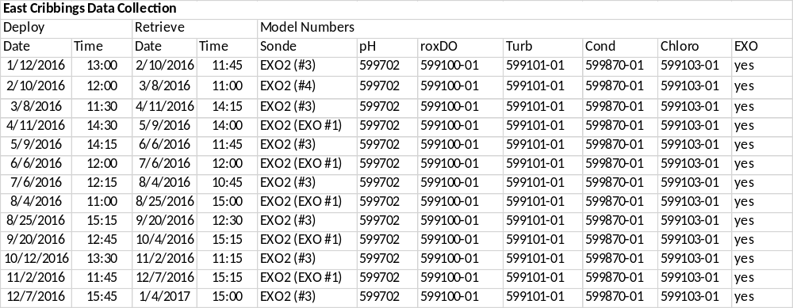

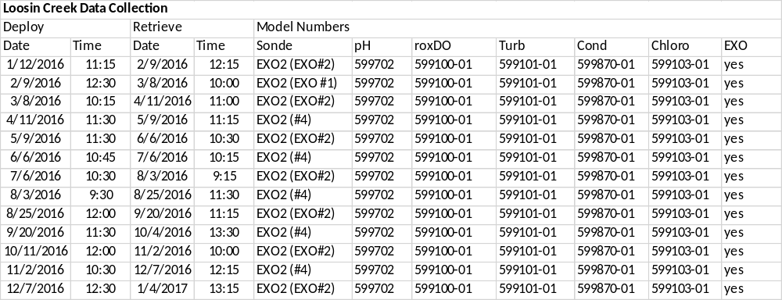

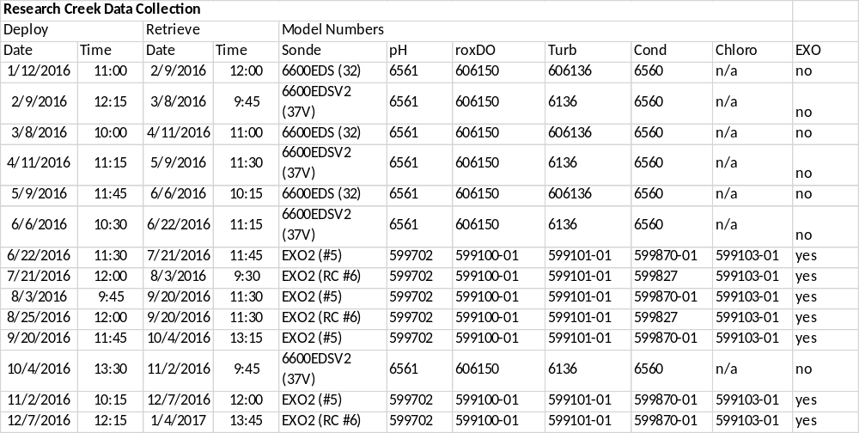

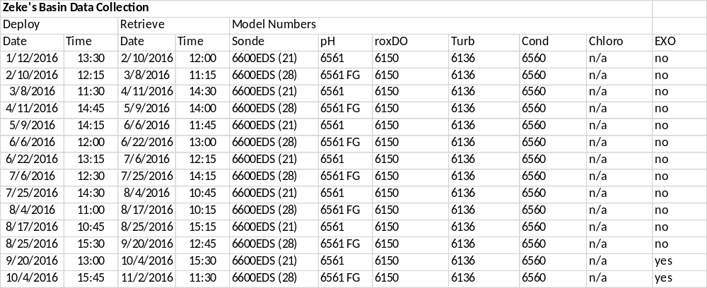

7) Distribution

NOAA retains the right to analyze, synthesize and publish summaries of the NERRS System-wide Monitoring Program data. The NERRS retains the right to be fully credited for having collected and process the data. Following academic courtesy standards, the NERR site where the data were collected should be contacted and fully acknowledged in any subsequent publications in which any part of the data are used. The data set enclosed within this package/transmission is only as good as the quality assurance and quality control procedures outlined by the enclosed metadata reporting statement. The user bears all responsibility for its subsequent use/misuse in any further analyses or comparisons. The Federal government does not assume liability to the Recipient or third persons, nor will the Federal government reimburse or indemnify the Recipient for its liability due to any losses resulting in any way from the use of this data.

Requested citation format:
NOAA National Estuarine Research Reserve System (NERRS). System-wide Monitoring Program. Data accessed from the NOAA NERRS Centralized Data Management Office website: http://www.nerrsdata.org/; accessed 12 October 2012.

Also include the following excerpt in the metadata which will address how and where the data can be obtained.

NERR water quality data and metadata can be obtained from the Research Coordinator at the individual NERR site (please see Principal Investigators and Contact Persons), from the Data Manager at the Centralized Data Management Office (please see personnel directory under the general information link on the CDMO home page) and online at the CDMO home page www.nerrsdata.org. Data are available in comma delimited format.
.

8) Associated researchers and projects

As part of the SWMP core monitoring program, the North Carolina Reserve also collects weather data from a meteorological station located at the Research Creek monitoring site and water chemistry/nutrient data from all 4 of the water quality monitoring sites. These data may be correlated with the water quality data.

Additional research projects are ongoing and continually changing. Check with the Research Coordinator or other contact person for an updated list of research.

II. Physical Structure Descriptors

9) Sensor specifications –

NOC NERR deployed 6600EDS at Research Creek until 6/22/2016 11:15, EXOs were then used for all deployments after except for the 10/4 deployment when a 6600 was used again. At Zeke’s Basin 6600s were used until 11/2/2016 11:30, EXOs were used from 11/2/2016 11:45 to the end of the year. EXO sondes were used at East Cribbings and Loosin Creek during 2016.

YSI 6600EDS data sonde:

Parameter: Temperature
Units: Celsius (C)
Sensor Type: Thermistor
Model#: 6560
Range: -5 to 50 C
Accuracy: +/- 0.15
Resolution: 0.01 C

Parameter: Conductivity
Units: milli-Siemens per cm (mS/cm)
Sensor Type: 4-electrode cell with autoranging
Model#: 6560
Range: 0 to 100 mS/cm
Accuracy: +/- 0.5% of reading + 0.001 mS/cm
Resolution: 0.001 mS/cm to 0.1 mS/cm (range dependant)

Parameter: Salinity
Units: parts per thousand (ppt)
Sensor Type: Calculated from conductivity and temperature
Range: 0 to 70 ppt
Accuracy: +/- 1.0% of reading pr 0.1 ppt, whichever is greater
Resolution: 0.01 ppt

Parameter: Dissolved Oxygen % saturation
Units: percent air saturation (%)
Sensor Type: Rapid Pulse - Clark type, polargraphic
Model#: 6562
Range: 0 to 500% air saturation
Accuracy: 0-200% air saturation: +/- 2% of the reading or 2% air saturation, whichever is greater; 200 to 500% air saturation: +/- 6% of the reading
Resolution: 0.1% air saturation

or

Sensor Type: Optical probe w/ mechanical cleaning
Model#: 6150 ROX
Range: 0 to 500% air saturation
Accuracy: 0-200% air saturation: +/- 1% of the reading or 1% air saturation, whichever is greater 200-500% air saturation: +/- 15% or reading
Resolution: 0.1% air saturation

Parameter: Dissolved Oxygen mg/L (Calculated from % air saturation, temperature, and salinity)
Units: milligrams/Liter (mg/L)
Sensor Type: Rapid Pulse - Clark type, polargraphic
Model#: 6562
Range: 0 to 50 mg/L
Accuracy: 0-20 mg/L: +/- 2% of the reading or 0.2 mg/L, whichever is greater
20 to 50 mg/L: +/- 6% of the reading
Resolution: 0.01 mg/L

or

Units: milligrams/Liter (mg/L)
Sensor Type: Optical probe w/ mechanical cleaning
Model#: 6150 ROX
Range: 0 to 50 mg/L
Accuracy: 0-20 mg/L: +/-0.1 mg/l or 1% of the reading, whichever is greater
20 to 50 mg/L: +/- 15% of the reading
Resolution: 0.01 mg/L

Parameter: Non-vented Level - Shallow (Depth)
Units: feet or meters (ft or m)
Sensor Type: Stainless steel strain gauge
Range: 0 to 30 ft (9.1 m)
Accuracy: +/- 0.06 ft (0.018 m)
Resolution: 0.001 ft (0.001 m)

Parameter: pH – bulb probe or EDS flat glass probe
Units: pH units
Sensor Type: Glass combination electrode
Model#: 6561 or 6561FG
Range: 0 to 14 units
Accuracy: +/- 0.2 units
Resolution: 0.01 units

Parameter: Turbidity
Units: nephelometric turbidity units (NTU)
Sensor Type: Optical, 90 degree scatter, with mechanical cleaning
Model#: 6136
Range: 0 to 1000 NTU
Accuracy: +/- 2% of reading or 0.3 NTU (whichever is greater)
Resolution: 0.1 NTU

Parameter: Chlorophyll Fluorescence
Units: micrograms/Liter
Sensor Type: Optical probe w/ mechanical cleaning
Model#: 6025
Range: 0 to 400 ug/Liter
Accuracy: Dependent on methodology
Resolution: 0.1 ug/L chl a, 0.1% FS

YSI EXO Sonde:

Parameter: Temperature
Units: Celsius (C)
Sensor Type: CT2 Probe, Thermistor
Model#: 599870
Range: -5 to 50 C
Accuracy: -5 to 35: +/- 0.01, 35 to 50: +/- .005
Resolution: 0.01 C

Parameter: Conductivity
Units: milli-Siemens per cm (mS/cm)
Sensor Type: CT2 Probe, 4-electrode cell with autoranging
Model#: 599870
Range: 0 to 200 mS/cm
Accuracy: 0 to 100: +/- 0.5% of reading or 0.001 mS/cm; 100 to 200: +/- 1% of reading
Resolution: 0.001 mS/cm to 0.1 mS/cm (range dependant)

Parameter: Salinity
Units: practical salinity units (psu)/parts per thousand (ppt)
Sensor Type: CT2 probe, Calculated from conductivity and temperature
Range: 0 to 70 psu
Accuracy: +/- 1.0% of reading pr 0.1 ppt, whichever is greater
Resolution: 0.01 psu

OR

Parameter: Temperature
Units: Celsius (C)
Sensor Type: Wiped probe; Thermistor
Model#: 599827
Range: -5 to 50 C
Accuracy: ±0.2 C
Resolution: 0.001 C

Parameter: Conductivity
Units: milli-Siemens per cm (mS/cm)
Sensor Type: Wiped probe; 4-electrode cell with autoranging
Model#: 599827
Range: 0 to 100 mS/cm
Accuracy: ±1% of the reading or 0.002 mS/cm, whichever is greater
Resolution: 0.0001 to 0.01 mS/cm (range dependent)

Parameter: Salinity
Units: practical salinity units (psu)/parts per thousand (ppt)
Model#: 599827
Sensor Type: Wiped probe; Calculated from conductivity and temperature
Range: 0 to 70 ppt
Accuracy: ±2% of the reading or 0.2 ppt, whichever is greater
Resolution: 0.01 psu

Parameter: Dissolved Oxygen % saturation
Sensor Type: Optical probe w/ mechanical cleaning
Model#: 599100-01
Range: 0 to 500% air saturation
Accuracy: 0-200% air saturation: +/- 1% of the reading or 1% air saturation, whichever is greater 200-500% air saturation: +/- 5% or reading
Resolution: 0.1% air saturation

Parameter: Dissolved Oxygen mg/L (Calculated from % air saturation, temperature, and salinity)
Units: milligrams/Liter (mg/L)
Sensor Type: Optical probe w/ mechanical cleaning
Model#: 599100-01
Range: 0 to 50 mg/L
Accuracy: 0-20 mg/L: +/-0.1 mg/l or 1% of the reading, whichever is greater
20 to 50 mg/L: +/- 5% of the reading
Resolution: 0.01 mg/L

Parameter: Non-vented Level - Shallow (Depth)
Units: feet or meters (ft or m)
Sensor Type: Stainless steel strain gauge
Range: 0 to 33 ft (10 m)
Accuracy: +/- 0.013 ft (0.004 m)
Resolution: 0.001 ft (0.001 m)

Parameter: pH
Units: pH units
Sensor Type: Glass combination electrode
Model#: 599701(guarded) or 599702(wiped)
Range: 0 to 14 units
Accuracy: +/- 0.01 units within +/- 10° of calibration temperature, +/- 0.02 units for entire temperature range
Resolution: 0.01 units

Parameter: Turbidity
Units: formazin nephelometric units (FNU)
Sensor Type: Optical, 90 degree scatter
Model#: 599101-01
Range: 0 to 4000 FNU
Accuracy: 0 to 999 FNU: 0.3 FNU or +/-2% of reading (whichever is greater); 1000 to 4000 FNU +/-5% of reading
Resolution: 0 to 999 FNU: 0.01 FNU, 1000 to 4000 FNU: 0.1 FNU

Parameter: Chlorophyll
Units: micrograms/Liter
Sensor Type: Optical probe
Model#: 599102-01
Range: 0 to 400 ug/Liter
Accuracy: Dependent on methodology
Resolution: 0.1 ug/L chl a, 0.1% FS

Dissolved Oxygen Qualifier (Rapid Pulse / Clark type sensor):
The reliability of dissolved oxygen (DO) data collected with the rapid pulse / Clark type sensor after 96 hours post-deployment for non-EDS (Extended Deployment System) data sondes may be problematic due to fouling which forms on the DO probe membrane during some deployments (Wenner et al. 2001). Some Reserves utilize the YSI 6600 EDS data sondes, which increase DO accuracy and longevity by reducing the environmental effects of fouling. Optical DO probes have further improved data reliability. The user is therefore advised to consult the metadata for sensor type information and to exercise caution when utilizing rapid pulse / Clark type sensor DO data beyond the initial 96-hour time period. Potential drift is not always problematic for some uses of the data, i.e. periodicity analysis. It should also be noted that the amount of fouling is very site specific and that not all data are affected. If there are concerns about fouling impacts on DO data beyond any information documented in the metadata and/or QAQC flags/codes, please contact the Research Coordinator at the specific NERR site regarding site and seasonal variation in fouling of the DO sensor.

Depth Qualifier:

The NERR System-Wide Monitoring Program utilizes YSI data sondes that can be equipped with either vented or non-vented depth/level sensors. Readings for both vented and non-vented sensors are automatically compensated for water density change due to variations in temperature and salinity; but for all non-vented depth measurements, changes in atmospheric pressure between calibrations appear as changes in water depth. The error is equal to approximately 1.02 cm for every 1 millibar change in atmospheric pressure, and is eliminated for vented sensors because they are vented to the atmosphere throughout the deployment time interval.

Beginning in 2006, NERR SWMP standard calibration protocol calls for all non-vented depth sensors to read 0 meters at a (local) barometric pressure of 1013.25 mb (760 mm/hg). To achieve this, each site calibrates their depth sensor with a depth offset number, which is calculated using the actual atmospheric pressure at the time of calibration and the equation provided in the SWMP calibration sheet or digital calibration log. This offset procedure standardizes each depth calibration for the entire NERR System. If accurate atmospheric pressure data are available, non-vented sensor depth measurements at any NERR can be corrected.

In 2010, the CDMO began automatically correcting depth/level data for changes in barometric pressure as measured by the Reserve’s associated meteorological station during data ingestion. These corrected depth/level data are reported as cDepth and cLevel, and are assigned QAQC flags and codes based on QAQC protocols. Please see sections 11 and 12 for QAQC flag and code definitions.

NOTE: older depth data cannot be corrected without verifying that the depth offset was in place and whether a vented or non-vented depth sensor was in use. No SWMP data prior to 2006 can be corrected using this method. The following equation is used for corrected depth/level data provided by the CDMO beginning in 2010:
((1013-BP)*0.0102)+Depth/Level = cDepth/cLevel.

Salinity Units Qualifier:

In 2013, EXO sondes were approved for SWMP use and began to be utilized by Reserves. While the 6600 series sondes report salinity in parts per thousand (ppt) units, the EXO sondes report practical salinity units (psu). These units are essentially the same and for SWMP purposes are understood to be equivalent, however psu is considered the more appropriate designation. Moving forward the NERR System will assign psu salinity units for all data regardless of sonde type.

Turbidity Qualifier:

In 2013, EXO sondes were approved for SWMP use and began to be utilized by Reserves. While the 6600 series sondes report turbidity in nephelometric turbidity units (NTU), the EXO sondes use formazin nephelometric units (FNU). These units are essentially the same but indicate a difference in sensor methodology, for SWMP purposes they will be considered equivalent. Moving forward, the NERR System will use FNU/NTU as the designated units for all turbidity data regardless of sonde type. If turbidity units and sensor methodology are of concern, please see the Sensor Specifications portion of the metadata.

Chlorophyll Fluorescence Disclaimer:
YSI chlorophyll sensors (6025 or 599102-01) are designed to serve as a proxy for chlorophyll concentrations in the field for monitoring applications and complement traditional lab extraction methods; therefore, there are accuracy limitations associated with the data that are detailed in the YSI manual including interference from other fluorescent species, differences in calibration method, and effects of cell structure, particle size, organism type, temperature, and light on sensor measurements.

10) Coded variable definitions:

Sampling station: Sampling site code: Station code:
Research Creek RC nocrcwq
Loosin Creek LC noclcwq
East Cribbings EC nocecwq
Zeke’s Basin ZB noczbwq

11) QAQC flag definitions

QAQC flags provide documentation of the data and are applied to individual data points by insertion into the parameter’s associated flag column (header preceded by an F_). During primary automated QAQC (performed by the CDMO), -5, -4, and -2 flags are applied automatically to indicate data that is missing and above or below sensor range. All remaining data are then flagged 0, passing initial QAQC checks. During secondary and tertiary QAQC 1, -3, and 5 flags may be used to note data as suspect, rejected due to QAQC, or corrected.

-5 Outside High Sensor Range
-4 Outside Low Sensor Range
-3 Data Rejected due to QAQC
-2 Missing Data
-1 Optional SWMP Supported Parameter
0 Data Passed Initial QAQC Checks
1 Suspect Data
2 Open - reserved for later flag
3 Calculated data: non-vented depth/level sensor correction for changes in barometric pressure
4 Historical Data: Pre-Auto QAQC
5 Corrected Data

12) QAQC code definitions

QAQC codes are used in conjunction with QAQC flags to provide further documentation of the data and are also applied by insertion into the associated flag column. There are three (3) different code categories, general, sensor, and comment. General errors document general problems with the deployment or YSI datasonde, sensor errors are sensor specific, and comment codes are used to further document conditions or a problem with the data. Only one general or sensor error and one comment code can be applied to a particular data point, but some comment codes (marked with an * below) can be applied to the entire record in the F_Record column.

General Errors
GIC No instrument deployed due to ice
GIM Instrument malfunction
GIT Instrument recording error; recovered telemetry data
GMC No instrument deployed due to maintenance/calibration
GNF Deployment tube clogged / no flow
GOW Out of water event
GPF Power failure / low battery
GQR Data rejected due to QA/QC checks
GSM See metadata
Corrected Depth/Level Data Codes
GCC Calculated with data that were corrected during QA/QC
GCM Calculated value could not be determined due to missing data
GCR Calculated value could not be determined due to rejected data
GCS Calculated value suspect due to questionable data
GCU Calculated value could not be determined due to unavailable data

Sensor Errors
SBO Blocked optic
SCF Conductivity sensor failure
SCS Chlorophyll spike
SDF Depth port frozen
SDG Suspect due to sensor diagnostics
SDO DO suspect
SDP DO membrane puncture
SIC Incorrect calibration / contaminated standard
SNV Negative value
SOW Sensor out of water
SPC Post calibration out of range
SQR Data rejected due to QAQC checks
SSD Sensor drift
SSM Sensor malfunction
SSR Sensor removed / not deployed
STF Catastrophic temperature sensor failure
STS Turbidity spike
SWM Wiper malfunction / loss

Comments
CAB* Algal bloom
CAF Acceptable calibration/accuracy error of sensor
CAP Depth sensor in water, affected by atmospheric pressure
CBF Biofouling
CCU Cause unknown
CDA* DO hypoxia (<3 mg/L)
CDB* Disturbed bottom
CDF Data appear to fit conditions
CFK* Fish kill
CIP * Surface ice present at sample station
CLT* Low tide
CMC* In field maintenance/cleaning
CMD* Mud in probe guard
CND New deployment begins
CRE* Significant rain event
CSM* See metadata
CTS Turbidity spike
CVT* Possible vandalism/tampering
CWD* Data collected at wrong depth
CWE* Significant weather event

13) Post deployment information

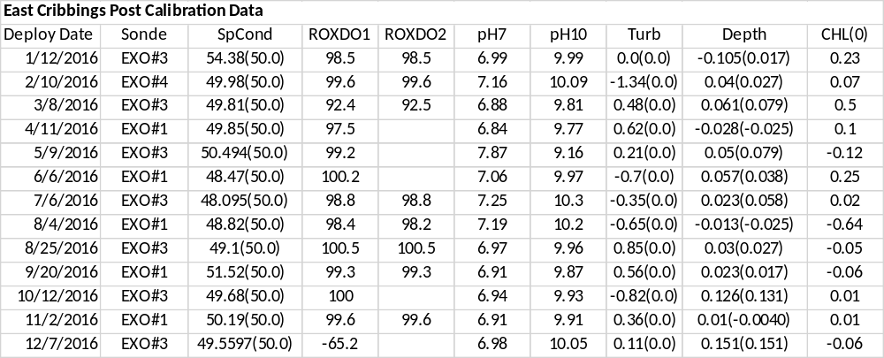

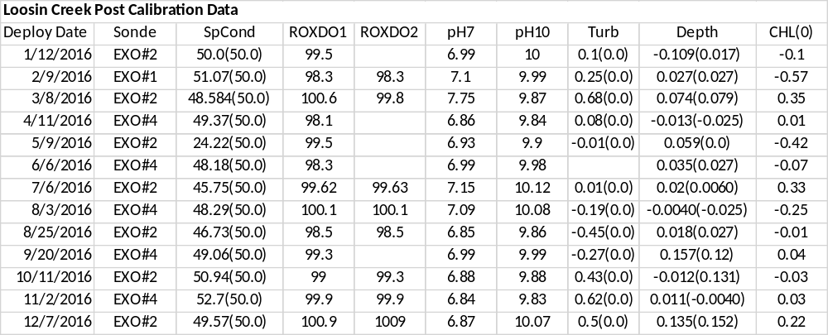

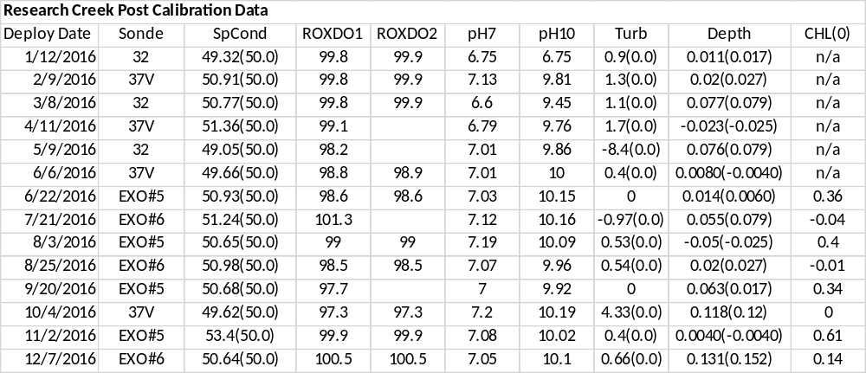

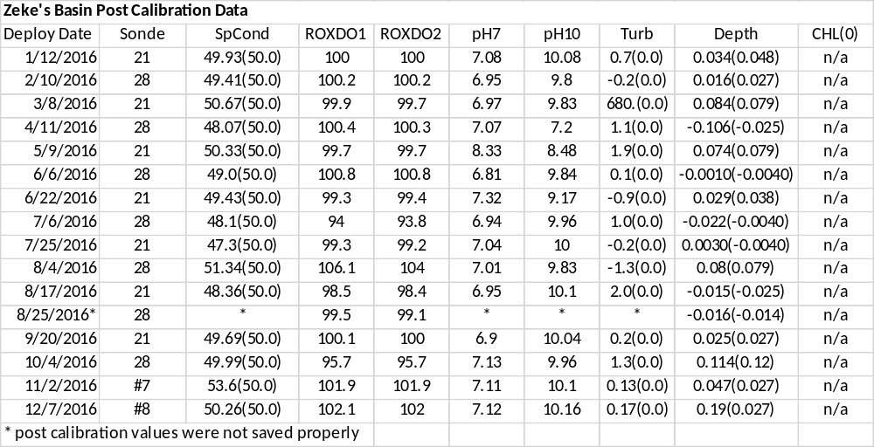

14) Other remarks/notes

Data are missing due to equipment or associated specific probes not being deployed, equipment failure, time of maintenance or calibration of equipment, or repair/replacement of a sampling station platform. Any NANs in the dataset stand for “not a number” and are the result of low power, disconnected wires, or out of range readings. If additional information on missing data is needed, contact the Research Coordinator at the reserve submitting the data.

For all data
New deployments were flagged as <0> (CND).

Temperature affected measurements (SpCond/Salinity, pH) were rejected anytime the temperature sensor was affected by out of water events (pronounced change in temp values during extreme low tide readings).

Data affected by low tide were coded (CLT). Lower SpCond/Salinity was addressed with <1> (CLT) due to the probability of fresher surface waters being measured as the water level decreased. Salinities approaching zero or less were addressed as <-3> [GOW] (CLT) and affected data were also rejected accordingly.

All depth data corresponding to rejected or suspect SpCond/Salinity data (due to low tide) were also rejected <-3> [SOW] (CLT) or flagged as suspect <1>[SOW](CLT). Depth sensor is located above Conductivity/Temperature (C/T) sensor and will be exposed when SpCond approaches 0.0. It is possible that some probes were still in the water during out of water events. The vertical orientation of the sondes means that shorter probes (pH, C/T) will be affected before longer probes (dissolved oxygen, turbidity).

All negative depth flagged and rejected unless affected by barometric pressure and coded as suspect <1> [SNV] (CAP).

Dissolved oxygen concentrations < 3 mg/L were coded <0> (CDA) along with corresponding values for DO% during hypoxic events.

Increased turbidity readings occurred throughout many deployments with unknown causes and were coded as such:
<-3> [STS] (CCU) = rejected turbidity spike
<1> [STS] (CCU) = Suspect turbidity spike

Small negative turbidity values < -2 NTU were flagged as suspect, <1> (CAF).

Negative chlorophyll values were flagged as <-3> [SNV] (CSM).

Chlorophyll spikes were flagged as suspect <1> [SCS] (CCU), or rejected <-3> [SCS] (CCU).

East Cribbings
General
This station was converted to EXO2 sondes during 2015, beginning with the 09/15/2015 deployment.

This site has had increasing problems with mud and silt in the deployment tube, affected readings and filling the guard above the level of the sensors.

This site is within a shallow lagoonal system and the sonde is subject to out of water events, especially at spring low tides. (Vertical deployment has been in place since 12/04/12.)

Data were missing sporadically and flagged <-2> [GPF] (CSM), during the following time period due to power/battery failure:
01/01/2016 00:00 - 01/12/2016 12:45
03/22/2016 01:45 - 04/11/2016 14:15
08/19/2016 2:45 – 08/25/2016 15:15
10/04/2016 15:30 - 10/12/2016 13:15

Station was negatively affected by silting during several extended periods. Mud and silt filled in the deployment tube, covering sensors and impacting data. These data were flagged as suspect or rejected, <-3> (CMD), for all parameters.
07/29/2016 00:00 - 08/19/2016 02:30
08/30/2016 20:00 - 09/20/2016 12:30

Data were missing from 10/04 – 10/12/2016 as sonde was pulled from the water as Hurricane Matthew approached the North Carolina coast.

Data were missing due to a sonde swap: 03/08/2016 11:15, 11/02/2016 11:30, 12/07/2016 15:30

Depth
Small negative depth values occurred due to changes in barometric pressure. Other sensors were not affected, but depth data were flagged as suspect <1> [SNV] (CAP) for the following times:
09/02/2016 5:45 – 6:00
09/03/2016 4:45 – 6:00
09/18/2016 16:15 and 17:00 – 17:30
09/19/2016 4:30 – 5:45
09/19/2016 17:15 – 18:30
09/20/2015 5:15
09/20/2017 17:30
09/21/2016 5:45 – 7:00
09/27/2016 12:15 – 13:30
09/28/2016 1:00 – 1:45

Throughout the 10/14/2016 deployment, there were out of water events, with some negative depth readings which were rejected. There were periods where the depth was negative due to fluctuations in barometric pressure but it appears probes were in the water. In both cases, depth data were rejected.

10/14/2016, 11/02/2016 and 12/07/2016 deployments, data showed several out of water events. Some of these events affected specific probes while others resulted in all data being rejected.

SpCond/Salinity
The SpCond/Salinity post-calibration values were unacceptable for several deployment periods. All data were flagged as suspect for the following affected deployments:
01/12/2016
03/07/2016
06/06/2016

07/06/2016 deployment, post calibration values were slightly below acceptable range and data were flagged as suspect for the first portion of the deployment. When the sonde was retrieved, field notes documented mud and silt within the guard and covering sensors. Data from 7/29/2016 through the end of the deployment was rejected.

08/04/2016 deployment, values at the beginning of deployment flagged as suspect due to mud in the guard. Beginning 08/05/2016, data values were rejected as they were affected by mud in guard.

08/25/2016 deployment, data were rejected from 08/30/2016 through the end of the deployment (09/20/2016) due to mud in the guard.

10/14/2016 deployment, data showed several out of water events. Some of these events affected specific probes while others resulted in all data being rejected. Often the records directly before or after these events were flagged as suspect. These records may have measured a fresh water lens at the surface or may have been in and out of the water.

10/14/2016, 11/02/2016 and 12/07/2016 deployments, SpCond/Salinity sensors experienced out of water events and data was rejected. The readings directly prior and after these events were flagged as suspect and may have measured a fresh water lens or may have been in and out of the water during these times. Flagged suspect or rejected, SOW CSM or GOW CSM

Dissolved Oxygen
Dissolved oxygen data can be quite variable. These cycles often correlate with tidal fluctuation, and may be accentuated by presence of invasive drift algae, Gracilaria vermiculophylla.

Values above 100% saturation are not uncommon and values above 200% may occur during warmer months. These reflect conditions at the site, occurring at the same time as elevated pH values and data were retained (unless affected by out of water events, potentially driven by G. vermiculophylla presence). Data were not flagged as suspect though some of the upper limits for percent saturation were surpassed.

03/08/2016 deployment, post-calibration values were unacceptable. DO data during this deployment are likely (~6% Sat, 0.5mg/L) below actual levels All data were flagged as suspect for the following affected deployments <1> [SDO] (CSM):

07/06/2016 deployment, field notes documented mud and silt within the guard and covering sensors when sonde was retrieved from the field. Data from 7/29/2016 through the end of the deployment was rejected.

08/04/2016 deployment, all values were rejected as they were affected by mud in the guard.

08/25/2016 deployment, data were rejected from 08/30/2016 through the end of the deployment (09/20/2016) due to mud in the guard.

10/14/2016, 11/02/2016 and 12/07/2016 deployments, data showed several out of water events. Some of these events affected specific probes while others resulted in all data being rejected.

12/07/2016 deployment, data for dissolved oxygen was negative and rejected. Upon retrieval, this sonde’s wiper was not functioning properly. Data prior to the negative values was flagged as suspect due to negative values during post calibration <1> [SPC] (CSM). All negative data rejected <-3> [SQR] (CSM).
pH
03/08/2016 deployment, pH post-calibration values were unacceptable due to standard contamination. All data were flagged as suspect <1> [SIC] (CSM).

05/09/2016 deployment, pH post calibration was not within acceptable range for the 10 standard. Data seem to fit conditions for the site and were flagged as suspect <1> [SPC] (CDF).
07/06/2016 deployment, field notes documented mud and silt within the guard and covering sensors when sonde was retrieved from the field. Data from 7/29/2016 through the end of the deployment was rejected.

08/04/2016 deployment, all values were rejected as they were affected by mud in the guard.

08/25/2016 deployment, data were rejected from 08/30/2016 through the end of the deployment (09/20/2016) due to mud in the guard.

10/14/2016, 11/02/2016 and 12/07/2016 deployments, data showed several out of water events. Some of these events affected specific probes while others resulted in all data being rejected.

Turbidity
Elevated turbidity readings were rejected or flagged as suspect.

07/06/2016 deployment, field notes documented mud and silt within the guard and covering sensors when sonde was retrieved from the field. Data from 7/29/2016 through the end of the deployment was rejected.

08/04/2016 deployment, all values were rejected as they were elevated due to mud in the guard.

08/25/2016 deployment, data were rejected from 08/29/2016 through the end of the deployment (09/20/2016) due to mud in the guard.

09/20/2016 deployment, turbidity spikes were rejected beginning 09/23/2016. The cause is unknown.

10/14/2016, 11/02/2016 and 12/07/2016 deployments, data showed several out of water events. Some of these events affected specific probes while others resulted in all data being rejected.

Chlorophyll
Occasional chlorophyll spikes occurred and were flagged as suspect or rejected, cause unknown.

07/06/2016 deployment, field notes documented mud and silt within the guard and covering sensors when sonde was retrieved from the field. Data from 7/29/2016 through the end of the deployment was rejected.

08/04/2016 deployment, values were flagged as suspect in the early portion of the deployment and then rejected beginning 08/17/2016, as they were elevated due to mud in the guard.
08/25/2016 deployment, data were rejected from 08/30/2016 through the end of the deployment (09/20/2016) due to mud in the guard.

10/14/2016, 11/02/2016 and 12/07/2016 deployments, data showed several out of water events. Some of these events affected specific probes while others resulted in all data being rejected.

Loosin Creek
General
This site typically has low turbidity values, occasionally these values approach zero and fit conditions of the site. Negative one readings were retained and marked as (CAF), acceptable calibration/accuracy error of the sensor.

This station was converted to EXO2 sondes during 2015, beginning with the 04/08/2015 deployment.

Missing records due to sonde swap: 04/11/2016 11:15, 08/25/2016 11:45, 11/02/2016 10:15

Missing records due to battery failure: 01/01/2016 – 01/12/2016

Missing data due to Hurricane Matthew approaching the North Carolina coast: 10/04/2016 13:45 – 10/11/2016 11:45. Sonde was redeployed three days after event and impacts from the storm were not as great as some forecasts predicted.

SpCond/Salinity
The following deployments were flagged as suspect due to SpCond/Salinity post calibration values that were outside the acceptable range:
05/09/2016 data appears to be elevated, disjunct from previous deployment
07/06/2016
08/25/2016

11/02/2016 deployment was flagged as suspect due to post calibration values that were outside of the acceptable range. The values for the deployment seem elevated and the standard for calibration may have been contaminated.

pH
Values for pH during the 02/09/2016 deployment were higher than surrounding deployments and data is flagged as suspect. Calibration and post calibration values were all within acceptable range but there may have been a malfunction with the probe.
Turbidity
Elevated turbidity readings were rejected or flagged as suspect.

Beginning 04/07/2016 turbidity values were elevated. Values were rejected from this point through the end of the deployment 04/11/2016.

Beginning 05/29/2016 turbidity values were elevated. Values were rejected from this point through the end of the deployment 06/06/2016.

Chlorophyll
Negative chlorophyll values were flagged as <-3> [SNV] (CSM).

Chlorophyll spikes were flagged as suspect <1> [SCS] (CCU), or rejected <-3> [SCS] (CCU).

Research Creek
General
Missing due to sonde swap: 11/02/2016 10:00

Missing data due to battery failure:
01/12/2016 01:00 – 8:00 resumed at 8:15 on 01/12/2016 and sonde was swapped later that morning.
04/08/2016 21:00 – 04/11/2016 11:00
06/20/2016 06:45 – 06/22/2016 11:30

SpCond/Salinity
Dips in salinity occurred during low tide. There may have been some stratification and sensors may be measuring a fresh water lens as approaching the surface.

12/01/2015 deployment, SpCond failed to pass post calibration within an acceptable range. The data from 01/01/2016 – 01/12/2016 was flagged as suspect.

11/02/2016 deployment, SpCond/Sal failed to pass post calibration within acceptable ranges. Values for the entire deployment were flagged as suspect and seem elevated. There may have been contamination of the standard used for calibration as there were similar results with the Loosin Creek sonde.

12/12/2016, data shows a drop in salinity near low tide, cause is unknown but probe appears to be functioning properly. Data was not flagged.

Dissolved Oxygen
Dissolved oxygen concentrations were highly variable during March 2016, with values oscillating between 17 – 130% with tidal cycles. These occurred as the water temperature increased. Though turbidity values for this time were flagged as suspect or rejected, the increased turbidity and possibly presence of macroalgae affected dissolved oxygen.

03/13/2016, elevated turbidity values occurred at the same time that dissolved oxygen dropped to zero. While low DO readings were present during this deployment, the drop to zero may have been due to the optical probes malfunctioning. The zero reading was rejected due to QA/QC checks and the low dissolved oxygen readings were retained.
pH
12/01/2015 deployment, pH failed to pass post calibration within acceptable range for both the 7 and 10 standard. The slope was fine. There was mud caked on the sensor after retrieval from the field. Data for the entire deployment were flagged as suspect, from 01/01/2016 – 01/12/2016.

01/12/2016 deployment, pH failed to pass post calibration within acceptable range for both the 7 and 10 standard. Data for the entire deployment were flagged as suspect.

02/09/2016 deployment, pH failed to pass post calibration within acceptable range for the 10 standard. Data for the entire deployment were flagged as suspect.

03/08/2016 deployment, pH failed to pass post calibration within acceptable range for both the 7 and 10 standard. Data for the entire deployment were flagged as suspect.

10/04/2016 deployment, pH appeared to be elevated and more variable than surrounding deployments. The entire deployment was flagged as suspect due to QAQC checks.

Turbidity
Turbidity spikes were rejected or flagged as suspect.

01/12/2016 deployment, turbidity passed post calibration within acceptable range but the data was elevated for entire deployment. Data was rejected from 01/12/2016 – 02/09/2016.

03/09/2016 deployment had periods of elevated turbidity values. These were rejected if over the sensor limit or isolated data points, but flagged as suspect if continuous and under 1000 NTU.

05/09/2016 deployment had lots of negative values during the deployment and the post calibration values were outside of acceptable range. Turbidity data for the entire deployment was rejected.

06/22/2016 deployment, turbidity probe failure occurred on 06/24/2016. No turbidity data was collected for the remainder of the deployment.

08/03/2016 turbidity spikes were flagged as suspect or rejected, cause unknown.

08/25/2016 turbidity spikes were flagged as suspect or rejected, cause unknown.

10/04/2016 deployment had some isolated elevated turbidity values and did not pass post calibration with acceptable values. Much of the deployment seems to reflect conditions of the site but was flagged as suspect due to post calibration values.

11/02/2016 deployment had some isolated elevated turbidity values that surpassed the sensor limits and were rejected, cause unknown.

Zeke’s Basin
General
This site is within a shallow lagoonal system and the sonde is subject to our of water events, especially at spring low tides.

Station converted to support EXO sondes 11/2/2016 11:45.
Growth of invasive Gracilaria vermiculophylla has been heavy around this site. Increased biomass, sedimentation, and decaying organic material are becoming a chronic problem in this location. Optical probes are increasingly affected.

Data missing due to battery failures: 05/03/2016 17:00 - 05/09/2016 14:00

Missing data due sonde swap: 01/12/2016 13:15 and 08/17/2016 10:30

Out of water events are described in Depth section.

Accumulation of mud in the sonde deployment tube/guard resulted in rejected and suspect data for DO, Turbidity, and Chlorophyll. Mud may affect probes individually. Most of these data are flagged as suspect
<1> [SBO] (CMD) or <-3> [SBO] (CMD) when data are obviously affected by mud or outside the sensor range.

After the 11/02/2016 deployment, the wiper was missing upon sonde retrieval. The data was retained and seems to fit conditions for the site.

Depth
There were several times that changes in barometric pressure affected the depth sensor. The depth records were flagged as suspect, <1> [SNV] (CAP) when the values were negative but the sensors were still in the water.

09/02/2016 15:45 - 09/02/2016 17:00, low tide exposed salinity contacts and depth data was flagged as suspect. Other parameters were unaffected.

SpCond/Salinity
Sporadic temporary small dips in salinity at low tide are assumed to be lower salinity surface waters. Often these were associated with out of water events and may be coded as suspect, low tide <1> CLT or as suspect sensor out of water <1> [SOW] (CLT).

04/05/2016 15:00 – 15:30 was flagged as suspect <1>[SOW] (CLT). Temperature and other parameters were not affected.

04/11/2016 deployment, SpCond was low during post calibration. Data was flagged as suspect though appears to fit conditions for the site and was flagged <1> [SPC] (CDF).

For the following deployment SpCond vales were low during post calibration. Data was flagged as suspect and though data appears to fit conditions for the site, the post cal values may have been affected by biofouling, flagged <1> [SPC] (CBF).
07/06/2016
07/25/2016
08/17/2016

09/02/2016 15:45 - 09/02/2016 17:00 salinity and SpCond data were rejected during the low tide due to a sensor out of water event. Data were flagged <-3> [SOW] (CLT).

11/02/2016 deployment, SpCond values were above the acceptable range for post calibration. Data was flagged as suspect for the entire deployment.

Dissolved Oxygen
Especially during summer months, oxygen data can be quite variable. These cycles often correlate with tidal fluctuation and were likely driven by presence of drift algae (Gracilaria vermiculophylla).

High values were recorded for dissolved oxygen, sometimes surpassing 200% saturation. These reflect conditions at the site, occurring at the same time as elevated pH values and data were retained (unless affected by out of water events, potentially driven by G. vermiculophylla presence). Data were retained.

Repeated episodic hypoxic events at Zeke’s Basin WQ station occurred through the months of January and February 2016, which is uncharacteristic of this time of year. Events span one or several days. This effect was also detected by the East Cribbing’s WQ station as the tide ebbed following two such episodes.

Postcalibration values not within accepatable range for dissolved oxygen during the following the deployments due to biofouling. Data flagged suspect <1> [SPC] (CBF). Next deployment’s DO values align well and are NOT disjunct.
07/06/2016
10/04/2016

Postcalibration failure for dissolved oxygen during the following the deployments due to biofouling. Data flagged suspect <1> [SPC] (CBF).
08/4/2016

10/04/2016 deployment, post calibration for dissolved oxygen was low. Much of the data fits conditions for the site but the entire deployment was flagged as suspect.
pH
Several pH values >9.0 were associated with high dissolved oxygen concentrations and presumed to be resulting from high rates of photosynthesis and a large standing crop of macrophytic algae, G. vermiculophylla, in the area. The algal biomass is not ephemeral and therefore not considered an “algal bloom”. These data were closely scrutinized and retained after determining the cause.

04/11/2016 deployment, pH failed to pass post calibration within acceptable range for the 10 standard. Data for the entire deployment were flagged as suspect.

05/09/2016 14:30 deployment, pH postcalibration values were unacceptable. Data flatlined around 7.7 from 05/26/2016 00:45 through the end of the deployment (06/06/2016 11:45) and were rejected. Prior data seems to fit conditions. However, data flagged suspect from the initial deployment through 05/26/2016 00:45 as a precaution due to this failure.

pH sensor affected by biofouling in the following deployments and flagged as suspect:
06/06/2016
06/22/2016

10/04/2016 deployment, pH slope was below ideal range during post calibration. This data was not flagged as suspect because the probe had acceptable values for both the 7 and 10 post calibration solutions.

Turbidity
Periods of elevated turbidity values were crosschecked with weather data to determine if they were driven by weather. Turbidity at Zeke’s Basin station is particularly sensitive to high or sustained winds due to winds during periods of low water and is a normal occurrence. All data above 1000 NTU were rejected <-3> [STS] (CSM).

Turbidity sensor wiper began parking over the wiper during the 03/07/16 deployment. Data rejected and flagged <-3> [SBO] (CSM) 04/06/2016 14:15 through the rest of the deployment. When the wiper was removed the probe, postcalibration was acceptable. Preceding data from that deployment was retained.

08/17/2016 deployment, turbidity failed to pass post calibration within acceptable range. The entire deployment was flagged as suspect <1> [SPC] (CBF), unless values were rejected for surpassing 1000 NTU.

During the data collected for 10/08-09/2016, turbidity was elevated then dropped to zero and slightly negative values over a 7 hour period. The values that were above the sensor range were rejected and the low and negative values were flagged as suspect, cause unknown. Some elevated data following this event was flagged as suspect as well.

