Narragansett Bay (NAR) National Estuarine Research Reserve Water Quality Metadata

January to December 2008
Latest update: Monday January 16, 2017

I. Data Set and Research Descriptors

- Principal Investigator and Contact Persons

Address: Narragansett Bay NERR
55 South Reserve Drive
Prudence Island, RI 02872
Phone: 401-683-6780
Fax: 401-682-7366

Contact Persons:
Dr. Kenneth Raposa, Research Coordinator

E-mail: kenny@nbnerr.org; (401) 683-7849

Dr. Daisy Durant, Marine Research Specialist II

E-mail: daisy@nbnerr.org (401) 683-7368

- Entry Verification

Data are downloaded from the YSI Model 6600 sondes to comma-delimited files (*.csv) and PC6000 files (*.dat) to a PC located at the reserve laboratory. Graphs are produced from the .dat files using the EcoWatch application supplied by YSI and examined for obvious sensor failure, using the suggested data analysis protocol provided to the NERRS by YSI. A post-deployment check is run on the sondes to determine if there is significant sensor drift (>10%) due to biofouling. Fouling of sensors is detected by 1) visual inspection of the instrument, 2) post-deployment measurements taken using calibration standards, and 3) by comparing final measurements of a given deployment with initial measurements of the succeeding deployment.
Deployment data are uploaded from the YSI data logger to a Personal Computer (IBM compatible). Files are exported from EcoWatch in a comma-delimited format (.CDF) and uploaded to the CDMO where they undergo automated primary QAQC; automated depth/level corrections for changes in barometric pressure (cDepth or cLevel parameters); and become part of the CDMO’s online provisional database. All pre- and post-deployment data are removed from the file prior to upload. During primary QAQC, data are flagged if they are missing or out of sensor range. The edited file is then returned to the Reserve for secondary QAQC where it is opened in Microsoft Excel and processed using the CDMO’s NERRQAQC Excel macro. The macro inserts station codes, creates metadata worksheets for flagged data and summary statistics, and graphs the data for review. It allows the user to apply QAQC flags and codes to the data, remove any overlapping deployment data, append files, and export the resulting data file for upload to the CDMO. Upload after secondary QAQC results in ingestion into the database as provisional plus data, recalculation of cDepth or cLevel parameters, and finally tertiary QAQC by the CDMO and assimilation into the CDMO’s authoritative online database. Where deployment overlap occurs between files, the data produced by the newly calibrated sonde is generally accepted as being the most accurate. For more information on QAQC flags and codes, see Sections 11 and 12. The person responsible for data management is Dr. Durant.
Sea-truthing was conducted by measuring water quality with an additional data logger taking real-time measurements at the time of deployment (except for the Nag Creek site). The data were recorded using a hand-held YSI 556-MPS data logger. Values for temperature, salinity, DO (mg/L), pH, and time were recorded real-time at either 0.5 or 1.0 meter intervals between the surface and bottom at each deployment site. The preparation and post-deployment procedures for the data logger used in sea-truthing follows the same general procedure as that for data loggers used in deployments, and is the responsibility of the reserve technician.
- Research objectives
YSI 6600 data loggers are being deployed off Prudence Island in Narragansett Bay as part of the National Estuarine Research Reserve's (NERR) System Wide Monitoring Program (SWMP). The goal is to develop long-term data sets for representative estuarine systems in order to track changes in water quality over time. Because Prudence Island is located in the geographic center of Narragansett Bay, it is an ideal location for monitoring the status and trends in water quality in the Bay over time. One NERR water quality monitoring station has been established at Potter Cove, on the island's northeastern shore. This area is impacted by boat traffic and storm runoff from mainland urban and residential areas. The second NERR water quality monitoring station, T-Wharf, is situated on the southeastern shore of the island, facing the open waters of Rhode Island Sound. It is approximately 6 miles south of the Potter Cove site. Boat traffic is sparse at this site and storm runoff is less likely to have a significant impact on water quality. A third monitoring site was added in March 2002. This monitoring site is located in Nag Creek, a salt marsh tidal creek which flows into the West Passage of Narragansett Bay. The addition of this site completes our representation of dominant habitat types occurring in Narragansett Bay (i.e. marsh, cove, and open water). In July of 2002, the T-Wharf monitoring station was replaced with two new monitoring sites located a short distance from the original T-Wharf location. The new stations are situated on either side of a wharf support piling. One data logger records water quality near the surface while the second records water quality parameters approximately 1.0 meters off the bottom. This allows for the identification of both the frequency and duration of any stratification which may occur in the open waters of Narragansett Bay. The Narragansett Bay water quality monitoring programs began in December 1995 at Potter Cove, and in September 1996 at T-Wharf (see Section 5, Site Location and Character section for description of sites). YSI electronic data loggers were deployed to measure the water temperature, specific conductance, dissolved oxygen, pH, depth, and turbidity conditions at 30-minute intervals. However, since 2004, data have been collected at 15-minute intervals.
- Research Methods
One data logger is deployed at each permanent monitoring station in Narragansett Bay. The instruments are deployed for approximately two weeks at a time, depending on the season, and measurements are taken every 15 minutes (see note below). The monitoring station at Potter Cove was originally constructed in 1995, and it consisted of a PVC pipe mounted vertically on a piling located approximately 6 feet west of a floating dock. To facilitate water flow across the sensors, openings were cut into the PVC pipes. The pipes were positioned to ensure that the sensors were less than 1 meter from the bottom. In 2006, the infrastructure at Potter Cove was replaced. It currently consists of a short PVC tube attached to an adjacent dock, with a line attached through the pipe to an anchor on the bottom. The sonde is attached to the anchor via a shackle and hook set-up, and a float is attached to the bottom of the sonde to keep it approximately 0.5 m off the bottom. With this setup, the sonde is free and clear of any pipe affects since the pipe does not extend to the bottom and serves only as a “decoy pipe” to prevent vandalism.
In 1996, the original T-Wharf station was put into service using a PVC pipe mounted on a piling attached to a pier. In 2002, the two replacement T-Wharf sites (surface and bottom) were also deployed in PVC pipes mounted to a piling. The sonde at the T-Wharf surface station is maintained just below the surface by means of a buoy attached by rope to the adjacent wharf; the sonde at T-wharf bottom is maintained approximately 1.0 m off the bottom. The pipes are cleaned monthly with a chimney brush during the summer to reduce the impact of biofouling on the data. On 10/11/06, the PVC deployment pipes and securing structures were replaced at the T-Wharf site. The design was similar to the previous pipe design and consisted of holes drilled through the pipe and large slits at the bottom of the pipe to allow for free water movement at the sonde. The T-wharf bottom pipe extends approximately 6.1 m though the water to the bottom of the site, where the sonde is kept approximately 1.0 m off the bottom. The T-wharf surface pipe extends approximately 1.5 m under the surface of the water (at low tide), where the sonde is attached to a float to keep it approximately 0.5 m below the surface of the water.
The Nag Creek sonde was originally deployed in a metal cage which was tethered to the bank. A permanent deployment structure was installed 12/31/02, consisting of a 4” x 4” pressure-treated post with a hinged 2” x 4” horizontal arm. On 09/08/06, the sonde deployment structure was redesigned and changed. The new structure consists of an L-shape wooden structure that held in place in the sediment by a large metal tripod sunk into the mud. The sonde is extended from the arm into the water via a cleat, eye and line system and hangs approximately 0.5 m from the bottom of the creek.
For each sampling period, each instrument is calibrated against known standards: the specific conductivity probe is calibrated using conductivity calibrator 50,000 µS/cm; a two point calibration is done for pH using pH buffer 7, and 10; a two point calibration of 0 and 123 is done for turbidity using deionized water and YSI 6073G turbidity standard, respectively; a one point calibration is done in water-saturated air for dissolved oxygen (DO); and a one point calibration (0) with deionized water is done for chlorophyll fluoresces (data only available upon request). When using EDS sondes, the dissolved oxygen (DO) membrane is replaced and allowed to stretch for a minimum of 12 hours before the Rapid Pulse DO sensor is calibrated in water-saturated air. The sonde is programmed to begin taking measurements approximately 12 hours in advance of planned deployment, allowing the DO membrane to stabilize. The file is checked for DO sensor drift before the DO probe is calibrated. The V2 sondes have optical DO probes (DO ROX), membranes are changed annually or when readings are not stable, and can be calibrated at the same time as the other sensors. For both types of sondes, calibration of the dissolved oxygen sensor is usually done within 2 hours of deployment. At the end of each sampling period, the data loggers are retrieved and recently calibrated instruments are deployed. The retrieved data loggers are brought back to the laboratory, post-deployment evaluations of the instrument are carried out, and the device is cleaned and serviced by methods outlined in the YSI Operating and Service Manual.
Note: Data from all stations was historically collected at 30-minute sampling intervals. In 2004, the Narragansett Bay NERR became involved with a statewide fixed site water quality monitoring program (refer to Section 8). Data collection at all stations was changed to 15 a minute sampling interval in order to be compliant with this local monitoring effort.
A Sutron Sat-Link2 transmitter was installed at the T-Wharf Bottom monitoring site on 07/27/06 and transmits data to the NOAA GOES satellite, NESDIS ID #3B0335EE. The transmissions are scheduled hourly and contain four (4) datasets reflecting fifteen minute data sampling intervals. Upon receipt by the CDMO, the data undergoes the same automated primary QAQC process detailed in Section 2 above. The “real-time” telemetry data become part of the provisional dataset until undergoing secondary and tertiary QAQC and assimilation in the CDMO’s authoritative online database. Provisional and authoritative data are available at http://cdmo.baruch.sc.edu.
- Site location and character
The NBNERR consists of 4376 acres of diverse estuarine and terrestrial habitats ranging from deep water to salt marshes to forested uplands. The land holdings include 65% of Prudence Island, most of nearby Patience Island, and all of Hope and Dyer Islands. The Reserve is located close to the geographic center of Narragansett Bay in Rhode Island.
The Narragansett Bay watershed consists of nine subwatersheds draining an area of approximately 4,836 square km ¹(Pilson, 1985) and numerous and substantial freshwater inputs to the Bay. Approximately 39% of the watershed lies in Rhode Island and 61% in Massachusetts. It is referred to as a shallow estuary; however, its water depth varies considerably. Depth averages approximately 9.0 m throughout the Bay, but it’s deeper in the East Passage (approximately 15.2 m) and shallower in the West Passage (approximately 7.5 m). More information and a detailed description of the Narragansett Bay NERR and the Narragansett Bay watershed can be found in ²Raposa and Schwartz, available at http://www.nbnerr.org/profile.htm.
Specific characteristics of the Narragansett Bay National Estuarine Research Reserve.
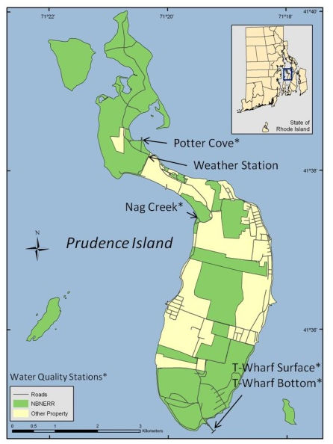
Location: 41°38’30” N, 71°20’30” W
Tidal range: -0.2 to 1.7 meters MLW
Salinity: 15 to 32 ppt
Temperature: -1.0 to 26 C
Province: North temperate, Virginian bioregion

Specific characteristics of the Nag Creek site are:
Location: 41º 37' 29.458" N, 71º 19' 27.421" W
Depth: 0.1 to 1.4 meters
Bottom habitat: Organic mud
Pollutants: Negligible
Watershed: Narragansett Bay, West Passage

Specific characteristics of the Potter Cove site are:
Location: 41º 38' 25.984" N, 71º 20' 27.165" W
Depth: 0.9 to 3.9 meters
Bottom habitat: Sand, silt, some organic mud
Pollutants: Boaters’ wastes, storm runoff from mainland urban areas
Watershed: Narragansett Bay, North Prudence (4801 square km)

Specific characteristics of the T-Wharf Surface site are:
Location: 41º 34' 42.099" N, 71º 19' 16.049" W
Depth: 0.2 to 0.9 meters
Bottom habitat: Sand, silt, some organic mud
Pollutants: Negligible
Watershed: Narragansett Bay, South Prudence

Specific characteristics of the T-Wharf Bottom site are:
Location: 41º 34' 42.099" N, 71º 19' 16.049" W
Depth: 4.6 to 6.9 meters
Bottom habitat: Sand, silt, some organic mud
Pollutants: Negligible
Watershed: Narragansett Bay, South Prudence

¹ Pilson, M.E.Q. 1985. On the residence time of water in Narragansett Bay. Estuaries 8:2–14.
² Narragansett Bay National Estuarine Research Reserve. 2007. An Ecological Profile of the Narragansett Bay National Estuarine Research Reserve. K.B. Raposa and M.L. Schwartz (eds.), Rhode Island Sea Grant, Narragansett, R.I. 176pp.
- Data collection period
The information in the following tables includes deployment and retrieval date and time of the first and last readings included in the dataset where the sonde was deployed at the correct depth for each monitoring site during 2008.

Nag Creek (data collection ongoing since 2002).
Sonde | Deploy Date | Time | Retrieval Date | Time
04C4394AA | 03/27/08 | 09:45 | 04/18/08 | 09:45
02A0229AA | 04/18/08 | 10:00 | 05/02/08 | 13:30
04C4394AA | 05/02/08 | 13:45 | 05/19/08 | 11:00
05E1300AE-EDS | 05/19/08 | 11:15 | 05/30/08 | 10:00
04C4394AA | 05/30/08 | 10:30 | 06/18/08 | 10:15
05E1300AE-EDS | 06/18/08 | 10:30 | 07/03/08 | 10:45
04C4394AA | 07/03/08 | 12:45 | 07/15/08 | 10:30
05E1300AE-EDS | 07/15/08 | 10:45 | 08/01/08 | 11:00
04C4394AA | 08/01/08 | 11:30 | 08/19/08 | 11:00
05E1300AE-EDS | 08/19/08 | 11:15 | 09/03/08 | 11:15
04C4394AA | 09/03/08 | 11:45 | 09/17/08 | 11:15
05E1300AE-EDS | 09/17/08 | 11:30 | 10/01/08 | 11:30
04C4394AA | 10/01/08 | 11:45 | 10/15/08 | 11:00
05E1300AE-EDS | 10/15/08 | 11:15 | 10/30/08 | 13:30
02A0229AA | 10/30/08 | 13:45 | 11/13/08 | 11:30
05E1300AE-EDS | 11/13/08 | 12:00 | 11/26/08 | 12:15
00E0937AB-V2 ¹ | 11/26/08 | 12:30 | 12/09/08 | 04:30
04C4394AA | 12/10/08 | 12:45 | 01/05/09 | 10:15
Notes
¹ Batteries died during deployment. Sonde retrieved on 12/10/08 @ 12:30.

Potter Cove (data collection ongoing since 1995).
Sonde | Deploy Date | Time | Retrieval Date | Time
05E1300AE-EDS | 12/20/2007 | 13:45 | 01/04/2008 | 12:00
04C4394AA | 01/04/2008 | 12:30 | 01/16/2008 | 08:45
05E1065AE-EDS | 01/16/2008 | 09:00 | 02/07/2008 | 09:00
05E1300AE-EDS | 02/07/2008 | 09:30 | 02/21/2008 | 13:00
05E1065AE-EDS | 02/21/2008 | 13:15 | 03/05/2008 | 11:30
05E1300AE-EDS | 03/05/2008 | 12:00 | 03/26/2008 | 11:45
05E1065AE-EDS | 03/26/2008 | 14:00 | 04/18/2008 | 10:15
00E0937AD-V2 | 04/18/2008 | 10:30 | 05/02/2008 | 13:00
00E0937AB-V2 | 05/02/2008 | 13:30 | 05/19/2008 | 10:30
01E0566AA-EDS | 05/19/2008 | 10:45 | 05/30/2008 | 10:30
00E0937AD-V2 ¹ | 05/30/2008 | 10:45 | 06/15/2008 | 08:30
00E0937AB-V2 ² | 06/18/2008 | 11:00 | 06/21/2008 | 09:45
01E0566AA-EDS | 07/03/2008 | 11:30 | 07/15/2008 | 10:45
00E0937AD-V2 | 07/15/2008 | 11:00 | 08/01/2008 | 11:15
00E0937AB-V2 | 08/01/2008 | 11:45 | 08/19/2008 | 10:15
01E0566AA-EDS | 08/19/2008 | 10:45 | 09/03/2008 | 10:45
00E0937AD-V2 | 09/03/2008 | 11:00 | 09/17/2008 | 10:30
00E0937AB-V2 | 09/17/2008 | 10:45 | 10/01/2008 | 10:30
01E0566AA-EDS | 10/01/2008 | 11:00 | 10/15/2008 | 10:15
00E0937AD-V2 | 10/15/2008 | 10:30 | 10/30/2008 | 13:00
00E0937AB-V2 | 10/30/2008 | 13:15 | 11/13/2008 | 11:00
01E0566AA-EDS | 11/13/2008 | 11:30 | 11/26/2008 | 11:30
00E0937AD-V2 | 11/26/2008 | 11:45 | 12/09/2008 | 10:45
06C1207AA-V2 | 12/09/2008 | 11:15 | 12/22/2008 | 11:30
01E0566AA-EDS | 12/22/2008 | 12:00 | 01/13/2009 | 11:45
Notes
¹ Batteries died a few days before retrieval. Last data point collected was on 06/15/08 @ 08:30
² Batteries died a few days before retrieval. Last data point collected was on 06/21/08 @ 09:45.

T-Wharf Surface (data collection ongoing since 2002).
Sonde | Deploy Date | Time | Retrieval Date | Time
00E0937AB-V2 | 12/27/2007 | 11:45 | 01/11/2008 | 09:15
05E1300AE-EDS | 01/11/2008 | 09:30 | 01/31/2008 | 10:30
00E0937AB-V2 | 01/31/2008 | 10:45 | 02/14/2008 | 12:00
00E0937AD-V2 | 02/14/2008 | 12:15 | 02/28/2008 | 12:00
00E0937AB-V2 | 02/28/2008 | 12:15 | 03/21/2008 | 08:00
00E0937AD-V2 | 03/21/2008 | 10:30 | 04/04/2008 | 13:30
00E0937AD-V2 ¹ | 04/04/2008 | 14:00 | 04/22/2008 | 21:15
01E0566AA-V2 | 04/25/2008 | 10:00 | 05/08/2008 | 12:45
00E0937AD-V2 | 05/08/2008 | 13:00 | 05/23/2008 | 13:45
00E0937AB-V2 | 05/23/2008 | 14:00 | 06/04/2008 | 10:45
01E0566AA-V2 | 06/04/2008 | 11:00 | 06/26/2008 | 10:30
00E0937AD-V2 | 06/26/2008 | 10:45 | 07/10/2008 | 10:00
00E0937AB-V2 | 07/10/2008 | 10:30 | 07/29/2008 | 10:15
01E0566AA-V2 | 07/29/2008 | 10:45 | 08/15/2008 | 10:30
00E0937AD-V2 | 08/15/2008 | 11:00 | 08/26/2008 | 10:30
00E0937AB-V2 | 08/26/2008 | 10:45 | 09/11/2008 | 10:15
01E0566AA-V2 | 09/11/2008 | 10:45 | 09/24/2008 | 10:00
00E0937AD-V2 | 09/24/2008 | 10:15 | 10/08/2008 | 10:00
00E0937AB-V2 | 10/08/2008 | 10:30 | 10/21/2008 | 10:45
01E0566AA-V2 | 10/21/2008 | 11:45 | 11/06/2008 | 11:00
00E0937AD-V2 | 11/06/2008 | 11:15 | 11/18/2008 | 10:30
06C1207AA-V2 | 11/18/2008 | 10:45 | 12/02/2008 | 11:00
01E0566AA-V2 | 12/02/2008 | 11:15 | 12/18/2008 | 10:30
00E0937AD-V2 | 12/18/2008 | 10:30 | 01/06/2009 | 10:30
Notes
¹ Batteries died during deployment. Sonde was retrieved on 04/25/08 @ 09:45.

T-Wharf Bottom (data collection ongoing since 2002).
Sonde | Deploy Date | Time | Retrieval Date | Time
05E1065AE-EDS | 12/27/2007 | 11:45 | 01/11/2008 | 09:15
02A0229AA-EDS ¹ | 01/11/2008 | 09:30 | 01/24/2008 | 20:15
04C4394AA-EDS | 01/31/2008 | 10:45 | 02/14/2008 | 12:00
02A0229AA-EDS | 02/14/2008 | 12:15 | 02/28/2008 | 12:00
04C4394AA-EDS ² | 02/28/2008 | 12:30 | 03/21/2008 | 08:15
02A0229AA-EDS ³ | 03/21/2008 | 10:15 | 04/04/2008 | 13:45
05E1300AE-EDS | 04/04/2008 | 15:15 | 04/25/2008 | 09:30
05E1065AE-EDS | 04/25/2008 | 09:45 | 05/08/2008 | 13:00
02A0229AA-EDS | 05/08/2008 | 13:15 | 05/23/2008 | 13:45
05E1065AE-EDS | 05/23/2008 | 14:00 | 06/04/2008 | 10:45
02A0229AA-EDS | 06/04/2008 | 11:00 | 06/26/2008 | 10:30
02A0229AA-EDS | 06/26/2008 | 10:45 | 07/10/2008 | 10:15
02A0229AA-EDS ⁴ | 07/10/2008 | 10:30 | 07/29/2008 | 10:15
05E1065AE-EDS | 07/29/2008 | 10:45 | 08/15/2008 | 10:30
02A0229AA-EDS | 08/15/2008 | 11:00 | 08/26/2008 | 10:15
05E1065AE-EDS | 08/26/2008 | 10:45 | 09/11/2008 | 10:30
02A0229AA-EDS | 09/11/2008 | 10:45 | 09/24/2008 | 10:00
05E1065AE-EDS | 09/24/2008 | 10:15 | 10/08/2008 | 10:00
02A0229AA-EDS | 10/08/2008 | 10:30 | 10/21/2008 | 11:30
05E1065AE-EDS | 10/21/2008 | 11:45 | 11/14/2008 | 11:15
02A0229AA-EDS | 11/14/2008 | 11:30 | 12/02/2008 | 11:00
05E1065AE-EDS | 12/02/2008 | 11:30 | 12/18/2008 | 10:30
02A0229AA-EDS | 12/18/2008 | 10:45 | 01/06/2009 | 10:45
Notes
¹ Batteries died during deployment. Sonde was retrieved on 01/3108 @ 10:30.
² Batteries died during deployment on 03/13/08 00:15 to 03/14/08 8:00, although a few data points were collected in between. Batteries were changed in the field.
³ Batteries died during deployment. No data was collected between 3/25/08 06:15 and 4/1/08 11:00. Batteries were changed in the field.
⁴ Batteries died during deployment. No data collected from 07/19/08 23:15 to 07/25/08 12:45. Batteries were changed in the field.

- Distribution
According to the Ocean and Coastal Resource Management Data Dissemination Policy for the NERRS System-wide Monitoring Program,
NOAA/ERD retains the right to analyze, synthesize and publish summaries of the NERRS System-wide Monitoring Program data. The PI retains the right to be fully credited for having collected and processed the data. Following academic courtesy standards, the PI and NERR site where the data were collected will be contacted and fully acknowledged in any subsequent publications in which any part of the data are used. Manuscripts resulting from the NOAA/OCRM supported research that are produced for publication in open literature, including refereed scientific journals will acknowledge that the research was conducted under an award from the Estuarine Reserves Division, Office of Ocean and Coastal Resource Management, National Ocean Service, National Oceanic and Atmospheric Administration. The data set enclosed within this package/transmission is only as good as the quality assurance and quality control procedures outlined by the enclosed metadata reporting statement. The user bears all responsibility for its subsequent use/misuse in any further analyses or comparisons. The Federal government does not assume liability to the Recipient of third persons, nor will the Federal government reimburse or indemnify the Recipient for its liability due to any losses resulting in any way from the use of this data.
NERR water quality data and metadata can be obtained from the Research Coordinator at the individual NERR site (please see section 1, Principal investigators and contact persons), from the Data Manager at the Centralized Data Management Office (please see personnel directory under general information link on CDMO homepage) and online at the CDMO homepage http://cdmo.baruch.sc.edu. Data are available in text tab-delimited format, Microsoft Excel spreadsheet format and comma-delimited format.
- Associated researchers and projects
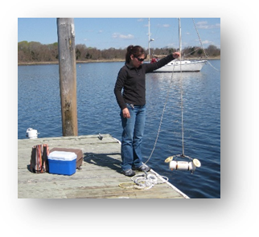
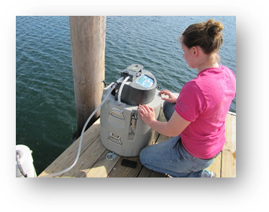
Complementary to the existing long-term water quality monitoring program, the NERRS implemented a new nutrient and chlorophyll monitoring program in 2002. The two sub-components of this program include monthly grab sampling at each of the four water quality stations, and diel sampling once a month at one site. The grab sampling program requires the collection of duplicate water samples every month from each of the four long-term water quality monitoring stations with the purpose of quantify seasonal patterns of nutrient and chlorophyll concentrations in different estuarine habitats (marsh creek, cove, surface open water, bottom open water).
Grab sampling done by Reserve staff.
The diel sampling program requires to collect a series of samples from one station over an approximately 24-hour period each month to examine how nutrient and chlorophyll concentrations change over diel and tidal cycles. Previously (from 2002 to 2010) the diel station was located at T-Wharf. However, after analyzing the historic data from the site, no significant trends or patterns were found over time. Therefore, the diel station was moved to Potter Cove in January of 2011 in order to characterize nutrients and chlorophyll from this site. All collected grab and diel samples are analyzed for concentrations of phosphates (PO₄), ammonia (NH₄), nitrite (NO₂), nitrate (NO₃), NO₂+NO₃, dissolved inorganic nitrogen (DIN), silicates (SiO₄) and chlorophyll a.
Reserve staff setting the ISCO at Potter Cove.
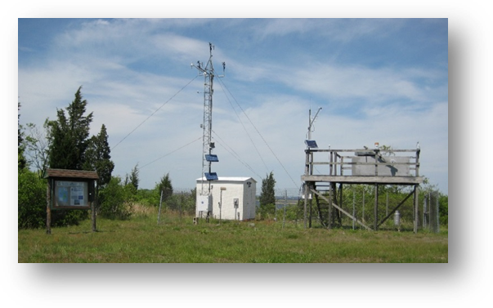
Since 2001, meteorological data has been collected as part of the SWMP at the weather station (see image below) located on Prudence Island, approximately 389 m south of Potter Cove (41º 38’ 13.703” N, 71º 20’ 21.790” W, Trimble Geo XT, GeoExplorer 2008 Series; see map on section 5, Site Location and Character). Data on air temperature, relative humidity, barometric pressure, wind speed and direction, photosynthetic active radiation, and precipitation are collected. Meteorological data is continually used to complement the water quality, biological monitoring and scientific research efforts at NBNERR and at Narragansett Bay, and to assist educational and stewardship activities around the Bay.
All this information is available to any interested party through the CDMO http://cdmo.baruch.sc.edu/, NBNERR http://nbnerr.org/, or directly contacting the Research Coordinator or the Marine Research Specialist II.
In 2004, the NBNERR became involved in the Bay Window Monitoring Program, which is a Bay-wide water quality monitoring program. Although the NBNERR is no longer involved with managing data from the Bay window program, NBNERR SWMP data are still shared with and used for analysis in the program. The NBNERR also provides SWMP data to:

Dr. Candace Oviatt at URI-GSO is using NBNERR chlorophyll data to track the timing and magnitude of winter/spring blooms in Narragansett Bay.

Heather Stoffel at URI-GSO is using NBERR data from T-Wharf Surface, T-Wharf Bottom, and Potter's Cove stations in a local monitoring network strategy partially funded through Bay Window and headed by RIDEM-OWR.
II. Physical Structure Descriptors
- Sensor specifications
NAR NERR deployed YSI 6600/YSI 6600EDS/YSI 6600V2 data loggers in January through December 2008. Rapid-pulse and ROX DO sensors were deployed at NAR in 2008. Rapid pulse probes were used at NC and TB throughout 2008, except for the 11/26/2014 deployment at NC. ODO ROX sensors were deployed at TS and PC.
Parameter: Temperature
Units: Celsius - oC
Sensor Type: Thermistor
Model #: 6560
Range: -5 to 45 °C
Accuracy: +/-0.15 °C
Resolution: 0.01 °C
Parameter: Conductivity
Units: milli-Siemens per cm (mS/cm)
Sensor Type: 4-electrode cell with autoranging
Model #: 6560
Range: 0 to 100 mS/cm
Accuracy: +/-0.5% of reading + 0.001 mS/cm
Resolution: 0.001 mS/cm to 0.1 mS/cm (range dependent)

Parameter: Salinity
Units: Parts per thousand (ppt)
Sensor Type: Calculated from conductivity and temperature
Range: 0 to 70 ppt
Accuracy: +/- 1.0% of reading or 0.1 ppt, whichever is greater
Resolution: 0.01 ppt

Parameter: Dissolved Oxygen
Units: Percent air saturation (%)
Sensor Type: Rapid Pulse – Clark type, Polarographic
Model #: 6562
Range: 0 to 500 % air saturation
Accuracy: 0-200 % air saturation, +/- 2 % of the reading or 2 % air saturation, whichever is greater; 200 500 % air saturation, +/- 6 % of the reading
Resolution: 0.1 % air saturation
- or -
Sensor Type: Optical probe with mechanical cleaning
Model #: 6150 ROX
Range: 0 to 500% air saturation
Accuracy: 0-200% air saturation: +/-1% of the reading or 1% air saturation, whichever is greater; 200 500% air saturation: +/- 15% of reading
Resolution: 0.1% air saturation

Parameter: Dissolved Oxygen (Calculated from % air saturation, temperature and salinity)
Units: milligrams per Liter (mg/L)
Sensor Type: Rapid Pulse – Clark type, polarographic
Model #: 6562
Range: 0 to 50 mg/L
Accuracy: 0 to 20 mg/L, +/- 2 % of the reading or 0.2 mg/L, whichever is greater; 20 to 50 mg/L, +/- 6 % of the reading
Resolution: 0.01 mg/L
- or -
Units: milligrams/Liter (mg/L)
Sensor Type: Optical probe with mechanical cleaning
Model #: 6150 ROX
Range: 0 to 50 mg/L
Accuracy: 0-20 mg/L: +/-0.1% mg/L or 1% of the reading, whichever is greater; 20 to 50 mg/L: +/-15% of the reading
Resolution: 0.01 mg/L

Parameter: Non-Vented Level – Shallow (Depth)
Units: feet or meters (ft or m)
Sensor Type: Stainless steel strain gauge
Range: 0 to 30 ft (9.1 m)
Accuracy: +/- 0.06 ft (0.018 m)
Resolution: 0.001 ft (0.001 m)

Parameter: Vented Level – Shallow (Depth)
Units: feet or meters (ft or m)
Sensor Type: Stainless steel strain gauge
Range: 0 to 30 ft (9.1 m)
Accuracy: 0-10 ft: +/- 0.01 ft (0.003 m)
Accuracy: 10-30 ft: +/- 0.06 ft (0.018 m)
Resolution: 0.001 ft (0.001 m)

Parameter: Vented Level – Deep (Depth)
Units: feet or meters (ft or m)
Sensor Type: Stainless steel strain gauge
Range: 0 to 656 ft (200 m)
Accuracy: +/- 1 ft (0.3 m)
Resolution: 0.001 ft (0.001 m)

Parameter: pH (specify whether EDS probe or not)
Units: units
Sensor Type: Glass combination electrode
Model #: 6561
Range: 0 to 14 units
Accuracy: +/- 0.2 units
Resolution: 0.01 units

Parameter: Turbidity
Units: Nephelometric turbidity units (NTU)
Sensor Type: Optical, 90° scatter, with mechanical cleaning
Model #: 6136
Range: 0 to 1000 NTU
Accuracy: +/- 2 % reading or 2 NTU (whichever is greater)
Resolution: 0.1 NTU

Dissolved Oxygen Qualifier:

The reliability of the dissolved oxygen (DO) data after 96 hours post-deployment for non-EDS (Extended Deployment System) data sondes may be problematic due to fouling which forms on the DO probe membrane during some deployments (Wenner et al. 2001). Many reserves have upgraded to the YSI 6600 EDS data sondes, which increases DO accuracy and longevity by reducing the environmental effects of fouling. The user is therefore advised to consult the metadata and to exercise caution when utilizing the DO data beyond the initial 96-hour time period. However, this potential drift is not always problematic for some uses of the data, i.e. periodicity analysis. It should also be noted that the amount of fouling is very site specific and that not all data are affected. The Research Coordinator at the specific NERR site should be contacted concerning the reliability of the DO data because of the site and seasonal variation in the fouling of the DO sensor.

Depth Qualifier:

The NERR System-Wide Monitoring Program utilizes YSI data sondes that can be equipped with either depth or water level sensors. Both sensors measure water depth, but by convention, level sensors refer to atmospherically vented measurements and depth refers to non-vented measurements. Readings for both vented and non-vented sensors are automatically compensated for water density change due to variations in temperature and salinity; but for all non-vented depth measurements, changes in atmospheric pressure between calibrations appear as changes in water depth. The error is equal to approximately 1.03 cm for every 1 millibar change in atmospheric pressure, and is eliminated for level sensors because they are vented to the atmosphere throughout the deployment time interval.

Beginning in 2006, NERR SWMP standard calibration protocol calls for all non-vented depth sensors to read 0 meters at a (local) barometric pressure of 1013.25 mb (760 mm/hg). To achieve this, each site calibrates their depth sensor with a depth offset number, which is calculated using the actual atmospheric pressure at the time of calibration and the equation provided in the SWMP calibration sheet or Digital Calibration Log. This offset procedure standardizes each depth calibration for the entire NERR System. If accurate atmospheric pressure data are available, non-vented sensor depth measurements at any NERR site can be corrected. The Research Coordinator at the specific NERR site should be contacted in order to obtain information regarding atmospheric pressure data availability.
- Coded variable definitions
Sampling station: Sampling site code: Station code:
Potter Cove PC narpcwq
Nag Creek NC narncwq
T-Wharf Surface TS nartswq
T-Wharf Bottom TB nartbwq

- QAQC flag definitions
QAQC flags provide documentation of the data and are applied to individual data points by insertion into the parameter’s associated flag column (header preceded by an F_). During primary automated QAQC (performed by the CDMO), -5, -4, and -2 flags are applied automatically to indicate data that is above or below sensor range. All remaining data are then flagged 0, passing initial QAQC checks. During secondary and tertiary QAQC 1, -3, and 5 flags may be used to note data as suspect, rejected due to QAQC, or corrected.
-5 Outside High Sensor Range
-4 Outside Low Sensor Range
-3 Data Rejected due to QAQC
-2 Missing Data
-1 Optional SWMP Supported Parameter

0 Data Passed Initial QAQC Checks
1 Suspect Data
2 Open - reserved for later flag
3 Open - reserved for later flag
4 Historical Data: Pre-Auto QAQC
5 Corrected Data

- QAQC code definitions
QAQC codes are used in conjunction with QAQC flags to provide further documentation of the data and are also applied by insertion into the associated flag column. There are three (3) different code categories, general, sensor, and comment. General errors document general problems with the deployment or YSI data sonde, sensor errors are sensor specific, and comment codes are used to further document conditions or a problem with the data. Only one general or sensor error and one comment code can be applied to a particular data point.
General Errors
GIC No Instrument Deployed due to Ice
GIM Instrument Malfunction
GIT Instrument Recording Error; Recovered Telemetry Data
GMC No Instrument Deployed Due to Maintenance/Calibration
GNF Deployment Tube Clogged / No Flow
GOW Out of Water Event
GPF Power Failure / Low Battery
GQR Data Rejected Due to QA/QC Checks
GSM See Metadata

Sensor Errors
SBO Blocked Optic
SCF Conductivity Sensor Failure
SDF Depth Port Frozen
SDO DO Suspect
SDP DO Membrane Puncture
SIC Incorrect Calibration / Contaminated Standard
SNV Negative Value
SOW Sensor Out of Water
SPC Post Calibration Out of Range
SSD Sensor Drift
SSM Sensor Malfunction
SSR Sensor Removed / Not Deployed
STF Catastrophic Temperature Sensor Failure
STS Turbidity Spike
SWM Wiper Malfunction / Loss

Comments
CAB Algal Bloom
CAF Acceptable Calibration/Accuracy Error
CAP Depth Sensor in Water, Affected by Atmospheric Pressure
CBF Biofouling
CCU Cause Unknown
CDA DO hypoxia (<28% sat)
CDB Disturbed Bottom
CDF Data Appear to Fit Conditions
CFK Fish Kill
CIP Surface Ice Present at Sample Station
CLT Low Tide
CMC In Field Maintenance/Cleaning
CMD Mud in Probe Guard
CND New Deployment Begins
CRE Significant Rain Event
CSM See Metadata
CTS Turbidity Spike
CVT Possible Vandalism/Tampering
CWD Data Collected at Wrong Depth

- Post deployment information
Post-calibration readings for the four water quality stations were taken shortly after retrieval using calibration standards. From January to October, the specific conductivity standard used was 50 mS/cm solution; from November and December, 10 mS/cm was used. Empty cells indicate no post-calibration readings were done. Superscript numbers belong to notes at the bottom of each table.
Nag Creek
Deploy  Date | Post-calib.  Date | Specific Cond. (mS/cm) | Dissolved Oxygen ¹  1 2 |  | pH |  | Turbidity |  | Depth | Chl
mm/dd/yy |  | mSiemen/cm | Percent saturation |  | units |  | NTU |  | offset | µg L⁻¹
 |  | (50.00) | (100%) |  | (7.0) | (10.0) | (0) | (123) | m | (0.0)
03/25/08 | 04/18/08 | 49.87 | 99.8 | 99.0 | 7.0 | 9.9 | 0 |  | -0.001 | 1.3
04/18/08 | 05/02/08 | 49.09 | 104.3 | 104.3 | 7.4 | 10.4 | 2 |  | 0.057 | 1.2
05/02/08 | 05/19/08 | 50.78 | 102.8 | 101.8 | 7.0 | 10.0 | 0 |  | -0.183 | -0.3
05/19/08 | 05/30/08 | 49.30 | 101.3 | 101.1 | 7.0 | 9.9 | 0 |  | 0.058 | 0.4
05/30/08 | 06/18/08 | 51.20 | 93.4 | 93.0 | 6.8 | 9.7 | 1 | 123 | -0.063 | 2.0
06/18/08 | 07/03/08 | 48.77 | 104.2 | 104.2 | 7.1 | 10.0 | 1 | 125 | -0.009 | 0.5
07/03/08 | 07/15/08 | 48.91 | 93.3 | 102.3 | 7.0 | 10.0 | 0 | 123 | 0.040 | 0.9
07/15/08 | 08/01/08 | 49.72 | 102.2 | 102.3 | 7.4 | 10.4 | 0 | 121 | -0.105 | 1.9
08/01/08 | 08/19/08 | 50.46 | 36.7 | 36.8 | 7.1 | 10.0 | 0 | 122 | -0.031 | 7.4
08/19/08 | 09/03/08 | 50.35 | 139.3 | 139.6 | 6.8 | 9.9 | 0 | 98 | -0.022 | 0.1
09/03/08 | 09/17/08 | 51.50 | 94.6 | 94.6 | 6.9 | 9.8 | 1 | 120 | 0.064 | 0.5
09/17/08 | 10/01/08 | 49.37 | 101.3 | 101.2 | 7.2 | 10.1 | -1 | 119 | -0.110 | 0.4
10/01/08 | 10/15/08 | 49.74 | 104.1 | 104.0 | 7.0 | 10.0 | -1 | 120 | 0.046 | -0.2
10/15/08 | 10/30/08 | 49.90 | 103.5 | 103.4 | 7.1 | 10.2 | 1 | 106 | 0.115 | 3.0
10/29/08 | 11/13/08 | 10.43 | 104.2 | 104.1 | 7.1 | 10.0 | 17 | 150 | 0.094 | 0.7
11/13/08 | 11/26/08 | 9.84 | 100.0 | 99.8 | 7.2 | 10.1 | 0 | 137 | -0.030 | 0.8
11/26/08 | 12/10/08 | 9.03 | 99.6 | 99.6 | 7.0 | 9.9 | 0 | 122 | 0.049 | 0.1
12/10/08 | 01/05/09 | 9.87 | 101.6 | 101.6 | 7.1 | 10.1 | 1 | 123 | -0.040 | 0.7
Notes
¹ All dissolved oxygen information was collected using a Dissolved Oxygen Rapid Pulse probe.

Potter Cove
Deploy  Date | Post-calib.  Date | Specific Cond. (mS/cm) | Dissolved Oxygen ¹  1 2 |  | pH |  | Turbidity |  | Depth | Chl
mm/dd/yy |  | mSiemen/cm | Percent saturation |  | units |  | NTU |  | offset | µg L⁻¹
 |  | (50.00) | (100%) |  | (7.0) | (10.0) | (0) | (123) | m | (0.0)
12/20/07 | 01/04/08 | 50.4 | 97.2 | 97.3 | 7.2 | 10.3 | 0 |  | 0.149 | 1.3
01/04/08 | 01/16/08 | 35.6 | 92.0 | 91.2 | 7.1 | 10.0 | 0 |  | 0.047 | 0.3
01/16/08 ² | 02/07/08 | 51.1 | 101.5 | 100.7 | 6.8 | 6.8 | 0 |  | -0.089
02/07/08 | 02/21/08 | 45.3 | 97.6 | 96.8 | 7.1 | 10.2 | 0 |  | 0.129 | 0.2
02/21/08 | 03/05/08 | 49.7 | 94.9 | 90.8 | 7.1 | 10.1 | 0 |  | -0.158 | 0.4
03/05/08 ² | 03/26/08 | 50.3 | 102.9 | 102.1 | 7.0 | 10.0 | 0 |  | -0.023
03/26/08 | 04/18/08 | 50.3 | 105.9 | 105.2 | 7.0 | 10.0 | -1 |  | 0.010 | 0.4
04/18/08 | 05/02/08 | 49.9 | 95.9 | 95.9 | 7.1 | 10.1 | 0 |  | 0.049 | 0.4
05/02/08 | 05/19/08 | 49.3 | 90.9 | 90.9 | 7.0 | 10.0 | 0 |  | -0.188 | 0.5
05/19/08 | 05/30/08 | 48.8 | 100.6 | 100.6 | 7.1 | 10.1 | 0 |  | 0.062 | 1.6
05/30/08 | 06/18/08 | 50.5 | 101.0 | 100.8 | 7.0 | 9.9 | 23 | 142 | -0.072 | 0.1
06/18/08 | 07/03/08 | 49.8 | 90.7 | 90.7 | 7.0 | 10.0 | 2 | 127 | -0.003 | 0.2
07/03/08 | 07/15/08 | 49.7 | 97.0 | 97.0 | 7.0 | 10.0 | 0 | 121 | 0.032 | 0.2
07/15/08 | 08/01/08 | 50.3 | 98.0 | 98.0 | 7.0 | 10.0 | 0 | 122 | -0.092 | -0.8
08/01/08 | 08/19/08 | 48.0 | 96.2 | 96.2 | 6.9 | 10.0 | 1 | 114 | -0.026 | 34.0
08/19/08 | 09/03/08 | 50.5 | 101.0 | 100.0 | 7.1 | 10.1 | -1 | 119 | -0.011 | 1.3
09/03/08 | 09/17/08 | 51.9 | 99.8 | 99.8 | 7.2 | 10.3 | 0 | 120 | 0.069 | -0.8
09/17/08 | 10/01/08 | 49.9 | 102.8 | 102.8 | 7.0 | 10.1 | 1 | 123 | -0.105 | -0.5
10/01/08 | 10/15/08 | 50.3 | 101.6 | 101.6 | 7.0 | 10.1 | 0 | 119 | 0.043 | 0.2
10/15/08 | 10/30/08 | 49.7 | 102.2 | 102.2 | 6.9 | 9.9 | 0 | 107 | 0.110 | 0.7
10/30/08 | 11/13/08 | 10.3 | 101.1 | 101.2 | 7.0 | 10.0 | -1 | 148 | 0.100 | -1.0
11/13/08 | 11/26/08 | 10.1 | 91.3 | 90.0 | 7.0 | 10.0 | 1 | 105 | -0.016 | -0.6
11/26/08 | 12/09/08 | 10.1 | 98.9 | 98.8 | 7.0 | 10.0 | 1 | 123 | 0.150 | -0.9
12/09/08 | 12/22/08 | 9.9 | 93.3 | 93.1 | 7.1 | 10.1 | 0 | 123 | -0.049 | -0.6
12/22/08 | 01/13/09 | 10.1 | 122.8 | 122.8 | 7.0 | 10.0 | 1 | 120 | 0.023 | -0.4
Notes
¹ Information in gray cells in the Dissolved Oxygen column were collected using a Rapid Pulse probe; otherwise, an Optical probe was used.
² No chlorophyll probe deployed.

T-Wharf Surface
Deploy  Date | Post-calib.  Date | Specific Cond. (mS/cm) | Dissolved Oxygen ¹  1 2 |  | pH |  | Turbidity |  | Depth | Chl
mm/dd/yy |  | mSiemen/cm | Percent saturation |  | units |  | NTU |  | offset | µg L⁻¹
 |  | (50.00) | (100%) |  | (7.0) | (10.0) | (0) | (123) | m | (0.0)
12/27/07 | 01/11/08 | 49.00 | 101.8 | 101.8 | 7.2 | 10.2 |  | 1 |  | -0.053
01/11/08 | 01/31/08 | 50.03 | 72.6 | 70.9 | 7.1 | 10.1 |  | 0 |  | 0.190
01/31/08 | 02/14/08 | 52.12 | 102.3 | 102.3 | 7.1 | 10.1 |  | -1 |  | -0.041
02/14/08 | 02/28/08 | 50.44 | 103.4 | 103.2 | 7.0 | 9.9 |  | 206 |  | 0.018
02/28/08 | 03/21/08 | 50.44 | 100.6 | 100.6 | 7.0 | 10.1 |  | 0 |  | -0.077
03/21/08 | 04/04/08 | 46.77 | 100.6 | 100.6 | 7.2 | 10.2 |  | 0 |  | -0.102
04/04/08 | 04/25/08 | 49.77 | 109.1 | 109.0 | 7.0 | 9.9 |  | 0 |  | 0.070
04/25/08 | 05/08/08 | 58.22 | 101.6 | 101.6 | 7.2 | 10.2 |  | 0 |  | -0.115
05/08/08 | 05/23/08 | 48.84 | 98.7 | 98.7 | 7.2 | 10.2 |  | -1 |  | -0.071
05/23/08 | 06/04/08 | 46.85 | 100.2 | 100.2 | 7.0 | 10.0 |  | 0 | 125 | -0.038
06/04/08 | 06/26/08 | 49.05 | 99.4 | 99.4 | 6.6 | 9.6 |  | -1 | 121 | -0.220
06/26/08 | 07/10/08 | 48.44 | 98.8 | 98.5 | 6.8 | 9.7 |  | 1 | 122 | -0.019
07/10/08 | 07/29/08 | 50.25 | 107.5 | 107.6 | 7.0 | 10.0 |  | 0 | 110 | -0.043
07/29/08 | 08/15/08 | 49.48 | 100.0 | 100.0 | 7.0 | 10.0 |  | -1 | 122 | 0.015
08/15/08 | 08/26/08 | 50.08 | 102.1 | 102.1 | 7.0 | 10.0 |  | -1 | 120 | 0.014
08/26/08 | 09/11/08 | 50.10 | 102.4 | 102.4 | 7.1 | 10.2 |  | -1 | 118 | 0.149
09/11/08 | 09/24/08 | 51.90 | 102.0 | 102.0 | 7.0 | 9.9 |  | 1 | 126 | 0.174
09/24/08 | 10/08/08 | 49.78 | 100.4 | 100.4 | 6.9 | 9.8 |  | -1 | 118 | 0.070
10/08/08 | 10/21/08 | 50.39 | 94.3 | 94.3 | 7.1 | 10.1 |  | 0 | 111 | -0.042
10/21/08 | 11/06/08 | 10.13 | 103.8 | 103.8 | 7.2 | 10.2 |  | 0 | 129 | 0.002
11/06/08 | 11/18/08 | 10.03 | 102.3 | 102.2 | 7.1 | 10.0 |  | 0 | 123 | 0.004
11/18/08 | 12/02/08 | 10.67 | 96.1 | 96.1 | 7.0 | 10.0 |  | 0 | 121 | 0.022
12/02/08 | 12/18/08 | 10.19 | 104.6 | 104.5 | 7.0 | 10.0 |  | -3 | 122 | 0.109
12/18/08 | 01/06/09 | 10.04 | 100.1 | 104.5 | 7.1 | 10.1 |  | 0 | 123 | 0.016
Notes
¹ Information in gray cells in the Dissolved Oxygen column were collected using a Rapid Pulse probe; otherwise, an Optical probe was used.

T-Wharf Bottom
Deploy  Date | Post-calib.  Date | Specific Cond. (mS/cm) | Dissolved Oxygen ¹  1 2 |  | pH |  | Turbidity |  | Depth | Chl
mm/dd/yy |  | mSiemen/cm | Percent saturation |  | units |  | NTU |  | offset | µg L⁻¹
 |  | (50.00) | (100%) |  | (7.0) | (10.0) | (0) | (123) | m | (0.0)
12/27/07 | 01/11/08 | 50.98 | 97.2 | 95.1 | 7.3 | 10.3 | 1 |  | -0.055
01/11/08 | 01/31/08 | 51.64 | 84.3 | 84.0 | 6.9 | 9.9 | 0 |  | 0.159 | 0.6
01/31/08 | 02/14/08 | 45.95 | 103.9 | 103.1 | 6.8 | 9.9 | 0 |  | 0.001 | 0.4
02/14/08 | 02/28/08 | 49.68 | 82.3 | 82.1 | 7.3 | 10.5 | 0 |  | -0.008 | -0.2
02/28/08 | 03/21/08 | 52.10 | 53.9 | 53.8 | 7.3 | 10.2 | -1 |  | 0.053 | -0.8
03/21/08 | 04/04/08 | 48.16 | 100.2 | 100.0 | 7.6 | 10.9 | 1 |  | -0.092 | 1.6
04/04/08 | 04/25/08 | 48.10 | 101.2 | 99.8 | 7.0 | 10.0 | 2 |  | 0.111 | 0.1
04/25/08 | 05/08/08 | 50.26 | 102.4 | 101.7 | 7.0 | 9.9 | 0 |  | -0.113 | 1.2
05/08/08 | 05/23/08 | 49.14 | 102.4 | 101.8 | 7.0 | 10.1 | -1 |  | -0.086 | 3.3
05/23/08 | 06/04/08 | 49.76 | 111.4 | 110.6 | 7.0 | 9.9 | 0 | 123 | -0.040 | -0.8
06/04/08 | 06/26/08 | 49.85 | 102.2 | 101.7 | 7.0 | 9.8 | 0 | 121 | -0.022 | -1.3
06/26/08 | 07/10/08 | 49.66 | 101.6 | 101.3 | 7.0 | 9.9 | 1 | 124 | -0.027 | -2.2
07/10/08 | 07/29/08 | 50.40 | 107.0 | 106.7 | 7.2 | 10.2 | 0 | 120 | -0.035 | -0.4
07/29/08 | 08/15/08 | 48.95 | 102.5 | 102.2 | 7.0 | 9.9 | 1 | 120 | 0.009 | -4.5
08/15/08 | 08/26/08 | 51.06 | 103.7 | 103.6 | 7.5 | 10.2 | 0 | 121 | -0.014 | 1.7
08/26/08 | 09/11/08 | 50.36 | 165.5 | 165.3 | 6.8 | 9.8 | 0 | 118 | 0.137 | -4.2
09/11/08 | 09/24/08 | 51.55 | 104.3 | 104.2 | 7.1 | 10.1 | 0 | 125 | 0.176 | 0.3
09/24/08 | 10/08/08 | 49.44 | 123.1 | 123.1 | 7.3 | 10.3 | 0 | 120 | 0.078 | 3.8
10/08/08 | 10/21/08 | 49.94 | 103.5 | 103.3 | 7.2 | 10.1 | 0 | 113 | -0.033 | 0.5
10/21/08 | 11/14/08 | 9.78 | 104.7 | 104.3 | 7.1 | 10.1 | 1 | 135 | 0.004 | -1.8
11/14/08 | 12/02/08 | 10.13 | 104.5 | 104.4 | 7.3 | 10.3 | 1 | 126 | 0.023 | 0.3
12/02/08 | 12/18/08 | 9.94 | 66.6 | 66.5 | 7.0 | 10.1 | 0 | 129 | 0.102 | 2.0
12/18/08 | 01/06/09 | 10.38 | 105.0 | 104.9 | 7.4 | 10.4 | 0 | 127 | 0.017 | 0.8
Notes
¹ All the information in Dissolved Oxygen column were collected using a Rapid Pulse probe.

- Other Remarks / Notes
Data are missing due to equipment or associated specific probes not being deployed, equipment failure, time of maintenance or calibration of equipment, or repair/replacement of a sampling station platform. If additional information on missing data is needed, contact the Research Coordinator at the reserve submitting the data.
Slight depth anomalies occurred at the T-Wharf surface monitoring station. The datalogger at this station is suspended from the bottom of a buoy attached by rope to the adjacent wharf. On occasion it became apparent that the sonde and/or buoy had become caught up in the rope, but never to such an extent that the sonde came out of the water unless otherwise noted. Wave action during periods of high winds may be responsible for some of the depth variation. Because this sonde is attached to a float it is readily impacted by heavy wave action. Deployment near the surface also allows for depth measurements to be altered by changes in atmospheric pressure. At no time were the variations in depth considered sufficient to alter the validity of the data.
Slight depth anomalies frequently occur at the Nag Creek deployment location. Depth at this site may have been influenced to some extent by changes in atmospheric pressure because the sonde was situated in very shallow waters. On occasion, the combination of low atmospheric pressure and shallow water resulted in negative depth values. Weather station data appear to support this theory. It is also suspected that due to its shallow location and location in a salt marsh, freshwater runoff from the island may affect specific conductivity/salinity readings several days after a rain event has occurred. Specific conductivity, salinity, and dissolved oxygen can also vary greatly in Nag Creek over tidal and diel cycles. Nag creek is a very shallow site and is highly affected by tides and rain events. On some occasions, dissolved oxygen is recorded as negative values at the Nag Creek deployment location. DO frequently ranges between supersaturation and complete anoxic conditions (DO = 0 % saturation) at this site during the summer months. Ice is also common in Nag Creek. There have been occasions where ice has affected all sonde parameters and are marked in the data as “see metadata”.
Chlorophyll and fluorescence data were collected along with the data represented in this document, but because chlorophyll and fluorescence are not part of the NERR SWMP Water Quality Program, the data are not reported within this dataset. Chlorophyll and fluorescence data are available upon request by contacting the Reserve.
The following are description of different events that happened during deployment and explanations to the CSM (Comment-See Metadata) code for the four water quality station data files from January to December of 2015.
Nag Creek
Sondes at Nag Creek are pulled every winter due to ice in the creek. Sondes were pulled in November of 2007 and deployed again at the end of March 2008.
Small turbidity spikes are marked 0 GSM CTS and 1 STS CSM throughout the dataset that we believe are due to small fish, shrimp, crabs or drift algae that gets caught up on the station and affects the turbidity data.
Deployment 08/19 to 09/03/2008 – This sonde was deployed with no wiper brush by mistake. Turbidity data is marked 0/1 SWM CSM.
Deployment 10/15 to 10/30/2008 - In the dataset, it is apparent that the turbidity probe had a wiper parking issue and at some point during the deployment the wiper fell off the probe and was found in the deploying guard when the sonde was retrieved.
Deployment 10/30 to 11/13/2008 – Turbidity probe had issue with wiper which caused data to appear elevated and erratic. Data is marked 1/-3 SWM CSM.
Deployment 12/10 to 01/05/2009 – Shortly after the deployment, the low temperatures and shallowness of the creek started the on and off formation of ice until it froze up almost completely for about three weeks (until Jan 05, 2009), but collected data during that time. All water quality parameters are affected by this process.
Deployment 11/24 to 12/10/2008 – Due to a mistake in the sonde program, the time recorded during this deployment was not correct; however, it was corrected in the dataset.
Potter Cove
Small turbidity spikes are marked 0 GSM CTS and 1 STS CSM throughout the dataset that we believe are due to small fish, shrimp, crabs that affect the turbidity data.

Jan 01-04, the sonde collected data at a slightly deeper depth. However, since this site is a shallow cove of approximately 3.5m on high tide, we are certain that the water quality parameters collected are not affected by this slight depth change. The deployment depth was fixed after this date.
Deployment 05/02 14:45 to 05/12 11:30, a slight depth problem is apparent in the data set. We suspect the sonde might have been tangled during this period. The other water quality parameters were not affected.
Deployment 10/30 to 11/13/2008 – Due to a mistake in the sonde program, the time recorded during this deployment was not correct; however, it was corrected in the dataset.
T-Wharf Bottom
Small turbidity spikes are marked 0 GSM CTS and 1 STS CSM throughout the dataset that we believe are due to small fish, shrimp, crabs or drift algae that gets caught up on the station and affects the turbidity data.
On the retrieval of the T-Wharf Bottom sonde on 09/24/2008, a total of nine sea stars (Asterias sp.) where found on the sonde: seven on the sonde body, and two on the external screen. In addition, a good amount of mussels where on the sonde body and screen.
On the retrieval of the T-Wharf bottom sonde on 10/08/2008, a total of four sea stars (Asterias sp.) were also found on the sonde: two on the sonde body, and two on the external screen. A good amount of mussels where on the sonde body and screen (Figure 1).
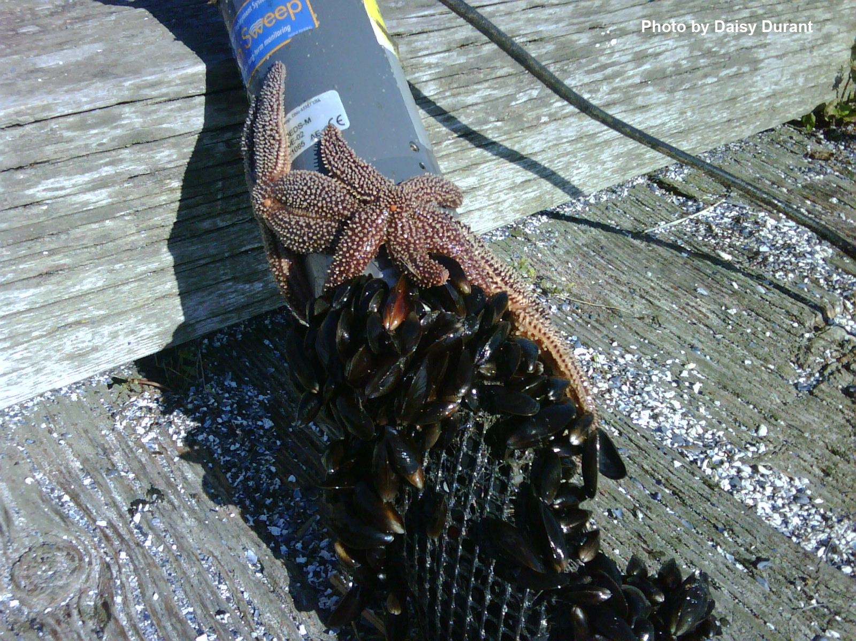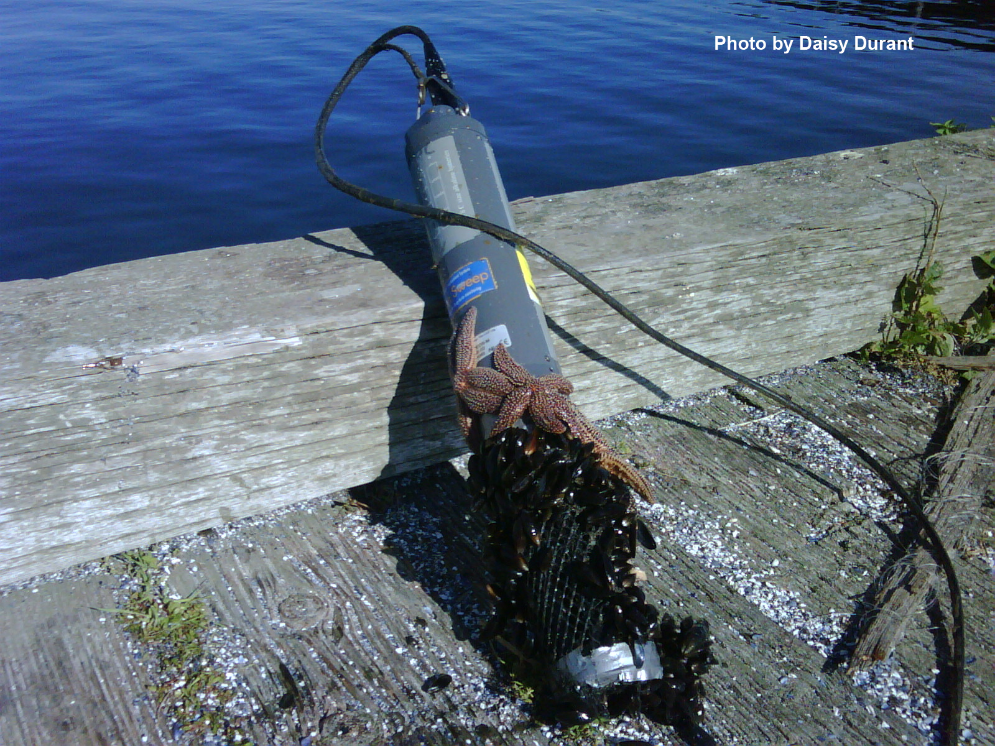
a
b

Figure 1. a) Sea stars and mussels found attached during the retrieval of the T-Wharf bottom sonde at the Narragansett Bay NERR, b) close-up of same sonde.
On 7/25 12:45 the sonde was pulled up and the batteries were replaced in the middle of a deployment.
On September 11, 2008, the retrieval of the T-Wharf bottom sonde showed mud on the external screen and on the probes.
At T-Wharf Bottom on September 26, 2008 10:45:00 am, the structure (the bottom section of the PVC structure where the sonde is deployed) holding the sonde approximately 1.0 m off the bottom gave way. The structure was fixed and the deployment depth was corrected on September 11, 2009. The change in depth has been flagged in the depth column. We believe the water quality parameters collected during this period were not affected by this incident.

T-Wharf Surface
The sonde might have not been moving freely inside the PVC deploying structure during the following dates which were flagged and coded as (0) CSM in the depth column of the dataset. Even though this slightly affected the depth readings, the other water quality parameters were not affected.
02/11/2008 01:45-5:00
02/11/2008 13:15-17:00
02/19/2008 23:00-2/20 00:45
02/20/2008 23:00-2/21 00:45
03/09/2008 11:30-15:15
03/10/2008 00:30-2:45
03/21/2008 13:00-15:15
03/22/2008 01:15-3:45
03/25/2008 09:15-15:30
04/08/2008 18:15-4/9 13:15
04/18/2008 17:00
07/04/2008 09:15-11:15
07/06/2008 04:30-7:00
07/08/2008 00:15-1:45
07/09/2008 11:30-12:45
07/30/2008 12:00-13:15
08/15/2008 23:30-00:30
08/16/2008 12:15-14:30
08/21/2008 04:15-7:00
08/22/2008 04:45-7:15
09/01/2008 01:00-45
11/16/2008 14:30-20:15
11/17/2008 02:30-7:00
11/18/2008 04:00-7:15
11/30/2008 00:30-1:45
12/10/2008 08:00-30
12/13/2008 22:00-30
Small turbidity spikes are marked 0 GSM CTS and 1 STS CSM throughout the dataset that we believe are due to small fish, shrimp, crabs or drift algae that gets caught up on the station and affects the turbidity data.

The PVC deploying structure that contained and protected the T-Wharf Surface sonde broke off of the wharf and fell in the water during the deployment of June 26; the exact time is unknown. However, the sonde was still connected to the wharf with a security line, was collecting data at its usual depth (approximately 1 m below water surface at low tide) and was never out of the water. For subsequent deployments, the T-Wharf Surface sonde was deployed in the PVC deploying structure holding and protecting the T-Wharf Bottom sonde until November 11, 2008 when a new PVC deploying structure was installed for T-Wharf Surface. The Surface and Bottom sondes did not interfered with each other since the PVC deploying pipe was 6” in diameter and the Bottom sonde was collecting data at a depth of 6m while the Surface sonde was deployed at 1 m below water surface at low tide (its usual deploying depth). This event did not affect the parameters collected by either sondes.
The pH slope at calibration during the 1/31 deployment was quite odd reading -58. There are no notes in the log as to whether the mV were listed correctly. However, the slope at the post was in range. Due to this issue we marked pH data during this deployment 1 SDG CSM.
The pH slope at calibration during the 2/28 deployment was quite odd reading -37. There are no notes in the log as to whether the mV were listed correctly. However, the slope at the post was in range. Due to this issue we marked pH data during this deployment 1 SDG CSM.

