**Gelatin Aquaria**

Designed by Madeline Frey and Grant Lockridge in 2021.

**Motivation:**

Observation of small burrowing animals is very difficult due to the opaque nature of sediment. Thin aquaria (also called "ant farms") are commonly used to restrict animal movement, but rigid aquarium walls modify the physical properties of the sediment inside, with the proportion affected increasing as the width of the tank decreases (Dorgan et al. 2006). Gelatin is a transparent analog for mud, and has been used to observe worm burrowing behavior (Dorgan

et al. 2005). Being a homogeneous gel, gelatin has no particles to measure mixing with. So, we combined the use of a clear gel analog and mud to get a tiny aquarium that you can see small worms with and measure their mixing activity.

**Materials:**

* 1” thick HDPE sheet: [8619K492](https://www.mcmaster.com/nav/enter.asp?partnum=8619K492)
* 3/16” thick Clear Acrylic: [8589K62](https://www.mcmaster.com/nav/enter.asp?partnum=8589K62)
* 1 ¼” 10-32 Screws:[91735A837](https://www.mcmaster.com/#91735A837)
* 10-32 Stainless Steel Nuts:
* Slippery UMHW sheet ⅛” thick: [4296A37](https://www.mcmaster.com/#4296A37)
* [Silicone Sheets](https://www.amazon.com/Silicone-Rubber-Gasket-Flexible-12x20x1/dp/B071FFJGSC?pd_rd_w=M8klB&content-id=amzn1.sym.deffa092-2e99-4e9f-b814-0d71c40b24af&pf_rd_p=deffa092-2e99-4e9f-b814-0d71c40b24af&pf_rd_r=JK4TS503G6GQ0RD9VYPX&pd_rd_wg=b8uph&pd_rd_r=af1f2873-13c7-464b-92da-04141a2c611a&pd_rd_i=B071FFJGSC&psc=1&ref_=pd_bap_d_rp_1_t)
* [Aquarium silicone sealant](https://www.amazon.com/Clear-Aquarium-Silicone-Sealant-Cartridge/dp/B00EZB1QQ2?pd_rd_w=M8klB&content-id=amzn1.sym.deffa092-2e99-4e9f-b814-0d71c40b24af&pf_rd_p=deffa092-2e99-4e9f-b814-0d71c40b24af&pf_rd_r=JK4TS503G6GQ0RD9VYPX&pd_rd_wg=b8uph&pd_rd_r=af1f2873-13c7-464b-92da-04141a2c611a&pd_rd_i=B00EZB1QQ2&psc=1&ref_=pd_bap_d_rp_2_t)
* [SilPoxy](https://www.amazon.com/Sil-Poxy-Silicone-Adhesive-Ounce-Tube/dp/B00IRC1YI0?pd_rd_w=M8klB&content-id=amzn1.sym.deffa092-2e99-4e9f-b814-0d71c40b24af&pf_rd_p=deffa092-2e99-4e9f-b814-0d71c40b24af&pf_rd_r=JK4TS503G6GQ0RD9VYPX&pd_rd_wg=b8uph&pd_rd_r=af1f2873-13c7-464b-92da-04141a2c611a&pd_rd_i=B00IRC1YI0&psc=1&ref_=pd_bap_d_rp_13_t)
* [Plastic Wrap](https://www.amazon.com/Reynolds-912-Foodservice-Clear-Plastic/dp/B09246S98F/ref=sr_1_5?crid=34EPKJIRA4PQI&keywords=meat+and+deli+saran+wrap&qid=1663345560&sprefix=meat+and+deli+saran+wrap%2Caps%2C76&sr=8-5)
* [Gelatin](https://bulkfoods.com/gelling-agents/unflavored-gelatin.html)

“U” = white plastic middle chunk

“Window” = acrylic panels

“Spacers” = Slippery UMHW sheets cut to tank inner dimensions: ~3x3.5”

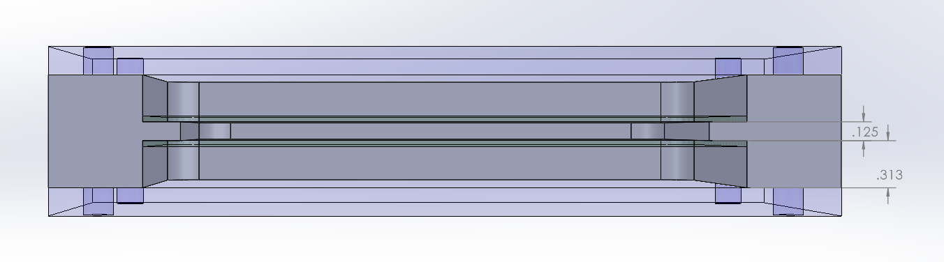

**Assembly:**

1. Cut silicone sheets to the inner dimensions of the U: 4 x 3.5”. (I think this is easiest with an x-acto knife and ruler, and without removing the outer coverings). Cut the points off the bottom 2 corners -the inside is rounded.
2. Remove the films from the silicone. Now put it back on the hard plastic one so that it lays flat. Take some plastic wrap and carefully apply it to the silicone. It will naturally stick, but smooth out as many bubbles and wrinkles as possible. Cut the plastic wrap around the edges of the sheet with scissors as precisely as possible. Remove the protective film.
   1. The plastic wrap serves to prevent the silicone providing oxygen to the sediment (silicone is oxygen-permeable), make it easier to reuse the silicone sheets, and make them slippery enough to use spacers.
3. Using a small spatula, apply a layer of silpoxy to the “lip” of the U. Add the silicone sheet with the plastic wrap towards the inside. Use the spatula to squish everything and make sure there are no air bubbles between the sheet and the U. Let this set for a few minutes before repeating on the other side.
   1. I think it helps to stand the U up and stretch the silicone at the top to make sure it’s the least floppy possible.
4. Apply a line of silicone caulk around the edge of the U, then put the window on. Repeat on the other side. Add the screws and nuts and tighten just a SMIDGE. Overtightening will ruin the seal by causing the plastic to warp. I tighten them only until they stop.
5. Let the silicone set overnight. The next day, prepare jello with DI water and unflavored gelatin. (Recipe: 28g gelatin/1L water) Boil the jello mix in the microwave and let cool to room temp before adding to ant farms. Put the spacers in the mud compartment to make sure it stays the correct thickness. I find it easiest to fill the jello using a 50mL beaker. Pour on both sides because the liquid will be displaced by the other side. Fill as close to the top as possible. Cover with plastic wrap (important!) and refrigerate overnight.
   1. Tip: each ant farm requires ~ 100mL of jello.
6. Once the jello is set, use the silicone caulk to make a cap for the jello. It is essential that this covers the entire thing and fills in all cracks and bubbles. Smooth out the top and let dry.
   1. An incomplete seal will cause the jello to decompose or melt. This could be due to water or bacterial intrusion, or it’s possible that the silicone and jello interact badly when there’s air trapped inside.
7. Once the silicone is dry, it’s time to add your mud. Suspending the mud in some seawater and pipetting it works well.

**Citations:**

Dorgan, K.M., Jumars, P.A., Johnson, B.D., and Boudreau, B.P. 2006. Macrofaunal burrowing: the medium is the message. *Oceanography and Marine Biology: An Annual Review* 44: 85-121.

Dorgan, K.M., Jumars, P.A., Johnson, B., Boudreau, B.P., and Landis, E. 2005. Burrow extension by crack propagation. *Nature* 433: 475.

