**LeapMotion Gesture Recognition**

*Pointer Finger Statistics:*

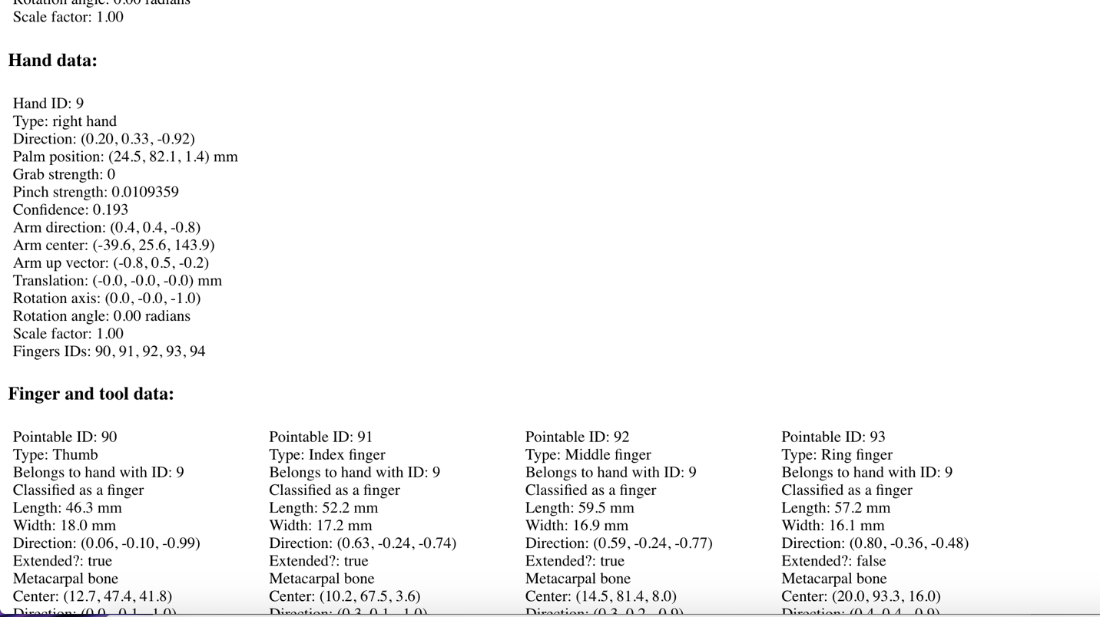

*Pinky Finger Statistics:*

