**Lesson Prep:**

Github of teaching material: <https://github.com/heaps/workshop>

Link to training session slides: <https://bit.ly/trainbp>

Curriculum Packet: <https://docs.google.com/document/d/1ClAQs0Aevxv7CZEYlpFrSp0ItsABhCApviM3IzRGnVE/edit>

Schedule is here: <https://drive.google.com/file/d/1CApUuuAsGcJJs2WJI1fhJvxHwv9s8V32/view?usp=sharing>

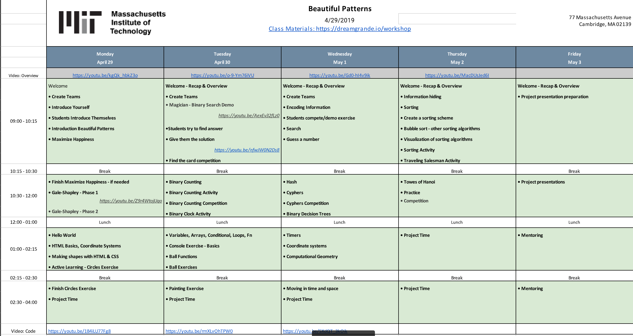

Go through github and download code, download and modify sample slides

Watch youtube video

**============================================================**

**Monday**

TA Meeting Pre-Class:

* Index cards / paper, tape for draw an engineer activity
* introduction
* **TAs have camera phone for taking photos** **of draw an engineer cards / collaborate wall**, upload to google photos
* Wristbands, cards for maximizing happiness
* Write collaborative wall, have post-it notes

Teams

* Number off 1-5

Draw an Engineer

* TA’s hand out index cards / paper
* Group by patterns
* Tape to wall

Restaurant as a Computer:

* Going to restaurant with a parent
* Notice different patterns
  + You give orders to waiter, waiter relays them to kitchen
  + Oven always cooks food at certain temperature

Making a Quesadilla:

* Example: Take tortilla out of bag. Put tortilla on pan. Take 2 scoops cheese out of bag. Put cheese on tortilla in pan. Cook for 5 minutes. Turn tortilla. You can write this on the board...

Maximizing Happiness:

* Required minimum score is 11
* Team with high score gets wristbands
* SOLUTION: 25 (based on bbc program)

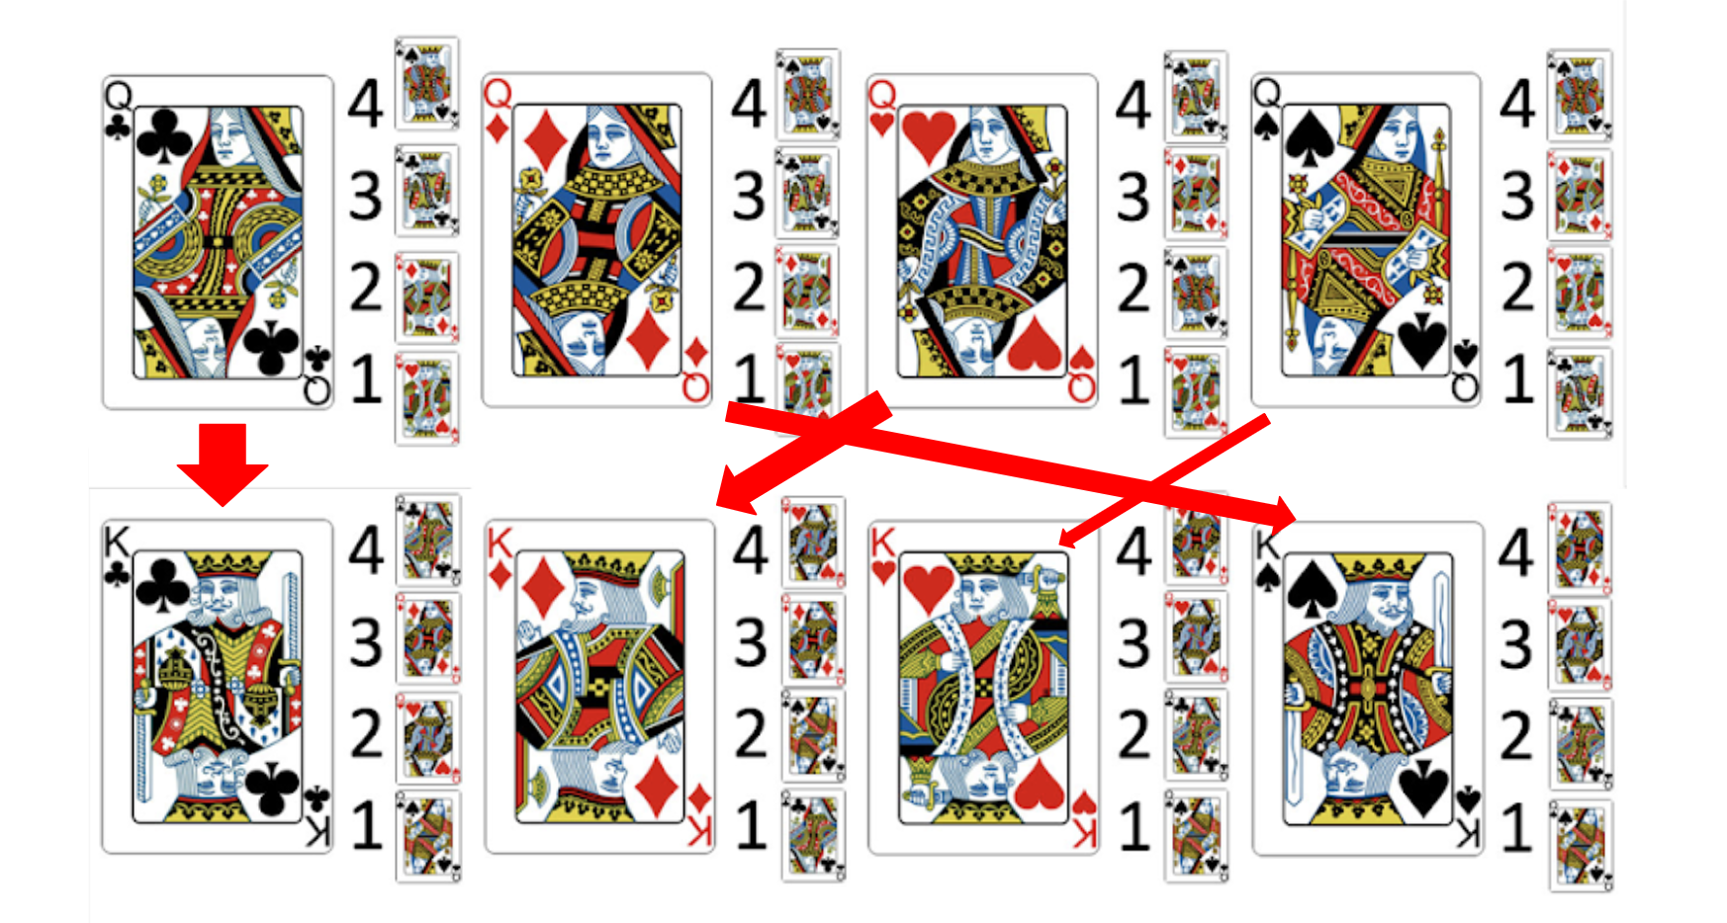

Gale-Shapley:

Algo - Round 1:

- Queens select their top 4 choices

- Queens select their top choice (first paring)

- King consider offers

- King selects top offer

(rejects others)

- Rejected queens top choice is removed

Algo - Round 2:

- Queens select their next top choice

- King consider offers

- King selects top offer

(rejects others)

- Rejected queens top choice is removed

* Apply Gale-Shapley to other real life situations
* present

Collaborative Wall

* *If you have the chance to write a book, what would it be about?* [*¿Si tuvieras la oportunidad de escribir un libro, de que se trataría?]*
* they can come up to the chart paper at any time and answer it anonymously. There will also be post-its for the students to write their answers on.

<https://dreamgrande.io/workshop> Monday:

* Hello World - with basics
  + 8ball.html in the github is solution to shapes
* Document Example 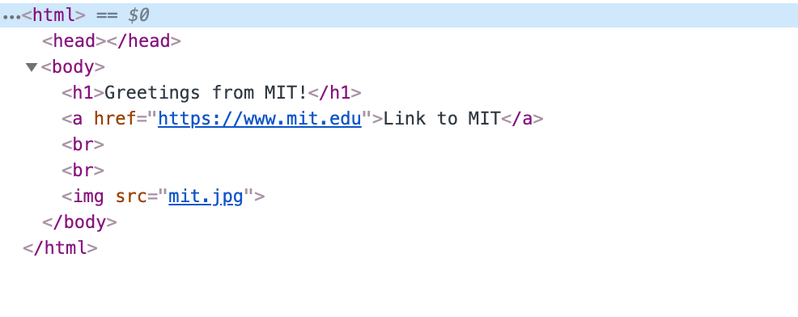
* Cover (change pic)
* Carousel
* Bootstrap
* Final project guidelines

End of Day Tasks

* Instructor Reflection
* TA Reflection
* Student Reflection - 1 minute video or form (see curriculum packet for instructions: <https://docs.google.com/document/d/1ClAQs0Aevxv7CZEYlpFrSp0ItsABhCApviM3IzRGnVE/edit?usp=sharing>)

**============================================================**

**Tuesday**

TAs are responsible for:

* Taking photo of collaborative wall at end of day
* Document videos / photos (when learning is being demonstrated, students are giving explanations of their solutions, describing applications of algorithms, or presenting their projects)
* **Form teams balanced by ability before start of class**
* **Practice card trick with TAs**
* Make sure cards are there

Collab Wall:

*What are you nervous about this week?*

Magic Trick - need to review this lmao

* Demo: <https://www.youtube.com/watch?v=AexEv32fLz0&feature=youtu.be>
* Answer: <https://www.youtube.com/watch?v=nfwJW0N2Ds8&feature=youtu.be> (put card in 16th position)

Binary Competition

* Pair up
* Whoever writes down right number in dec first wins

Design a Binary Clock

* No additional information, just have them draw something
* Present hints if stuck

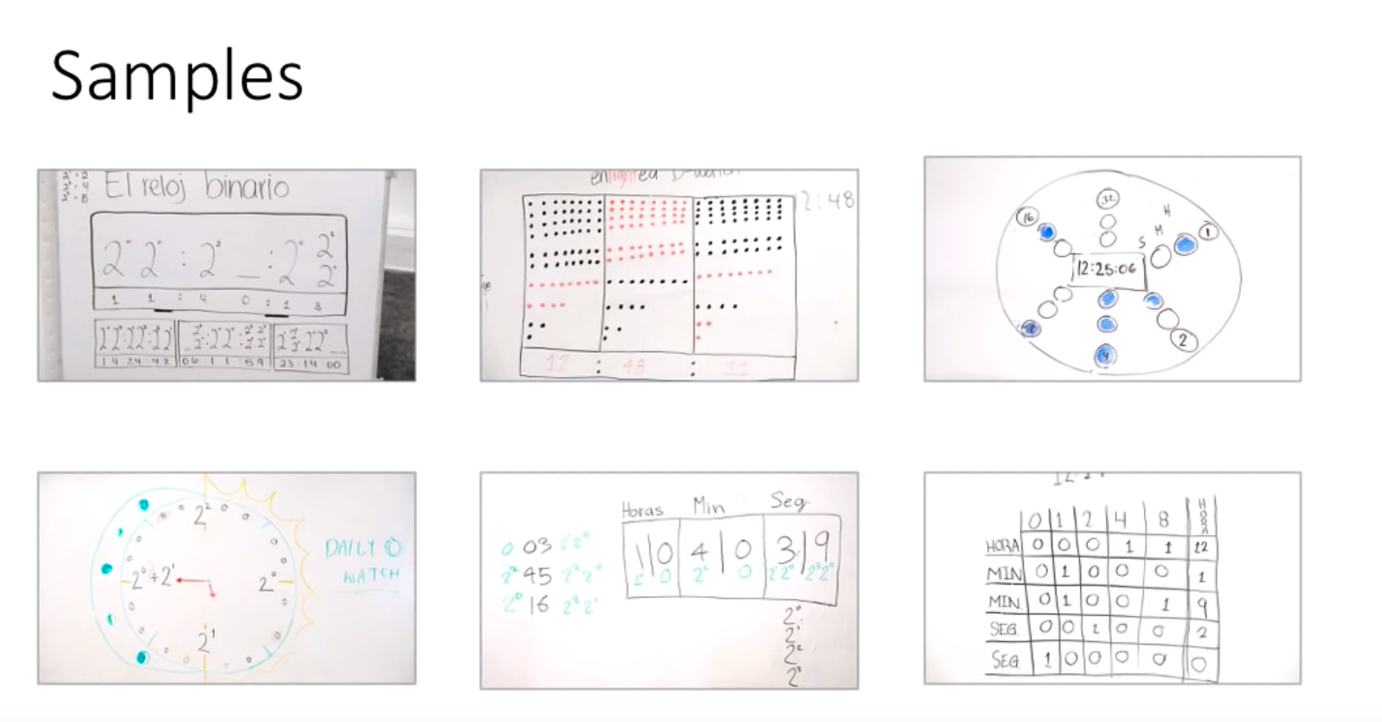

<https://dreamgrande.io/workshop> Tuesday:

* Ball
  + Show them console, especially magic.js
  + Can either write in console or in ball.js -> same as creating html div elements
* Painting 1 - Mona Lisa
* Painting 2 - ?
* Binary Hand - ?

End of Day Tasks

* Reflections
* TA take photo of collab wall

**============================================================**

**Wednesday**

**Tuesday**

TAs are responsible for:

* Taking photo of collaborative wall at end of day
* Document videos / photos (when learning is being demonstrated, students are giving explanations of their solutions, describing applications of algorithms, or presenting their projects)
* **Form teams balanced by ability before start of class**

Collaborative Wall: *What problems could patterns help solve in the real world?*

Guessing Game

* Take suggestions from audience for some cells to shade
* Then add row + column to make 6 x 6, shade in some so that every row and column is even
* Go outside, have a person remove 1 cell
* See whichever one is odd - that’s the one

Search for number (20 mins) - have 15 students go outside

- Select cards with numbers 1-to-15

- Shuffle cards

- Select 15 students from class

- Have them come up to the board

- Give a each student a shuffled card

- Ask each group to make a guess

- They are trying to find a number we selected

- ask: was there a strategy?

Search for number - Linear (20 mins)

- this time numbers are in order

- do not tell class numbers in order

- ask: was there a strategy?

<https://dreamgrande.io/workshop> Wednesday:

* Timer: write code in empty html in chrome console
* Move Ball: have them open moveBall.html in simulation (moveBallSimpleSolution.html)

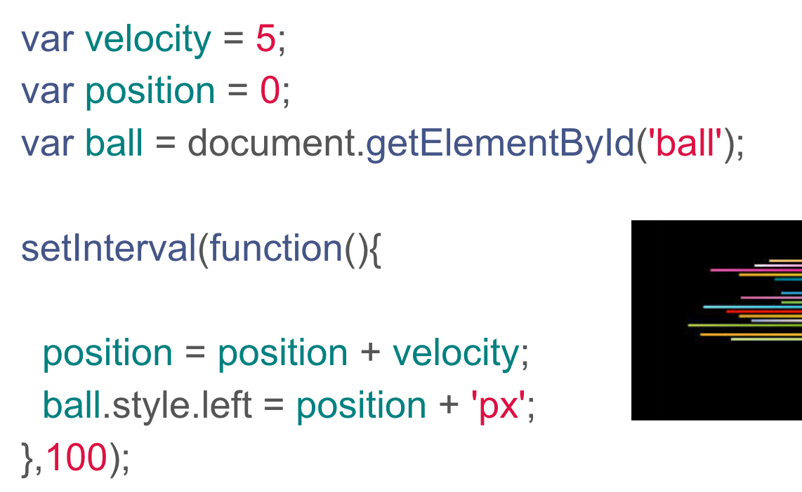

* Edge detection: moveball_solution.html - probably show this so they know what I’m talking about

**============================================================**

**Thursday**

Collab wall: *What was your favorite part of yesterday?*

TAs are responsible for:

* Taking photo of collaborative wall at end of day
* Document videos / photos (when learning is being demonstrated, students are giving explanations of their solutions, describing applications of algorithms, or presenting their projects)
* **Form teams balanced by ability before start of class**
* Towers of hanoi stuff?

**Information hiding**

**- first person chooses a random number**

**- first person adds allowance to random number**

**(creates new note)**

**- first person passes note to next person**

**- next person adds allowance to number**

**(creates new note)**

**- next person passes note to next person**

**- repeat until finished**

**- upon completion remove random number**

**divide by number in group to get allowance average**

Have them act out bubble sort and selection sort

Explain merge sort

Towers of Hanoi

* Only one disk can be moved at a time.
* Each move consists of taking the upper disk from one of the stacks and placing it on top of another stack or on an empty rod.
* No larger disk may be placed on top of a smaller disk,
* Have competitions

Pepper if there’s time?

Pepper (30 mins)

- Put candies and pepper in a container

- Place thirteen candies and one pepper

- Ask student team to go to front of class

- teacher: selects first, takes 1 candy

- student: selects second, takes 1-to-3 candies only

- teacher: selects third, takes 4 minus student selection

- Game ends when all candies are gone

The Orange Game (40 mins)

- Groups of 5 sits in a circle.

- Distribute the oranges or fruit randomly

- assign fruit choice

- student has two pieces, except for one student who has only one.

- The students pass the oranges/fruit around until each student gets there fruit

- You must follow two rules

- Only one piece of fruit may be held in a hand.

- A piece of fruit can only be passed to an empty hand of an immediate

neighbour in the circle.

- It may be necessary to emphasize that individuals don’t “win” the game, but that the puzzle is solved when everyone has the correct fruit.