### **Implementing CRM for Result tracking of a candidate with internal marks**

# INTRODUCTION

* 1. **Overview**

The project aim is to create for the Administrator should be able to create all base data including Semester, Candidate, Course and Lecturer, Lecturer should have the ability to create Internal Results, Dean, who is one of the Lecturer, should be the only one with ability to update Internal Results, Re-evaluation Can be initialised by Candidate for all Internal Results. Now only dean can update the marks after re- evaluation

* 1. **Purpose**

It is saves a lot of time. The purpose of the project is to manage the school student's result tracking process in the easy way. Students do not need to check the notice board and everyone will stay updated this is the main purpose of this project Can work easily. Increase candidate quality.

1. **Problem Definition & Design Thinking**
   1. 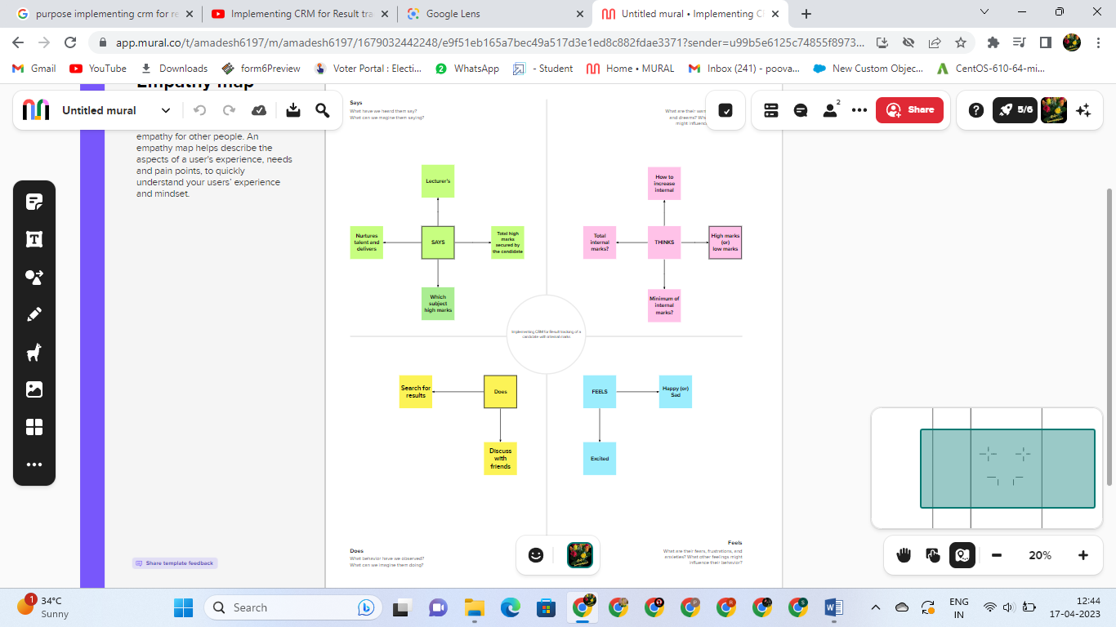**Empathy Map**
   2. **Ideation & Brainstorming Map**

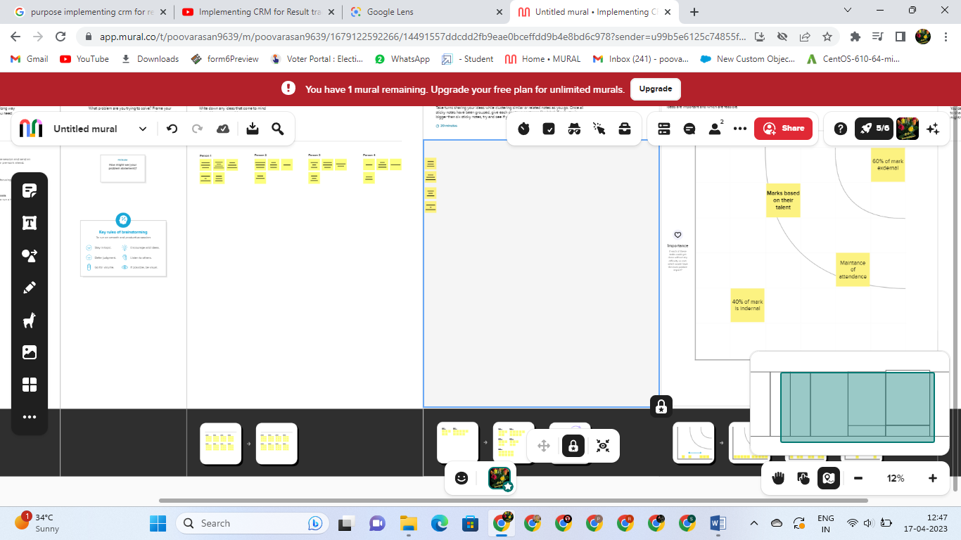­­­­­­

# RESULT

* 1. **Data Model:**

|  |  |
| --- | --- |
| **Object name** | **Fields in the Object** |
| **COURSE DETAILS** | |  |  | | --- | --- | | **Field label** | **Data type** | | Course Details | Text(20) | | Course Details | Text(80) | |
| **INTERNAL RESULTS** | |  |  | | --- | --- | | **Field label** | **Data type** | | Internal Results | Text(20) | | Internal Results Name | Text(80) | |

# Activity & Screenshot

**Milestone:2**

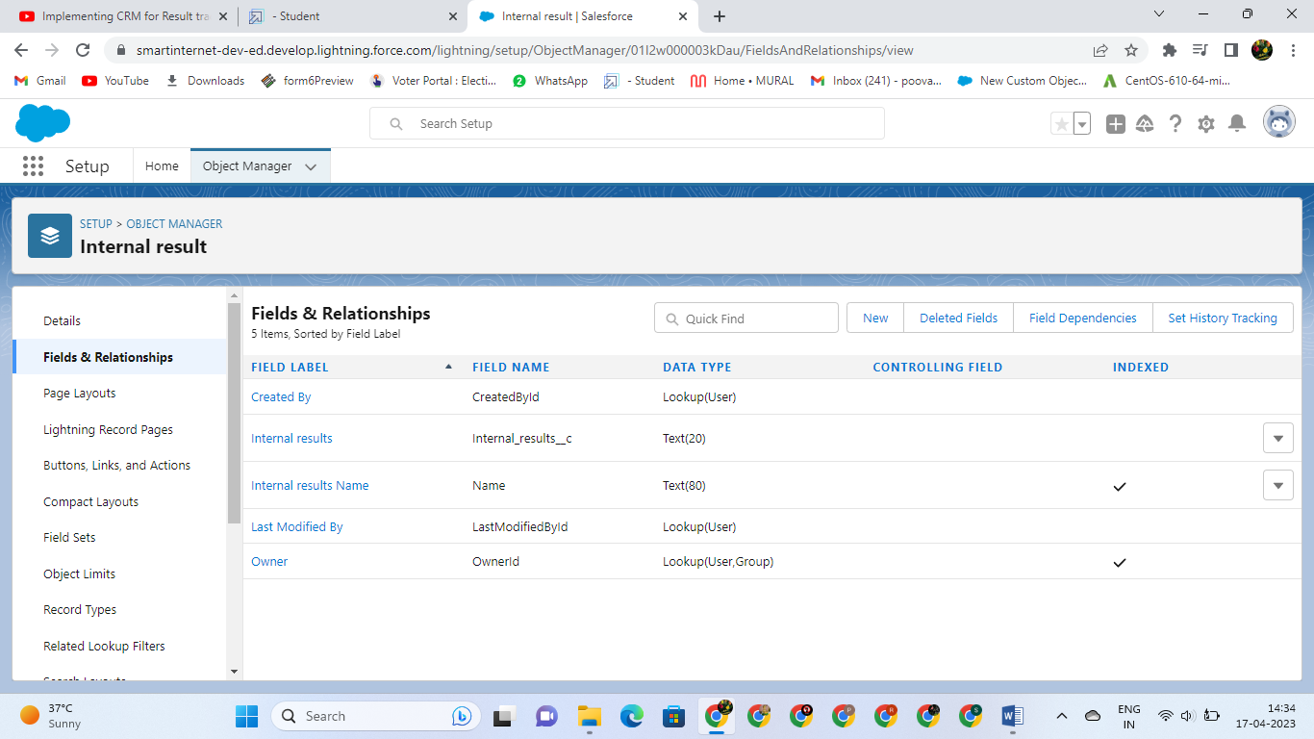 **Activity:1**

**­­ Milestone:2**

**Activity:2**

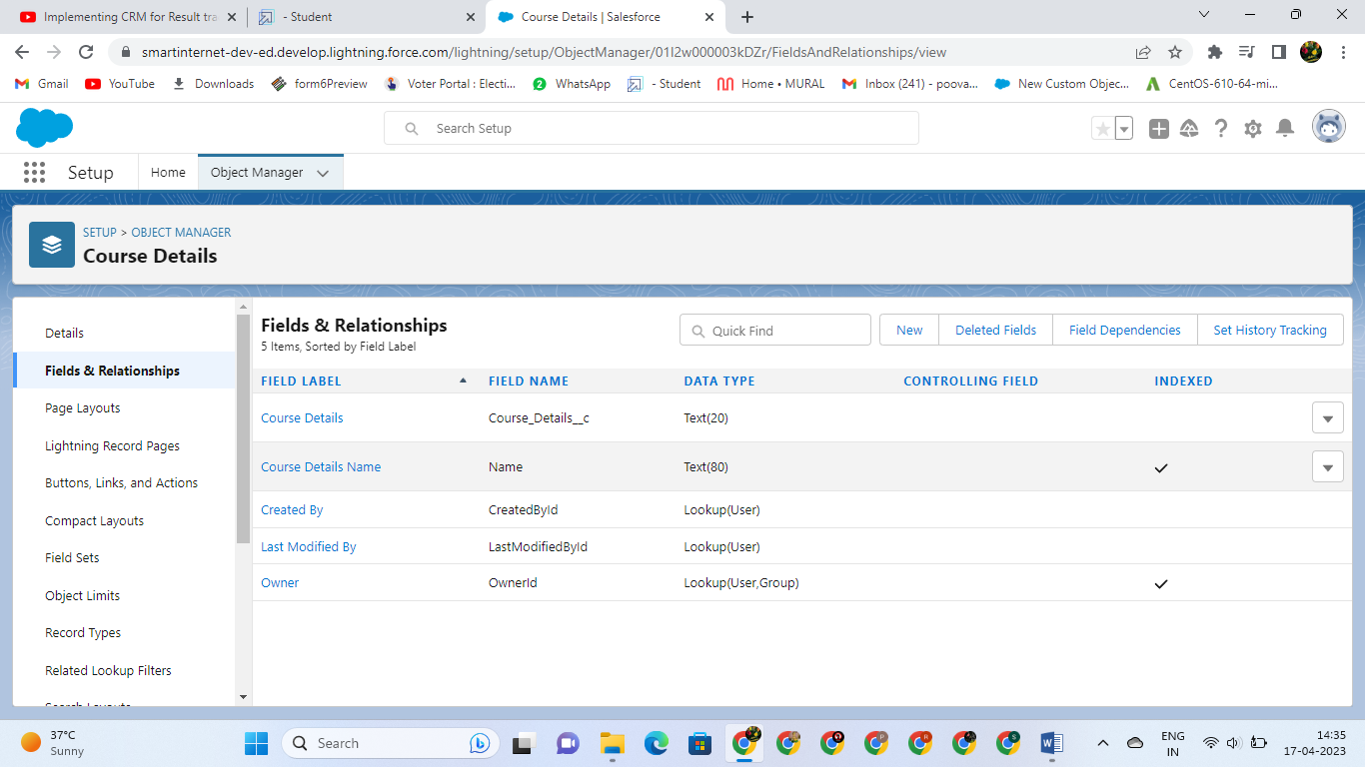

**­­**

**Milestone:2**

**Activity:3**

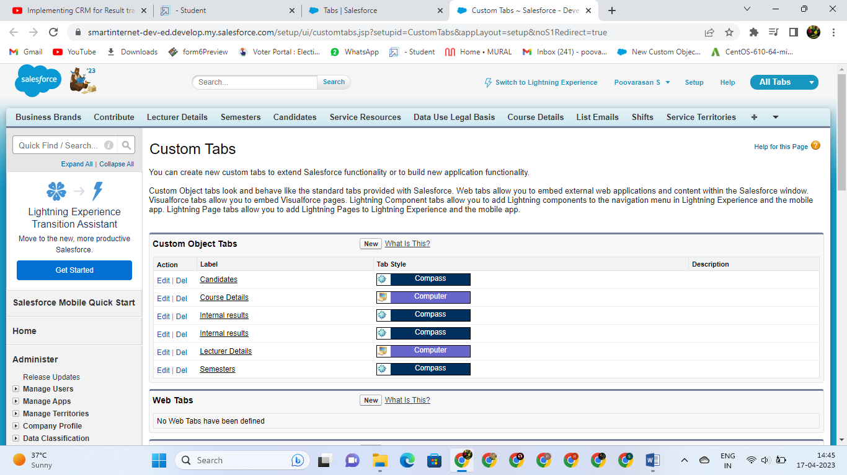

**­­ Milestone:3**

**Activity:1**

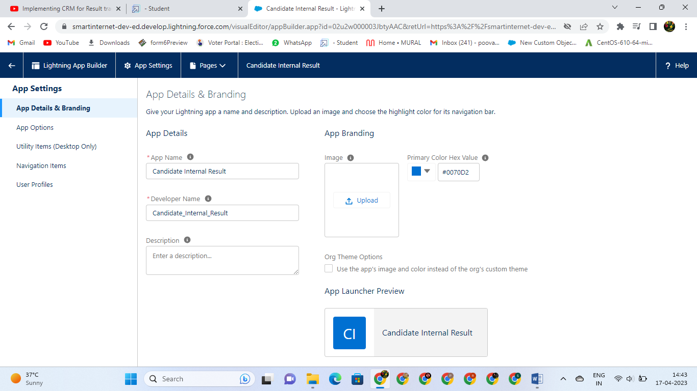**­­**

**Milestone:4**

**Activity:1**

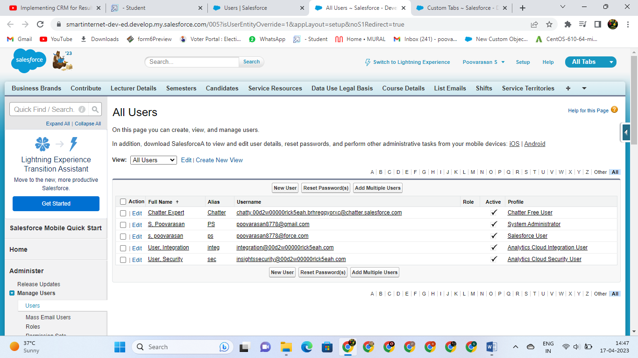

**Milestone:5**

**Activity:1**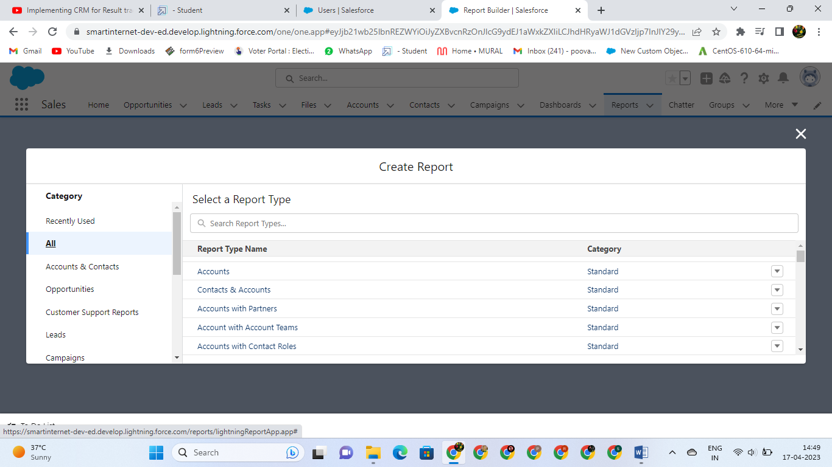

# Trailhead Profile Public URL

**Team Lead – A MADESH**

**https://trailblazer.me/id/mkiller5**

**Team Member 1 – S POOVARASAN**

<https://trailblazer.me/id/poovarasan8>

**Team Member 2 – R SIVA**

**https://trailblazer.me/id/spavithra15**

**Team Member 3 – D RAMESH**

**https://trailblazer.me/id/ramesh4**

1. **ADVANTAGES**

* [Reduce time to hire](https://resources.workable.com/stories-and-insights/advantages-disadvantages-of-internal-recruitment#reduce-time-to-hire)
* [Shorten on boarding times](https://resources.workable.com/stories-and-insights/advantages-disadvantages-of-internal-recruitment#shorten-onboarding-times)
* [Cost less](https://resources.workable.com/stories-and-insights/advantages-disadvantages-of-internal-recruitment#cost-less)
* [Strengthen employee engagement](https://resources.workable.com/stories-and-insights/advantages-disadvantages-of-internal-recruitment#strengthen-employee-engagement)

# APPLICATIONS

* I want something reliable
* Target marketing
* Increase candidate quality
* Can work easily Streamlining intimal sales processes

# CONCLUSION

* Student Internal Mark Management System deals with student details, academic related reports, college details and course details.
* It tracks all the details of a student from the day one to the end of his course which can be used for all reporting purpose, tracking of progress in the course, completed semester, upcoming semester details, exam details, project or any other assignment details, and final exam result.

# FUTURE SCOPE

* Scope of education means range of view, outlook, field or opportunity of activity, operation and application of education.
* Education has a wider meaning and application.