CI/CD using Maven, GitHub, VS Code and Jenkins
Step 1: Install Java (JDK)
- Download and install JDK 11 or above
- Set JAVA_HOME and add to PATH
- Verify using: java -version
Step 2: Install Maven
- Download apache-maven zip
- Extract to C:\apache-maven-3.9.14
- Set MAVEN_HOME and add %MAVEN_HOME%\bin to PATH
- Verify using: mvn -version
Step 3: Create Maven Project
Command:
mvn archetype:generate
GroupId: com.example
ArtifactId: my-app
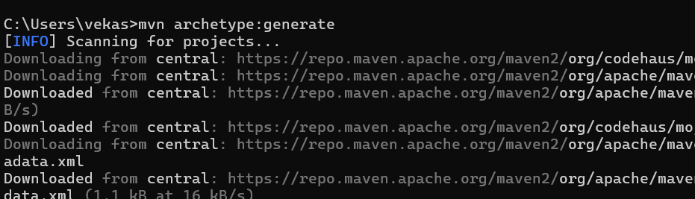
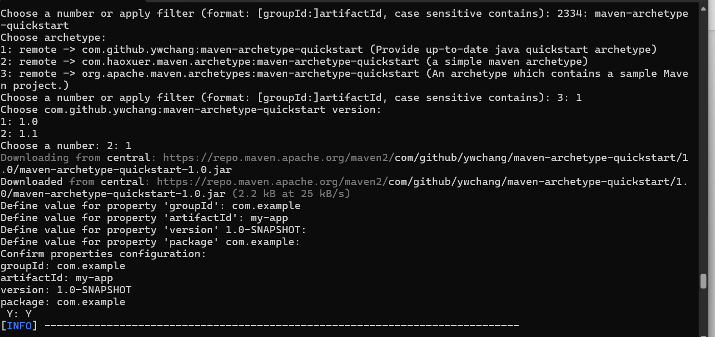
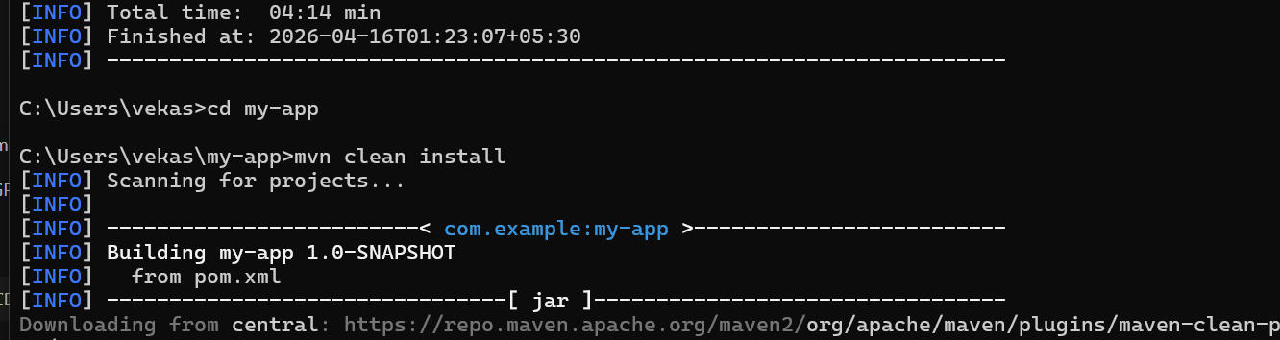
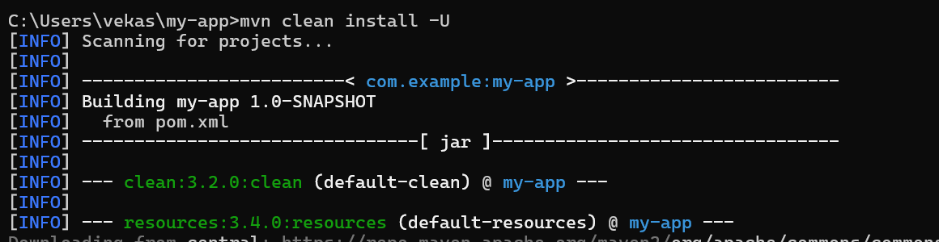
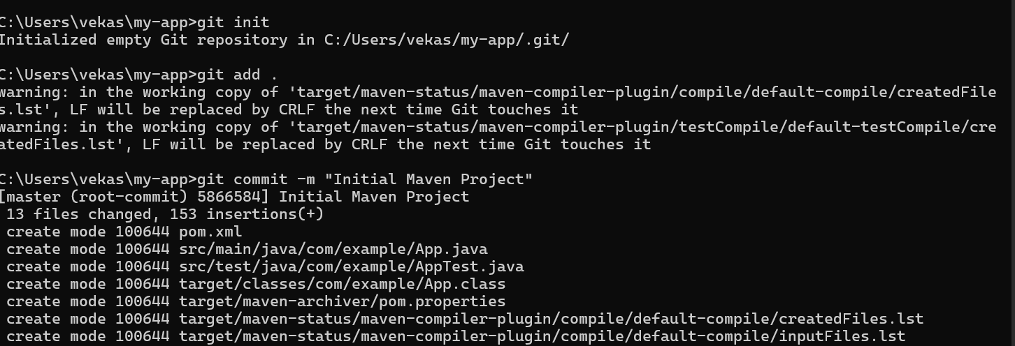
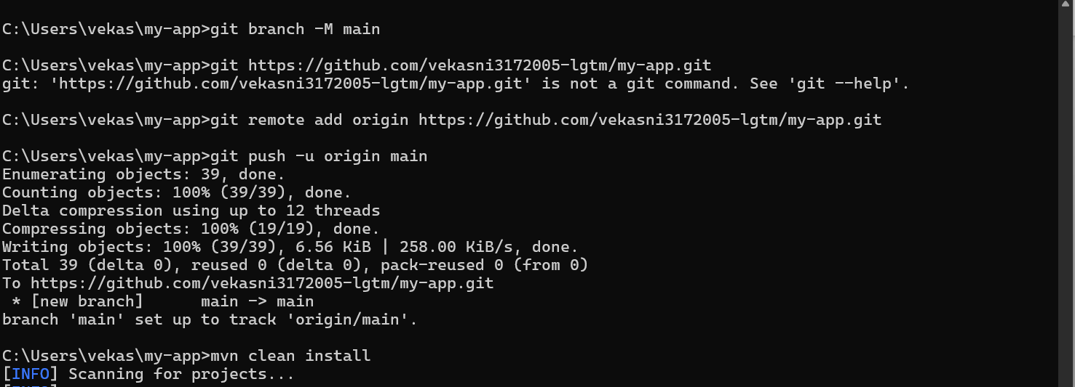
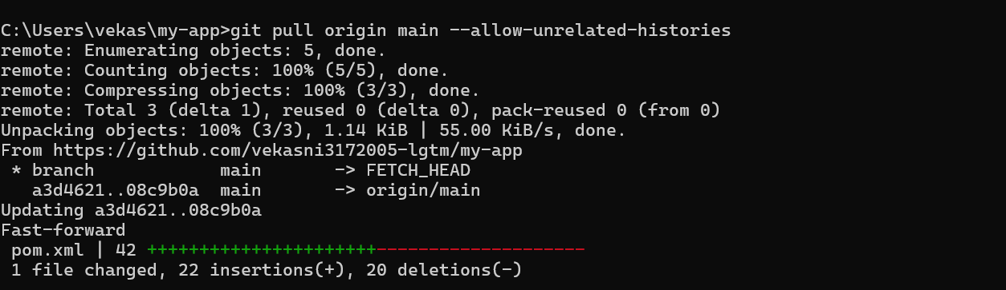

Step 4: Build Project
Command:
mvn clean install
Step 5: Push Project to GitHub
Commands:
git init
git add .
git commit -m "Initial commit"
git branch -M main
git remote add origin <repo-url>
git pull origin main --allow-unrelated-histories
git push -u origin main
Step 6: Modify Code
Edit App.java and AppTest.java
Step 7: Fix pom.xml (JUnit)
Add dependency:
<dependency>
<groupId>junit</groupId>
<artifactId>junit</artifactId>
<version>4.13.2</version>
<scope>test</scope>
</dependency>
Step 8: Install Jenkins
Open: http://localhost:8080
Install plugins
Step 9: Configure Maven in Jenkins
Manage Jenkins → Tools
Add Maven:
Name: M3
Path: C:\apache-maven-3.9.14
Step 10: Create Pipeline
New Item → Pipeline
Name: my-app-pipeline
Step 11: Pipeline Script
pipeline {
agent any
tools { maven 'M3' }
stages {
stage('Clone') {
steps {
checkout([
$class: 'GitSCM',
branches: [[name: '*/main']],
userRemoteConfigs: [[url: '<repo-url>']]
])
}
}
stage('Build') { steps { bat 'mvn clean install' } }
stage('Test') { steps { bat 'mvn test' } }
}
}
Step 12: Run Pipeline
Click Build Now
Check Console Output
Result: BUILD SUCCESS

