**CREATE TABLE DEPARTMENT(dep_id int PRIMARY KEY,dep_name varchar(123))**

**INSERT INTO DEPARTMENT VALUES(102,'Manager');**

**INSERT INTO DEPARTMENT VALUES(103,'IT HEAD');**

**INSERT INTO DEPARTMENT VALUES(104,'Saleshead');**

**INSERT INTO DEPARTMENT VALUES(101,'Finance');**

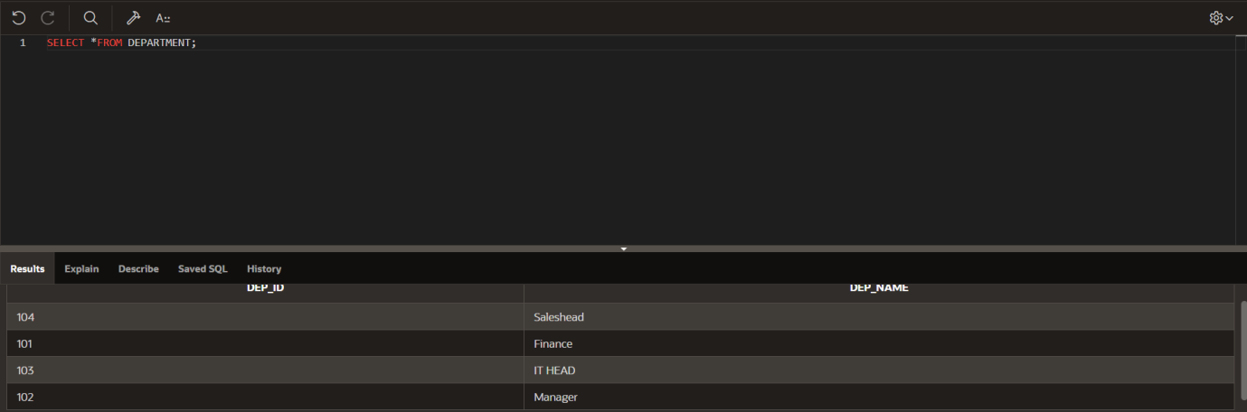

**CREATE TABLE EMPLOYEE(emp_id int PRIMARY KEY,emp_name varchar(123),dep_id int,FOREIGN KEY (dep_id) REFERENCES DEPARTMENT(dep_id));**

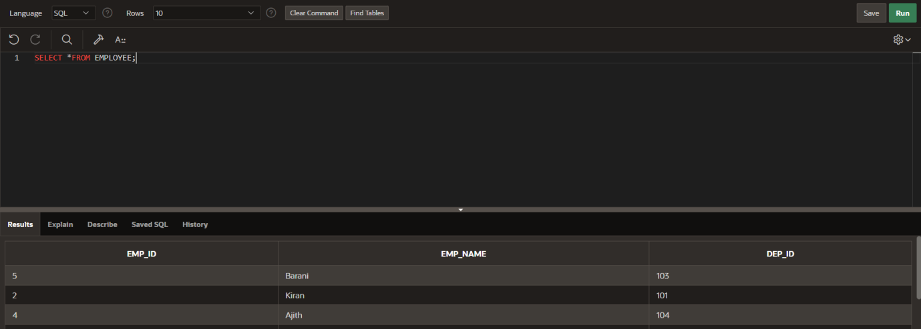

**SELECT EMPLOYEE.EMP_ID,DEPARTMENT.DEP_NAME FROM EMPLOYEE LEFT JOIN DEPARTMENT ON EMPLOYEE.DEP_ID=DEPARTMENT.DEP_ID;**

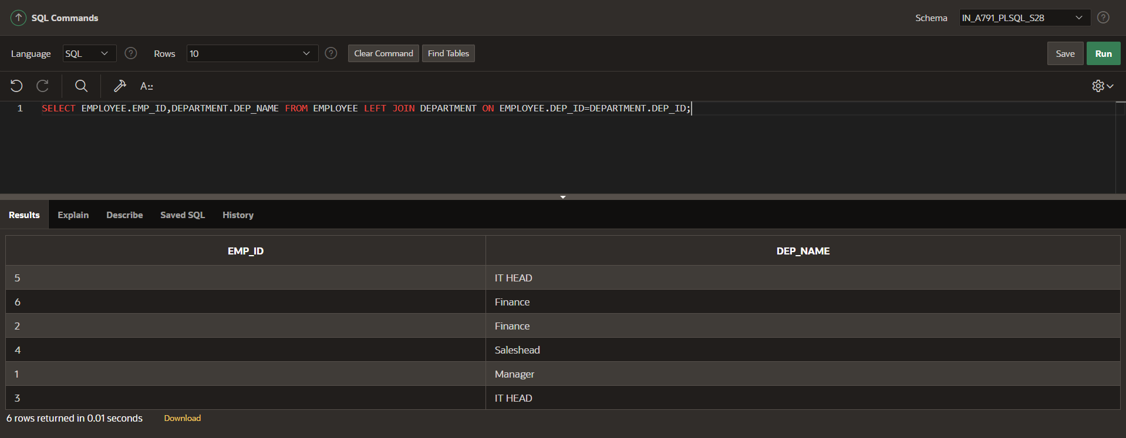

**SELECT DEPARTMENT.DEP_ID,EMPLOYEE.EMP_NAME**

**FROM DEPARTMENT**

**RIGHT JOIN EMPLOYEE ON DEPARTMENT.DEP_ID=EMPLOYEE.DEP_ID;**

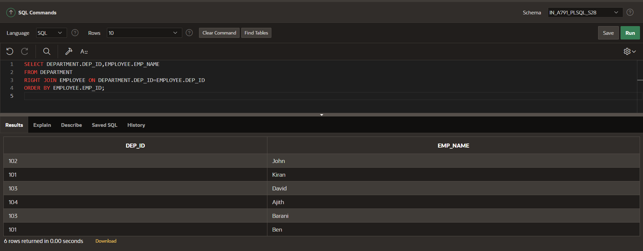

**SELECT EMP_ID,DEP_ID,DEP_NAME FROM EMPLOYEE NATURAL JOIN DEPARTMENT;**

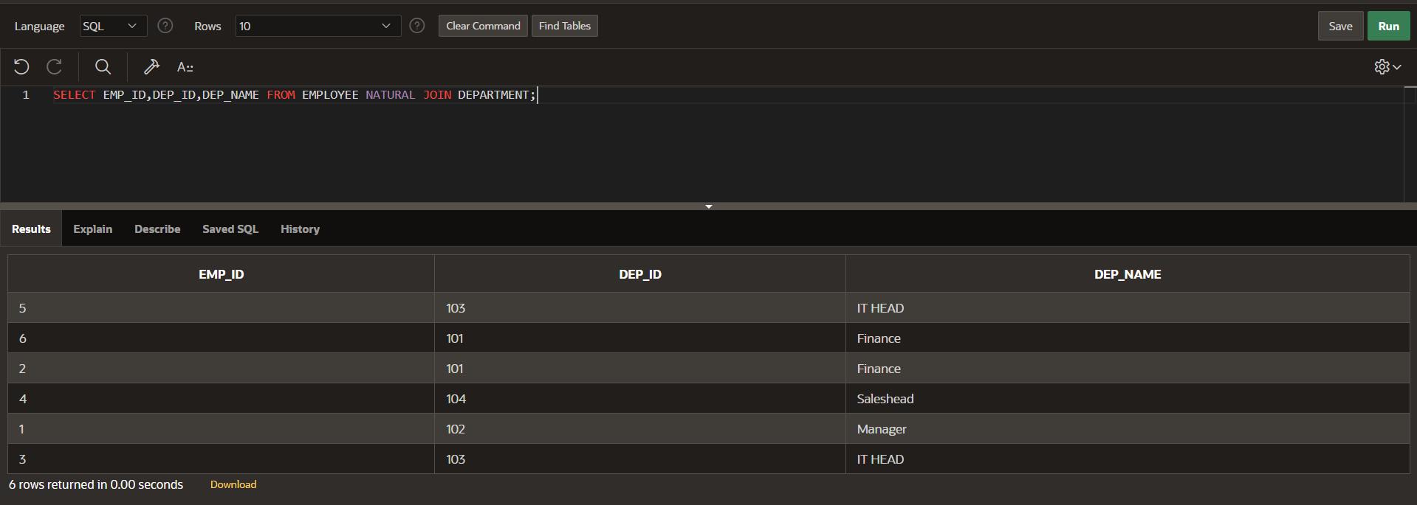

**SELECT a.EMP_ID,b.DEP_NAME FROM EMPLOYEE a JOIN DEPARTMENT b ON a.DEP_ID=b.DEP_ID**

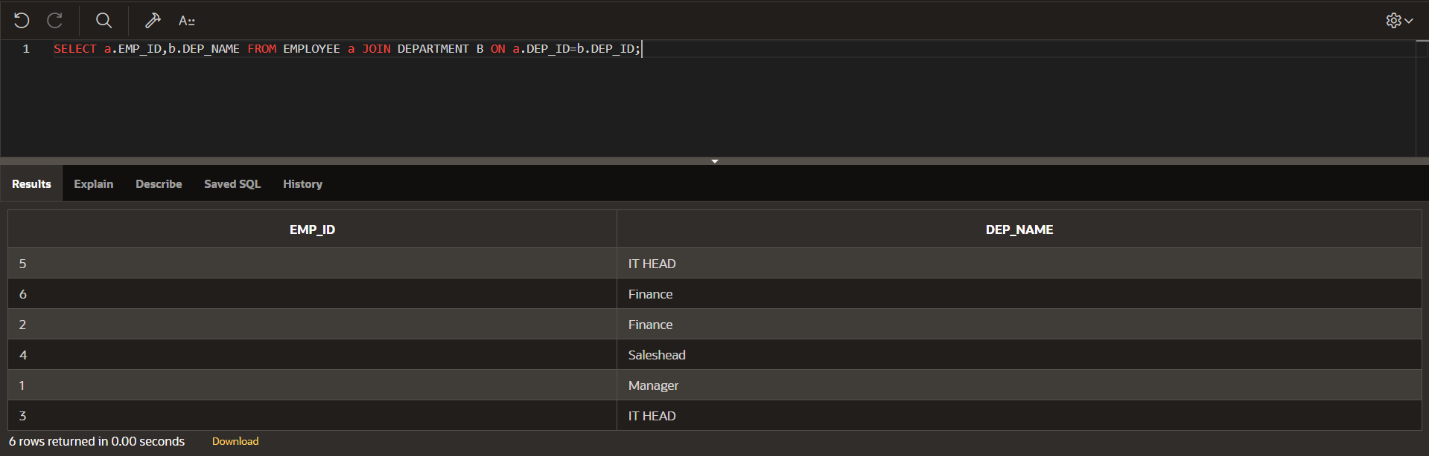

**SELECT EMP_ID,EMP_NAME,DEP_NAME FROM EMPLOYEE INNER JOIN DEPARTMENT ON EMPLOYEE.DEP_ID=DEPARTMENT.DEP_ID;**

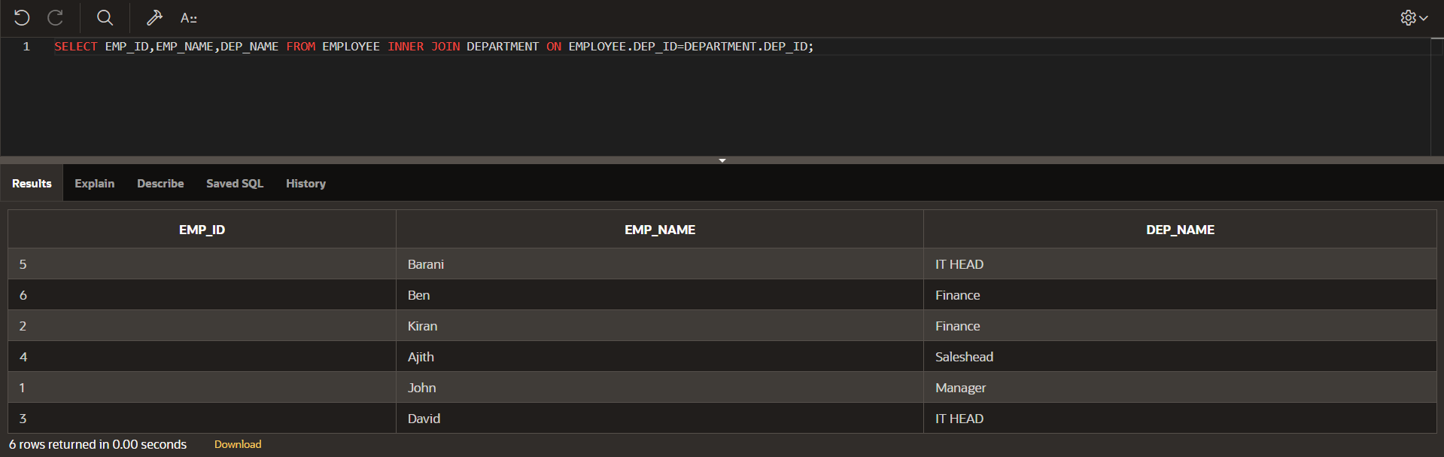

**SELECT EMP_ID,EMP_NAME,DEPARTMENT.DEP_ID,DEP_NAME from EMPLOYEE FULL OUTER JOIN DEPARTMENT ON EMPLOYEE.DEP_ID =DEPARTMENT.DEP_ID;**

