SIMATS ENGINEERING
ASSESSMENT TOOL 1

COURSE CODE: CSA1610 COURSE NAME: Data Warehousing and Data Mining

COURSE OUTCOME COVERED

CO3: Evaluate the effectiveness of classification techniques on real-time data for accurate prediction, enabling informed decision-making. (BL3,BL4,BL5)

QUESTIONS: 5 Total Marks:50

Annexure A

Experiments

Criteria | Understanding of Concepts (2.5) | Experimental Design (3) | Use of Tools (2) | Analysis of Results (1.5) | Documentation (1) | Total(10)
Weightage | 25% | 30% | 20% | 15% | 10% | 100%
Q1
Q2
Q3
Q4
Q5

Code of Conduct:

I _P.Madesh_192365007_ (Name / Reg No) certify that this submission is my original work and that I have adhered to the guidelines specified for this assessment.
I understand that any violation of academic integrity rules will result in disciplinary action.

Signature of the student:


RUBRICS FOR CALCULATION:

Criteria | Weightage | Level 4 – Exemplary | Level 3 – Proficient | Level 2 – Developing | Level 1 – Beginning
Understanding of Concepts | 25 | Demonstrates thorough understanding and effectively integrates multiple concepts/technologies | Good understanding with proper integration of most concepts | Basic understanding; limited or partial integration | Poor understanding; unable to integrate concepts
Experimental Design | 30 | Well-planned, systematic implementation with optimal solution | Correct implementation with minor issues | Basic implementation with errors or inefficiencies | Incorrect or incomplete implementation
Use of Tools | 20 | Effective and advanced use of tools/technologies with proper configuration | Appropriate use of tools with correct execution | Limited or inconsistent use of tools | Incorrect or minimal use of tools
Analysis of Results | 15 | Insightful analysis with accurate interpretation and validation of results | Good analysis with reasonable interpretation | Basic analysis with limited insights | Poor or incorrect analysis of results
Documentation | 10 | Clear, well-structured documentation with diagrams, code, and results | Organized documentation with necessary details | Basic documentation with missing details | Poor or incomplete documentation

Annexure C

Experiments :

Children of three ages are asked to indicate their preference for three photographs of adults. Do the data suggest that there is a significant relationship between age and photograph preference? What is wrong with this study? (10 Marks)

Photograph:
Age of child A B C
5-6 years: 18 22 20

7-8 years: 2 28 40

9-10 years: 20 10 40

Use cov() to calculate the sample covariance between B and C.
Use another call to cov() to calculate the sample covariance matrix for the preferences.
Use cor() to calculate the sample correlation between B and C.
Use another call to cor() to calculate the sample correlation matrix for the preferences.
2. Assume the Tennis coach wants to determine if any of his team players are scoring outliers. To visualize the distribution of points scored by his players, then how can he decide to develop the box plot? (10 Marks)

Player ID | Player Name | Points Scored
P1 | Player A | 12
P2 | Player B | 15
P3 | Player C | 14
P4 | Player D | 10
P5 | Player E | 18
P6 | Player F | 20
P7 | Player G | 22
P8 | Player H | 13
P9 | Player I | 11
P10 | Player J | 35
P11 | Player K | 16
P12 | Player L | 17
P13 | Player M | 19
P14 | Player N | 21
P15 | Player O | 23

3. A bank wants to decide whether to approve a loan based on customer attributes like:
- Age
- Income
- Employment Status
- Credit Score
Using historical data, build a Decision Tree classifier to predict Loan Approval (Yes/No). (10 Marks)
Consider the Data Set
young,high,employed,good,yes
young,high,self-employed,average,yes
middle,high,employed,good,yes
old,medium,employed,good,yes
old,low,unemployed,poor,no
old,low,self-employed,average,no
middle,low,unemployed,poor,no
young,medium,employed,average,yes
young,low,unemployed,poor,no
old,medium,self-employed,good,yes
middle,medium,employed,average,yes
middle,high,self-employed,good,yes
old,medium,unemployed,poor,no
young,medium,self-employed,average,yes
middle,low,employed,poor,no

4. Two Maths teachers are comparing how their Year 9 classes performed in the end of year exams. Their results are as follows: (5 Marks)
Class A: 76, 35, 47, 64, 95, 66, 89, 36, 8476,35,47,64,95,66,89,36,84
Class B: 51, 56, 84, 60, 59, 70, 63, 66, 5051,56,84,60,59,70,63,66,50
(i) Find which class had scored higher mean, median and range.
(ii) Plot above in boxplot and give the inferences

5. Suppose that a hospital tested the age and body fat data for 18 randomly selected adults with the following results: (10 Marks)

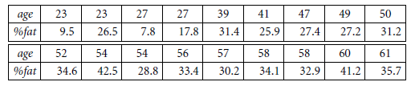
(a) Calculate the mean, median, and standard deviation of age and %fat.
(b) Draw the boxplots for age and %fat.
(c) Draw a scatter plot and a q-q plot based on these two variables.

Question 1 — Age vs Photograph Preference (10 Marks)
Problem: Children of three age groups indicated their preference for three photographs (A, B, C) of adults. We must determine whether age and photograph preference are significantly related, and identify flaws in the study design.

Observed Data
Age of Child | Photograph A | Photograph B | Photograph C | Row Total
5–6 years | 18 | 22 | 20 | 60
7–8 years | 2 | 28 | 40 | 70
9–10 years | 20 | 10 | 40 | 70
Column Total | 40 | 60 | 100 | 200

Test of Significant Relationship — Chi-Square Test of Independence
Since both variables (Age group and Photograph preference) are categorical, the appropriate test for association is the Chi-Square (χ²) test of independence.
H₀ (Null hypothesis): Age and photograph preference are independent (no relationship).
H₁ (Alternative hypothesis): Age and photograph preference are NOT independent (a relationship exists).
Expected frequency for each cell = (Row Total × Column Total) / Grand Total
Age of Child | Expected A | Expected B | Expected C
5–6 years | 12.00 | 18.00 | 30.00
7–8 years | 14.00 | 21.00 | 35.00
9–10 years | 14.00 | 21.00 | 35.00

χ² = Σ [ (Observed − Expected)² / Expected ] = 29.60
- Degrees of freedom, df = (rows − 1)(cols − 1) = (3−1)(3−1) = 4
- Critical value of χ² at 5% significance level, df = 4 → 9.488
- Calculated χ² (29.60) > Critical χ² (9.488) ⟹ Reject H₀
Conclusion: There IS a statistically significant relationship between the age of the child and photograph preference (p < 0.001). Younger children (5–6) show a more even spread, the 7–8 group strongly favours photographs B and C over A, and the 9–10 group favours C most.

Covariance and Correlation using R
Treating each photograph's preference counts across the 3 age groups as a variable (A, B, C), we can build a preference matrix and use R's cov() and cor() functions:
# Preference data (rows = age groups, columns = photographs)
A <- c(18, 2, 20)
B <- c(22, 28, 10)
C <- c(20, 40, 40)
pref <- cbind(A, B, C)
# (i) Sample covariance between B and C
cov(B, C)
# (ii) Sample covariance matrix for A, B, C
cov(pref)
# (iii) Sample correlation between B and C
cor(B, C)
# (iv) Sample correlation matrix for A, B, C
cor(pref)
Results (computed):
Quantity | Value
cov(B, C) | -20.00
cor(B, C) | -0.189

Covariance matrix cov(A,B,C):
 | A | B | C
A | 97.33 | -74.00 | -46.67
B | -74.00 | 84.00 | -20.00
C | -46.67 | -20.00 | 133.33

Correlation matrix cor(A,B,C):
 | A | B | C
A | 1.000 | -0.818 | -0.410
B | -0.818 | 1.000 | -0.189
C | -0.410 | -0.189 | 1.000

Interpretation: A and B are strongly negatively correlated (-0.818) — as preference for A rises across groups, preference for B falls. B and C are weakly negatively correlated (-0.189). A and C are moderately negatively correlated (-0.410).

What is Wrong with this Study?
- Very small / uneven cell counts — the cell '7–8 years, Photo A = 2' is extremely small, making the chi-square approximation unreliable for that cell (expected count rule of thumb: expected ≥ 5 in every cell is preferred).
- No random sampling / random assignment described — children may not represent the general population of each age group.
- Confounding variables not controlled — gender, cultural background, and familiarity with the photographed adults could influence preference.
- Age grouping is arbitrary — collapsing continuous age into 3 bins can hide or exaggerate real trends (ecological/aggregation bias).
- Only 3 photographs used — limited stimuli reduce generalizability of 'photograph preference' as a construct.
- No repeated trials / no measure of preference strength — a single forced choice does not capture intensity of preference.
- Chi-square shows association, not causation — the test cannot explain WHY age relates to preference.

Question 2 — Boxplot for Outlier Detection in Tennis Scores (10 Marks)
Problem: The coach wants to detect scoring outliers among 15 players and visualise the distribution of points scored using a boxplot.

Data
Player ID | P1 | P2 | P3 | P4 | P5 | P6 | P7 | P8
Points | 12 | 15 | 14 | 10 | 18 | 20 | 22 | 13

Player ID | P9 | P10 | P11 | P12 | P13 | P14 | P15
Points | 11 | 35 | 16 | 17 | 19 | 21 | 23

Steps to Construct the Boxplot
- Step 1 — Sort the data: 10, 11, 12, 13, 14, 15, 16, 17, 18, 19, 20, 21, 22, 23, 35
- Step 2 — Find the median (Q2): middle value = 17
- Step 3 — Find Q1 (median of lower half) = 13.5 and Q3 (median of upper half) = 20.5
- Step 4 — Compute IQR = Q3 − Q1 = 20.5 − 13.5 = 7.0
- Step 5 — Compute fences: Lower fence = Q1 − 1.5×IQR = 13.5 − 10.5 = 3.0; Upper fence = Q3 + 1.5×IQR = 20.5 + 10.5 = 31.0
- Step 6 — Any point outside [3.0, 31.0] is plotted as an outlier. Here, Player J = 35 exceeds the upper fence ⟹ Player J is a scoring outlier.
R code to build the boxplot:
points <- c(12,15,14,10,18,20,22,13,11,35,16,17,19,21,23)
boxplot(points,
main = "Boxplot of Points Scored by Tennis Players",
ylab = "Points Scored", col = "lightgreen")
boxplot.stats(points)$out # returns outlier values -> 35
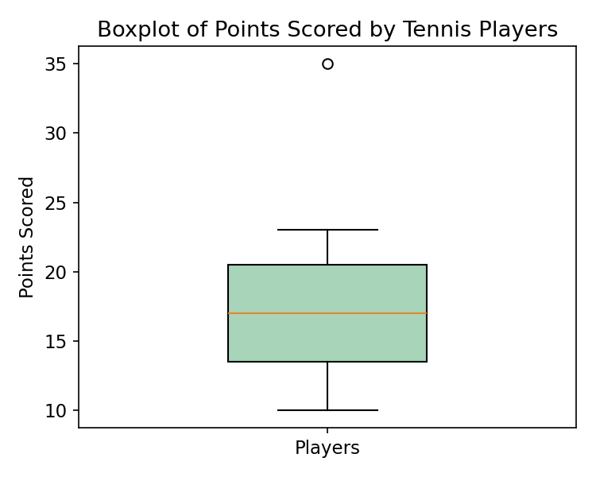

Decision
Q1 = 13.5, Median = 17, Q3 = 20.5, IQR = 7.0, Mean ≈ 17.73, Std. Dev ≈ 6.25.
The coach can conclude that Player J's score of 35 lies well beyond the upper fence (31.0) and stands out as a statistical outlier — either an exceptionally strong performance or a data-entry anomaly worth verifying. All other players fall within the expected range of variation.

Question 3 — Decision Tree Classifier for Loan Approval (10 Marks)
Problem: Build a Decision Tree classifier (ID3 algorithm, using Information Gain) to predict Loan Approval (Yes/No) from Age, Income, Employment Status and Credit Score.

Training Data
# | Age | Income | Employment | Credit Score | Loan Approved
1 | young | high | employed | good | yes
2 | young | high | self-employed | average | yes
3 | middle | high | employed | good | yes
4 | old | medium | employed | good | yes
5 | old | low | unemployed | poor | no
6 | old | low | self-employed | average | no
7 | middle | low | unemployed | poor | no
8 | young | medium | employed | average | yes
9 | young | low | unemployed | poor | no
10 | old | medium | self-employed | good | yes
11 | middle | medium | employed | average | yes
12 | middle | high | self-employed | good | yes
13 | old | medium | unemployed | poor | no
14 | young | medium | self-employed | average | yes
15 | middle | low | employed | poor | no

Class distribution: 9 records = "yes", 6 records = "no" (n = 15)

Step 1 — Entropy of the Whole Dataset
Entropy(S) = −Σ pᵢ log₂(pᵢ)
Entropy(S) = −(9/15)·log₂(9/15) − (6/15)·log₂(6/15) = 0.4421 + 0.5288 = 0.971 bits

Step 2 — Information Gain for Each Attribute
Information Gain(S, Attribute) = Entropy(S) − Σ (|Sᵥ|/|S|) × Entropy(Sᵥ) for each value v of the attribute
Attribute | Weighted Remaining Entropy | Information Gain
Age | 0.888 | 0.083
Income | 0.260 | 0.711
Employment Status | 0.501 | 0.470
Credit Score | 0.241 | 0.730

Credit Score gives the highest Information Gain (0.730) ⟹ it becomes the ROOT node.

Step 3 — Split on Credit Score
- Credit Score = poor → {5 records, all "no"} ⟹ Pure node ⟹ Leaf = NO
- Credit Score = good → {5 records, all "yes"} ⟹ Pure node ⟹ Leaf = YES
- Credit Score = average → {5 records: 4 yes, 1 no} ⟹ Not pure, needs further splitting. Entropy = 0.722 bits

Step 4 — Split the "Average" Credit-Score Branch
Within the Credit Score = average subset, Information Gain is recalculated for the remaining attributes (Age, Income, Employment). Income (and Age, which ties) gives the highest gain; splitting on Income cleanly separates the classes:
- Income = low → {1 record: no} ⟹ Leaf = NO
- Income = medium → {3 records: yes, yes, yes} ⟹ Leaf = YES
- Income = high → {1 record: yes} ⟹ Leaf = YES

Final Decision Tree
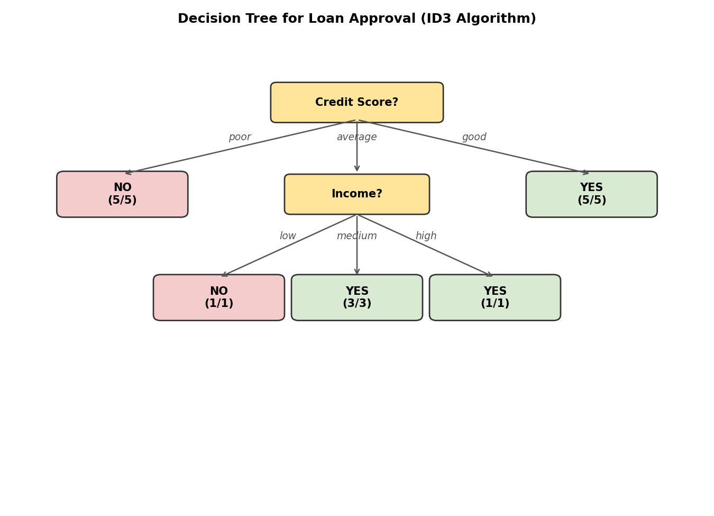

Decision Rules extracted from the tree:
- IF Credit Score = good → Loan Approved = YES
- IF Credit Score = poor → Loan Approved = NO
- IF Credit Score = average AND Income = low → Loan Approved = NO
- IF Credit Score = average AND Income ∈ {medium, high} → Loan Approved = YES
R code (using the rpart / party package):
library(rpart)
library(rpart.plot)
loan <- data.frame(
Age = c("young","young","middle","old","old","old","middle","young",
"young","old","middle","middle","old","young","middle"),
Income = c("high","high","high","medium","low","low","low","medium",
"low","medium","medium","high","medium","medium","low"),
Employment = c("employed","self-employed","employed","employed","unemployed",
"self-employed","unemployed","employed","unemployed","self-employed",
"employed","self-employed","unemployed","self-employed","employed"),
CreditScore = c("good","average","good","good","poor","average","poor","average",
"poor","good","average","good","poor","average","poor"),
Approved = c("yes","yes","yes","yes","no","no","no","yes",
"no","yes","yes","yes","no","yes","no")
)
model <- rpart(Approved ~ Age + Income + Employment + CreditScore,
data = loan, method = "class")
rpart.plot(model)

Question 4 — Comparing Class A and Class B Exam Results (5 Marks)
Problem: Two Year-9 Maths classes are compared on end-of-year exam scores.

Data
Class A
76, 35, 47, 64, 95, 66, 89, 36, 84

Class B
51, 56, 84, 60, 59, 70, 63, 66, 50

(i) Mean, Median and Range
Statistic | Class A | Class B | Higher
Mean | 65.78 | 62.11 | Class A
Median | 66.00 | 60.00 | Class A
Range (Max − Min) | 95 − 35 = 60 | 84 − 50 = 34 | Class A

Class A scored higher on all three measures — mean, median, and range. Class A's much larger range (60 vs 34) also shows its scores are far more spread out / less consistent than Class B's.

(ii) Boxplot and Inference
Statistic | Class A | Class B
Minimum | 35 | 50
Q1 | 47 | 56
Median (Q2) | 66 | 60
Q3 | 84 | 66
Maximum | 95 | 84
IQR | 37 | 10

classA <- c(76, 35, 47, 64, 95, 66, 89, 36, 84)
classB <- c(51, 56, 84, 60, 59, 70, 63, 66, 50)
boxplot(classA, classB, names = c("Class A","Class B"),
col = c("orange","skyblue"),
main = "Boxplot Comparison: Class A vs Class B",
ylab = "Exam Score")
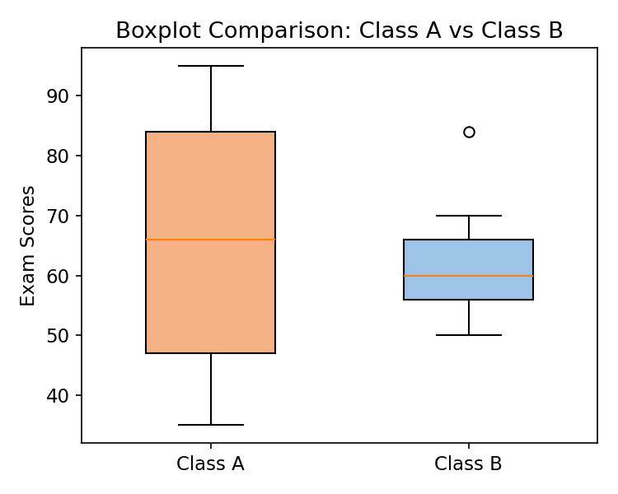
Fig 4.1: Boxplot comparison of Class A and Class B exam scores.
Inferences:
- Class A has a higher median score and a wider spread (IQR = 37 vs 10) — its box is taller, indicating greater variability in student performance.
- Class B's scores are more tightly clustered around the median (IQR = 10), suggesting more consistent performance across students.
- Class A's box is skewed — the median (66) is closer to Q3 (84) than Q1 (47), suggesting a left (negative) skew, i.e. more students scored above the median with a few low scorers pulling the range down.
- No outliers appear beyond the whiskers for either class (within 1.5×IQR of the quartiles), so all scores are considered typical for their class.
- Overall: Class A performed better on average but less uniformly; Class B performed slightly lower on average but more uniformly.

Question 5 — Age and Body Fat (%fat) Analysis (10 Marks)
Problem: A hospital recorded age and %body-fat for 18 randomly selected adults.

Data
age | 23 | 23 | 27 | 27 | 39 | 41 | 47 | 49 | 50
%fat | 9.5 | 26.5 | 7.8 | 17.8 | 31.4 | 25.9 | 27.4 | 27.2 | 31.2

age | 52 | 54 | 54 | 56 | 57 | 58 | 58 | 60 | 61
%fat | 34.6 | 42.5 | 28.8 | 33.4 | 30.2 | 34.1 | 32.9 | 41.2 | 35.7

(a) Mean, Median, Standard Deviation
Statistic | Age | %fat
Mean | 46.44 | 28.78
Median | 51.00 | 30.70
Standard Deviation (sample) | 13.22 | 9.25

age <- c(23,23,27,27,39,41,47,49,50,52,54,54,56,57,58,58,60,61)
fat <- c(9.5,26.5,7.8,17.8,31.4,25.9,27.4,27.2,31.2,34.6,42.5,28.8,33.4,30.2,34.1,32.9,41.2,35.7)
mean(age); median(age); sd(age)
mean(fat); median(fat); sd(fat)

(b) Boxplots for Age and %fat
boxplot(age, main = "Boxplot of Age", ylab = "Age (years)", col = "gold")
boxplot(fat, main = "Boxplot of %fat", ylab = "Body Fat (%)", col = "orchid")
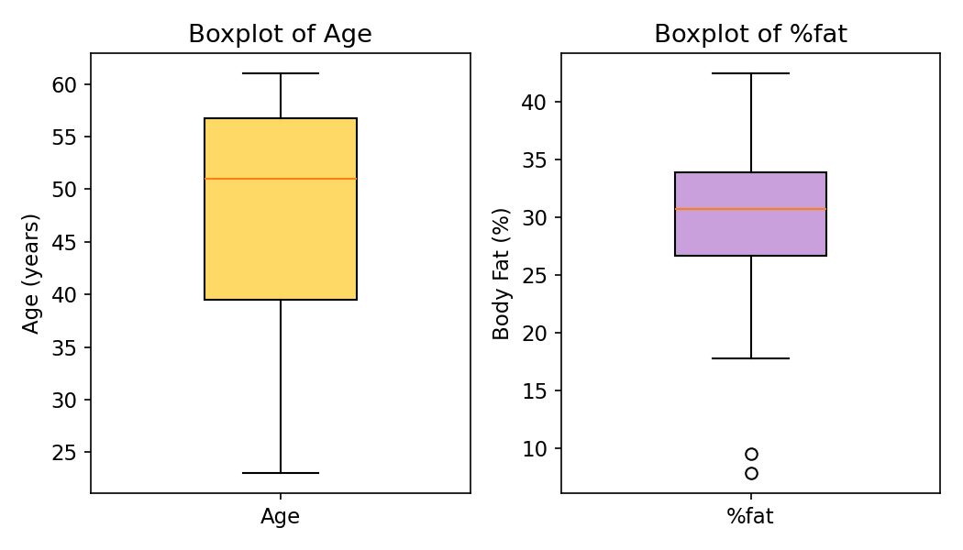
Fig 5.1: Boxplots of Age (left) and %fat (right). The two low %fat values (7.8, 9.5) appear as mild outliers below the lower whisker.

(c) Scatter Plot and Q-Q Plot
plot(age, fat, main = "Scatter Plot: Age vs %fat",
xlab = "Age", ylab = "%fat", pch = 19, col = "blue")
abline(lm(fat ~ age), col = "red", lty = 2)
cor(age, fat)
qqplot(age, fat, main = "Q-Q Plot: Age vs %fat",
xlab = "Age quantiles", ylab = "%fat quantiles")
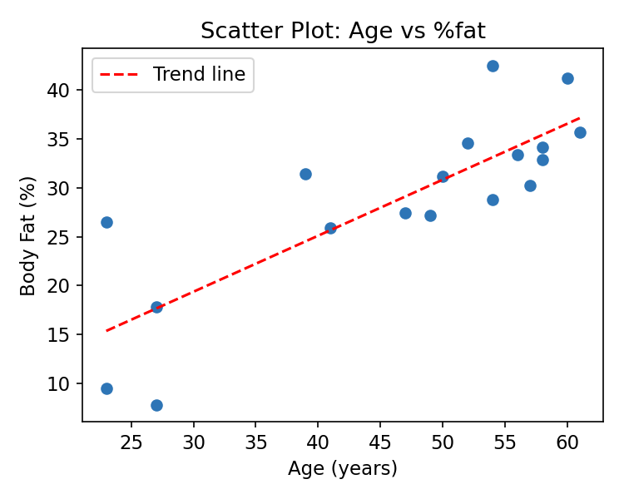
Fig 5.2: Scatter plot of Age vs %fat with fitted trend line (r ≈ 0.818, strong positive linear relationship).
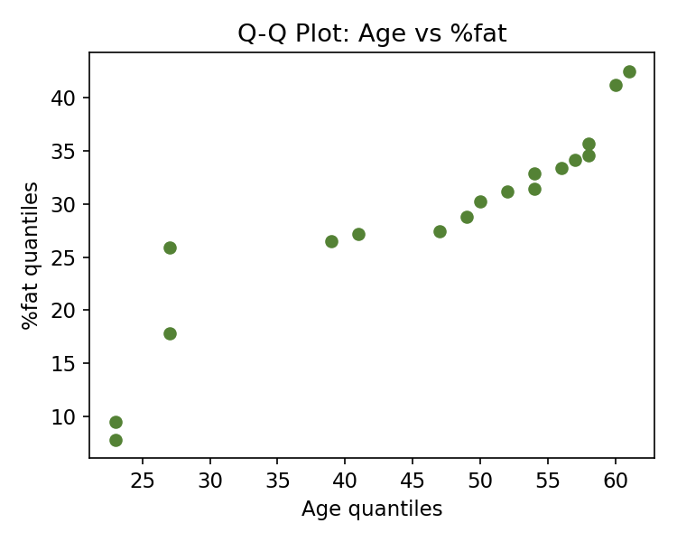
Fig 5.3: Q-Q plot comparing the quantiles of Age and %fat — the near-linear pattern confirms the two distributions have a similar shape/relationship.
Interpretation:
- The scatter plot shows a strong positive linear relationship between age and body fat (r ≈ 0.82) — %fat tends to rise as age increases.
- The boxplot of %fat shows two mild low outliers (7.8% and 9.5%), corresponding to the two youngest adults (age 23, 27) with unusually low body fat.
- The Q-Q plot's roughly straight/linear pattern indicates that the quantiles of age and %fat increase together at a fairly constant rate, reinforcing the strong positive association seen in the scatter plot.
- Age is fairly symmetric (mean 46.44 ≈ median 51 loosely), while %fat is close to symmetric with a median (30.7) slightly above the mean (28.78), suggesting a mild left skew caused by the two low outlier values.

