KARSENZ
PICKUP & LOGISTICS MANAGEMENT SYSTEM
Product Requirements Document
A scheduling, dispatch and proof-of-pickup platform designed to prevent missed future bookings, improve driver utilisation and provide end-to-end visibility from customer request to workshop handover.

Document Version | 1.0
Prepared For | Karsenz Total Car Care Pvt. Ltd.
Prepared Date | 16 July 2026
Product Owner | Karsenz Operations / Customer Service Management
Primary Users | Customer Service, Dispatchers, Drivers, Branch Teams and Management
Status | Initial build-ready baseline for review and estimation

CONFIDENTIAL - INTERNAL USE

Document Control

Version History
Version | Date | Author / Owner | Summary
1.0 | 16-Jul-2026 | Karsenz Product Team | Initial PRD covering MVP, architecture, UX concepts and delivery roadmap

Approvals
Role | Name | Decision | Date
Business Sponsor | To be assigned | Pending | -
Product Owner | To be assigned | Pending | -
Operations Lead | To be assigned | Pending | -
Technology Lead | Madeshwaran / nominee | Pending | -

Intended Audience
- Karsenz directors and branch management
- Customer service management and pickup dispatch coordinators
- Engineering, UX, QA, DevOps and security teams
- Implementation partners for WhatsApp, maps, hosting or CRM integration
Baseline principle
This PRD defines the product outcome and minimum behaviour. UI appearance and implementation details may evolve, but business rules, auditability and acceptance criteria must remain traceable.

Table of Contents
1. Executive Summary
2. Business Context and Problem Statement
3. Product Vision, Goals and Success Measures
4. Scope and Release Strategy
5. Users, Roles and Permissions
6. End-to-End Process and Status Model
7. Functional Requirements
8. Business Rules and Validation
9. User Stories and Acceptance Criteria
10. UX and Figma-Ready Screen Specifications
11. Data Model
12. API and Integration Requirements
13. Solution Architecture and Technology Stack
14. Non-Functional Requirements
15. Security, Privacy and Audit
16. Reporting and Analytics
17. Notification Templates
18. Testing and Acceptance Strategy
19. Deployment and Operations
20. Delivery Roadmap, Risks and Open Decisions
Appendices

1. Executive Summary
Karsenz currently coordinates customer vehicle pickups primarily through WhatsApp messages. This method works for immediate requests but does not reliably support bookings scheduled several days in advance. Messages can become buried, ownership is unclear, driver availability is not visible, and there is no single record that proves whether a pickup was scheduled, assigned, completed, delayed or cancelled.
The proposed Pickup & Logistics Management System will introduce a central booking calendar, dispatcher control tower, driver mobile workflow, customer notifications and proof-of-pickup process. Customer service staff will be able to create future-dated bookings, dispatchers will assign one of the six drivers based on branch, location and availability, and drivers will execute a guided checklist until the vehicle is formally handed over to the workshop.
Recommended MVP outcome
A browser-based operations portal plus mobile-friendly driver application that supports future bookings, assignment, live status, evidence capture, alerts and reporting. WhatsApp remains a notification channel, but the system becomes the source of truth.

Business Benefits
- Prevent missed pickups by storing every request against a specific future date and time window.
- Improve driver utilisation through a daily calendar and dispatcher view of all six drivers.
- Reduce customer follow-up calls using automated confirmation, driver assignment and arrival notifications.
- Create accountability with timestamps, users, status history, photos, signatures and handover confirmation.
- Enable management reporting across branches, drivers, cancellations, delays and service conversion.
- Provide a scalable foundation for route optimisation, Zoho CRM integration and customer self-service.

Recommended Product Shape
Component | Primary Users | Purpose
Operations Web Portal | Customer service, dispatcher, branch team, management | Booking, scheduling, assignment, monitoring, reports and administration
Driver Mobile App / PWA | Drivers | View assigned jobs, navigate, update statuses and capture pickup evidence
Notification Service | Customers and internal teams | Send WhatsApp/SMS/email confirmations, reminders and exception alerts
Integration/API Layer | Karsenz systems and partners | Connect CRM, maps, reporting, storage and future workshop systems

2. Business Context and Problem Statement

2.1 Current Operating Model
- A customer requests vehicle pickup through phone or WhatsApp.
- Customer service posts the request in an internal WhatsApp conversation or group.
- A driver may be assigned informally based on availability and individual awareness.
- Future-dated requests remain in chat history and may not resurface on the required day.
- Status updates, customer communication and workshop handover are handled manually.
- Management lacks a consolidated view of pickup volume, delays, utilisation and outcomes.

2.2 Core Problem
Problem statement
Karsenz needs a reliable way to record, schedule and execute pickup requests for today or any future date, while coordinating six drivers and multiple branches without depending on chat history or individual memory.

2.3 Root Causes
Root Cause | Operational Impact
WhatsApp is conversation-oriented, not schedule-oriented | Future bookings are buried and may be missed
No central calendar or pickup register | Teams cannot see a complete daily or weekly workload
No structured driver assignment | Double booking, uneven workload and last-minute decisions
No mandatory status workflow | Unclear whether the driver departed, arrived or completed pickup
No proof and handover checklist | Disputes about vehicle condition, documents, fuel or accessories
No automated reminders or escalations | Delayed pickups are identified only after customer complaints
No consistent reporting | Management cannot identify trends or process leakage

2.4 Constraints and Assumptions
- Initial operation has approximately six drivers; the design must scale to more drivers and branches.
- Customer service staff will continue receiving many requests through WhatsApp or phone during MVP.
- Drivers are expected to have Android smartphones with mobile data and camera access.
- Exact real-time GPS tracking is optional for MVP; timestamped location capture at key events is sufficient.
- WhatsApp Business API onboarding and template approval may require a third-party provider and Meta approval.
- The product must support India-specific addresses, phone numbers, vehicle registration formats and time zone Asia/Kolkata.

3. Product Vision, Goals and Success Measures

3.1 Product Vision
Vision
Every Karsenz vehicle pickup is planned, owned, visible and provable - from the first customer request to workshop acceptance.

3.2 Product Goals
ID | Goal | Description
G1 | Reliable future scheduling | Allow a pickup to be booked days or weeks in advance and automatically surface it on the correct day.
G2 | Efficient dispatch | Give dispatchers one view of demand, driver capacity, branch and location.
G3 | Controlled execution | Guide drivers through a consistent status and evidence workflow.
G4 | Customer transparency | Send timely confirmations and operational updates through approved channels.
G5 | Management visibility | Measure pickup volume, punctuality, cancellations, utilisation and conversion.
G6 | Scalable platform | Support multiple branches, more drivers and future integrations without redesigning the core.

3.3 Target Success Metrics
Metric | Target | Measurement Definition
Booking capture rate | ≥ 98% | All accepted pickup requests are entered into the system
Missed future pickups | < 1% | Booking not executed without recorded cancellation or reschedule
On-time arrival | ≥ 90% | Driver arrives within confirmed pickup window
Assignment lead time | ≥ 95% assigned before shift | Upcoming jobs have a named driver before execution
Evidence completeness | ≥ 95% | Required photos, odometer, fuel, documents and signature captured
Status compliance | ≥ 95% | All mandatory state transitions recorded
Customer notification success | ≥ 95% | Confirmation and operational updates delivered or failure surfaced
Dispatcher efficiency | 30-50% reduction | Less manual coordination through calls and repeated WhatsApp follow-up

Targets should be validated after four weeks of baseline measurement. The system must record enough data to calculate these metrics automatically.

4. Scope and Release Strategy

4.1 MVP In Scope
- Customer and vehicle master records with duplicate detection.
- Create, edit, cancel and reschedule same-day or future pickup bookings.
- Calendar and dispatcher board with driver availability and workload.
- Manual driver assignment and reassignment with conflict warnings.
- Driver mobile job list, navigation link, click-to-call and status updates.
- Pickup checklist, vehicle condition photos, odometer, fuel level, accessories and signature.
- Workshop/branch handover confirmation and closing notes.
- WhatsApp/SMS/email notifications through a configurable provider.
- Dashboard, standard reports, CSV export and audit log.
- Multi-branch configuration, users, roles, service areas and business hours.
- Responsive web UI and installable PWA or Flutter mobile client.
- REST APIs, secure authentication, logging, backups and CI/CD.

4.2 Explicitly Out of Scope for MVP
- Fully automatic route optimisation across all drivers.
- Customer-facing public booking portal or consumer mobile application.
- Live continuous GPS tracking and geofencing throughout every journey.
- Driver payroll, attendance, fuel expense or fleet maintenance management.
- Workshop job-card, spare parts, invoicing and accounting replacement.
- Machine-learning demand forecasting or dynamic pricing.
- Two-way WhatsApp conversational bot beyond approved notification templates.

4.3 Suggested Release Plan
Release | Scope | Outcome
MVP / Release 1 | Booking, calendar, assignment, driver workflow, proof, notifications, basic reports | Replace WhatsApp as the system of record
Release 1.1 | Capacity planning, recurring reminders, SLA alerts, improved analytics, CRM sync | Strengthen daily operations and data quality
Release 2 | Route optimisation, customer booking link, live tracking, expense capture | Optimise scale and customer experience
Release 3 | Workshop job-card integration, predictive demand and operational automation | End-to-end connected service operations

5. Users, Roles and Permissions
Role | Capabilities | Restrictions
Customer Service Executive | Create customer/vehicle; create, edit, reschedule or cancel booking; view status; contact customer | No user administration; cannot alter completed proof
Dispatcher / Logistics Coordinator | View all jobs; assign/reassign drivers; manage availability; monitor SLA; escalate exceptions | Cannot delete audit history or security settings
Driver | View only assigned jobs; start navigation; update allowed statuses; capture proof; raise issue | Cannot view other drivers' jobs or change booking commercial details
Branch Reception / Service Advisor | Acknowledge vehicle handover; record received condition; link job-card/reference | Cannot assign drivers unless granted dispatcher role
Operations Manager | View all branches; override assignment; approve exceptions; access reports and audits | No infrastructure configuration unless also administrator
System Administrator | Manage users, roles, branches, master data, templates, integrations and retention | Operational actions remain audited
Read-only Management | View dashboards and reports | No create, edit or workflow actions

5.1 Permission Model
- Role-based access control (RBAC) with optional branch-level data scope.
- Users may hold more than one role, but permissions must be explicit and auditable.
- Sensitive overrides such as reopening a closed booking require reason capture.
- Driver access is restricted to current and recent assigned jobs; customer data exposure is minimised.
- Administrative changes to notification templates, SLA rules and integrations require elevated permission.

5.2 Responsibility Matrix
Activity | Customer Service | Dispatcher | Driver | Branch | Manager
Create booking | R | C | - | C | A
Assign driver | C | R/A | - | C | A
Execute pickup | - | C | R/A | - | C
Accept handover | - | C | C | R/A | C
Cancel / reschedule | R | R | C | C | A for override
Review KPI / exception | C | R | C | C | A

R = Responsible, A = Accountable, C = Consulted.

6. End-to-End Process and Status Model
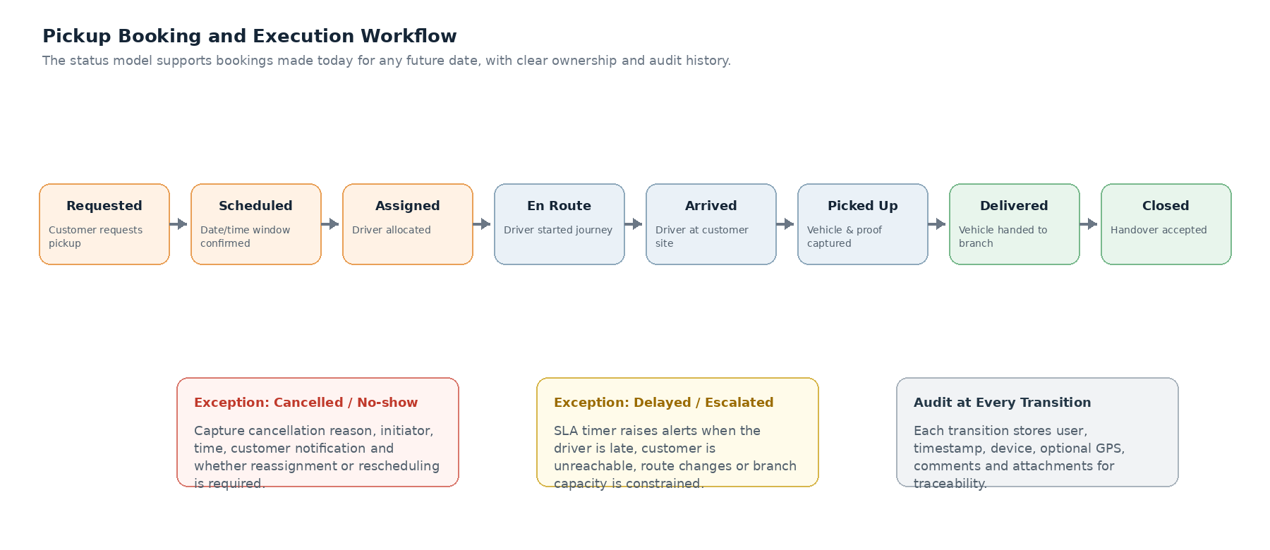
Figure 1 - Standard pickup lifecycle and controlled exception paths

6.1 Standard Process
- Customer service identifies or creates the customer and vehicle record.
- The pickup is scheduled with date, time window, address, contact and service intent.
- The system validates branch hours, driver capacity and duplicate/conflicting bookings.
- Dispatcher assigns a driver immediately or leaves the job in an unassigned queue.
- The customer receives booking confirmation and, when available, driver details.
- Driver views the job, contacts the customer if needed and starts the journey.
- Driver records arrival and completes the pickup checklist with evidence.
- Vehicle is marked picked up and transported to the assigned branch.
- Branch representative verifies handover and records job-card/reference details.
- Booking is closed; operational metrics and audit events become reportable.

6.2 Status Definitions
Status | Meaning | Allowed Actor | Key Rule
Draft | Booking started but not confirmed | Customer service | No notifications; not counted as committed demand
Requested | Request received but details may be incomplete | Customer service | Must move to Scheduled, Cancelled or Draft
Scheduled | Date/time and location confirmed | Customer service / Dispatcher | Visible in future calendar and daily queue
Assigned | Named driver allocated | Dispatcher | Conflict validation required
En Route | Driver started journey | Driver | Timestamp and optional GPS captured
Arrived | Driver reached pickup location | Driver | Arrival notification may be sent
Picked Up | Vehicle custody transferred | Driver | Mandatory proof rules enforced
Delivered to Branch | Vehicle reached Karsenz branch | Driver / Branch | Awaiting handover acceptance
Closed | Branch accepted vehicle and logistics task finished | Branch / Manager | Record locked except controlled reopen
Cancelled | Pickup no longer required | Authorised role | Reason and customer communication required
No-show / Unreachable | Customer/vehicle unavailable | Driver / Dispatcher | Attempt details and evidence required
Delayed / On Hold | Temporary exception | Dispatcher | Reason, expected resolution and escalation required

6.3 SLA Timers
Trigger | Default Rule | Alert Recipients
Unassigned upcoming booking | Alert 12 hours and 2 hours before pickup window | Dispatcher, operations manager
Driver not En Route | Alert 30 minutes before window start | Driver, dispatcher
Arrival overdue | Alert 15 minutes after window end | Dispatcher, customer service
Picked up but not delivered | Alert based on expected travel time + configurable buffer | Dispatcher, branch
Handover pending | Alert 20 minutes after vehicle reaches branch | Branch reception, dispatcher

7. Functional Requirements
Requirement priorities use Must, Should and Could. Must items define MVP acceptance.

7.1 Customer and Vehicle Management
ID | Priority | Requirement
FR-CV-001 | Must | Create customer using name, primary phone, alternate phone, email and preferred language.
FR-CV-002 | Must | Search customers by phone, name, vehicle registration or customer reference.
FR-CV-003 | Must | Warn about possible duplicate customers based on phone or matching identity data.
FR-CV-004 | Must | Create one or more vehicles per customer with make, model, variant, registration, VIN/chassis and fuel type.
FR-CV-005 | Must | Store pickup addresses separately from billing or primary customer address.
FR-CV-006 | Should | Show previous pickups, cancellations, service intent and preferred branch.
FR-CV-007 | Should | Mark customer or vehicle warnings such as restricted access, towing requirement or special handling.
FR-CV-008 | Could | Import customer and vehicle records from CSV or Zoho CRM.

7.2 Pickup Booking and Scheduling
ID | Priority | Requirement
FR-BK-001 | Must | Create a booking for today or any allowed future date.
FR-BK-002 | Must | Capture pickup date, start/end time window, branch, exact address, landmark and map coordinates when available.
FR-BK-003 | Must | Capture service intent, customer notes, vehicle condition concerns and transport type.
FR-BK-004 | Must | Save incomplete booking as Draft without notifying customer.
FR-BK-005 | Must | Confirm booking only when mandatory fields and validations pass.
FR-BK-006 | Must | Reschedule confirmed booking while retaining complete old/new values in audit history.
FR-BK-007 | Must | Cancel booking with mandatory reason, initiator and optional customer note.
FR-BK-008 | Must | Detect duplicate bookings for the same vehicle and overlapping date/time.
FR-BK-009 | Must | Support configurable pickup time slots and branch business hours.
FR-BK-010 | Should | Support priority levels: Normal, Urgent, VIP and Breakdown/Towing.
FR-BK-011 | Should | Attach reference documents, customer screenshots or prior estimates.
FR-BK-012 | Could | Create recurring or multi-vehicle pickup bookings.

7.3 Calendar and Dispatch Board
ID | Priority | Requirement
FR-DP-001 | Must | Provide day, week and list views of all bookings.
FR-DP-002 | Must | Provide Kanban columns for Unassigned, Assigned, En Route, Picked Up and Delivered.
FR-DP-003 | Must | Filter by date, branch, driver, status, priority and service area.
FR-DP-004 | Must | Display driver availability, assigned count and overlapping jobs.
FR-DP-005 | Must | Assign or reassign a driver with reason capture after execution has started.
FR-DP-006 | Must | Warn if assignment overlaps another job or violates driver unavailability.
FR-DP-007 | Should | Suggest drivers based on branch, distance, workload and availability.
FR-DP-008 | Should | Support drag-and-drop assignment with server-side validation.
FR-DP-009 | Should | Show SLA badges, overdue flags and customer contact shortcuts.
FR-DP-010 | Could | Display a map with route clusters and current checkpoint locations.

7.4 Driver Mobile Workflow
ID | Priority | Requirement
FR-DR-001 | Must | Authenticate driver securely and show only assigned jobs.
FR-DR-002 | Must | Show chronological Today, Upcoming and Completed job lists.
FR-DR-003 | Must | Display customer contact, address, vehicle, instructions and branch destination.
FR-DR-004 | Must | Provide click-to-call and open-navigation actions.
FR-DR-005 | Must | Allow permitted status changes with timestamp and optional location.
FR-DR-006 | Must | Capture customer unavailable, vehicle not ready, location inaccessible and other exception reasons.
FR-DR-007 | Must | Work under intermittent connectivity by queuing updates locally and syncing safely.
FR-DR-008 | Should | Support biometric/PIN re-entry for sensitive proof submission.
FR-DR-009 | Should | Prevent completion until mandatory evidence is present.
FR-DR-010 | Could | Offer Tamil and English UI language selection.

7.5 Pickup Proof and Handover
ID | Priority | Requirement
FR-PF-001 | Must | Capture configurable vehicle photos: front, rear, left, right, dashboard/odometer and damage close-ups.
FR-PF-002 | Must | Record odometer, fuel level, visible warning lights and existing damage notes.
FR-PF-003 | Must | Record keys, documents, accessories and valuables transferred.
FR-PF-004 | Must | Capture customer name and signature or approved acknowledgement method.
FR-PF-005 | Must | Generate a proof summary with booking number, timestamps and media references.
FR-PF-006 | Must | Allow branch team to accept handover and record discrepancies.
FR-PF-007 | Must | Lock proof after pickup completion; amendments require manager override and reason.
FR-PF-008 | Should | Share pickup acknowledgement with customer as a secure link or PDF.
FR-PF-009 | Should | Compress images while preserving evidence quality and metadata.
FR-PF-010 | Could | Apply image quality checks for blur, darkness or missing angle.

7.6 Notifications and Communication
ID | Priority | Requirement
FR-NT-001 | Must | Send booking confirmation with date, time window, vehicle and branch.
FR-NT-002 | Must | Send reschedule and cancellation notifications.
FR-NT-003 | Must | Send driver assignment or arrival information where business rules permit.
FR-NT-004 | Must | Record provider message ID, delivery status and failure reason.
FR-NT-005 | Must | Allow manual resend or alternate channel when delivery fails.
FR-NT-006 | Should | Send internal alerts for unassigned, overdue or exception jobs.
FR-NT-007 | Should | Support English and Tamil templates with configurable branch contact information.
FR-NT-008 | Could | Accept customer confirmation through a secure response link.

7.7 Branch, Driver and Administration
ID | Priority | Requirement
FR-AD-001 | Must | Configure branches, service areas, hours, holidays and contact details.
FR-AD-002 | Must | Create drivers, active/inactive status, home branch, shift and availability.
FR-AD-003 | Must | Manage users, roles, permissions and branch scope.
FR-AD-004 | Must | Configure status rules, mandatory checklist fields, SLA thresholds and cancellation reasons.
FR-AD-005 | Must | Configure notification providers and templates without code changes.
FR-AD-006 | Should | Record driver leave, vehicle/transport unavailability and temporary service area restrictions.
FR-AD-007 | Should | Maintain master lists for vehicle makes, service intents, priorities and issue reasons.
FR-AD-008 | Could | Support feature flags for controlled rollout by branch.

7.8 Dashboards, Reports and Audit
ID | Priority | Requirement
FR-RP-001 | Must | Show today's totals, unassigned, active, delayed, completed and cancelled.
FR-RP-002 | Must | Provide booking search with full status timeline.
FR-RP-003 | Must | Report pickup volume by date, branch, driver, status and service intent.
FR-RP-004 | Must | Report on-time performance, assignment lead time and evidence completeness.
FR-RP-005 | Must | Export authorised report data to CSV/XLSX.
FR-RP-006 | Must | Maintain immutable audit events for create, update, assignment, status, proof and configuration changes.
FR-RP-007 | Should | Report estimate/job-card conversion when workshop reference is available.
FR-RP-008 | Should | Schedule daily or weekly management summary delivery.
FR-RP-009 | Could | Provide custom dashboard widgets and saved filters.

8. Business Rules and Validation
Rule ID | Business Rule
BR-001 | A confirmed booking must have customer, vehicle, branch, pickup date, valid time window, contact number and address.
BR-002 | Booking time must use Asia/Kolkata and must not be in the past at confirmation time.
BR-003 | A vehicle cannot have two active bookings whose time windows overlap unless a manager provides an override reason.
BR-004 | A driver cannot be assigned to overlapping jobs or marked unavailable without an authorised override.
BR-005 | A Scheduled booking may remain unassigned, but SLA alerts must begin according to configured lead time.
BR-006 | Only assigned driver, dispatcher or manager may start execution; all actions identify the actor.
BR-007 | Picked Up status requires all mandatory proof items or manager-approved exception.
BR-008 | Closed status requires branch handover acceptance and branch representative identity.
BR-009 | Cancellation after En Route requires reason, actor, customer communication outcome and optional charge/approval marker.
BR-010 | Rescheduling preserves the original schedule and creates a new schedule version in the audit trail.
BR-011 | Evidence media is never physically overwritten; corrected submissions create a new version.
BR-012 | Customer phone numbers must be stored in normalised E.164-compatible format where possible.
BR-013 | Completed and cancelled records cannot be hard-deleted through the application.
BR-014 | System-generated notifications must be linked to the booking and visible to authorised users.
BR-015 | Driver may not access another driver's customer details unless a dispatcher reassigns the job.
BR-016 | Branch-specific rules may override global defaults only when explicitly configured.
BR-017 | Urgent or Breakdown/Towing requests require a visible priority flag and optional specialist transport requirement.
BR-018 | When offline, client actions are queued with original device timestamp and reconciled against server state to avoid duplicate transitions.

8.1 Validation Examples
Scenario | Expected Behaviour
Booking entered today for pickup after three days | Saved against future date, visible in calendar, included in assignment reminders
Same BMW registration already booked in overlapping slot | Block confirmation or require authorised override
Driver has an 11:00 pickup and new 10:45-11:30 assignment | Warn conflict and show both locations / expected travel
Driver tries to mark Picked Up without odometer photo | Block completion and highlight missing proof
Customer cancels after driver starts journey | Capture cancellation reason, travel status, communication and manager review flag
Network unavailable during proof capture | Store locally, show pending-sync state and upload when connectivity returns

9. User Stories and Acceptance Criteria

US-001 - Customer Service
As a Customer Service, I want to create a pickup for a future date so that the request is not lost in WhatsApp history.
- Given a valid customer and vehicle, when a date three days in the future is selected and the booking is confirmed, then the booking is visible on that future day's calendar.
- The system sends confirmation and starts assignment reminders according to SLA.
- The booking remains searchable by phone, vehicle registration and booking number.

US-002 - Dispatcher
As a Dispatcher, I want to see all unassigned pickups by day so that I can allocate drivers before service begins.
- The dispatch board shows unassigned jobs ordered by pickup window and priority.
- Each card displays customer, vehicle, area, branch and SLA state.
- Assignment warns about driver conflicts and unavailability.

US-003 - Dispatcher
As a Dispatcher, I want to reassign a driver so that operations can recover from absence or delay.
- A permitted user can select a new available driver.
- If execution already started, a reason is mandatory.
- Old and new drivers receive appropriate notification and the audit trail records both assignments.

US-004 - Driver
As a Driver, I want to view my jobs in chronological order so that I can plan my day.
- Today's assigned jobs show time window, customer, vehicle, area and status.
- The driver can call customer and open navigation without retyping data.
- Other drivers' jobs are not visible.

US-005 - Driver
As a Driver, I want to capture vehicle pickup evidence so that Karsenz and the customer have a reliable record.
- The app requests configured photo angles, odometer, fuel, damage, keys/documents and signature.
- Completion is blocked when mandatory evidence is missing.
- Evidence is timestamped and linked to the booking.

US-006 - Branch Representative
As a Branch Representative, I want to accept the vehicle handover so that custody transfer is clear.
- The branch can view the pickup proof and record discrepancies.
- Acceptance captures employee identity and timestamp.
- Booking closes only after acceptance or authorised exception.

US-007 - Customer Service
As a Customer Service, I want to reschedule a pickup so that the customer receives accurate information without losing history.
- The old schedule remains visible in audit history.
- The new date appears on the correct calendar and assignment state is revalidated.
- Customer receives a reschedule message.

US-008 - Operations Manager
As a Operations Manager, I want to review delayed and missed pickups so that I can improve service quality.
- Dashboard identifies overdue arrival and handover tasks.
- The report shows reason, driver, branch, customer impact and resolution.
- Data can be exported for monthly review.

US-009 - Administrator
As a Administrator, I want to configure branches and drivers so that the system reflects real operating capacity.
- A branch can have hours, holidays, service areas and contact details.
- A driver can be active/inactive and have shift or leave periods.
- Unavailable drivers are excluded from normal assignment suggestions.

US-010 - Customer Service
As a Customer Service, I want to know whether a customer message was delivered so that I can follow up when automation fails.
- Each notification shows queued, sent, delivered, read or failed where supported.
- Failures show provider reason and allow resend or alternate channel.
- Manual communication can be recorded as a note.

10. UX and Figma-Ready Screen Specifications
The following screens can be recreated directly in Figma using desktop 1440 px and mobile 390 px frames.

10.1 UX Principles
- Schedule-first: future dates and time windows are prominent; chat is not the primary record.
- Exception-first: unassigned, overdue, conflict and failed-notification states are visually obvious.
- Low cognitive load: common operations require minimal clicks and no re-entry of customer/vehicle data.
- Mobile field usability: large touch targets, camera-first proof capture and offline awareness.
- Audit confidence: users can see who changed what and when without exposing technical logs.
- Accessible contrast, keyboard navigation and responsive layouts.

10.2 Suggested Design Tokens
Token | Suggested Value | Usage
Primary | #152536 | Navigation, headings, primary structure
Accent | #F28C28 | Primary actions, priority highlights
Success | #2E8B57 | Completed, delivered, proof complete
Warning | #D39A00 | Due soon, delayed or attention needed
Error | #C0392B | Failed, cancelled, severe SLA breach
Surface | #FFFFFF / #F4F6F8 | Cards and application background
Typography | Aptos / Inter / Roboto | Use one consistent sans-serif family
Grid | 8 px base | Spacing, components and responsive layout

10.3 Figma Concept A - Dispatcher Control Tower
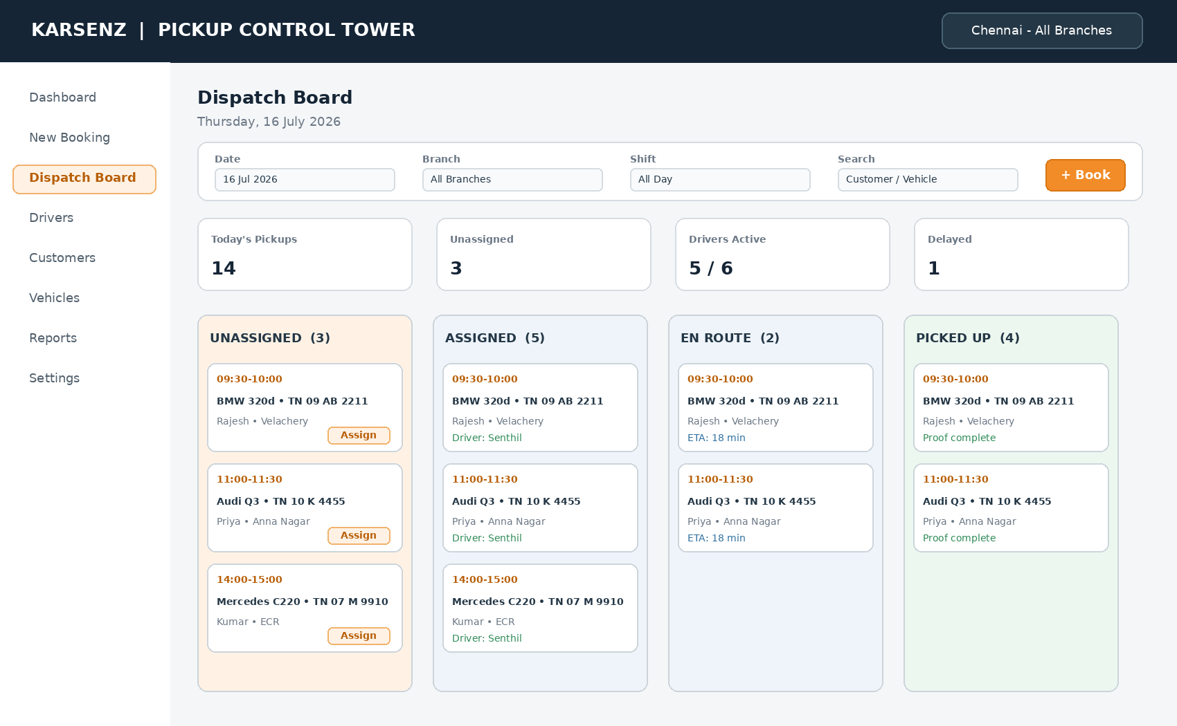
Figure 2 - Desktop dispatch board concept
Area | Required Elements
Top navigation | Company/product identity, branch scope, notifications, user menu
Filter bar | Date, branch, shift, status, driver, service area and search
KPI row | Today's pickups, unassigned, drivers active, delayed and cancelled
Kanban/list | Booking cards with time, vehicle, customer, area, driver, status and SLA
Quick actions | Create booking, assign/reassign, call, open booking, mark exception
Responsive behaviour | Switch to grouped list under 1024 px; preserve filters and priority flags

10.4 Figma Concept B - Future Pickup Booking
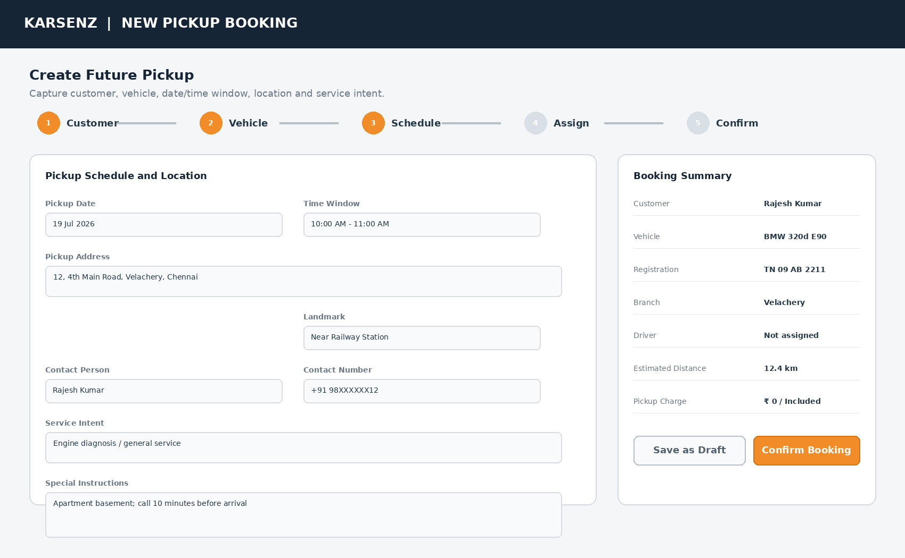
Figure 3 - Guided booking wizard with future schedule and summary
Step | Fields / Behaviour
Customer | Search existing by phone/name; create new; show duplicate warning
Vehicle | Select existing vehicle or add make/model/registration/VIN
Schedule | Date, time window, address, map pin, branch, service intent, priority
Assign | Optional driver selection with availability and conflict status
Confirm | Validation summary, customer communication channel, final confirmation

10.5 Figma Concept C - Driver App
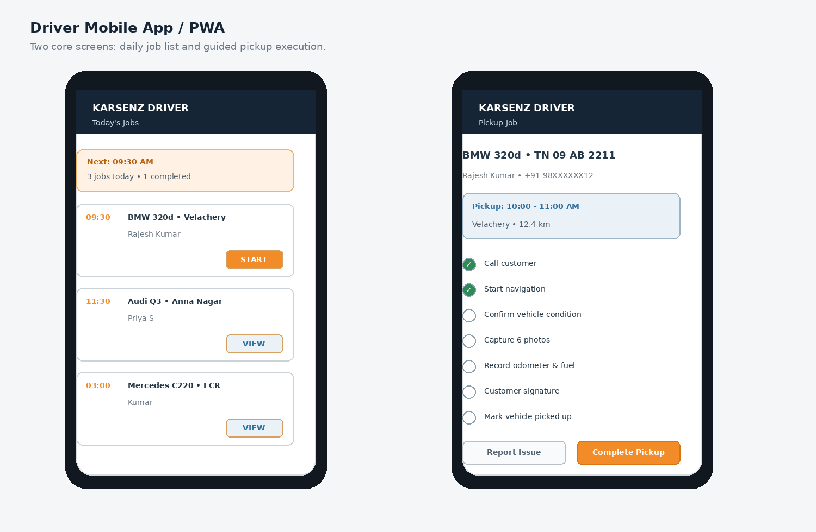
Figure 4 - Mobile daily job list and guided execution screen
Screen | Core Components
Driver Home | Today/Upcoming/Completed tabs, next job banner, sync status and urgent alerts
Job Detail | Customer call, navigation, time window, vehicle, instructions and branch destination
Execution | Status buttons, checklist, photo capture, odometer, fuel, signature and issue reporting
Offline State | Pending sync badge, locally saved evidence and safe retry
Completion | Proof summary, customer acknowledgement and destination handover action

10.6 Screen Inventory
ID | Screen | Primary User
WEB-01 | Login / SSO | All internal users
WEB-02 | Operations Dashboard | Dispatcher, manager
WEB-03 | Pickup Calendar | Customer service, dispatcher
WEB-04 | Dispatch Board | Dispatcher
WEB-05 | New/Edit Booking Wizard | Customer service
WEB-06 | Booking Detail and Timeline | All authorised roles
WEB-07 | Customer and Vehicle Detail | Customer service, branch
WEB-08 | Driver Directory and Availability | Dispatcher, admin
WEB-09 | Branch Handover | Branch team
WEB-10 | Reports and Exports | Manager
WEB-11 | Audit Viewer | Manager, admin
WEB-12 | Settings and Templates | Admin
MOB-01 | Driver Login / PIN | Driver
MOB-02 | Driver Job List | Driver
MOB-03 | Driver Job Detail | Driver
MOB-04 | Pickup Checklist and Photos | Driver
MOB-05 | Issue / Exception | Driver
MOB-06 | Handover and Completion | Driver / branch

11. Data Model

11.1 Core Entities
Entity | Key Attributes
Customer | customer_id, name, primary_phone, alternate_phone, email, language, notes, status
CustomerAddress | address_id, customer_id, label, address lines, landmark, latitude, longitude, service_area
Vehicle | vehicle_id, customer_id, registration_no, make, model, variant, year, VIN, fuel_type, notes
Branch | branch_id, name, address, coordinates, business_hours, holidays, contact, active
Driver | driver_id, employee_ref, name, phone, home_branch, shift, status, active
DriverAvailability | availability_id, driver_id, start, end, type, reason
PickupBooking | booking_id, booking_no, customer_id, vehicle_id, branch_id, schedule, address_id, priority, service_intent, status
BookingAssignment | assignment_id, booking_id, driver_id, assigned_by, assigned_at, released_at, reason
BookingStatusEvent | event_id, booking_id, from_status, to_status, actor, timestamp, location, comments
PickupChecklist | checklist_id, booking_id, template_version, odometer, fuel_level, warning_lights, notes, completed_by
PickupItem | item_id, checklist_id, type, description, quantity, condition
EvidenceMedia | media_id, booking_id, category, file_uri, checksum, captured_at, captured_by, metadata
Signature | signature_id, booking_id, signer_name, signer_role, file_uri, signed_at
Handover | handover_id, booking_id, branch_user, accepted_at, discrepancies, job_card_ref
Notification | notification_id, booking_id, channel, template, recipient, provider_id, status, timestamps, error
AuditEvent | audit_id, entity_type, entity_id, action, actor, timestamp, before_json, after_json, reason
UserRole | user_id, role_id, branch_scope, active
Configuration | key, scope, value, version, changed_by, changed_at

11.2 Key Relationships
- One Customer has many Vehicles and many CustomerAddresses.
- One PickupBooking references one Customer, Vehicle, Branch and pickup address snapshot.
- One PickupBooking may have many assignments over time but only one active assignment.
- One PickupBooking has many status events, notifications, evidence media and audit events.
- A completed pickup has one checklist version and one or more signatures or acknowledgement records.
- One Handover closes the operational custody cycle and may reference a workshop job card.

11.3 Data Retention Recommendation
Data Type | Recommended Retention | Notes
Bookings, status and audit | 7 years or approved legal/business period | No hard delete; archival permitted
Photos and signatures | 3-7 years based on policy | Encrypt and lifecycle to lower-cost storage
Notification delivery logs | 2 years | Keep message metadata; avoid excessive message content
Location checkpoints | 1-2 years | Store only required operational points, not continuous tracking
Application logs | 90-180 days | Longer for security events where required

12. API and Integration Requirements

12.1 API Principles
- REST/JSON APIs under versioned base path such as /api/v1.
- OAuth2/OIDC or secure token-based authentication with short-lived access tokens.
- Idempotency keys for booking creation, status transitions and evidence finalisation.
- Optimistic concurrency/version fields to prevent silent overwrites.
- Consistent error model with code, message, field errors and correlation ID.
- Pagination, filters and export jobs for large datasets.
- OpenAPI specification generated and maintained with the codebase.

12.2 Representative Endpoints
Method | Endpoint | Purpose
POST | /customers | Create customer
GET | /customers/search | Search by phone/name/vehicle
POST | /vehicles | Create vehicle
POST | /bookings | Create booking or draft
GET | /bookings | Filter calendar/list data
GET | /bookings/{id} | Retrieve booking detail and timeline
PATCH | /bookings/{id} | Edit allowed booking fields
POST | /bookings/{id}/confirm | Confirm draft/request
POST | /bookings/{id}/reschedule | Create schedule version
POST | /bookings/{id}/cancel | Cancel with reason
POST | /bookings/{id}/assignments | Assign/reassign driver
POST | /bookings/{id}/transitions | Change status
POST | /bookings/{id}/evidence/presign | Create secure upload target
POST | /bookings/{id}/pickup-complete | Validate and finalise proof
POST | /bookings/{id}/handover | Accept branch handover
GET | /dispatch/board | Return dispatch board dataset
GET | /drivers/availability | Return capacity and conflicts
GET | /reports/operations | Operational KPIs
POST | /notifications/{id}/retry | Retry failed message
GET | /audit | Authorised audit search

12.3 Integration Requirements
Integration | MVP Requirement | Fallback / Risk Control
WhatsApp Business API | Approved templates, message status webhooks, provider ID tracking | SMS/manual call fallback; visible delivery failure
Maps | Address autocomplete, coordinates, navigation deep link, distance estimate | Manual address and landmark remain mandatory
Object Storage | Private photo/signature storage with signed URLs and lifecycle | Local temporary queue only; never public bucket
Zoho CRM - optional | Customer/vehicle sync or link to source record | CSV import/export until integration is approved
Workshop/WMS - future | Create or attach job-card reference after handover | Manual reference field in MVP
Email/SMS | Alternate customer/internal notification channels | Provider abstraction avoids lock-in

12.4 Webhook Events
- notification.sent, notification.delivered, notification.failed
- booking.created, booking.rescheduled, booking.cancelled
- assignment.created, assignment.changed
- pickup.started, pickup.completed, handover.completed
- sla.breached, evidence.upload.failed

13. Solution Architecture and Technology Stack
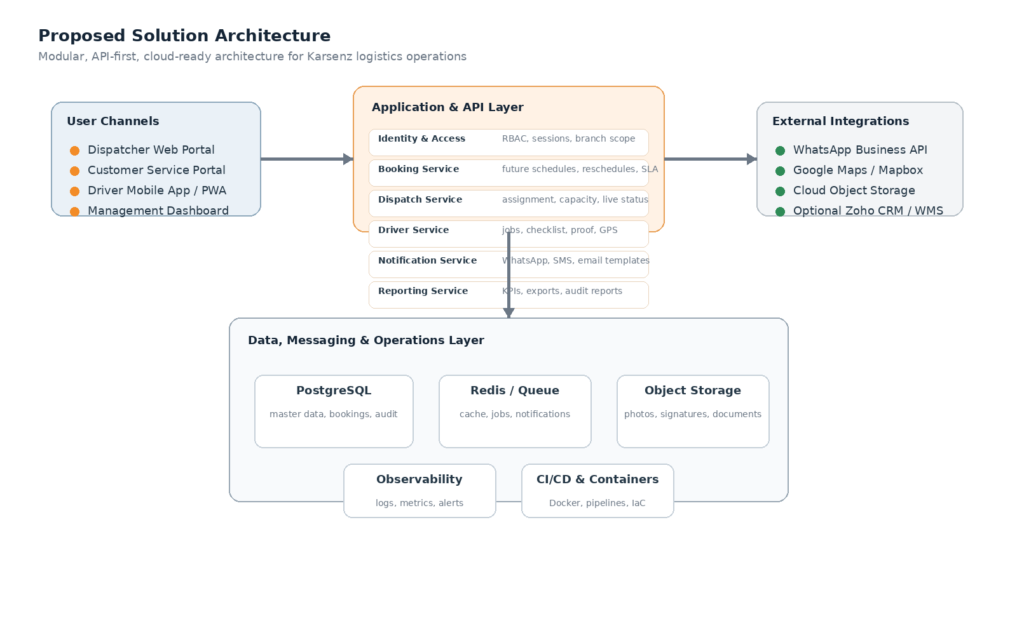
Figure 5 - Recommended modular architecture

13.1 Recommended Technology Stack
Layer | Recommendation | Rationale
Operations Web | Next.js + React + TypeScript | Mature component ecosystem, SSR where useful, strong forms and dashboard support
Backend API | NestJS + TypeScript | Modular architecture, validation, OpenAPI, queues and consistent stack with front end
Database | PostgreSQL | Relational integrity, scheduling queries, auditability and reporting
Caching / Jobs | Redis + BullMQ or managed queue | Notifications, retries, exports and async processing
Driver Client | Flutter or responsive PWA | Flutter for richer offline/camera experience; PWA for faster MVP and single web stack
Storage | AWS S3 / Azure Blob / compatible object storage | Secure scalable evidence media with signed URLs
Authentication | Keycloak, Auth0, Azure AD B2C/Entra or managed OIDC | RBAC, MFA and token lifecycle
Maps | Google Maps Platform or Mapbox | Autocomplete, geocoding, distance and navigation
Notifications | Meta WhatsApp Cloud API or authorised BSP; SMS/email provider | Template notifications with delivery webhooks
Deployment | Docker + managed container service or Kubernetes when scale requires | Repeatable environments and CI/CD
Observability | OpenTelemetry + Grafana/Cloud monitoring + central logs | Correlation IDs, SLA and failure monitoring
Testing | Playwright, Jest, Supertest, contract tests, mobile integration tests | Automation aligned with Karsenz technical capability

13.2 PWA vs Flutter Decision
Criterion | PWA | Flutter
MVP speed | Faster with shared web skills | Moderate additional effort
Offline evidence | Possible but browser-dependent | Stronger local storage and background sync control
Camera / device APIs | Adequate for normal photos | Better native integration
App distribution | URL/install prompt; no store required | APK/managed distribution or stores
Recommended choice | Start PWA if timeline is primary | Choose Flutter if offline reliability and native camera workflow are critical

Architecture recommendation
Use a modular monolith for MVP rather than microservices. Keep clear domain modules and asynchronous queues, then extract services only when scale, team ownership or integration load justifies it.

14. Non-Functional Requirements
ID | Category | Requirement
NFR-001 | Availability | 99.5% monthly availability for MVP excluding announced maintenance.
NFR-002 | Performance | 95th percentile API response under 800 ms for normal reads and under 1.5 s for standard writes, excluding external provider latency.
NFR-003 | Capacity | Support at least 100 internal users, 100 drivers and 10,000 bookings/month without architectural change.
NFR-004 | Scalability | Stateless API nodes and scalable workers; storage and database sized independently.
NFR-005 | Mobile Resilience | Driver actions and evidence survive short network loss and sync without duplication.
NFR-006 | Security | TLS in transit, encryption at rest, RBAC, secure secrets and protected media URLs.
NFR-007 | Auditability | Critical create/update/status/configuration events are immutable and searchable.
NFR-008 | Usability | Common booking creation achievable in under 2 minutes by trained staff.
NFR-009 | Accessibility | Web UI targets WCAG 2.1 AA for contrast, labels, focus and keyboard access.
NFR-010 | Compatibility | Latest two versions of Chrome and Edge; Android driver devices supported based on chosen client.
NFR-011 | Backup | Daily full or equivalent managed backup plus point-in-time recovery where available.
NFR-012 | Recovery | Target RPO ≤ 15 minutes and RTO ≤ 4 hours for production.
NFR-013 | Maintainability | Automated tests, code quality gates, API documentation and environment parity.
NFR-014 | Observability | Structured logs, metrics, traces, provider failure dashboards and alerts.
NFR-015 | Localisation | All dates, times, currency and numbers display correctly for India; Tamil-ready text architecture.
NFR-016 | Privacy | Collect minimum customer and location data; configurable retention and access logging.

14.1 Performance Scenarios
Scenario | Target
Open daily dispatch board with 200 jobs | Initial useful content within 2 seconds on normal office broadband
Create/confirm booking | Server validation and confirmation within 1.5 seconds excluding notification delivery
Upload six compressed images | Progress visible; resume/retry supported; no loss on transient failure
Generate monthly operational export | Async job completes within 2 minutes for expected MVP volume

15. Security, Privacy and Audit

15.1 Security Controls
- MFA for administrators and managers; strong authentication for all internal users.
- Short-lived access tokens, secure refresh process and device/session revocation.
- Least-privilege RBAC with branch scope and driver-specific data restrictions.
- Input validation, parameterised queries, output encoding and secure file-type validation.
- Rate limits and abuse protection on login, public callbacks and notification endpoints.
- Private object storage, encrypted uploads, signed URLs and malware scanning where feasible.
- Secrets stored in a managed vault and never committed to source control.
- Security headers, CSRF protection where applicable, CORS allowlists and secure cookies.
- Dependency scanning, SAST, container scanning and periodic penetration testing.
- Database backups encrypted and restoration tested at defined intervals.

15.2 Privacy Requirements
- Display customer phone and address only to users who need them for the active operation.
- Do not store continuous driver/customer location history unless explicitly approved.
- Mask customer phone numbers in broad management reports.
- Provide retention and archival rules for photos, signatures and location checkpoints.
- Record access to sensitive evidence when feasible.
- Support lawful deletion/anonymisation requests where not blocked by operational or legal retention.

15.3 Audit Event Minimum Fields
Field | Description
Event ID | Globally unique identifier
Entity | Booking, customer, driver, configuration, notification or evidence
Action | Create, update, assign, transition, override, upload, delete/anonymise or access
Actor | User/service identity and role
Timestamp | Server time in UTC plus local display
Before/After | Changed fields or version references
Reason | Mandatory for override, cancel, reopen and reassignment after start
Context | IP/device, correlation ID and optional checkpoint location

16. Reporting and Analytics

16.1 Operational Dashboard
- Today's pickups by status and branch.
- Future bookings for next 7 and 30 days.
- Unassigned jobs by SLA severity.
- Driver availability and active workload.
- Delayed arrival and pending handover exceptions.
- Notification failures requiring manual follow-up.

16.2 Standard Reports
Report | Content
Pickup Register | Date, booking, customer, vehicle, branch, driver, schedule, status
Driver Utilisation | Assigned/completed jobs, working hours proxy, on-time rate, exceptions
On-Time Performance | Arrival within window, average delay, branch/area/driver breakdown
Cancellation and No-show | Reason, stage, initiator, repeat customers and driver travel impact
Evidence Compliance | Missing photos/signature/checklist items and override usage
Notification Delivery | Sent/delivered/failed by channel and template
Future Capacity | Bookings versus available drivers by day and time slot
Service Conversion | Pickup to workshop job-card/estimate/repair conversion where linked
Audit and Override | Reassignments, reopened jobs, proof amendments and configuration changes

16.3 KPI Definitions
KPI | Formula
On-time arrival % | Arrived within confirmed window / eligible completed pickups × 100
Missed pickup % | Eligible bookings with no completion/cancellation/reschedule outcome / eligible bookings × 100
Driver utilisation | Completed jobs or active job minutes / available shift capacity
Assignment lead time | Assignment timestamp minus pickup window start
Evidence completeness % | Bookings satisfying all mandatory evidence / completed pickups × 100
Cancellation rate | Cancelled bookings / confirmed bookings × 100
Pickup-to-service conversion | Bookings linked to workshop job card or repair / completed pickups × 100

17. Notification Templates
Template compliance
WhatsApp initiated messages generally require approved templates and customer consent/legitimate business use. Exact wording must be validated with the selected provider and current platform policy before production.

Template | Draft Content
Booking Confirmation | Hello {{customer_name}}, your {{vehicle}} pickup is booked for {{date}} between {{time_window}}. Pickup address: {{short_address}}. Karsenz branch: {{branch}}. Booking: {{booking_no}}.
Driver Assigned | Your Karsenz pickup {{booking_no}} has been assigned to {{driver_name}}. Contact: {{masked_driver_phone_or_link}}. Please keep the vehicle, keys and documents ready.
Driver En Route | Our driver has started towards your location for booking {{booking_no}}. Expected arrival: {{eta_or_window}}.
Driver Arrived | Our driver has arrived at the pickup location for {{vehicle}}. Please contact {{branch_phone}} if assistance is needed.
Pickup Completed | Your vehicle {{vehicle}} has been collected at {{pickup_time}}. Pickup acknowledgement: {{secure_link}}.
Delivered to Branch | Your vehicle has reached Karsenz {{branch}} at {{delivery_time}}. Our service team will contact you with the next update.
Rescheduled | Booking {{booking_no}} has been rescheduled to {{new_date}} between {{new_time_window}}. Previous schedule: {{old_schedule}}.
Cancelled | Booking {{booking_no}} has been cancelled. Reason: {{customer_safe_reason}}. Contact {{branch_phone}} to arrange another pickup.
Internal Unassigned Alert | Pickup {{booking_no}} for {{date_time}} remains unassigned. Branch: {{branch}}; Area: {{service_area}}; SLA: {{severity}}.
Internal Delay Alert | Pickup {{booking_no}} is overdue by {{minutes}} minutes. Driver: {{driver}}; current status: {{status}}; action required.

17.1 Notification Rules
- Customer-facing messages use safe language and do not expose unnecessary internal information.
- Every send attempt is recorded; retry must not create accidental duplicate messages.
- Template language is selected by customer preference where available.
- Quiet-hour rules and emergency exceptions are configurable.
- Manual calls or WhatsApp replies can be logged as communication notes.

18. Testing and Acceptance Strategy

18.1 Test Layers
Layer | Coverage
Unit Tests | Domain rules, validation, scheduling conflicts, status transitions and template rendering
API Integration Tests | Database interactions, RBAC, idempotency, audit creation, queue and webhook handling
Contract Tests | WhatsApp/maps/storage provider adapters and OpenAPI compatibility
UI Functional Tests | Booking wizard, calendar, dispatch board, reports and administration using Playwright
Mobile/PWA Tests | Offline queue, camera/evidence, status workflow, device permissions and responsive layouts
Performance Tests | Board loading, booking creation, exports, concurrent driver sync and evidence upload
Security Tests | Authentication, authorisation, file upload, session, OWASP controls and dependency scans
UAT | Real Karsenz staff execute same-day, future, reschedule, cancellation and exception scenarios

18.2 MVP Exit Criteria
- All Must functional requirements are implemented or formally waived.
- No open Critical or High severity defects; Medium defects have agreed workaround/plan.
- Booking made at least three days in advance appears correctly and triggers reminders.
- Six-driver assignment and conflict scenarios pass UAT.
- Driver offline evidence scenario completes without data loss or duplicate status.
- Customer notification delivery and failure handling are proven in a test/production-approved channel.
- Backup restore, monitoring alerts and security controls are verified.
- Operations users complete training and a pilot branch signs off.

18.3 Critical UAT Scenarios
ID | Scenario | Expected Result
UAT-01 | Book pickup for three days later | Visible on exact date; notification sent; assignment SLA scheduled
UAT-02 | Assign same driver to overlapping jobs | Conflict warning blocks or requires authorised override
UAT-03 | Reschedule an assigned future pickup | History retained; driver/notifications updated; calendar moves
UAT-04 | Driver loses network during photo capture | Data remains safe and syncs once network returns
UAT-05 | Complete pickup with missing mandatory evidence | System blocks and identifies missing item
UAT-06 | Customer cancels after En Route | Reason and impact captured; notification and audit created
UAT-07 | Branch finds handover discrepancy | Discrepancy recorded; manager/dispatcher alerted
UAT-08 | WhatsApp message fails | Failure visible; retry/alternate channel available

19. Deployment and Operations

19.1 Environments
Environment | Purpose | Data
Development | Developer integration and automated tests | Synthetic only
SIT / QA | End-to-end integration, provider sandbox, regression | Masked/synthetic
UAT | Karsenz business validation and pilot rehearsal | Controlled test data
Production | Live operations | Real customer and vehicle data

19.2 CI/CD Pipeline
- Pull request: lint, unit tests, SAST, dependency scan and build.
- Main branch: integration tests, container scan, versioned artifact and deployment to SIT.
- UAT promotion: approval gate, database migration check and automated smoke tests.
- Production release: approved change, backup, controlled rollout and rollback plan.
- Post-release: health checks, smoke suite, notification test and monitoring confirmation.

19.3 Operational Monitoring
- API error rate and latency by endpoint.
- Database health, connection usage and slow queries.
- Queue depth, notification retry count and dead-letter jobs.
- Evidence upload failures and storage errors.
- Unassigned/overdue pickup SLA events.
- Authentication failures and suspicious access patterns.
- Mobile sync backlog and duplicate conflict events.

19.4 Support Model
Severity | Example | Response Target
P1 Critical | System unavailable; bookings or evidence cannot be recorded | Immediate alert; restore/mitigate as highest priority
P2 High | Major workflow or notification provider failure | Same business day mitigation
P3 Medium | Partial function issue with workaround | Planned within agreed sprint/SLA
P4 Low | Cosmetic or enhancement | Backlog prioritisation

20. Delivery Roadmap, Risks and Open Decisions

20.1 Indicative Delivery Plan
Phase | Indicative Duration | Outputs
Phase 0 - Discovery | 1-2 weeks | Process workshops, data fields, branch rules, provider decisions, UX validation
Phase 1 - Foundation | 2 weeks | Project setup, authentication, users/roles, branches, CI/CD, core schema
Phase 2 - Booking and Dispatch | 3-4 weeks | Customer/vehicle, booking wizard, calendar, dispatch board, assignment
Phase 3 - Driver and Evidence | 3-4 weeks | Mobile/PWA workflow, offline queue, camera, checklist, proof and handover
Phase 4 - Notifications and Reports | 2-3 weeks | WhatsApp/SMS/email, dashboards, exports, SLA alerts and audit
Phase 5 - UAT and Pilot | 2 weeks | Training, migration, pilot branch, fixes, production rollout

Overall MVP indication: approximately 13-17 weeks for a focused cross-functional team. Actual duration depends on staffing, provider approvals, mobile choice and integration scope.

20.2 Suggested Team
Role | Indicative Allocation
Product Owner / Business Analyst | 0.5-1.0 FTE
UX/UI Designer | 0.5 FTE during discovery and UI build
Frontend Engineer | 1 FTE
Backend Engineer | 1-2 FTE
Mobile/PWA Engineer | 0.5-1 FTE depending on choice
QA Automation Engineer | 1 FTE
DevOps / Cloud Engineer | 0.25-0.5 FTE
Operations SMEs | Part-time for workshops and UAT

20.3 Key Risks and Mitigations
Risk | Impact | Mitigation
Staff continue using WhatsApp without entering bookings | High | Make portal faster than chat; training; daily reconciliation; dashboard accountability
WhatsApp template approval/provider delay | Medium | Abstract provider; use SMS/email/manual process during pilot
Driver connectivity and device variation | High | Offline-first workflow, image compression, device pilot and clear sync state
Poor customer/vehicle master data | Medium | Search/duplicate detection, mandatory phone/registration normalisation
Scope expands into workshop ERP | High | Maintain MVP boundary and integration contracts
Driver conflict logic too simplistic | Medium | Start with explicit warnings and dispatcher judgment; improve with travel data
Evidence storage cost or privacy risk | Medium | Compression, lifecycle policies, access logging and retention approval
Multi-branch process differences | Medium | Configurable rules with global defaults; pilot one branch before scale
Users bypass status workflow | Medium | Mandatory transitions, operational dashboard and manager exception review

20.4 Open Decisions
ID | Decision | Recommendation / Next Action
OD-01 | PWA or Flutter for driver client? | Select after device/offline proof-of-concept.
OD-02 | Which WhatsApp BSP or Cloud API approach? | Compare approval time, cost, support and webhook capability.
OD-03 | Which cloud platform and identity provider? | Align with Karsenz cost, skills and existing accounts.
OD-04 | Will pickup be free, chargeable or rule-based? | Define visibility and approval; payment is not in MVP unless required.
OD-05 | What exact pickup proof fields are mandatory by vehicle/service type? | Approve checklist template with operations/legal.
OD-06 | How will branch handover link to job card? | Manual reference, Zoho or WMS API.
OD-07 | Should customers receive secure proof link/PDF? | Validate privacy, branding and support impact.
OD-08 | What retention period applies to signatures/photos? | Obtain business/legal approval.
OD-09 | What are official business hours, pickup slots and SLA thresholds by branch? | Configure before pilot.
OD-10 | Which branch should pilot first? | Choose one with engaged staff and representative pickup volume.

Appendix A - Booking Field Catalogue
Group | Field | Description | Priority
Booking | Booking number | System generated | Must
Booking | Source | Phone, WhatsApp, walk-in, CRM | Must
Booking | Status | Controlled status model | Must
Customer | Name | Customer/contact person | Must
Customer | Primary phone | Normalised phone number | Must
Customer | Preferred language | English, Tamil, other | Should
Vehicle | Registration | Vehicle registration number | Must
Vehicle | Make/model/variant | Vehicle identity | Must
Vehicle | VIN/chassis | Optional identity | Should
Schedule | Pickup date | Today or future date | Must
Schedule | Time window start/end | Confirmed service window | Must
Location | Address and landmark | Pickup location | Must
Location | Latitude/longitude | Map coordinate | Should
Branch | Destination branch | Workshop destination | Must
Service | Intent / complaint | Why pickup is required | Must
Service | Priority | Normal/Urgent/VIP/Breakdown | Should
Assignment | Driver | Assigned driver | Can be later
Proof | Odometer and photo | Vehicle mileage | Must at pickup
Proof | Fuel level | Configurable scale | Must at pickup
Proof | Vehicle condition photos | Required angles | Must at pickup
Proof | Keys/documents/accessories | Transferred items | Must at pickup
Proof | Customer signature | Custody acknowledgement | Must or approved alternative
Handover | Branch receiver | Employee accepting vehicle | Must
Handover | Job-card reference | Workshop link | Should

Appendix B - Example Status Transition Matrix
From | Allowed To | Actor
Draft | Requested, Scheduled, Cancelled | Customer service
Requested | Scheduled, Cancelled | Customer service / dispatcher
Scheduled | Assigned, Cancelled, Delayed | Customer service / dispatcher
Assigned | En Route, Scheduled, Cancelled, Delayed | Dispatcher / assigned driver
En Route | Arrived, Cancelled, No-show, Delayed | Driver / dispatcher
Arrived | Picked Up, No-show, Cancelled, Delayed | Driver
Picked Up | Delivered to Branch, Delayed | Driver
Delivered to Branch | Closed, Delayed | Branch / dispatcher
Delayed | Previous valid path or Cancelled | Dispatcher / manager
Closed | Reopened only by controlled manager override | Manager
Cancelled | Rescheduled as a new/linked booking if required | Customer service / dispatcher

Appendix C - Figma Handoff Checklist
- Create desktop frames at 1440 × 1024 and mobile frames at 390 × 844.
- Build reusable components: navigation, KPI card, booking card, status badge, form field, date/time picker, driver chip, proof checklist row, modal and toast.
- Create variants for normal, hover, selected, disabled, error, warning and loading states.
- Prototype primary flows: Create Future Booking, Assign Driver, Driver Completes Pickup, Branch Accepts Handover and Reschedule/Cancel.
- Include empty, offline, failed notification, conflict and SLA overdue states.
- Use Auto Layout, 8 px spacing system and named text/color styles.
- Annotate validation rules, permissions and API/data dependencies on each screen.
- Test responsive behaviour and touch targets of at least 44 × 44 px for driver actions.
- Export icons as SVG; avoid embedding critical text in images.
- Run design review with one customer-service user, one dispatcher, two drivers and one branch representative before development lock.
Suggested Figma page structure
00 Cover & Notes / 01 Foundations / 02 Components / 03 Web - Booking / 04 Web - Dispatch / 05 Web - Reports / 06 Mobile - Driver / 07 Prototypes / 08 Edge Cases & Handoff

Appendix D - Definition of Ready and Definition of Done

Definition of Ready
- Business rule and acceptance criteria are documented.
- Required fields, permissions and error states are known.
- Figma design and responsive behaviour are approved for UI stories.
- API contract or data model impact is identified.
- External provider dependency and test environment are available.
- Analytics and audit events are specified.

Definition of Done
- Code reviewed and merged with automated tests passing.
- Acceptance criteria demonstrated in SIT/UAT as applicable.
- Security, accessibility, logging and error handling requirements met.
- API documentation and configuration updated.
- Monitoring and alerts added for operationally important behaviour.
- No unresolved high-severity defects; release notes and support guidance completed.

Appendix E - Glossary
Term | Meaning
Booking | A planned customer vehicle pickup logistics task.
Dispatcher | Person responsible for assigning and monitoring drivers.
Time Window | Confirmed earliest and latest expected arrival time.
Proof of Pickup | Photos, readings, items, signature and timestamps proving custody transfer.
Handover | Transfer of the vehicle from driver to Karsenz branch representative.
SLA | Service-level timing rule used for alerts and reporting.
PWA | Progressive Web App that can behave like an installable mobile application.
BSP | Business Solution Provider supporting WhatsApp Business API.
RBAC | Role-Based Access Control.
Idempotency | Safe retry behaviour that prevents duplicate operation creation.
RPO / RTO | Recovery Point Objective / Recovery Time Objective.
System of Record | The authoritative source used for operational truth and reporting.

KARSENZ PICKUP & LOGISTICS MANAGEMENT SYSTEM
Product Requirements Document v1.0
Next recommended action: validate the field catalogue, workflow and Figma concepts with Karsenz operations, then convert the Must requirements into a prioritised implementation backlog.

