**Adekoniye, Adedoyin Michael**

17 Babatunde Street, Agosi Estate, Ifo, Ogun State.

+2348159277099 | +2349070763392 | [michaeladekoniye@gmail.com](mailto:michaeladekoniye@gmail.com)

**PROFESSIONAL SUMMARY**

Technically-sound Application Engineer effective in analyzing relevant information and guiding product cycle from conception to completion. Manages design effort and guides installation process for on-schedule product launches. Consults with internal and external clientele and employs additional system resources to review and enhance configuration for optimal customer satisfaction.

Self-directed and motivated Software Engineer experienced working effectively in dynamic environments. Fluent in JavaScript. .Net and PHP programming languages, including Adobe Software and Linux Systems.

**SOME PROFESSIONAL CERTIFICATIONS**

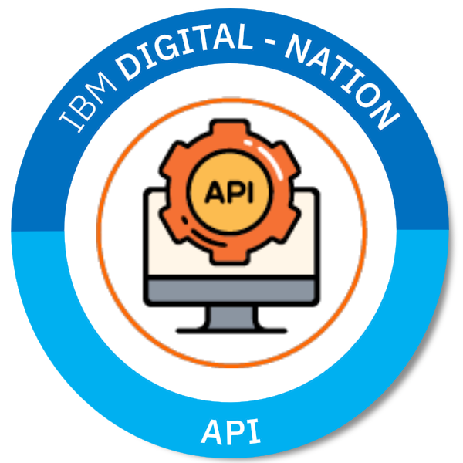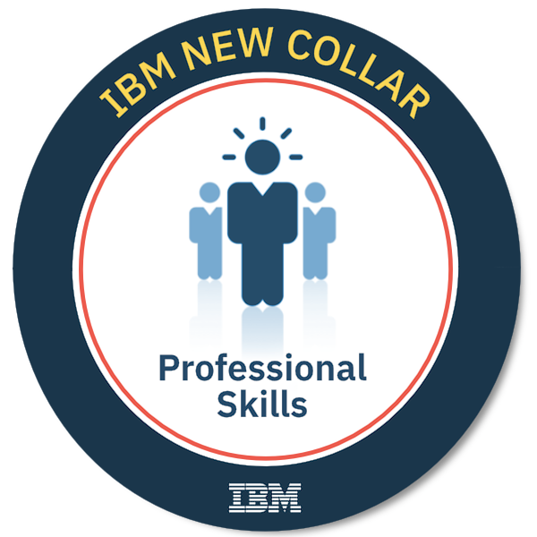

**TECHNICAL PROFICIENCIES**

**OS Platforms:** Windows XP/Vista/7/8.1/10/Server | Linux Ubuntu/Kali/Fedora

| Mac OS X.

**Software:** Microsoft Office | Microsoft SQL | Adobe Dreamweaver | Firebase

| Visual Studio | PhoneGap | Android Studio | GitHub | Corel Draw

| Adobe Fireworks | Adobe Photoshop | Adobe Illustrator

| Gnu Image Manipulator.

**Programming Languages:** Java | JavaScript | Android Java | HTML5 | CSS3 | VB | ASP .Net

| PHP | C | C++ | SQL | C# .Net.

**Frameworks:** jQuery.js | Service Workers | Bootstrap.css | Code Igniter

| Laravel | ASP.Net MVC Core.

**API:** Google Maps | Web Speech | Coin Base.

**CMS:** Joomla |WordPress | MyBB Forum.

**PERSONAL DETAILS**

**Date of Birth:** 9th June, 1993

**Sex:** Male

**Marital Status:** Single

**State of Origin:** Ogun State

**Local Government:** Yewa South

**Nationality:** Nigerian

**Languages:** Proficient in English and Yoruba languages.

**Interests:** Music, Chess, Reading, Scrabble, and Travelling.

**PROFESSIONAL DEVELOPMENT**

**API** January 2020

IBM Digital Nation Africa

[*https://www.youracclaim.com/badges/dd5f1b1a-3619-4fad-9724-b869e7a391a7/public_url*](https://www.youracclaim.com/badges/dd5f1b1a-3619-4fad-9724-b869e7a391a7/public_url)

**Web Security** January 2020

IBM Digital Nation Africa

[*https://www.youracclaim.com/badges/ba2eab45-f0e7-4c42-bce4-3d8648bae125/public_url*](https://www.youracclaim.com/badges/ba2eab45-f0e7-4c42-bce4-3d8648bae125/public_url)

**Identify and Investigate Cybersecurity Threats!** January 2020

IBM Digital Nation Africa

[*https://www.youracclaim.com/badges/1706578c-c296-4fe4-ac67-4206355fc4a3/public_url*](https://www.youracclaim.com/badges/1706578c-c296-4fe4-ac67-4206355fc4a3/public_url)

**Advance Mobile Application, Wordpress,** August 2018

**PHP Framework – Code Igniter/Laravel**

Ultra Media Solutions

[*http://www.ultramediasolution.com*](http://www.ultramediasolution.com)

**Android Application Development** September 2017

Udacity Nanodegree Program

[*http://www.udacity.com*](http://www.udacity.com)

**Cross Platform Application Development(**Code<2>Earn**)** March 2016

*Sponsored by: Aiki Nigeria, Google, and Microsoft.*

[*http://bit.ly/code2earn*](http://bit.ly/code2earn)

**ASP, VB, C#, MVC Core .Net Framework** May 2015

HTS Knowledge Building

*Mary Land, Lagos, Nigeria.*

**EDUCATION**

**Tai Solarin University of Education, Ijagun, Ijebu-Ode.** 2012 – 2016

B. Sc. (Second Class Upper Division), Computer Science.

**Coker Area Comprehensive High School, Coker Area, Ifo.** 2012

West African Secondary School Certificate.

**Community Primary School, Agosi Estate, Ifo.** 1997 – 2003

First School Leaving Certificate.

**PROFESSIONAL EXPERIENCE**

**Schoolville Limited** November 2018 – Present

*Job Assignment: Full Stack .Net Web Developer, Database Admin,*

*Programming Instructor.*

**Ultra Media Solutions**  May 2018 – August 2018

*Job Assignment: Volunteer Programming Tutor.*

**Independent National Electoral Commission** November 2017

**Anambra Gubernatorial Election**

*Job Assignment: Election Presiding Officer.*

St. Anthony College, Enugu. (NYSC) 2016 – 2017

*Job Assignment: Computer Instructor.*

High Tech Synergy, Magodo, Lagos. September 2016

*Job Assignment: Technical Support Staff, Database Manager.*

Remo Secondary School, Sagamu. (Teaching Practice) 2015 – 2016

*Job Assignment: Computer Instructor.*

High Tech Synergy, Mary Land, Lagos. (SIWES) 2014 – 2015

*Job Assignment: Full Stack Web Developer, Database Admin,*

*Programming Instructor.*

**TECHNICAL EXPERIENCE**

No of Years of experience in IT Industry: 2012 – Present

No of Years of experience in PHP: 2013 – Present

No of Years of experience in Code Igniter: 2018 – Present

No of Years of experience in .Net Frameworks (ASP.Net, VB, C#, MVC): 2014 – Present

No of Years of experience in MySQL/MSSQL: 2013 – Present

**PROFESSIONAL SKILLS**

IBM Digital Nation Africa

Verified Certificate URL:

*https://www.youracclaim.com/badges/2a9733a9-b068-4198-8dbf-9f59f66607a0/public_url*

* Solving Problems with Critical and Creative Thinking
* Present with Purpose
* Interpersonal Skills
* Delivering Quality Work with Agility
* Collaborate Effectively
* Enterprise Design Thinking Practitioner

**PERSONAL QUALITIES**

Good leadership skills. | I possess excellent communication skills. | I am a highly motivated team player. | I am creative and organized. | I have the ability to gain new experiences through training.

**LEADERSHIP POSITIONS**

**Presiding Officer** November2017

Independent National Electoral Commission

**Welfare Director** 2016 **–** 2017

Charity CDS Group (NYSC, Enugu)

**REFEREES**

Chief Akanji Mr. Olaleye Olayemi

*Asipa House, Ilaro, Ogun State.* *1, Olaleye Strt, Ifo, Ogun State.*

**Asipa of Ilaro**  **Youth Coordinator (Edmac Anglican Church)**

08033289345 07063621373