# | Full Name/s | Nationality | Complete address | Type:  Legal Entity or Start Up or Natural Person(s)
1 |  | Indian |  | Natural
2 |  | Indian |  | Natural
3 |  | Indian |  | Natural

- Title of the invention:
System and Method for Automated Respiratory Disease Diagnostics Utilizing Hybrid Neuro-Fuzzy Inference

- Specify field of technology to which the invention belongs to:
The invention relates to the fields of Artificial Intelligence (AI), Biomedical Signal Processing, and Healthcare Diagnostics. Specifically, it pertains to a hybrid diagnostic architecture combining deterministic rule-based logic with probabilistic neural networks to analyze acoustic biomarkers in respiratory emissions.

- List all the currently existing technologies/products that are similar to your invention:
  - Opaque High-Dimensional Neural Architectures: Contemporary diagnostic frameworks predominantly leverage Convolutional Neural Networks (CNNs) and Recurrent Neural Networks (RNNs) for acoustic feature extraction. These architectures operate with an inherent interpretability deficit, functioning as algorithmic "black boxes". This opacity fundamentally restricts clinicians from auditing the classification rationale and degrades system efficacy when processing overlapping or ambiguous physiological signal boundaries.
  - Static Boundary Acoustic Classifiers: Conventional deterministic algorithms utilize rigid, immutable thresholds to categorize audio features. These legacy systems are devoid of the probabilistic and contextual reasoning mechanisms required to accurately map the high variance and overlapping multidimensional feature spaces characteristic of complex respiratory pathologies.
  - Discretized Acoustic Analysis Frameworks: Extant diagnostic software frequently evaluates physiological audio as isolated, discrete data entities rather than continuous temporal sequences. These products lack embedded contextual reasoning layers, rendering them incapable of tracking the sequential physiological evolution of a biological emission over time.

Technical details of the invention
- Background of the invention: (Please explain the background of the technology on which, the invention is based upon without mentioning details of your invention. Also, include the details of need for the invention)

Pathological alterations within the human respiratory tract, such as those induced by pneumonia, asthma, or chronic obstructive pulmonary disease (COPD), systematically modify the spectral and temporal characteristics of emitted acoustic signals, including coughs and forced vocalizations. While traditional diagnostics rely heavily on subjective clinical auscultation or resource-intensive radiographic imaging, the automated analysis of these acoustic biomarkers presents a scalable, non-invasive diagnostic alternative.
The integration of Machine Learning (ML) into this domain is constrained by the highly non-stationary nature of real-world physiological acoustics and prevalent environmental noise. A critical technological deficiency exists in current computational models: the inability to simultaneously extract multidimensional acoustic features from dynamic environments and interpret them with the transparent, clinical logic mandated by medical regulatory standards.
Concurrently, the proliferation of Artificial Intelligence (AI) and Machine Learning (ML) has facilitated the automated analysis of complex biomedical data. AI-driven acoustic analysis holds the potential to scale respiratory diagnostics for telemedicine and remote monitoring applications. However, real-world acoustic signals are highly non-stationary and frequently contaminated by background noise. The fundamental technological challenge lies in developing computational systems capable of not only extracting relevant multidimensional acoustic features from dynamic environments but also interpreting these features with the clinical reliability and transparency required by medical regulatory frameworks. There is an critical need for an automated diagnostic architecture that bridges advanced pattern recognition with interpretable clinical logic.

- Drawbacks in existing state-of-art and how your invention helps to overcome such drawbacks: (Please list the disadvantages of the existing technologies, which are rectified/solved by your invention)

Drawbacks in Existing State-of-Art:
- The Interpretability Deficit: Standard deep learning models (CNNs/RNNs) function as opaque statistical processing engines. They output probabilistic classifications without delineating a traceable logical pathway, rendering the diagnostic decision clinically unverifiable.
- Temporal Myopia: Conventional acoustic classifiers evaluate isolated audio frames, failing to process the sequential temporal trajectory of a physiological event (e.g., the explosive onset and subsequent decay of a cough burst). This severely limits diagnostic precision for pathologies exhibiting subtle temporal variations.
- Boundary Classification Brittleness: Existing models fail to resolve the ambiguous acoustic boundaries between "healthy" variances and "mildly abnormal" pathologies due to overlapping feature distributions and a lack of contextual reasoning.
Solutions Provided by the Invention:
- Explainable Traceability via Deterministic Logic: The system fundamentally resolves algorithmic opacity by integrating a Fuzzy Inference System. By mapping complex acoustic data directly to linguistic clinical rules (e.g., "IF Spectral Centroid is High AND Zero-Crossing Rate is Medium THEN Risk is High"), the architecture guarantees a transparent, human-readable rationale for every classification.
- Sequential Trajectory Analysis: The invention bypasses static analysis constraints by embedding an $N$-frame "Context Buffer" within the reasoning layer. This facilitates the continuous evaluation of acoustic feature evolution, capturing the complete physiological signature of the respiratory event.
- Contextual Ambiguity Resolution: To navigate overlapping clinical distributions, the architecture integrates a Large Language Model (LLM). When the deterministic fuzzy rules identify conflicting or boundary-state data, the LLM executes probabilistic, contextual reasoning on the feature embeddings to definitively resolve the diagnostic uncertainty.

- The technical features of your invention which are different from the existing inventions/applications:

- Hybrid Neuro-Fuzzy Inference Architecture: The core structural novelty is the direct integration of a rule-based Mamdani Fuzzy Inference Engine with a probabilistic, transformer-based Large Language Model. This specific synthesis of deterministic logic and neural reasoning within a single diagnostic pipeline is absent in conventional acoustic classifiers.
- Dynamic Prompt Builder Submodule: The invention includes a specialized computational unit that automatically translates numerical feature vectors and triggered fuzzy logic states into structured natural language queries. This allows the neural network layer to contextually evaluate specific clinical uncertainties flagged by the deterministic logic engine.
- Decision Fusion Module with Contextual Buffering: The system utilizes a novel bridging architecture that synchronizes the outputs of the fuzzy layer with the LLM. This module employs an $N$-frame context buffer, allowing the LLM to analyze the temporal progression of the acoustic biomarkers rather than evaluating isolated data points.
- Direct Biomarker-to-Linguistic Mapping: The feature engineering module performs simultaneous extraction of high-dimensional data (Frequency, Perceptual, Spectral, Time-Domain, and Temporal features) and executes a proprietary normalization process that directly maps these mathematical vectors to discrete linguistic fuzzy variables for medical interpretation.

- Main advantages of your invention:

- Interpretability and Explainability: Unlike conventional "black-box" artificial intelligence diagnostics, the integration of a Fuzzy-LLM layer establishes transparent, rule-based decision logic. This structure permits medical professionals to verify the exact reasoning path (e.g., "High Spectral Centroid indicates High Risk") behind every AI-generated diagnosis.
- Temporal Context Evaluation: The inclusion of a Context Buffer allows the system to analyze the temporal evolution of acoustic events rather than evaluating isolated, static audio snapshots. This sequential processing significantly improves diagnostic precision when assessing complex respiratory sounds.
- Resolution of Clinical Ambiguity: By employing a Decision Fusion Module, the architecture effectively bridges rigid deterministic rules with probabilistic neural reasoning. This hybrid approach successfully interprets the overlapping feature ranges or "grey areas" that standard classifiers frequently misclassify.
- Authentic Biomarker Representation: The comprehensive feature extraction methodology ensures high spectral fidelity. Critical acoustic biomarkers remain mathematically authentic to their original physiological sources, preventing data distortion during the classification phase.

- Complete description of the invention
The present invention constitutes a hybrid artificial intelligence diagnostic architecture engineered to ingest human acoustic emissions and deduce underlying respiratory pathology. The primary innovation resolves the critical "black-box" interpretability barrier prevalent in medical AI via a transparent, multi-stage decision pipeline.

The core analytical workflow executes as follows:
- Acoustic Biomarker Extraction: Input audio sequences are segmented for quantitative analysis. The system isolates specific mathematical characteristics (acoustic biomarkers), such as spectral brightness (Spectral Centroid), frequency dispersion (Spectral Bandwidth), and oscillation frequency (Zero-Crossing Rate). These multidimensional arrays are subsequently normalized to a standardized 0-to-1 numerical matrix.
- Deterministic Rule Evaluation: The normalized matrices are processed by a Fuzzy Logic system. This module translates raw numerical data into discrete linguistic variables (e.g., "Low," "High") and executes pre-configured, interpretable medical rules.
- Contextual Neural Reasoning: In parallel, the data array interfaces with a Large Language Model (LLM) reasoning layer. This probabilistic component analyzes the sequential frame data over time to discern broader contextual acoustic patterns.
- Decision Fusion: The deterministic outputs of the rule-based system and the probabilistic evaluations of the neural system are synchronized at the Decision Fusion Module. Should the rule-based logic encounter ambiguity or rule conflict, it triggers a dynamic prompt generation protocol. The LLM assesses this prompt against the historical acoustic context to calculate a resolved probability.
- Final Classification Synthesis: The fused data stream is routed to a terminal classifier, outputting a definitive clinical status ("Healthy," "Abnormal," or "Uncertain") and generating an explicit textual audit trail detailing the specific fuzzy rules triggered to achieve the classification.

The structural layout of these interconnected components within the broader diagnostic application is further visualized in Figure 2.

- What is your invention?
The invention is a comprehensive AI-Based Early Disease Detection System structured around a novel Decision Fusion Module. It is an end-to-end diagnostic pipeline that integrates multi-domain feature engineering with a hybrid inference architecture. By bridging a deterministic Rule-Based Fuzzy Inference Engine with a probabilistic Contextual LLM Reasoning Layer, the invention provides a transparent, verifiable, and context-aware mechanism for classifying non-stationary biomedical acoustic signals.

- Components/Embodiments involved in the invention (Provide the details of each of the component i.e. structure, assembly and function)

As illustrated in the broader system overview in Figure 2, the invention is embodied in three primary integrated computational blocks:
- Feature Engineering Block:
- Structure and Assembly: This block comprises sequential processing units, including Framing & Windowing modules (utilizing Hamming windows), and parallel analytical streams for Frequency Analysis and Time-Domain Analysis. These streams converge at a Normalization and Dimensionality Reduction node.
- Function: It converts raw audio input into a high-dimensional feature vector. It simultaneously extracts Perceptual features (e.g., MFCCs), Spectral features (e.g., Centroid, Roll-off), Time-Domain features (e.g., ZCR, RMS), and Temporal features. The final dimensionality reduction ensures the data is mathematically optimized for the classification engine.
- Hybrid Inference Block:
- Structure and Assembly: This is the core analytical engine, consisting of a Fuzzy Layer (containing rule interpreters and triangular membership functions), a Decision Fusion Module, and an LLM Reasoning Layer. The LLM layer is further assembled with a specific Context Buffer (storing the previous N frames) and a Prompt Builder submodule.
- Function: This block fuses deterministic rule-based logic with probabilistic neural reasoning. The Fuzzy Layer assigns linguistic variables and confidence scores based on explicit rules. The Prompt Builder translates these active rules into queries for the LLM. The LLM uses the Context Buffer to analyze the temporal evolution of the features and resolve any logic conflicts or boundary uncertainties output by the Fuzzy Layer. The Decision Fusion Module aggregates these inputs into a final diagnostic probability vector.
- Output & Decision Block:
- Structure and Assembly: This terminal block includes an LLM Output Post-Processing unit, a Final Classifier thresholding matrix, and an Output & Reporting User Interface (UI).
- Function: It parses the aggregated data from the Decision Fusion Module to assign a definitive clinical label ("Healthy," "Abnormal," or "Uncertain"). It subsequently formats the diagnostic decision, alongside the transparent text-based explanation generated by the active fuzzy rules, delivering the final interpretable result to the end user or medical professional.

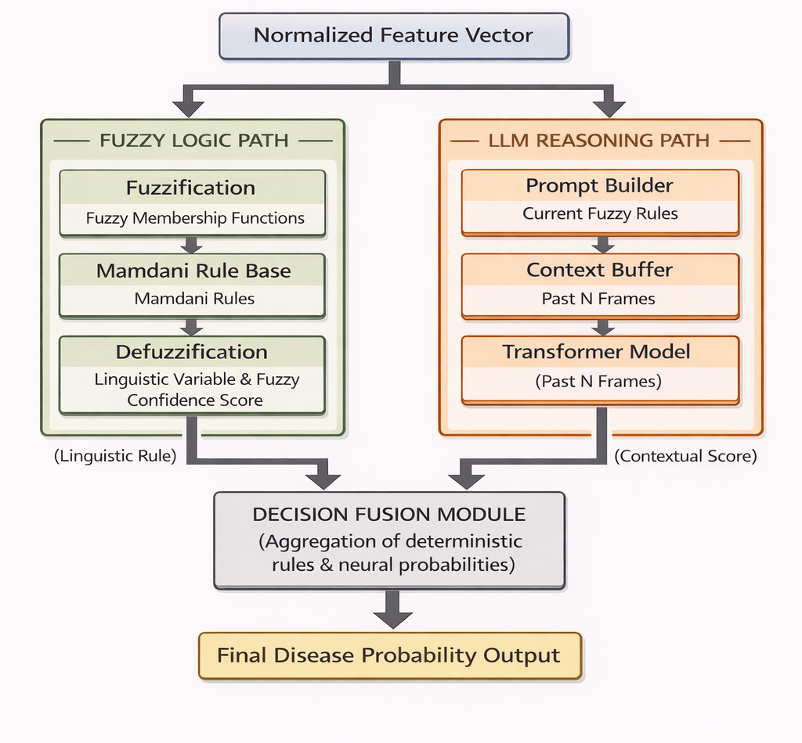
- How are the components installed/arranged?
Figure 1:Hybrid Neuro-Fuzzy Inference Mechanism

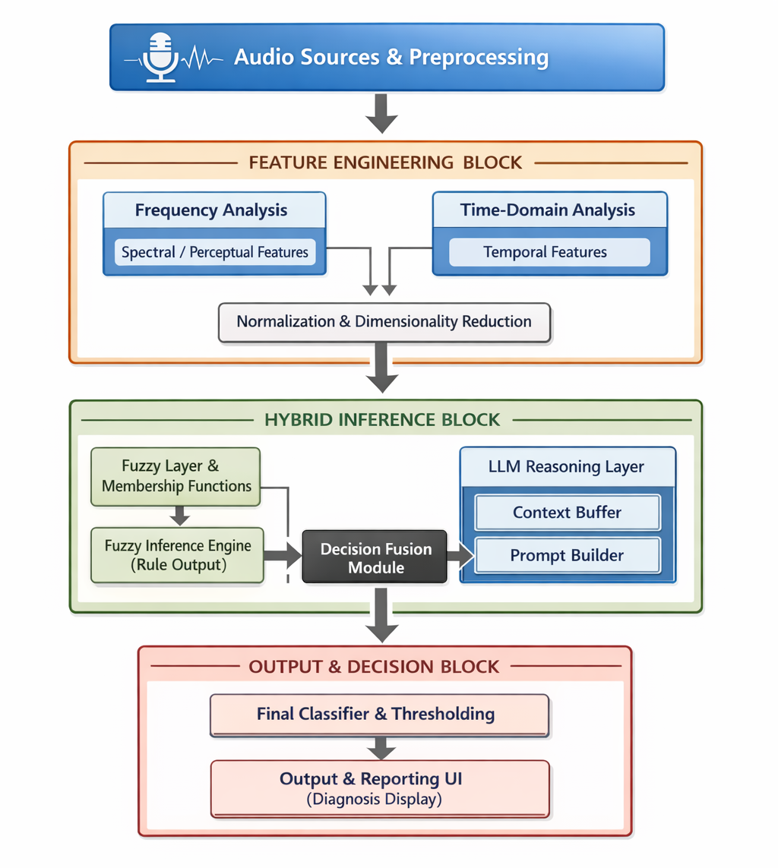
Figure 2:- Comprehensive System Architecture Block Diagram

- List of novel features in the invention

Note: Novel features are new elements/components/features, which include new procedure, new techniques, a new device, new compound, new combination of compounds, new components or new arrangement, and new installation used to obtain the present invention.

Novel elements must be retrieved from or based on the above-mentioned complete description (iv).
Please list the novel features on priority basis
Novel Features 1 (NF1): Hybrid Decision Fusion Architecture A classification architecture that integrates a deterministic Fuzzy Inference System (utilizing Mamdani rules) with a probabilistic Large Language Model (LLM) reasoning layer to interpret overlapping feature ranges and provide context-aware disease probability. This structure fuses rigid rule-based logic with neural reasoning to classify health status without relying solely on opaque, black-box deep learning models.
Novel Features 2 (NF2): Temporal Context Buffering for Acoustic Evaluation The implementation of a specific "Context Buffer" within the LLM reasoning layer that stores the last N frames of acoustic data. This configuration enables the diagnostic system to analyze the temporal evolution and sequential trajectory of a respiratory sound over time, rather than evaluating isolated, static acoustic snapshots.
Novel Features 3 (NF3): Dynamic Prompt Generation Submodule The inclusion of a "Prompt Builder" component within the hybrid inference pipeline that dynamically constructs natural language LLM queries based on real-time Fuzzy Rule evaluations. This allows the neural network layer to specifically and contextually address the "uncertain" classifications or logic conflicts flagged by the deterministic fuzzy engine.
Novel Features 4 (NF4): Multi-Domain Acoustic Biomarker Fuzzification A feature engineering and normalization technique that systematically maps a high-dimensional vector of extracted acoustic characteristics (including Perceptual, Spectral, Time-Domain, and Temporal features) directly into discrete linguistic variables (e.g., Low, Medium, High). This specific mapping arrangement ensures that every mathematical acoustic marker is translatable into human-readable medical reasoning via triangular membership functions.

- List of keywords relevant to the invention:

- Hybrid Neuro-Fuzzy Inference
- Decision Fusion
- Large Language Model (LLM)
- Explainable AI
- Acoustic Biomarkers
- Contextual Reasoning
- Respiratory Disease Diagnostics
- Fuzzy Logic Inference
- Biomedical Signal Processing
- Feature Engineering.
- Any other relevant details:
The hybrid system intrinsically eliminates the "Black Box" problem prevalent in contemporary medical AI applications by ensuring that every generated diagnosis is backed by an active, transparent Fuzzy Rule path (e.g., "High Centroid detected"). By providing interpretable linguistic rules alongside contextual probability scores, the invention yields a diagnostic output that is fully verifiable by medical professionals, which is a necessary threshold for deployment in regulated clinical environments. Furthermore, the architecture is specifically designed to interpret the "grey areas" between healthy and abnormal classifications, effectively mimicking human medical reasoning in complex or ambiguous patient cases.

