# | Full Name/s | Nationality | Complete address | Type:  Legal Entity or Start Up or Natural Person(s)
1 | Onkar Singh | Indian | SAGE University, Kailod Kartal, Indore-Dewas By-Pass Road Indore-452020, Madhya Pradesh India | Natural
2 | Jyoti Kumari | Indian | SAGE University, Kailod Kartal, Indore-Dewas By-Pass Road Indore-452020, Madhya Pradesh India | Natural
3 | Rashi Tomar | Indian | SAGE University, Kailod Kartal, Indore-Dewas By-Pass Road Indore-452020, Madhya Pradesh India | Natural
4 | Ati Jain | Indian | SAGE University, Kailod Kartal, Indore-Dewas By-Pass Road Indore-452020, Madhya Pradesh India | Natural
5 | Suranjit Kosta | Indian | SAGE University, Kailod Kartal, Indore-Dewas By-Pass Road Indore-452020, Madhya Pradesh India | Natural
6 |  | Indian | SAGE University, Kailod Kartal, Indore-Dewas By-Pass Road Indore-452020, Madhya Pradesh India | Natural

- Title of the invention:
Closed-Loop Model Governance System for Cough Diagnostics Incorporating Human-in-the-Loop Feedback and Automated Retraining Queues

- Specify field of technology to which the invention belongs to:
The invention relates to the fields of Artificial Intelligence (AI), Machine Learning Operations (MLOps), and Medical Diagnostic Governance. Specifically, it pertains to a Closed-Loop Feedback System for automated continuous learning, Active Learning protocols for medical data, and Regulatory Compliance mechanisms for verifying AI decision-making in clinical environments.
- List all the currently existing technologies/products that are similar to your invention:
• Static Diagnostic AI Models: Conventional medical AI systems (e.g., standard CNNs for X-ray or audio analysis) that are trained once and deployed as "frozen" models. These systems lack an intrinsic mechanism to update themselves when faced with new disease strains or shifting acoustic environments, leading to "model drift" over time.
• Offline Manual Auditing: Traditional governance methods where model errors are only identified during periodic, manual audits weeks or months after deployment, rather than being flagged in real-time by the system itself.
• "Black Box" Neural Networks: Deep learning models that output a simple probability score without explainable logic. These systems cannot automatically identify "Uncertain" cases based on conflicting logic (e.g., rule violation vs. probability), making it impossible to effectively trigger a targeted Human-in-the-Loop review.
• General Purpose MLOps Platforms: Generic AI monitoring tools (e.g., standard dashboarding) that track server latency or basic accuracy but lack the specific Biomedical Governance Protocols required to anonymize patient data, enforce medical A/B testing, and manage "Gold Standard" clinical validation sets automatically.
Technical details of the invention
- Background of the invention: (Please explain the background of the technology on which, the invention is based upon without mentioning details of your invention. Also, include the details of need for the invention)

Artificial Intelligence (AI) and Machine Learning (ML) models are increasingly utilized in healthcare for diagnostic purposes, such as detecting respiratory diseases from audio signals. Typically, these systems are trained on a fixed dataset of clinical samples and then deployed as static software tools.
However, the medical environment is inherently dynamic. Disease patterns evolve (e.g., new viral strains), and recording environments change (e.g., different microphones or background noise levels). A critical challenge in this field is "model drift," where the accuracy of a deployed diagnostic tool degrades over time because the real-world data begins to differ from the initial training data. Furthermore, regulatory standards for medical software require strict oversight and auditability to ensure patient safety.
Currently, maintaining these systems involves manual, periodic audits where human experts review logs retrospectively. This process is slow, labor-intensive, and often fails to catch diagnostic errors in real-time. There is a significant need for an automated infrastructure that can monitor AI performance continuously, identify uncertain cases as they happen, and safely integrate new knowledge into the system without requiring complete manual redevelopment.
- Drawbacks in existing state-of-art and how your invention helps to overcome such drawbacks: (Please list the disadvantages of the existing technologies, which are rectified/solved by your invention)
Drawbacks in Existing Art:
- Static Model Decay (Model Drift): Most medical AI models are "frozen" upon deployment. They cannot adapt to new acoustic environments or disease variations without a complete, manual retraining cycle, leading to a gradual loss of diagnostic accuracy.
- Lack of Real-Time Safety Mechanisms: Existing systems often output a binary diagnosis even when confidence is low. They lack an intrinsic trigger to halt the process and request human intervention during "grey area" cases, potentially leading to misdiagnosis.
- "Black Box" Unverifiability: Deep learning models typically do not provide accessible logic for their decisions. This makes it difficult for medical professionals to verify why a diagnosis was made or to correct specific logic errors effectively.
- Manual Compliance Bottlenecks: The process of validating a model update against medical "Gold Standards" is typically a manual administrative task, creating long delays between the detection of an error and the deployment of a fix.
Solution by Invention:
- Automated Active Learning: The invention overcomes model drift by implementing a Closed-Loop Feedback System. It automatically captures "Uncertain" samples, routes them for human labeling, and queues them for retraining, allowing the model to evolve continuously with the disease environment.
- Human-in-the-Loop (HITL) Safety Net: Unlike static systems, this invention integrates a Real-Time Review Queue. If the decision engine detects conflicting data (e.g., between the Fuzzy Logic and the LLM), it automatically diverts the case to a medical expert, ensuring that low-confidence AI predictions never reach the patient unverified.
- Explainable Audit Trails: By logging the specific Fuzzy Rules and decision paths alongside the audio data, the system provides a transparent, immutable audit trail. This solves the "Black Box" problem by allowing regulators to trace every diagnosis back to specific logic and human approvals.
- Automated Medical Governance: The invention includes a dedicated Model Update Service that automatically performs A/B testing against a validation set. This ensures that no model update is deployed unless it statistically outperforms the previous version, automating the safety compliance process.
- The technical features of your invention which are different from the existing inventions/applications: (Please list technical features of your invention that are different or not found in the existing technologies)
• Conflict-Based Uncertainty Triggering: Unlike standard confidence thresholds, this invention employs a "Decision Fusion Monitor" that specifically flags inputs where the deterministic output (Fuzzy Logic Rule Base) conflicts with the probabilistic output (LLM Confidence Score). This discrepancy is used to automatically route samples to the "Human-in-the-Loop" queue, ensuring that only genuinely ambiguous cases consume expert time.
• Automated "Gold Standard" Validation Protocol: The system integrates a "Model Update Service" that does not merely retrain the model but automatically executes an A/B test against a fixed, clinically validated dataset (Gold Standard). A new model version is only promoted to the active diagnostic role if its performance metrics (Sensitivity/Specificity) statistically exceed the currently deployed version, automating safety compliance.
• Immutable Decision Path Logging: The governance layer records the exact "Active Fuzzy Rule" (e.g., "IF High Centroid THEN High Risk") alongside the final classification for every patient interaction. This creates a traceable, explainable audit trail that standard "Black Box" logging systems do not provide, which is critical for medical liability and regulatory audits.
• Dynamic Retraining Queues: The system features a specialized "Feedback Loop" architecture where expert-verified labels are not just stored but are automatically formatted and injected into a priority retraining queue. This allows the diagnostic engine to "learn" from its mistakes in near real-time without requiring manual dataset curation by engineers.
- Main advantages of your invention:
• Continuous Clinical Adaptation: The system autonomously combats "model drift" by integrating new confirmed cases into its training set, allowing the diagnostic tool to adapt to new disease strains or changing acoustic environments without manual software updates.
• Enhanced Patient Safety: By automatically identifying and intercepting "Uncertain" diagnoses before they reach the patient, the system prevents low-confidence AI errors from affecting clinical decisions, significantly reducing the risk of misdiagnosis.
• Regulatory Auditability: The comprehensive logging of both the AI's logic (Fuzzy Rules) and the human expert's intervention provides a transparent compliance trail, facilitating faster regulatory approval and easier medical auditing.
• Operational Efficiency: The system optimizes the use of medical experts by only requesting their input on complex, conflicting cases rather than requiring them to review routine, high-confidence diagnoses.

- Complete description of the invention
The invention describes a Closed-Loop Model Governance System designed to supervise and maintain the accuracy of medical Artificial Intelligence (AI) diagnostic tools. Its primary function is to monitor the AI's decisions in real-time, identify when the AI is "uncertain" or "confused," and automatically manage the process of fixing those errors using human experts.
The system functions as a safety layer that sits on top of the diagnostic engine. It is composed of four interconnected modules that work in a continuous cycle:
1. The Uncertainty Detection Module (The "Watchdog") This module acts as a gatekeeper for every diagnosis generated by the AI. Instead of just accepting the AI's result, it analyzes the "confidence score" and the internal logic path.
- Function: It specifically looks for "Logic Conflicts." For example, if the Rule-Based component (Fuzzy Logic) indicates "High Risk" but the Probabilistic component (Neural Network/LLM) indicates "Low Risk," this module flags the case as "Uncertain."
- Improvement: Unlike standard systems that only look at a simple percentage score, this module cross-references the deterministic rules against the probabilistic output to find subtle errors.
2. The Human-in-the-Loop (HITL) Review Interface Once a case is flagged as "Uncertain," it is blocked from being sent to the patient and is instead routed to this secure dashboard.
- Function: This interface presents the anonymous audio data and the AI's "reasoning" (the specific rules it tried to apply) to a verified medical expert. The expert reviews the file and provides the "Ground Truth" (the correct diagnosis).
- Improvement: This ensures that the AI never makes a final decision on a "grey area" case without human verification, ensuring patient safety.
3. The Automated Retraining Queue & Model Update Service This is the engine of self-correction. Once the human expert provides the correct label, the system does not just store it; it actively uses it.
- Function: The "Model Update Service" takes these corrected examples and adds them to a "Retraining Queue." When enough new examples are collected, the system automatically triggers a re-training process for the AI model.
- Improvement: This automates the maintenance of the AI. The system "learns" from its own mistakes without engineers having to manually rebuild the database every time.
4. The A/B Testing & Governance Protocol Before the newly retrained model is allowed to diagnose real patients, it must pass this safety check.
- Function: The system runs a simulation (A/B Test) comparing the New Model against the Old Model using a fixed "Gold Standard" dataset (a set of cases known to be 100% accurate).
- Safety Lock: The system will only replace the Old Model if the New Model proves it is statistically more accurate. If the New Model fails, the update is rejected, and an alert is sent to the administrators.
Summary of Operation:
- Monitor: The system watches the AI's diagnosis.
- Catch: It catches "Uncertain" diagnoses based on logic conflicts.
- Correct: A human expert fixes the mistake via the review interface.
- Learn: The system retrains itself on the corrected data.
- Verify: The system tests itself before going live.
This cycle ensures the medical AI remains accurate and compliant with safety regulations, even as diseases or environments change over time.
- What is your invention?
The invention is a Self-Correcting Governance System for medical AI that automates the entire lifecycle of model monitoring, error correction, and retraining.
It is a specialized "Quality Assurance" layer that:
- Detects Confusion: Automatically identifies when an AI diagnostic model is unsure of a result by analyzing conflicts between its internal logic layers (Fuzzy Rules vs. Neural Probabilities).
- Facilitates Correction: Routes these confusing cases to human doctors for verification.
- Enables Evolution: Uses the doctors' corrections to automatically update the AI model, ensuring it adapts to new disease strains or recording environments without requiring manual engineering intervention.
Essentially, it turns a static "one-time" AI tool into a dynamic system that continuously learns and improves while adhering to strict medical safety protocols.

- Components/Embodiments involved in the invention
The invention is embodied in a specialized "Feedback & Governance Block" comprising four primary computational subsystems, as illustrated in the comprehensive system architecture.
- Logging & Monitoring Module:
  - Structure: A dedicated data ingestion engine connected to the output of the main diagnostic inference pipeline. It includes a "Decision Path Recorder" and an "Uncertainty Trigger" logic unit.
  - Function: This component continuously captures the full inference trace, including raw audio input, extracted feature vectors, and the specific Fuzzy Rules triggered during classification. Its primary function is to identify and flag diagnostic outputs that are "Uncertain" (e.g., where the Fuzzy Logic confidence score conflicts with the LLM probability score) or "Low Confidence".
- Human-in-the-Loop (HITL) Feedback Interface:
  - Structure: A secure, web-based or application-based dashboard accessible only by verified medical personnel. It is linked directly to the "Uncertainty Trigger" of the Logging Module.
  - Function: This interface presents the flagged "Uncertain" cases—including the visual signal data and the AI’s generated explanation—to a human expert. It captures the expert’s "Ground Truth" correction (verified diagnosis) and tags the data entry as "Validated" for downstream processing.
- Model Update Service (Automated Retraining Engine):
  - Structure: A background computational service consisting of a "Retraining Queue" database and an "A/B Testing" validation controller.
  - Function: This component aggregates the "Validated" data from the HITL Interface. It automatically initiates a retraining cycle for the underlying Fuzzy-LLM model using the updated dataset. Crucially, it executes a "shadow deployment" (A/B Test) where the new model is tested against a fixed medical "Gold Standard" dataset to ensure performance metrics have improved before full deployment.
- Governance & Security Protocol Module:
  - Structure: An encryption and compliance layer that wraps the entire data flow. It includes a "Patient Anonymizer" and an "Immutable Audit Log."
  - Function: This module ensures that all patient identifiers are removed from the audio data before it enters the retraining loop (Data Privacy). It also maintains a permanent, tamper-proof record of every model version change and every human intervention, ensuring the system remains auditable by regulatory bodies.

- How are the components installed/arranged?
The components are arranged in a Closed-Loop Cyclical Workflow designed to operate in parallel with the main diagnostic inference engine. The arrangement follows a specific data pipeline:
- Data Ingestion & Monitoring: The Logging & Monitoring Module is installed at the output stage of the "Decision Fusion Module." It acts as a filter, allowing high-confidence diagnoses to pass to the user while intercepting "Uncertain" cases.
- Divergence to Feedback Loop: When a case is intercepted, the data flow diverges. The signal data is securely routed to the HITL Feedback Interface, effectively removing it from the immediate clinical decision path to prevent misdiagnosis.
- Re-Integration via Update Service: Once the human expert provides a correction, the data is routed to the Model Update Service. This component is arranged to function asynchronously, processing the "Retraining Queue" in batches without disrupting the live system.
- Governance Oversight: The Governance Module is arranged as a wrapper around the entire pipeline. It monitors the "Model Update Service," permitting the deployment of a new model version only after the A/B Testing controller signals a successful validation against the Gold Standard. This creates a "Check-and-Balance" architecture where no AI update can occur without passing through the governance gate
- Figures/Structures: (Please attach the figures or structures as line drawings)
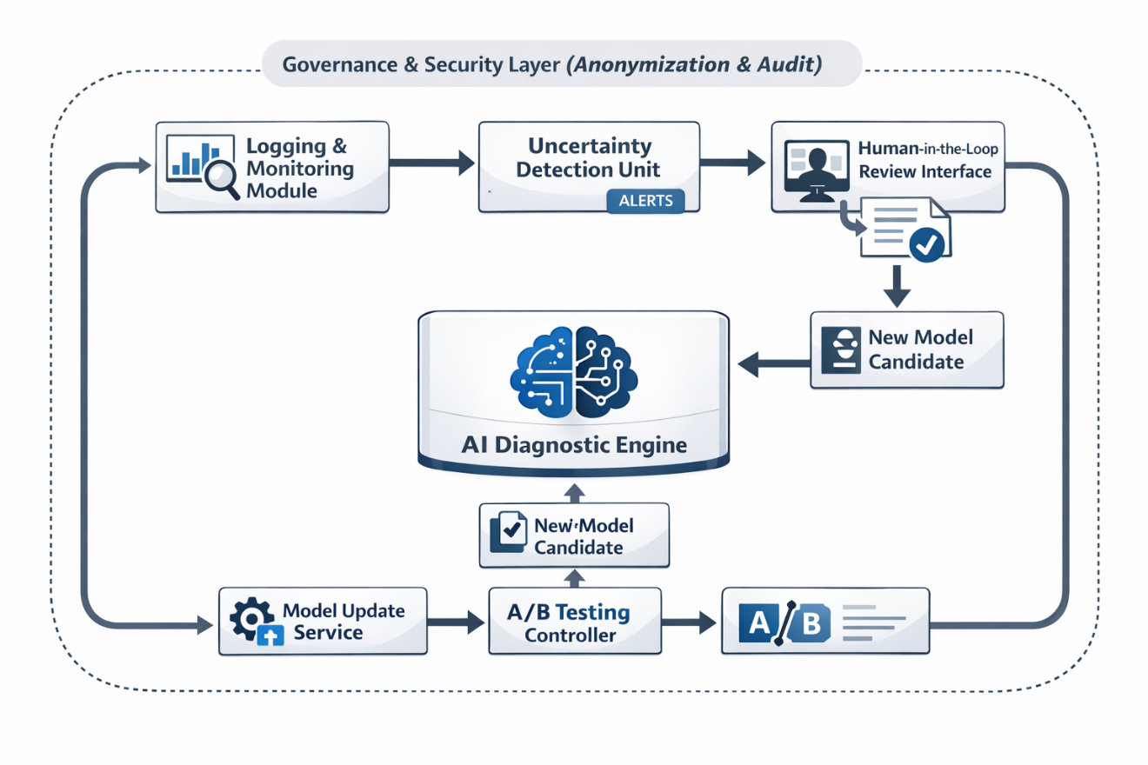
Figure 1: Comprehensive Closed-Loop Governance Architecture

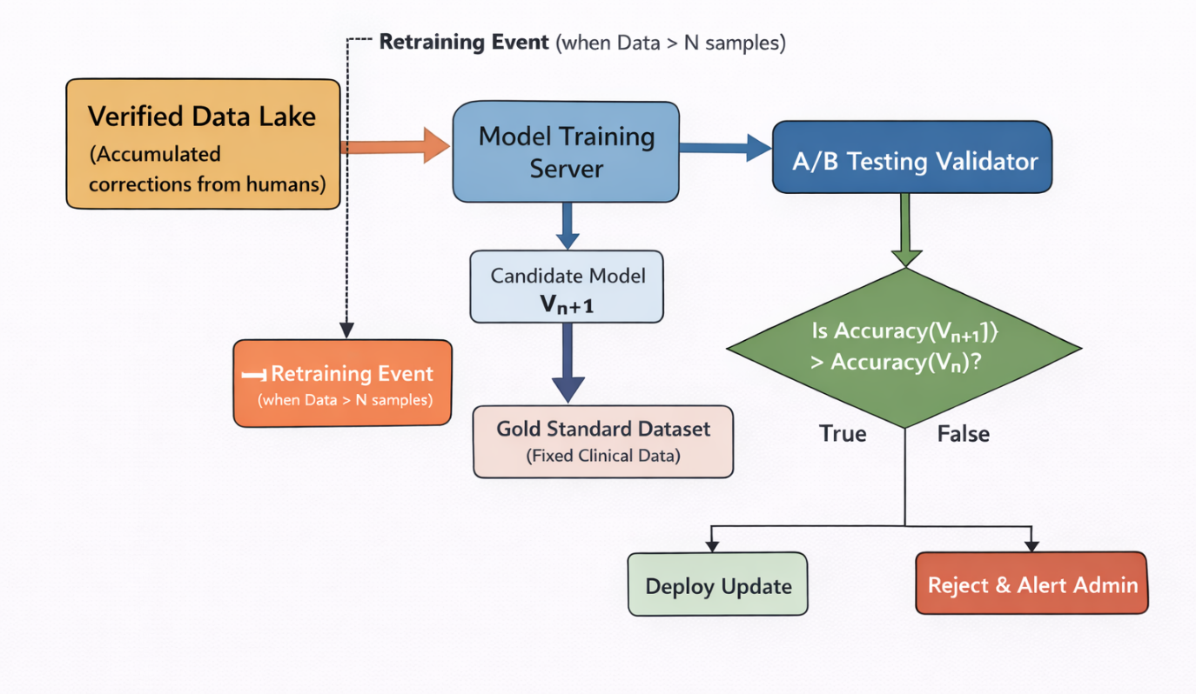
Figure 2: Schematic of the Automated Model Retraining & Validation Pipeline

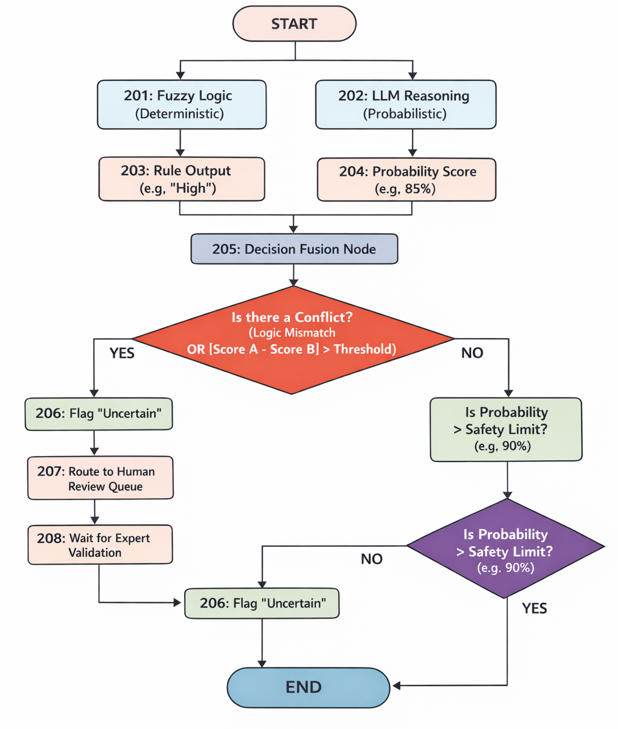
Figure 3: Logic Flowchart of the Uncertainty Detection Module

- List of novel features in the invention

Novel Features 1 (NF1): Conflict-Based Human-in-the-Loop Triggering Mechanism A novel monitoring procedure that identifies "Uncertain" diagnostic states not merely by low probability scores, but by detecting a specific Logic Conflict between the deterministic output of the Fuzzy Inference System (e.g., Rule: "High Risk") and the probabilistic output of the Neural Network (e.g., Score: "Low Confidence"). This creates a dual-verification safety net that routes only genuinely ambiguous cases to human experts, optimizing the use of medical personnel.

Novel Features 2 (NF2): Automated "Shadow" A/B Testing for Compliance A novel model update technique where the system automatically executes a "Shadow Deployment" of a newly retrained model against a fixed, clinically validated "Gold Standard" dataset. Unlike standard MLOps pipelines that deploy based on general accuracy, this feature enforces a strict medical safety protocol where the new model is rejected unless it statistically outperforms the currently active model on specific sensitivity/specificity metrics, automating regulatory compliance.

Novel Features 3 (NF3): Immutable "Logic Path" Audit Logging A new data logging arrangement that records the specific "Active Fuzzy Rule" (e.g., "IF Spectral Centroid is High THEN Disease Probability is High") alongside the final classification and the human expert's verification. This provides a transparent, explainable audit trail for every single diagnosis, solving the "Black Box" problem inherent in standard deep learning medical devices and facilitating regulatory audits.

Novel Features 4 (NF4): Dynamic Retraining Queue Injection A new active learning installation that automatically formats and injects expert-verified data from the "Human-in-the-Loop" interface directly into a Priority Retraining Queue. This creates a continuous, self-correcting feedback loop where the diagnostic engine adapts to new disease strains or acoustic environments in near real-time without requiring manual dataset curation or offline engineering intervention.

- List of keywords relevant to the invention:

• Closed-Loop Governance
• Human-in-the-Loop (HITL)
• Medical AI Safety
• Automated Retraining
• Logic Conflict Detection
• Explainable AI Audit
• Model Drift Correction
• A/B Testing Compliance
• Active Learning Feedback
• Diagnostic Reliability
- Any other relevant details:
The system is designed to be regulatory-agnostic, meaning the "Gold Standard" validation dataset used in the A/B Testing module can be swapped to meet different regional standards (e.g., FDA in the US, CE MDR in Europe) without changing the underlying governance architecture. This allows the invention to be deployed globally while maintaining local medical compliance automatically.

