**一：一元函数作图**

1,ezpolar('3*cos(3*(theta)) ',[0,2*pi])

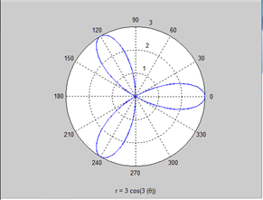

2,  ezpolar('3*sin(2*(theta))',[0,2*pi])

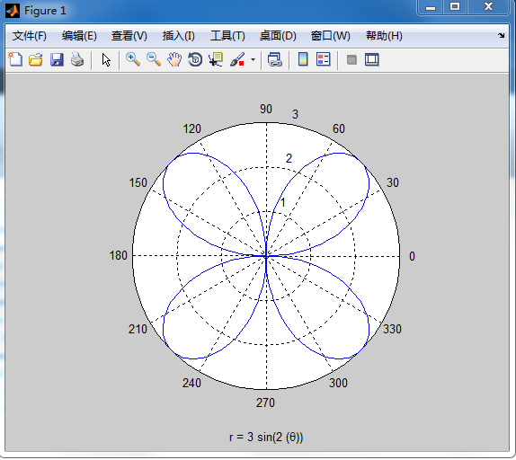

3, ezplot('2*(t+sin(t))','2*((cos(t))-1)',[0,2*pi])

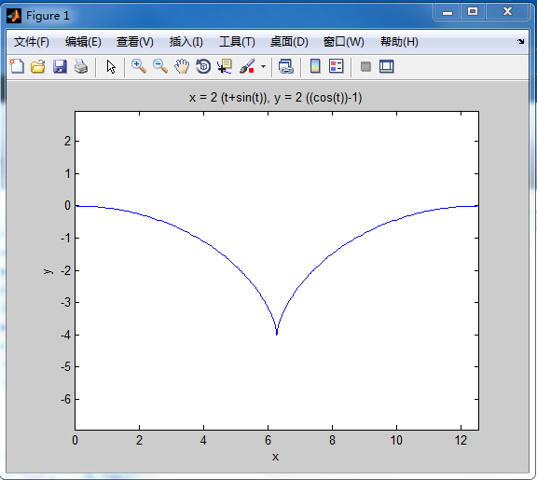

4, ezplot('(x^2)*(y^2)=(y+1)^2*(4-y^2)',[-10,10])

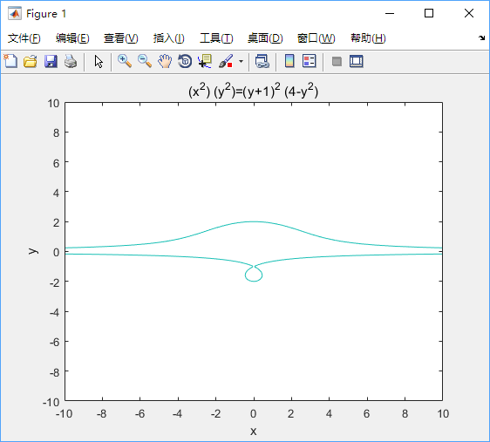

5． ezplot('x^2+(y-(x^2)^(1/3))^2=1')

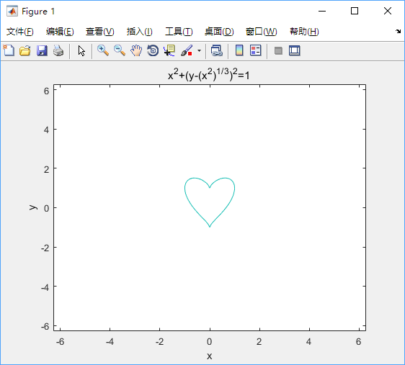

**二：极限的计算**

1. syms x;

>> limit(sin(sin(x))/x-1,x,0)  
  ans=0

2，syms n;

>> limit(tan(pi/4+1/n)^n,n,inf)

ans=exp(2)

3，syms x;

>> limit(x*(pi/2-asin(x/(sqrt(x*x+1)))),x,inf)

ans=1

4

(1) syms x;

>> limit(1/(1+exp(1/(x-1))),x,1,'left')

ans=1

(2) syms x;

>> limit(1/(1+exp(1/(x-1))),x,1,'right')

ans=0

**三：级数**

1. syms n;

>> symsum(1/n^2,n,1,inf)  
  ans=pi^2/6

2，syms n;

>> symsum((-1)^(n+1)/2^n,n,0,inf)

ans=-2/3

3，syms n;  
>> symsum((-1)^(n+1)*x^(n+1)/n*(n+1),n,1,inf)  
ans=piecewise([abs(x)<1,x+x*log(x+1)+1/(x+1)-1],[abs(x)<=1andx<-1,Inf+x*log(x+1)])

**四：泰勒级数**

1，syms x;

>> y=taylor(sin(x),'Order',3);

>> x=3*pi/180;

>> eval(y)

ans=0.0524

2，syms x;

>> y=taylor(x^(1/3),x,30,'Order',3)

y=30^(1/3) + (30^(1/3)*(x - 30))/90 - (30^(1/3)*(x - 30)^2)/8100

>> x=30;

>> eval(y)

ans =3.1072

3，syms x;

>> y=taylor(x^(1/2),x,4,'Order',2)

y =x/4 + 1

>> x=4.4;

>> eval(y)

ans=2.1000

**五、微分方程**

1、

命令行：

x=-5:0.01:5;

>> for C1=-5:5;

for C2=-5:5

y=C1*exp(-x)+C2*exp(x);

plot(x,y)

axis([-5 5 -1000 1000])

hold on

end

end

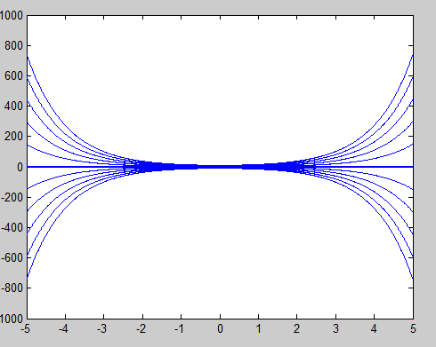

2、M文件：

function f=fun(x,y)

f=(-1-x^2*y*sin(x))/x;

end

命令行：

x=1:0.2:4;

>> [x,y]=ode45('fun',[1,4],1);

>> plot(x,y)

图像：

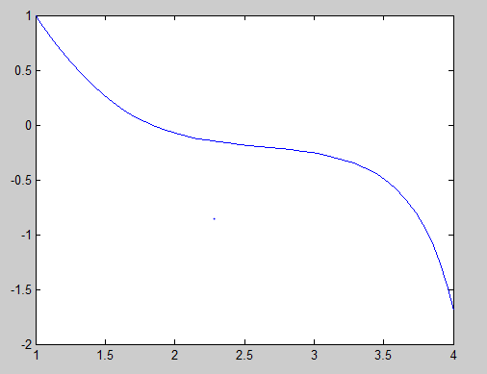

**六、二次曲面**

1、代码：

>> [x,y]=meshgrid(-10:0.1:10);

>> z1=sqrt(x.^2-y.^2);

>> [x,y]=meshgrid(3:0.1:4,1:0.1:2);

>> z1=sqrt(x.^2-y.^2);

>> mesh(x,y,z1)

>> hold on

>> z2=-sqrt(x.^2-y.^2);

>> mesh(x,y,z2)

图像：

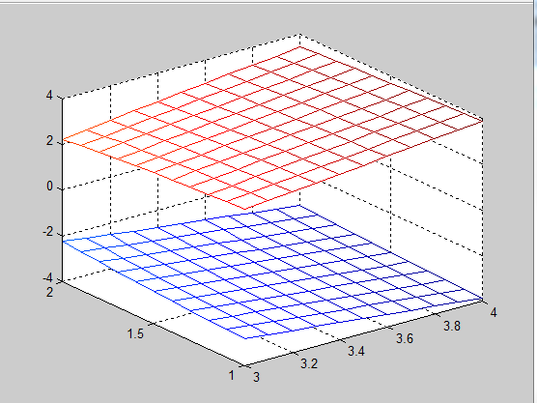

2、命令行：

>> u=[0:0.1:1]';

>> v=0:0.1:2*pi;

>> x=u*cos(v);

>> y=u*sin(v);

>> z=(0*u+1)*1*v;

>> mesh(x,y,z)

图像：

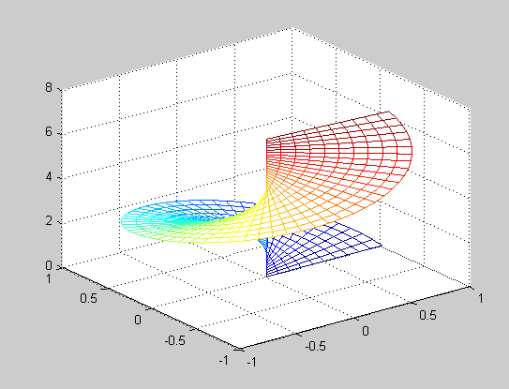

3、

>> [x,y]=meshgrid(-10:0.1:10);

>> z=x.^2+y.^2+k*x*y;

>> mesh(x,y,z)

图像：k=1

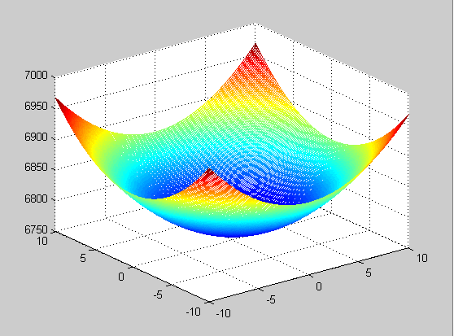

k=10:

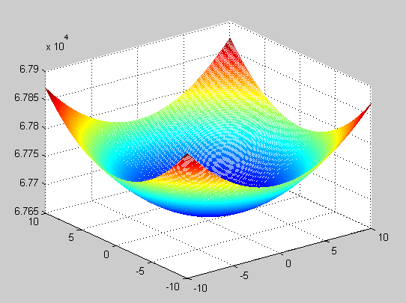

k=-10:

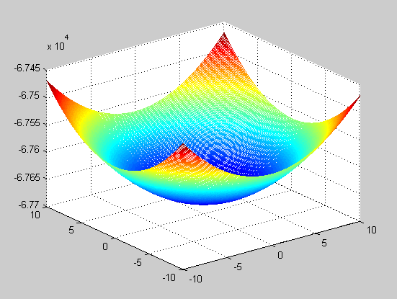

**七、多元函数微分学**

1、

>> syms x y z;

>> f=sqrt(x^2+y^2)-z;

>> u=diff(f,x);

>> v=diff(f,y);

>> x=1;

>> y=1;

>> z=sqrt(2);

>> a=eval(u);

>> b=eval(v);

>> t=-2:0.1:4;

>> x3=a*t+1;

>> y3=b*t+1;

>> z3=-t+sqrt(2);

>> [x,y]=meshgrid(-2:0.1:3);

>> z1=sqrt(x.^2+y.^2);

>> z2=a*(x-1)+b*(y-1)+sqrt(2);

>> mesh(x,y,z1)

>> hold on

>> mesh(x,y,z2)

>> hold on

>> plot3(x3,y3,z3)

图像：

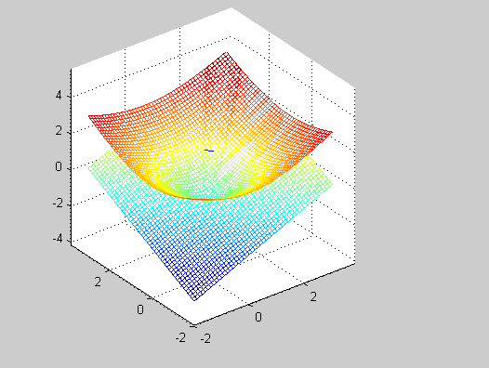

2、(u)

>> [x,y]=meshgrid(-2:0.01:2);

>> u=x.^2-y.^2;

>> mesh(x,y,u)

>> hold on

>> x1=linspace(-2,2,25);

>> y1=linspace(-2,2,25);

>> [x,y]=meshgrid(x1,y1);

>> z1=x.^2-y.^2;

>> h=contour(z1);

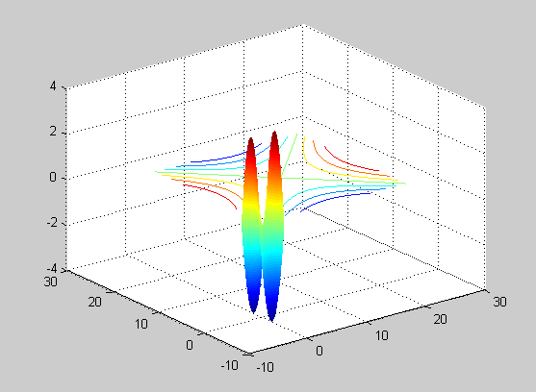

(v)

>> [x,y]=meshgrid(-2:0.001:2);

>> v=2*x.*y;

>> mesh(x,y,v)

>> hold on

>> x1=linspace(-2,2,25);

>> y1=linspace(-2,2,25);

>> [x,y]=meshgrid(x1,y1);

>> z2=2*x.*y;

>> h=contour(z2);

图像：

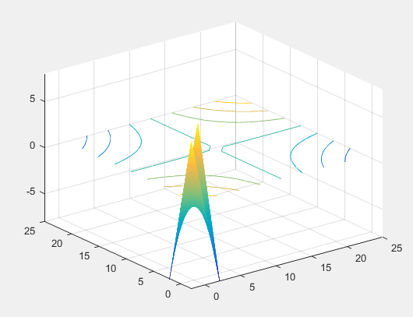

3、命令行：

>> x1=linspace(-10,10,1000);

>> y1=linspace(-10,10,1000);

>> [x,y]=meshgrid(x1,y1);

>> f=x.^4-8*x.*y+2*y.^2-3;

>> h=contour(f);

图像：

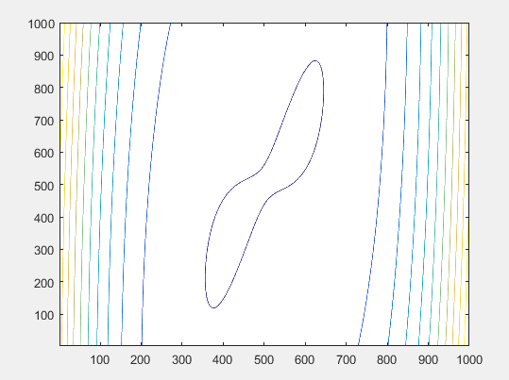

>> syms x y;

>> f=x^4-8*x*y+2*y*y-3;

>> dfx=diff(f,x)

dfx =4*x^3 - 8*y

>> dfy=diff(f,y)

dfy=4*y - 8*x

>> dfxx=diff(f,x,2)

dfxx =12*x^2

>> dfxy=diff(dfx,y)

dfxy =-8

>> dfyy=diff(f,y,2)

dfyy =4

1. x=0,y=0,dfxx*dfyy-dfxy^2<0;
2. x=2,y=4,dfxx*dfyy-dfxy^2>0,,dfxx>0,极小值f(2,4)=-10;
3. x=-2,y=-4,dfxx*dfyy-dfxy^2>0,dfxx>0, 极小值f(-2,-4)=-1；

**八、多元函数积分学**

1、

>> syms r t;

>> int(int(r^2,r,0,1),t,0,2*pi)

ans =(2*pi)/3

2、>> syms p x y;

>> int(int(int(p^2*sin(x)*sin(x)*p^2*sin(x),p,1,2),x,0,pi),y,0,2*pi)

ans =(248*pi)/15

3、

>>syms x1 y1 z1 x2 y2 z2;

>> y1=sqrt(1-x1*x1-z1*z1);

>> dyx=diff(y1,x1)

dyx =

-x1/(- x1^2 - z1^2 + 1)^(1/2)

>> z2=sqrt(1-x2*x2-y2*y2);

>> dzx=diff(z2,x2)

dzx =

-x2/(- x2^2 - y2^2 + 1)^(1/2)

>> int(1*sqrt(1+1+(-x/(-x^2-x^2+1)^(1/2))^2),x,-sqrt(2/x),sqrt(x)/2)

ans =

int((2 - x^2/(2*x^2 - 1))^(1/2), x, -2^(1/2)*(1/x)^(1/2), x^(1/2)/2)

4、

>> syms x y z1 z2;

>> z1=sqrt(1-x*x-y*y)+1;

>> dz1x=diff(z1,x)

dz1x =

-x/(- x^2 - y^2 + 1)^(1/2)

>> dz1y=diff(z1,y)

dz1y =

-y/(- x^2 - y^2 + 1)^(1/2)

int(int((x*x+y*y+z1*z1-2*z1)*sqrt(1+dz1x^2+dz1y^2),x,-sqrt(2*z1-z1^2-y^2),sqrt(2*z1-z1^2-y^2)),y,1/4,1/2)

ans =

0

>> z2=-sqrt(1-x*x-y*y)+1;

>> dz2x=diff(z2,x)

dz2x =

x/(- x^2 - y^2 + 1)^(1/2)

dz2y=diff(z2,y)

dz2y =

y/(- x^2 - y^2 + 1)^(1/2)

int(int((x*x+y*y+z2*z2-2*z2)*sqrt(1+dz2x^2+dz2y^2),x,-sqrt(2*z2-z2^2-y^2),sqrt(2*z2-z2^2-y^2)),y,1/4,1/2)

ans =

0