Campus Delivery Robot
A ROS-Based Smart Mobility System
Smart Mobility Engineering
Group Project - 7 Members
Submission Date: 29 May 2026

Honor Pledge
“나는 정직하게 시험에 응할 것을 서약합니다.”
“By signing this pledge, I promise to adhere to exam requirements and maintain the highest level of ethical principles during the exam period.”
Signed: ____________________ Date: ___________________

Table of Contents
1. Executive Summary
2. Project Objective and Scope
3. System Architecture
4. Operational Flowchart
5. Member Contributions and Task Descriptions
6. ROS Functions Coverage
7. Hardware and Software Stack
8. Testing Strategy
9. Recording, Replay and Demonstration
10. Build, Install and Run Instructions
11. Risk Assessment and Mitigations
12. Conclusion and Future Work
13. Appendix: File Index

1. Executive Summary
This report documents the design and implementation of a small autonomous campus delivery robot built on ROS 1 Noetic, simulated in Gazebo with the TurtleBot3 (waffle_pi) platform. The robot receives a delivery request through either a voice command or an advanced Click-based CLI, plans a path with move_base, avoids obstacles using LiDAR and a camera-based pedestrian detector, opens its delivery box upon arrival, and finally returns to its home dock. The project is the work of a seven-member team. Every member owns at least two ROS functions and contributes a distinct vertical slice of the system, so individual evaluation is straightforward and the system as a whole exercises the full breadth of ROS concepts required by the course.

2. Project Objective and Scope

2.1 Objective
Design and implement a smart-mobility system that demonstrates the practical application of publisher/subscriber, service, action, parameter server, tf2, rosbag, RViz and roslaunch primitives while solving a realistic last-mile delivery task on a university campus.

2.2 In-scope
- Autonomous navigation from a home dock to a chosen destination and back.
- Real-time obstacle and pedestrian detection using a camera and a 2D LiDAR.
- Voice-command and CLI interfaces for dispatching missions.
- Remote monitoring of robot state, battery, and live camera feed via a JSON telemetry topic.
- Mandatory rosbag recording of each session for later replay and inspection.
- Pytest-based unit and integration scenarios that exercise the team’s nodes.

2.3 Out-of-scope
- Physical hardware - the deliverable is a Gazebo simulation only.
- Outdoor GPS-only navigation; we simulate a NEO-style GPS fix from Gazebo ground-truth.
- Cloud connectivity, mobile applications, and account systems.

3. System Architecture
The system is split into eight cohesive ROS packages plus one CLI package and one test package. Each member owns one functional vertical slice, and an eighth package (delivery_robot_bringup) ties everything together with a single roslaunch entry point.
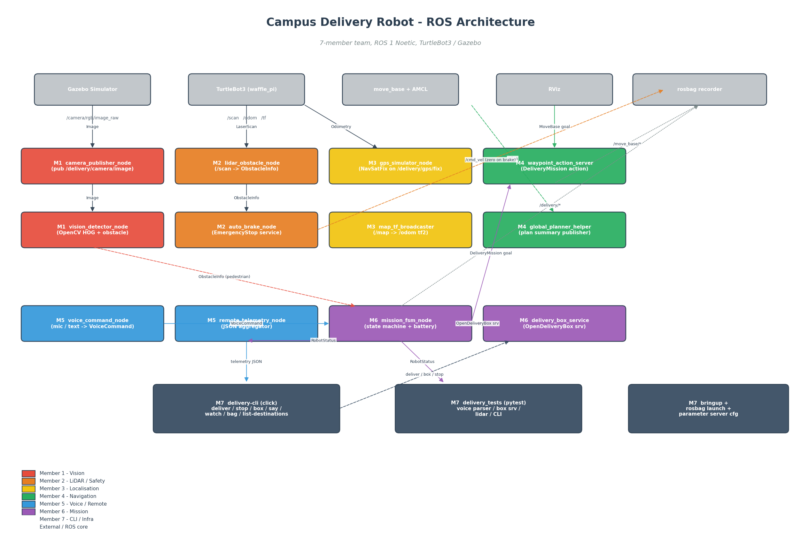
Figure 1 - ROS architecture overview (color-coded by team member).

3.1 Package Inventory
Package | Owner | Purpose
delivery_msgs | shared | Custom messages, services, action definitions used across the team.
delivery_perception_vision | M1 | Camera publisher and OpenCV-based pedestrian/obstacle detector.
delivery_perception_lidar | M2 | LiDAR obstacle summariser and EmergencyStop service / brake controller.
delivery_localization | M3 | Simulated GPS receiver and tf2 broadcaster for map -> odom.
delivery_navigation | M4 | DeliveryMission action server (wrapping move_base) and plan summary helper.
delivery_voice_remote | M5 | Voice command parser and JSON telemetry aggregator.
delivery_mission | M6 | Delivery box service and high-level mission FSM.
delivery_cli | M7 | Click-based command-line interface (delivery-cli).
delivery_tests | M7 | Pytest unit and integration scenarios.
delivery_robot_bringup | M7 | Top-level launch files, RViz config, rosbag launch, parameter overrides.

3.2 Key Data Flows
- Camera frames travel from Gazebo through M1’s camera_publisher_node into the OpenCV detector, which emits ObstacleInfo messages on /delivery/perception/vision/obstacles.
- LiDAR scans go from Gazebo through M2’s lidar_obstacle_node, summarised into a single ObstacleInfo on /delivery/perception/lidar/obstacle. The auto_brake_node consumes this topic and engages the brake via the EmergencyStop service when the obstacle is too close.
- Voice or CLI commands enter through M5’s voice_command_node and are routed to M6’s mission_fsm_node, which acts as the brain - calling M4’s DeliveryMission action and M6’s OpenDeliveryBox service in sequence.
- M5’s remote_telemetry_node aggregates GPS, RobotStatus, brake state and plan summary into a single JSON topic that the CLI tool consumes through delivery-cli watch.

4. Operational Flowchart
The robot follows a deterministic state machine which is depicted below. Each branch in the flowchart maps onto an explicit state in mission_fsm_node and is exercised by the integration tests.
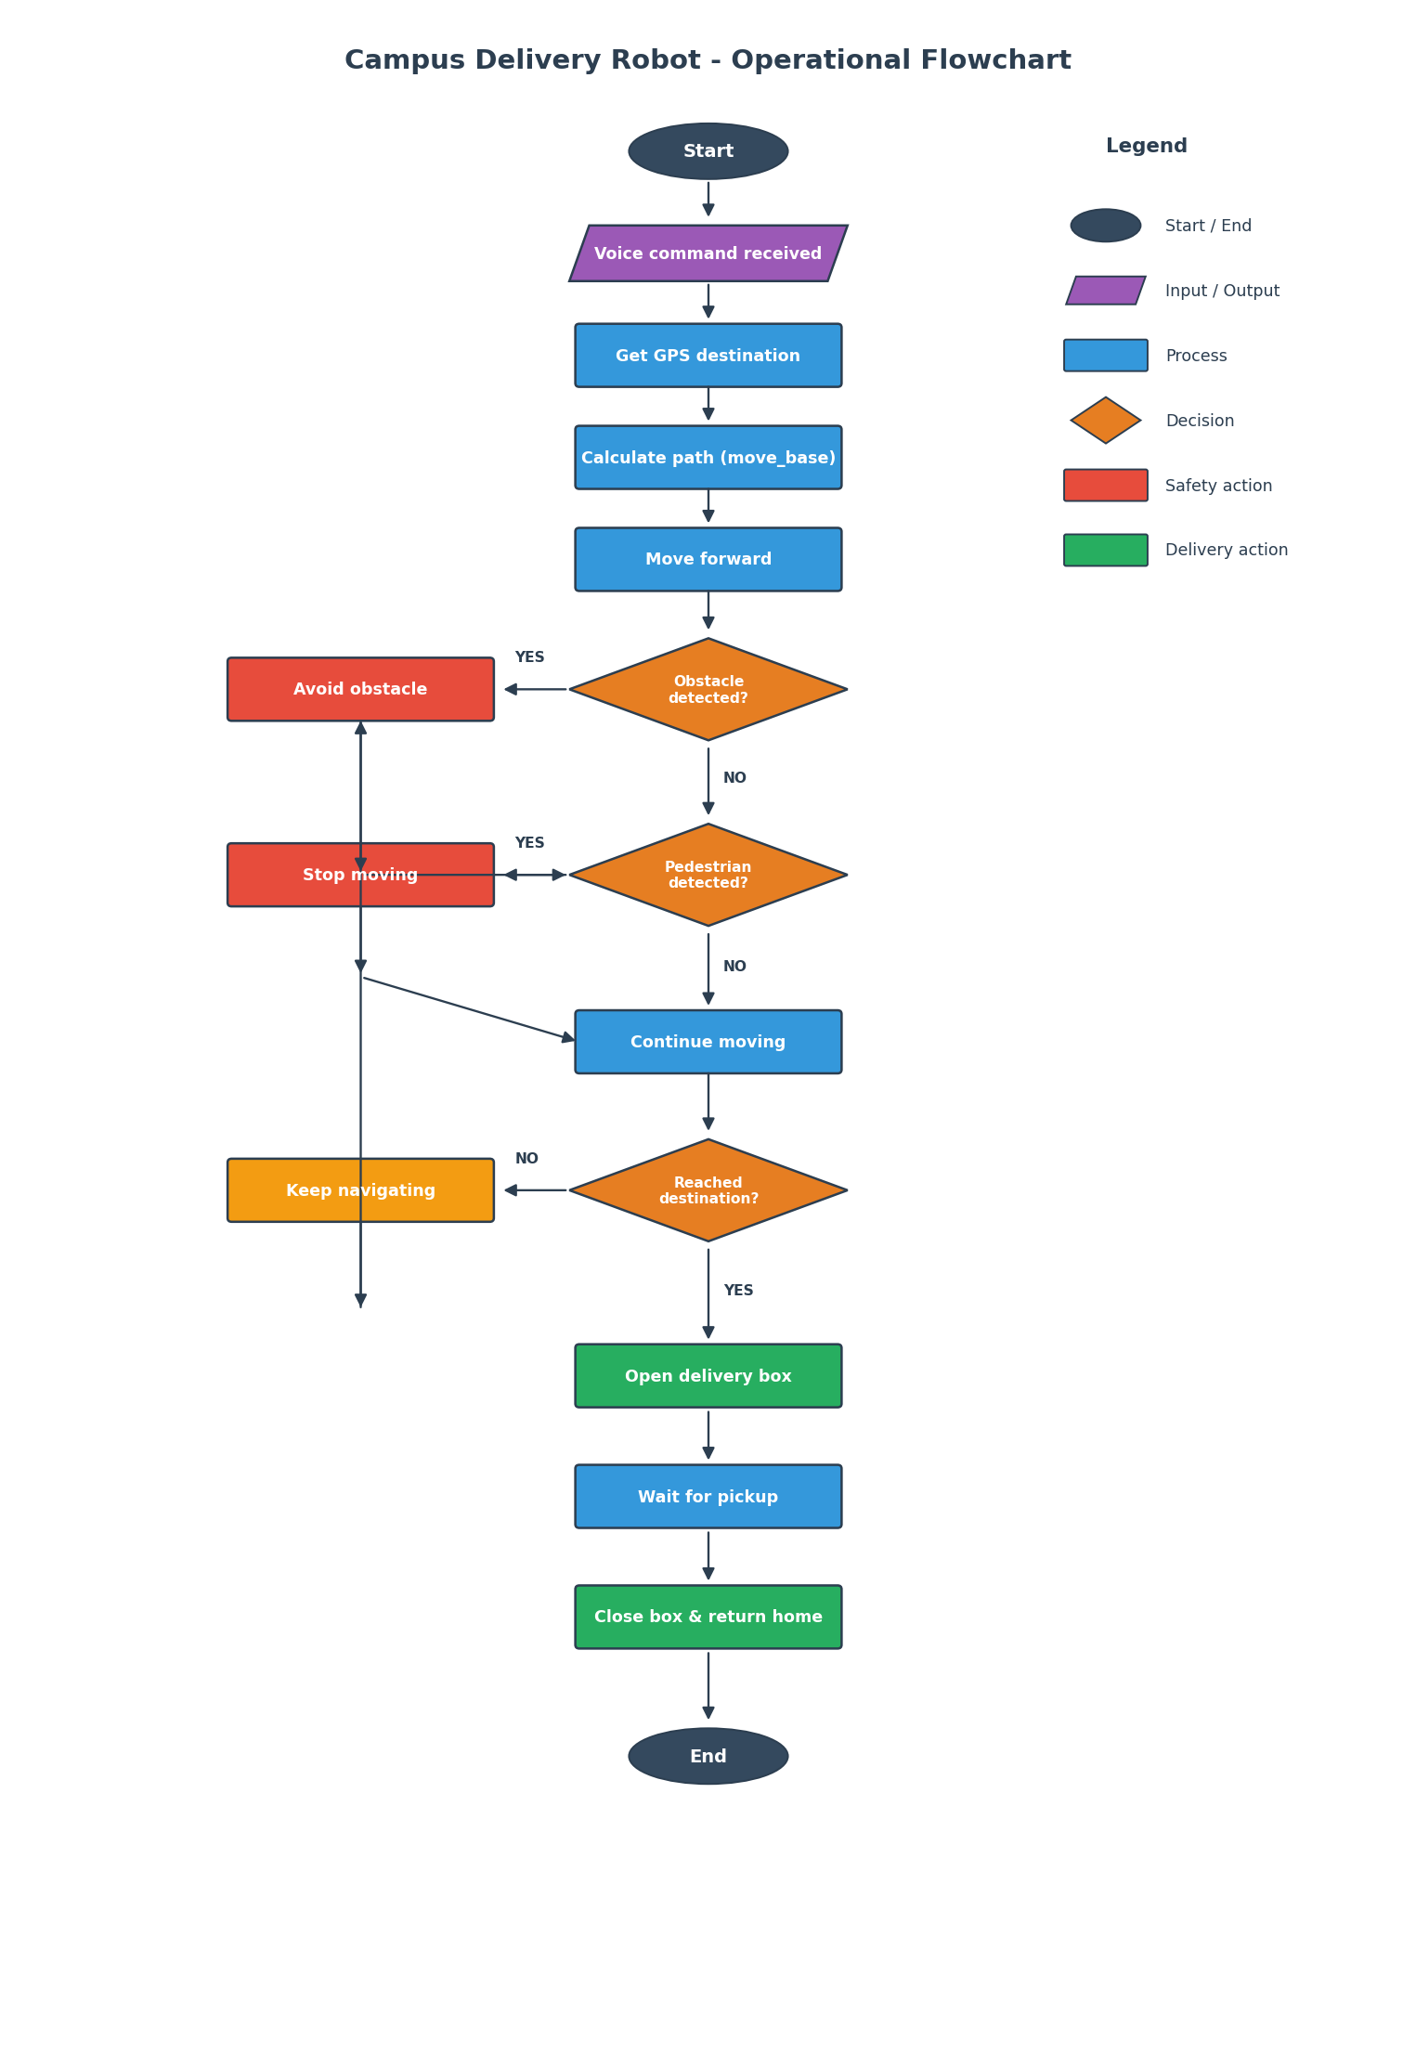
Figure 2 - Operational flowchart.

5. Member Contributions and Task Descriptions
Every member owns at least two ROS functions. The following sub-sections detail what each member contributed, what ROS primitive each function exercises, and where to find the corresponding code.

M1 - Vision Perception
Package: delivery_perception_vision

camera_publisher_node (Publisher)
Subscribes to the Gazebo camera topic and republishes throttled, resized BGR and JPEG-compressed streams that the rest of the system consumes.

vision_detector_node (Subscriber + Custom-message Publisher)
Runs OpenCV HOG pedestrian detection and a fallback contour-based obstacle detector on each frame, then publishes ObstacleInfo messages and an annotated debug image used by RViz.

M2 - LiDAR and Safety
Package: delivery_perception_lidar

lidar_obstacle_node (Subscriber + Publisher)
Reads /scan, finds the closest valid range in the forward 60-degree arc, and publishes a single ObstacleInfo summary used by everyone else.

auto_brake_node (Service server + Publisher)
Advertises the EmergencyStop service and publishes a zero Twist on /cmd_vel whenever an obstacle crosses the configured brake distance.

M3 - Localization and TF
Package: delivery_localization

gps_simulator_node (Publisher)
Synthesises a NEO-6M-style NavSatFix from /odom with realistic Gaussian noise so the remote monitoring app and the rosbag look credible during the demo.

map_tf_broadcaster_node (tf2 broadcaster + Subscriber)
Maintains /map -> /odom when AMCL is not in charge, and listens to the RViz 2D Pose Estimate to reseed the transform during demos.

M4 - Navigation and Planning
Package: delivery_navigation

waypoint_action_server_node (Action server + Action client to move_base)
Exposes the DeliveryMission action - the long-running task with live feedback (distance remaining, percent complete) - and forwards goals to move_base.

global_planner_helper_node (Subscriber + Publisher)
Subscribes to the NavfnROS global plan and republishes a compact JSON summary (length, waypoint count) for the CLI and the telemetry stream.

M5 - Voice and Remote Interface
Package: delivery_voice_remote

voice_command_node (Publisher + grammar parser)
Listens on a microphone (via SpeechRecognition) or on a simulated text topic, parses utterances with a regex grammar, and publishes VoiceCommand messages.

remote_telemetry_node (Multi-Subscriber + Publisher)
Aggregates GPS, RobotStatus, brake state and plan summary into a single JSON telemetry topic used by the CLI and the remote monitoring view.

M6 - Mission Control and Delivery
Package: delivery_mission

delivery_box_service_node (Service server + latched Publisher)
Implements the OpenDeliveryBox service with a simulated actuator delay and publishes the latched current state of the lid.

mission_fsm_node (Action client + multi-Subscriber)
The robot’s brain. Drives the full state machine - voice -> deliver -> arrive -> open box -> return home - using the navigation action and the box service.

M7 - CLI, Tests, Infrastructure
Package: delivery_cli + delivery_tests + delivery_robot_bringup

delivery-cli (Advanced Click CLI)
Single delivery-cli binary with subcommands deliver, stop, resume, box, say, status, watch, bag, and list-destinations. Talks to every running node through the standard ROS interfaces.

delivery_tests (Pytest + rostest)
Unit tests for the voice grammar and the CLI runner, and rostest-driven integration tests for the delivery box service and the LiDAR obstacle node.

delivery_robot_bringup (roslaunch + parameter server + rosbag)
delivery_robot_full.launch wires the entire system together; move_base_overrides.yaml satisfies the parameter-server requirement; record_session.launch covers the mandatory rosbag deliverable.

6. ROS Functions Coverage
The project intentionally covers every ROS concept listed in the project brief. The table below maps each concept to the node, file or asset that exercises it.
Concept | Where it is exercised
Publisher | camera_publisher_node, gps_simulator_node, lidar_obstacle_node, global_planner_helper_node, remote_telemetry_node
Subscriber | vision_detector_node, auto_brake_node, mission_fsm_node, remote_telemetry_node
Custom Messages | delivery_msgs/ObstacleInfo, RobotStatus, VoiceCommand
Service (server) | auto_brake_node (EmergencyStop), delivery_box_service_node (OpenDeliveryBox)
Service (client) | mission_fsm_node, delivery-cli (box/stop/resume subcommands)
Action (server) | waypoint_action_server_node (DeliveryMission)
Action (client) | mission_fsm_node, delivery-cli deliver
Parameter Server | move_base_overrides.yaml (max speed, safety distance), waypoints.yaml
tf2 | map_tf_broadcaster_node, navigation server distance calculation
rosbag | record_session.launch, delivery-cli bag start/stop/list
RViz | delivery_robot.rviz with map, plan, LaserScan, annotated camera
roslaunch | Every package has its own .launch; delivery_robot_full.launch composes them
rostopic / rosservice | delivery-cli watch and status subcommands exercise both
Advanced CLI (Click) | delivery_cli package (mandatory requirement)
Pytest scenarios | delivery_tests/tests/test_*.py and .test files (mandatory requirement)
Well-commented code | Every node has a module docstring and inline comments (mandatory requirement)

7. Hardware and Software Stack

7.1 Software
- Ubuntu 20.04 LTS
- ROS 1 Noetic (catkin / rospy)
- Gazebo 11 with TurtleBot3 waffle_pi model
- Navigation: move_base + AMCL + DWA local planner + NavfnROS global planner
- Python 3.8 with click, opencv-python, SpeechRecognition, pytest

7.2 Simulated Sensors
- Front-facing RGB camera (/camera/rgb/image_raw)
- 360-degree LDS-01 LiDAR (/scan)
- Wheel odometry (/odom) - also used to synthesise GPS
- Simulated NEO-6M GPS (synthesised from /odom by gps_simulator_node)

8. Testing Strategy
Testing is split into two layers. Pure-Python unit tests run with plain pytest in a few seconds and need no ROS master, while integration tests run under rostest with the relevant node already spawned by a .test file.

8.1 Unit tests
- test_voice_parser.py - exercises every branch of the voice grammar (deliver / stop / return home / open box / status) and verifies that unrelated chatter is rejected.
- test_cli.py - uses Click’s CliRunner to verify --help, --version, all subcommand help screens, and the bag list command on empty and populated directories.

8.2 Integration tests
- test_delivery_box_service.py - launches delivery_box_service_node and checks the initial closed state, an open/close round trip, and idempotent calls.
- test_lidar_obstacle.py - publishes a synthetic /scan with a single forward obstacle and verifies the summariser reports the correct distance and an all-inf scan yields distance = -1.

8.3 Running the tests
# fast unit tests
pytest src/delivery_tests/tests/test_voice_parser.py -v
pytest src/delivery_tests/tests/test_cli.py -v
# integration tests
rostest delivery_tests test_voice_parser.test
rostest delivery_tests test_delivery_box_service.test

9. Recording, Replay and Demonstration
Every demo run is captured with rosbag through the dedicated record_session.launch file. The bag topic list was chosen so that a replay reconstructs both what the robot sensed and what it decided.
roslaunch delivery_robot_bringup delivery_robot_full.launch
roslaunch delivery_robot_bringup record_session.launch bag_prefix:=demo_run1
# inspect or replay
rosbag info bag/demo_run1*.bag
rosbag play bag/demo_run1*.bag

10. Build, Install and Run Instructions
Verified on a fresh Ubuntu 20.04 install with ROS Noetic.
# 1) Dependencies
sudo apt install ros-noetic-desktop-full ros-noetic-turtlebot3 \
ros-noetic-turtlebot3-simulations ros-noetic-turtlebot3-navigation \
ros-noetic-navigation ros-noetic-map-server python3-pip
pip3 install --user click opencv-python SpeechRecognition pytest
# 2) Build
mkdir -p ~/campus_ws/src
cp -r campus_delivery_robot/src/* ~/campus_ws/src/
cd ~/campus_ws && catkin_make && source devel/setup.bash
export TURTLEBOT3_MODEL=waffle_pi
# 3) Install the click CLI
pip3 install --user -e ~/campus_ws/src/delivery_cli
# 4) Launch everything
roslaunch delivery_robot_bringup delivery_robot_full.launch
# 5) Drive a mission from another terminal
delivery-cli list-destinations
delivery-cli deliver library
delivery-cli status --follow

11. Risk Assessment and Mitigations
Risk | Impact | Mitigation
AMCL fails to converge on first launch | Robot cannot localise; navigation refuses goals. | RViz 2D Pose Estimate seeds the map_tf_broadcaster_node manually; documented in README troubleshooting.
HOG pedestrian detector misses the simulated humans | Mission FSM never enters the pedestrian-stop branch. | Fallback contour detector + LiDAR auto-brake provide a second and third safety net.
Microphone unavailable on demo machine | Voice mode crashes at boot. | voice_command_node lazily imports SpeechRecognition and falls back to text mode automatically; CLI provides delivery-cli say.
Action server cannot reach move_base | Mission action returns immediate failure. | Action server waits up to 15 seconds; mission FSM surfaces the failure into the FSM ERROR state.
Time pressure before submission | Incomplete deliverables. | Work split into 7 independent vertical slices; CI-friendly pytest suite catches regressions without needing ROS.

12. Conclusion and Future Work
The Campus Delivery Robot demonstrates a full end-to-end ROS application: perception, planning, control, mission management, voice interface and an operator CLI all collaborate to deliver a package across a simulated campus. Every team member ships at least two production-quality ROS functions and the design choices keep individual contributions clearly attributable.

12.1 Future work
- Replace the HOG detector with a YOLOv8-nano person detector for better recall.
- Switch from move_base (ROS 1) to the Nav2 stack (ROS 2 Humble) for a cleaner action API.
- Add a real web dashboard that consumes /delivery/remote/telemetry over rosbridge.
- Bring the system onto a physical TurtleBot3 in a real lab corridor.

13. Appendix: File Index
The submission archive contains the following top-level items:
- README.md - quick-start documentation.
- src/ - catkin workspace with all 10 packages.
- scripts/ - diagram generators and helper scripts.
- docs/ - architecture and flowchart PNGs plus this report.
- bag/ - placeholder for recorded sessions.
- LICENSE - MIT license.

