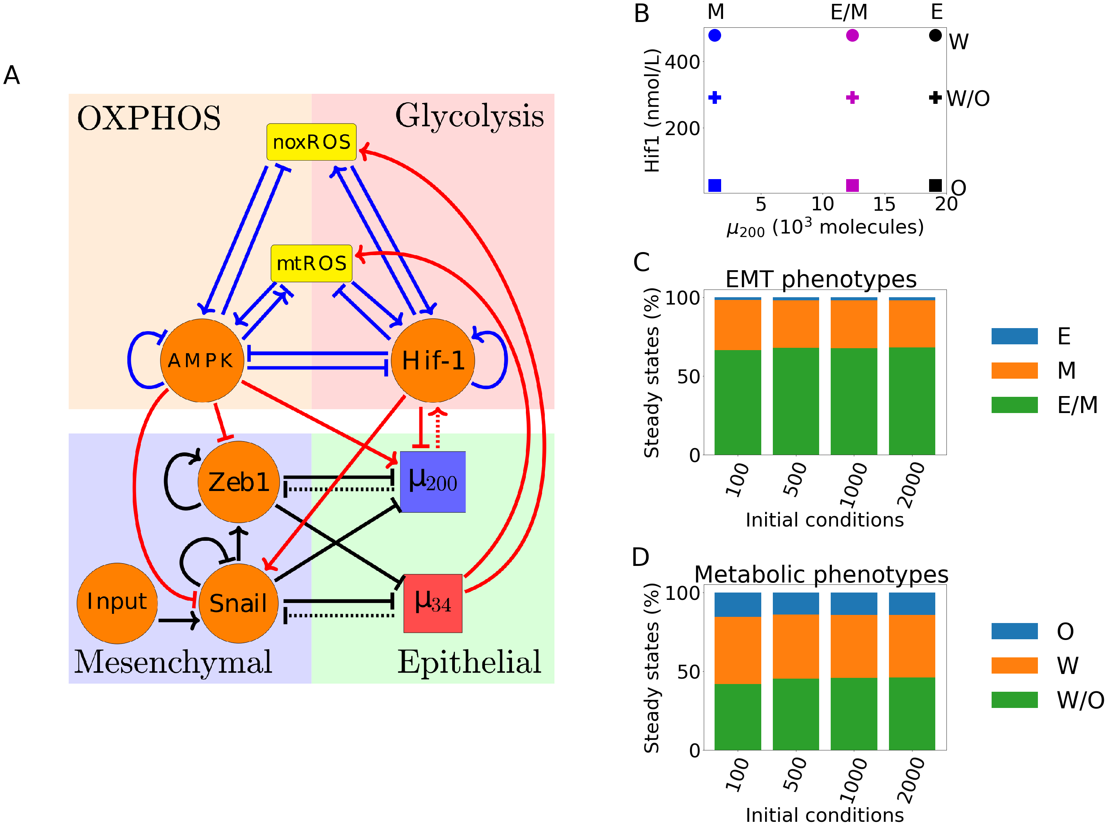
Figure 1
The coupled EMT/MR circuit results in 9 coupled steady states. (A) The network showing the core EMT module (bottom) with regulatory links designated by black, the core metabolic circuit (top) with regulatory links designated by blue, and the crosstalks noted in red. The dashed lines denote miRNA regulation rather than transcriptional. (B) The 9 possible coupled states when all crosstalks are present but inactive. (C) The percent of initial conditions leading to either E, M, or E/M phenotypes for increasing numbers of initial conditions shows minor changes as the number of initial conditions increases. (D) Same as (C) for the W, O, and W/O metabolic phenotypes.

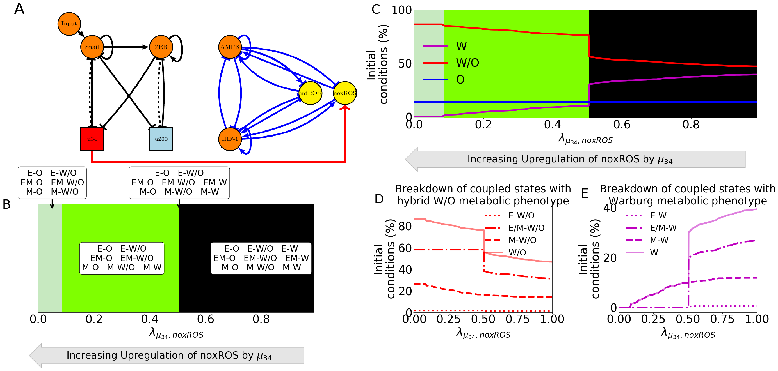
Figure 2
noxROS upregulated by mir34 results in upregulated W/O phenotype and associated with upregulated E/M-W/O phenotype. (A) A diagram of the core EMT circuit (left) and the core metabolic circuit (right) connected by the crosstalk between u34 upregulating noxROS (red link representing transcriptional regulation). (B) Of the nine possible coupled states, as noxROS is upregulated by mir34, there are 4 distinct groupings. All possible coupling of the EMT circuit phenotypes (E, M, and E/M) with both the O and W/O metabolic phenotypes persist for all levels of noxROS upregulation. The coupled states associated with the W metabolic phenotypes, (E-W, E/M-W, and M-W), as the level of noxROS regulation increases for the blue, yellow, and orange regions, respectively. (C) The background colors correpond to the colors representing the possible steady states of (B). The lines represent the total number of initial conditions leading to the W, O, or W/O phenotypes as a function of increasing regulation of noxROS by mir34. The W/O phenotype is upregulated, W phenotype is downregulated, and O is unchanged. (D) Showing the breakdown of the coupled states associated with the W/O phenotype (i.e., E-W/O, M-W/O, and E/M-W/O). The E/M-W/O coupled state is greatly upregulated once lambda=0.5 while the M-W/O coupled state is only slightly upregulated, and no change is seen for E-W/O coupled state. (E) Same as (d) but for the coupled states associated with the Warburg phenotype. Once lambda=0.5, both the E-W and M-W states are fully suppressed. The E/M-W coupled state continues to be downregulated until it is fully suppressed near lambda=0.1.

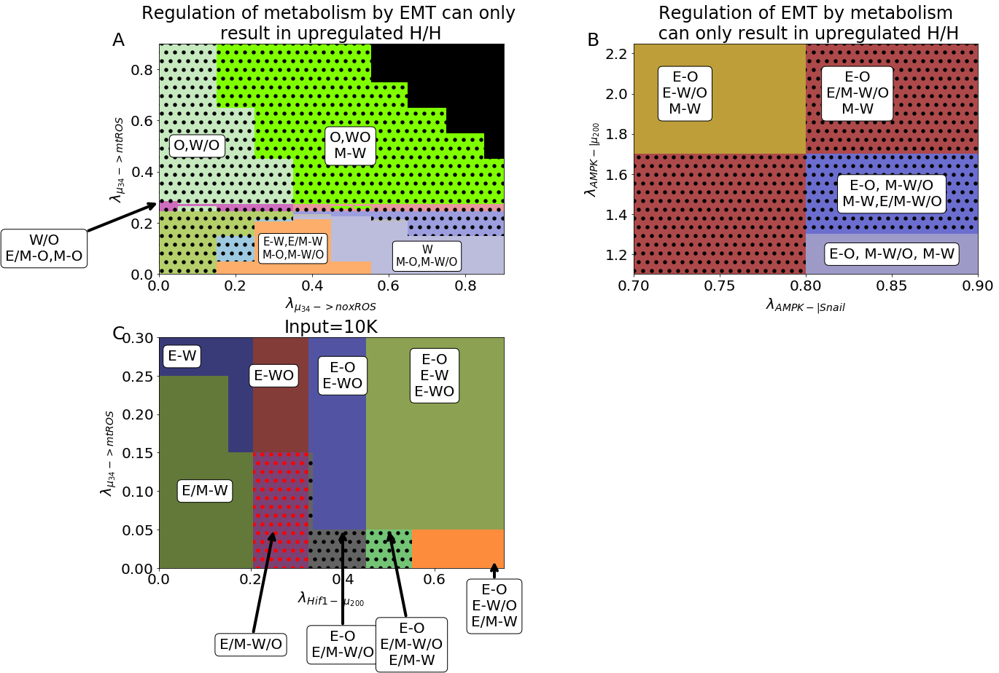
Figure 3
The hybrid E/M and W/O states are coupled. (A) The coupled states when only ROS of the metabolic circuit (mt and nox) are regulated by u34. The E/M-W/O state is present in most regions. (B) The coupled states when only TFs and miRNAs of the EMT circuit are regulated by TFs of the metabolic circuit (AMPK-|Snail, AMPK-|Zeb=?, AMPK->u200, Hif1-|u200=?, Hif1->Snail=?). The E/M-W/O state is present in some regions. (C) When crosstalks in both directions are active there are parameter spaces in which the only possible coupled state is the E/M-W/O state.

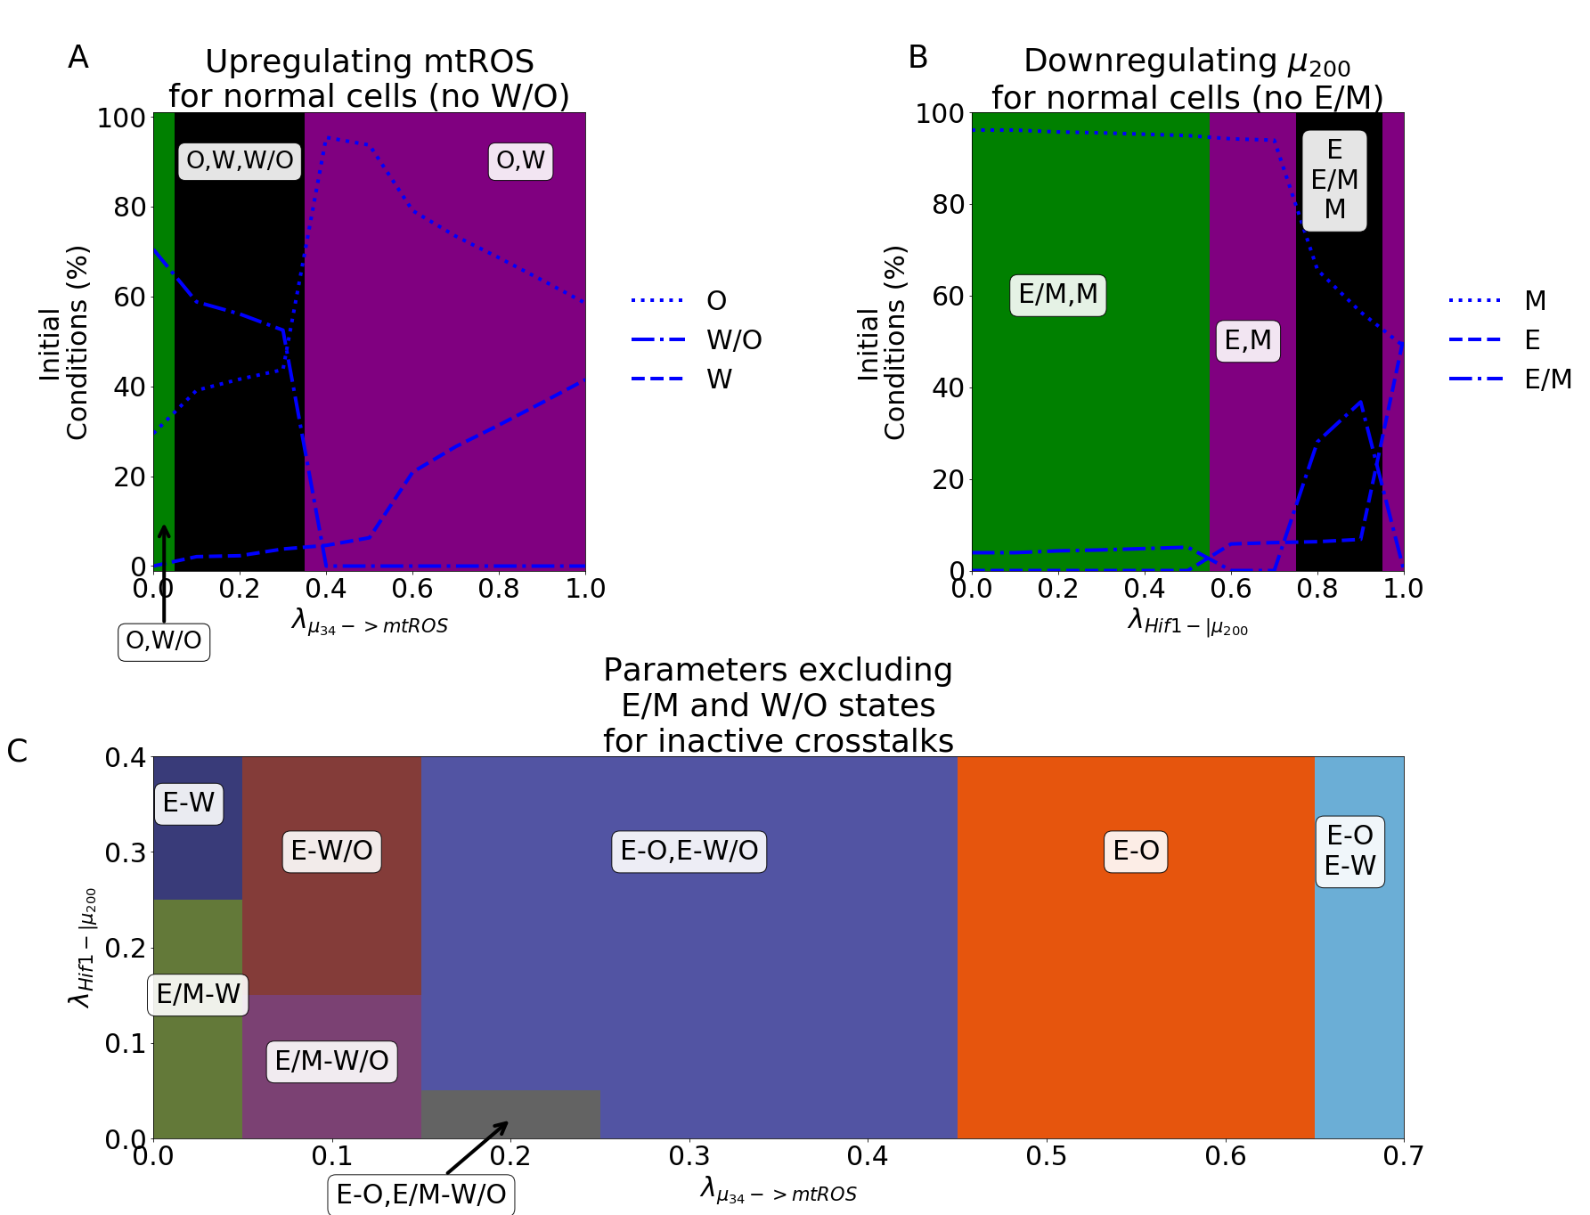
Figure 4
Parameter ranges which exclude the possibility of the hybrid state can be modulated by crosstalk to generate the hybrid state. (A) Our model using parameters that remove the hybrid W/O metabolic state from the steady state possibilities when the crosstalk is inactive (lambda(u34−>𝑚𝑡𝑅𝑂𝑆)=1.). Initially, only the OXPHOS and Warburg metabolic states can be accessed with an increase in the percent of OXPHOS steady states and decrease in Warburg phenotypes. Once lambda(u34)=0.35, there is a sharp change with the hybrid W/O phenotype becoming the most often occupied phenotype. (B) Our model using parameters that remove the hybrid E/M phenotype from the accessible states when the crosstalks are inactive. By adjusting the level of input to Snail (y-axis) and the inhibition of u200 by Hif-1 (x-axis), the system can access the E/M hybrid state (orange, light blue, and purple regions). (C) Focusing on the region in (B) where the input to snail is 10K, the percent of initial conditions leading to E, M, or the E/M phenotype can be seen. As the inhibition increases ( lambda(𝐻𝑖𝑓1−|𝜇200) goes towards zero), the system goes from all initial conditions leading to the Epithelial state to a region with both E and E/M phenotypes accessible. (D) Combining the models from (A) and (B), we generate a model which only has 4 possible coupled states if the crosstalks are inactive (E-O, E-W, M-O, and M-W). By setting the input to snail to be 10K, upregulating mtROS, and downregulating mir200 the E/M-W/O state becomes accessible and, at around lambda(u34−>𝑚𝑡𝑅𝑂𝑆)=0.1 and lambda(𝐻𝑖𝑓1−|𝜇200)=0.1, the E/M-W/O state is the only one accessible, similar to the model with parameters always allowing access to the E/M-W/O state.

