**Decoding the coupling decision-making of epithelial-mesenchymal transition and metabolic reprogramming in cancer**

Madeline Galbraith1, Herbert Levine2*, José Onuchic1*, and Dongya Jia3*

Correspondence should be addressed to the following authors:

*Herbert Levine: h.levine@northeastern.edu

*José Onuchic: jonuchic@rice.edu

*Dongya Jia:

1Center for Theoretical Biological Physics, Rice University, Houston, TX, USA

2Center for Theoretical Biological Physics, Department of Physics, and Department of Bioengineering, Northeastern University, Boston, MA, USA

3Immunodynamics Group, Laboratory of Integrative Cancer Immunology, Center for Cancer Research, National Cancer Institute, Bethesda, MD, USA

**Abstract**

Cancer metastasis is an orchestration of multiple traits driven by different functional modules such as metabolism and epithelial-mesenchymal transition (EMT). Cancer cells can adjust their metabolism during metastasis, but the underlying mechanisms remain unclear. When leaving the primary tumor and entering blood circulation, cancer cells can increase their oxidative phosphorylation (OXPHOS) without compromising glycolysis, thus acquiring a hybrid metabolic phenotype (W/O) with a high metastatic potential. In many cases, EMT serves as the primary instigator of metastasis. Cancer cells undergoing EMT can acquire a hybrid epithelial/mesenchymal (E/M) phenotype, combining epithelial and mesenchymal features. To decipher how metabolism drives metastasis and vice versa, we couple the decision-making networks of metabolism and EMT to elucidate how crosstalk effects the stability of the E/M-W/O state. We show crosstalk can give rise to the E/M-W/O state, irrespective of individual E/M or W/O availability. Additionally, to acquire an E/M-W/O state, the W/O state emerges first and is followed by the E/M state, suggesting metabolism may be a primary driver of EMT. In summary, our work emphasizes the mutual activation of the metabolism module and EMT module, and serves as an initiative towards understanding the entirety of cancer metastasis.

**Introduction**

Metastasis remains the leading cause of cancer-related deaths [1] and it is critical to understand the physiological properties of cells that migrate from the primary tumor and initiate metastatic lesions. Typically, these properties have been studied one at a time. For example, cell motility is assumed to be related to the epithelial-mesenchymal transition (EMT). During EMT, the cells progressively lose epithelial (E) features such as cell-cell adhesion and apical-basal polarity, and acquire mesenchymal (M) features such as migration, invasion, and resistance to immune response [2]. The EMT has consistently been implicated in cells acquiring metastatic potential [3], and plays a role in therapeutic resistance [4]. Recently, the bimodal picture of EMT has been superseded by a more complex scenario involving the hybrid epithelial/mesenchymal (E/M) phenotype which exhibits combined traits of epithelial (cell-cell adhesion) and mesenchymal (invasion) at the single-cell level. The hybrid E/M cells migrate collectively and may account for the majority of metastases [5–8]. The existence of a hybrid E/M state has since been experimentally verified and associated with therapy resistance alongside with poor survival rates [9–12]. Most importantly, these E/M states appear to the most capable of initiating metastatic growth [12,13]. Fully understanding the behavior of the hybrid E/M phenotype is still an active area of research.

Metabolic reprogramming, another hallmark of cancer, enables cancer cells to adjust their metabolic activity for biomass and energy supply to survive in hostile environments [1,14]. Normal cells typically utilize oxidative phosphorylation (OXPHOS, O) under normoxic conditions and glycolysis when there is a lack of oxygen. However, cancer cells often prefer glycolysis even when oxygen is available, referred to as the Warburg effect (W) or aerobic glycolysis [15,16]. During metastasis, cancer cells adjust their metabolic phenotype to survive in varying environments, resulting in these cells switching between different types of metabolism [17–19]. Metabolic reprogramming, specifically in the context of switching between the O state and W state, can enable cancer cells to combine different metabolic modes, such as the acquisition of a hybrid W/O phenotype. The W/O cells, often associated with enhanced metabolic potentials, actively use both glycolysis and OXPHOS [20,21]. The high metastatic potential enabled by the hybrid metabolic phenotype has been confirmed in additional experimental studies [22,23]. Together, these experiments suggest a tight connection between metabolic plasticity and cancer metastasis, specifically the hybrid W/O state with high metastatic potential.

As already mentioned, many studies of metastasis focused on either EMT or metabolism[5–8,17–19]. However, it has become increasingly clear that there exists extensive crosstalk between EMT and metabolism [23]. Recent studies show that metabolic reprogramming can drive EMT and increase metastatic potential, or conversely that induction of EMT can drive metabolic reprogramming [24–28]. The underlying mechanisms that control how the metabolism functional module drives the EMT functional model, and vice versa, remain poorly understood, with several hypotheses as discussed below. Kang et. al. suggested cancer cells typically undergo metabolic reprogramming first and then trigger EMT [29]; this coupling, presumably, is a consequence of changes in the tumor microenvironment fostering metabolic reprogramming which drives EMT [27,28]. Another hypothesis is that mutual activation between EMT and metabolic reprogramming can contribute to flexible coupling of various EMT states (E, M, and E/M) with metabolic states (W, O, W/O). Possibly, the two hybrid phenotypes (E/M and W/O) become coupled under certain crosstalk, leading to a greatly increased metastatic potential [23]. Evidence supporting this connection has recently been noticed in CTCs, where the CTCs exhibit enhanced OXPHOS with no compromise in glycolysis [30] and have also been shown to mainly consist of hybrid E/M cells, especially at high levels of NRF2, an antioxidation regulator [31]. Consistent coupling of E/M and W/O has been seen in breast cancer stem cells (BCSCs). Specifically, the hybrid E/M-like BCSCs (E/M-BCSCs) exhibit higher levels of both OXPHOS and glycolysis as compared to the mesenchymal-like BCSCs (M-BCSCs) [32,33]. While there have been preliminary indications of the coupling of EMT states and metabolic states, a systematic analysis of how different EMT and metabolism states are coupled remains to be explored.

To decode the coupled decision-making of EMT and metabolism, we developed a mathematical model which couples the core gene regulatory circuit of EMT – /SNAIL//ZEB [5] with that of metabolism – AMPK/HIF-1/ROS [34]. Regarding the EMT circuit, the miRNAs, and promote the E state while the transcription factors (TFs) SNAIL and ZEB promote the M state. In the metabolism circuit, AMPK promotes the O state while HIF-1 promotes the W state, and the reactive oxygen species (ROS) may be associated with the W/O state. By analyzing the coupled circuit, we identified the /HIF-1/mtROS//SNAIL axis as a key promoter of the “double-hybrid” state, namely the hybrid E/M state coupled with the hybrid metabolic phenotype (i.e., the E/M-W/O state). Additionally, as we will show later, HIF-1 may play a more central role in metabolism driving EMT than AMPK. Strikingly, we found that when the crosstalk is bi-directional parameter space regions exist for which the E/M-W/O state is the only accessible state, and the biological significance of these parameters will depend on details of the microenvironment. Interestingly, even if the individual circuit cannot give rise to the hybrid phenotype (i.e., neither the E/M or W/O states are initially accessible), upon including crosstalk, the coupled E/M-W/O state emerges. Our results therefore suggest that a highly aggressive plastic phenotype along both the EMT and metabolic axes (E/M-W/O) is a likely choice for a subset of cancer cells and, speculatively, may be critical for metastasis.

**Model: Coupling the regulatory networks of EMT and metabolism**

While the mechanisms of EMT and cancer metabolism have been investigated individually, the crosstalk between the two circuits and how the phenotypes are correlated is still largely unknown. To decode the crosstalk between EMT and metabolism, we couple our previously published regulatory networks of EMT [5] and metabolism [34] by including the mutual regulatory links between these two circuits; see Fig. 1A for the coupled network and Table S5 for details of the crosstalk. The crosstalk between the EMT circuit and the metabolism circuit can be direct (e.g., HIF-1 upregulating SNAIL) or indirect (e.g., upregulating mtROS), the latter arising because our formulation focuses only on a few core components and effective interactions between them can occur via intermediate reactants. We initially focus on the core networks and investigate the role of crosstalk on the coupling of EMT and metabolism states. Then we examine whether crosstalk contributes to the emergence of the hybrid states. Lastly, we evaluate the role of the E/M PSFs, OVOL and GRHL2,on the stability of the E/M-W/O state.

The core EMT network is comprised of the EMT-inducing transcription factors (EMT-TFs), ZEB and SNAIL, and the microRNA families, μ200 and μ34. It is modeled as a transcription-translation chimeric circuit [5]. For a two-component chimeric circuit consisting of one microRNA (μ) and one TF (RNA m, protein B), the binding/unbinding dynamics are given by

(1)

(2)

(3)

where the three functions, , and which represent the active miRNA degradation rate, active mRNA degradation rate, and translation rate (details in SI section 1.1, Fig. S1-S3). The transcriptional activation and inhibition are mathematically represented as a shifted Hill function [35],

(4)

The fold change () represents the magnitude of the activation ( >1) or inhibition (0=< <1), and the sensitivity to the changes in X is represented by the Hill coefficient n (Fig. S3). For readability of the figures, we define the parameter Λ=1-λ such that maximal inhibition occurs when Λ=1 (λ=0) and no inhibition occurs when Λ=0 (λ=1).

Previous investigation of the core EMT network by Lu and collaborators showed that the /ZEB module was responsible for the EMT tristability – epithelial (E, high /low ZEB), mesenchymal (M, low /low ZEB), and E/M (intermediate /intermediate ZEB) – whereas the /SNAIL module mainly acted as a noise buffer [5](see Fig. 1B, and section S2.1).

In a separate line of investigation, a proposed generic regulatory circuit of metabolism AMPK/HIF-1/ROS, provided insight into cancer metabolism plasticity and switching between different metabolism phenotypes. Through this reduced circuit, Yu and collaborators show that cancer cells can acquire at least three different metabolic phenotypes – an “O” state (high AMPK/low HIF-1), a ‘W’ state (low AMPK/high HIF-1), and a hybrid ‘W/O’ state (intermediate AMPK/HIF-1) [34](see Fig. 1C).

To couple the regulatory circuits of EMT and metabolism, we did extensive literature search and identified the main bi-directional crosstalk between these two circuits (see Fig. 1A). For example, regarding EMT regulating metabolism, ROS levels are increased by  via downregulating the NRF2-dependent antioxidant capability [36], downregulating SOD2 [37], or upregulating the p53 pathway [38]. This increase in ROS levels by is potentially more pronounced for mitochondrial ROS (mtROS) versus NADPH oxidase mediated ROS (noxROS), and we will explain in more detail later [36]. Next, family members can either upregulate or downregulate Hif1 expression [39]. While miR-429 upregulates HIF-1, both miR-200b [40] and miR-200c [41] downregulate HIF-1 expression. We focus on the negative feedback loop which seems to be present in a larger portion of the miR-200 family members [39,42]. Regarding metabolism regulating EMT, HIF-1 inhibits miR-200b through upregulation of the HIF-1 downstream target ASCL2 [40]. Therefore, there is a mutual inhibitory feedback loop between and HIF-1. Additionally, HIF-1 can directly upregulate SNAIL [43], while AMPK represses the production of SNAIL [44] by activating FOXO3. Similarly, AMPK suppresses ZEB2 by activating FOXO1 [45]. Additionally, CREB, after being activated by AMPK via phosphorylation, can transcribe resulting in the upregulation of [46–48]. Please refer to supplementary Table S5 for a detailed description of all crosstalks that have been included in our modeling framework.

The new model we propose here is built by including these crosstalk links so as to couple the circuits of EMT and metabolism (see SI Section 1.3 for the full equations and SI Section 1.4 for the parameters and brief explanation). We started with parameters such that both the EMT and metabolic networks are tristable. Thus, when the crosstalk is inactive, at maximum nine possible combinations of the EMT and metabolic phenotypes occur: E-W, E-O, E-W/O, M-W, M-O, M-W/O, E/M-W, E/M-O, and E/M-W/O (Fig. 1D, details of numerical integration using the Euler method are given in section S2.2). By activating the regulatory links, we can identify how the crosstalk affects the coupling between EMT states and metabolism states.

First, we must develop a classification of these coupled states. While the W state is characterized by high HIF-1/low AMPK and the E state is characterized by high /low ZEB expression, including the crosstalk will quantitatively alter the expression profiles for the various steady states. Therefore, the use of fixed thresholds to determine the state of the cell is no longer appropriate. Instead, we use a distance metric normalized by the expression of the decoupled network to classify the generated expression profiles as indicative of one of the nine coupled states (see Section S2.3 for details). With our baseline decoupled network parameters, we show the hybrid states (W/O and E/M) are most populous followed by the W and M states, with the O and E states being least populated (Fig. S4-S6, note the frequency of these states depends on the model parameters).

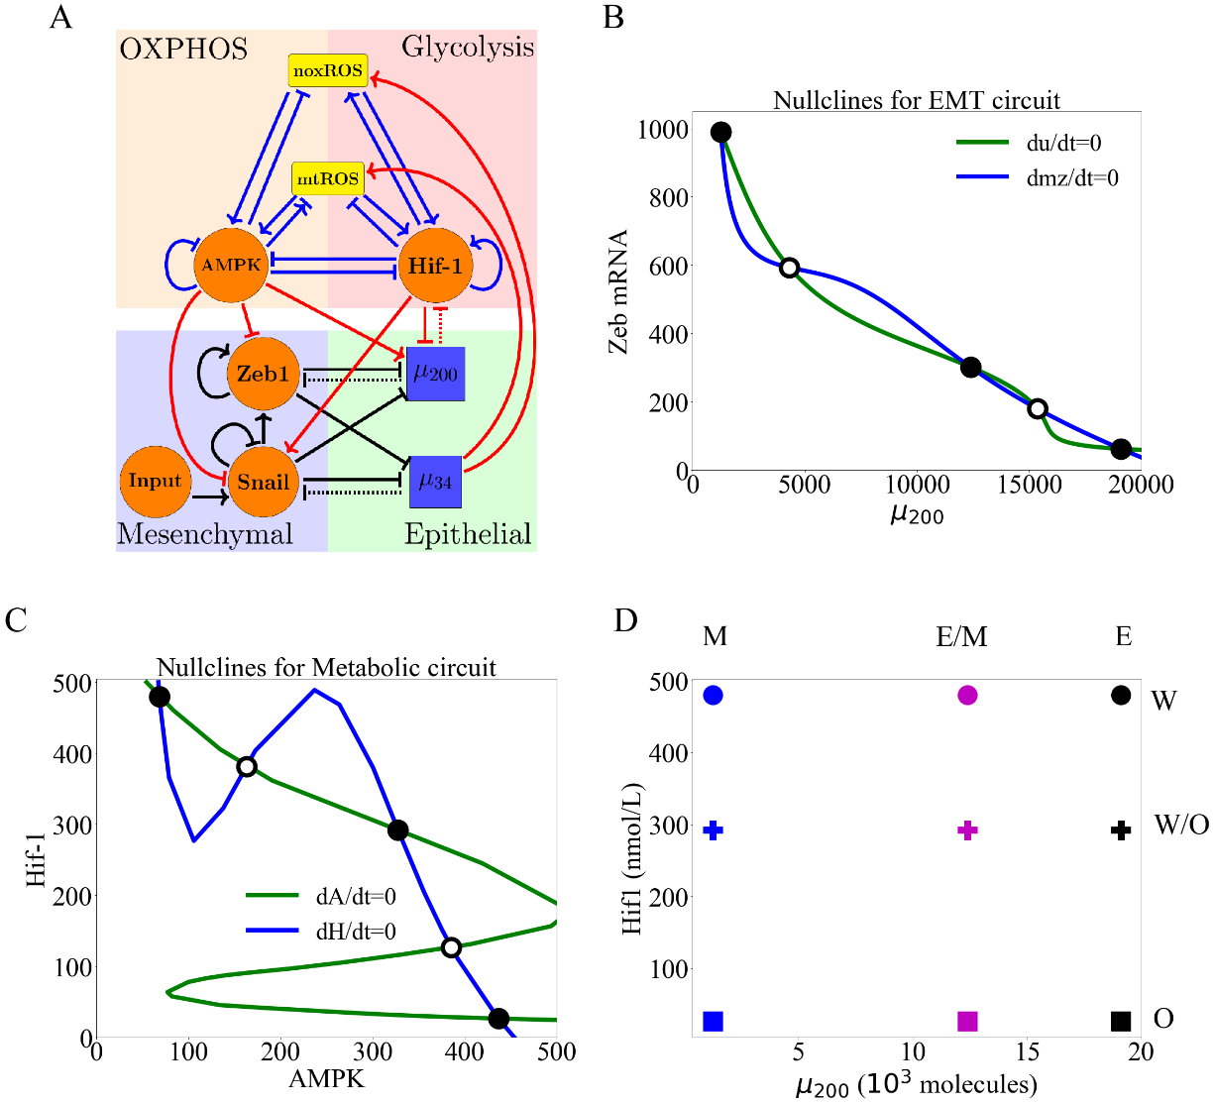

**Figure 1**. **The coupled EMT/MR circuit results in nine possible steady states.** With inactive crosstalk all combinations of the steady states of the core EMT and metabolic networks are accessible. **(A)** The network showing the core EMT module (bottom), the core metabolic module (top), and the crosstalk noted in red. The dashed lines denote miRNA-based regulation. The solid lines denote transcriptional regulation. Regulatory links ending in bars represent inhibition while arrows represent activation. **(B)** The nullclines of the EMT network. The system is tristable with states E (high /low Zeb) , M (low /high ZEB), and E/M (intermediate /ZEB). **(C)** The nullclines of the metabolic network. The system is tristable with stable states O (high AMPK/low HIF-1), W (low AMPK/high HIF-1), and W/O (intermediate AMPK/HIF-1). **(D)** The nine possible states when all crosstalks are inactive. The blue, purple, and black markers represent the M, E/M, and E states. The circle, cross, and square represent the W, W/O, and O states (e.g., the coupled E/M-W/O state is represented as a purple cross).

**Results**

**Individual crosstalk can push the downstream circuit towards a single state:** Let us start by making just one crosstalk active, e.g., caused by an EMT-related microRNA. Now, in our model there is an unaffected upstream subnetwork (EMT, from where the link originates) and a regulated downstream one. (Note that the model ignores any possible dilution of the microRNA due to its action on ROS; see below).

When noxROS is upregulated by (Fig. 2A), as there is no feedback to the EMT network, the occupancy of the E, E/M, and M states are unchanged. As the level of noxROS increases, the W-associated states are lost; first the E-W state, then the E/M-W, and finally the M-W state (Fig. 2B, section S2.4). Additionally, as noxROS increases, the W/O-associated states are stabilized and little change occurs for O-associated states (Fig. 2C). Upon analyzing the coupled states, if noxROS increases then the E/M state becomes more likely to be associated with the W/O state (Fig. 2D). For the W-associated states, we found that the M-W state exists for a larger parameter space compared to other W-associated states(Fig. 2E). This is as expected since the M state has the lowest level, resulting in a smaller increase of noxROS compared with other EMT states (Fig. 2E).

Similar changes have been observed via the upregulation of mtROS (Fig. S7); the E-W and E/M-W states are suppressed first. Consistent with the effect of upregulating noxROS, upregulating mtROS is correlated with an increase of the E/M-W/O state. Additionally, upregulating mtROS exhibited a greater increase in the E/M-W/O state than upregulating noxROS. Further, activation of mtROS stabilizes the W/O state but results in a reduction of the O state and W state. Together, these results suggest mtROS and noxROS may be critical factors in regulating the coupling of two hybrid states (E/M-W/O).

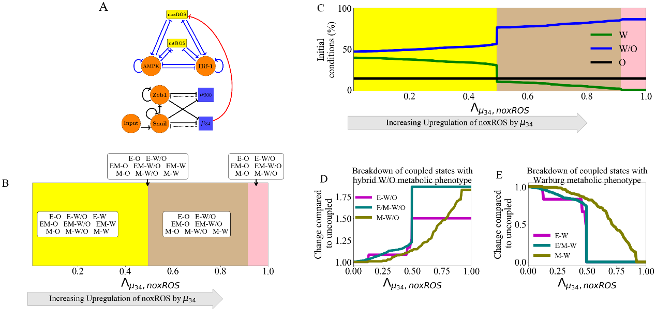

**Figure 2. noxROS upregulated by stabilizes the W/O state and enhances the E/M-W/O coupled state. (A)** A diagram of the core EMT (bottom) and metabolic (top) circuits connected by the crosstalk upregulating noxROS (red link). The EMT network is unchanged, as there is no feedback. **(B)** As upregulates noxROS, 4 distinct phases occur; all nine couple states followed by loss of the E-W, E/M-W, and M-W states (yellow, red, tan, and pink regions, respectively). **(C)** The lines represent the number of initial conditions leading to the W (green) , O (black), or W/O (blue) states as noxROS increases. (Background colors correspond to the phase colors of (B).) **(D)** The frequency of the W/O-associated states (i.e., E-W/O, M-W/O, and E/M-W/O) compared to the inactive system (). All W/O-associated states are promoted, with the E/M-W/O state being greatly increased once . **(E)** Same as (D) but for W-associated states. Once both the E-W and M-W states are fully suppressed (), the E/M-W coupled state continues to be downregulated until it is fully suppressed near .

**Regulation of HIF-1 affects both subcircuits:** While the links only affects the downstream network, the miRNA regulation of HIF-1 by can affect both networks. This arises in our model because mediates both the transcription and translation of HIF-1 mRNA, and as a result, can be recycled or degraded. Therefore, while the downstream metabolic network is modulated, the upstream EMT network is also affected via change of We have defined a function to stimulate the above-mentioned effect of on HIF-1 (details of silencing function in section S2.5). Note that as silencing increases, the first thing which occurs is the restriction of the EMT state; close to the only EMT state allowed is M while all the metabolic phenotypes are allowed. As silences HIF-1, the W/O and W states are suppressed sequentially, and the O state is promoted. Additionally, as suppresses HIF-1, the degradation of caused by binding to HIF-1 RNA is reduced, resulting in a gradual disappearance of the M state. Thus, when HIF-1 mRNA is fully silenced, only the E-O and E/M-O states remain (Fig. S8). Since the E/M state does not reappear until after the metabolic system has fully transitioned to O, the coupled E/M-W/O state is not observed for any value of silencing HIF-1 mRNA. These results suggest overexpression could promote the O-associated states (E-O and E/M-O) and destabilize the coupled E/M-W/O state.

**Inclusion of multiple miRNAs of the EMT network can stabilize the W/O metabolic phenotype**: We next wish to determine how including links emanating from both and can synergistically drive metabolic reprogramming and promote the coupled E/M-W/O state. While upregulation of ROS causes an increase in the E/M-W/O state, we showed that silencing HIF-1 suppresses the E/M-W/O state; therefore, we expect some suppression of the E/M-W/O state when including both and crosstalks. Interestingly, the hybrid E/M-W/O state can be fully suppressed when decreasing HIF-1 and upregulating noxROS, but only partially suppressed when downregulating HIF-1 and upregulating mtROS (Fig. S10). These results suggest the type of ROS present has different effects on the existence of the E/M-W/O state.

The hybrid E/M-W/O state is stabilized if mtROS is upregulated, but upregulating noxROS has minimal effect on the E/M-W/O state. Strikingly, when all miRNA crosstalks are active ( silencing HIF-1, and upregulating noxROS and mtROS, Fig. 3A) the E/M-W/O state can be suppressed even if the W/O state is present (Fig. 3B). Further, the E/M-W/O state is present for all values of noxROS but is only present at increased levels of mtROS (Fig. 3B-C and S11). Additionally, at high levels of mtROS, the E/M state is likely to be associated with the W/O state (Fig. 3C). Further, depending on the initial conditions, the system can access the hybrid E/M-W/O state if HIF-1 is partially silenced and there are high levels of noxROS and mtROS (Fig. 3D). This suggests upregulating mtROS may stabilize the E/M-W/O state. There also seems to be a synergistic effect between the three crosstalks, resulting in an increased parameter space enabling the E/M-W/O state than expected based on the individual crosstalks. Further, the difference in the effect of noxROS and mtROS seems to result from the frustrated regulation of mtROS by HIF-1 and . Therefore, feedback loops between mtROS, HIF-1, , and together control the appearance of the E/M-W/O state.

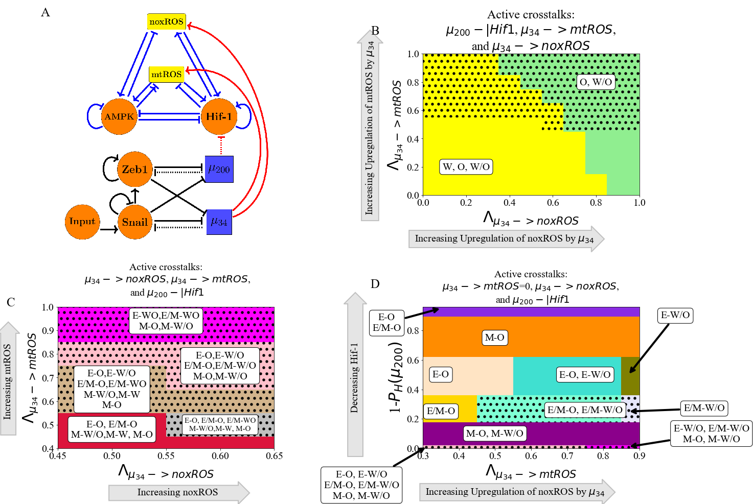

**Figure 3. and can upregulate the W/O phenotype.** When all three miRNA-mediated crosstalks are active, the E/M-W/O state can be upregulated. The E/M-W/O state is accessible when mtROS is high but noxROS seems to have minimal effect. **(A)** Schematic illustration of the coupled metabolic (top) and EMT (bottom) networks with all miRNA-mediated regulatory links active ( upregulating mtROS, upregulating noxROS, and silencing HIF-1). **(B)** The phase plane corresponding to all miRNA-mediated links (pictured in A). In this phase plane, silencing HIF-1 corresponds to the rightmost blue region of Fig. S8 (all metabolic phenotypes are possible), increased noxROS suppresses the W state, and increasing mtROS causes the E/M-W/O coupled state to appear (black dotted region). **(C)** The coupled states of (B), zoomed in on the middle region. The E/M-W/O state exists when mtROS is upregulated. **(D)** At maximum noxROS levels, increased mtROS levels (x-axis), and moderately silenced HIF-1 (y-axis) there are regions where the E/M-W/O state is possible (black dotted regions).

**Metabolic reprogramming can drive EMT:** We next consider information flowing in the opposite direction, from metabolism to EMT. To elucidate the way in which metabolic reprogramming can drive EMT, we determined the effect of each metabolism-driven crosstalk on the coupled states. First, we analyzed the links in which HIF-1 upregulates SNAIL (Fig. 4A and S12) or inhibits (Fig. S13). As expected, both HIF-1 mediated links push the system towards the M state. Further, both the E and E/M states are most associated with the O state (when the HIF-1 level is relatively low) while the M state is initially associated with the W state. This correlation between the E-O and M-W states is assumed in much of the literature [23]. Similarly, modulating the EMT-inducing signals, such as TGF-β, that activate SNAIL can alter the stability of the E/M state and the coupled states (see Fig. S14). Opposite to the HIF1-mediated crosstalks, AMPK-mediated crosstalks (upregulating , downregulating SNAIL, or downregulating ZEB) push the EMT network to adopt an E state and suppress the E/M state, followed by the suppression of the M state (Fig. 4B and S15-17). Additionally, when AMPK regulates the EMT circuit alone, the E and M states are still most associated with the O and W states, however, the E/M state is associated with the W state. This is in direct contrast to HIF-1 driven crosstalk in which the E/M state is coupled with O state. The results suggest neither OXPHOS nor Warburg metabolism is automatically associated with the E/M state and the E/M state has metabolic plasticity.

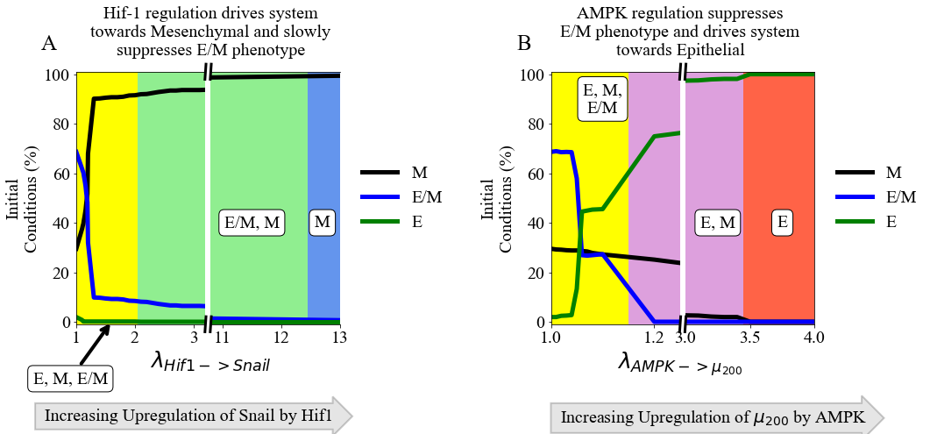

**Figure 4. The role of metabolism in driving EMT.** HIF-1 mediated crosstalks drive the EMT circuit towards the M state, while AMPK mediated crosstalks drive the EMT network towards the E state. **(A)** The frequency of the E/M, M, or E state as HIF-1 upregulates SNAIL and drives the EMT network towards mesenchymal. **(B)** The frequency of the E/M, M, or E state as AMPK upregulates and drives the system towards epithelial. The E/M state exists for larger portions of the parameter spaces for HIF-1 regulation than for AMPK-mediated crosstalks.

**TFs of the metabolic network can stabilize the E/M metabolic phenotype**: Two distinct events are at play when the metabolic network regulates the EMT circuit. AMPK regulation quickly suppresses the E/M state and pushes the system towards the E state, whereas HIF-1 regulation can allow the system to maintain the E/M state for a range of strengths while ultimately pushing the system towards the M state (Fig. 4A and 4B). Thus, HIF-1 and AMPK-mediated crosstalk should act antagonistically to stabilize the hybrid state.

When at least one of the AMPK crosstalks and one of the HIF-1 crosstalks are activated, the E/M state is stabilized. Additionally, if AMPK and HIF-1 target different EMT-TFs, the E/M-W/O state may exist in larger parameter spaces than if they target the same EMT-TF (Fig. S18). This suggests activating multiple crosstalks and targeting multiple TFs is likely to stabilize the E/M-W/O state. Therefore, if all HIF-1 and AMPK-mediated crosstalks are active (Fig. 5A) then significant regions occur in which the E/M state exists (Fig. 5B). However, when analyzing the system for the existence of the E/M-W/O state, it only exists in a small region where is minimally upregulated. Moreover, HIF-1 driven crosstalks are able to maintain the E/M state longer than AMPK driven crosstalks suggesting, the reduction of the E/M-W/O state is likely due to the suppression of the E/M state by AMPK-mediated crosstalks, as mentioned above (see Fig. S15-S17). This suggests HIF-1 driven crosstalk is more strongly correlated with the E/M state than AMPK driven crosstalk.

If all EMT regulating crosstalks are active, then there are regions where the E/M-W/O state exists. Additionally, the E state is typically coupled to the O state (E-O), the M state is associated with the W state (M-W), and when the E/M state is present it is typically associated with the hybrid W/O state (Fig. 5C). In fact, for any system, if only three coupled states are available and each has a distinct phenotype of the EMT and metabolic networks, then the only possible set of states is E-O, M-W, and E/M-W/O. This behavior represents the full coordination of EMT and metabolism and suggests clusters of migrating cells utilize a combination of aerobic glycolysis and OXPHOS. Given tumors are metabolically heterogeneous, this result suggests the topology and parameters of the system may only represent certain microenvironments and is a limitation of our study.

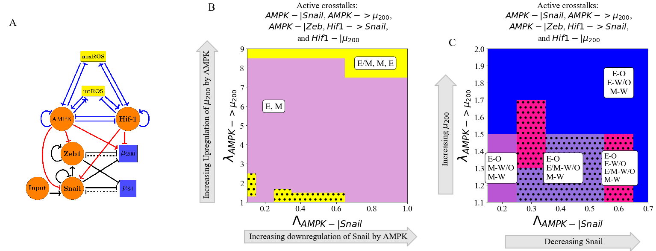

**Figure 5. AMPK and HIF-1 cooperate to upregulate the hybrid E/M state.** When all HIF-1 and AMPK controlled crosstalks are active (HIF1->Snail, HIF1-|, AMPK-|Snail, AMPK-|Zeb, AMPK-> ) the E/M-W/O state can be stabilized. The metabolism-mediated crosstalks work antagonistically to stabilize the E/M state. **(A)** Schematical illustration of the network showing the metabolism-mediated crosstalk. **(B)** The phase plane of potential EMT states when all metabolic driven crosstalks are active. The E/M state is only accessible when λAMPK-> μ200 is near 1 or very high (i.e., at the extremes of regulation). **(C)** The coupled states when the EMT circuit is regulated by the metabolic circuit (pictured in A). The results suggest a direct correlation between the E, E/M, and M states to the O, W/O, and W states, respectively.

**The Hybrid E/M-W/O phenotype:** Recently, it has been suggested that the most aggressive cancer phenotype is characterized by the hybrid E/M and W/O states, enabling a high degree of plasticity and thereby enabling metastatic spread and drug resistance [23]. Therefore, we now focus on how the crosstalk between EMT and metabolism networks affects the E/M-W/O state and the possibility that it could be the only coupled state for certain parameter spaces. From our analysis of activating individual crosstalks, we deduce two competing metabolic driven crosstalk and one competing EMT driven crosstalk would be minimally necessary to enable only the E/M-W/O state.

The hybrid E/M-W/O state can be promote for multiple combinations of crosstalk. For example, the E/M-W/O state can be stabilized when AMPK downregulates SNAIL, HIF-1 downregulates , and upregulates mtROS. The E/M-W/O state exists in much of the space and is increased in prevalence when SNAIL is significantly repressed by AMPK, mtROS is upregulated, and levels have been moderately downregulated (Fig. 7A and S19A). Further, if the regulatory link, HIF-1 downregulating , is replaced by increasing the EMT inducing signal to SNAIL, the E/M-WO state becomes even more prevalent (Fig. 6B and S19B). Interestingly, while the E/M-W/O state was stabilized in both cases (Fig. 6A and B), neither set of crosstalk could enable only the E/M-W/O state. However, it is possible to enable only the E/M-W/O state with just three regulatory links; HIF-1 inhibiting , upregulating mtROS, and modulating the EMT-inducing signal (Fig. 6C and S19C). In fact, no other combination consisting of only three regulatory links seems to enable only the E/M-W/O state. Additionally, this region, which only includes the E/M-W/O state, persists even if all crosstalks are activated (Fig. 6D and S19D).

The proximal phases of the phase enabling only the E/M-W/O state suggests that stabilization of the E/M-W/O state requires mutual activation between metabolic reprogramming and EMT. When the E/M-W/O state is the only available state, the surrounding phases (E-O and E-W/O) are the same whether only three crosstalks (Fig. 6C) or all crosstalks (Fig. 6D) are active, suggesting there may be a sequential path to generate the E/M-W/O state. Further, if the E/M-W/O state is not the only allowed state (Fig. 6A and 6B), the surrounding phases include both E-associated and M-associated states (E-O, E-W/O, M-O, M-W/O, and M-W). Together, the results suggest to reach the E/M-W/O state for epithelial cancer, first metabolic reprogramming should occur (acquiring the E/M-W/O state), followed by partial EMT (E/M-W/O). Additionally, the persistence of the E/M-W/O state when all crosstalks are active suggests there might be other combinations of crosstalks that generate phases where only the E/M-W/O state is possible, although it is outside the scope of this manuscript to find all possible combinations of crosstalk that can enable only the hybrid E/M-W/O coupled state. However, based on these results, we would expect HIF-1 suppressing and upregulating mtROS to be prominent among all such combinations.

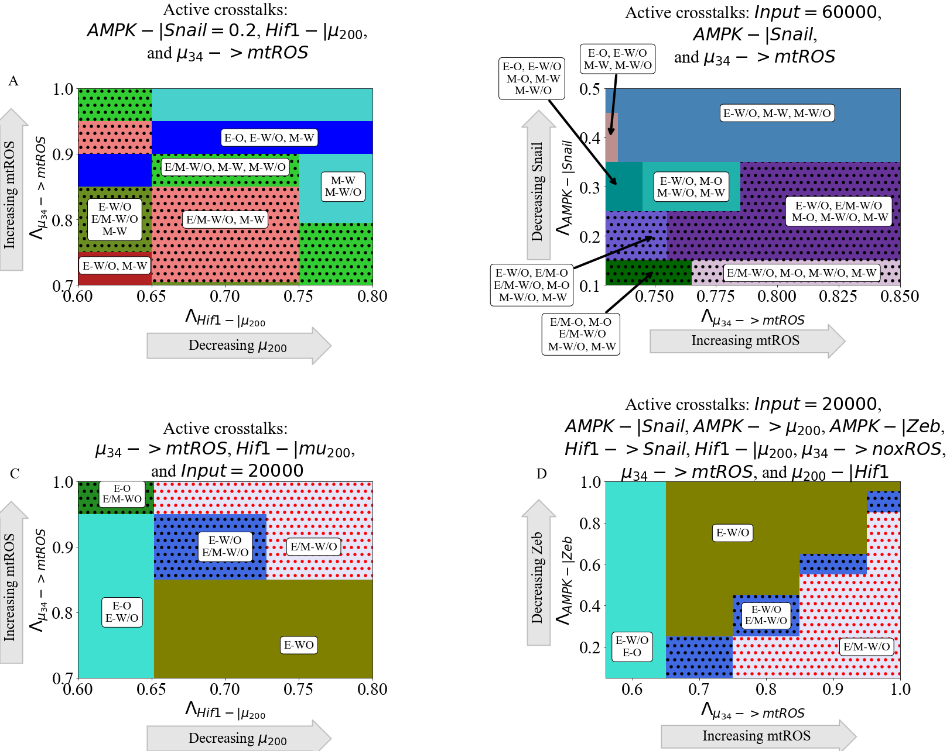

**Figure 6. The coupling of the EMT and metabolic regulatory networks can enable a coupled hybrid E/M-W/O state.** Minimally, three links (one effecting the metabolic network and two controlling the EMT network) are necessary to enable only the E/M-W/O state. **(A)** Phase diagrams of the coupled states when considering three crosstalks; the Input=60000 molecules, AMPK downregulates SNAIL, and upregulates mtROS. The E/M-W/O state is promoted when mtROS levels are increased. **(B)** The phase diagram of the coupled states when considering AMPK inhibiting SNAIL, HIF-1 inhibiting μ200, and upregulating mtROS. The E/M-W/O state is stabilized for some regions. **(C)** When considering the bi-directional regulation between EMT and metabolism by the three minimally necessary regulatory links ( upregulating mtROS, HIF-1 inhibiting , and an EMT-inducing signal on SNAIL) parameter regions exist enabling only the E/M-W/O state. **(D)** When all crosstalks are active there are regions where only the E/M-W/O state exists. Similar sets of phases in (C) and (D) suggest a progression that drives the system towards the E/M-W/O state.

**Hybrid phenotypes are enabled by crosstalk in cells initially without the E/M or W/O state:** We have shown that the E/M and W/O states are often connected, the population in the E/M-W/O state can be expanded depending on the relative strength of various links, and there are parameter sets enabling only the hybrid E/M-W/O. Next, to investigate whether the crosstalk between EMT and metabolism enables cancer plasticity (e.g., by acquiring the hybrid states) we simulate scenarios where the individual EMT and metabolism networks cannot acquire a hybrid state. This scenario corresponds to normal physiological conditions where we expect most cells will be restricted to a binary choice of E versus M and W versus O [49] (see Fig. S20-S22 for the inactive bistable networks). Then we systematically analyze whether any crosstalk can enable the hybrid state to emerge.

As already mentioned, the EMT network can drive metabolic reprogramming via microRNA-mediated links. We first kept the metabolic circuit as a bistable system where only W and O are the available stable states (i.e., no hybrid W/O state with inactive crosstalk) and individually activated microRNA-mediated links. We found the hybrid W/O state emerges when upregulates mtROS (Fig. 7A) but the W/O state does not appear if only noxROS is upregulated or μ200 is downregulated (Fig. S23). Further, upregulating noxROS increases the frequency of the O-associated states, in contrast with the tristable circuit (Fig. S23 compared to Fig. 2). Additionally, the E/M-W/O state is also stabilized as mtROS increases. This suggests, noxROS may play a context-dependent role on the coupled state, while mtROS often stabilizes the E/M-W/O state.

Next to see whether metabolic reprogramming can enable the emergence of the hybrid E/M state, we kept the metabolic circuit tristable and set the EMT network to be bistable (i.e., unable to acquire a hybrid E/M state). When the HIF-1 driven crosstalks are considered individually, we find the E/M-W/O state can be generated when either HIF-1 inhibits (Fig. 7B) or HIF-1 upregulates SNAIL (Fig. S24). Additionally, when HIF-1 inhibits , the E/M-W/O state is quickly suppressed once generated, but the E/M state exists for a larger parameter space (coupled to the O state). Furthermore, both HIF-1 driven crosstalks stabilize the system in the same phase at saturation, and stably maintain the hybrid E/M state. This suggests the master regulator of glycolysis, HIF-1, can drive cells towards the hybrid E/M state. Conversely, an individual AMPK-mediated crosstalk is unable to generate the hybrid E/M state and saturates in the epithelial phase (Fig. S24), similar to the tristable circuit saturation. Additionally, as with the tristable networks, the hybrid E/M-W/O state can be stabilized by two competing crosstalks, such as AMPK upregulating SNAIL and HIF-1 downregulating (Fig. S25). These results suggest HIF-1 can drive the EMT network to the hybrid E/M state while AMPK can only help stabilize the E/M-W/O state if it is already present.

When both networks are in the parameter regime where the hybrid state is not available (i.e., neither the E/M or W/O state), the crosstalk can enable the emergence of these hybrid states. Recall that for the coupled tristable circuits, the simplest set of crosstalk with a parameter region that enabled only the E/M-W/O state consisted of three regulatory links; HIF-1 inhibiting , upregulating mtROS, and EMT-inducing signaling acting on SNAIL. When these same links are active for the bistable EMT and metabolism circuits, the results qualitatively agree with the tristable circuit results (Fig. 7C and S26 compared to Fig. 6C). The E/M state is only possible near full inhibition of and the W/O state is possible when mtROS is greatly upregulated. Further, the system must be near maximum regulation to enable only the hybrid E/M-W/O state. Additionally, the nearby phases surrounding the E/M-W/O state (E-O and E-W/O) are similar to those of the tristable circuit, further supporting a progression that must be followed to reach the E/M-W/O state.

Overall, we showed if the metabolic network is bistable (W or O states) and the EMT network is tristable (E, E/M, or M states), upregulating mtROS can generate the W/O state and upregulate the E/M-W/O state. Conversely, if the EMT network is bistable (E or M) and the metabolic network is tristable (W, O, or W/O), a HIF-1 controlled crosstalk can briefly generate the E/M state and stabilize the E/M-W/O state. If both networks are bistable, the same three links as the tristable case (-> mtROS, HIF1-| and reducing the EMT-inducing signal) generates the E/M-W/O state and suppresses all other coupled states. These results suggest the E/M-W/O state can be promoted by the crosstalk, independent of the initially available states.

We also identified a progression to reach the coupled hybrid E/M-W/O state. starting from an E state (typically associated with an O state) then transitioning from E-O to E-W/O, and finally transitioning to the hybrid E/M-W/O state. In other words, cells may first reprogram their metabolism from O to the hybrid W/O state, followed by the initiation of EMT and a transition to the hybrid E/M state, thus exhibiting the E/M-W/O state.

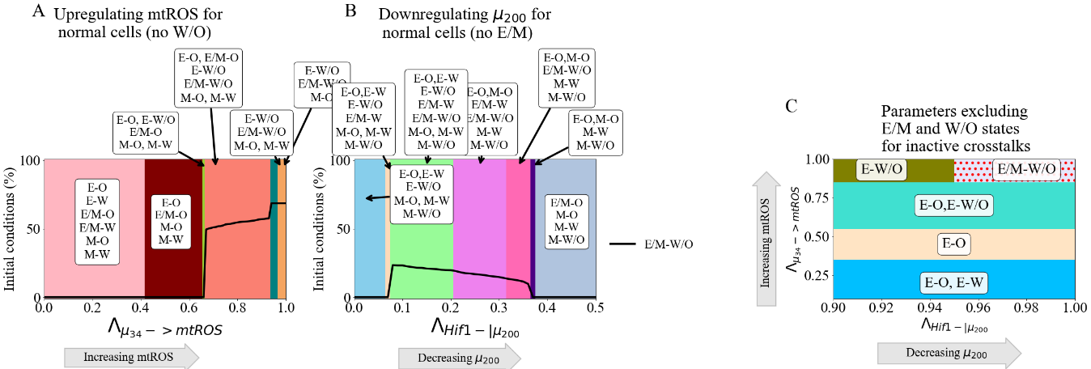

**Figure 7. Crosstalk can generate the hybrid states.** The activation of a single crosstalk (-> mtROS, HIF1 -> SNAIL, or HIF1 -|) can generate the hybrid state of the downstream network (W/O, E/M, or E/M), respectively. **(A)** The phase diagram showing coupled states for the bistable metabolism network (O or W when the crosstalk is inactive ). Once mtROS is increased (near ), there is a sharp change with the hybrid W/O state becoming the most often occupied state. **(B)** The phase diagram of coupled states when the hybrid E/M state is not available initially when the crosstalk is inactive. As mir200 decreases, the E/M state becomes accessible. **(C)** Combining the models from (A) and (B), we generate a network which only has 4 possible coupled states if the crosstalk is inactive (E-O, E-W, M-O, and M-W). At maximum upregulation of mtROS and downregulation of , only the E/M-W/O state is enabled, similar to Fig. 6C.

**GRHL2 and OVOL can stabilize the coupled E/M-W/O state:** Previously, we reported transcription factors, such as OVOL and GRHL2 can stabilize the hybrid E/M state [11,50], referred to as phenotypic stability factors (PSFs) of the hybrid E/M state. We are curious whether these PSFs may also have a role in stabilizing the coupling of the hybrid E/M state with the hybrid W/O state. Since GRHL2 upregulates ROS in a manner similar to [51], GRHL2 may also stabilize the W/O state. Therefore, we extended the original coupled EMT-metabolism network to include these PSFs (Fig. 8A, parameters and modified equations of the PSF stabilized network are in Section S1.6). When the crosstalks are inactive, we find the PSF stabilized network is mainly in the E/M-W/O state with less than 10% occupancy of the E/M-O state (Fig. S27) When a single crosstalk is active in the PSF coupled network, the behavior is as expected. For instance, the hybrid E/M-W/O state exists for the entire parameter space when only one of the following crosstalk is active - AMPK downregulating SNAIL, AMPK upregulating , upregulating mtROS, or upregulating noxROS (see Fig. S28). Additionally, any EMT-mediated upregulation of mtROS or noxROS will have a similar effect by stabilizing the W/O state (and also the E/M-W/O state). The parameter space enabling the phases where the E/M-W/O state exists is also when HIF-1 downregulates or HIF-1 upregulates SNAIL (Fig. S28).

Next, we studied the effect of the PSFs on the E/M-W/O state when multiple crosstalks are active. If two competing crosstalks acting on the EMT circuit are active (e.g., one HIF-1 and one AMPK driven regulation active), then the E/M-W/O state is available for most of the parameter space (Fig. 8B). Further, the E/M-W/O state is stabilized by activating the three crosstalks that were shown in the tristable and bistable networks to enable only the E/M-W/O state (i.e., upregulating mtROS, HIF-1 downregulating , and including the EMT-inducing signaling acting on Snail). Once again, there is a phase where only the E/M-W/O state exists (Fig. 8C). Additionally, this phase exists in a far larger region in the presence of the PSFs (Fig. 8C and S29) relative to the absence of the PSFs (the light red region at the top right corner of Fig. 8D is the location of the E/M-W/O when no PSFs are present). The large red region on the right side of Fig. 8D is the additional parameter space where the E/M-W/O state is stabilized when the PSFs are coupled with the network. Further, the coupled states in the phases surrounding the region of the E/M-W/O state are the same as those in the bistable networks (E-W/O and E-O), and also appear in the analysis of the tristable network. These results confirm the PSFs can stabilize both the E/M state and the E/M-W/O state.

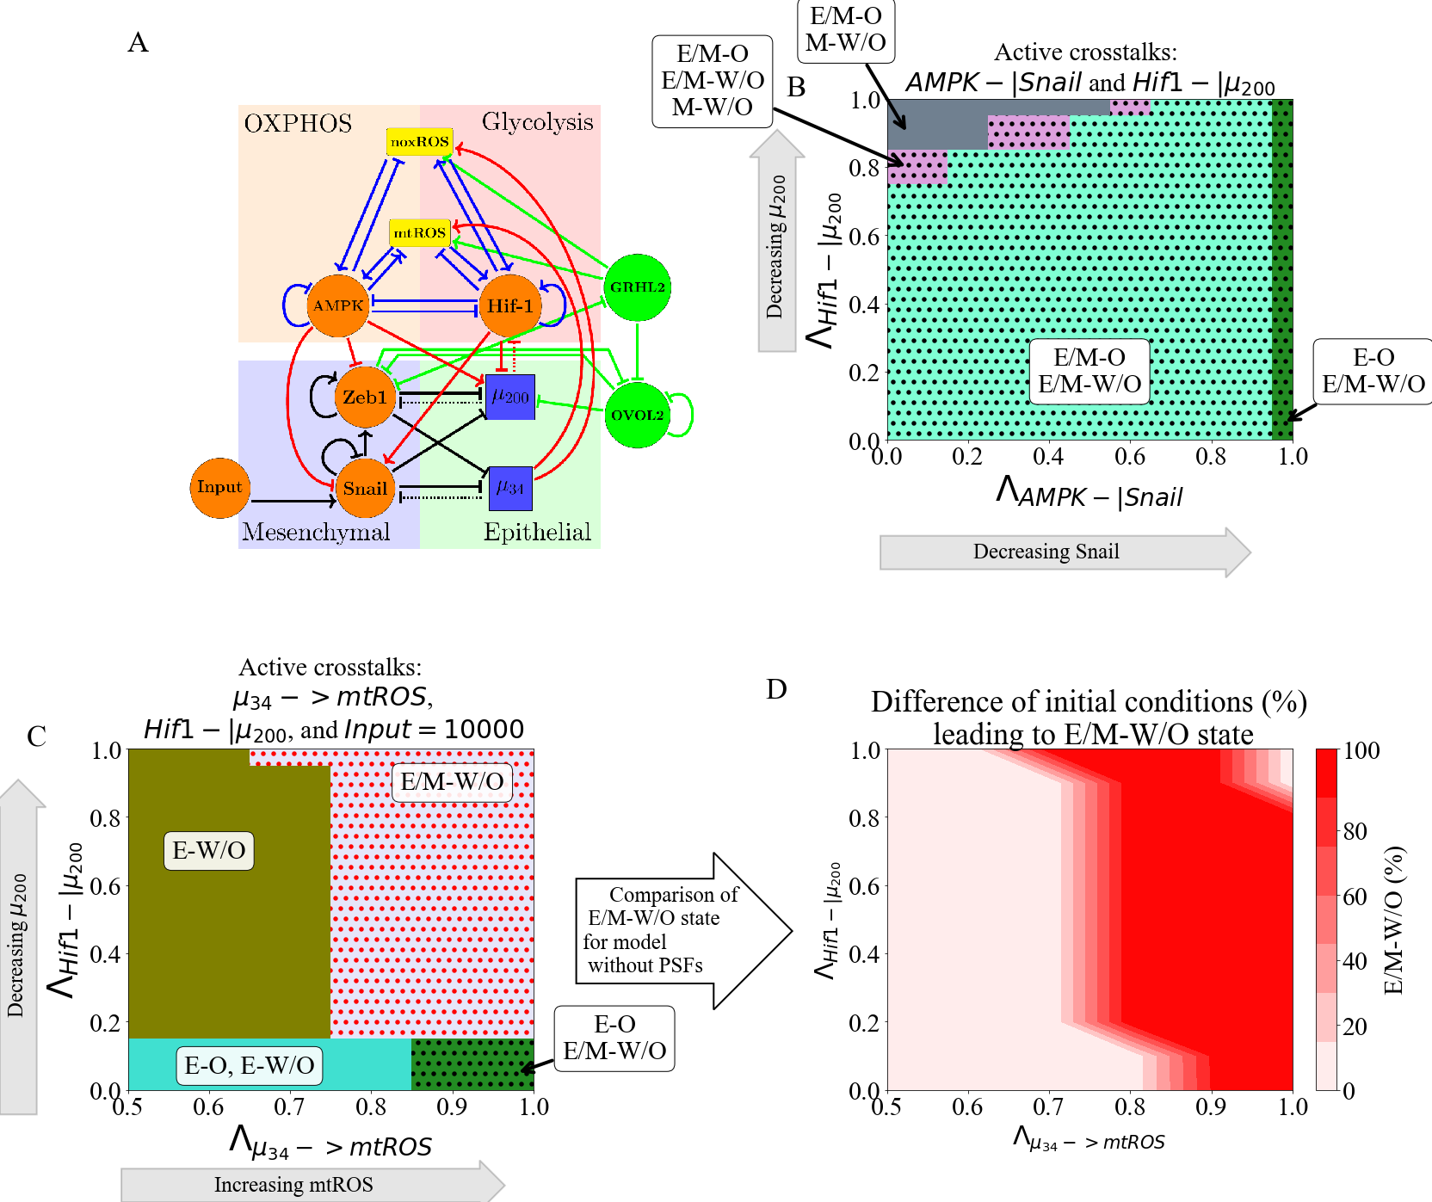

**Figure 8. PSFs stabilizing the E/M state can stabilize the association of the E/M state with the W/O state. (A)** The coupled EMT-metabolism network including PSFs GRHL2 and OVOL2. **(B)** The phase diagram of the coupled states shows the E/M-W/O state is present in a larger parameter space due to the PSFs stabilizing the E/M state. **(C)** The phase diagram of the coupling states when the three links (-> mtROS, HIF1-|, and reducing the EMT-inducing signal) are active. The parameter regime of the phase enabling only the E/M-W/O state is significantly enlarged compared to the coupled network without PSFs. **(D)** The difference in the frequency of the E/M-W/O state between (C, PSFs present) and the original model (Fig. S29B, PSFs not present). The dark red region shows the phases where only the PSF stabilized model can enable the E/M-W/O state. The light red in the top right corner is the region where only the E/M-W/O state enabled, irrespective of the presence of PSFs.

**Discussion**

Cancer malignancy relies on the orchestration of multiple hallmarks driven by different functional modules, such as metabolism and stemness [1]. It has become increasingly clear that different hallmarks of cancer are not independent and indeed are extensively coupled. In this work, we focused on how reprogrammed cancer metabolism is coordinated with cancer metastasis. As EMT is often employed by cancer as part of the metastasic process, we analyzed the mutual regulation between metabolism and EMT, through coupling their corresponding gene regulatory circuits. We systematically analyzed the effect of both individual and multiple crosstalks on each of the nine coupled states. The stability of the coupled states was found to vary depending on which crosstalk was active, and multiple crosstalks could exhibit synergistic or antagonistic effects. Therefore, we decided to focus primarily on the E/M-W/O state, as we expect these cells to be the most metastatically capable. We found that (1) the E/M-W/O state can be stabilized by a single crosstalk mediated by miR-34 or two antagonistic crosstalks regulating the EMT network; (2) the similarities between the effects of different crosstalk (e.g., HIF1 suppressing μ200 compared to HIF-1 upregulating SNAIL) suggest a degree of consistency in how EMT drives metabolic reprogramming, and vice versa; (3) if crosstalk is bidirectional, it is possible to enable only the E/M-W/O state and this stabilization can be facilitated even under conditions when the individual core circuits do not generate hybrid states; (4) the PSFs (OVOL, GRHL2) that have been shown to stabilize the hybrid E/M state also stabilize the coupled E/M-W/O state; (5) to enable only the hybrid E/M-W/O, our results indicate a progression of coupled states must be followed. Together, the results highlight the vital role of the EMT-metabolism crosstalk in mediating cancer metastasis.

The results of our model suggest metabolic reprogramming can drive EMT, but metabolic reprogramming does not have to be complete before EMT begins; this feature allows stabilizing of the most aggressive E/M-W/O state. Further, we identified a scenario wherein the system can follow a progression from the E-O state, undergoing metabolic reprogramming while maintaining epithelial characteristics (E-W/O coupled state), then beginning EMT and finally stabilizing in the E/M-W/O state. Strikingly, the prevalence of the E/M-W/O state is increased by EMT-metabolism crosstalk regardless of initial phenotypic availability (i.e., whether the initial system is significantly E/M-W/O or only E-O, E-W, M-O, and M-W). Therefore, our current model provides a possible explanation for the mutual activation of metabolic reprogramming and EMT, depending on the initiating signal.

Our findings indicate that all else being equal, undergoing EMT tends to correlate with using additional glycolysis, in qualitative agreement with a recent pan-cancer study based on NCBI GEO microarray datasets and other studies [23,52]. We find that HIF-1 (a marker of glycolysis) is strongly associated with EMT, suggesting the E/M state can be stabilized if HIF-1 (glycolysis) is upregulated. Additionally, our model predicts the coupling of the hybrid E/M state and high glycolysis/high OXPHOS (W/O). Notably, in its current form, our model is unable to explain the cases wherein low glycolysis metabolism is correlated with EMT. However, extending the model to explicitly include coupling with additional metabolic pathways[53] may be able to explain the low glycolysis states of the pan-cancer study [52].

The coupling of the E/M and W/O states is somewhat surprising given the widespread impression that primary tumors often exhibit the Warburg effect, possibly because of their need to limit the amount of ATP produced in favor of maximizing biomass production and growth (see [54] and references therein). However, this finding is consistent with the general idea that moving from E to E/M is connected with increasing stemness, and stem-like capabilities often rely on glycolysis. It is also consistent with HIF-1 activation diminishing OXPHOS while driving EMT. Note that this tendency might be over-ridden for cells that require sufficient energy production to enable motility, such as leader cells. One possibility is that the basic Warburg effect corresponds to the transition between E-O to E-W/O when cells first become malignant and then as the cells undergo EMT they tend to switch to more and more W until reaching a mesenchymal-like E/M state with mostly W. Then as cells become even more mesenchymal and fully differentiated, they revert back to using mostly OXPHOS. The connection between EMT and metabolism may also depend on external signals other than EMT-inducing signals that act on SNAIL, such as the level of oxygen in the TME. For example, mesenchymal cells that reduce proliferation and have to traverse the ECM should switch to more OXPHOS, whereas ones that become quiescent in a hypoxic metastatic niche should favor glycolysis. Resolution of this issue must await a more precise idea of the phrase ‘all else being equal”.

The importance of the //HIF-1/ROS/SNAIL axis for the regulation of the E/M-W/O state arises from our analysis. Our results suggest mtROS is critical for the metabolic activation of EMT. In agreement with our results, recent experimental work has posited that mtROS can drive EMT [55], control cancer invasiveness [56], and has a much stronger role than noxROS [36,55]. Another important regulator of both metabolism and EMT is HIF-1. It is generally accepted that HIF-1 is a master regulator of glycolysis [18] and EMT [7]. Our results suggest the mtROS/HIF-1 axis is critical to stabilizing the highly aggressive E/M-W/O state. The connection between the mtROS/HIF-1 axis (via the accumulation of mtROS enhancing HIF-1 stability) and hypoxia-induced cancer aggressiveness has also been indicated [57]. Additionally, both mtROS and HIF-1 are controlled by the miRNAs of the EMT network, and , confirming the importance of miRNAs in mediating the coupling of EMT and metabolism [58]. While we have tried to ensure our parameters are within biologically relevant ranges (utilizing values from literature whenever available), one limitation of this study is knowing how these results translate to experimental cancer studies. Thus, the significance of the mtROS/HIF-1 feedback loop should be experimentally tested by e.g., modulating ROS level via antioxidant factors such as NRF2, or modulating hypoxia to perturb HIF-1.

In line with the above, this work is merely a first step, and it is quite likely that incorporating additional pathways especially those that regulate cell motility, may be necessary to improve our understanding of EMT-metabolism coupling. Previous work has shown that cancer cells can transition from collective migration of E/M cells to individual migration of amoeboid cells, via the regulation of the RHO-ROCK signaling network [7,59]. Inclusion of the RHO-ROCK signaling could provide a detailed understanding of how metabolism is coupled to different modes of cancer cell migration. Overall, the importance of external signaling in our model is in conceptual agreement with a hypothesis by Sciacovelli and Frezza that, in an adverse tumor microenvironment, metabolic reprogramming drives EMT to allow cells to find more favorable metabolic niches [27].

The overall goal of this project is toward understanding all the interrelated aspects of cancer metastasis. Previous studies coupling EMT, stemness, and Notch signaling have shown that therapy resistance and increased metastatic potential are associated with stem-like hybrid E/M cells [60–62]. Furthermore, these couplings also resulted in unexpected behaviors such as the co-localization of hybrid E/M cells [60] and a tunable stemness window [61]. Studying individual gene regulatory network modules, even in the presence of signals, is unable to give a thorough understanding of the network properties. Therefore, to understand how various cancer traits are correlated, and potentially identify key regulators, multiple network modules and their crosstalk should be studied concurrently.

**Acknowledgements**

This work was supported by National Science Foundation by sponsoring the Center for Theoretical Biological Physics – award PHY-2019745 (JNO, HL) and by awards PHY-1605817 (HL), CHE-1614101 (JNO), and PHY-1522550 (JNO, MG). JNO is a CPRIT Scholar in Cancer Research. MG was also supported by the NSF GRFP no. 1842494.

**References**

1. Hanahan D. Hallmarks of Cancer: New Dimensions. Cancer Discov. 2022;12(1):31–46.

2. Hay ED. The mesenchymal cell, its role in the embryo, and the remarkable signaling mechanisms that create it. Dev Dynam. 2005;233(3):706–20.

3. Pietilä M, Ivaska J, Mani SA. Whom to blame for metastasis, the epithelial–mesenchymal transition or the tumor microenvironment? Cancer Lett. 2016;380(1):359–68.

4. Cho ES, Kang HE, Kim NH, Yook JI. Therapeutic implications of cancer epithelial-mesenchymal transition (EMT). Arch Pharm Res. 2019;42(1):14–24.

5. Lu M, Jolly MK, Levine H, Onuchic JN, Ben-Jacob E. MicroRNA-based regulation of epithelial–hybrid–mesenchymal fate determination. Proc National Acad Sci. 2013;110(45):18144–9.

6. Saitoh M. Involvement of partial EMT in cancer progression. J Biochem. 2018;164(4):257–64.

7. Saxena K, Jolly MK, Balamurugan K. Hypoxia, partial EMT and collective migration: Emerging culprits in metastasis. Transl Oncol. 2020;13(11):100845.

8. Bakir B, Chiarella AM, Pitarresi JR, Rustgi AK. EMT, MET, Plasticity, and Tumor Metastasis. Trends Cell Biol. 2020;30(10):764–76.

9. Fustaino V, Presutti D, Colombo T, Cardinali B, Papoff G, Brandi R, et al. Characterization of epithelial-mesenchymal transition intermediate/hybrid phenotypes associated to resistance to EGFR inhibitors in non-small cell lung cancer cell lines. Oncotarget. 2017;8(61):103340–63.

10. George JT, Jolly MK, Xu J, Somarelli J, Levine H. Survival outcomes in cancer patients predicted by a partial EMT gene expression scoring metric. Cancer Res. 2017;77(22):canres.3521.2016.

11. Jolly MK, Tripathi SC, Jia D, Mooney SM, Celiktas M, Hanash SM, et al. Stability of the hybrid epithelial/mesenchymal phenotype. Oncotarget. 2016;7(19):27067–84.

12. Pastushenko I, Brisebarre A, Sifrim A, Fioramonti M, Revenco T, Boumahdi S, et al. Identification of the tumour transition states occurring during EMT. Nature. 2018;556(7702):463–8.

13. Simeonov KP, Byrns CN, Clark ML, Norgard RJ, Martin B, Stanger BZ, et al. Single-cell lineage tracing of metastatic cancer reveals selection of hybrid EMT states. Cancer Cell. 2021;39(8):1150-1162.e9.

14. Dey P, Kimmelman AC, DePinho RA. Metabolic Codependencies in the Tumor Microenvironment. Cancer Discov. 2021;candisc.1211.2020.

15. Warburg O, Wind F, Negelein E. THE METABOLISM OF TUMORS IN THE BODY. J Gen Physiol. 1927;8(6):519–30.

16. Liberti MV, Locasale JW. The Warburg Effect: How Does it Benefit Cancer Cells? Trends Biochem Sci. 2016;41(3):211–8.

17. Ohshima K, Morii E. Metabolic Reprogramming of Cancer Cells during Tumor Progression and Metastasis. Metabolites. 2021;11(1):28.

18. Nagao A, Kobayashi M, Koyasu S, Chow CCT, Harada H. HIF-1-Dependent Reprogramming of Glucose Metabolic Pathway of Cancer Cells and Its Therapeutic Significance. Int J Mol Sci. 2019;20(2):238.

19. Cheng Y, Lu Y, Zhang D, Lian S, Liang H, Ye Y, et al. Metastatic cancer cells compensate for low energy supplies in hostile microenvironments with bioenergetic adaptation and metabolic reprogramming. Int J Oncol. 2018;53(6):2590–604.

20. Porporato PE, Payen VL, Pérez-Escuredo J, De Saedeleer CJ, Danhier P, Copetti T, et al. A Mitochondrial Switch Promotes Tumor Metastasis. Cell Reports. 2014;8(3):754–66.

21. Jia D, Park JH, Jung KH, Levine H, Kaipparettu BA. Elucidating the Metabolic Plasticity of Cancer: Mitochondrial Reprogramming and Hybrid Metabolic States. Cells. 2018;7(3):21.

22. Dupuy F, Tabariès S, Andrzejewski S, Dong Z, Blagih J, Annis MG, et al. PDK1-Dependent Metabolic Reprogramming Dictates Metastatic Potential in Breast Cancer. Cell Metab. 2015;22(4):577–89.

23. Jia D, Park JH, Kaur H, Jung KH, Yang S, Tripathi S, et al. Towards decoding the coupled decision-making of metabolism and epithelial-to-mesenchymal transition in cancer. Brit J Cancer. 2021;1–10.

24. Sung JY, Cheong JH. Pan-Cancer Analysis Reveals Distinct Metabolic Reprogramming in Different Epithelial–Mesenchymal Transition Activity States. Cancers. 2021;13(8):1778.

25. Choudhary KS, Rohatgi N, Halldorsson S, Briem E, Gudjonsson T, Gudmundsson S, et al. EGFR Signal-Network Reconstruction Demonstrates Metabolic Crosstalk in EMT. Plos Comput Biol. 2016;12(6):e1004924.

26. Feng S, Zhang L, Liu X, Li G, Zhang B, Wang Z, et al. Low levels of AMPK promote epithelial‐mesenchymal transition in lung cancer primarily through HDAC4‐ and HDAC5‐mediated metabolic reprogramming. J Cell Mol Med. 2020;24(14):7789–801.

27. Sciacovelli M, Frezza C. Metabolic reprogramming and epithelial‐to‐mesenchymal transition in cancer. Febs J. 2017;284(19):3132–44.

28. Huang R, Zong X. Aberrant cancer metabolism in epithelial–mesenchymal transition and cancer metastasis: Mechanisms in cancer progression. Crit Rev Oncol Hemat. 2017;115:13–22.

29. Kang X, Wang J, Li C. Exposing the Underlying Relationship of Cancer Metastasis to Metabolism and Epithelial-Mesenchymal Transitions. Iscience. 2019;21:754–72.

30. LeBleu VS, O’Connell JT, Herrera KNG, Wikman H, Pantel K, Haigis MC, et al. PGC-1α mediates mitochondrial biogenesis and oxidative phosphorylation in cancer cells to promote metastasis. Nat Cell Biol. 2014;16(10):992–1003.

31. Bocci F, Tripathi SC, Mercedes SAV, George JT, Casabar JP, Wong PK, et al. NRF2 activates a partial epithelial-mesenchymal transition and is maximally present in a hybrid epithelial/mesenchymal phenotype. Integr Biol. 2019;11(6):251–63.

32. Luo M, Shang L, Brooks MD, Jiagge E, Zhu Y, Buschhaus JM, et al. Targeting Breast Cancer Stem Cell State Equilibrium through Modulation of Redox Signaling. Cell Metab. 2018;28(1):69-86.e6.

33. Colacino JA, Azizi E, Brooks MD, Harouaka R, Fouladdel S, McDermott SP, et al. Heterogeneity of Human Breast Stem and Progenitor Cells as Revealed by Transcriptional Profiling. Stem Cell Rep. 2018;10(5):1596–609.

34. Yu L, Lu M, Jia D, Ma J, Ben-Jacob E, Levine H, et al. Modeling the Genetic Regulation of Cancer Metabolism: Interplay between Glycolysis and Oxidative Phosphorylation. Cancer Res. 2017;77(7):1564–74.

35. Lu M, Jolly MK, Gomoto R, Huang B, Onuchic J, Ben-Jacob E. Tristability in Cancer-Associated MicroRNA-TF Chimera Toggle Switch. J Phys Chem B. 2013;117(42):13164–74.

36. Kovac S, Angelova PR, Holmström KM, Zhang Y, Dinkova-Kostova AT, Abramov AY. Nrf2 regulates ROS production by mitochondria and NADPH oxidase. Biochimica Et Biophysica Acta Bba - Gen Subj. 2015;1850(4):794–801.

37. Bai XY, Ma Y, Ding R, Fu B, Shi S, Chen XM. miR-335 and miR-34a Promote Renal Senescence by Suppressing Mitochondrial Antioxidative Enzymes. J Am Soc Nephrol. 2011;22(7):1252–61.

38. Navarro F, Lieberman J. miR-34 and p53: New Insights into a Complex Functional Relationship. Plos One. 2015;10(7):e0132767.

39. Serocki M, Bartoszewska S, Janaszak-Jasiecka A, Ochocka RJ, Collawn JF, Bartoszewski R. miRNAs regulate the HIF switch during hypoxia: a novel therapeutic target. Angiogenesis. 2018;21(2):183–202.

40. Shang Y, Chen H, Ye J, Wei X, Liu S, Wang R. HIF-1α/Ascl2/miR-200b regulatory feedback circuit modulated the epithelial-mesenchymal transition (EMT) in colorectal cancer cells. Exp Cell Res. 2017;360(2):243–56.

41. Byun Y, Choi YC, Jeong Y, Lee G, Yoon S, Jeong Y, et al. MiR-200c downregulates HIF-1α and inhibits migration of lung cancer cells. Cell Mol Biol Lett. 2019;24(1):28.

42. Bartoszewska S, Rochan K, Piotrowski A, Kamysz W, Ochocka RJ, Collawn JF, et al. The hypoxia‐inducible miR‐429 regulates hypoxia‐inducible factor‐1α expression in human endothelial cells through a negative feedback loop. Faseb J. 2015;29(4):1467–79.

43. Xu X, Tan X, Tampe B, Sanchez E, Zeisberg M, Zeisberg EM. Snail Is a Direct Target of Hypoxia-inducible Factor 1α (HIF1α) in Hypoxia-induced Endothelial to Mesenchymal Transition of Human Coronary Endothelial Cells*. J Biol Chem. 2015;290(27):16653–64.

44. Chou CC, Lee KH, Lai IL, Wang D, Mo X, Kulp SK, et al. AMPK Reverses the Mesenchymal Phenotype of Cancer Cells by Targeting the Akt–MDM2–Foxo3a Signaling Axis. Cancer Res. 2014;74(17):4783–95.

45. Dong T, Zhang Y, Chen Y, Liu P, An T, Zhang J, et al. FOXO1 inhibits the invasion and metastasis of hepatocellular carcinoma by reversing ZEB2-induced epithelial-mesenchymal transition. Oncotarget. 2016;8(1):1703–13.

46. Huang W, Cao J, Liu X, Meng F, Li M, Chen B, et al. AMPK Plays a Dual Role in Regulation of CREB/BDNF Pathway in Mouse Primary Hippocampal Cells. J Mol Neurosci. 2015;56(4):782–8.

47. Janin M, Esteller M. Oncometabolite Accumulation and Epithelial-to-Mesenchymal Transition: The Turn of Fumarate. Cell Metab. 2016;24(4):529–30.

48. Thomson DM, Herway ST, Fillmore N, Kim H, Brown JD, Barrow JR, et al. AMP-activated protein kinase phosphorylates transcription factors of the CREB family. J Appl Physiol. 2008;104(2):429–38.

49. Tripathi S, Kessler DA, Levine H. Biological Networks Regulating Cell Fate Choice Are Minimally Frustrated. Phys Rev Lett. 2020;125(8):088101.

50. Jia D, Li X, Bocci F, Tripathi S, Deng Y, Jolly MK, et al. Quantifying Cancer Epithelial-Mesenchymal Plasticity and its Association with Stemness and Immune Response. J Clin Medicine. 2019;8(5):725.

51. Farris JC, Pifer PM, Zheng L, Gottlieb E, Denvir J, Frisch SM. Grainyhead-like 2 Reverses the Metabolic Changes Induced by the Oncogenic Epithelial–Mesenchymal Transition: Effects on Anoikis. Mol Cancer Res. 2016;14(6):528–38.

52. Muralidharan S, Sahoo S, Saha A, Chandran S, Majumdar SS, Mandal S, et al. Quantifying the Patterns of Metabolic Plasticity and Heterogeneity along the Epithelial–Hybrid–Mesenchymal Spectrum in Cancer. Biomol. 2022;12(2):297.

53. Jia D, Lu M, Jung KH, Park JH, Yu L, Onuchic JN, et al. Elucidating cancer metabolic plasticity by coupling gene regulation with metabolic pathways. Proc National Acad Sci. 2019;116(9):201816391.

54. Tripathi S, Park JH, Pudakalakatti S, Bhattacharya PK, Kaipparettu BA, Levine H. A mechanistic modeling framework reveals the key principles underlying tumor metabolism. Plos Comput Biol. 2022;18(2):e1009841.

55. Radisky DC, Levy DD, Littlepage LE, Liu H, Nelson CM, Fata JE, et al. Rac1b and reactive oxygen species mediate MMP-3-induced EMT and genomic instability. Nature. 2005;436(7047):123–7.

56. Ishikawa K, Takenaga K, Akimoto M, Koshikawa N, Yamaguchi A, Imanishi H, et al. ROS-Generating Mitochondrial DNA Mutations Can Regulate Tumor Cell Metastasis. Science. 2008;320(5876):661–4.

57. SHIDA M, KITAJIMA Y, NAKAMURA J, YANAGIHARA K, BABA K, WAKIYAMA K, et al. Impaired mitophagy activates mtROS/HIF-1α interplay and increases cancer aggressiveness in gastric cancer cells under hypoxia. Int J Oncol. 2016;48(4):1379–90.

58. Babaei G, Raei N, milani AT, Aziz SGG, Pourjabbar N, Geravand F. The emerging role of miR-200 family in metastasis: focus on EMT, CSCs, angiogenesis, and anoikis. Mol Biol Rep. 2021;48(10):6935–47.

59. Graziani V, Rodriguez-Hernandez I, Maiques O, Sanz-Moreno V. The amoeboid state as part of the epithelial-to-mesenchymal transition programme. Trends Cell Biol. 2021;32(3):228–42.

60. Bocci F, Gearhart-Serna L, Boareto M, Ribeiro M, Ben-Jacob E, Devi GR, et al. Toward understanding cancer stem cell heterogeneity in the tumor microenvironment. Proc National Acad Sci. 2018;116(1):201815345.

61. Jolly MK, Jia D, Boareto M, Mani SA, Pienta KJ, Ben-Jacob E, et al. Coupling the modules of EMT and stemness: A tunable ‘stemness window’ model. Oncotarget. 2015;6(28):25161–74.

62. Bocci F, Jolly MK, George JT, Levine H, Onuchic JN. A mechanism-based computational model to capture the interconnections among epithelial-mesenchymal transition, cancer stem cells and Notch-Jagged signaling. Oncotarget. 2018;9(52):29906–20.