**Decoding the coupling decision-making of epithelial-mesenchymal transition and metabolic reprogramming in cancer**

Madeline Galbraith1, Herbert Levine2*, José Onuchic1*, and Dongya Jia3*

Correspondence should be addressed to the following authors:

*Herbert Levine: h.levine@northeastern.edu

*José Onuchic: jonuchic@rice.edu

*Dongya Jia:

1Center for Theoretical Biological Physics, Rice University, Houston, TX, USA

2Center for Theoretical Biological Physics, Department of Physics, and Department of Bioengineering, Northeastern University, Boston, MA, USA

3Immunodynamics Group, Laboratory of Integrative Cancer Immunology, Center for Cancer Research, National Cancer Institute, Bethesda, MD, USA

**Abstract**

Cancer metastasis is an orchestration of multiple traits driven by different functional modules such as metabolism and epithelial-mesenchymal transition (EMT). Cancer cells can adjust their metabolism during metastasis, but the underlying mechanisms remain unclear. When leaving the primary tumor and entering blood circulation, cancer cells can increase their oxidative phosphorylation (OXPHOS) without compromising glycolysis, thus acquiring a hybrid metabolic phenotype (W/O) with a high metastatic potential. In many cases, EMT serves as the primary instigator of metastasis. Cancer cells undergoing EMT can acquire a hybrid epithelial/mesenchymal (E/M) phenotype, combining epithelial and mesenchymal features. To decipher how metabolism drives metastasis and vice versa, we couple the decision-making networks of metabolism and EMT to elucidate how crosstalk effects the stability of the E/M-W/O state. We show crosstalk can give rise to the E/M-W/O state, irrespective of individual E/M or W/O availability. Additionally, to acquire an E/M-W/O state, the W/O state emerges first and is followed by the E/M state, suggesting metabolism may be a primary driver of EMT. In summary, our work emphasizes the mutual activation of the metabolism module and EMT module, and serves as an initiative towards understanding the entirety of cancer metastasis.

**Introduction**

Metastasis remains the leading cause of cancer-related deaths [1] and it is critical to understand the physiological properties of cells that migrate from the primary tumor and initiate metastatic lesions. Typically, these properties have been studied one at a time. For example, cell motility is assumed to be related to the epithelial-mesenchymal transition (EMT). During EMT, the cells progressively lose epithelial (E) features such as cell-cell adhesion and apical-basal polarity, and acquire mesenchymal (M) features such as migration, invasion, and resistance to immune response [2,3]. The EMT has consistently been implicated in cells acquiring metastatic potential [4,5], and plays a role in therapeutic resistance [6]. Recently, the bimodal picture of EMT has been superseded by a more complex scenario involving the hybrid epithelial/mesenchymal (E/M) phenotype which exhibits combined traits of epithelial (cell-cell adhesion) and mesenchymal (invasion) at the single-cell level. The hybrid E/M cells migrate collectively as a cluster and may account for the majority of metastases [7–10]. The existence of a hybrid E/M state has since been experimentally verified both in vitro (in many cancer cell lines) and in vivo (e.g. using a genetic mouse model of squamous cell carcinoma) and has been shown to be associated with therapy resistance alongside with poor survival rates [11–14]. Most importantly, these states appear to the most capable of initiating metastatic growth [15,16]. Fully understanding the behavior of the hybrid E/M phenotype is still an active area of research.

Metabolic reprogramming, another hallmark of cancer, enables cancer cells to adjust their metabolic activity for biomass and energy supply to survive in hostile environments [1,17]. Normal cells typically utilize oxidative phosphorylation (OXPHOS, O) under normoxic conditions and glycolysis when there is a lack of oxygen. However, cancer cells often prefer glycolysis even when oxygen is available, referred to as the Warburg effect (W) or aerobic glycolysis [18,19]. During metastasis, cancer cells must be able to adjust their metabolic phenotype to survive in varying environments, resulting in these cells switching between different types of metabolism [20–23]. Metabolic reprogramming, specifically in the context of switching between the O state and W state, can enable cancer cells to combine different metabolic modes, leading to the acquisition of a hybrid W/O phenotype and metabolic low-low phenotype (L/L). The W/O cells, often associated with enhanced metabolic potentials, actively use both glycolysis and OXPHOS [24,25]. The L/L cells are metabolically inactive, exhibiting both low glycolysis and low OXPHOS, and are associated with therapy resistance in melanoma [26]. The highly metastatic murine breast cancer 4T1 cells exhibit both higher glycolytic and OXPHOS activity relative to the isogenic and less metastatic 67NR cells [27]. Furthermore, when the circulating tumor cells (CTCs) formed by 4T-1 cells exhibited enhanced OXPHOS relative to both the primary tumor and lung metastasis formed by 4T1 [28]. The high metastatic potential enabled by the hybrid metabolic phenotype has been confirmed in a number of additional experimental studies [27,29]. Together, these experiments suggest a tight connection between metabolic plasticity and cancer metastasis, specifically the hybrid W/O state with high metastatic potential.

As already mentioned, many studies of metastasis focused on either EMT or metabolism[7–10,20–23]. However, it has become increasingly clear that there exists extensive crosstalk between EMT and metabolism [29]. For example, there is bi-directional regulation between hypoxia-inducible factor 1 (HIF-1) and miR-200 [30]. The repression of miR-200 by HIF-1 induces EMT [31] and HIF-1 is able to repress the expression of HIF-1 [32]. Recent studies show that metabolic reprogramming can drive EMT and increase metastatic potential, or conversely that induction of EMT can drive metabolic reprogramming [36–40]. The underlying mechanisms that control how the metabolism functional module drives the EMT functional model, and vice versa, remain poorly understood, with several hypotheses as discussed below. Kang et. al. suggested cancer cells typically undergo metabolic reprogramming first and then trigger EMT [41,42]; this coupling, presumably, is a consequence of changes in the tumor microenvironment fostering metabolic reprogramming which drives EMT [43–45]. Another hypothesis is that the mutual activation between EMT and metabolic reprogramming can contribute to flexible coupling of various EMT states (E, M, and E/M) with different metabolic states (W, O, W/O) and possibly the two hybrid phenotypes (E/M and W/O) become coupled under certain crosstalk, leading to a greatly increased metastatic potential [29]. Evidence supporting this connection has recently been noticed in CTCs, where the CTCs exhibit enhanced OXPHOS with no compromise in glycolysis [28] and have also been shown to mainly consist of hybrid E/M cells, especially at high levels of NRF2, an antioxidation regulator [46]. Consistent coupling of E/M and W/O has been seen in breast cancer stem cells (BCSCs). Specifically, the hybrid E/M-like BCSCs (E/M-BCSCs) exhibit higher levels of both OXPHOS and glycolysis as compared to the mesenchymal-like BCSCs (M-BCSCs) [47,48]. While there have been preliminary indications of the coupling of EMT states and metabolic states, a systematic analysis of how different EMT and metabolism states are coupled remains to be explored.

To decode the coupled decision-making of EMT and metabolism, we developed a mathematical model which couples the core gene regulatory circuit of EMT – /SNAIL//ZEB [7] with that of metabolism – AMPK/HIF-1/ROS [49]. Regarding the EMT circuit, the miRNAs, and promote the E state while the transcription factors (TFs) SNAIL and ZEB promote the M state. In the metabolism circuit, AMPK promotes the O state while HIF-1 promotes the W state, and the reactive oxygen species (ROS) may be associated with the W/O state. By analyzing the coupled circuit, we found that mtROS is a key promoter of “double-hybrid” state, namely the hybrid E/M state coupled with the hybrid metabolic phenotype, referred to as the coupled E/M-W/O state. Additionally, as we will show later, HIF-1 may play a more central role in metabolic reprogramming driving EMT than AMPK. Strikingly, we found that when the crosstalk is bi-directional there are parameter space regions for which the E/M-W/O state is the only accessible state, and the biological significance of these parameters will depend on details of the microenvironment. Interestingly, even if the individual circuit cannot give rise to the hybrid phenotype (i.e., neither the E/M or W/O states are initially accessible), upon including crosstalk, the coupled E/M-W/O state emerges. Our results therefore suggest that a highly aggressive plastic phenotype along both the EMT and metabolic axes (E/M-W/O) is a likely choice for a subset of cancer cells and, speculatively, may be critical for metastasis.

**Model: Coupling the regulatory networks of EMT and metabolism**

While the mechanisms of EMT and cancer metabolism have been investigated individually, the crosstalk between the two circuits and how the phenotypes are correlated is still largely unknown. To decode the crosstalk between EMT and metabolism, we couple our previously published regulatory networks of EMT [7] and metabolism [49] by including the mutual regulatory links between these two circuits; see Fig. 1A for the coupled network and see SI for details for each of the crosstalks (Table S5). The crosstalk between the EMT circuit and the metabolism circuit can be direct (e.g., HIF-1 upregulating SNAIL) or indirect (e.g., upregulating mtROS), the latter arising because our formulation focuses only on a few core components and effective interactions between them that can occur via intermediate reactants. We initially focus on the core networks and investigate the role of crosstalk on the coupling of different EMT and metabolism states. Then we ask an interesting question whether the crosstalks contributed to the emergence of the hybrid states.

The core EMT network is comprised of the EMT-inducing transcription factors (EMT-TFs), ZEB and SNAIL, and the microRNA families, μ200 and μ34. It is modeled as a transcription-translation chimeric circuit [7]. For a two-component chimeric circuit consisting of one microRNA (μ) and one TF (RNA m, protein B), the binding/unbinding dynamics are given by

(1)

(2)

(3)

where the three functions, , and which represent respectively the active miRNA degradation rate, active mRNA degradation rate, and translation rate (details in SI section 1.1, Fig. S1-S3). The transcriptional activation and inhibition by SNAIL and ZEB are mathematically represented as a shifted Hill function [51] which is defined shown below,

(4)

The fold change () represents the magnitude of the activation ( >1) or inhibition (0=< <1), and the sensitivity to the changes in X is represented by the Hill coefficient n (Fig. S3). For readability of the figures, we define the parameter Λ=1-λ such that maximal inhibition occurs when Λ=1 (λ=0) and no inhibition occurs when Λ=0 (λ=1).

Previous investigation of the core EMT network by Lu and collaborators showed that the /ZEB module was responsible for the EMT tristability – epithelial (E) with high /low ZEB, mesenchymal (M) with low /low ZEB, and E/M with intermediate /intermediate ZEB, whereas the /SNAIL module mainly acted as a noise buffer [7](see Fig. 1B, and section S2.1).

In a separate line of investigation, a proposed generic regulatory circuit of metabolism AMPK/HIF-1/ROS, provided insight into cancer metabolism plasticity and switching between different metabolism phenotypes. Through this reduced circuit, Yu and collaborators show that cancer cells can acquire at least three different metabolic phenotypes – an “O” state (high AMPK/low HIF-1), a ‘W’ state (low AMPK/high HIF-1), and a hybrid ‘W/O’ state (intermediate AMPK/HIF-1) [49](see Fig. 1C).

To couple the regulatory circuits of EMT and metabolism, we did extensive literature search and identified the main bi-directional crosstalk between these two circuits (see Fig. 1A). For example, regarding EMT regulating metabolism, ROS levels are increased by  via downregulating the NRF2-dependent antioxidant capability [52–54], downregulating SOD2 [55], or upregulating the p53 pathway [56,57]. This increase in ROS levels by is potentially more pronounced for mitochondrial ROS (mtROS) versus NADPH oxidase mediated ROS (noxROS), and we will explain in more detail later[52,58]. Next, family members can either upregulate or downregulate Hif1 expression [30]. While miR-429 upregulates HIF-1, both miR-200b [31] and miR-200c [59] downregulate HIF-1 expression. We focus on the negative feedback loop which seems to be present in a larger portion of the miR-200 family members [30,60]. Regarding metabolism regulating EMT, HIF-1 inhibits miR-200b through upregulation of the HIF-1 downstream target ASCL2 [31]. Therefore, there is a mutual inhibitory feedback loop between and HIF-1. Additionally, HIF-1 can directly upregulate SNAIL [61], while AMPK represses the production of SNAIL [62] by activating FOXO3. Similarly, AMPK suppresses ZEB2 by activating FOXO1 [63,64]. Additionally, CREB, after being activated by AMPK via phosphorylation, can transcribe resulting in the upregulation of [65–69]. Please refer to supplementary Table S5 for a detailed description of all crosstalks that have been included in our modeling framework.

The new model we propose here is built by including these crosstalk links so as to couple the circuits of EMT and metabolism (see SI Section 1.3 for the full equations and SI Section 1.4 for the parameters and brief explanation). We started with parameters such that both the EMT and metabolic networks are tristable. Thus, when the crosstalk are inactive, there are at maximum nine possible combinations of the EMT and metabolic phenotypes: E-W, E-O, E-W/O, M-W, M-O, M-W/O, E/M-W, E/M-O, and E/M-W/O (Fig. 1D, details of numerical integration using the Euler method are given in section S2.2). By activating the regulatory links, we can identify how the crosstalk affects the coupling between EMT states and metabolism states.

First, we must develop a classification of these coupled states. While the W state is characterized by high HIF-1/low AMPK and the E state is characterized by high /low ZEB expression, including the crosstalk will quantitatively alter the expression profiles for the various steady states. Therefore, the use of fixed thresholds to determine the state of the cell is no longer appropriate. Instead, we use a distance metric normalized by the expression of the decoupled network to classify the generated expression profiles as indicative of one of the nine coupled states (see Section S2.3 for details). With our baseline decoupled network parameters, we show the hybrid states (W/O and E/M) are most populous followed by the W and M states, with the O and E states being least populated (Fig. S4-S6, note the fraction of initial conditions leading to these states depends on the model parameters).

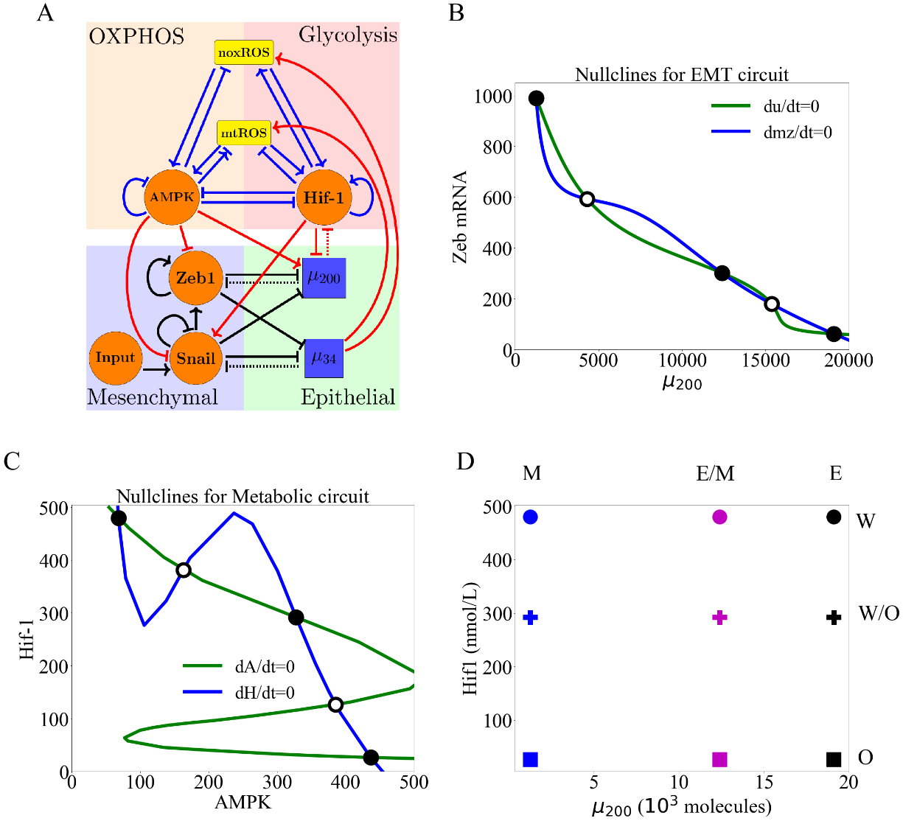

**Figure 1**. **The coupled EMT/MR circuit results in nine possible steady states.** With inactive crosstalk all combinations of the steady states of the core EMT and metabolic networks are accessible. **(A)** The network showing the core EMT module (bottom) with regulatory links designated by black, the core metabolic module (top) with regulatory links designated by blue, and the crosstalk noted in red. The dashed lines denote miRNA-based regulation. The solid lines denote transcriptional regulation. Regulatory links ending in bars represent inhibition while arrows represent activation. **(B)** The nullclines of the EMT network. The system is tristable and the three stable states (high /low Zeb, low /high ZEB, and intermediate /ZEB) represent E, M, and E/M. **(C)** The nullclines of the metabolic network. The system is tristable with three stable states (high AMPK/low HIF-1, low AMPK/high HIF-1, and intermediate AMPK/HIF-1) represent O, W, and W/O. **(D)** The nine possible phenotypic states when all crosstalks are inactive. The blue, purple, and black markers represent the M, E/M, and E states. The circle, cross, and square represent the W, W/O, and O states (e.g., the coupled E/M-W/O state is represented as a purple cross).

**Results**

**Individual crosstalk can push the downstream circuit towards a single state:** Let us start by making just one crosstalk active, e.g., caused by an EMT-related microRNA. Now, in our model there is a clearly an unaffected upstream subnetwork (EMT, from where the link originates) and a regulated downstream one. (Note that the model ignores any possible dilution of the microRNA due to its action on ROS; see below).

When noxROS is upregulated by (Fig. 2A), as there is no feedback to the EMT network, the occupancy of the E, E/M, and M states are unchanged. As the level of noxROS increases, the W-associated states are lost; first the E-W state, then the E/M-W, and finally the M-W state (Fig. 2B, section S2.4). Additionally, as noxROS increases, the W/O-associated states are stabilized and little change occurs for O-associated states (Fig. 2C). Upon analyzing the coupled states, if noxROS increases then the E/M state becomes more likely to be associated with the W/O state (Fig. 2D). For the W-associated states, we found that the M-W state exists for a larger parameter space compared to other W-associated states, as the coupling is increased (Fig. 2E). This is as expected since the M state has the lowest level, resulting in a lower increase of noxROS compared with other EMT states (Fig. 2E).

Similar changes have been observed via the upregulation of mtROS (Fig. S7); the E-W and E/M-W states are suppressed first. Consistent with the effect of upregulating noxROS, upregulating mtROS is also correlated with an increase of the E/M-W/O state. Further, activation of mtROS results in a downregulation of the O state alongside downregulation of the W state, thus stabilizing the W/O state. Together, these results suggest mtROS and noxROS may be critical factors in regulating the coupling of two hybrid states (E/M-W/O), but mtROS exhibited a greater increase in the E/M-W/O state than noxROS.

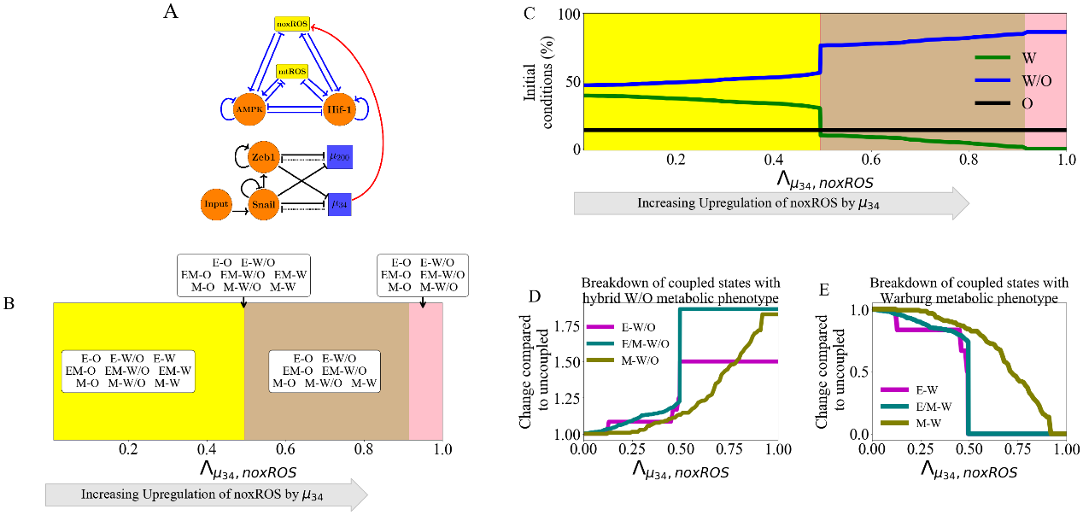

**Figure 2. noxROS upregulated by stabilizes the W/O state and enhances the E/M-W/O coupled state.** As noxROS is upregulated by , the W/O state is upregulated and the E/M-W/O state is promoted (the EMT network is unchanged, as there is no feedback). **(A)** A diagram of the core EMT circuit (bottom) and the core metabolic circuit (top) connected by the crosstalk upregulating noxROS (red link). **(B)** As noxROS is upregulated by , there are 4 distinct phases; all nine couple states followed by loss of the E-W, E/M-W, and M-W states (yellow, red, tan, and pink regions, respectively). **(C)** The lines represent the total number of initial conditions leading to the W (green) , O (black), or W/O (blue) states as a function of increasing noxROS. (The background colors correspond to the colors representing the possible steady states of (B).) **(D)** Showing the breakdown of the coupled states associated with the W/O state (i.e., E-W/O, M-W/O, and E/M-W/O) compared to the inactive system (). All W/O-associated states are upregulated, with the E/M-W/O state being strongly upregulated once . **(E)** Same as (D) but for the coupled states associated with the W state. Once both the E-W and M-W states are fully suppressed (), the E/M-W coupled state continues to be downregulated until it is fully suppressed near .

**Regulation of HIF-1 affects both subcircuits:** While the previous link only affected the downstream network, the miRNA regulation of HIF-1 by can affect both networks. This arises because of the reduction in the microRNA level caused by this coupling. In our model, mediates both the transcription and translation of HIF-1 mRNA, and as a result, can be recycled or degraded. Therefore, while the downstream metabolic network is modulated, the upstream EMT network is also affected via change of We have defined a function to stimulate the above-mentioned effect of on HIF-1 (details of silencing function in section S2.5). Note that as we include increased silencing, the first thing which occurs is the restriction of the EMT state; close to the only EMT state allowed is M. When we enter this region, all the metabolic phenotypes are allowed. As the silences HIF-1, the W/O and W states are suppressed sequentially, and the O state is promoted. Additionally, as suppresses HIF-1, the degradation of caused by binding to HIF-1 RNA is reduced, resulting in a gradual disappearance of the M state. Thus, when HIF-1 mRNA is fully silenced, only the E-O and E/M-O coupled states remain (Fig. S8). Since the E/M state does not reappear until after the metabolic system has fully transitioned to O, the coupled E/M-W/O state is not observed for any value of silencing HIF-1 mRNA. These results suggest overexpression could promote the O-associated states (E-O and E/M-O) and destabilize the coupled E/M-W/O state.

**Inclusion of multiple miRNAs of the EMT network can stabilize the W/O metabolic phenotype**: We next wish to determine how including links emanating from both and can synergistically drive metabolic reprogramming and promote the coupled E/M-W/O state. While upregulation of ROS causes an increase in the E/M-W/O state, we showed that silencing HIF-1 mRNA suppresses the E/M-W/O state; therefore, we may expect some suppression of the E/M-W/O state when including both and crosstalks. Interestingly, the hybrid E/M-W/O state can be fully suppressed when HIF-1 is downregulated and noxROS is upregulated, but only partially suppressed when HIF-1 is downregulated and mtROS is upregulated (Fig. S10). These results suggest the type of ROS present can have different effects on the existence of the E/M-W/O state.

The coupled hybrid E/M-W/O state is stabilized if mtROS is upregulated, but noxROS upregulation has minimal effect on the E/M-W/O state. Strikingly, if all three miRNA crosstalk are active ( silencing HIF-1 mRNA and upregulating noxROS and mtROS, Fig. 3A) the E/M-W/O coupled state can be suppressed even if the W/O state is present (Fig. 3B). Further, the E/M-W/O state is present for all values of noxROS upregulation but is only present at high values of mtROS upregulation (Fig. 3B-C and S11). Additionally, the E/M state is more likely to be associated with the O state at lower levels of mtROS while at higher levels of mtROS, the E/M state is more likely to be associated with the W/O state (Fig. 3C). Depending on the initial conditions, if noxROS is maximally upregulated (λu34,noxROS=0), mtROS is upregulated, and HIF-1 is partially silenced by the system can access the hybrid E/M-W/O state (Fig 3D). There also seems to be a synergistic effect between the three crosstalks resulting in an increased parameter space leading to the E/M-W/O state than what is expected from the individual crosstalks. Further, the difference in the effect of noxROS and mtROS seems to result from the frustrated regulation of mtROS by HIF-1 and . Therefore, feedback loops between mtROS, HIF-1, , and together control the appearance of the E/M-W/O state.

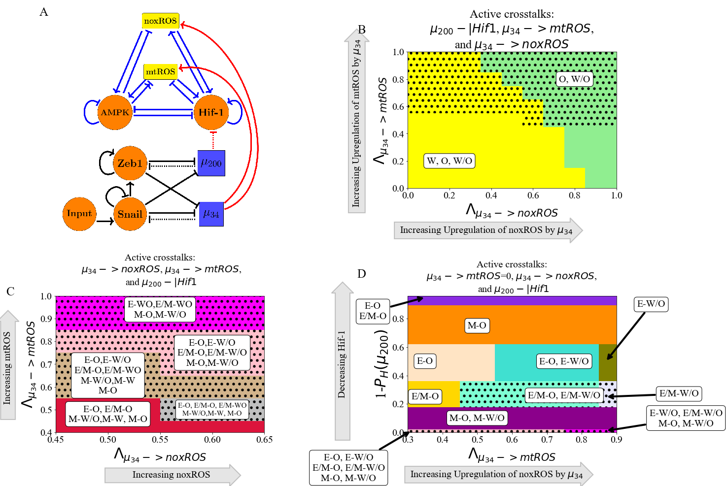

**Figure 3. and can upregulate the W/O phenotype.** When all three miRNA-mediated crosstalks are active, the E/M-W/O state can be upregulated. The E/M-W/O state is accessible when mtROS is high and at intermediate silencing of HIF-1, but noxROS seems to have minimal effect. **(A)** Schematic illustration of the coupled metabolic (top) and EMT (bottom) regulatory network with all miRNA-mediated regulatory links active ( upregulating mtROS, upregulating noxROS, and silencing HIF-1). **(B)** The phase plane corresponding to all miRNA-mediated links (pictured in A). The regulation of HIF-1 by in this phase plane corresponds to the rightmost, blue region of Fig. S8 where all metabolic phenotypes are possible. As noxROS is upregulated, the W state is suppressed. However, as the level of mtROS increases, the E/M-W/O coupled state appears (black dotted region), suggesting mtROS may have a stronger effect on the E/M-W/O state than noxROS. **(C)** The coupled states of (B), zoomed in on the middle region. The E/M-W/O state exists when mtROS is upregulated. **(D)** At maximum upregulation of noxROS (=0), as mtROS increases (x-axis) and HIF-1 is moderately silenced (y-axis) there are regions where the E/M-W/O state is possible (black dotted regions).

**Metabolic reprogramming can drive EMT:** We next turn to a consideration of information flowing in the other direction, from metabolism to EMT. To elucidate the way in which metabolic reprogramming can drive EMT, we determined the effect of each metabolism-driven crosstalk on the coupled states. First, we analyzed the links in which HIF-1 upregulates SNAIL (Fig. 4A and S12) or inhibits (Fig. S13). As expected, both HIF-1 mediated links push the system towards the M state. Further, both the E and hybrid E/M states are most associated with the O state (when the HIF-1 level is relatively low) while the M state is initially associated with the W state. This correlation between the E-O and M-W states is assumed in much of the literature [29]. Similarly, modulating the EMT-inducing signals such as TGF-β that can activate SNAIL can alter the stability of the E/M state and therefore the coupled states (see Fig. S14). Opposite to the HIF-1 results, AMPK-mediated crosstalks (AMPK upregulating , AMPK downregulating SNAIL, or AMPK downregulating ZEB) pushes the EMT network to adopt an E state and suppresses the E/M state followed by the suppression of the M state (Fig. 4B and S15-17). Additionally, when AMPK regulates the EMT circuit alone, the E and M states are still most associated with the O and W states, respectively; however, the E/M state is associated with the W state. This is in direct contrast to HIF-1 driven crosstalk in which the E/M state is coupled with O state. The results suggest that neither OXPHOS nor Warburg metabolism is automatically associated with the E/M state and that the E/M state has metabolic plasticity to mix and match different metabolic phenotypes.

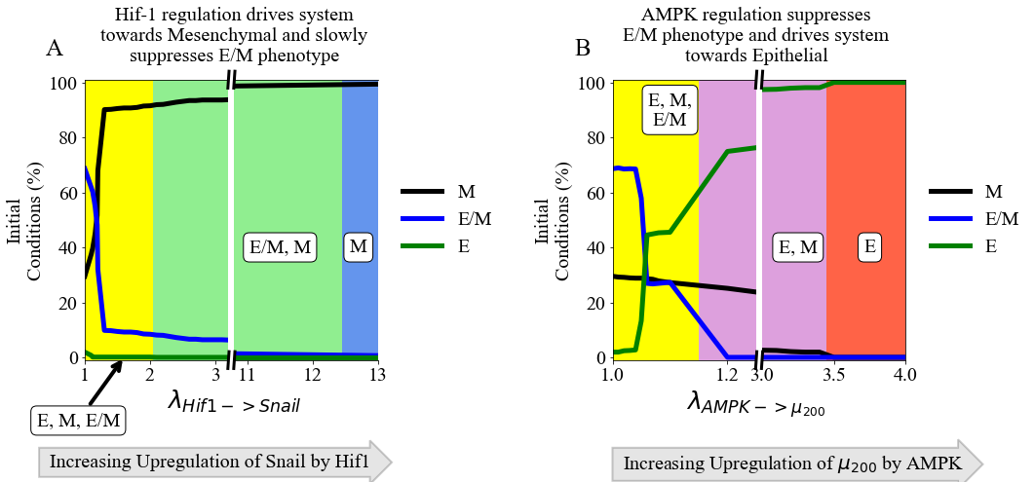

**Figure 4. The role of metabolism in driving EMT.** HIF-1 mediated crosstalks drive the EMT circuit towards the M state, while AMPK mediated crosstalks drive the EMT network towards the E state. **(A)** The number of initial conditions leading to an E/M, M, or E state as HIF-1 upregulates SNAIL and drives the EMT network towards mesenchymal. **(B)** The number of initial conditions leading to an E/M, M, or E state as AMPK upregulates and drives the system towards epithelial. The E/M state exists for larger portions of the parameter spaces for HIF-1 regulation than for AMPK-mediated crosstalks.

**TFs of the metabolic network can stabilize the E/M metabolic phenotype**: There are two distinct events at play when the metabolic network regulates the EMT circuit. AMPK regulation quickly suppresses the E/M state and pushes the system towards the E state whereas HIF-1 regulation can allow the system to maintain the E/M state for a range of strengths while ultimately pushing the system towards the M state (Fig. 4A and 4B). As AMPK and HIF-1 push the system towards opposite states, having active links emanating from both should push the circuit towards a hybrid state, which is exactly what happens.

When at least one of the three AMPK crosstalks and at least one of the two HIF-1 crosstalks are activated, the E/M state is stabilized. However, the exact parameter spaces where the E/M and E/M-W/O states exist depends on the type of regulation (Fig. S18). Additionally, if AMPK and HIF-1 target different EMT TFs, the E/M-W/O state may exist in larger parameter spaces than if they target the same EMT TF (Fig. S18), suggesting multiple crosstalks should be active and multiple gene regulators should be targeted to stabilize the E/M-W/O state. If all crosstalks involving AMPK and HIF-1 regulating the EMT circuit are active (Fig. 5A) then there are significant regions in which the E/M state exists (Fig. 5B). However, when analyzing the system for the existence of the E/M-W/O state, it only exists in a small region where is minimally upregulated. Moreover, HIF-1 driven crosstalks are able to maintain the E/M state longer than AMPK driven crosstalks suggesting, the reduced regions of E/M-W/O existence is likely due to the suppression of the E/M state by AMPK regulated crosstalks, as mentioned above (see Fig. S15-S17). This suggests HIF-1 driven crosstalk is more strongly correlated with the E/M state than AMPK driven crosstalk, in agreement with a recent study based on publicly available expression data [70].

To stabilize the E/M state, both AMPK and HIF-1 crosstalk are necessary, and if all EMT regulating crosstalks are active then there are regions where the E/M-W/O state exists. Additionally, the E state is typically coupled to the O state (E-O), the M state is associated with the W state (M-W), and when the E/M state is present it is typically associated with the hybrid W/O state (Fig. 5C). In fact, for any system, if there are only three coupled states available and each has a distinct phenotype of the EMT and metabolic networks, then the only possible set of states is E-O, M-W, and E/M-W/O. This behavior represents the full coordination of EMT and metabolism and suggests clusters of migrating cells utilize a combination of aerobic glycolysis and OXPHOS. Given tumors are metabolically heterogeneous, this result suggests the topology and parameters of the system may only represent certain microenvironments and is a limitation of our study.

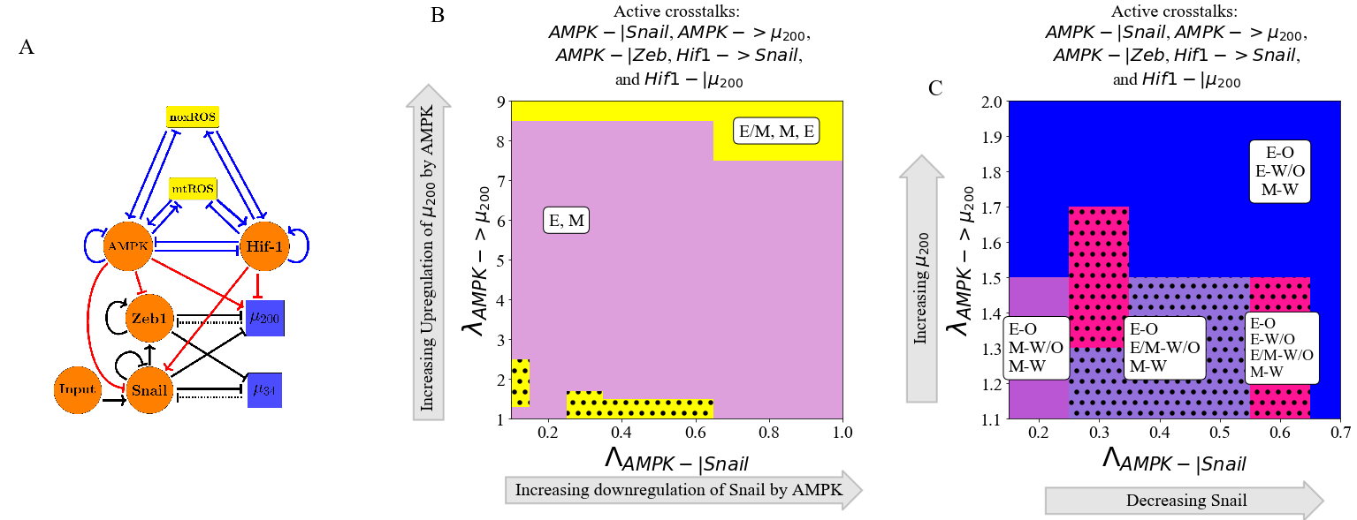

**Figure 5. AMPK and HIF-1 cooperate to upregulate the hybrid E/M state.** When all HIF-1 and AMPK controlled crosstalks are active (HIF1->Snail, HIF1-|, AMPK-|Snail, AMPK-|Zeb, AMPK-> ) the E/M-W/O state can be stabilized. HIF-1 driving the network to mesenchymal and AMPK driving the system towards the E state results in HIF-1 and AMPK cooperatively stabilizing the E/M state. **(A)** Schematical illustration of the network showing the metabolism-mediated crosstalk. **(B)** The phase plane of potential EMT states when all metabolic driven crosstalks are active. The E/M state is only accessible when λAMPK-> μ200 is near 1 or very high (i.e., at the extremes of regulation). **(C)** The coupled states when the EMT circuit is regulated by the metabolic circuit (pictured in A). The results suggest a direct correlation between the E, E/M, and M states to the O, W/O, and W states, respectively.

**The Hybrid E/M-W/O phenotype:** Recently, it has been suggested that the most aggressive cancer phenotype is characterized by the hybrid E/M state and hybrid W/O state, enabling a high degree of plasticity and thereby enabling metastatic spread and drug resistance [29]. Therefore, it is now useful to focus our discussion onto how the crosstalk between EMT and metabolism regulatory networks specifically affects the E/M-W/O state and the possibility that it could be the only possible coupled state for certain parameter spaces. From our analysis of activating individual crosstalks, we deduce that two competing metabolic driven crosstalk and one competing EMT driven crosstalks would be minimally necessary to fully stabilize the E/M-W/O state and suppress all other coupled states.

In detail, the hybrid E/M-W/O state can be promoted when AMPK downregulates SNAIL, HIF-1 downregulates , and upregulates mtROS. The E/M-W/O state exists in much of the space and is increased in prevalence when SNAIL is significantly repressed by AMPK (λAMPK-| SNAIL=0.2), mtROS is upregulated, and levels have been moderately downregulated (Fig. 7A and S19A). Further, if HIF-1 downregulating is replaced by increasing the EMT inducing signal to SNAIL, the E/M-WO state can become even more prevalent (Fig. 6B and S19B). While, the E/M-W/O state was stabilized in both cases (Fig. 6A and B), neither set of crosstalk could enable only the E/M-W/O state.

It is possible to suppress all states except the coupled E/M-W/O state with just three regulatory links; HIF-1 inhibiting , upregulating mtROS, and modulating the EMT-inducing signal (Fig. 6C and S19C). In fact, no other combination consisting of only three regulatory links seems to enable only the E/M-W/O state(Fig. S?). Additionally, this region which only includes the E/M-W/O state persists even if all remaining crosstalks are activated (Fig. 6D and S19D).

Looking at the proximal phases next to the one with only the E/M-W/O state suggests that stabilization of the E/M-W/O state requires mutual activation between metabolic reprogramming and EMT. When the E/M-W/O state is the only available state, the surrounding phases are the same whether only three crosstalks (Fig. 6C) or all crosstalks (Fig. 6D) are active (E-O and E-W/O), suggesting there may be a sequential path to generate the E/M-W/O state. Further, if the E/M-W/O state is not the only allowed state (Fig. 6A and 6B), the surrounding phases include M-coupled states (M-O, M-W/O, and M-W) as well as E-coupled states (E-O and E-W/O). Together the results suggest that to reach the E/M-W/O state for epithelial cancer, first metabolic reprogramming should occur and the E-W/O state should be acquired, followed by partial EMT (E/M-W/O). Additionally, the persistence of the E/M-W/O state when all crosstalks are active suggests there might be other combinations of crosstalks that generate phases where only the E/M-W/O state is possible, although it is outside the scope of this manuscript to find all possible combinations of crosstalks that can enable only the hybrid E/M-W/O coupled state. However, based on these results, we would expect HIF-1 suppressing and upregulating mtROS to be prominent among all such combinations.

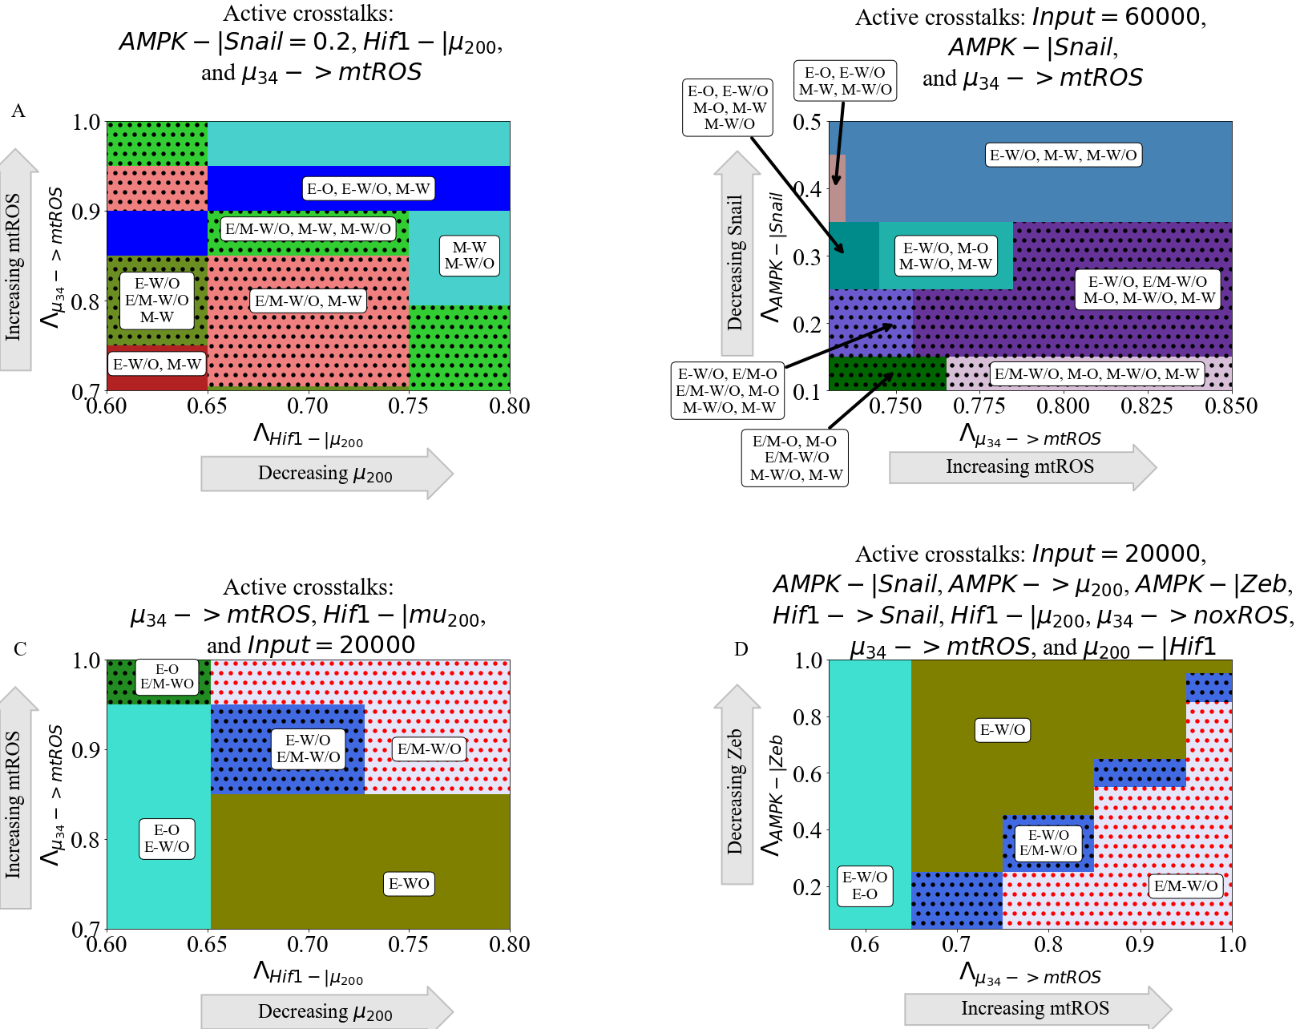

**Figure 6. The coupling of the EMT and metabolic regulatory networks can enable a coupled hybrid E/M-W/O state.** Minimally, three links (one effecting the metabolic network and two controlling the EMT network) are necessary to enable only the E/M-W/O state – e.g, upregulating mtROS, HIF-1 inhibiting , and an EMT-inducing signal on SNAIL. **(A)** Phase diagrams of the coupled states when considering three crosstalk; the Input=60000 molecules, AMPK downregulates SNAIL, and upregulates mtROS. The E/M-W/O state is upregulated when mtROS levels are increased. **(B)** The phase diagram of the coupled states when considering the inhibition of SNAIL by AMPK (λAMPK-| SNAIL=0.2), HIF-1 inhibiting μ200, and upregulating mtROS. The E/M-W/O state is upregulated for some regions. **(C)** When considering the bi-directional regulation between EMT and metabolism by the three minimally necessary regulatory links, there are parameter regions in which the only possible coupled state is the E/M-W/O state. **(D)** When all crosstalks are active there are regions where only the E/M-W/O state exists. Similar sets of coupled states in (C) and (D) suggest a progression that drives the system towards the hybrid E/M-W/O coupled state.

**Hybrid phenotypes are enabled by crosstalk in cells initially without the E/M or W/O state:** We have shown that the E/M and W/O states are often connected, the population in the E/M-W/O state can be expanded depending on the relative strength of various links, and there are parameter sets with only the hybrid E/M-W/O state available and all other coupled states suppressed. Next, to investigate whether the crosstalk between EMT and metabolism enables cancer plasticity e.g., by acquiring the hybrid states we simulate scenarios where the individual EMT and metabolism networks cannot acquire a hybrid state. This scenario corresponds to normal physiological conditions where we expect most cells will be restricted to a binary choice of E versus M and W versus O [71] (see Fig. S20-S22 for the inactive bistable networks). Then we systematically analyze whether any crosstalk can enable the hybrid state to emerge.

As already mentioned, the EMT network can drive metabolic reprogramming via microRNA-mediated links. We first kept the metabolic circuit as a bistable system where only W and O are the available stable states, i.e., no hybrid W/O state when the cross-talk is inactive. Then we analyzed the coupled states considering links - upregulating mtROS, downregulating HIF-1, or upregulating noxROS. We found that the metabolic circuit becomes tristable, i.e., the hybrid W/O state emerges, when mtROS is upregulated by (Fig. 7A) but doesn’t appear if only noxROS is upregulated or μ200 is downregulated (Fig. S23). Additionally, the upregulation of mtROS by can further stabilize the coupled E/M-W/O state so that all E/M states become coupled with the W/O states. Furthermore, the upregulation of noxROS in the bistable circuit causes an increase in the frequency of the O state, in contrast to an increase of the frequency of the hybrid W/O state in the tristable circuit (Fig. S23 compared to Fig. 2). This suggests, noxROS may play a context-dependent role on the coupled state, while mtROS often stabilizes the E/M-W/O state.

Next to see whether metabolic reprogramming can enable the emergence of the hybrid E/M state, we kept the metabolic circuit as a tristable circuit and set the EMT network to be bistable (i.e., unable to acquire a hybrid E/M state alone). Then we investigated the effects of the following crosstalk, HIF-1 inhibiting , and HIF-1 upregulating SNAIL. When analyzing the inhibition of by HIF-1, we found that the coupled EMT-metabolism network can quickly generate the E/M-W/O state before it is once again suppressed (Fig. 7B). However, the E/M state persists but is coupled to the O state (E/M-O). Additionally, when analyzing the effect of HIF-1 upregulating SNAIL, we found that the E/M-W/O state is only generated when SNAIL is moderately upregualted (Fig. S24). Furthermore, both HIF-1 inhibiting and HIF-1 upregulating SNAIL can stabilize the system in the phase - (E/M-O, M-W, M-O, M-W/O), where the hybrid E/M state can be stably maintained. This suggests the master regulator of glycolysis, HIF-1, can drive cells towards the hybrid E/M state. Conversely, an individual AMPK-mediated crosstalk is unable to generate the hybrid E/M state and saturates in the epithelial phase (Fig. S24), as seen in the tristable circuit. Additionally, as with the tristable networks, the coupled hybrid E/M-W/O state can be stabilized by two competing crosstalk, such as AMPK upregulating SNAIL and HIF-1 downregulating (Fig. S25). These results suggest HIF-1 can strongly affect and drive EMT into a hybrid E/M state while AMPK can only help stabilize the E/M-W/O state if it is already present.

When both the EMT and metabolism networks are in the parameter regime where hybrid E/M or hybrid metabolism state is not available, the crosstalk can enable the emergence of these hybrid states. Recall that for the coupled tristable circuits, the simplest set of crosstalk with a parameter region that suppressed all coupled states except the E/M-W/O state consisted of three regulatory links: (1) HIF-1 inhibiting , (2) upregulating mtROS, and (3) EMT-inducing signaling acting on SNAIL. When these same links are active for the bistable EMT and metabolism circuits, the results qualitatively agree with the tristable circuit results (Fig. 7C and S26 compared to Fig. 6C). The E/M state is only possible near full inhibition of and the W/O state is possible when mtROS is greatly upregulated. Further, the system must be near maximum regulation (i.e., and must be close to zero) to generate the region where only the coupled hybrid E/M-W/O state is available. Additionally, the nearby phases surrounding the phase containing only the E/M-W/O state (E-O and E-W/O) is similar relative to those of the tristable circuit, further supporting a progression that must be followed to reach the E/M-W/O state.

Overall, we showed that if the metabolic network is bistable (W or O states) and the EMT network is tristable (E, E/M, or M states), upregulating mtROS can generate the W/O state and upregulate the E/M-W/O state. Conversely, if the EMT network is bistable (E or M) and the metabolic network is tristable (W, O, or W/O), a HIF-1 controlled crosstalk can briefly generate the E/M state and stabilize the E/M-W/O state. If both networks are bistable, the same three links as the tristable case (-> mtROS, HIF1-| and reducing the EMT-inducing signal) generates the E/M-W/O state and suppresses all other coupled states. Further, those three links also include parameter spaces where only the E/M-W/O state is enabled when the network is stabilized by PSFs OVOL and GRHL2 (i.e., the inactive states include E/M-W/O or the E/M-O state, Fig. S27). These results suggest the E/M-W/O state can be promoted by the crosstalk, independent of the initially available states.

We also identified a sequential event to reach the coupled hybrid E/M-W/O state. starting from an E state, which typically associated with an O state, then transitioning from E-O to E-W/O, and finally transitioning to the coupled hybrid E/M-W/O state. In other words, cells may first reprogram their metabolism from O to the hybrid W/O state, followed by the initiation of EMT and a transition to the hybrid E/M state, thus exhibiting the E/M-W/O state.

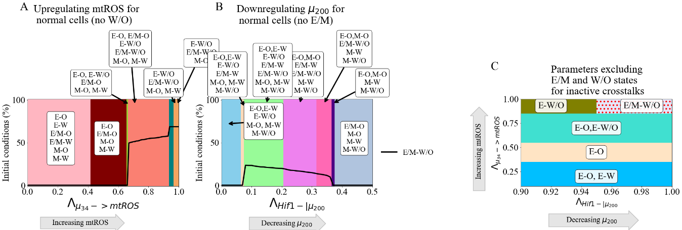

**Figure 7. Crosstalk can generate the hybrid states.** The activation of a single crosstalk (-> mtROS, HIF1 -> SNAIL, or HIF1 -|) can generate the hybrid state of the downstream network (W/O, E/M, or E/M), respectively. **(A)** The phase diagram showing coupled states for the bistable metabolism network (O or W when the crosstalk is inactive ). Once mtROS is increased (near ), there is a sharp change with the hybrid W/O state becoming the most often occupied state. **(B)** The phase diagram of coupled states when the hybrid E/M state is not available initially when the crosstalk is inactive. As mir200 decreases, the E/M state becomes accessible. **(C)** Combining the models from (A) and (B), we generate a network which only has 4 possible coupled states if the crosstalk is inactive (E-O, E-W, M-O, and M-W). At maximum upregulation of mtROS and downregulation of , only the E/M-W/O state is enabled, similar to Fig. 6C.

**Discussion**

Cancer malignancy relies on the orchestration of multiple hallmarks driven by different functional modules, such as metabolism and stemness [1]. It has become increasingly clear that different hallmarks of cancer are not independent and indeed are extensively coupled. Therefore, deciphering how these different modules affect each other can be critical to better understand cancer malignancy.

In this work, we focused on how reprogrammed cancer metabolism is coordinated with cancer metastasis. As EMT is often employed by cancer as part of the metastasic process, we analyzed the mutual regulation between metabolism and EMT, through coupling their corresponding gene regulatory circuits – AMPK/HIF-1/ROS and miR-34/SNAIL/miR-200/ZEB. As both circuits potentially exhibit tristability, coupling of these two circuits in principle can give rise to nine coupled states. We systematically analyzed the effect of both individual and multiple crosstalks on each of the nine coupled states. The stability of the coupled states was found to vary depending on which crosstalk was active, with multiple crosstalks potentially exhibiting synergistic or antagonistic effects. Therefore, we decided to focus primarily on the E/M-W/O state, as we expect these cells to be the most metastatically capable. Our model helps reconcile the paradoxical observations regarding the coupling of EMT states with metabolism states, e.g., the fact that E/M states can be associated with both high glycolysis/low OXPHOS (the W state) and high glycolysis/high OXPHOS (the W/O state) [70].

The hybrid E/M and W/O states have both been associated with elevated metastatic potentials, suggesting cancer cells can maximize their overall aggressiveness by acquiring flexibility in both EMT and metabolism. Therefore, deciphering the crosstalk stabilizing the coupled hybrid-hybrid state can indicate critical targets for anti-metastasis therapies. We found that (1) the E/M-W/O state can be stabilized by a single crosstalk mediated by miR-34 or two antagonistic crosstalks regulating the EMT network; (2) the similarities between the effects of different crosstalk (e.g., HIF1 suppressing μ200 compared to HIF-1 upregulating SNAIL) suggest a degree of consistency in how EMT drives metabolic reprogramming, and vice versa; (3) if crosstalk is bidirectional, it is possible to enable only the E/M-W/O state and this stabilization can be facilitated even under conditions when the individual core circuits do not generate hybrid states; (4) to enable only the hybrid E/M-W/O, our results indicate a progression of coupled states must be followed. Together, the results highlight the vital role of the EMT-metabolism crosstalk in mediating cancer metastasis.

The results of our model suggest metabolic reprogramming can drive EMT, but metabolic reprogramming does not have to be complete before EMT begins; this feature allows stabilizing of the most aggressive E/M-W/O state. Further, we identified a scenario wherein the system can follow a progression from the E-O state, undergoing metabolic reprogramming while maintaining epithelial characteristics (E-W/O coupled state), then beginning EMT and finally stabilizing in the E/M-W/O state. Strikingly, the prevalence of the E/M-W/O state is increased by EMT-metabolism crosstalk regardless of initial phenotypic availability (i.e., whether the initial system is significantly E/M-W/O or only E-O, E-W, M-O, and M-W). Therefore, our current model provides a possible explanation for the mutual activation of metabolic reprogramming and EMT, depending on the initiating signal.

Our findings indicate that all else being equal, undergoing EMT tends to correlate with using additional glycolysis, in qualitative agreement with a recent pan-cancer study based on NCBI GEO microarray datasets and other studies [29,70]. We find that HIF-1 (a marker of glycolysis) is strongly associated with EMT, suggesting the E/M state can be stabilized in HIF-1 (glycolysis) is upregulated. Additionally, our model predicts the coupling of the hybrid E/M state and high glycolysis/high OXPHOS (W/O). Notably, in its current form, our model is unable to explain the cases wherein low glycolysis metabolism is correlated with EMT. However, extending the model to explicitly include the coupling with the metabolic pathways [73] may be able to explain the low glycolysis states of the pan-cancer study [70].

The coupling of the E/M and W/O states is somewhat surprising given the widespread impression that primary tumors often exhibit the Warburg effect, possibly because of their need to limit the amount of ATP produced in favor of maximizing biomass production and growth (see [72] and references therein). However, this finding is consistent with the general idea that moving from E to E/M is connected with increasing stemness, and stem-like capabilities often rely on glycolysis. It is also consistent with HIF-1 activation diminishing OXPHOS while driving EMT. Note that this tendency might be over-ridden for cells that actually require sufficient energy production to enable motility, such as leader cells. One possibility is that the basic Warburg effect corresponds to the transition between E-O to E-W/O when cells first become malignant and then as the cells undergo EMT they tend to switch to more and more W until reaching a mesenchymal-like E/M state with mostly W. Then as cells become even more mesenchymal and fully differentiated, they revert back to using mostly OXPHOS. The connection between EMT and metabolism may also depend on external signals other than EMT-inducing signals that act on SNAIL, such as the level of oxygen in the TME. For example, mesenchymal cells that reduce proliferation and have to traverse the ECM should switch to more OXPHOS, whereas ones that become quiescent in a hypoxic metastatic niche should favor glycolysis. Resolution of this issue must await a more precise idea of the phrase ‘all else being equal”.

The importance of the //HIF-1/ROS/SNAIL axis for the regulation of the E/M-W/O state arises from our analysis. Our results suggest mtROS is critical for the metabolic activation of EMT. For instance, replacing mtROS with noxROS can prevent the system from enabling only the E/M-W/O state. In agreement with our results, recent experimental work has posited that mtROS can drive EMT [74], control cancer invasiveness [75,76], and has a much stronger role than noxROS [52,74]. Another important regulator of both metabolism and EMT is HIF-1. It is generally accepted that HIF-1 is a master regulator of glycolysis [22] and EMT [9]. Our results suggest the mtROS/HIF-1 axis is critical to stabilizing the highly aggressive coupled E/M-W/O state. The connection between the mtROS/HIF-1 axis (via the accumulation of mtROS enhancing HIF-1 stability) and hypoxia-induced cancer aggressiveness has also been indicated [77]. Additionally, both mtROS and HIF-1 are controlled by the miRNAs of the EMT network, and , confirming the importance of miRNAs in mediating the coupling of EMT and metabolism [78]. While we have tried to ensure our parameters are within biologically relevant ranges (utilizing values from literature whenever available), one limitation of this study is knowing how these results translate to experimental cancer studies. Thus, the significance of the mtROS/HIF-1 feedback loop should be experimentally tested by e.g., modulating ROS level via antioxidant factors such as NRF2, or modulating hypoxia to perturb HIF-1.

In line with the above, this work is merely a first step, and it is quite likely that incorporating additional pathways especially the ones that regulate cell motility, may be necessary to improve our understanding of EMT-metabolism coupling. Previous work has shown that cancer cells can transition from collective migration of E/M cells to individual migration via amoeboid cells, via the regulation of the RHO-ROCK signaling network [9,79]. Inclusion of the RHO-ROCK signaling could provide a detailed understanding of how metabolism is coupled to different modes of cancer cell migration. Overall, the importance of external signaling in our model is in conceptual agreement with a hypothesis by Sciacovelli and Frezza that, in an adverse tumor microenvironment, metabolic reprogramming drives EMT to allow cells to find more favorable metabolic niches [43].

The overall goal of this project is toward understanding all the interrelated aspects of cancer metastasis. Previous studies coupling EMT, stemness, and Notch signaling have shown that therapy resistance and increased metastatic potential are associated with stem-like hybrid E/M cells [80–82]. Furthermore, these couplings also resulted in unexpected behaviors such as the co-localization of hybrid E/M cells [80] and a tunable stemness window [81]. Studying individual gene regulatory network modules, even in the presence of signals, is unable to give a thorough understanding of the network properties. Therefore, to understand how various cancer traits are correlated, and potentially identify key regulators, multiple network modules and their crosstalk should be studied concurrently.

**Acknowledgements**

This work was supported by National Science Foundation by sponsoring the Center for Theoretical Biological Physics – award PHY-2019745 (JNO, HL) and by awards PHY-1605817 (HL), CHE-1614101 (JNO), and PHY-1522550 (JNO, MG). JNO is a CPRIT Scholar in Cancer Research. MG was also supported by the NSF GRFP no. 1842494.

**References**

1. Hanahan D. Hallmarks of Cancer: New Dimensions. Cancer Discov. 2022;12(1):31–46.

2. Kalluri R. EMT: When epithelial cells decide to become mesenchymal-like cells. J Clin Invest. 2009;119(6):1417–9.

3. Hay ED. The mesenchymal cell, its role in the embryo, and the remarkable signaling mechanisms that create it. Dev Dynam. 2005;233(3):706–20.

4. Pietilä M, Ivaska J, Mani SA. Whom to blame for metastasis, the epithelial–mesenchymal transition or the tumor microenvironment? Cancer Lett. 2016;380(1):359–68.

5. Talbot LJ, Bhattacharya SD, Kuo PC. Epithelial-mesenchymal transition, the tumor microenvironment, and metastatic behavior of epithelial malignancies. Int J Biochem Mol Biol. 2012 May 18;3(2):117–36.

6. Cho ES, Kang HE, Kim NH, Yook JI. Therapeutic implications of cancer epithelial-mesenchymal transition (EMT). Arch Pharm Res. 2019;42(1):14–24.

7. Lu M, Jolly MK, Levine H, Onuchic JN, Ben-Jacob E. MicroRNA-based regulation of epithelial–hybrid–mesenchymal fate determination. Proc National Acad Sci. 2013;110(45):18144–9.

8. Saitoh M. Involvement of partial EMT in cancer progression. J Biochem. 2018;164(4):257–64.

9. Saxena K, Jolly MK, Balamurugan K. Hypoxia, partial EMT and collective migration: Emerging culprits in metastasis. Transl Oncol. 2020;13(11):100845.

10. Bakir B, Chiarella AM, Pitarresi JR, Rustgi AK. EMT, MET, Plasticity, and Tumor Metastasis. Trends Cell Biol. 2020;30(10):764–76.

11. Pastushenko I, Blanpain C. EMT Transition States during Tumor Progression and Metastasis. Trends Cell Biol. 2018;29(3):212–26.

12. Fustaino V, Presutti D, Colombo T, Cardinali B, Papoff G, Brandi R, et al. Characterization of epithelial-mesenchymal transition intermediate/hybrid phenotypes associated to resistance to EGFR inhibitors in non-small cell lung cancer cell lines. Oncotarget. 2017;8(61):103340–63.

13. George JT, Jolly MK, Xu J, Somarelli J, Levine H. Survival outcomes in cancer patients predicted by a partial EMT gene expression scoring metric. Cancer Res. 2017;77(22):canres.3521.2016.

14. Jolly MK, Tripathi SC, Jia D, Mooney SM, Celiktas M, Hanash SM, et al. Stability of the hybrid epithelial/mesenchymal phenotype. Oncotarget. 2016;7(19):27067–84.

15. Pastushenko I, Brisebarre A, Sifrim A, Fioramonti M, Revenco T, Boumahdi S, et al. Identification of the tumour transition states occurring during EMT. Nature. 2018;556(7702):463–8.

16. Simeonov KP, Byrns CN, Clark ML, Norgard RJ, Martin B, Stanger BZ, et al. Single-cell lineage tracing of metastatic cancer reveals selection of hybrid EMT states. Cancer Cell. 2021;39(8):1150-1162.e9.

17. Dey P, Kimmelman AC, DePinho RA. Metabolic Codependencies in the Tumor Microenvironment. Cancer Discov. 2021;candisc.1211.2020.

18. Warburg O, Wind F, Negelein E. THE METABOLISM OF TUMORS IN THE BODY. J Gen Physiol. 1927;8(6):519–30.

19. Liberti MV, Locasale JW. The Warburg Effect: How Does it Benefit Cancer Cells? Trends Biochem Sci. 2016;41(3):211–8.

20. Ohshima K, Morii E. Metabolic Reprogramming of Cancer Cells during Tumor Progression and Metastasis. Metabolites. 2021;11(1):28.

21. Carvalho TMA, Cardoso HJ, Figueira MI, Vaz CV, Socorro S. The peculiarities of cancer cell metabolism: A route to metastasization and a target for therapy. Eur J Med Chem. 2019;171:343–63.

22. Nagao A, Kobayashi M, Koyasu S, Chow CCT, Harada H. HIF-1-Dependent Reprogramming of Glucose Metabolic Pathway of Cancer Cells and Its Therapeutic Significance. Int J Mol Sci. 2019;20(2):238.

23. Cheng Y, Lu Y, Zhang D, Lian S, Liang H, Ye Y, et al. Metastatic cancer cells compensate for low energy supplies in hostile microenvironments with bioenergetic adaptation and metabolic reprogramming. Int J Oncol. 2018;53(6):2590–604.

24. Porporato PE, Payen VL, Pérez-Escuredo J, De Saedeleer CJ, Danhier P, Copetti T, et al. A Mitochondrial Switch Promotes Tumor Metastasis. Cell Reports. 2014;8(3):754–66.

25. Jia D, Park JH, Jung KH, Levine H, Kaipparettu BA. Elucidating the Metabolic Plasticity of Cancer: Mitochondrial Reprogramming and Hybrid Metabolic States. Cells. 2018;7(3):21.

26. Jia D, Paudel BB, Hayford CE, Hardeman KN, Levine H, Onuchic JN, et al. Drug-Tolerant Idling Melanoma Cells Exhibit Theory-Predicted Metabolic Low-Low Phenotype. Frontiers Oncol. 2020;10:1426.

27. Dupuy F, Tabariès S, Andrzejewski S, Dong Z, Blagih J, Annis MG, et al. PDK1-Dependent Metabolic Reprogramming Dictates Metastatic Potential in Breast Cancer. Cell Metab. 2015;22(4):577–89.

28. LeBleu VS, O’Connell JT, Herrera KNG, Wikman H, Pantel K, Haigis MC, et al. PGC-1α mediates mitochondrial biogenesis and oxidative phosphorylation in cancer cells to promote metastasis. Nat Cell Biol. 2014;16(10):992–1003.

29. Jia D, Park JH, Kaur H, Jung KH, Yang S, Tripathi S, et al. Towards decoding the coupled decision-making of metabolism and epithelial-to-mesenchymal transition in cancer. Brit J Cancer. 2021;1–10.

30. Serocki M, Bartoszewska S, Janaszak-Jasiecka A, Ochocka RJ, Collawn JF, Bartoszewski R. miRNAs regulate the HIF switch during hypoxia: a novel therapeutic target. Angiogenesis. 2018;21(2):183–202.

31. Shang Y, Chen H, Ye J, Wei X, Liu S, Wang R. HIF-1α/Ascl2/miR-200b regulatory feedback circuit modulated the epithelial-mesenchymal transition (EMT) in colorectal cancer cells. Exp Cell Res. 2017;360(2):243–56.

32. Jin HF, Wang JF, Song TT, Zhang J, Wang L. MiR-200b Inhibits Tumor Growth and Chemoresistance via Targeting p70S6K1 in Lung Cancer. Frontiers Oncol. 2020;10:643.

33. Georgakopoulos-Soares I, Chartoumpekis DV, Kyriazopoulou V, Zaravinos A. EMT Factors and Metabolic Pathways in Cancer. Frontiers Oncol. 2020;10:499.

34. Fedele M, Sgarra R, Battista S, Cerchia L, Manfioletti G. The Epithelial–Mesenchymal Transition at the Crossroads between Metabolism and Tumor Progression. Int J Mol Sci. 2022;23(2):800.

35. Burger GA, Danen EHJ, Beltman JB. Deciphering Epithelial–Mesenchymal Transition Regulatory Networks in Cancer through Computational Approaches. Frontiers Oncol. 2017;7:162.

36. Hu Y, Xu W, Zeng H, He Z, Lu X, Zuo D, et al. OXPHOS-dependent metabolic reprogramming prompts metastatic potential of breast cancer cells under osteogenic differentiation. Brit J Cancer. 2020;123(11):1644–55.

37. Sung JY, Cheong JH. Pan-Cancer Analysis Reveals Distinct Metabolic Reprogramming in Different Epithelial–Mesenchymal Transition Activity States. Cancers. 2021;13(8):1778.

38. Choudhary KS, Rohatgi N, Halldorsson S, Briem E, Gudjonsson T, Gudmundsson S, et al. EGFR Signal-Network Reconstruction Demonstrates Metabolic Crosstalk in EMT. Plos Comput Biol. 2016;12(6):e1004924.

39. Feng S, Zhang L, Liu X, Li G, Zhang B, Wang Z, et al. Low levels of AMPK promote epithelial‐mesenchymal transition in lung cancer primarily through HDAC4‐ and HDAC5‐mediated metabolic reprogramming. J Cell Mol Med. 2020;24(14):7789–801.

40. Schieber MS, Chandel NS. ROS Links Glucose Metabolism to Breast Cancer Stem Cell and EMT Phenotype. Cancer Cell. 2013;23(3):265–7.

41. Kang X, Wang J, Li C. Exposing the Underlying Relationship of Cancer Metastasis to Metabolism and Epithelial-Mesenchymal Transitions. Iscience. 2019;21:754–72.

42. Kang X, Li C. A Dimension Reduction Approach for Energy Landscape: Identifying Intermediate States in Metabolism‐EMT Network. Adv Sci. 2021;2003133.

43. Sciacovelli M, Frezza C. Metabolic reprogramming and epithelial‐to‐mesenchymal transition in cancer. Febs J. 2017;284(19):3132–44.

44. Huang R, Zong X. Aberrant cancer metabolism in epithelial–mesenchymal transition and cancer metastasis: Mechanisms in cancer progression. Crit Rev Oncol Hemat. 2017;115:13–22.

45. Jiang L, Xiao L, Sugiura H, Huang X, Ali A, Kuro-o M, et al. Metabolic reprogramming during TGFβ1-induced epithelial-to-mesenchymal transition. Oncogene. 2015;34(30):3908–16.

46. Bocci F, Tripathi SC, Mercedes SAV, George JT, Casabar JP, Wong PK, et al. NRF2 activates a partial epithelial-mesenchymal transition and is maximally present in a hybrid epithelial/mesenchymal phenotype. Integr Biol. 2019;11(6):251–63.

47. Luo M, Shang L, Brooks MD, Jiagge E, Zhu Y, Buschhaus JM, et al. Targeting Breast Cancer Stem Cell State Equilibrium through Modulation of Redox Signaling. Cell Metab. 2018;28(1):69-86.e6.

48. Colacino JA, Azizi E, Brooks MD, Harouaka R, Fouladdel S, McDermott SP, et al. Heterogeneity of Human Breast Stem and Progenitor Cells as Revealed by Transcriptional Profiling. Stem Cell Rep. 2018;10(5):1596–609.

49. Yu L, Lu M, Jia D, Ma J, Ben-Jacob E, Levine H, et al. Modeling the Genetic Regulation of Cancer Metabolism: Interplay between Glycolysis and Oxidative Phosphorylation. Cancer Res. 2017;77(7):1564–74.

50. Jia D, Li X, Bocci F, Tripathi S, Deng Y, Jolly MK, et al. Quantifying Cancer Epithelial-Mesenchymal Plasticity and its Association with Stemness and Immune Response. J Clin Medicine. 2019;8(5):725.

51. Lu M, Jolly MK, Gomoto R, Huang B, Onuchic J, Ben-Jacob E. Tristability in Cancer-Associated MicroRNA-TF Chimera Toggle Switch. J Phys Chem B. 2013;117(42):13164–74.

52. Kovac S, Angelova PR, Holmström KM, Zhang Y, Dinkova-Kostova AT, Abramov AY. Nrf2 regulates ROS production by mitochondria and NADPH oxidase. Biochimica Et Biophysica Acta Bba - Gen Subj. 2015;1850(4):794–801.

53. He F, Ru X, Wen T. NRF2, a Transcription Factor for Stress Response and Beyond. Int J Mol Sci. 2020;21(13):4777.

54. Li N, Muthusamy S, Liang R, Sarojini H, Wang E. Increased expression of miR-34a and miR-93 in rat liver during aging, and their impact on the expression of Mgst1 and Sirt1. Mech Ageing Dev. 2011;132(3):75–85.

55. Bai XY, Ma Y, Ding R, Fu B, Shi S, Chen XM. miR-335 and miR-34a Promote Renal Senescence by Suppressing Mitochondrial Antioxidative Enzymes. J Am Soc Nephrol. 2011;22(7):1252–61.

56. Navarro F, Lieberman J. miR-34 and p53: New Insights into a Complex Functional Relationship. Plos One. 2015;10(7):e0132767.

57. Italiano D, Lena AM, Melino G, Candi E. Identification of NCF2/p67phox as a novel p53 target gene. Cell Cycle. 2012;11(24):4589–96.

58. Chou HL, Fong Y, Wei CK, Tsai EM, Chen JYF, Chang WT, et al. A Quinone-Containing Compound Enhances Camptothecin-Induced Apoptosis of Lung Cancer Through Modulating Endogenous ROS and ERK Signaling. Arch Immunol Ther Ex. 2017;65(3):241–52.

59. Byun Y, Choi YC, Jeong Y, Lee G, Yoon S, Jeong Y, et al. MiR-200c downregulates HIF-1α and inhibits migration of lung cancer cells. Cell Mol Biol Lett. 2019;24(1):28.

60. Bartoszewska S, Rochan K, Piotrowski A, Kamysz W, Ochocka RJ, Collawn JF, et al. The hypoxia‐inducible miR‐429 regulates hypoxia‐inducible factor‐1α expression in human endothelial cells through a negative feedback loop. Faseb J. 2015;29(4):1467–79.

61. Xu X, Tan X, Tampe B, Sanchez E, Zeisberg M, Zeisberg EM. Snail Is a Direct Target of Hypoxia-inducible Factor 1α (HIF1α) in Hypoxia-induced Endothelial to Mesenchymal Transition of Human Coronary Endothelial Cells*. J Biol Chem. 2015;290(27):16653–64.

62. Chou CC, Lee KH, Lai IL, Wang D, Mo X, Kulp SK, et al. AMPK Reverses the Mesenchymal Phenotype of Cancer Cells by Targeting the Akt–MDM2–Foxo3a Signaling Axis. Cancer Res. 2014;74(17):4783–95.

63. Ohshima J, Wang Q, Fitzsimonds ZR, Miller DP, Sztukowska MN, Jung YJ, et al. Streptococcus gordonii programs epithelial cells to resist ZEB2 induction by Porphyromonas gingivalis. Proc National Acad Sci. 2019;116(17):201900101.

64. Dong T, Zhang Y, Chen Y, Liu P, An T, Zhang J, et al. FOXO1 inhibits the invasion and metastasis of hepatocellular carcinoma by reversing ZEB2-induced epithelial-mesenchymal transition. Oncotarget. 2016;8(1):1703–13.

65. Huang W, Cao J, Liu X, Meng F, Li M, Chen B, et al. AMPK Plays a Dual Role in Regulation of CREB/BDNF Pathway in Mouse Primary Hippocampal Cells. J Mol Neurosci. 2015;56(4):782–8.

66. Jin H, Xue L, Mo L, Zhang D, Guo X, Xu J, et al. Downregulation of miR-200c stabilizes XIAP mRNA and contributes to invasion and lung metastasis of bladder cancer. Cell Adhes Migr. 2019;13(1):236–48.

67. Janin M, Esteller M. Oncometabolite Accumulation and Epithelial-to-Mesenchymal Transition: The Turn of Fumarate. Cell Metab. 2016;24(4):529–30.

68. Zhang Q, Zheng S, Wang S, Wang W, Xing H, Xu S. Chlorpyrifos induced oxidative stress to promote apoptosis and autophagy through the regulation of miR-19a-AMPK axis in common carp. Fish Shellfish Immun. 2019;93:1093–9.

69. Thomson DM, Herway ST, Fillmore N, Kim H, Brown JD, Barrow JR, et al. AMP-activated protein kinase phosphorylates transcription factors of the CREB family. J Appl Physiol. 2008;104(2):429–38.

70. Muralidharan S, Sahoo S, Saha A, Chandran S, Majumdar SS, Mandal S, et al. Quantifying the Patterns of Metabolic Plasticity and Heterogeneity along the Epithelial–Hybrid–Mesenchymal Spectrum in Cancer. Biomol. 2022;12(2):297.

71. Tripathi S, Kessler DA, Levine H. Biological Networks Regulating Cell Fate Choice Are Minimally Frustrated. Phys Rev Lett. 2020;125(8):088101.

72. Tripathi S, Park JH, Pudakalakatti S, Bhattacharya PK, Kaipparettu BA, Levine H. A mechanistic modeling framework reveals the key principles underlying tumor metabolism. Plos Comput Biol. 2022;18(2):e1009841.

73. Jia D, Lu M, Jung KH, Park JH, Yu L, Onuchic JN, et al. Elucidating cancer metabolic plasticity by coupling gene regulation with metabolic pathways. Proc National Acad Sci. 2019;116(9):201816391.

74. Radisky DC, Levy DD, Littlepage LE, Liu H, Nelson CM, Fata JE, et al. Rac1b and reactive oxygen species mediate MMP-3-induced EMT and genomic instability. Nature. 2005;436(7047):123–7.

75. Mori K, Uchida T, Yoshie T, Mizote Y, Ishikawa F, Katsuyama M, et al. A mitochondrial ROS pathway controls matrix metalloproteinase 9 levels and invasive properties in RAS‐activated cancer cells. Febs J. 2019;286(3):459–78.

76. Ishikawa K, Takenaga K, Akimoto M, Koshikawa N, Yamaguchi A, Imanishi H, et al. ROS-Generating Mitochondrial DNA Mutations Can Regulate Tumor Cell Metastasis. Science. 2008;320(5876):661–4.

77. SHIDA M, KITAJIMA Y, NAKAMURA J, YANAGIHARA K, BABA K, WAKIYAMA K, et al. Impaired mitophagy activates mtROS/HIF-1α interplay and increases cancer aggressiveness in gastric cancer cells under hypoxia. Int J Oncol. 2016;48(4):1379–90.

78. Babaei G, Raei N, milani AT, Aziz SGG, Pourjabbar N, Geravand F. The emerging role of miR-200 family in metastasis: focus on EMT, CSCs, angiogenesis, and anoikis. Mol Biol Rep. 2021;48(10):6935–47.

79. Graziani V, Rodriguez-Hernandez I, Maiques O, Sanz-Moreno V. The amoeboid state as part of the epithelial-to-mesenchymal transition programme. Trends Cell Biol. 2021;32(3):228–42.

80. Bocci F, Gearhart-Serna L, Boareto M, Ribeiro M, Ben-Jacob E, Devi GR, et al. Toward understanding cancer stem cell heterogeneity in the tumor microenvironment. Proc National Acad Sci. 2018;116(1):201815345.

81. Jolly MK, Jia D, Boareto M, Mani SA, Pienta KJ, Ben-Jacob E, et al. Coupling the modules of EMT and stemness: A tunable ‘stemness window’ model. Oncotarget. 2015;6(28):25161–74.

82. Bocci F, Jolly MK, George JT, Levine H, Onuchic JN. A mechanism-based computational model to capture the interconnections among epithelial-mesenchymal transition, cancer stem cells and Notch-Jagged signaling. Oncotarget. 2018;9(52):29906–20.