**Coupling the epithelial-to-mesenchymal transition and metabolic reprogramming**

Madeline Galbraith, Dongya Jia, Herbert Levine, and José Onuchic

**Introduction**

The hallmarks of cancer have been investigated for many years with focus typically on a single facet. One such hallmark is metastasis which remains a leading cause of cancer related deaths[1]. The epithelial-to-mesenchymal transition (EMT) increases a cell’s capacity for migration, invasiveness, and resistance to apoptosis [2]. While crucial for embryogenesis of neural crest cells, EMT in tumor progression allows these tumor cells to metastasize [3]. In understanding how EMT regulates metastasis, a partial EMT state was hypothesized. This state combines the motility and invasiveness of the mesenchymal cells with the cellular adhesion seen in epithelial cells allowing for collective migration[4,5].

Cells typically utilize oxidative phosphorylation (OXPHOS) under normoxic conditions and glycolysis when there is a lack of oxygen. However, some types, such as neural crest cells, use aerobic glycolysis when completing the EMT [6]. While, critical to the proper function of neural crest cells, and others, the use of aerobic glycosis is also present in cancer cells, termed the Warburg effect [7,8]. The metabolic reprogramming of cancer cells may also lead to a “hybrid” state in which both OXPHOS and aerobic glycolysis are used[9].

As more research has been conducted it has become increasingly clear that the crosstalk between EMT and metabolic reprogramming must be understood[10,11]. The exact mechanism of interaction between EMT and metabolic reprogramming is still unknown but there are a few studies suggesting the hybrid E/M state may be associated with high levels of OXPHOS and glycolysis[12–14].

To decode the coupled decision-making of EMT and metabolism, we coupled the core gene regulatory circuits of EMT (reference) and metabolic reprogramming (reference) to identify whether the most aggressive phenotypes (E/M and W/O) are coupled and which crosstalks are crucial. We found that ROS is a key upregulator of the hybrid/hybrid state while Hif-1 may have slightly stronger affects than AMPK on the EMT network. By combining the crosstalks of both circuits on the other, there were regions in which the E/M-W/O was the only accessible state. Further, this phase was accessible whether the networks were initially tristable, mostly E/M-W/O, or bistable (no hybrid states). Through analyzing the coupled bistable networks (neither E/M or W/O states initially accessible), we determined the crosstalks were able to generate a the hybrid states. We also confirmed stabilizing the E/M using the PSFs GRHL2 and OVOL2 and upregulating the W/O state using GRHL2, further stabilized the E/M-W/O state for all sets of active crosstalks compared to the coupled tristable network.

**Model**

While the mechanism of EMT and cancer metabolism have been investigated individually, the crosstalk between the two circuits and how the phenotypes are correlated is still largely unknown.

Here we couple the EMT [4] and metabolic [9] regulatory networks (see Figure 1A for the coupled network). Our model inclues the production, degredation, and regulatory terms of the two individual networks and introduces crosstalk between them. We only consider crosstalks between components of the core circuits; therefore, modeling of the crosstalks is independent of whether the crosstalk is an indirect or direct regulation. Starting with the miRNA crosstalks, by targeting and downregulating NRF2, the elimination of ROS is reduced by  [15–17]. ROS production may also be upregulated through downregulating SOD2[18] or via the p53 pathway [19,20]. This increase in ROS levels is potentially more pronounced in mitochondrial ROS (mtROS) than NADPH oxidase mediated ROS (noxROS) [15] and has recently been indicated as a factor in cancer drug resistance [21]. The crosstalk between Hif1 and family members can either upregulate or downregulate Hif1 expression[22]. While mir-429 upregulates Hif1, both mir-200b[23] and mir-200c[24] downregulate Hif1 expression. Further, there is a negative regulatory feedback loop between mir-200b and Hif1[23]. The inhibition of mir-200b by Hif-1 is indirect through upregulation of the downstream target ASCL2 [23]. Additionally, HIF1 can upregulate Snail[25]. The production of Snail is also regulated by AMPK through an inhibitory crosstalk[26]. AMPK also represses the production of Zeb1 [27]. Additionally, AMPK indirectly increases the production of by upregulating Sirt1 which downregulates the creb cycle and therefore [28–31].

The model of the two core circuits is generalized to include these crosstalks. The coupled network is modeled as a set of ordinary differential equations (ODEs). Transcriptional regulations (represented as solid lines in Figure 1A) are modeled as a shifted Hill function that up/downregulates either the production or degredation term based on experimental results. For the shifted Hill function, once the threshold of the regulator is acheived, the foldchange () essentially becomes a multiplier of the production or degradation term (details in SI section 1.1). The miRNA regulatory links (represented as dashed lines in Figure 1A) are modeled through three functions that reflect the steps of translation. The functions , , and represent the active miRNA degredation rate, active mRNA degredation rate, and translation rate (details in SI section 1.2). Lastly, within the metabolism network there is competitive regulation of ROS by Hif1 and AMPK which is modeled by a competition function similar to the shifted Hill function (details in SI section 1.3). The full equations for all components of the circuit are given in SI Section 1.4 and the parameters along with a brief explanation are given in SI Section 1.5. Unless specified, all crosstalks are assumed to be in the inactive state (the foldchange, , of the crosstalk is equal to one or for the value of for the , , and equations).

We initially only include crosstalks between the core networks, then we investigate whether these crosstalks are sufficient to generate the hybrid states (details in SI Section 1.6),. Lastly, we evaluate the phenotype stability factors (PSFs) OVOL and GRHL2 to determine stability of the E/M-W/O state (details and rate equations in SI Section 1.7).

**Results**

**Coupling the EMT and metabolic regulatory networks results in nine possible coupled states**

Individually, the EMT and metabolic regulatory networks are tristable with stable states (E, M, and E/M) and (W, O, and W/O), respectively (see Fig S1 for nullclines, section S2.5). By including the crosstalks, we identify how the components of the networks interact and which states are coupled. When the networks are coupled but the regulations are inactive, there are nine possible couplings of the EMT and metabolic phenotypes: E-W, E-O, E-W/O, M-W, M-O, M-W/O, E/M-W, E/M-O, and E/M-W/O (Fig 1B, details of simulation in section S2.1).

While, the Warburg state is characterized as high/low Hif1/AMPK expression and the Epithelial state is characterized as high/low /Zeb mRNA expression, the crosstalks may alter the expression profiles for the steady states such that the thresholds of the steady states change. Therefore, we use a distance metric normalized by the expression of the inactive network to classify the generated expression profiles as one of the nine coupled states (see Section S2.2 for details). With our coupled network parameters, the results stabilize at 1000 initial conditions - the hybrid state is most populous (W/O and E/M) followed by the W and M phenotypes, with the fewest initial conditions leading to the E and O states (Fig S3-S5). This is just one set of parameters, other parameters may lead to a different fraction of initial conditions leading to these states.

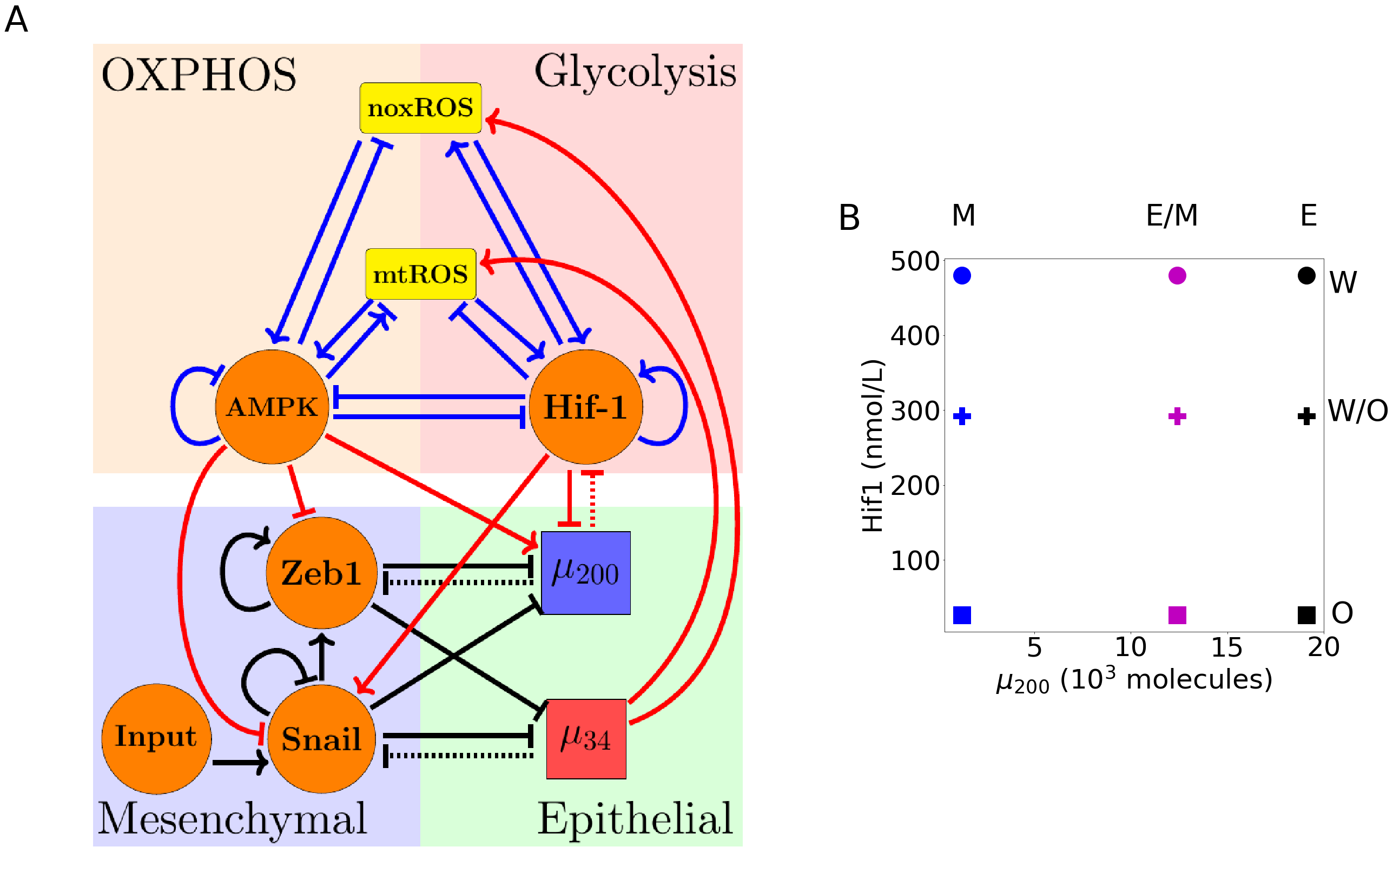

The coupled EMT/MR circuit results in 9 coupled steady states. (A) The network showing the core EMT module (bottom) with regulatory links designated by black, the core metabolic circuit (top) with regulatory links designated by blue, and the crosstalks noted in red. The dashed lines denote miRNA regulation rather than transcriptional. (B) The 9 possible coupled states when all crosstalks are present but inactive. The blue, purple, and black markers represent the mesenchymal (M), hybrid epithelial-mesenchymal (E/M), and epithelial (E) steady states, respectively. The circle, cross, and square represent the Warburg (W), hybrid Warburg-OXPHOS (W/O), and OXPHOS (O) metabolic phenotypes, respectively. The coupled M/O state is therefore represented as a blue square.

**Individual crosstalks push regulated half of circuit towards a single state**

Based on the network and crosstalks in Fig 1A, it would be assumed that AMPK (which downregulates Snail and Zeb while upregulating ) should push the system towards epithelial while Hif1 (which downregulates and upregulates Snail) should push the system towards mesenchymal. Additionally, should downregulate Hif1 resulting in an inhibition of the Warburg and hybrid W/O states. Lastly, upregulating ROS is not as clear and may stabilize the hybrid W/O state. If a single crosstalk is slowly increased/decreased, a clear progression from all nine coupled states to saturation of a single state is expected.

**The miRNA of the EMT network can stabilize the W/O metabolic phenotype**

When noxROS is upregulated by (Fig 2A), the hybrid W/O state is upregulated along with the coupled E/M-W/O phenotype. As the level of noxROS increases ( upregulates noxROS by reducing the degredation), the possible coupled states reduce from all nine losing first the E-W, then the E/M-W, and finally losing the M-W state (Fig 2B, section S2.4). Since only the Warburg state is fully suppressed at maximum upregulation (), analyzing the percent of initial conditions that lead to the metabolic phenotype shows the lost coupled states associated with the W phenotype are pushed towards the W/O phenotype but no change occurs for the O phenotype (Fig 2C). As there is no regulation on the EMT network, the total number of E, E/M, and M states are constant but the E/M state is more likely to be associated with the hybrid W/O metabolic phenotype (Fig 2D). Analyzing the states coupled with the Warburg phenotype, however, shows the mesenchymal phenotype (M-W) persists longer (Fig 2E). Comparing to the upregulation of mtROS (Fig S6), the E-W and E/M-W states are also the first suppressed states. Additionally, upregulating mtROS is also correlated to an upregulation of the E/M-W/O phenotype. Further, activation of mtROS results in a downregulation of the OXPHOS metabolic phenotype alongside the Warburg phenotype. Together, these results suggest ROS is critical to tumor progression, and mtROS may play a stronger role than noxROS.

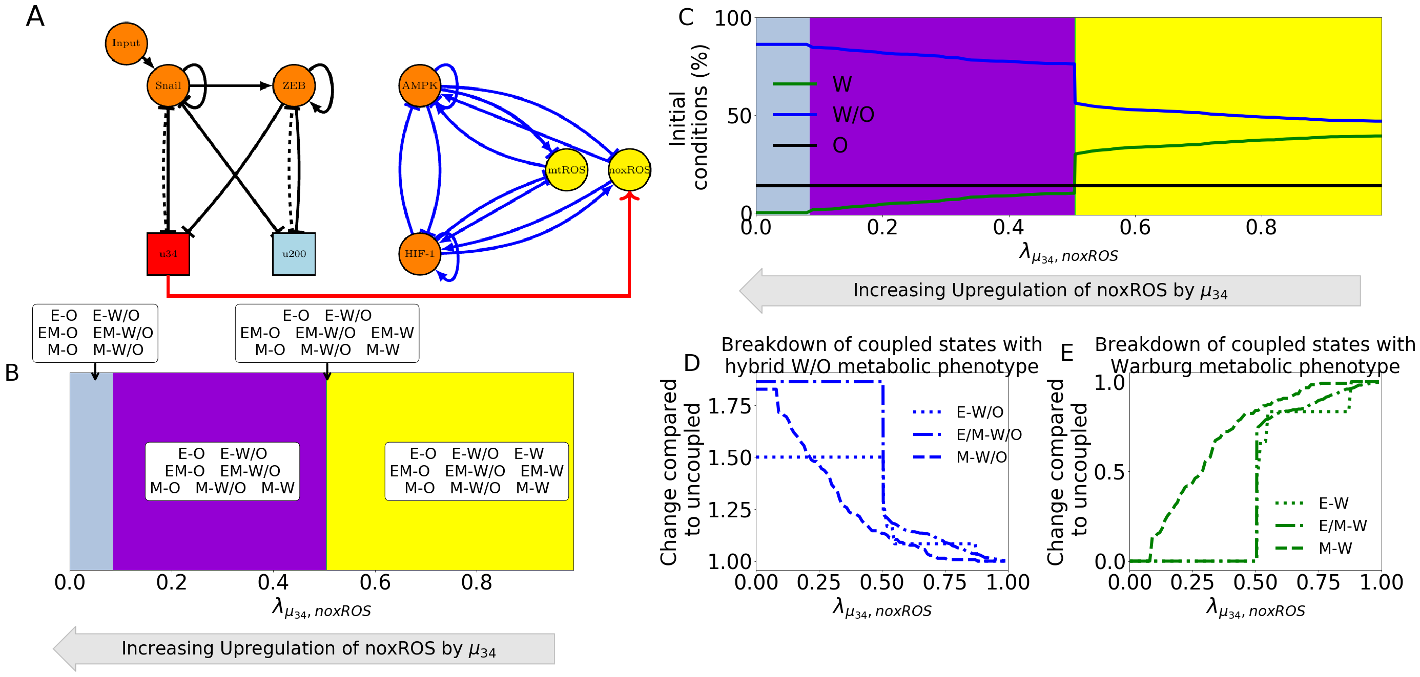

noxROS upregulated by mir34 results in upregulated W/O phenotype and associated with upregulated E/M-W/O phenotype. (A) A diagram of the core EMT circuit (left) and the core metabolic circuit (right) connected by the crosstalk between upregulating noxROS (red link representing transcriptional regulation). (B) Of the nine possible coupled states, as noxROS is upregulated by mir34, there are 4 distinct groupings. All possible coupling of the EMT circuit phenotypes (E, M, and E/M) with both the O and W/O metabolic phenotypes persist for all levels of noxROS upregulation. The coupled states associated with the W metabolic phenotypes, (E-W, E/M-W, and M-W), are lost as the level of noxROS regulation increases for the blue, green, and grey regions, respectively. (C) The background colors correpond to the colors representing the possible steady states of (B). The lines represent the total number of initial conditions leading to the W, O, or W/O phenotypes as a function of increasing regulation of noxROS by mir34. The W/O phenotype is upregulated, W phenotype is downregulated, and O is unchanged. (D) Showing the breakdown of the coupled states associated with the W/O phenotype (i.e., E-W/O, M-W/O, and E/M-W/O). The E/M-W/O coupled state is greatly upregulated once while the M-W/O coupled state is only slightly upregulated, and no change is seen for E-W/O coupled state. (E) Same as (d) but for the coupled states associated with the Warburg phenotype. Once , both the E-W and M-W states are fully suppressed. The E/M-W coupled state continues to be downregulated until it is fully suppressed near .

If we want to determine how both miRNA of the EMT network drive the metabolism network, and specifically the E/M-W/O state, we can first look at only the metabolic phenotypes. While upregulating ROS pushes the system towards the hybrid W/O metabolic phenotype, silencing Hif1 mRNA results in first the hybrid W/O phenotype being suppressed and then the Warburg phenotype being suppressed, leaving only OXPHOS as a possible metabolism (Fig 3A, detail of silencing function in section S2.3). As mentioned previously, if ROS is upregulated than the W/O phenotype is upregulated (Fig 3B). Given the similar behavior between noxROS and mtROS, when either is active alongside downregulating Hif1 there are regions in which the hybrid W/O and coupled E/M-W/O states are fully suppressed (Fig S?). If both noxROS and mtROS are upregulated by the E/M-W/O state is further upregulated (Fig S?). Interestingly, if all three miRNA crosstalks are active (Fig 3C) the W/O state is present but the E/M-W/O coupled state may be suppressed (Fig 3D). The E/M-W/O is present for all values of noxROS upregulation but is only present at high values of mtROS upregulation. This result, suggests a feedback loop between mtROS, HIf1 and controls the expression of the E/M-W/O state.

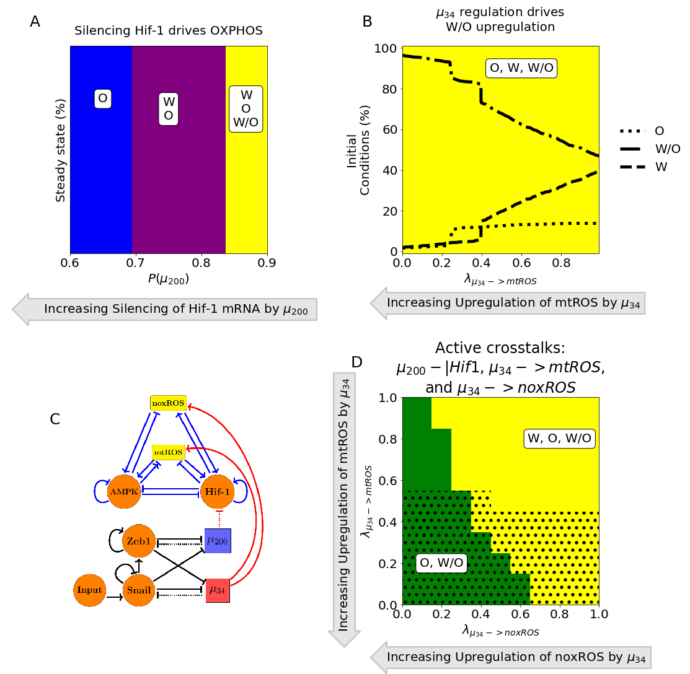

Crosstalks in one direction not enough to suppress all coupled states except E/M-W/O. (A) The number of initial conditions leading to the W, O, or W/O metabolic phenotypes. The colors (blue, purple, and grey) represent the possible phenotypes (O, [W,O], and [W,O,W/O]) as the Hif1 mRNA is silenced. (B) Similar to (A) but for an increasing upregulation of mtROS by . (C) The networks showing the regulating of Hif1 by and ROS by . When all three crosstalks are active there is a parameter space in which W/O phenotype persists and the dotted regions show where the E/M-W/O coupled state exists.

**TFs of the metabolic network can stabilize the E/M metabolic phenotype**

Looking more closely at the crosstalks in which Hif-1 regulates Snail and , we see they push the system towards the mesenchymal state. Further, both the epithelial and hybrid E/M states are most associated with the OXPHOS metabolic state while the mesenchymal state is initially associated with the Warburg state. Interestingly, when Hif-1 regulates the EMT circuit, the E-O and E/M-O coupled states persist, with the E/M-O existing at more values of the foldchange than the E-O state. Opposite to Hif1 crosstalks, AMPK pushes the EMT network to adopt an epithelial phenotype and suppresses the E/M state before the mesenchymal state. Additionally, if AMPK is regulating the EMT circuit, the epithelial and mesenchymal states are still most associated with the OXPHOS and Warburg metabolic phenotypes, respectively, but the E/M state is associated with the Warburg state. A different metabolic phenotype associated with the hybrid E/M depending on the crosstalk suggests neither is strongly associated with the E/M phenotype. Furthermore, AMPK inhibiting Zeb or Snail have nearly identical phases (Fig S7 and S11) but AMPK upregulating goes through different sets of possible steady states before saturating at fully epithelial (Fig S8). Similarly, Hif1 inhibiting and Hif1 upregulating Snail go through different sets of possible steady states before nearly saturating at mesenchymal (Figs S10 and S9).

There are two distinct events at play when the metabolic network regulates the EMT circuit. AMPK regulation quickly suppresses the E/M phenotype and pushes the system towards the Epithelial state whereas Hif1 regulation can allow the system to maintain the E/M phenotype while ultimately pushing the system towards mesenchymal (Fig 4A and 4B). Further, modulating the input to Snail can alter the location of the E/M state (see Fig S12). As AMPK and Hif1 push the system towards opposite states, having one of each would suggest the circuit would be pushed toward hybrid. That is exactly what happens for any combination of the three AMPK crosstalks and two Hif1 crosstalks, although the exact values of where the E/M-W/O state exists depends on the type of regulation (Fig S?). If all crosstalks involving AMPK and Hif1 regulating the EMT circuit are active (Fig 4C) then there are regions in which the E/M state exists (Fig 4D). However, when analyzing the system for the existence of the E/M-W/O phenotype, it only exists in smaller regions compared to full regulation of the metabolism network (the black dotted regions of Fig 4D compared to Fig 3D).

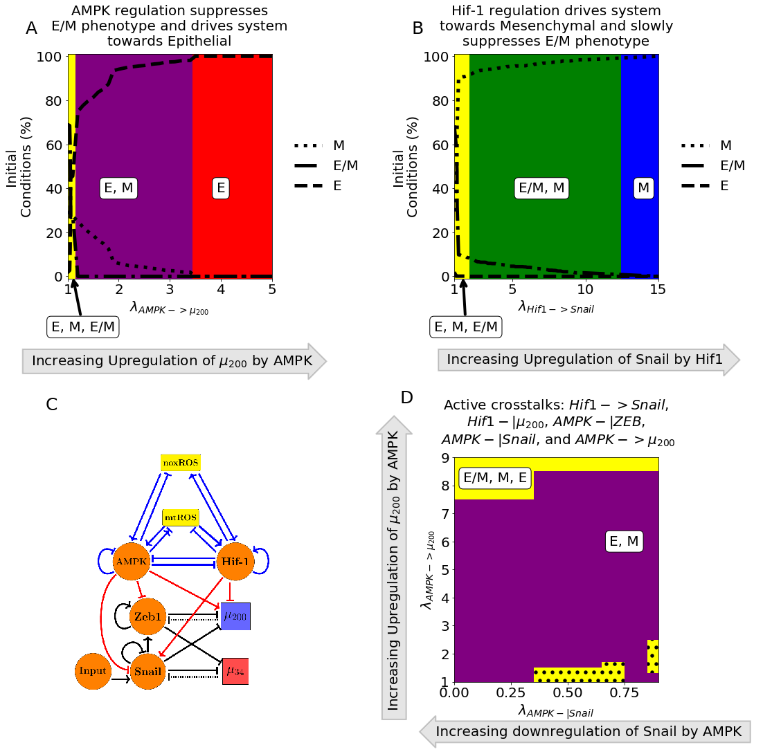

Crosstalks in one direction not enough to suppress all coupled states except E/M-W/O. (A) The number of initial conditions leading to an E/M, M, or E phenotype as AMPK upregulates . The hybrid E/M phenotype is suppressed quickly as the system is driven towards epithelial. (B) Similar to (A) but for Hif-1 driving the system towards mesenchymal. The E/M state persists longer for Hif-1 regulation than AMPK.(C) The network showing the active crosstalks in red. (D) The crosstalks involving AMPK (top) and Hif1 (bottom). When all five crosstalks are actively regulating the EMT circuit, there are only a few regions where the E/M phenotype exists alongside the E and M phenotype. Additionally, there are some regions (the dotted black areas) where the E/M-W/O coupled state also exists.

**Hybrid E/M-W/O phenotype can be stabilized**

As the most aggressive cancers phenotypes are characterized by the hybrid states of both the EMT and metabolism networks, we narrow our search onto how the crosstalks in both directions affect the presence of the E/M-W/O state and the behavior of the coupled states as the regulatory crosstalks change.

Identifying the phases present when all metabolism regulating crosstalks ( silencing HIf1 mRNA and upregulating noxROS and mtROS) are active shows the E/M-W/O state is suppressed when mtROS is only slightly upregulated (Fig 3C shows only the W, O, and WO states of 5A). Further, the epithelial and E/M states are associated with the OXPHOS phenotype when mtROS levels are slightly upregulated. Interestingly, the mesenchymal state is coupled with O and W/O metabolic phenotypes while the E and E/M states are only coupled to the W/O phenotype when mtROS is fully upregulated. The upregulation of the E/M-W/O phentotype as the mtROS levels increase suggests ROS is necessary for the EMT.

To stabilize the E/M state an AMPK and Hif1 crosstalk are necessary, and if all EMT regulating crosstalks are active then there are regions where the E/M-W/O state exists. Additionally, the epithelial state is typically coupled to OXPHOS metabolism (E-O), the mesenchymal state is associated with the Warburg metabolic phenotype (M-W), and when the E/M state is present it is associated with the hybrid metabolic phenotype (Fig 5B). In fact, for any system, if there are only three coupled states available and each has a distinct phenotype of the EMT and metabolic networks than the only possible set of states is E-O, M-W, and E/M-W/O. This suggests, just as the epithelial and mesenchymal states are expected to use OXPHOS or aerobic glycolysis, the hybrid E/M state utilizes the hybrid W/O metabolism.

To stabilize and upregulate the E/M-W/O state one would expect ROS must be upregulated and two competing crosstalks regulating the EMT network would be needed. The E/M-W/O state is upregulated if these conditions are met and can even be upregulated for small ranges of parameters if there is one crosstalk in both directions. Interestingly, with just three regulations (Hif1 inhibiting , upregulating mtROS, and modulating the input to Snail) can suppress all states except the E/M-W/O state (Fig 5C). This region persists even if all crosstalks are active (Fig 5D). Further, the other phases present with these active crosstalks are the same, suggesting there is a progression that must be followed to generate the E/M-W/O state. Additionally, the persistence of the E/M-W/O state suggests there are other combinations that generate phases where only the E/M-W/O state is possible, although it is outside the scope to find all possible combinations of crosstalks that can suppress all states except the E/M-W/O.

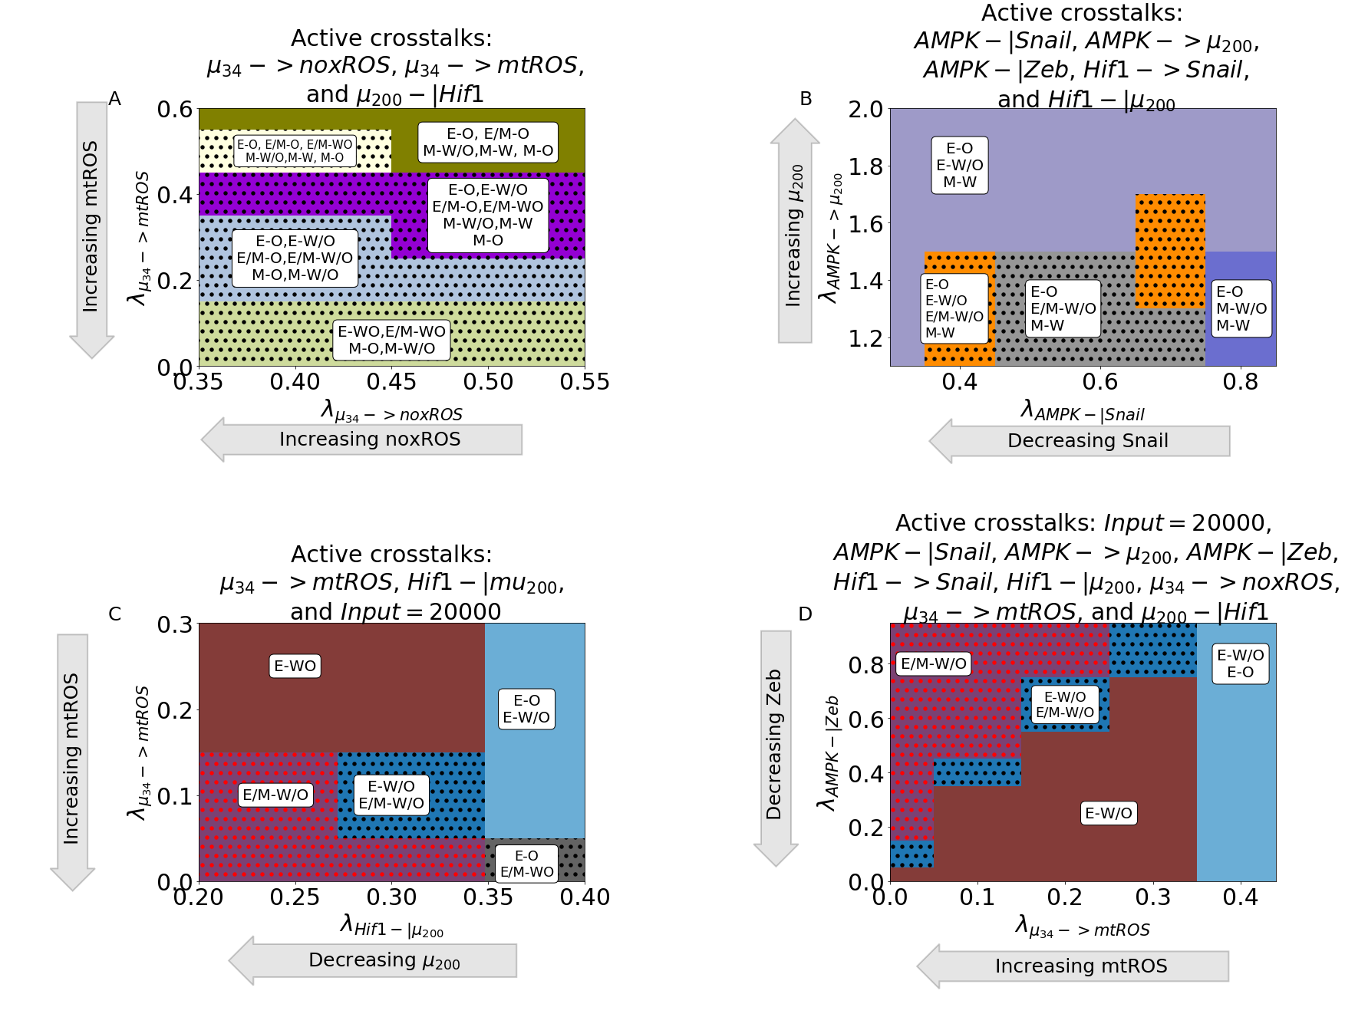

The hybrid E/M and W/O states are coupled. (A) The coupled states when only ROS of the metabolic circuit (mt and nox) are regulated by u34. The E/M-W/O state is present in most regions. (B) The coupled states when only TFs and miRNAs of the EMT circuit are regulated by TFs of the metabolic circuit (AMPK-|Snail, AMPK-|Zeb=?, AMPK->u200, Hif1-|u200=?, Hif1->Snail=?). The E/M-W/O state is present in some regions. (C) When crosstalks in both directions are active there are parameter spaces in which the only possible coupled state is the E/M-W/O state. (D) When all crosstalks are active there are regions where only the E/M-W/O state exists.

**Normal cells can become cancerous when crosstalks introduced**

We have confirmed that the E/M and W/O states are coupled, the E/M-W/O state can be upregulated, and there are parameter sets with only E/M-W/O and all other states suppressed. Now we determine whether the crosstalks are strong enough to generate the hybrid states. The model of the previous sections was for the tristable circuits so we modified the parameters to ensure each circuit was initially bistable (i.e., only the E, M, W, and O states are possible). We confirmed the parameters of the inactive coupled system resulted in a bistable system by calculating the nullclines (Table S? for parameters that were changed compared with the coupled tristable systems and Fig S2, Fig S14-S15).

For the metabolic circuit, the system only becomes tristable at high levels of mtROS upregulation (Fig 6A). Additionally, when activates mtROS it can even upregulate the E/M-W/O as compared to the initially tristable system with no active crosstalks. The system remains bistable if only noxROS is upregulated or Hif1 is downregulated (Fig S?). Furthermore, when looking at the crosstalks on the bistable EMT network (i.e., no E/M stable state) AMPK regulating a single crosstalk cannot generate the E/M state but regulation by Hif1 or modulating the input to snail can (Fig 6B and S?). The system can also attain tristability if there are two competing crosstalks, such as AMPK upregulating Snail and HIf1 downregulating .

When comparing these results to the tristable circuit we can look at the simplest set of crosstalks with a parameter region that suppressed all coupled states except the E/M-W/O state (namely Hif1 inhibiting , upregulating mtROS, and modulating the input to snail). The results for the bistable circuit are qualitatively very similar to the tristable circuit (Fig 5C compared to Fig 6C). The E/M state is only possible near full inhibition of and the W/O state is possible when mtROS greatly upregulated. Further, the system must be near maximum regulation (i.e. both foldchanges must be close to zero) to generate the region where only E/M-W/O is possible. The nearby phases being similar to the tristable circuit further supports the existence of a preferential pathway to stabilize the E/M-W/O state that follows intuition. As the EMT starts with an epithelial state, and knowing the epithelial state typically uses OXPHOS, the transition from E-O to E-W/O to E/M-W/O suggests metabolism may help drive EMT. These results suggest upregulating mtROS and Hif1 regulating EMT may stabilize the E/M-W/O state more than the other crosstalks.

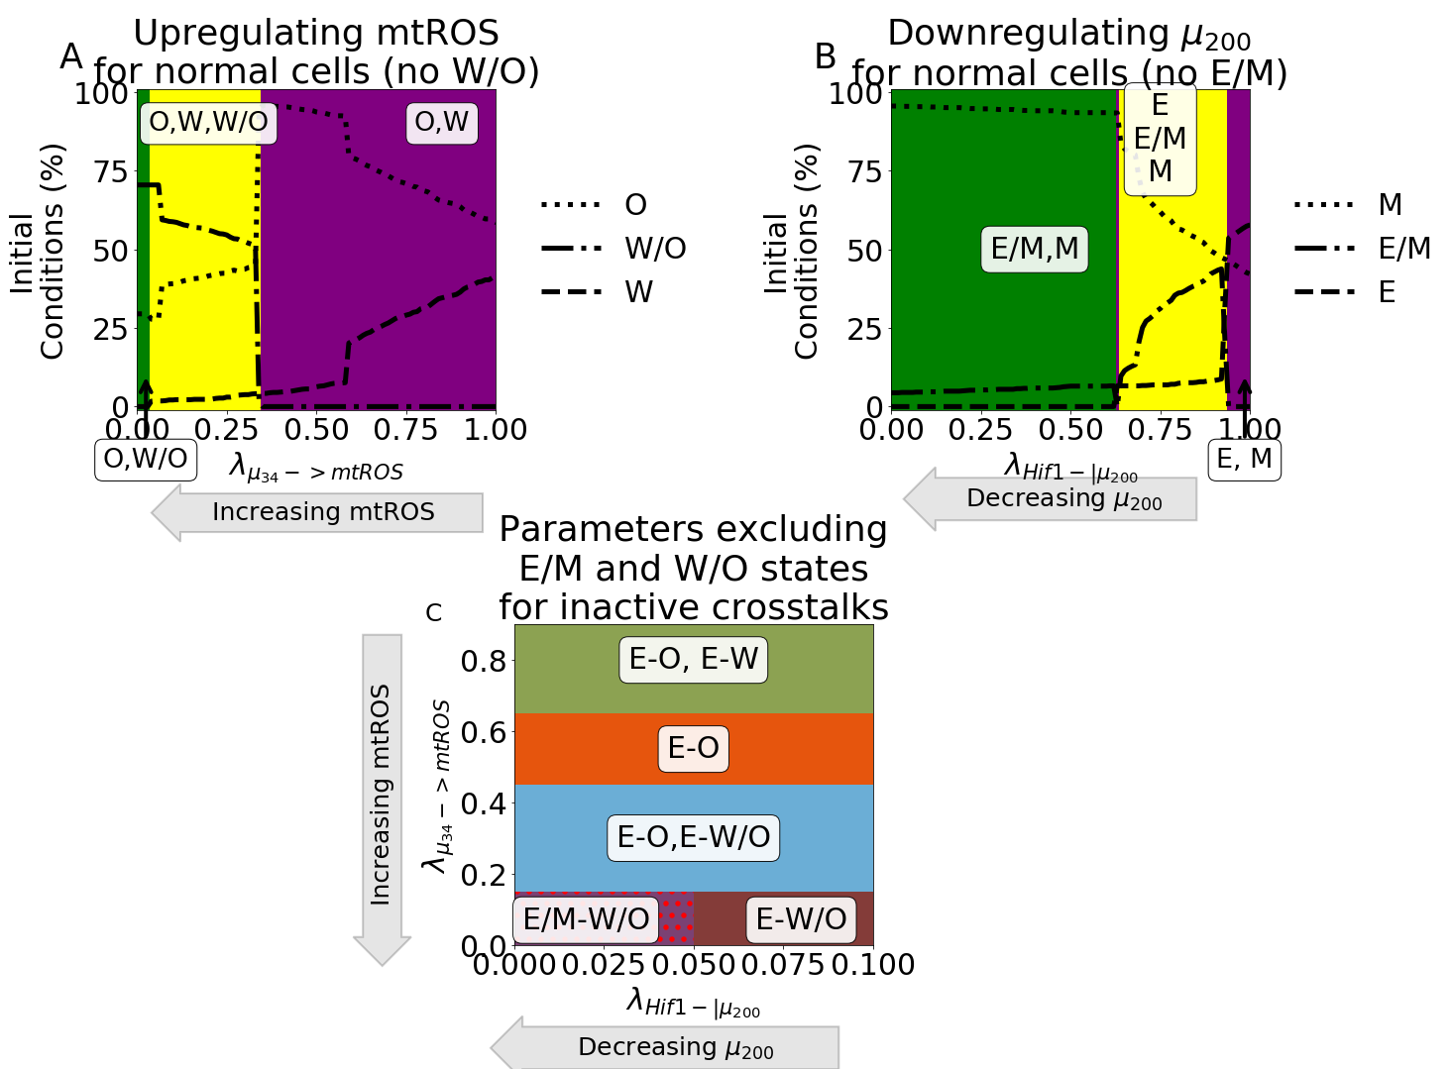

Parameter ranges which exclude the possibility of the hybrid state can be modulated by crosstalk to generate the hybrid state. (A) Our model using parameters that remove the hybrid W/O metabolic state from the steady state possibilities when the crosstalk is inactive (). Initially, only the OXPHOS and Warburg metabolic states can be accessed with an increase in the percent of OXPHOS steady states and decrease in Warburg phenotypes. Once , there is a sharp change with the hybrid W/O phenotype becoming the most often occupied phenotype. (B) Our model using parameters that remove the hybrid E/M phenotype from the accessible states when the crosstalks are inactive. By adjusting the level of input to Snail (y-axis) and the inhibition of by Hif-1 (x-axis), the system can access the E/M hybrid state (orange, light blue, and purple regions). (C) Focusing on the region in (B) where the input to snail is 10K, the percent of initial conditions leading to E, M, or the E/M phenotype can be seen. As the inhibition increases ( goes towards zero), the system goes from all initial conditions leading to the Epithelial state to a region with both E and E/M phenotypes accessible. (D) Combining the models from (A) and (B), we generate a model which only has 4 possible coupled states if the crosstalks are inactive (E-O, E-W, M-O, and M-W). By setting the input to snail to be 10K, upregulating mtROS, and downregulating mir200 the E/M-W/O state becomes accessible and, at around and , the E/M-W/O state is the only one accessible, similar to the model with parameters always allowing access to the E/M-W/O state.

**PSFs stabilize the E/M state which stabilized W/O state**

Lastly we determined whether theE/M and W/O states could be further stabilized, and therefore upregulate the E/M-W/O state, by adding two protein stability factors GRHL2 and OVOL2 to the network. Both work together to stabilize the E/M state, but GRHL2 also upregulates ROS (Fig 7A). The PSF stabilized coupled network with inactive crosstalks can either be in the E/M-W/O or E/M-O state.

When a single crosstalk is active, the behavior is as expected with the E/M-W/O state persisting for more values than the tristable coupled network. When any of the individual crosstalks by Hif1 regulating the EMT circuit are active, there is an increased region in which the E/M-W/O state is possible (Fig S?). Further, if AMPK is regulating the EMT circuit than the E/M-W/O is possible throughout the entire region analyzed for the tristable circuit (Fig S?).

When multiple crosstalks are active the stability of the E/M-W/O state persists. If two competing crosstalks on the EMT circuit are active (i.e., one Hif1 and one AMPK regulation active), then the E/M-W/O state is possible for most of the parameter space (Fig 7B). The regulatory crosstalks controlled by Hif1 seem to have a stronger affect than the AMPK crosstalks, and can push the system towards mesenchymal. This follows what’s seen in the tristable coupled network where AMPK upregulating seems to have a weaker effect, specifically on the E/M-W/O state, than Hif1 downregulating . Lastly, we can compare the regions where E/M-W/O is the only state when upregulates mtROS, Hif1 downregulates , and the input to Snail is modulated. We see the state exists in a far larger region when stabilized by the PSFs than in the tristable coupled network (Fig 7C). Once again the phases close to the E/M-W/O only region are similar to the possible sets of coupled states that also exist for the same group of active crosstalks in the tristable circuit.

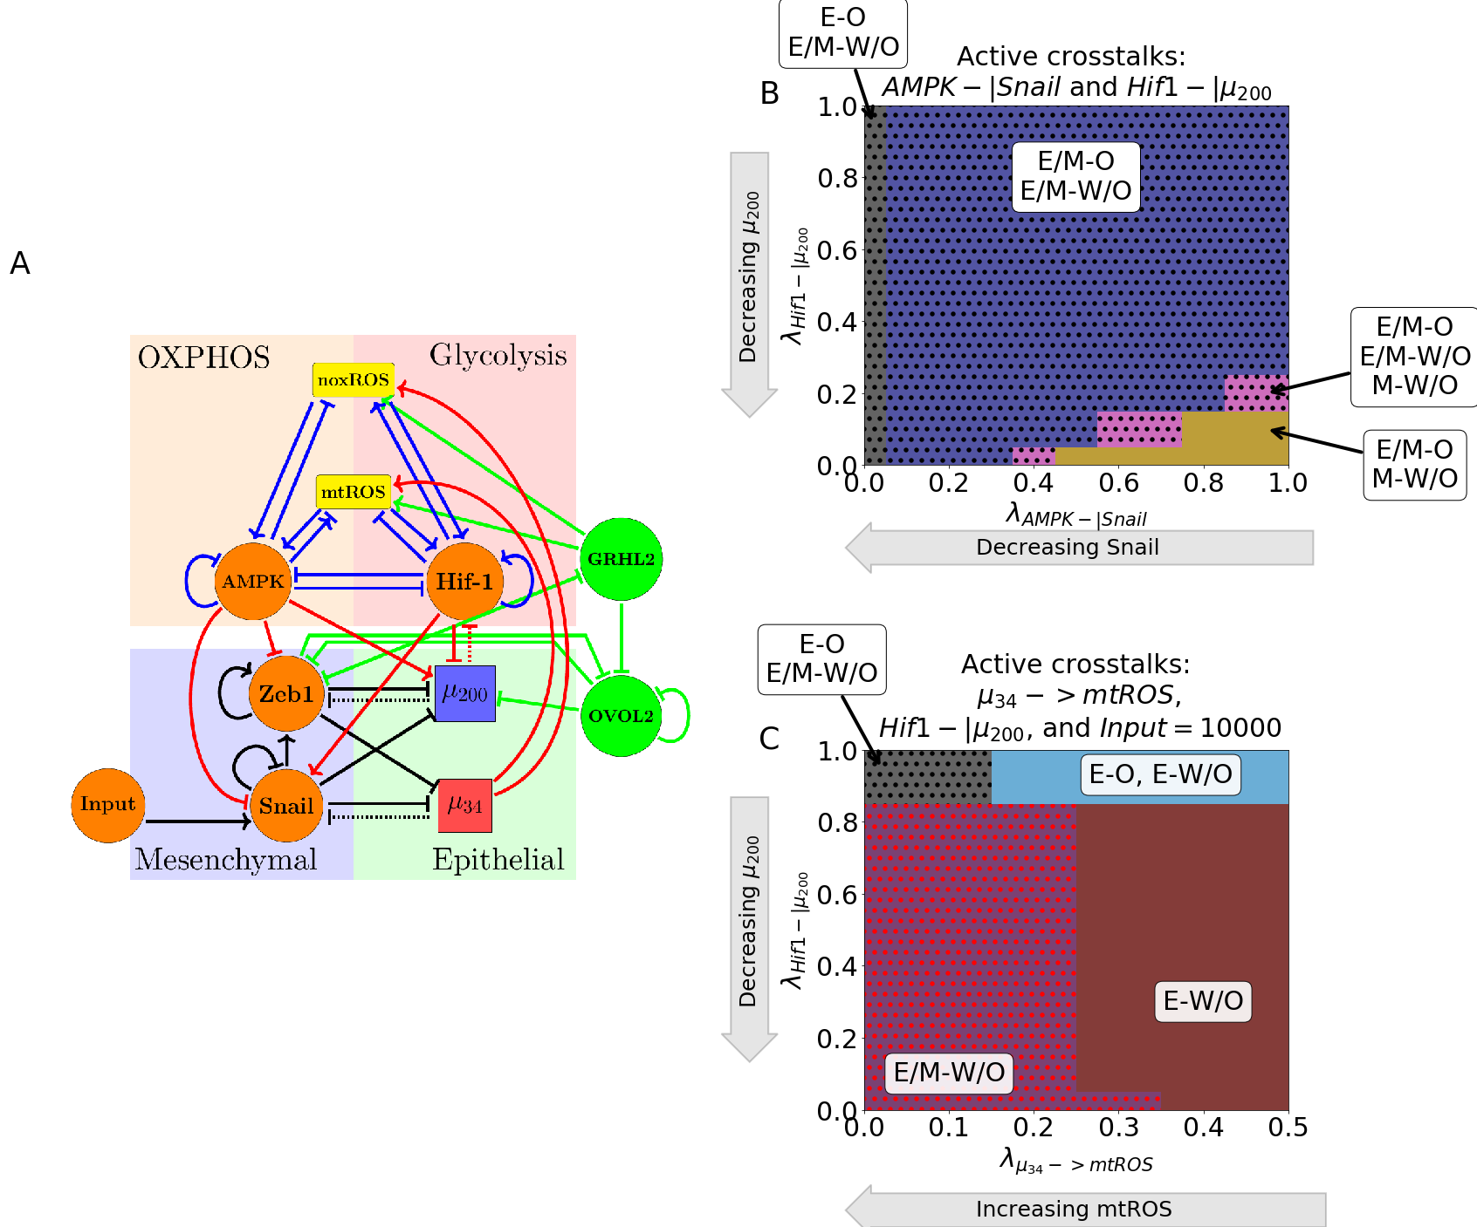

PSFs stabilizing E/M state can increase parameters spaces of E/M-W/O states. (A) The modified network to include GRHL2, OVOL2, and TGF. (B) The phase space when the Input to Snail is set to 10K, is upregulating mtROS, and Hif1 is downregulating . There is a larger region where E/M-W/O is the only possible coupled state compared to the original model (see Fig 4C). (C) The coupled E/M-W/O state is present in more of the space due to the PSFs stabilizing the E/M state even when AMPK downregulates Snail and Hif1 downregulated .

**Discussion**

Based on this work we have seen that there does seem to be a link between the hybrid E/M and W/O states suggesting that metastasing cells require a hybrid approach to increase their rate of energy production. We’ve identified some crosstalks that could be expanded upon to increase our understanding of metastasis.

mtROS nearly suppressing the OXPHOS and Warburg phenotypes combined with the results that increase of ROS is more pronounced for mtROS than noxROS[15] suggests mtROS specifically is critical to tumor progression. Recent work by Radisky and collaborators has suggested ROS may be important to begin the epithelial to mesenchymal transition [32]. Our results that Hif-1 crosstalks seem to be stronger than AMPK corresponds to the well-known role of hypoxia triggering the EMT [33]. Recently, the role of miRNAs in the cancer metastasis [34] has been emphasized and we have seen the role ROS play in triggering the W/O phenotype. Further, our work suggests the existence of a feedback loop between , , Hif-1 and ROS that may be critical to stabilizing the E/M-W/O state associated with tumorigenesis.

The feedback, especially upregulating ROS, may be of critical importance given the two pathways mentioned previously, p53 and KEAP1-NRF2, may have competing effects on EMT and metabolism. For instance, there is a connection between NRF2 upregulation and the E/M phenotype [12] but NRF2 is also an antioxidant that must be downregulated to upregulate ROS production [15–17]. However, the metabolic phenotype of NRF2 stabilized E/M cells may correspond to a hybrid W/O phenotype [35]. The p53 pathway seems to upregulate noxROS [19,20]. Here we establish a connection between ROS upregulation and the E/M-W/O phenotype, and to further elucidate the mechanism by which ROS promotes tumorigenesis, additional pathways such as the KEAP1-NRF2 and p53 pathways should also be explored in conjuction with crosstalk between the EMT and metabolic circuits. Additionally, the E/M-W/O state was stabilized when the input to Snail was modulated confirming the tumor microenvironment and other signals, such as TGF-, may be important to generating the E/M-W/O state.

To stabilize only the E/M-W/O state, the system seems to first require the E-O state, then the E-W/O or E/M-O states, before stabilizing the E/M-W/O state and suppressing all other systems. This result suggests the mechanism to stabilize the E/M-W/O may be less about stabilizing the state and more about stopping the transition. Additionally, the E/M-W/O can be fully upregulated and all other coupled states suppressed regardless of whether the system is initially near that state or not, suggesting the crosstalks involved in tumorigenesis have evolved to ensure survival and proliferation. Therefore, to cancer therapies should be developed that target the EMT pathway in conjunction with the metabolic pathway.

**Acknowledgements**

[1] D. Hanahan and R. A. Weinberg, *Hallmarks of Cancer: The Next Generation*, Cell **144**, 646 (2011).

[2] R. Kalluri, *EMT: When epithelial cells decide to become mesenchymal-like cells*, Journal of Clinical Investigation **119**, 1417 (2009).

[3] J. M. Lee, S. Dedhar, R. Kalluri, and E. W. Thompson, *The epithelial–mesenchymal transition: new insights in signaling, development, and disease*, The Journal of Cell Biology **172**, 973 (2006).

[4] M. Lu, M. K. Jolly, H. Levine, J. N. Onuchic, and E. Ben-Jacob, *MicroRNA-based regulation of epithelial–hybrid–mesenchymal fate determination*, Proceedings of the National Academy of Sciences **110**, 18144 (2013).

[5] M. Saitoh, *Involvement of partial EMT in cancer progression*, The Journal of Biochemistry **164**, 257 (2018).

[6] D. Bhattacharya, A. P. Azambuja, and M. Simoes-Costa, *Metabolic Reprogramming Promotes Neural Crest Migration via Yap/Tead Signaling*, Developmental Cell **53**, 199 (2020).

[7] O. Warburg, F. Wind, and E. Negelein, *THE METABOLISM OF TUMORS IN THE BODY*, Journal of General Physiology **8**, 519 (1927).

[8] M. V. Liberti and J. W. Locasale, *The Warburg Effect: How Does it Benefit Cancer Cells?*, Trends in Biochemical Sciences **41**, 211 (2016).

[9] L. Yu, M. Lu, D. Jia, J. Ma, E. Ben-Jacob, H. Levine, B. A. Kaipparettu, and J. N. Onuchic, *Modeling the Genetic Regulation of Cancer Metabolism: Interplay between Glycolysis and Oxidative Phosphorylation*, Cancer Research **77**, 1564 (2017).

[10] I. Georgakopoulos-Soares, D. V. Chartoumpekis, V. Kyriazopoulou, and A. Zaravinos, *EMT Factors and Metabolic Pathways in Cancer*, Frontiers in Oncology **10**, 499 (2020).

[11] D. Jia, J. H. Park, H. Kaur, K. H. Jung, S. Yang, S. Tripathi, M. Galbraith, Y. Deng, M. K. Jolly, B. A. Kaipparettu, J. N. Onuchic, and H. Levine, *Towards decoding the coupled decision-making of metabolism and epithelial-to-mesenchymal transition in cancer*, British Journal of Cancer 1 (2021).

[12] F. Bocci, S. C. Tripathi, S. A. V. Mercedes, J. T. George, J. P. Casabar, P. K. Wong, S. M. Hanash, H. Levine, J. N. Onuchic, and M. K. Jolly, *NRF2 activates a partial epithelial-mesenchymal transition and is maximally present in a hybrid epithelial/mesenchymal phenotype*, Integrative Biology **11**, 251 (2019).

[13] M. Luo, L. Shang, M. D. Brooks, E. Jiagge, Y. Zhu, J. M. Buschhaus, S. Conley, M. A. Fath, A. Davis, E. Gheordunescu, Y. Wang, R. Harouaka, A. Lozier, D. Triner, S. McDermott, S. D. Merajver, G. D. Luker, D. R. Spitz, and M. S. Wicha, *Targeting Breast Cancer Stem Cell State Equilibrium through Modulation of Redox Signaling*, Cell Metabolism **28**, 69 (2018).

[14] J. A. Colacino, E. Azizi, M. D. Brooks, R. Harouaka, S. Fouladdel, S. P. McDermott, M. Lee, D. Hill, J. Madden, J. Boerner, M. L. Cote, M. A. Sartor, L. S. Rozek, and M. S. Wicha, *Heterogeneity of Human Breast Stem and Progenitor Cells as Revealed by Transcriptional Profiling*, Stem Cell Reports **10**, 1596 (2018).

[15] S. Kovac, P. R. Angelova, K. M. Holmström, Y. Zhang, A. T. Dinkova-Kostova, and A. Y. Abramov, *Nrf2 regulates ROS production by mitochondria and NADPH oxidase*, Biochimica et Biophysica Acta (BBA) - General Subjects **1850**, 794 (2015).

[16] F. He, X. Ru, and T. Wen, *NRF2, a Transcription Factor for Stress Response and Beyond*, International Journal of Molecular Sciences **21**, 4777 (2020).

[17] N. Li, S. Muthusamy, R. Liang, H. Sarojini, and E. Wang, *Increased expression of miR-34a and miR-93 in rat liver during aging, and their impact on the expression of Mgst1 and Sirt1*, Mechanisms of Ageing and Development **132**, 75 (2011).

[18] X.-Y. Bai, Y. Ma, R. Ding, B. Fu, S. Shi, and X.-M. Chen, *miR-335 and miR-34a Promote Renal Senescence by Suppressing Mitochondrial Antioxidative Enzymes*, Journal of the American Society of Nephrology **22**, 1252 (2011).

[19] F. Navarro and J. Lieberman, *miR-34 and p53: New Insights into a Complex Functional Relationship*, PLoS ONE **10**, (2015).

[20] D. Italiano, A. M. Lena, G. Melino, and E. Candi, *Identification of NCF2/p67phox as a novel p53 target gene*, Cell Cycle **11**, 4589 (2012).

[21] H.-L. Chou, Y. Fong, C.-K. Wei, E.-M. Tsai, J. Y.-F. Chen, W.-T. Chang, C.-Y. Wu, H.-W. Huang, and C.-C. Chiu, *A Quinone-Containing Compound Enhances Camptothecin-Induced Apoptosis of Lung Cancer Through Modulating Endogenous ROS and ERK Signaling*, Archivum Immunologiae et Therapiae Experimentalis **65**, 241 (2017).

[22] M. Serocki, S. Bartoszewska, A. Janaszak-Jasiecka, R. J. Ochocka, J. F. Collawn, and R. Bartoszewski, *miRNAs regulate the HIF switch during hypoxia: a novel therapeutic target*, Angiogenesis **21**, 183 (2018).

[23] Y. Shang, H. Chen, J. Ye, X. Wei, S. Liu, and R. Wang, *HIF-1a/Ascl2/miR-200b regulatory feedback circuit modulated the epithelial-mesenchymal transition (EMT) in colorectal cancer cells*, Experimental Cell Research **360**, 243 (2017).

[24] Y. Byun, Y.-C. Choi, Y. Jeong, G. Lee, S. Yoon, Y. Jeong, J. Yoon, and K. Baek, *MiR-200c downregulates HIF-1a and inhibits migration of lung cancer cells*, Cellular & Molecular Biology Letters **24**, 28 (2019).

[25] X. Xu, X. Tan, B. Tampe, E. Sanchez, M. Zeisberg, and E. M. Zeisberg, *Snail Is a Direct Target of Hypoxia-inducible Factor 1a (HIF1a) in Hypoxia-induced Endothelial to Mesenchymal Transition of Human Coronary Endothelial Cells\**, Journal of Biological Chemistry **290**, 16653 (2015).

[26] C.-C. Chou, K.-H. Lee, I.-L. Lai, D. Wang, X. Mo, S. K. Kulp, C. L. Shapiro, and C.-S. Chen, *AMPK Reverses the Mesenchymal Phenotype of Cancer Cells by Targeting the Akt–MDM2–Foxo3a Signaling Axis*, Cancer Research **74**, 4783 (2014).

[27] J. Ohshima, Q. Wang, Z. R. Fitzsimonds, D. P. Miller, M. N. Sztukowska, Y.-J. Jung, M. Hayashi, M. Whiteley, and R. J. Lamont, *Streptococcus gordonii programs epithelial cells to resist ZEB2 induction by Porphyromonas gingivalis*, Proceedings of the National Academy of Sciences **116**, 201900101 (2019).

[28] W. Huang, J. Cao, X. Liu, F. Meng, M. Li, B. Chen, and J. Zhang, *AMPK Plays a Dual Role in Regulation of CREB/BDNF Pathway in Mouse Primary Hippocampal Cells*, Journal of Molecular Neuroscience **56**, 782 (2015).

[29] H. Jin, L. Xue, L. Mo, D. Zhang, X. Guo, J. Xu, J. Li, M. Peng, X. Zhao, M. Zhong, D. Xu, X.-R. Wu, H. Huang, and C. Huang, *Downregulation of miR-200c stabilizes XIAP mRNA and contributes to invasion and lung metastasis of bladder cancer*, Cell Adhesion & Migration **13**, 236 (2019).

[30] M. Janin and M. Esteller, *Oncometabolite Accumulation and Epithelial-to-Mesenchymal Transition: The Turn of Fumarate*, Cell Metabolism **24**, 529 (2016).

[31] Q. Zhang, S. Zheng, S. Wang, W. Wang, H. Xing, and S. Xu, *Chlorpyrifos induced oxidative stress to promote apoptosis and autophagy through the regulation of miR-19a-AMPK axis in common carp*, Fish & Shellfish Immunology **93**, 1093 (2019).

[32] D. C. Radisky, D. D. Levy, L. E. Littlepage, H. Liu, C. M. Nelson, J. E. Fata, D. Leake, E. L. Godden, D. G. Albertson, M. A. Nieto, Z. Werb, and M. J. Bissell, *Rac1b and reactive oxygen species mediate MMP-3-induced EMT and genomic instability*, Nature **436**, 123 (2005).

[33] K. Saxena, M. K. Jolly, and K. Balamurugan, *Hypoxia, partial EMT and collective migration: Emerging culprits in metastasis*, Translational Oncology **13**, 100845 (2020).

[34] G. Babaei, N. Raei, A. T. milani, S. G.-G. Aziz, N. Pourjabbar, and F. Geravand, *The emerging role of miR-200 family in metastasis: focus on EMT, CSCs, angiogenesis, and anoikis*, Molecular Biology Reports **48**, 6935 (2021).

[35] V. S. LeBleu, J. T. O’Connell, K. N. G. Herrera, H. Wikman, K. Pantel, M. C. Haigis, F. M. de Carvalho, A. Damascena, L. T. D. Chinen, R. M. Rocha, J. M. Asara, and R. Kalluri, *PGC-1a mediates mitochondrial biogenesis and oxidative phosphorylation in cancer cells to promote metastasis*, Nature Cell Biology **16**, 992 (2014).

1. Hanahan D. Hallmarks of Cancer: New Dimensions. Cancer Discov. 2022;12(1):31–46.

2. Kalluri R. EMT: When epithelial cells decide to become mesenchymal-like cells. J Clin Invest. 2009;119(6):1417–9.

3. Lee JM, Dedhar S, Kalluri R, Thompson EW. The epithelial–mesenchymal transition: new insights in signaling, development, and disease. J Cell Biology. 2006;172(7):973–81.

4. Lu M, Jolly MK, Levine H, Onuchic JN, Ben-Jacob E. MicroRNA-based regulation of epithelial–hybrid–mesenchymal fate determination. Proc National Acad Sci. 2013;110(45):18144–9.

5. Saitoh M. Involvement of partial EMT in cancer progression. J Biochem. 2018;164(4):257–64.

6. Bhattacharya D, Azambuja AP, Simoes-Costa M. Metabolic Reprogramming Promotes Neural Crest Migration via Yap/Tead Signaling. Dev Cell. 2020;53(2):199-211.e6.

7. Warburg O, Wind F, Negelein E. THE METABOLISM OF TUMORS IN THE BODY. J Gen Physiol. 1927;8(6):519–30.

8. Liberti MV, Locasale JW. The Warburg Effect: How Does it Benefit Cancer Cells? Trends Biochem Sci. 2016;41(3):211–8.

9. Yu L, Lu M, Jia D, Ma J, Ben-Jacob E, Levine H, et al. Modeling the Genetic Regulation of Cancer Metabolism: Interplay between Glycolysis and Oxidative Phosphorylation. Cancer Res. 2017;77(7):1564–74.

10. Georgakopoulos-Soares I, Chartoumpekis DV, Kyriazopoulou V, Zaravinos A. EMT Factors and Metabolic Pathways in Cancer. Frontiers Oncol. 2020;10:499.

11. Jia D, Park JH, Kaur H, Jung KH, Yang S, Tripathi S, et al. Towards decoding the coupled decision-making of metabolism and epithelial-to-mesenchymal transition in cancer. Brit J Cancer. 2021;1–10.

12. Bocci F, Tripathi SC, Mercedes SAV, George JT, Casabar JP, Wong PK, et al. NRF2 activates a partial epithelial-mesenchymal transition and is maximally present in a hybrid epithelial/mesenchymal phenotype. Integr Biol. 2019;11(6):251–63.

13. Luo M, Shang L, Brooks MD, Jiagge E, Zhu Y, Buschhaus JM, et al. Targeting Breast Cancer Stem Cell State Equilibrium through Modulation of Redox Signaling. Cell Metab. 2018;28(1):69-86.e6.

14. Colacino JA, Azizi E, Brooks MD, Harouaka R, Fouladdel S, McDermott SP, et al. Heterogeneity of Human Breast Stem and Progenitor Cells as Revealed by Transcriptional Profiling. Stem Cell Rep. 2018;10(5):1596–609.

15. Kovac S, Angelova PR, Holmström KM, Zhang Y, Dinkova-Kostova AT, Abramov AY. Nrf2 regulates ROS production by mitochondria and NADPH oxidase. Biochimica Et Biophysica Acta Bba - Gen Subj. 2015;1850(4):794–801.

16. He F, Ru X, Wen T. NRF2, a Transcription Factor for Stress Response and Beyond. Int J Mol Sci. 2020;21(13):4777.

17. Li N, Muthusamy S, Liang R, Sarojini H, Wang E. Increased expression of miR-34a and miR-93 in rat liver during aging, and their impact on the expression of Mgst1 and Sirt1. Mech Ageing Dev. 2011;132(3):75–85.

18. Bai X-Y, Ma Y, Ding R, Fu B, Shi S, Chen X-M. miR-335 and miR-34a Promote Renal Senescence by Suppressing Mitochondrial Antioxidative Enzymes. J Am Soc Nephrol. 2011;22(7):1252–61.

19. Navarro F, Lieberman J. miR-34 and p53: New Insights into a Complex Functional Relationship. Plos One. 2015;10(7):e0132767.

20. Italiano D, Lena AM, Melino G, Candi E. Identification of NCF2/p67phox as a novel p53 target gene. Cell Cycle. 2012;11(24):4589–96.

21. Chou H-L, Fong Y, Wei C-K, Tsai E-M, Chen JY-F, Chang W-T, et al. A Quinone-Containing Compound Enhances Camptothecin-Induced Apoptosis of Lung Cancer Through Modulating Endogenous ROS and ERK Signaling. Arch Immunol Ther Ex. 2017;65(3):241–52.

22. Serocki M, Bartoszewska S, Janaszak-Jasiecka A, Ochocka RJ, Collawn JF, Bartoszewski R. miRNAs regulate the HIF switch during hypoxia: a novel therapeutic target. Angiogenesis. 2018;21(2):183–202.

23. Shang Y, Chen H, Ye J, Wei X, Liu S, Wang R. HIF-1α/Ascl2/miR-200b regulatory feedback circuit modulated the epithelial-mesenchymal transition (EMT) in colorectal cancer cells. Exp Cell Res. 2017;360(2):243–56.

24. Byun Y, Choi Y-C, Jeong Y, Lee G, Yoon S, Jeong Y, et al. MiR-200c downregulates HIF-1α and inhibits migration of lung cancer cells. Cell Mol Biol Lett. 2019;24(1):28.

25. Xu X, Tan X, Tampe B, Sanchez E, Zeisberg M, Zeisberg EM. Snail Is a Direct Target of Hypoxia-inducible Factor 1α (HIF1α) in Hypoxia-induced Endothelial to Mesenchymal Transition of Human Coronary Endothelial Cells*. J Biol Chem. 2015;290(27):16653–64.

26. Chou C-C, Lee K-H, Lai I-L, Wang D, Mo X, Kulp SK, et al. AMPK Reverses the Mesenchymal Phenotype of Cancer Cells by Targeting the Akt–MDM2–Foxo3a Signaling Axis. Cancer Res. 2014;74(17):4783–95.

27. Ohshima J, Wang Q, Fitzsimonds ZR, Miller DP, Sztukowska MN, Jung Y-J, et al. Streptococcus gordonii programs epithelial cells to resist ZEB2 induction by Porphyromonas gingivalis. Proc National Acad Sci. 2019;116(17):201900101.

28. Huang W, Cao J, Liu X, Meng F, Li M, Chen B, et al. AMPK Plays a Dual Role in Regulation of CREB/BDNF Pathway in Mouse Primary Hippocampal Cells. J Mol Neurosci. 2015;56(4):782–8.

29. Jin H, Xue L, Mo L, Zhang D, Guo X, Xu J, et al. Downregulation of miR-200c stabilizes XIAP mRNA and contributes to invasion and lung metastasis of bladder cancer. Cell Adhes Migr. 2019;13(1):236–48.

30. Janin M, Esteller M. Oncometabolite Accumulation and Epithelial-to-Mesenchymal Transition: The Turn of Fumarate. Cell Metab. 2016;24(4):529–30.

31. Zhang Q, Zheng S, Wang S, Wang W, Xing H, Xu S. Chlorpyrifos induced oxidative stress to promote apoptosis and autophagy through the regulation of miR-19a-AMPK axis in common carp. Fish Shellfish Immun. 2019;93:1093–9.

32. Radisky DC, Levy DD, Littlepage LE, Liu H, Nelson CM, Fata JE, et al. Rac1b and reactive oxygen species mediate MMP-3-induced EMT and genomic instability. Nature. 2005;436(7047):123–7.

33. Saxena K, Jolly MK, Balamurugan K. Hypoxia, partial EMT and collective migration: Emerging culprits in metastasis. Transl Oncol. 2020;13(11):100845.

34. Babaei G, Raei N, milani AT, Aziz SG-G, Pourjabbar N, Geravand F. The emerging role of miR-200 family in metastasis: focus on EMT, CSCs, angiogenesis, and anoikis. Mol Biol Rep. 2021;48(10):6935–47.

35. LeBleu VS, O’Connell JT, Herrera KNG, Wikman H, Pantel K, Haigis MC, et al. PGC-1α mediates mitochondrial biogenesis and oxidative phosphorylation in cancer cells to promote metastasis. Nat Cell Biol. 2014;16(10):992–1003.