Business Understand & DBMS Foundation

Group Members :

1. Allan Cheerakunnil Alex
2. Babitha Tomy
3. Faisal Khan
4. Kartihik Reddy
5. Madan Dahiphale
6. Mansahib Singh

Domain : Fintech Industry

Company : Kredit Bee

Date : 11/04/2026

CASE STUDY
DA03: Financial Risk and Performance Analysis in Consumer Lending

The FinTech industry has emerged as a dynamic and transformative force in the financial sector, integrating technology with financial services to enhance efficiency, accessibility, and customer experience. In today's era, FinTech is crucial for democratizing financial services, providing underserved populations with access to banking, credit, and investment opportunities. It fosters innovation through digital payment systems, peer-to-peer lending platforms, and blockchain technology, revolutionizing traditional banking practices.

Data scientists play a pivotal role in the growth of FinTech by leveraging advanced analytics and machine learning to improve risk assessment, fraud detection, and personalized financial services. Their expertise enables FinTech companies to analyze vast amounts of financial data, uncovering insights that drive strategic decision-making, optimize operations, and enhance customer satisfaction. By harnessing the power of data, data scientists help FinTech firms stay competitive, innovate continuously, and contribute to a more inclusive and efficient financial ecosystem.

Product Dissection

1. Choose a leading platform from a domain related to the FinTech industry. Justify your selection by discussing the platform's popularity, impact, and relevance in its industry.
Answer:
Company Chosen: KreditBee
- ​Popularity: KreditBee is one of India's digital loan lending platforms, boasting over 100 million app downloads and a customer base exceeding 7 million active users. It has achieved massive scale with a credit disbursement tally crossing ₹30,000 crore.

- ​Impact: KreditBee disrupted the traditional banking sector by introducing a fully automated digital lending model. It bypassed legacy banking constraints by utilizing alternative data points (device data, location, SMS parsing) to underwrite loans for users
- who lacked traditional CIBIL scores, reducing loan disbursal times from days to a mere 10 minutes.

- ​Relevance: The Indian middle class and young professional demographic often face a "credit gap"—they need short-term liquidity for emergencies or purchases but lack the assets to secure traditional bank loans. KreditBee captures this "missing middle" market by providing unsecured personal loans ranging from ₹6,000 to ₹10 Lakhs, making formal credit accessible and driving financial inclusion in India.

2. Research and list the core features and functionalities of the selected platform. Describe how these features contribute to the platform’s success and user engagement.

Answer:

- Feature 1: Tiered Personal Loans (Flexi & Salaried): KreditBee offers highly customized loan products—ranging from small-ticket "Flexi Loans" for immediate needs to larger "Salaried Loans". Impact: This allows them to acquire a user at a low ticket size, build their credit history, and later upsell larger loans, directly increasing Customer Lifetime Value (LTV).

- ​Feature 2: 100% Digital KYC & Automated Underwriting: The platform uses OCR (Optical Character Recognition) for instant document verification and API integrations with credit bureaus. Impact: It drastically lowers Customer Acquisition Cost (CAC) by removing human intervention and operational bottlenecks, ensuring instant approvals.

- ​Feature 3: KreditBee UPI Integration: Users can link their bank accounts to a KreditBee UPI ID to make secure online and offline payments. Impact: This transitions KreditBee from a purely transactional loan app into an everyday utility app, massively increasing Daily Active Users (DAU) and app engagement.

- ​Feature 4: Seamless Repayment Ecosystem: The app features integrated payment gateways and auto-debit setups for EMI collections. Impact: This reduces friction during the repayment cycle, directly contributing to their high collection efficiency (typically 94-97%).

3. Identify the real-world problems that the platform aims to solve. Discuss how the platform addresses these problems through its features and functionalities.
Answer:
- Problem 1: Exclusion of "New to Credit" (NTC) Borrowers: Traditional banks reject young professionals because they lack a credit history.
Solution: KreditBee uses alternative data algorithms and AI-based risk profiling to underwrite young professionals and self-employed individuals without a rigid CIBIL footprint.
- ​Problem 2: High Turn-Around-Time (TAT) in Emergencies: Applying for a bank loan requires physical branch visits, heavy paperwork, and waiting days for approval, which is useless during a medical emergency.
Solution: KreditBee’s 100% online platform ensures eligibility checking, approval, and bank disbursal happens in under 10 minutes.
- ​Problem 3: Exploitation by Informal Moneylenders: Without access to formal banking, the working-class population relies on local loan sharks who charge 100-200% interest rates.
Solution: KreditBee provides a transparent, RBI-compliant alternative with clear processing fees and regulated APRs ranging from 17% to 50%.

Schema Design

4. Based on the features and functionalities you have identified, design a schema that reflects the platform’s data structure. Define the key entities, attributes, and relationships that underpin these features.

Key Entities and Attributes
1. User_Profile Table
Attribute | Type | Description
userID | Primary Key (UUID) | Unique user identifier for the user
mobileNumber | String | Registered Phone Number
monthlyIncome | Decimal | Users declared or verified income
cibilScore | Integer | Credit Score (Null if New-to-Credit)
kycVerified | Boolean | Aadhaar/PAN verification status

2. Loan_Product Table

Attribute | Type | Description
productID | Primary Key | Unique user identifier
productName | String | e.g., Flexi Personal Loan
minAmount | Decimal | Minimum disbursal (e.g., ₹6000)
maxAmount | Decimal | Maximum disbursal allowed
baseInterestRate | Decimal | Base annual interest rate

3. Loan_Application Table
Attribute | Type | Description
applicationID | Primary Key | Unique application identifier
userID | Foreign Key | Links to User_Profile
productID | Foreign Key | Minimum disbursal (e.g., ₹6000)
requestedAmount | Decimal | Amount requested by the user
riskTier | String | Risk category (A, B, C, High)
Status | String | Approved, Rejected, Disbursed, Defaulted
4. Repayment_Schedule Table
Attribute | Type | Description
EmiID | Primary Key | Unique EMI identifier
applicationID | Foreign Key | Link to Loan_Application
dueDate | Date | Payment due date
emiAmount | Decimal | Monthly installment amount
paymentStatus | String | Pending, Paid, Late, Default

5. Relationship Mapping Table
Relationship | Description
One-to-Many | One User_Profile → Multiple Loan_Applications
One-to-Many | One Loan_Product → Multiple Loan_Applications
One-to-Many | One Loan_Application → Multiple Repayment_Schedule entries

This schema design captures the essential data interactions and relationships within KreditBee, supporting its features and functionalities efficiently. It ensures scalability, performance, and a personalized user experience, contributing to the platform's overall success.

5. Utilise tools like the Miro platform or similar applications to create an illustrative Entity-Relationship (ER) diagram. This diagram should vividly depict the entities, attributes, and relationships present within your schema design.

Answer:

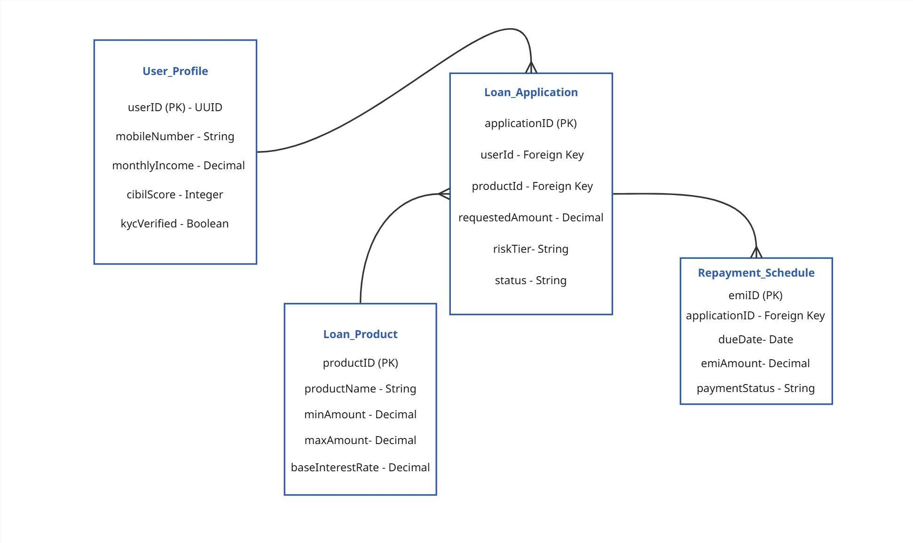

Revenue and Profit Growth Strategies

6. Question: After completing the product dissection and schema design steps for the chosen platform, conduct a comprehensive case study on the above chosen industry. Your goal is to identify and propose strategies to increase the profit of the industry by at least 25%

Analysing KreditBee’s Current Status
To understand KreditBee’s current position and build a strategy for 25% profit growth, we analyse:
- Current financial performance
- Revenue sources
- Expense structure
- Customer acquisition and retention

Category-wise Analysis

1. Current Financial Data
Category | Details
Collect Financial Data
Revenue | KreditBee earns from interest income, processing fees, penalties, and partner commissions. In FY25, service revenue was ₹486 crore and other income ₹103.8 crore (22% growth)
Expenses | Major costs include marketing, employee salaries, and operational expenses like collections and tech infrastructure.
Analyse Current Profit
Profit Calculation | Profit = Revenue – Expenses
Profit Trends | KreditBee improved profit significantly by reducing costs like ad spend and employee expenses.

2. Sources of Revenue
Category | Details
Identify Revenue Streams
Interest Income | Main revenue source from loans given to customers
Processing Fees | One-time fee charged during loan disbursal
Late Fees / Penalties | Charges for missed EMIs
Cross-Selling | Income from insurance, credit cards, and partner services
Other Services | Credit assessment and additional service fees
Analyse Revenue Contribution
Segmentation | Revenue is divided into interest + fees + partner income
Key Insight | Strong diversified model reduces dependency on a single source

3. Sources of Expenses

Category | Details
Identify Major Expenses
Marketing & Advertising | Major expense used to acquire new users
Technology Costs | Maintaining app, AI models, and infrastructure
Employee Salaries | Salaries for operations, tech, and support teams
Operational Costs | Collections, fraud checks, and backend processes
Analyse Expense Distribution
Segmentation | Marketing is the highest cost contributor
Cost Efficiency | KreditBee spends ₹0.61 to earn ₹1 — improving this ratio increases profit

4. Customer Acquisition & Retention

Category | Details
Analyse Customer Acquisition Channels
Channels | Digital ads, app installs, partnerships, referrals
Effectiveness | High marketing spend indicates dependency on paid acquisition
Understand Customer Behaviour & Retention
Customer Data | Users are mostly Tier-2/3 customers with repeat borrowing needs
Retention Rates | Repeat users contribute higher revenue with lower cost
Churn Analysis | Drop-offs occur due to pricing, trust, or repayment issues

Conclusion of Analysis
By analysing revenue, expenses, and customer behaviour, we identify:
- Revenue can be increased by expanding loans and improving pricing
- Costs can be reduced through automation and better marketing strategies
- Retention can improve lifetime value and profitability

II. Focus Areas for Increasing KreditBee’s Profit by 25%
To achieve 25% profit growth, KreditBee should focus on key business areas:

Strategy Table
Category | Focus Area | Measures
Internal Management ~8% | Operational Efficiency ~6% | Automate loan processing, fraud detection, and collections using AI.Optimize internal processes to handle more loans with fewer resources.Control costs by reducing unnecessary ad spend and improving CAC.
 | Employee Productivity ~2% | Train teams in data-driven decision making.Use performance metrics like approval rate, default rate, and efficiency tracking.
Financial Growth ~10–15% | Loan Book Expansion ~5–10% | Increase loan disbursement in Tier-2/3 markets.Launch new products like BNPL and credit cards.Expand partnerships to acquire more users.
 | Pricing Optimization ~5% | Use ML-based risk scoring to adjust interest rates.Offer premium services like instant disbursal for extra fees.Improve profit margins through smarter pricing.
Cost Management ~5–10% | Expense Reduction ~5% | Reduce marketing cost using referral programs.Automate customer support and collections.Negotiate better funding and vendor terms.
 | Unit Economics Improvement ~5% | Improve cost-to-revenue ratio (₹0.61 → ₹0.55).Use fraud detection to reduce bad loans.
Customer Growth ~5–10% | Customer Acquisition ~5% | Focus on underserved regions using local-language campaigns.Use partnerships instead of expensive ads.
 | Customer Retention ~5% | Introduce loyalty programs and rewards.Encourage repeat loans through pre-approved offers.Use reminders to reduce missed payments.

III. Defining Strategies

Category | Details
Optimize Expenses | Reduce operational costs through automation, better vendor deals, and efficient marketing strategies.
Enhance Revenue Streams | Increase loan volume, introduce new financial products, and improve pricing strategies using data.
Improve Customer Retention | Provide personalized offers, loyalty rewards, and better user experience to increase repeat usage.

Final Conclusion
By following an inside-out approach:
- First optimize expenses
- Then improve customer retention
- Finally scale revenue streams
KreditBee can achieve 25% profit growth in a structured and sustainable way.

Guesstimate Questions

1. What will be the percentage increase in global FinTech investments over the next five years?
Compound Annual Growth Rate (CAGR) model. Despite recent funding winters, the foundational shift to digital finance (especially in APAC and Africa) guarantees steady long-term growth.
Step | Assumption | Calculation
1 | Current Global FinTech Investment (Base Year) | Assume $100 Billion (for mathematical simplicity)
2 | Expected Annual Growth Rate (CAGR) | Assume 15% (industry standard projection)
3 | Growth Multiplier | 1 + 0.15 = 1.15
4 | Value after 5 Years | $100B × (1.15)^5 ≈ $201 Billion
5 | Percentage Increase | (($201B - $100B) / $100B) * 100 = 101%
Final Answer: We estimate a roughly 100% to 105% increase in global FinTech investments over the next five years, effectively doubling the current market size.

2. How many people will adopt digital banking services in developing countries over the next decade?
We have used India as a proxy for the developing world, utilizing a top-down population funnel based on smartphone penetration and internet access.
Step | Assumption | Calculation | Result
1 | Proxy Population (India) | Current population | 1.4 Billion
2 | Adult Population (18+) | 1.4B × 65% | ~910 Million
3 | Estimated Smartphone/Internet Users by 2030 | 910M × 80% penetration | ~728 Million
4 | Currently Using Digital Banking (e.g., UPI/Apps) | 728M × 50% | ~364 Million
5 | Remaining Unbanked/Cash-heavy Adults | 728M - 364M | ~364 Million
6 | Expected Adoption Rate over 10 Years | 364M × 75% adoption | ~273 Million
Final Answer: In India alone, we estimate 270 to 280 million new users will adopt digital banking. Scaled across other developing nations (like Brazil, Indonesia, Nigeria), the global figure will likely exceed 600 to 700 million new adopters over the next decade.
3. What percentage of small and medium-sized enterprises (SMEs) will use FinTech solutions for their financial needs by 2026?
SMEs are rapidly digitizing because traditional banks require heavy collateral that SMEs lack. FinTechs (like BharatPe or KreditBee Business) offer cash-flow-based lending.
Step | Assumption | Calculation | Result
1 | Total MSMEs in India | Official Government Estimates | ~63 Million
2 | Digitally Addressable SMEs | 63M × 60% (internet access/GST registered) | ~37.8 Million
3 | Current FinTech Adoption Rate | 37.8M × 40% | ~15.1 Million
4 | Projected Adoption Growth by 2025 | Increase to 70% of addressable market  37.8M × 70% | ~26.46  Million
5 | Total SMEs Using FinTech by 2026 | Projected Target | ~26.4 Million
6 | Final Percentage (Total Market) | (26.4M / 63M) * 100 | ~42%
Final Answer: We estimate that approximately 42% of all SMEs and up to 70% of digitally addressable SMEs will heavily rely on FinTech solutions by 2026.

4. What will be the average transaction value of mobile payments in the next three years?
Mobile payments started with micro-transactions (buying tea/groceries) but are now moving to high-ticket items (rent, electronics, loan EMIs) due to increased trust.
Step | Assumption | Calculation | Result
1 | Current Avg. Mobile Payment Value (P2M/P2P) | Baseline Assumption | ₹1,600
2 | Inflation Rate | Annualized | ~6%
3 | Digital Trust Factor (Larger purchases) | Additional growth | ~4%
4 | Total Annual Growth Rate | 6% + 4% | 10%
5 | Growth Multiplier | 1 + 0.10 | 1.10
6 | Value after 3 Years | ₹1,600 × (1.10)^3 | ₹2,129
Final Answer: Driven by inflation and higher consumer confidence in digital limits, the average transaction value is expected to grow to approximately ₹2,100 - ₹2,150 in the next three years.

5. How much will blockchain technology reduce the costs of cross-border transactions in the next five years?
Traditional remittances (like Western Union or SWIFT) involve multiple intermediary banks, Nostro/Vostro accounts, and forex margins. Blockchain enables direct peer-to-peer settlement.
Step | Assumption | Calculation | Result
1 | Current Avg. Cross-Border Transaction Fee | World Bank Data | ~6.0%
2 | Target Blockchain Settlement Fee | Direct network fees (e.g., Ripple/Stellar) | ~1.5%
3 | Total Fee Reduction | 6.0% - 1.5% | 4.5% absolute reduction
4 | Percentage Reduction in Cost | (4.5% / 6.0%) * 100 | 75% relative reduction
Final Answer: Blockchain technology has the potential to reduce cross-border transaction costs by roughly 75%, bringing the average fee down from 6% to around 1.5%.

Cohort Analysis

Question 1 : How would you perform a cohort analysis to calculate the yearly retention rate for users who signed up in different yearly?

Note : We were unable to obtain the KreditBee dataset required for the cohort analysis. As an alternative, we utilized a comparable fintech dataset to perform this analysis.
You can review the dataset here: [Link]

1. Define Cohort
Users are grouped into cohorts based on their loan issue date (issue_d).
Since the dataset does not contain sufficient variation at the monthly level, cohorts are defined at a year level (cohort_year) as a proxy for signup time.

2. Define User Activity (Proxy)
As transaction-level activity is not available, user engagement is approximated using repayment behaviour:
- A user is considered active if:
  - total_pymnt > 0, and
  - loan_condition = Good Loan
This indicates that the user is still financially engaged and has not defaulted.

3. Calculate Retention
For each cohort:
- Total Users = Number of unique users in the cohort
- Active Users = Users satisfying the activity condition
- Retention Rate = Active Users / Total Users

Cohort Year | Total Users | Active Users | Retention Rate
2007 | 139 | 95 | 0.683453
2008 | 516 | 417 | 0.808140
2009 | 1173 | 1003 | 0.855072
2010 | 2822 | 2400 | 0.850461
2011 | 4747 | 4031 | 0.849168
2012 | 11777 | 9899 | 0.840537
2013 | 29698 | 25575 | 0.861169
2014 | 19128 | 17616 | 0.920954

4. Compare Cohorts (Insights)
- Retention improves from 2007 (68.3%) → 2009 (85.5%), indicating better early cohort performance.
- Retention remains relatively stable between 2010–2012 (~84–85%).
- A noticeable increase is observed in later cohorts, with 2014 reaching 92.1%, the highest retention.
Overall, newer cohorts show improved retention, suggesting improvements in user quality, product experience, or risk management over time.

Q2. If you find that retention drops significantly after the first month, what are some possible reasons for this behaviour, and how can the company address this drop-off?

1. Possible Reasons for Drop in Retention
A significant drop in retention after the first month, our case year can be attributed to the following factors:

a. User Quality Issues
- Users with high debt-to-income (DTI) or lower credit grades may struggle to continue repayments.
- This leads to early disengagement (default or inactivity).

b. Pricing & Financial Burden
- Higher interest rates increase repayment pressure.
- Users may drop off after initial interaction due to affordability issues.

c. Lack of Engagement / Awareness
- Users may not clearly understand repayment schedules.
- Absence of reminders or guidance leads to missed payments.

d. Poor Targeting
- Loans may be issued to financially unstable users (low income, low employment stability).
- These users are less likely to sustain long-term engagement.

2. How to Address the Drop-Off

a. Improve Risk-Based Targeting
- Prioritize users with:
  - Lower DTI
  - Higher credit grades
- Strengthen credit evaluation models.

b. Optimize Pricing Strategy
- Offer flexible repayment options
- Adjust interest rates based on risk segments

c. Enhance User Engagement
- Send EMI reminders and notifications
- Provide clear onboarding about repayment schedules

d. Introduce Incentives
- Cashback or rewards for on-time or early payments
- Discounts for completing initial repayments

3. Data-Driven Validation (Advanced Insight)
The hypotheses can be validated by segmenting users based on:
- dti (debt-to-income ratio)
- grade (credit quality)
- income_category
and comparing retention rates across these segments.

A/B Test (2012 vs 2013 Cohorts)
Question 1:
How would you structure an A/B test to measure the impact of these notification designs on loan acceptance rates?
Step 1 — Define the Business Problem
Question:
Does offering a reduced interest rate encourage more users to accept loans without increasing default risk?
Groups:
Group | Year | Strategy
A (Control) | 2012 | Default interest rate
B (Treatment) | 2013 | Reduced interest rate

Step 2 — State the Hypotheses
- H₀ (Null): Reduced interest rates do not change loan acceptance or repayment behavior.
- H₁ (Alternative): Reduced interest rates increase loan acceptance without any risk.

Step 3 — Select Evaluation Metrics

Metric | Column(s) | Why It Matters
Loan Acceptance Rate | loan_condition | Core conversion outcome
Average Loan Amount | loan_amount | Borrowing confidence
Repayment Behaviour | total_rec_prncp, total_pymnt | Repayment quality
Default Risk | recoveries | Portfolio risk indicator

Step 4 — Prepare the Groups (Filter the Data)
Create two subsets:
- Group A: records where year = 2012
- Group B: records where year = 2013
This simulates control vs treatment cohorts.

Step 5 — Compute Metrics for Each Group
For each group, calculate:
- Loan Acceptance Rate
= Good Loans / Total Loans
(derived from loan_condition)
- Average Loan Amount
= mean(loan_amount)
- Repayment Behaviour
= average repayment level using total_rec_prncp or total_pymnt
- Default Risk
= avg of the recoveries

Step 6 — Build the Final Comparison Table
This is your core A/B test output.
Group | Loan Acceptance Rate | Avg Loan Amount | Repayment Behaviour | Default Risk
Group A (2012) | 0.841 | 13535.92 | 11466.81 | 138.90
Group B (2013) | 0.861 | 14740.59 | 10666.37 | 119.25
This table visually shows which strategy performs better.

Step 7 — Interpret the Results
Evaluate directional change between Group A (2012) and Group B (2013).
Observation | Interpretation
Loan Acceptance Rate increased (0.8405 → 0.8612) | Borrowers are slightly more willing to take loans in Group B. This suggests the lending conditions in 2013 improved loan uptake.
Average Loan Amount increased (13,535 → 14,740) | Borrowers are requesting larger loans, indicating greater borrowing confidence or higher credit availability.
Repayment Behaviour decreased (11,466 → 10,666) | Borrowers in Group B are repaying slightly less principal on average, which may indicate weaker repayment discipline or shorter repayment progress.
Default Risk decreased (recoveries 138.9 → 119.2) | Lower recoveries suggest fewer defaults or lower recovery activity, implying the credit risk profile may have improved slightly.

Key Insight
Group B shows:
- Higher loan adoption
- Higher borrowing amounts
- Slightly weaker repayment levels
- Lower default recoveries
Net effect: loan growth improved without a visible increase in default risk.

Step 8 — Business Decision
Based on the observed metrics Strategic Recommendation:
We should adopt the 2013 strategy cautiously.
Reasoning:
- Loan acceptance increased → market demand improved
- Average loan size increased → higher revenue potential
- Default risk decreased → no immediate deterioration in credit quality
- Repayment behaviour slightly declined → requires monitoring
Recommended Business Action
1. Adopt the lending strategy used in 2013.
2. Implement monitoring controls:
- Track repayment trends for the next lending cycle.
- Segment borrowers by risk grade or credit score.
3. Risk-adjusted expansion strategy:
- Offer larger loans or favourable rates primarily to low-risk borrowers.
- Apply stricter evaluation for high-risk segments.

Executive Summary
The 2013 lending environment appears to increase loan adoption and loan size while keeping default risk stable or slightly improved.
However, the drop in repayment behaviour signals a potential early warning, so scaling the strategy should be accompanied by risk monitoring and borrower segmentation.

DBMS & Data Architecture

ACID Properties:

1. A user initiates a fund transfer from Account A to Account B, but the app crashes midway. How would you ensure that no partial transaction corrupts the account balances?

Answer:

- Atomicity: In KreditBee, a loan disbursal must be treated as a single, indivisible transaction. Either both actions happen (debiting KreditBee's escrow account and crediting the user's bank account), or neither happens. If the app crashes midway, the database automatically rolls back the entire transaction, ensuring no funds are lost in transit.

- Durability: Once the disbursal is successful, the transaction is committed to the database permanently. Even if the database server crashes one second later, the record of that successful transfer remains intact upon reboot.

2. Two traders place orders for the same stock at nearly the same time. How would you ensure that each transaction executes reliably without interference?

Answer:

- Isolation: The database must use transaction isolation levels (like Read Committed or Serializable). If a user accidentally taps the "Pay EMI" button twice rapidly, the database processes the first transaction independently and locks the row. The second transaction will either wait or fail, preventing the user from being double-charged.

- Consistency: The system enforces database rules so that the user's outstanding loan balance never drops below zero incorrectly, maintaining the integrity of the ledger.

Indexing:

1. You need to generate real-time dashboards showing account balances and transactions for high-net-worth clients. How can indexing help here?

Answer:

Without indexing, the database would have to perform a full table scan across millions of KreditBee users to find one person's data. By creating a B-Tree index on frequently queried columns like userID and accountID, the database can locate the user's transaction history in milliseconds, allowing the real-time dashboard to load instantly.

2. Transaction data is frequently updated and queried by transaction ID and date. What indexing strategies would you use to optimize performance without increasing update costs too much?

Answer:

Indexing helps by creating a B-Tree index on frequently queried columns like userID and accountID. Instead of forcing the database to perform a slow, full table scan across millions of KreditBee users to find one person's data, the index allows the database to locate the user's transaction history in milliseconds, ensuring the real-time dashboard loads instantly.

Partitioning
1. Your transaction table contains billions of records across multiple years. How would you design it to allow efficient querying and archiving?
Answer:
We would implement Time-Based (Range) Partitioning. The Repayment_Schedule and Transactions tables would be partitioned by month or year (e.g., transactions_2024_Q1, transactions_2024_Q2). Active queries usually fetch recent data, so the database only scans the most recent partition. Older partitions (like 2021 data) can be compressed and archived to cheaper storage without affecting current application performance.
2. You need to comply with data residency laws that require customer data to stay within a particular region. How can partitioning help?
Answer:
We would use Geo-Partitioning (List Partitioning) based on location. To comply with Reserve Bank of India (RBI) data localization mandates, all transactions originating from Indian users are routed to and stored strictly within the "India" partition on local servers (e.g., AWS ap-south-1).

Sharding
1. During peak hours, your database hits performance limits while processing millions of microtransactions. How would you use sharding to scale horizontally?
Answer:
During high-traffic events (like festive season sales driving up "Flexi Loan" requests), a single database server becomes a bottleneck. We would implement Horizontal Sharding using userID as the Shard Key.
- User IDs 1 to 5,000,000 are stored on Server A.
- User IDs 5,000,001 to 10,000,000 are stored on Server B. This distributes the read/write load evenly across multiple machines, scaling horizontally to handle unlimited microtransactions.

2. You’ve implemented sharding by customer ID, but now need to perform analytics on global transaction patterns. What problems might you face?
Answer:
Sharding optimizes localized operations but breaks global analytics. To calculate the "Total Daily Default Rate" across all users, the system would have to perform Cross-Shard Joins, querying Server A, B, and C simultaneously, which is incredibly slow and resource-heavy. Solution: Analytical queries should not be run on the sharded operational database (OLTP). Instead, the data from all shards should be streamed into a centralized Data Warehouse for analytics.

Normalization and Denormalization
1. You’re designing a schema to store customer profiles, accounts, and KYC documents. How would normalization help here?
Answer: Normalization reduces data redundancy and prevents update anomalies. By separating the data into distinct tables (User_Profile, KYC_Details, Loan_Account) linked by Foreign Keys, we ensure that if a user updates their phone number, it only needs to be updated in one single place (User_Profile). It ensures strict data integrity for compliance purposes.
2. To speed up monthly financial reporting, would you prefer a normalized or denormalized schema? Explain why.
Answer: A Denormalized Schema is preferred for reporting. Generating monthly financial reports on a highly normalized database requires complex, slow JOIN operations across a dozen tables. A denormalized schema flattens this data into wide summary tables, accepting some data redundancy in exchange for massive improvements in read-heavy analytical performance.

Data Lakes vs. Data Warehouses
1. You receive unstructured logs, real-time clickstream data, and structured account data. Where would you store each, and why?
Answer:
- Data Lake (e.g., AWS S3): Used for the unstructured server logs and real-time app clickstream data. Lakes handle raw, unformatted data cheaply and efficiently at massive scale.
- Data Warehouse (e.g., Snowflake, BigQuery): Used for the structured account and loan data. Warehouses require a predefined schema and are optimized for fast, complex SQL querying by data analysts.
2. How would a data warehouse support fraud detection and risk analysis in a FinTech company?
Answer: A Data Warehouse excels at OLAP (Online Analytical Processing). It can instantly aggregate years of historical loan data. Risk analysts can write queries to detect complex fraud patterns—such as identifying if multiple defaulted loans across different states share the same underlying device ID or IP address over a 24-month period.

Data Ingestion and Pipelines
1. Describe how you would ingest real-time payments data from mobile apps into your system for fraud monitoring.
Answer: We would use a Streaming Data Pipeline powered by Apache Kafka or AWS Kinesis. As soon as a user makes a payment via KreditBee UPI, the event is pushed into a Kafka topic in real-time. A fraud-detection machine learning model consumes this stream instantly, analyzing the transaction context before it even hits the main database.
2. You need to import credit score data from third-party providers once a day. What ingestion approach would you use?
Answer: We would use a Batch Data Ingestion strategy orchestrated by a scheduling tool like Apache Airflow. At 2:00 AM during low-traffic hours, an automated ETL job triggers, calls the TransUnion/CIBIL APIs, fetches the updated credit scores in bulk and updates the User_Profile table.

ETL (Extract, Transform, Load)
1. How would you design an ETL pipeline to consolidate customer investment portfolios from multiple banking systems into a central analytics platform?
Answer:
- Extract: Pull raw data incrementally from various partner bank APIs.
- Transform: Cleanse the data. This involves standardizing currency formats, resolving mismatched dates (e.g., MM-DD-YYYY vs DD-MM-YYYY), and deduplicating records.
- Load: Insert the transformed, clean data into a centralized Data Warehouse schema, ready for business intelligence dashboards.
2. An ETL job failed after partial data load. How would you maintain consistency and resume safely?
Answer: The ETL pipeline must be built with Idempotency and Checkpointing. If a job fails midway, it should not blindly restart from the beginning (which would create duplicate loan entries). Instead, it reads the last successful checkpoint. Furthermore, "Upsert" logic (INSERT ON CONFLICT UPDATE) ensures that if a row was partially loaded, running the job again simply overwrites it safely rather than duplicating it.

Additional DBMS Topics
1. Regulators request a complete audit trail of customer loan applications. How would you ensure your DBMS can support this?
Answer: We would implement Audit Logging with an append-only architecture. Instead of just updating a user's loan status from "Pending" to "Approved," we write a new timestamped row to an Application_History ledger table. This provides an immutable, version-controlled timeline of exactly when decisions were made, satisfying regulatory compliance.
2. Your machine learning model needs daily updated training data on loan defaults. How would you manage the data pipeline to feed the model efficiently?
Answer: We would use Change Data Capture (CDC) combined with Incremental ETL. Instead of reloading the entire 10-year loan history every day, CDC listens to the database's transaction logs and extracts only the rows that changed status to "Defaulted" in the last 24 hours. This snapshot is efficiently fed into the ML feature store.
3. How would you detect and resolve duplicate records in credit card applications ingested from multiple sources?
Answer: During the "Transform" phase of the ETL pipeline, we apply Fuzzy Matching algorithms and deterministic data quality checks. We would compare composite keys (e.g., PAN Card Number + Date of Birth). If exact matches fail due to typos, algorithms like Levenshtein distance can flag similar names (e.g., "Rahul Sharma" vs "Rahul Sarma") for manual resolution.
4. You are tasked with maintaining real-time analytics dashboards for customer transactions, credit scores, and investments. What DBMS architecture would you propose?
Answer: We would deploy a Hybrid Transactional/ Analytical Processing (HTAP) architecture.
- The core application runs on an OLTP database (like PostgreSQL).
- We create Materialized Views to pre-calculate heavy aggregations (like "Total Disbursals Today") so the dashboard doesn't re-calculate the math on every page load.
- A caching layer (like Redis) sits in front to serve these dashboard metrics instantly, taking the heavy read load off the primary database.

References:
Product Dissection and Schema:
https://www.kreditbee.in/
https://economictimes.indiatimes.com/tech/startups
https://entrackr.com/
https://miro.com/
A/B Test Dataset [loan_final_33.csv]. Retrieved from [https://almabetter.notion.site/DA03-Financial-Risk-and-Performance-Analysis-in-Consumer-Lending-2e71a19a561780fa89bee0f27dc491ad]

SQL ETL, Excel EDA & Advanced Analytics

Cover Page
- Project Title: Financial Risk and Performance Analysis in Consumer Lending
- ​Dataset Name: loan dataset

Section 1: Project Overview & Objectives
​Project Overview:
This project focuses on the end-to-end data analytics process in the consumer lending landscape. Using the loan_final313_.csv dataset, we performed an ETL (Extract, Transform, Load) process using Colab to clean and structure the data. The transformed dataset was then analyzed in Excel to uncover patterns in borrower demographics, loan characteristics, and repayment histories.
​Objectives:
- ​Apply advanced data analysis techniques to deeply understand the loan portfolio.
- ​Assess loan risk profiles and evaluate financial performance metrics.
- ​Develop an interactive Excel dashboard for real-time strategic decision-making.
- ​Provide strategic recommendations for optimizing loan portfolio management and mitigating default risks.

​Section 2: ETL Phase (SQL)
​SQL Environment Setup & Queries Link:
- ​SQL ETL Process
Summary of ETL Execution:
- ​Extract: Created the loans table with appropriate data types and successfully loaded the raw .csv file. Verified record counts and unique categorical values.
- ​Transform: Replaced missing annual_inc values with the median. Standardized home_ownership to uppercase. Engineered new columns: profitability (Total Payment - Loan Amount) and risk_flag (1 for Bad Loan, 0 for Good Loan).
- ​Load: Created a final loans_cleaned table. Added default_rate_indicator and income_to_loan_ratio, extracted numeric loan terms, and exported the clean dataset to a new CSV for Excel analysis.

​Section 3: Excel Analysis
​Docs File Link:
Note: - Download the Excel file and open it in Excel (not in google sheet) for responsiveness of the dashboard.
- ​Excel_analysis.xlsx
​Summary of Exploratory Data Analysis (EDA):
- ​Distribution & Trends: Analyzed the distribution of loan amounts, interest rate trends over the years, and the correlation between income categories and loan amounts.
- ​Risk & Performance: Calculated year-over-year default rates, recovery rates across loan grades, and grade-wise profitability.
- ​Advanced Computation: Utilized SUMPRODUCT and SUMIF to calculate weighted average interest rates, and combined IF, MODE, and MATCH to determine the most common loan purpose for defaulted loans by region.
- ​Visual Formatting: Applied conditional formatting to highlight high-risk loans (high interest rates + low grades).
​Interactive Dashboard:
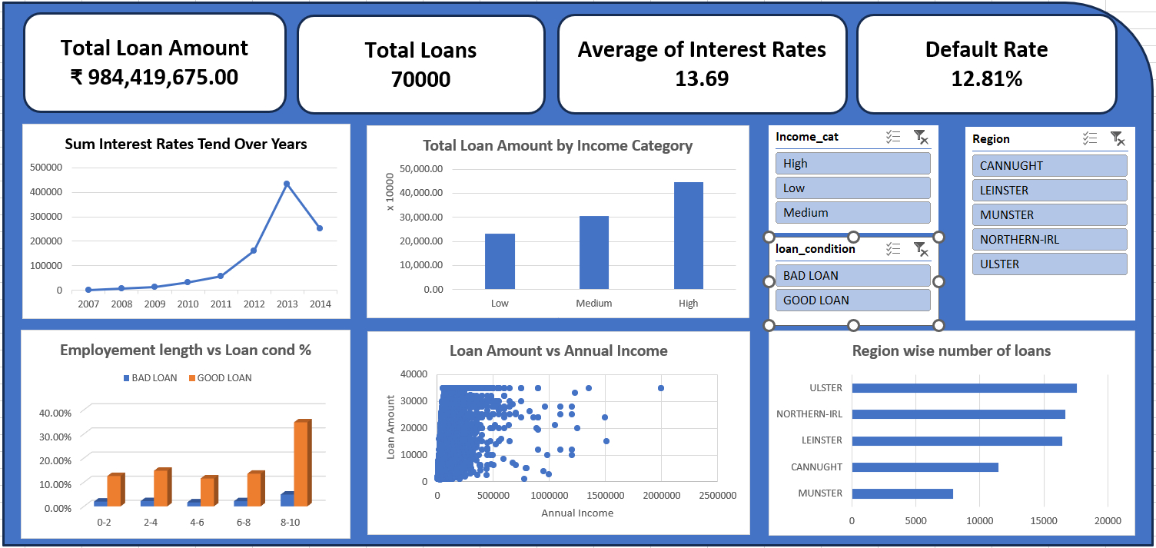

​Section 4: Insights & Observations
Top Findings:
- Debt consolidation dominates defaults across all regions, making it the highest-risk loan purpose.
- Default rate is ~12.8%, indicating a moderate level of credit risk in the portfolio.
- Medium-income borrowers yield the highest weighted interest rate, while high-income borrowers receive lower rates due to lower risk.
- Longer employment length reduces default risk, showing borrower stability is a key factor.
- Loan burden (loan-to-income) and higher interest rates increase default likelihood, highlighting financial stress as a major driver.

Recommended Business Actions:
- Tighten credit checks for debt consolidation loans, as they show the highest default tendency.
- Adjust pricing strategy for medium-income segment, balancing profitability and risk exposure.
- Incorporate employment stability as a key approval criterion to reduce defaults.
- Implement stricter risk thresholds for high loan-to-income applicants to avoid over-leveraged borrowers.
- Continuously monitor default trends and segment-wise risk to proactively manage the loan portfolio.

​Section 5: Reflection
​Section 5: Reflection
Challenges Faced:
- Faced issues with data mismatches (e.g., Income_cat not matching due to hidden formatting), which caused formulas like SUMPRODUCT to fail.
- Encountered #VALUE errors in Excel, mainly due to incorrect ranges (multi-column selection) and text values in numeric fields.
- Difficulty in implementing advanced formulas (INDEX + MODE + MATCH) due to array limitations and data inconsistencies.
- Struggled with pivot cache differences, where slicers were not connecting to all pivot tables.
- Dashboard formatting issues, including misaligned charts, disappearing slicers, and layout breakage after pivot refresh.
- Confusion while linking KPI cards with slicers, especially when using normal formulas instead of pivot-based values.
- Faced compatibility issues when uploading Excel to Google Drive, where dashboard elements (slicers, KPIs, formatting) broke in Google Sheets.
- Scatter plot visualization was cluttered, requiring adjustments like marker size, transparency, and axis limits.

Learning Outcomes:
- Learned how to build a complete Excel dashboard using pivot tables, charts, slicers, and KPI cards.
- Understood the importance of data cleaning (TRIM, CLEAN, correct data types) before applying formulas.
- Gained clarity on weighted average calculations using SUMPRODUCT, and why it is preferred over simple averages.
- Developed understanding of default rate calculation using average of binary risk_flag.
- Learned how to handle imbalanced data and model evaluation (accuracy vs recall trade-off) in analysis.
- Improved skills in debugging Excel errors systematically instead of guessing.
- Learned best practices for dashboard design — layout, color consistency, removing clutter, and adding insight sections.
- Understood limitations of tools and why Excel is preferred over Google Sheets for advanced dashboards.
- Learned how to make dashboards interactive using slicers and pivot connections.
- Improved ability to translate analysis into business insights, not just calculations.

Power BI Dashboard

Phase 1: Power BI Dashboarding (Task 5)
This phase is about visual storytelling. We will use cleaned loans_cleaned dataset and build an interactive dashboard that answers the business questions.
Dashboard : link
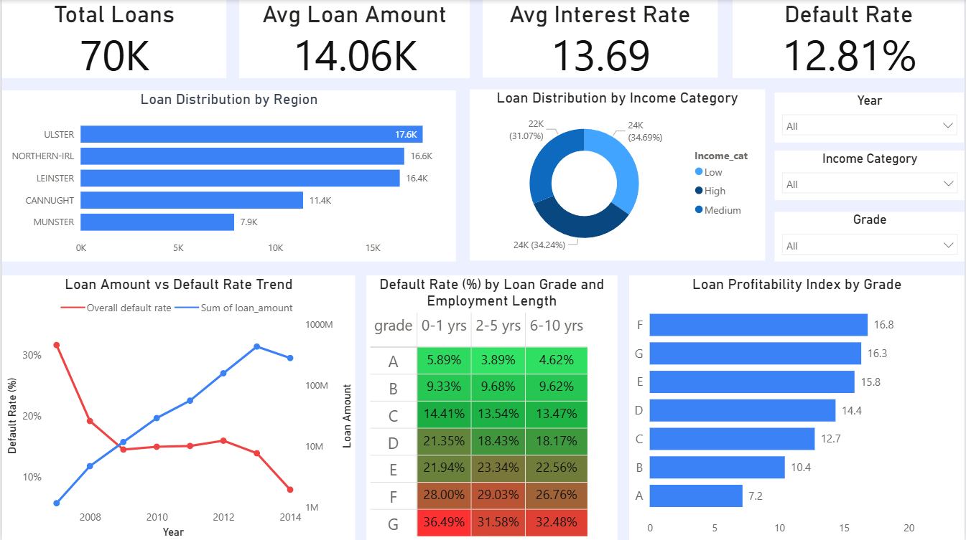

PORTFOLIO OVERVIEW
- The portfolio consists of approximately 70,000 loans with an average loan amount of around 14,000.
- The average interest rate is 13.69%, indicating a moderate-to-high risk lending strategy.
- The overall default rate is 12.81%, which is relatively high and signals notable credit risk exposure.

REGIONAL DISTRIBUTION AND RISK
- The majority of loans are concentrated in ULSTER, NORTHERN-IRL, and LEINSTER.
- CANNUGHT and MUNSTER contribute significantly less to total loan volume.
- Insights:
- High loan concentration in a few regions increases exposure to regional economic risks.
- Even if default percentages are similar across regions, higher volume regions contribute more to absolute defaults.

INCOME CATEGORY DISTRIBUTION
- Loans are fairly evenly distributed across low, medium, and high income categories.
- Insights:
- Default risk is not solely dependent on income category.
- Other factors such as credit grade and employment length play a more significant role in determining risk
LOAN AMOUNT VS DEFAULT RATE TREND
- Total loan disbursement has increased steadily over time.
- Default rate shows an initial spike, then stabilizes, and eventually declines in recent periods.
- Insights:
- Portfolio growth has not proportionally increased defaults, indicating improved credit selection over time.
- However, past volatility suggests sensitivity to borrower quality and external factors.

DEFAULT RISK BY GRADE AND EMPLOYMENT LENGTH
Credit Grade Impact:
- Grades A and B show low default rates (approximately 4% to 10%).
- Grades C and D show moderate default rates (approximately 13% to 21%).
- Grades E and F show high default rates (approximately 22% to 29%).
- Grade G shows extremely high default rates (above 30%).
- Insight:
- Credit grading is a strong predictor of default risk and is functioning effectively.
Employment Length Impact:
- Borrowers with 0–1 years of employment have the highest default rates.
- Borrowers with 2–10 years show relatively stable and lower risk.
Insight:
- Employment stability is a key indicator of repayment capability.
- Highest Risk Segment:
- Grade G borrowers with short employment history exhibit the highest default rates (above 35%).
- Grades E and F combined with low employment length also show significantly elevated risk.
- Insight:
- These segments represent critical risk pockets and require stricter controls.

PROFITABILITY VS RISK
- Higher grade risk (E, F, G) corresponds with higher profitability levels.
- Lower risk grades (A, B) generate lower returns.
- Insight:
- The portfolio follows a risk-return trade-off, where higher returns are driven by riskier loans.
- This increases vulnerability to defaults if not properly managed.

KEY RISK OBSERVATIONS
- A significant portion of the portfolio lies in higher-risk grades (D to G).
- The default rate is above typical safe thresholds, indicating elevated portfolio risk.
- Employment length and credit grade are the most influential factors in predicting defaults.
- Geographic concentration introduces additional systemic risk.

RECOMMENDATIONS
- Apply stricter approval criteria for:
- Grades E, F, and G
- Borrowers with less than 2 years of employment
- Rebalance portfolio exposure toward mid-risk segments (Grades B and C).
- Incorporate employment length more strongly into risk models.
- Introduce region-specific monitoring and controls.
- Optimize risk-based pricing to better compensate for high-risk segments.
SUMMARY
The portfolio is currently oriented toward higher returns but carries
elevated risk. Default behavior is strongly driven by credit grade and employment stability, and targeted tightening in high-risk segments is necessary to improve overall portfolio health.

Automation & GenAI
We will build these two specific workflows exactly as requested.
· Workflow 1: Automated Loan Portfolio Risk Summary
o Trigger: Schedule Trigger (Cron node - Weekly)
o Input Data: Simulated CSV/SQL fetch (Total active loans, % Bad Loans, High-risk grades, Avg interest rate by grade, Region-wise default %)
o GenAI Step: Prompt to summarize risk, highlight trends, explain patterns.
o Output: Email/Slack node (simulated)

N8n Workflow Image : json file of n8n workflow
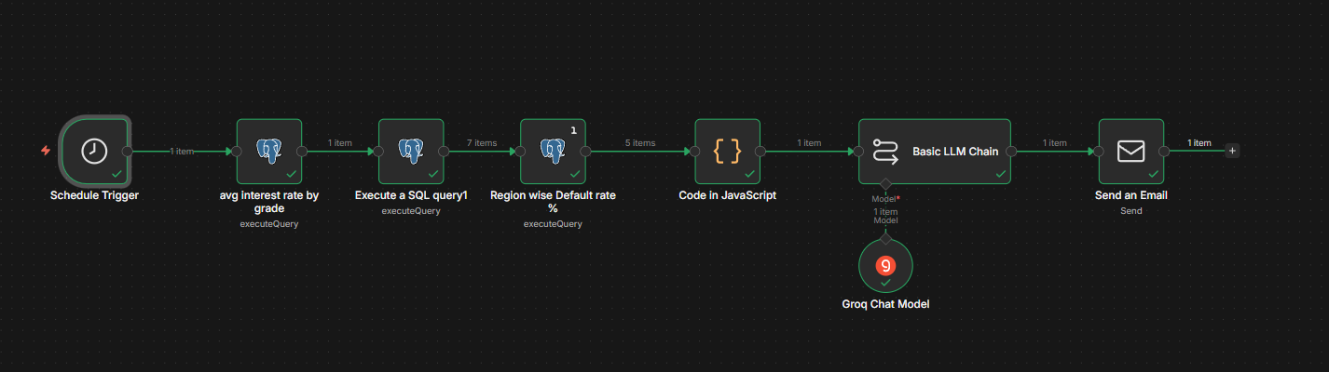
Output :
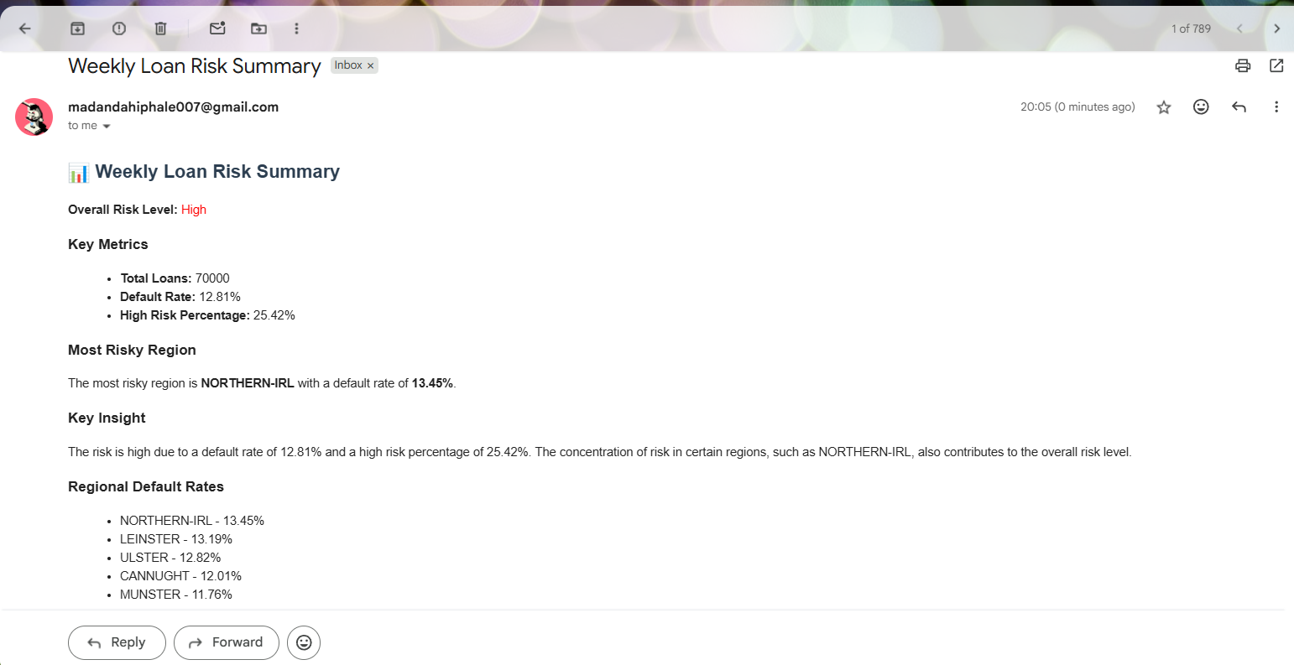
·
Workflow 2: AI-Based Loan Decision Explanation
o [ ] Trigger: Webhook (Input: Loan ID or question)
o [ ] Fetch Data: Simulated fetch of Grade, Interest rate, DTI, Income category, Emp length, Purpose
o [ ] GenAI Reasoning: Prompt to explain risk factors, compare with good loans, provide human-readable reasoning.
o [ ] Output: Webhook Response node (Text explanation)

N8n Workflow Image : json file of n8n workflow
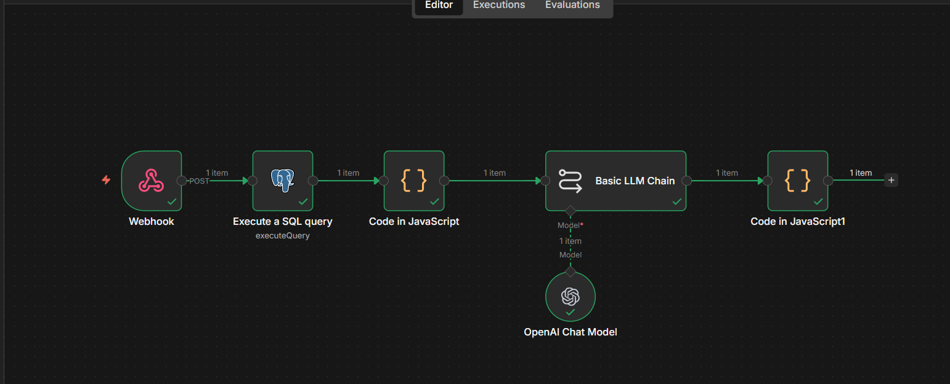

Output :
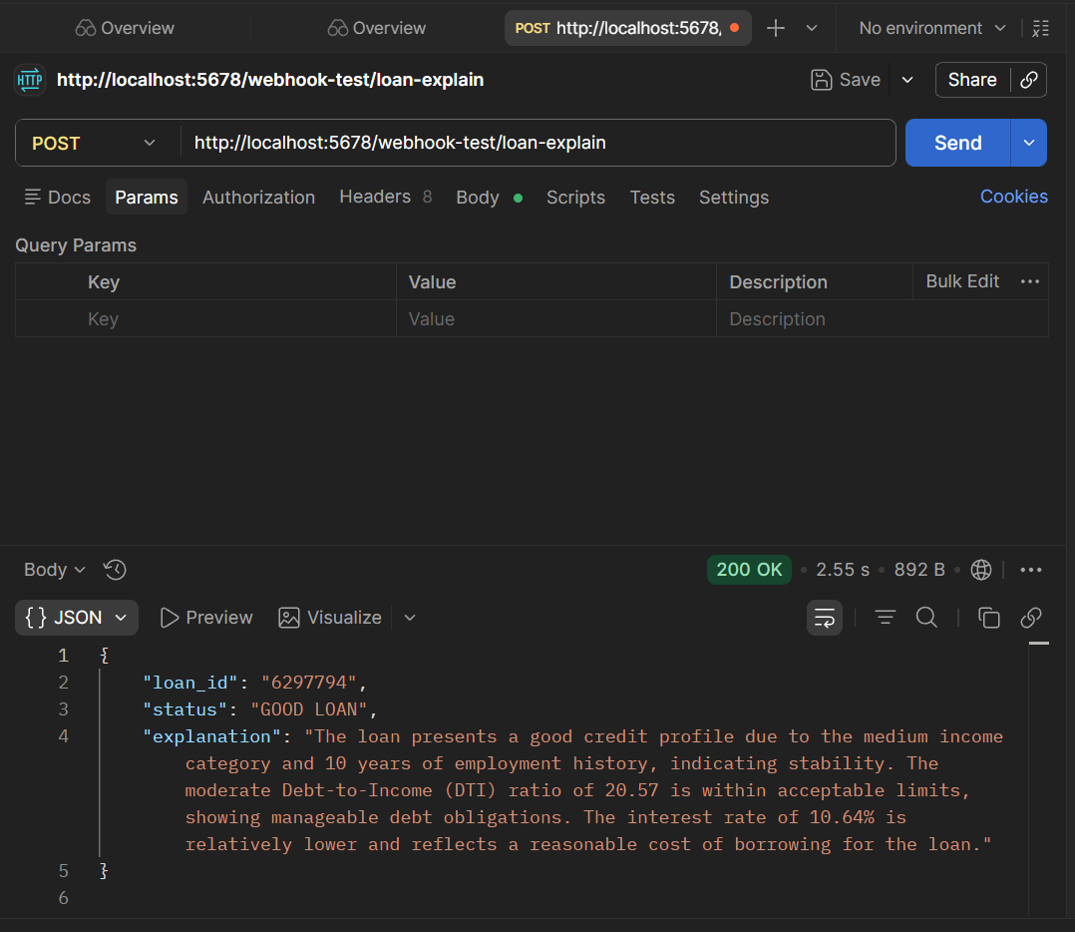

Phase 3: Submission Requirements
This is how we will package the final deliverable.
· [ ] GitHub Repository setup:
o [ ] Export n8n JSON files.
o [ ] Write README.md (Problem statement, workflow steps, GenAI usage, screenshots).
·
[ ] Final Google Doc compilation:
o [ ] Link to Colab/SQL (from previous weeks).
o [ ] Link to Excel sheet (from Week 2).
o [ ] Link to Power BI folder/file.
o [ ] Link to GitHub repository.
o [ ] Integrate the Business Insights provided by your colleague.

