

Product Dissection for ZERODHA

Company Overview:

Zerodha, founded in 2010 by Nithin Kamath and Nikhil Kamath, has revolutionized the way retail investors trade and invest in India. As a pioneering discount brokerage, Zerodha offers a technology-driven platform that makes stock, commodity, and mutual fund trading accessible, simple, and cost-effective. With its flagship trading platform, Kite, and ecosystem of tools like Coin and Console, Zerodha empowers millions of users to manage their investments efficiently while providing real-time data, analytics, and insights. Its innovative approach has positioned Zerodha as a leader in India’s fintech and retail trading landscape.

Product Dissection and Real-World Problems Solved by Zerodha:
Zerodha, India’s pioneering discount brokerage, has completely changed how people trade and invest. Before Zerodha, investing felt complicated, expensive, and limited to experts. Zerodha made it simple, transparent, and affordable for everyone — from students to professionals — by solving key real-world challenges through its different products.

 Kite by zerodha— Simplifying Trading
Kite is Zerodha’s flagship trading platform that makes buying and selling stocks as easy as shopping online.
It solves the problem of complex trading interfaces by offering a clean, fast, and user-friendly app.
With live market data, watchlists, real-time charts, and one-click buy/sell, Kite allows even beginners to trade confidently.
Its modern design removes financial jargon and builds trust by showing every detail clearly — from order price to portfolio performance.

Coin by zerodha— Direct Mutual Fund Investing
Coin solves the problem of poor access to mutual funds. Earlier, most people bought mutual funds through agents who charged hidden commissions.
Coin lets users invest directly in mutual funds with zero commission, linking easily with their Demat account.
This means investors earn higher returns and get full transparency over where their money goes.

 Console by Zerodha — Portfolio and Report Center
Console addresses the issue of fragmented portfolio tracking and lack of insights.
It brings all trading, investments, and performance reports into one simple dashboard.
Users can view profits, losses, tax reports, and dividend history in a single place.
By providing clear, visual summaries and downloadable statements, Console helps users track progress and plan smarter — something that was missing in older broker platforms.

 Varsity — Free Financial Education
Varsity is Zerodha’s way of solving lack of financial awareness.
It offers free, easy-to-understand lessons about trading, investing, and financial planning — written in simple language for everyone.
Beginners can learn concepts step-by-step, practice them, and gain confidence before investing real money.
With Varsity, Zerodha proves that learning finance doesn’t have to be complicated or expensive — just accessible.

Case Study - Real-World Problems and Solutions
This section explores five major real-world challenges that Zerodha identified in India’s investment ecosystem and how its innovative solutions — led by the Kite platform — transformed retail investing

Problem 1: High Brokerage Costs

Real-World Challenge: Traditional brokers charged 0.3-1% of trade value as brokerage, making it extremely expensive for retail investors to trade actively. A trader executing ₹1 lakh worth of trades daily would pay ₹300-1000 per day just in brokerage fees, often wiping out profits.

Zerodha's Solution: Zerodha disrupted the industry by introducing a flat ₹20 per executed trade for intraday and F&O trades, and zero brokerage for equity delivery trades. This revolutionary pricing model made trading affordable and attracted millions of price-conscious retail investors. The transparent, flat-fee structure eliminated confusion and made cost calculation straightforward, solving the problem of unpredictable trading expenses.
Problem 2: Intimidating and Complex Trading Interfaces
Real-World Challenge: Traditional trading terminals were cluttered, confusing, and required extensive training. New investors found them overwhelming, leading to mistakes and reluctance to participate in markets.
Zerodha's Solution: Zerodha developed Kite, a modern web and mobile trading platform with a minimalist design philosophy. Kite features an intuitive interface with customizable watchlists, advanced charting tools, quick order placement, and real-time market data. The platform balances simplicity for beginners with powerful features for experienced traders, making stock trading as easy as online shopping.
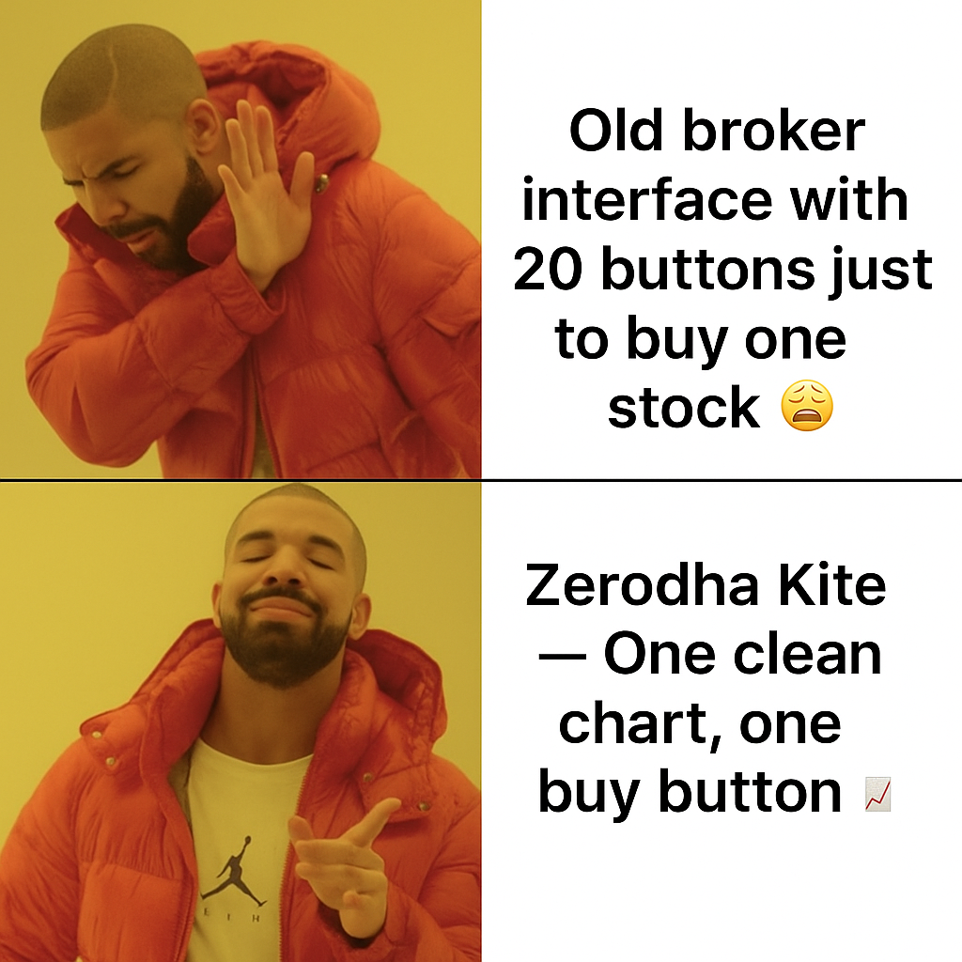

Problem 3: Financial Illiteracy and Lack of Investor Education
Real-World Challenge: Most Indians lacked basic understanding of stock markets, derivatives, and investment strategies. This knowledge gap led to poor investment decisions, losses, and reluctance to participate in wealth creation.
Zerodha's Solution: Zerodha created Varsity, one of India's most comprehensive financial education platforms, offering free courses on technical analysis, fundamental analysis, options trading, and personal finance. With easy-to-understand content in multiple languages, Varsity has educated millions of Indians, empowering them to make informed investment decisions. This educational initiative solved the problem of financial literacy while building trust and loyalty.

Problem 4: Slow Account Opening Process
Real-World Challenge: Opening a trading account traditionally involved physical documentation, in-person verification, and waiting periods of 7-15 days, creating friction for potential investors.
Zerodha's Solution: Zerodha pioneered digital account opening using Aadhaar-based eKYC and e-sign technology. Users can now open a complete trading and demat account in under 10 minutes from their smartphones, with instant verification. This frictionless onboarding process removed a major barrier to entry and enabled rapid customer acquisition.
Problem 5: Fragmented Investment Experience
Real-World Challenge: Investors needed multiple accounts and platforms to access different financial instruments - one for stocks, another for mutual funds, and yet another for bonds, creating complexity and inefficiency.
Zerodha's Solution: Zerodha built an integrated ecosystem: Kite for trading (stocks, F&O, currencies, commodities), Coin for mutual funds (direct plans with zero commissions), and Console for portfolio tracking and reports. This unified platform provides a seamless experience across all investment needs, solving the fragmentation problem.

Through these solutions, Zerodha not only simplified investing but also built a complete, transparent, and education-driven ecosystem. In the next section, we focus on Kite, the heart of this ecosystem, to understand its key features and schema design.

Top Features of Kite

1. User Account Management
Kite provides secure user authentication and profile management with KYC-verified accounts. Users can manage their personal details, PAN information, and contact preferences. The platform ensures regulatory compliance while keeping the account setup process simple and secure, solving the problem of complex account opening procedures.

2. Watchlist Management
Users can create and customize watchlists to monitor their preferred stocks and instruments. This feature allows traders to organize stocks by strategy, sector, or interest, enabling quick access to market prices and making it easy to track potential investment opportunities. Users can add or remove instruments instantly and view real-time price updates for all watchlisted stocks.

3. Funds Management
The platform provides real-time visibility of available trading balance and margin utilization. Users can instantly check their available funds before placing orders, view how much margin is being used by current positions, and manage deposits or withdrawals seamlessly. This solves the problem of slow fund transfers and provides transparency in capital allocation.

4. Order Placement & Execution
Kite offers a simplified order placement interface with multiple order types including Market orders (instant execution), Limit orders (buy/sell at specific price), and Stop-Loss orders (risk management). Users can specify quantity, price, and order type with just a few clicks. The clean interface eliminates the complexity typically associated with trading platforms, making it accessible for beginners while powerful enough for experienced traders.

5. Portfolio Tracking
Users get a comprehensive view of all their current holdings in one place. The portfolio feature displays the quantity held, average purchase price, current market value, and real-time profit/loss for each stock. This unified view solves the problem of fragmented investment tracking and helps users make informed decisions about their investments. The portfolio updates automatically with market movements, providing instant insights into investment performance.

Schema Description for Zerodha Kite

User Entity:
Users are at the core of Kite's trading platform. The user entity contains essential information about each trader:
- UserID (Primary Key): A unique identifier for each user.
- Username: The chosen username for login and identification.
- Email: The user's email address for account-related communication and notifications.
- Phone: Mobile number for authentication and alerts.
- Full_Name: The user's complete name as per official documents.
- PAN: Permanent Account Number for regulatory compliance.
- Registration_Date: The date when the user created their Kite account.

Instrument Entity:
Instruments represent all tradable securities available on the platform:
- InstrumentID (Primary Key): A unique identifier for each instrument.
- Symbol: The trading symbol of the instrument (e.g., "RELIANCE", "TCS").
- Exchange: The exchange where the instrument is traded (NSE, BSE).
- Instrument_Type: The type of instrument (Equity, Futures, Options).
- Lot_Size: The minimum quantity that can be traded.

Watchlist Entity:
Watchlists enable users to organize and monitor their preferred stocks:
- WatchlistID (Primary Key): A unique identifier for each watchlist.
- UserID (Foreign Key referencing User Entity): The user who created the watchlist.
- InstrumentID (Foreign Key referencing Instrument Entity): The instrument added to the watchlist.
- Watchlist_Name: A custom name given by the user (e.g., "My Stocks").
- Added_Date: The date when the instrument was added to the watchlist.

Funds Entity:
The funds entity manages the financial resources available to users for trading:
- FundID (Primary Key): A unique identifier for the funds account.
- UserID (Foreign Key referencing User Entity): The user who owns the funds account.
- Available_Balance: The total cash available for trading.
- Used_Margin: The amount currently blocked for open positions.
- Last_Updated: Timestamp of the last funds update.

Order Entity:
Orders capture all buy/sell instructions submitted by users:
- OrderID (Primary Key): A unique identifier for each order.
- UserID (Foreign Key referencing User Entity): The user who placed the order.
- InstrumentID (Foreign Key referencing Instrument Entity): The stock being traded.
- Order_Type: The type of order (Market, Limit, Stop-Loss).
- Transaction_Type: Whether the order is a Buy or Sell.
- Quantity: The number of shares to trade.
- Price: The desired price for the order.
- Status: Current order status (Pending, Complete, Cancelled).
- Order_Timestamp: When the order was placed.

Portfolio Entity:
The portfolio entity tracks all current holdings of users:
- PortfolioID (Primary Key): A unique identifier for each holding.
- UserID (Foreign Key referencing User Entity): The user who owns the holding.
- InstrumentID (Foreign Key referencing Instrument Entity): The stock held.
- Quantity: The total number of shares held.
- Average_Price: The average purchase price.
- Current_Value: The current market value of the holding.
- PnL: The profit or loss on the holding.

Relationships:
- Users add Instruments to Watchlists – Users can monitor multiple stocks in their watchlists.
- Users have Funds – Each user has one funds account to manage their trading capital.
- Users place Orders – Users place buy or sell orders for instruments they wish to trade.
- Orders reference Instruments – Each order specifies which stock to buy or sell.
- Users have Portfolio Holdings – After successful buy orders, stocks are added to the user's portfolio.
- Portfolio contains Instruments – Each portfolio entry shows which stocks the user currently owns.

Video link for the Project Dissection : Module3_Project.mp4

ER Diagram:

The ER diagram for Zerodha’s Kite illustrates how users, market instruments, orders, funds, portfolios, and watchlists are interconnected within the trading ecosystem. It visually represents how users place orders, manage funds, track instruments, and maintain portfolios. The diagram highlights key relationships like Users–Orders, Users–Funds, and Instruments–Portfolio, capturing the real-world flow of trading activities. Overall, it provides a clear overview of Kite’s data structure and its core business logic.

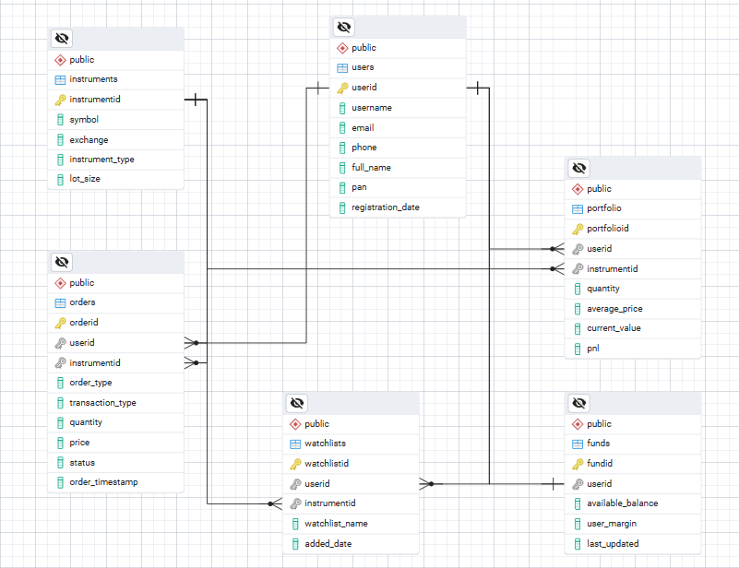

Conclusion

In this case study, we explored the design of Zerodha’s Kite schema and its Entity–Relationship diagram. Kite has transformed the landscape of online trading by providing a seamless, data-driven platform for investors and traders. Its robust data model — comprising entities like Users, Funds, Orders, Instruments, Portfolios, and Watchlists — forms the backbone of its operations. By understanding this schema, we gain insight into how Kite efficiently manages user accounts, executes trades, tracks portfolios, and maintains financial transactions, enabling a smooth and reliable trading experience for millions of users.

Some Important Terminologies :
- Retail Investor - individual person who buys and sells financial products.
- Discount brokerage = low-cost, mostly self-service trading platform.
- Stock = own a part of a company
- Commodity = trade physical goods (like gold, silver, oil, wheat, etc) or their contracts
- Mutual Fund = invest in a diversified portfolio managed by experts.
- Flagship = basically means the company’s star product.
- Democratizes = making something accessible to everyone,
- Fragmented = scattered, disorganized, or spread across multiple places.
- Intraday trades = Buy and sell same stock on same day.
- F&O trades = Futures & Options; contracts to trade on price movements, not actual shares.
- Equity delivery = Buying shares to hold in Demat beyond one day.
- Zero brokerage = No fee charged by broker for delivery trades.
- Margin = Borrowed money from your broker that lets you take larger trades than your actual balance.
- Margin utilization = how much of your total trading limit you’re using right now.
- Instrument = Any item you can buy or sell on the exchange.

