IWS №1
Development of a Python Program Using Control Structures and Functions
Project Topic: Simple Banking System
Student: Mazhit Alikhan
Group: CS2602

1. Project Title
Simple Banking System

2. Objective
The objective of this project is to create a menu-driven Python program that allows a user to check an account balance, deposit money, withdraw money, and view the updated balance. The project demonstrates conditional statements, loops, functions, parameters, return values, and input validation.

3. Problem Statement
A simple banking application is required. The program starts with an initial balance of 10,000 KZT and repeatedly displays a menu. The user can check the balance, deposit a positive amount, withdraw money if sufficient funds are available, or exit. Invalid menu choices, non-numeric amounts, and invalid transaction amounts must be handled clearly.

4. Algorithm Description
- Start the program and set the initial balance to 10,000 KZT.
- Display the banking menu: check balance, deposit, withdraw, or exit.
- Read the user's menu choice.
- Use if / elif / else to select the requested operation.
- For deposits, check that the amount is positive, then add it to the balance.
- For withdrawals, check that the amount is positive and does not exceed the current balance, then subtract it.
- Repeat the menu until the user chooses Exit.
- Display a closing message and stop.

5. Flowchart or Pseudocode
START
balance ← 10000
WHILE the user has not chosen Exit:
Display menu and read choice
IF choice = 1: display balance
ELSE IF choice = 2: read amount; validate; deposit
ELSE IF choice = 3: read amount; validate funds; withdraw
ELSE IF choice = 4: display goodbye message and stop loop
ELSE: display invalid option
END

6. Python Code
The complete Python source code is included in the separate file Simple_Banking_System.py. The following screenshots show the full program in consecutive parts.
Code screenshot 1
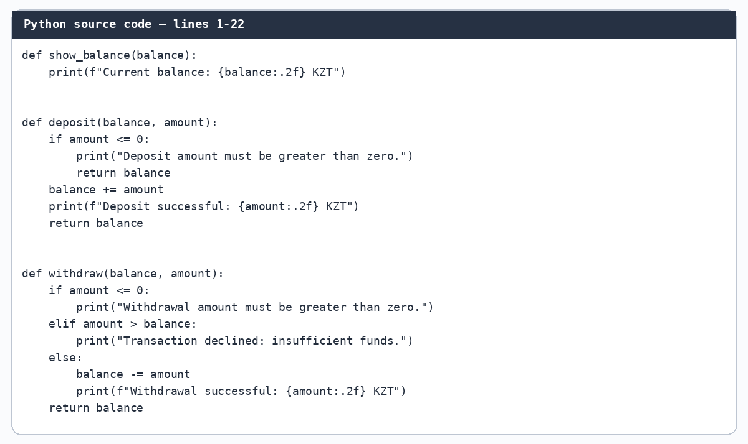
Code screenshot 2
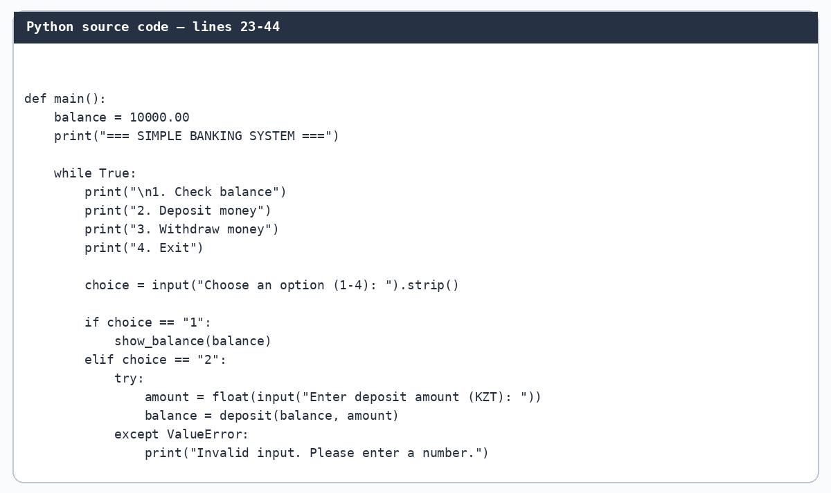
Code screenshot 3
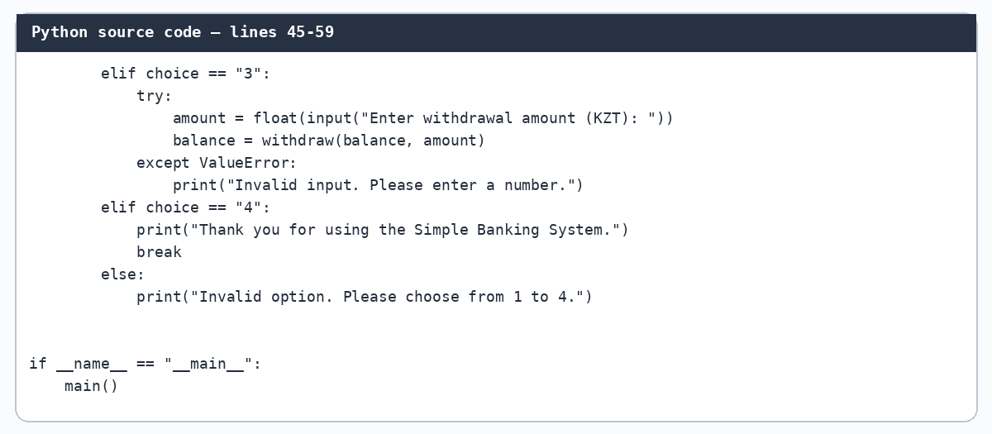

7. Program Output and Test Cases
The following outputs were produced by running the Python program with the input sequences shown in the test cases.

Test Case 1 — Check initial balance
Input sequence: 1 → 4
Expected result: The program displays the initial balance of 10,000.00 KZT and exits.
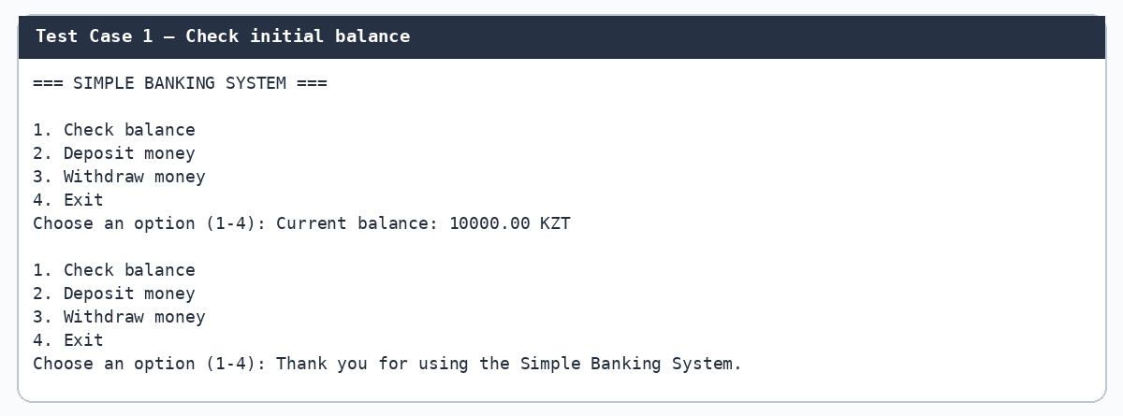

Test Case 2 — Deposit 2,500 KZT
Input sequence: 2 → 2500 → 1 → 4
Expected result: The deposit succeeds and the updated balance is 12,500.00 KZT.
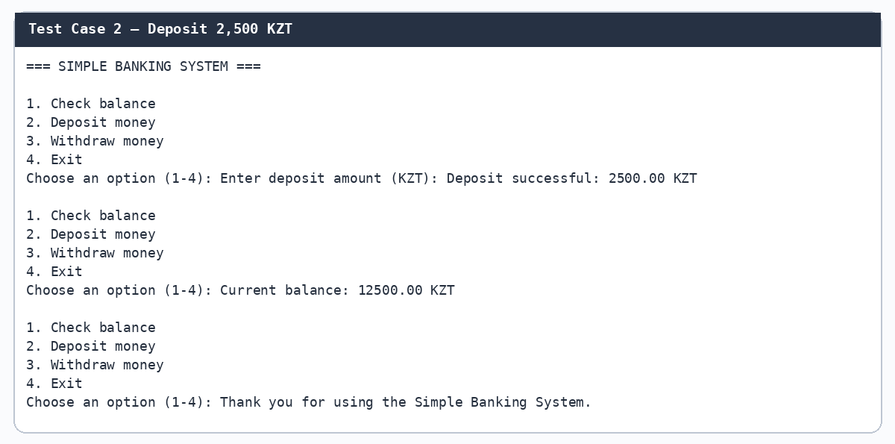

Test Case 3 — Withdraw 3,000 KZT
Input sequence: 3 → 3000 → 1 → 4
Expected result: The withdrawal succeeds and the updated balance is 7,000.00 KZT.
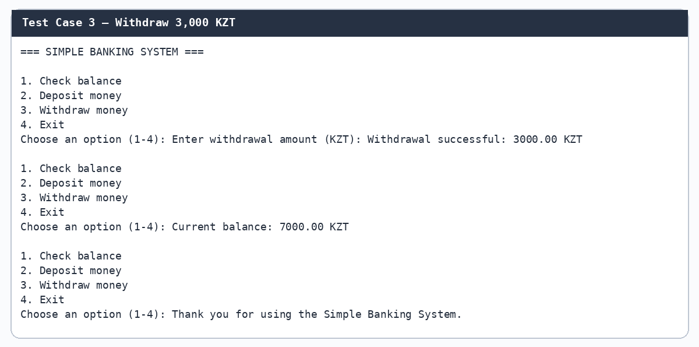

Additional Test — Insufficient funds
Input sequence: 3 → 20000 → 1 → 4
Expected result: The withdrawal is declined and the balance remains 10,000.00 KZT.
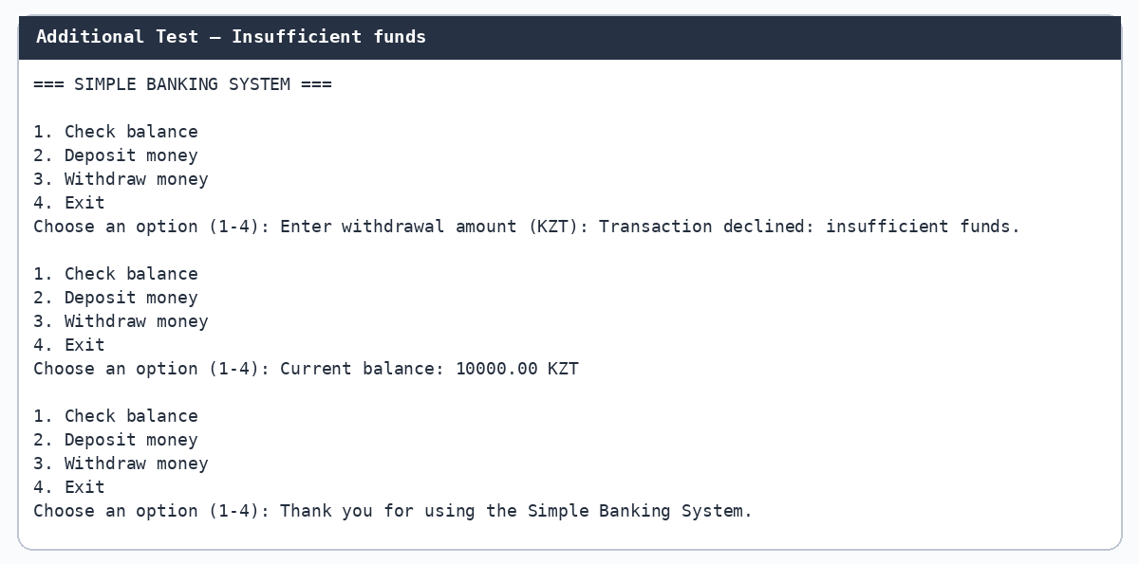

8. Conclusion
The Simple Banking System was developed and tested using Python. It can display the account balance, accept deposits, process withdrawals when sufficient funds are available, and exit through a menu. The program uses input() and print(), if / elif / else statements, a while loop, user-defined functions with parameters, return values, and validation. The test cases demonstrate successful transactions and insufficient-funds handling.

