# 

**User Guide**

**Word for PCs**

For ease of navigation we suggest you turn on the **Navigation Pane** located under the **View** tab in the menu bar.



**Word for Mac**

For ease of navigation we suggest you turn on the **Document Map Pane** located under the **View** tab in the menu bar. Select the **View** tab, select **Sidebar** then **Document Map** pane.



This will open up a clickable Navigation column on the left hand side of the document.

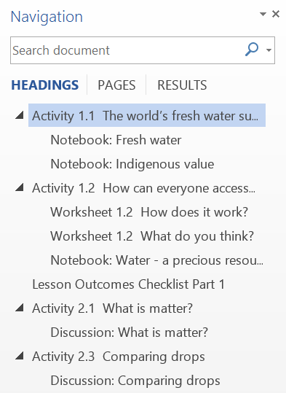

You can select the various elements of each Activity and move through the document with greater ease.

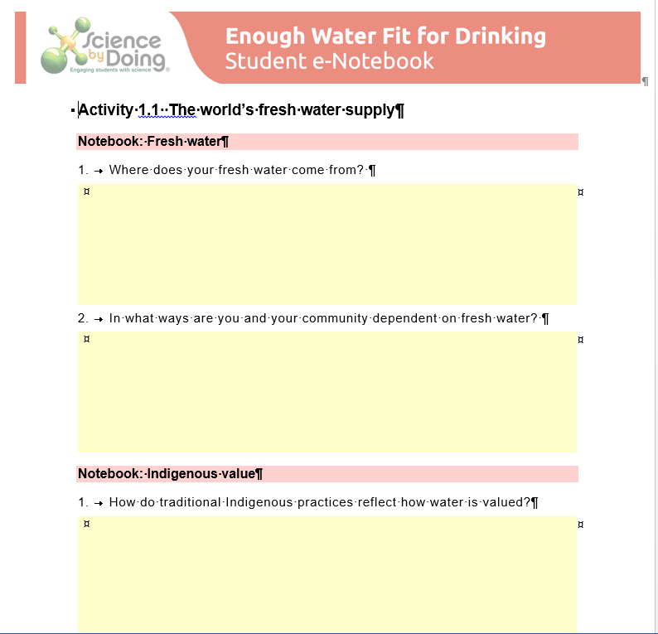

# Activity 3.1 How confusing!

## Names of organisms

**Discussion:**

1. Give an example of different organisms with the same name.

|  |
| --- |
|  |

1. Give an example of several different names for the same plant or animal.

|  |
| --- |
|  |

1. Is this a problem? Why?

|  |
| --- |
|  |

1. Can you think of any way to overcome these problems? Explain.

|  |
| --- |
|  |

# Activity 3.2 Classification based on observed characteristics

Why do scientists classify organisms into groups (phylum, class, order, family, etc.) instead of just giving each a name and noting its description?

|  |
| --- |
|  |

**Activity 3.2 Classification based on observed characteristics**

# Activity 3.3 Binomial naming of species

## Notebook: Binomial naming of species

1. The binomial name tells us how closely two organisms are related. Look at these names and select a pair of organisms that are closely related and a pair that are not, even though their names are similar.

*Cacatua sulphurea*

*Cacatua ophthalmica*

*Acridarachnea ophthalmica*

*Centaurea sulphurea*

Form into small groups and discuss your decisions.

Are you still happy with your answers after looking at **Hints**?

|  |
| --- |
|  |

2. How does the modern classification of *Eucalyptus regnans* differ from the Linnaean classification?

|  |
| --- |
|  |

3. What are the rules to naming a new species?

|  |
| --- |
|  |

**Activity 3.3 Binomial naming of species**

# Activity 3.4 What’s in a name?

## What’s in a name?

**Activity 3.4 What’s in a name?**

**Step 1** - Decide on your research topic. You may use one of these or, with the permission of your teacher, choose one of your own.

• What information does the scientific name tell you about a particular organism you have chosen?

• The work of a scientist who found and named a new Australian or Asian species.

• An example of a recent reclassification of a species because new information was discovered about it.

**Step 3** - Draft a newspaper article telling classmates what you have found out.

|  |
| --- |
|  |

**Step 5** - Produce a final report (including a suitable headline and illustration or photo).

|  |
| --- |
|  |

# Activity 3.5 What am I?

## Designing a classification key

**Discussion:**

Which characteristics were most useful in identifying the different animals?

**Activity 3.5 What am I?**

|  |
| --- |
|  |

**Lesson Outcomes Checklist Part 3**

**NAME:**

|  |  |  |
| --- | --- | --- |
| **ACTIVITY** | **LESSON OUTCOMES**  **At the end of these activities I can:** | **Please indicate if you achieved each learning outcome:**  **✓ = Yes**  **? = Partly**  **X = No** |
| **3.1 How confusing!** | * share ideas about the confusion which might arise when using common names for living things. |  |
| **3.2 Classification based on observed characteristics** | * explain the similarities and differences between the members of taxonomic groups. |  |
| * outline the advantages of using the scientific classification scheme to identify plants and animals. |  |
| **3.3 Binomial naming of species** | * explain the basic principles of giving every organism a genus and species name (binomial nomenclature). |  |
| **3.4 What’s in a name?** | * discuss the outcomes of researching an aspect of the scientific classification scheme. |  |
| **3.5 What am I?** | * design a simple dichotomous classification key. |  |
| **3.6 Can you convince others that using a common classification system is helpful?** | * demonstrate the value of using the scientific classification scheme to provide clarity in communication and to convey information about plants and animals in an ordered way. |  |

**Part 3 Lesson Outcomes Checklist**

# Acknowledgements

**Authors**

This resource was originally written in 2012 by Helen Trotter and Jef Byrne.

This resource was revised in 2017 by Jef Byrne and Dr Jim Woolnough.

*Science by Doing* would like to thank Spinks and Suns for the design and development of this resource.

**Acknowledgement of assistance**

The following people also assisted in the production of this resource:

Students from Melrose High School, Canberra  
Pip Trundle, Birrigai Outdoor School, Canberra

**Funding Acknowledgement**

*Science by Doing* is supported by the Australian Government.

**Project Management Team**

Executive Director: Professor Denis Goodrum, FACE   
Director of Curriculum Development: Jef Byrne  
Web and Digital Co-ordinator: Dr Jen Liu  
Education Specialist: Dr Jim Woolnough  
Administrative Coordinator: Katie Ryan  
Administrative Officer: Kathy Hamilton

**Copyright**

[© Australian Academy of Science 2017](https://www.sciencebydoing.edu.au/copyright)

*Circle of Life, Student e-Notebook:* ISBN *978 0 85847 486 4*

Published by the Australian Academy of Science  
GPO Box 783   
Canberra ACT 2601  
Telephone: 02 62019400

[www.science.org.au](http://www.science.org.au/" \t "_blank)



The details of the relevant licence conditions are available on the Creative Commons website (accessible using the links provided) as is the full legal code for the [Creative Commons Attribution-NonCommercial-ShareAlike 4.0 International (CC BY-NC-SA 4.0) licence](https://creativecommons.org/licenses/by-nc-sa/4.0/) (<https://creativecommons.org/licenses/by-nc-sa/4.0/legalcode>).

Click [here](https://www.sciencebydoing.edu.au/curriculum/circle-of-life/acknowledgements) for a full version of unit acknowledgements and sources or logon to [www.sciencebydoing.edu.au](http://www.sciencebydoing.edu.au).

**Last modified:** March 2019

[](http://www.sciencebydoing.edu.au)