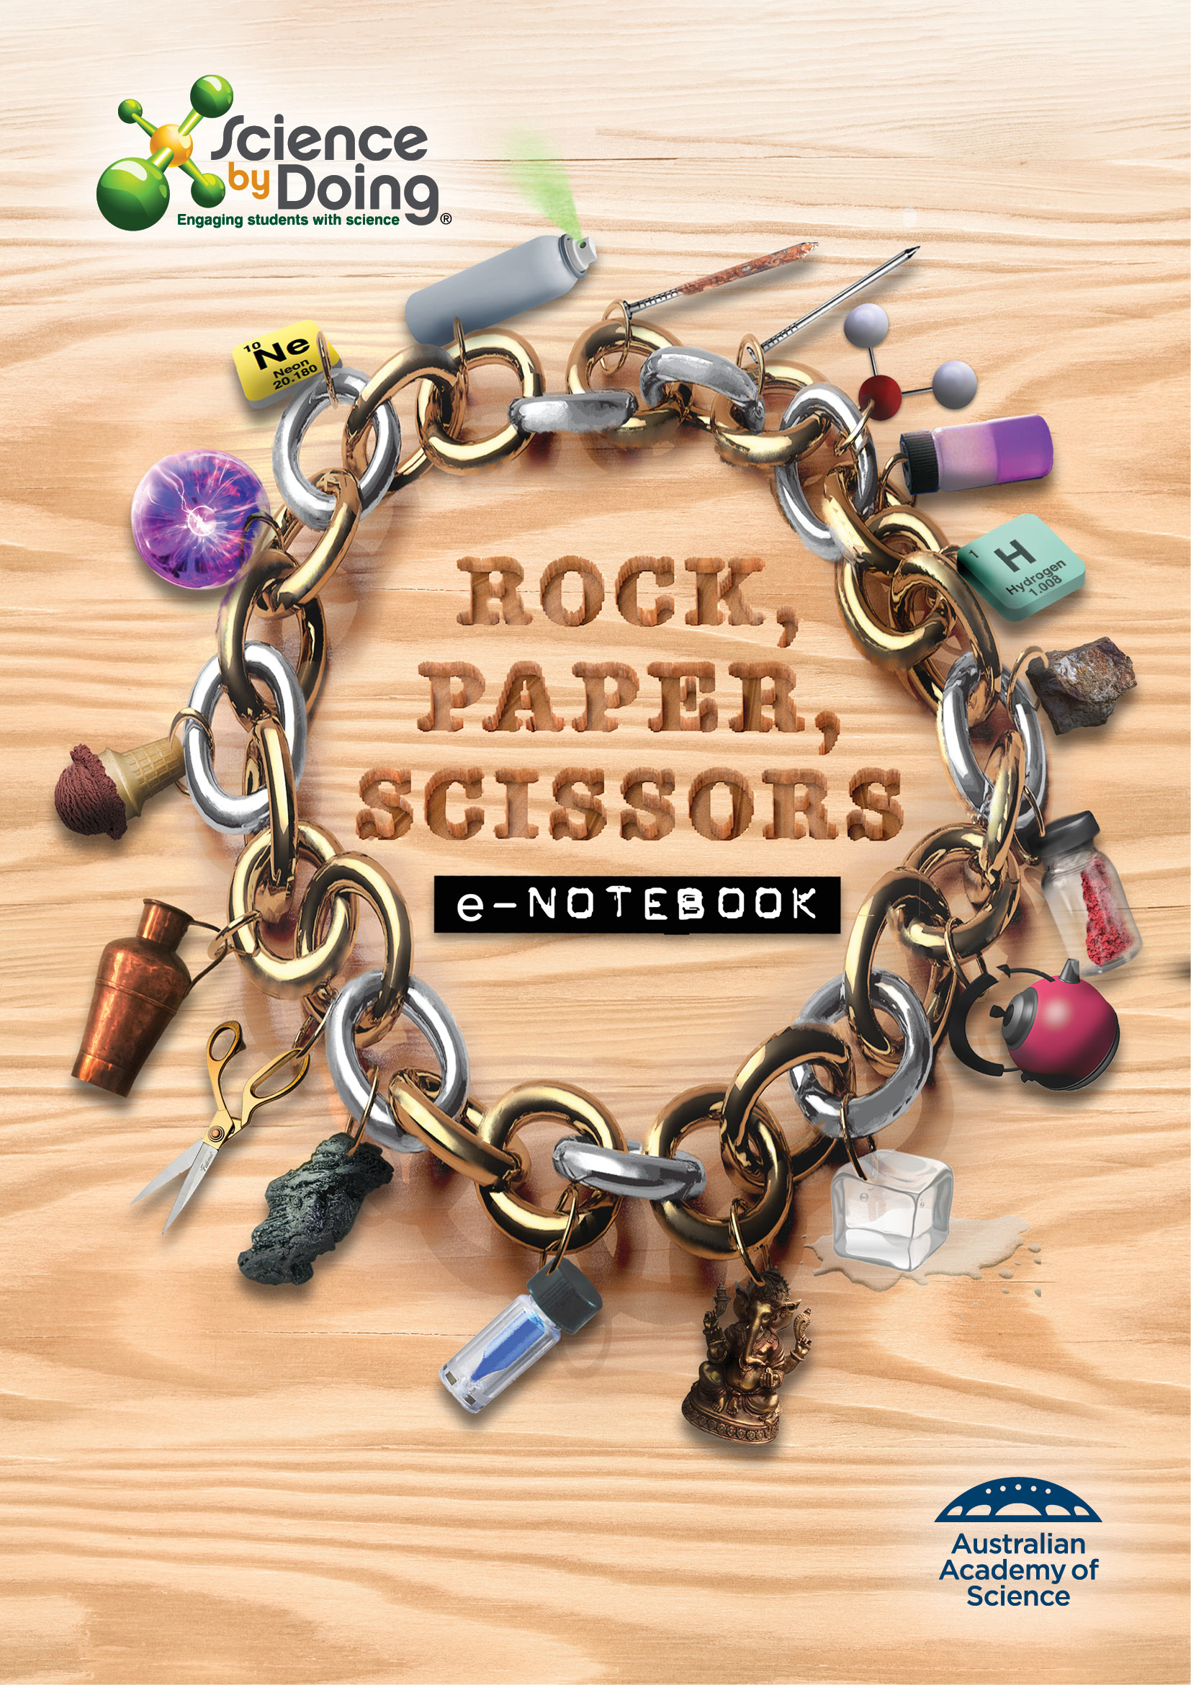**User Guide**

# Activity 4.1 Observing changes in water

**Heating water**

Record your results in the table.

|  |  |  |  |
| --- | --- | --- | --- |
| **Time (min)** | **Temperature (oC)** | **Time (min)** | **Temperature (oC)** |
| **0** |  | **16** |  |
| **1** |  | **17** |  |
| **2** |  | **18** |  |
| **3** |  | **19** |  |
| **4** |  | **20** |  |
| **5** |  | **21** |  |
| **6** |  | **22** |  |
| **7** |  | **23** |  |
| **8** |  | **24** |  |
| **9** |  | **25** |  |
| **10** |  | **26** |  |
| **11** |  | **27** |  |
| **12** |  | **28** |  |
| **13** |  | **29** |  |
| **14** |  | **30** |  |
| **15** |  |  |  |

**Graph your results**

## Discussion

At what temperature did the water start to melt?

|  |
| --- |
|  |

At what temperature did the water start to boil?

|  |
| --- |
|  |

On your graph label when the water was a solid, liquid and gas.

|  |
| --- |
|  |

**Summary**

Copy and complete the diagram in the *Student Guide* adding the name of the phase change on the arrows.

|  |
| --- |
|  |

Think of another example to illustrate the following:

a) a solid changes to a liquid

|  |
| --- |
|  |

b) a liquid changes to a gas

|  |
| --- |
|  |

c) a gas changes to a liquid

|  |
| --- |
|  |

d) a liquid changes to a solid

|  |
| --- |
|  |

## Notebook: Metals or non-metals

**States of Matter**

Choose the ‘*Solid, Liquid, Gas’* tab.

Select ‘*Water*’ in the ‘*Atoms & Molecules’* menu.

You will notice that the temperature is indicated in Kelvin (K) temperature scale.

On this scale;

0oC = 273K, and

100oC = 373K.

Start with the temperature at around 150K (use the Heat/Cool slider to change the temperature). The water is now solid ice.

What do you notice about the water molecules? Are they in relatively fixed positions? Do you notice a pattern in how they are arranged?

|  |
| --- |
|  |

2. Now heat the water to around 300K. It is now a liquid.

What do you notice about the molecules now? Do you still see a pattern? On average, do the molecules look closer to together or further away than when it was a solid?

|  |
| --- |
|  |

3. Now heat the water to around 450K. The water is now turning into a vapour. What do you notice about the behaviour of the molecules now? Are they still sticking together?

|  |
| --- |
|  |

**Challenge Question**

4. We know that ice floats on water, which is very unusual. Most materials sink when they become solid, but water is different. Check again how the water behaves as a solid and as a liquid. Can you explain why ice might float on liquid water?

|  |
| --- |
|  |

**Why is ice slippery?**

5. Play the video to explore the behaviour of ice in a skating rink. Can you explain why skates seem to slide across the ice so easily?

|  |
| --- |
|  |

## Find out more: Ice: temperature and time

Record your notes here about the ***Find Out More*** if instructed by your teacher.

|  |
| --- |
|  |

# Activity 4.2 Ice play

**Ice cream in a bag**

## Discussion

1. Explain why the ice cream froze in this recipe.

|  |
| --- |
|  |

2. Why was the salt important?

|  |
| --- |
|  |

**Experiment: How does salt affect the freezing point of water?**

My experimental method

|  |
| --- |
|  |

My results

|  |
| --- |
|  |

# Activity 4.3 Can matter skip states?

Draw the phase changes of matter in your ***Notebooks***.

|  |
| --- |
|  |

## Notebook: Can matter skip states?

**Iodine**

1. Describe the iodine gas. How does it behave? Does it appear to be lighter or heavier than air?

|  |
| --- |
|  |

2. What shape does the iodine gas take?

|  |
| --- |
|  |

3. How much space does the iodine gas take up?

|  |
| --- |
|  |

4. What happened to the iodine gas as it cooled?

|  |
| --- |
|  |

**Dry ice**

Watch the video of dry ice.

1. What is dry ice?

|  |
| --- |
|  |

2. What happens when the dry ice is added to water?

|  |
| --- |
|  |

3. What is inside the bubbles?

|  |
| --- |
|  |

4. At the top of the cylinder a white mist forms. This is not carbon dioxide, which is invisible. What is it?

|  |
| --- |
|  |

**Moth balls**

Moth balls are often made of a chemical called naphthalene. When moth balls are removed from the packet they sublime.

1. What are moth balls used for?

|  |
| --- |
|  |

# Activity 4.4 Detecting an invisible gas

**Observations**

Record your observations of what happened when you poured the large beaker onto the candle.

|  |
| --- |
|  |

## Discussion: How do we know that an invisible, odourless gas if really there?

1. What happened to the candle?

|  |
| --- |
|  |

2. Referring to the chemical equation shown at right, explain why the candle behaved in this way.

|  |
| --- |
|  |

3. Based on your observation do you think carbon dioxide is lighter or heavier than air?

|  |
| --- |
|  |

## Notebook: Invisible Gases

1. Which 3 gases account for 99% of the Earth’s atmosphere?

|  |
| --- |
|  |

2. Which two gases are most vital for life on Earth?

|  |
| --- |
|  |

3. Which gases appear to be the most toxic?

|  |
| --- |
|  |

4. Which gas is essential to life but toxic in high concentrations?

|  |
| --- |
|  |

**Lesson Outcomes Checklist Part 4**

**NAME:**

|  |  |  |
| --- | --- | --- |
| **ACTIVITY** | **LESSON OUTCOMES**  **At the end of these activities I can:** | **Please indicate if you achieved each learning outcome:**  **✓ = Yes**  **? = Partly**  **X = No** |
| **Activity 4.1 Observing changes in water** | * explain that substances can change state when they are heated or cooled. |  |
| * explain that a change in state does not produce a new chemical substance. |  |
| * interpret a graph documenting the change in temperature of water is it is heated and changes state. |  |
| **Activity 4.2 Ice play** | * explain how salt was used to lower the freezing point of water. |  |
| **Activity 4.3 Can matter skip states?** | * give examples and uses of sublimation. |  |
| **Activity 4.4 Detecting an invisible gas.** | * explain how carbon dioxide gas can be detected through its ability to smother a flame. |  |
| * identify a range of gases and describe their properties. |  |
| **Activity 4.5 What is happening to me?** | * describe what happens to particles when heated and cooled. |  |
| * use correct terminology for what takes place when matter changes state. |  |